Relief Map Tool: Qualtrics Prototype
Live prototype: https://alyssaselassie.github.io/Workforce-with-the-United-Nations/relief-map/
A team-level Relief Map for the UN Transformative Spaces initiative. Draft for discussion, November 13, 2026.
Relief Map team: Alyssa Selassie, Jianxiong Guo, Aris Azamee and Ignacio Valdez
1. What it is
The Relief Map Tool turns a short, anonymous Qualtrics survey into a team Relief Map: a line chart with six workplace settings along the bottom and average discomfort up the side. Each line is a group, so a team can see where people feel comfortable, included and heard, and where they do not. It adapts Maria Rodó-Zárate's Relief Maps (Rodó-Zárate, 2023) and the 2025 Relief Maps Tool from the NYU Intersectionality Lab for teams. It shows group averages, not individual maps.
2. The survey (about 6 minutes, on any phone)
Six settings: Team meetings, one-on-ones with supervisor, virtual and hybrid work, informal and social spaces, learning and development and decision-making. In each, people rate five statements from Strongly disagree (1) to Strongly agree (5), or choose Does not apply to me:
Measures | Statement | Source
Belonging | I feel that I belong. | New, informed by COPSOQ III (sense of community at work)
Psychological safety | It is safe to take a risk here. | Adapted from Edmondson (1999)
Inclusion | My skills and perspective are valued. | Adapted from Edmondson (1999)
Voice | I feel comfortable expressing a different opinion. | Assignment example; related to Edmondson (1999)
Comfort | I feel at ease. | New
Also: five optional questions (role category, gender, age group, working language and disability), each with "Prefer not to say", and one reflection question: "What is one enhancement that would make your team or workplace environment more collaborative and innovative?" Race, ethnicity and nationality are left out because they can identify people in small teams. Add them only for large groups, after a privacy review.
3. Sample Relief Map (fictional team of 48 people)
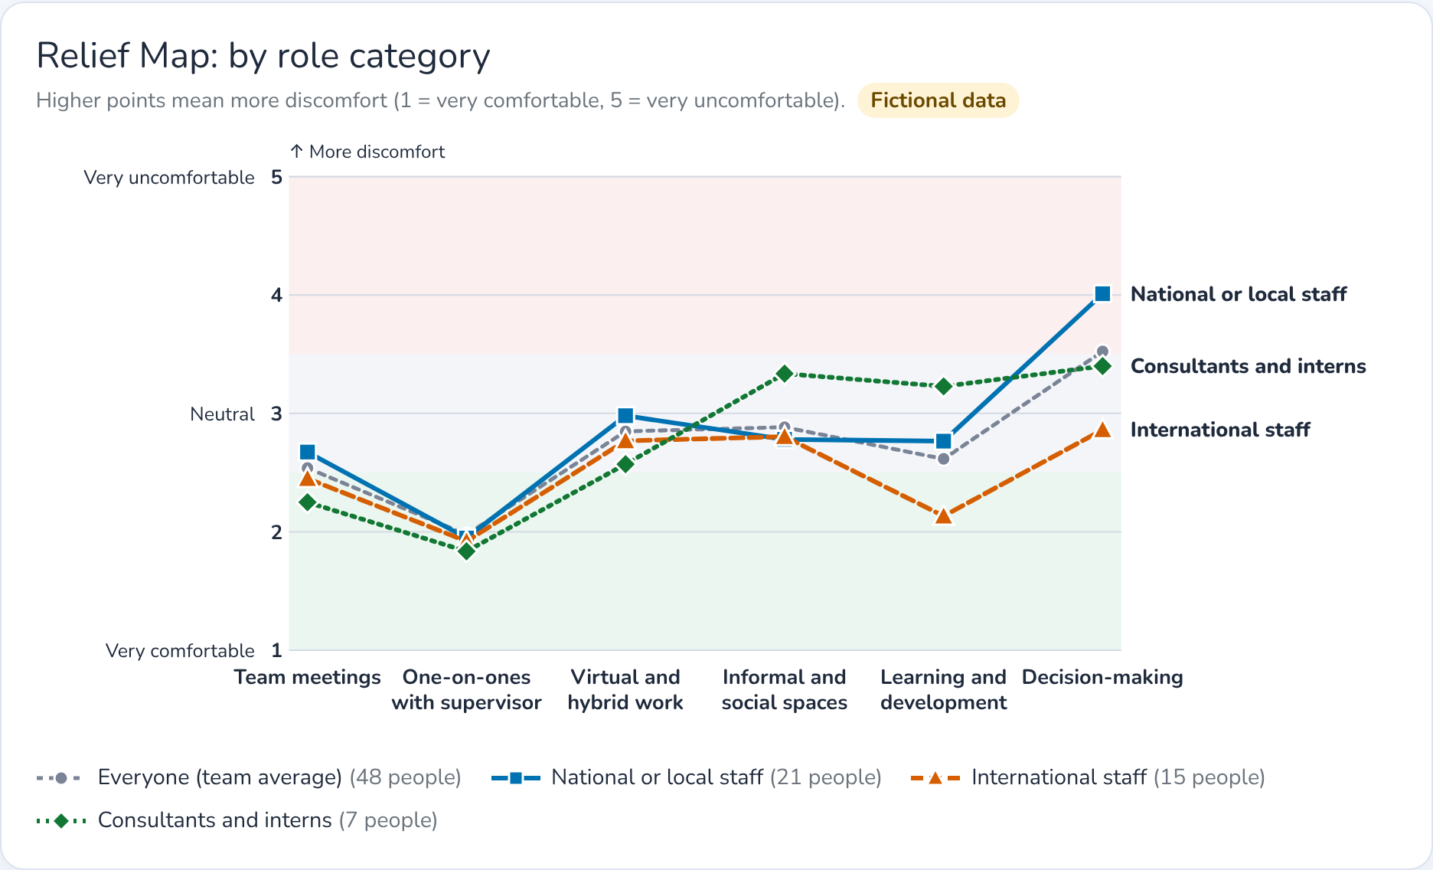
Higher means more discomfort. The dashed gray line is the team average. Groups with fewer than 5 people, such as the 3 people with a disability and the 2 non-binary people in this sample, are always hidden.
4. What the sample map suggests
- Decision-making is the least comfortable setting (3.5 for the whole team), most of all for national and local staff (4.0, against 2.9 for international staff) and for people under 35 (4.0, against 3.0 for people 50 or older). Voice (3.8) and psychological safety (3.7) are the weakest statements there.
- Consultants and interns report more discomfort in learning and development (3.2, against 2.1 for international staff) and in informal spaces (3.3).
- Women report more discomfort in informal and social spaces (3.3, against 2.4 for men).
- People working in a second language report more discomfort in virtual and hybrid work (3.1, against 2.5).
- One-on-ones with supervisors are the most comfortable setting (2.0): a strength the team can build on, for example to gather input before decisions.
Inclusion opportunities to discuss: explain how decisions are made and by whom, and ask for input before they are final; publish training and stretch opportunities openly, including for consultants and interns where the rules allow; hold social moments during working hours; and share documents before calls, use captions and chat, and confirm decisions in writing. The map describes experiences, not what any group is like, so discuss it with the whole team before acting.
5. Build it in Qualtrics (about 10 minutes)
- Create a new, blank survey project. Under Tools → Import/Export → Import survey, choose the file relief-map-survey.txt (download it from the prototype page). Delete any empty default question.
- In Survey options → Security, turn on Anonymize responses, so no IP address or location is recorded.
- Keep every question optional, show the progress bar and allow the Back button.
- Choose a high-contrast theme, keep the grid questions mobile friendly, run the accessibility checker and preview the survey on a phone.
- Distribute it with the anonymous link only: no contact lists, personal links or embedded data with names or IDs.
- To see the map, export the responses as a CSV file with numeric values, open the prototype page and choose Load a Qualtrics export. The file is read in the browser and never uploaded.
6. Pilot plan: one team or department
- Choose a team of about 15 to 40 people with a leader who will act on the results.
- Check privacy first: confirm the organization's data protection rules, use the anonymous link and turn on Anonymize responses.
- Explain it to the team: why it matters, that it is voluntary and anonymous, and that no individual results go to supervisors.
- Open it for two weeks with one reminder, aiming for at least 60% of the team.
- Share the map with everyone at once, then hold a one-hour debrief to agree on two or three actions with owners.
- Learn and repeat: ask about clarity, length and how safe people felt answering, test on phones and with a screen reader, and run it again in three to six months.
7. Privacy rules built into the map
- No names, staff IDs, IP addresses or locations are collected, and every question is optional.
- No group under the chosen minimum (5, 8 or 10 people) is ever shown. People in small groups, and those who chose not to say, are pooled; if that pool is too small, the comparison is hidden, so no one can work out a small group's answers.
- Only one identity question is compared at a time, and comments are never shown word for word, only as themes.
References
Burr, H., Berthelsen, H., Moncada, S., et al. (2019). The third version of the Copenhagen Psychosocial Questionnaire. Safety and Health at Work, 10(4), 482–503. https://doi.org/10.1016/j.shaw.2019.10.002
Edmondson, A. (1999). Psychological safety and learning behavior in work teams. Administrative Science Quarterly, 44(2), 350–383. https://doi.org/10.2307/2666999
Rodó-Zárate, M. (2023). Intersectionality and the spatiality of emotions in feminist research. The Professional Geographer, 75(4), 676–681. https://doi.org/10.1080/00330124.2022.2075406
Prototype for academic purposes; not an official United Nations product. The sample team and its data are fictional.

