Relief Map: Concept Document
A cultural intelligence and implicit-bias learning tool for UN fieldwork, with an outline of Team Compass, a global team collaboration tool
[Your name] · [Course] · Coaching session with Dr. Kristine Kerr: completed · Prototype: https://alyssaselassie.github.io/Workforce-with-the-United-Nations/
1. Concept
Relief Map helps UN personnel build cultural intelligence (Cultural Quotient, or CQ) and recognize implicit bias before and during fieldwork. Learners start from an interactive map of UN field missions (sourced from unmissions.org), read their duty station's mandate and geographic scope, then practice short, realistic decisions linked to that context. Each choice gets immediate feedback that names the bias involved and shows a better approach. All scenarios are fictional, so no real community is stereotyped.
2. Learner journey
1. Orient | 2. Reflect | 3. Practice | 4. Get feedback | 5. Build habits | 6. Discuss
Find the duty station on the map. Read its mandate and the countries it covers. | Answer prompts: What do I know? What am I assuming? Who might not be heard? | Play a linked scenario and make 1–2 decisions as a field officer. | See the rating, the scores, the bias at play and the strongest option. | Learn the PAUSE check (Pause, Ask who is missing, Unpack assumptions, Seek local evidence, Evaluate impact). | Debrief with the team in Team Compass and agree on actions.
3. Sample scenario: "Who speaks for the community?"
Question: You are a Civil Affairs Officer. Your team leader wants to plan new water points by meeting only the five older male leaders who usually attend mission meetings. Women and girls collect most of the water, and there are reports of harassment on the route. What do you recommend?
Response choice | Rating · scores* | Feedback shown to the learner
A. Go ahead as planned. The leaders represent the community. | Reconsider · 0-0-1-0 | The easiest voices to reach are not the most affected. Without women and girls, the plan could increase harm. Bias: availability, gender.
B. Meet the leaders, and also hold separate sessions with women and girls, run by female staff, at times and places they choose. | Strong · 3-3-3-3 | Respects community structures and safely includes the people most affected. This is standard good practice.
C. Skip the leaders and talk only to women at the water point. | Partial · 1-2-2-1 | Right to center women, but bypassing leaders may cause backlash, and the water point is not a safe, private space.
D. Send an online survey to the leaders' phones to forward. | Reconsider · 0-1-1-0 | Phone access is unequal, and gatekeepers filter who receives it, so the results will be unrepresentative. Bias: availability.
*Scores in the order Cultural Intelligence (CQ), Bias Awareness, Evidence, Do No Harm.
4. Feedback, proposed scoring and learner profile
- Feedback: after every choice, learners see a rating (Strong / Partial / Reconsider), a short explanation, the bias at play with a counter-strategy, and the strongest option. Each scenario ends with three key takeaways and a private reflection question.
- Scoring: each choice earns 0–3 points on four competencies: Cultural Intelligence (CQ), Bias Awareness, Evidence-Based Decisions and Do No Harm & Inclusion. Score = points earned ÷ points possible. Proposed bands: Emerging (under 50%), Developing (50–74%), Proficient (75% and above).
- Learner profile: learners create a profile with a profile photo, banner photo, headline, duty station, languages and a learning goal. It shows their competency scores, earned badges (such as Bias spotter and Team player) and recent activity. A downloadable backup lets them move their progress to another device.
- Safeguards: scoring is for learning only. It is never used for performance review, it does not claim to measure a person's implicit bias, and results stay on the learner's device.

5. Annotated prototype screens: Relief Map
Mission map  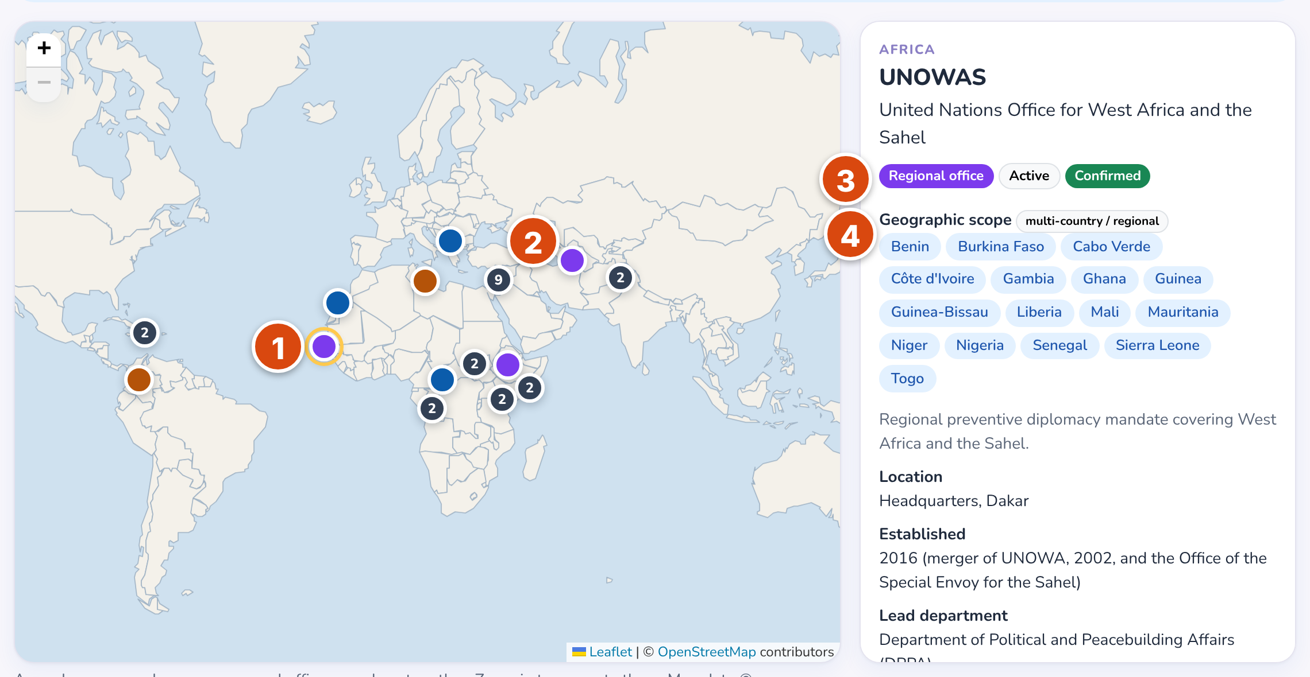  1 Selected mission (UNOWAS, Dakar). 2 Nearby offices grouped into one numbered pin.  3 Mission type, status and data-verification flag. 4 Every country a regional mandate covers. | Decision and feedback  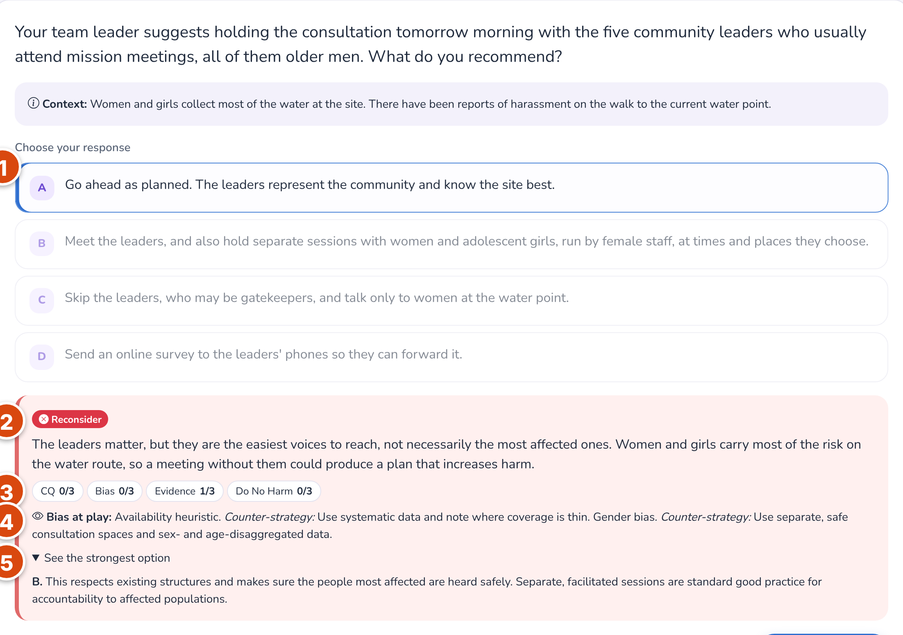  1 Learner's choice. 2 Rating. 3 Scores on the four competencies.  4 Bias at play, with a counter-strategy. 5 The strongest option, explained.
6. Outline: Team Compass, a global team collaboration and implicit-bias tool
Purpose: bias also lives in team habits: who speaks first, whose expertise counts and whose voice is missing. Team Compass helps teams spread across duty stations and time zones practice inclusive decision-making together, using the same scenarios as Relief Map.
- Users: team leaders as facilitators, and national, international and uniformed staff as participants.
- Team journey (4-week cycle): each member plays a scenario → members share perspectives online → a 30-minute live debrief, vote and comparison with the guidance → actions agreed and a short team pulse check.
- Built in the prototype: perspective wall, "who's missing" alert, group vote with the guidance revealed afterwards, action plan and summary.
- Planned: perspective-swap rounds, participation balance, fair meeting times across time zones, anonymous team inclusion pulse.
- Measures (team level only): voice coverage, participation balance, actions completed, inclusion pulse. There are no individual bias scores, and pulse results appear only when 5 or more members respond.
Team Debrief (working prototype)  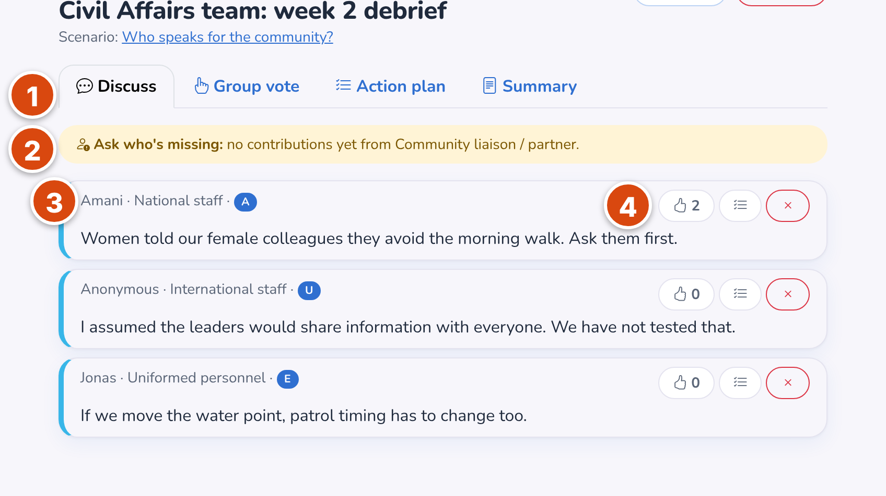  1 Steps: Discuss → Vote → Action plan → Summary. 2 "Who's missing" alert.  3 Each comment tagged with the speaker's role and a PAUSE step. 4 Agree, or turn into an action. | Planned features (concept mockup)  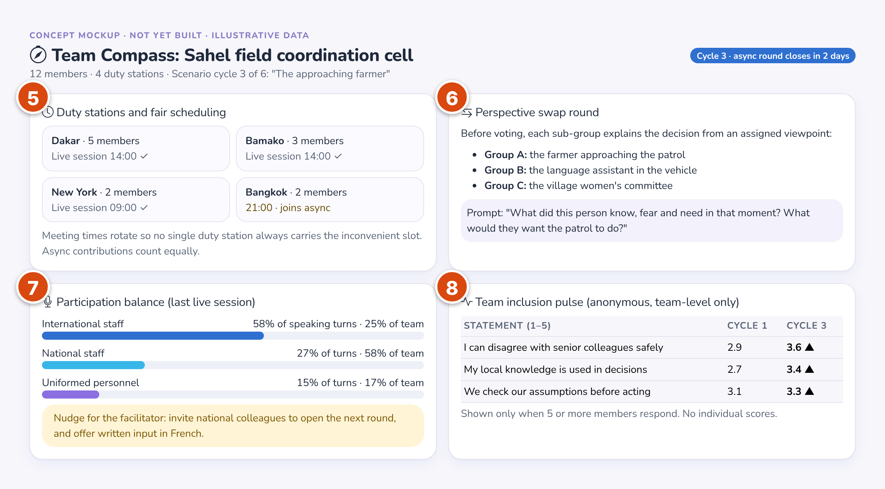  5 Fair scheduling across time zones. 6 Perspective-swap round.  7 Participation balance. 8 Anonymous team inclusion pulse.
Learning prototype for academic purposes. Not an official United Nations product.

