## **Background**

Last week, you started laying the groundwork for your UX/UI portfolio website during the Unit 16 Challenge by building the wireframe you designed during Week 16. This week we will continue to work on your portfolio by applying CSS Flex, CSS Grid, and media queries to make your UX/UI portfolio responsive. In this assignment, you will use CSS Flex to build a layout showcasing your UX skills. You will also use CSS Grid to create content for the case study you generated during Week 16. On top of this, you will continue to polish your UX/UI portfolio website’s CSS to make your site more attractive and employer-competitive.

**User Story:** As UX/UI professionals, accessibility is critical for your portfolio page. You must not operate under the assumption that your site will only be browsed via desktop. In today’s busy world, it's entirely possible that your target audience will not check out your work by desktop and browse on their mobile devices instead. This week is your chance to illustrate your front-end development skills by building flexible content that shows off your work and makes your UX/UI portfolio responsive.

**Note:** If you are using a content management system like Wix or Squarespace to build your portfolio, you MUST still complete this assignment for submission.

## **Workflow Tips**

The following general developer workflow tips help speed up your development process when building a webpage:

* Start by coding the skeleton of the wireframe first. Use outline: **1px solid red;** to see what you're doing on your page with your CSS. Remember to use the Web Inspector to preview changes to your CSS.
* Style your content inside your wireframe.
* Google a lot! There are many nuances to front-end development, and you will undoubtedly encounter problems when practicing coding. Using Google to search for answers is a normal part of all web developers’ workflow.
* Create an account at <https://stackoverflow.com/>. Stack Overflow is a community forum for developers and a great resource to answer all your development questions.

## **Resources**

## Pull up these resources as you are coding to help enforce your code syntax and troubleshoot issues via documentation.

* [Best practices for mobile design](https://xd.adobe.com/ideas/principles/web-design/best-practices-tips-responsive-design-multiple-screens/)
* [Media Query Tutorial By MDN](https://developer.mozilla.org/en-US/docs/Learn/CSS/CSS_layout/Media_queries)
* [MDN Flexbox basics](https://developer.mozilla.org/en-US/docs/Learn/CSS/CSS_layout/Flexbox)
* [MDN basic concepts of Grid layouts](https://developer.mozilla.org/en-US/docs/Web/CSS/CSS_Grid_Layout/Basic_Concepts_of_Grid_Layout)

*If you did not complete the Unit 17 homework or were not happy with the outcome, feel free to use this starter* [*template*](https://drive.google.com/a/2tor.com/file/d/1TXsrSUu6KVyTutg6ZBAXSk7QoJGRTqyh/view?usp=sharing)*. Make sure you style it to match your visual design from Unit 16.*

*Be sure to read through this document in its entirety before beginning work.*

## **Objectives**

## Here is what your instructor wants to see that you’re capable of:

* Practicing redlining a page layout to define HTML/CSS structure.
* Applying CSS Flex to improve a Responsive webpage.
* Utilizing and practicing CSS Grid to generate a web page layout.
* Customizing media queries to make your UX/UI portfolio breakpoints responsive.
* Using CSS Flex to build a layout.

## **Instructions**

**Step 1: Redline Your Portfolio’s “My UX Skills” and “My Work” Sections (1-2 hour)**

During the first part of this homework, you will continue to think like a developer by redlining the two sections we will be building using CSS Flex and CSS Grid.  
*Note: If your design does not match the wireframe examples, redline accordingly. Remember, this is your portfolio. You have creative freedom over the visual design of your website. If you are not confident in your front-end development skills, follow the basic steps here to create a wireframe. Then, style it to visually match your design.*

1. Redline your “My UX Skills” section. Your redlined design should contain the following tags:
   1. A <section> tag
   2. A <h1> tag
   3. A <div> tag containing the following tags:
      1. Three <div> tags that will serve as our flex children. Each <div> should contain the following tag:
         1. A img tag containing a skill you possess.
      2. A <h1> tag containing the title of the skill.
      3. A <p> tag describing how you apply your skillset

*Below is a sample of a redlined “My UX Skills” section:*

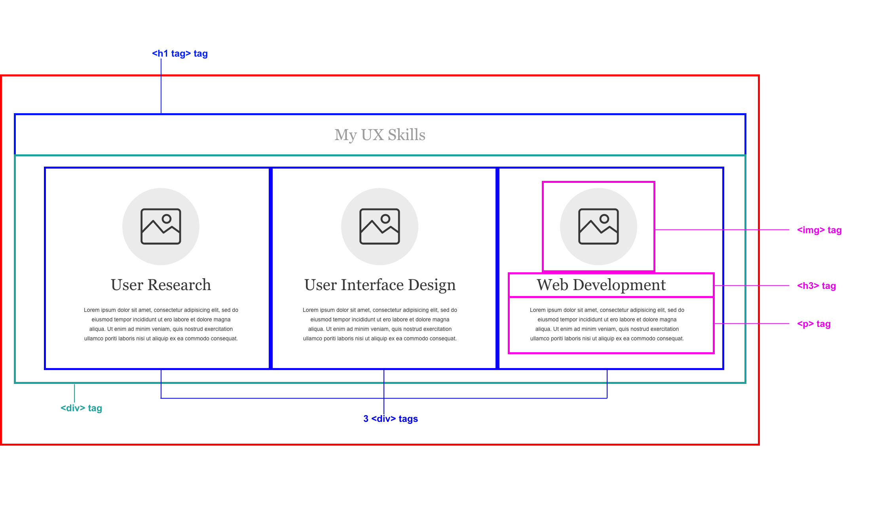

1. Redline your “My Work” section. Your redlined design should contain the following tags:
   1. A <section> tag
   2. A <h1> tag
   3. A <div> tag that contains the following tags:
      1. Two <div> tags, side-by-side:
         1. The first <div> should contain an <img>.
         2. The second <div> should contain a <h4> tag, a <p> tag, and a <button> tag.
      2. Two more <div> tags, side-by-side.
         1. The first <div> should contain an <img>.
         2. The second <div> should contain a <h4> tag, a <p> tag, and a <button> tag.
      3. Two more <div> tags, side-by-side.
         1. The first <div> should contain an <img>.
         2. The second <div> should contain a <h4> tag, a <p> tag, and a <button> tag.

*In total, we should have three rows of two.*

* 1. A <h3> tag

*Below is a sample of a redlined “My Work” section:* 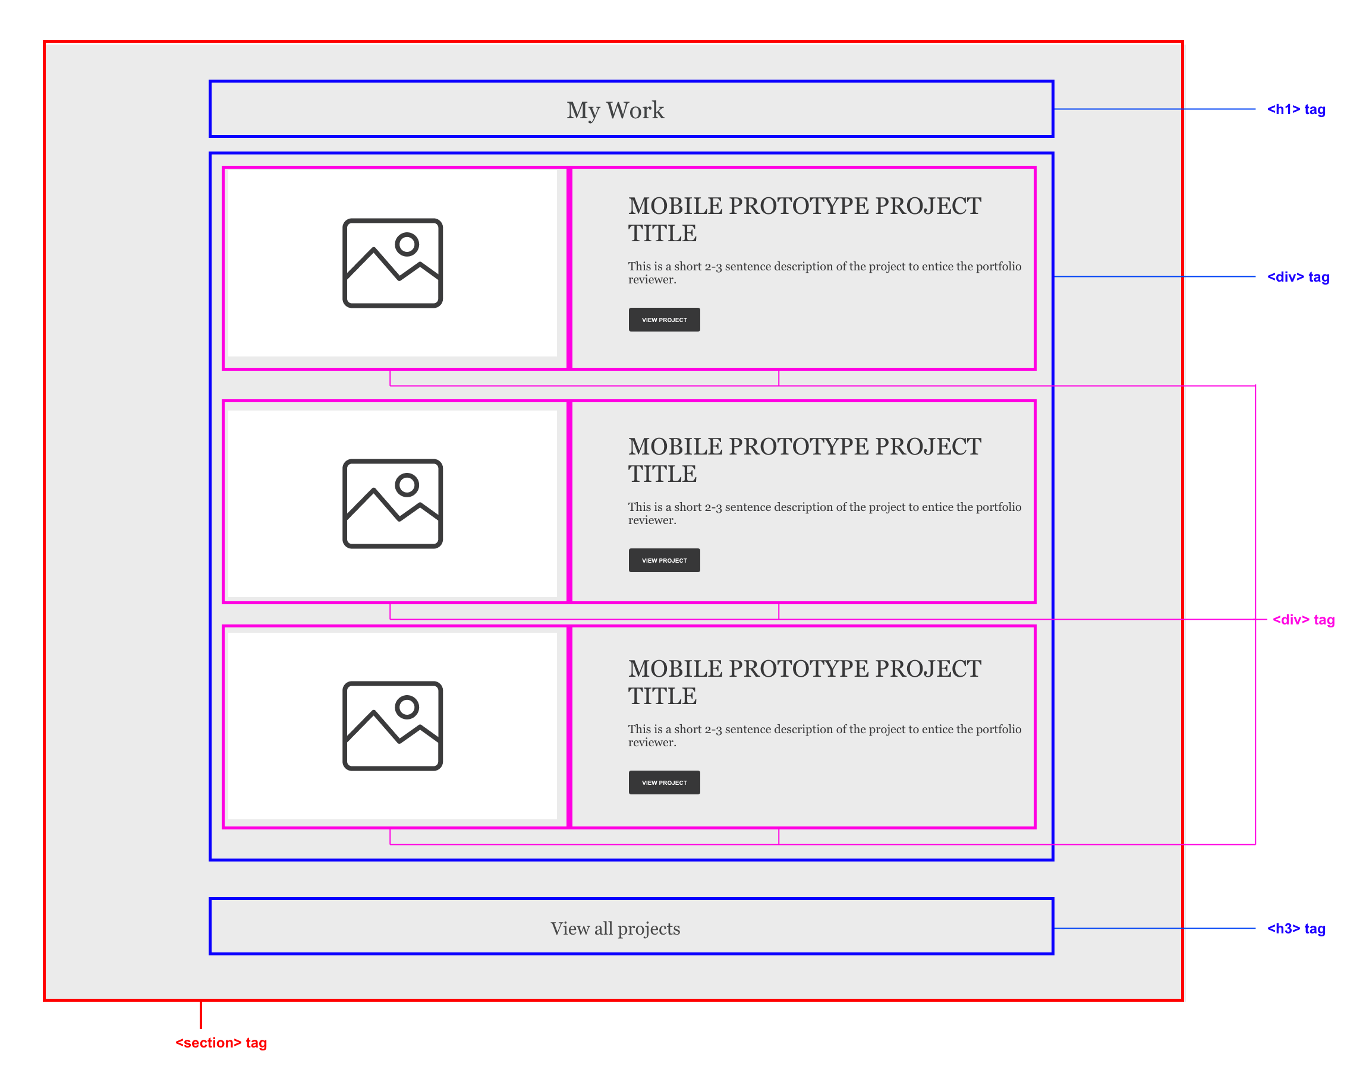

Now that we have visually mapped out your layout, let’s create a repo and start coding our sections!

**Step 2: Create a New GitHub Repository for This Unit's Homework (30 minutes)**

1. Before we start coding, create a new repository on [GitHub](https://www.github.com) and name it “UX_UI_HW_18.”  
   If you need a reminder of how to create and clone a repository, please reference last week’s [homework](https://docs.google.com/document/d/1BTveuMj619aBGFXeR6c-jarNLz5JXVh0dTgpHCZS1mM/).
2. Clone the blank repository to your desktop using GitHub Desktop.
3. Copy and paste your homework files from UX_UI_HW_17 into UX_UI_HW_18. You want to be able to show how your code abilities have grown during the course of the code section. Having multiple versions will allow you to show employers how your skills have grown.
4. Update your UX_UI_HW_18 repository with the new files.
5. Publish your site on GitHub pages. Click Settings on your repository’s homepage.
6. Scroll down to the GitHub Pages area in Settings and select the master branch.
7. Check the URL after the page refreshes. You're ready to code!

**Step 3: Code the HTML for Your “My UX Skills” and “My Work” Sections (1-2 hours)**

**Code the “My UX Skills” HTML**

1. Create a <[section>](https://www.w3schools.com/tags/tag_section.asp) tag with the [class](https://www.w3schools.com/html/html_classes.asp) of mySkills. Inside it, create the following tags:
   1. An [<h1>](https://www.w3schools.com/tags/tag_hn.asp) tag that contains the text “My UX Skills”
   2. A [<div>](https://www.w3schools.com/tags/tag_div.asp) tag with the [class](https://www.w3schools.com/html/html_classes.asp) of flexContainer that will serve as our flex container. This div will contain the following tags:
      1. Three [<div>](https://www.w3schools.com/tags/tag_div.asp) tags that will serve as our flex children. Each div should contain:
         1. An [<img>](https://www.w3schools.com/tags/tag_img.asp) tag. Pick or create an icon that will fit the skill.
         2. An [<h3>](https://www.w3schools.com/tags/tag_hn.asp) tag that contains text to describe the skill.
         3. A [<p>](https://www.w3schools.com/tags/tag_p.asp) tag containing a paragraph about how you use the skill.

That’s it for the HTML of our “My UX Skills” section. Let’s move on to the “My Work” section.

**Code the “My UX Skills” HTML**

1. Create a <[section>](https://www.w3schools.com/tags/tag_section.asp) tag with the [class](https://www.w3schools.com/html/html_classes.asp) of myWork. This section should contain the following tags:
   1. An [<h1>](https://www.w3schools.com/tags/tag_hn.asp) tag containing the text “My Work”.
   2. A [<div>](https://www.w3schools.com/tags/tag_div.asp) tag with the [class](https://www.w3schools.com/html/html_classes.asp) of workGrid. This div should contain the following tags:
      1. Two [<div>](https://www.w3schools.com/tags/tag_div.asp) tags. The farthest first [<div>](https://www.w3schools.com/tags/tag_div.asp) will contain an [<img>](https://www.w3schools.com/tags/tag_img.asp) tag and the second will contain:
         1. An [<h4>](https://www.w3schools.com/tags/tag_hn.asp) tag
         2. A [<p>](https://www.w3schools.com/tags/tag_p.asp) tag
         3. A [<button>](https://www.w3schools.com/tags/tag_button.asp) to view the project
      2. Two more [<div>](https://www.w3schools.com/tags/tag_div.asp) tags underneath the other two. The farthest first [<div>](https://www.w3schools.com/tags/tag_div.asp) will contain an [<img>](https://www.w3schools.com/tags/tag_img.asp) tag and the second will contain:
         1. An [<h4>](https://www.w3schools.com/tags/tag_hn.asp) tag
         2. A [<p>](https://www.w3schools.com/tags/tag_p.asp) tag
         3. A [<button>](https://www.w3schools.com/tags/tag_button.asp) to view the project
2. Under our grid, create an [<h3>](https://www.w3schools.com/tags/tag_hn.asp) tag tag that contains the text “View all projects.”

**Step 4: Code the CSS Style for the “My UX Skills” Section Using CSS Flex (4-6 hours)**

1. If your design differs from the HTML content we constructed earlier, create HTML tags to match your redlined design file for your CSS flex container. This will vary from design to design; each design is different.
2. The first step to creating your “My UX Skills” section is to set a flex container. Set [display: flex](https://www.w3schools.com/css/css3_flexbox.asp) to your <div> with the class of .flexContainer.
3. Now that you have a flex container created, we need to set the widths of the three <div> tags wrapped inside of it.
   1. Apply width 33% to each <div> wrapped inside to create a fully responsive row.  
      *Note: Don’t forget to apply margin and padding to these <div> tags, creating a layout that is evenly spaced.*
4. Write an [HTML comment](https://www.w3schools.com/html/html_comments.asp) above your section tag that says:  
    <!-- My UX Skills section coded using CSS flex -->
5. Now that you have the basic structure and style created for your “My UX Skills” section, your job is to style it to match your visual design! Here are a couple of tips to get you working:
   1. Use [flex-direction](https://www.w3schools.com/cssref/css3_pr_flex-direction.asp) on your flex container to set it to display as either a column or a row.
   2. If you are using the placeholder content for this section, fill it with your own content from the design you created during the Week 16 homework.
   3. If your design differs from the placeholder content, add in your HTML elements to make it match your design and style accordingly.

**Step 5: Code the CSS Style for the “My Work” Section Using CSS Grid (4-6 hours)**

1. If your design differs from the HTML content we constructed earlier, create HTML tags for your CSS Grid. This will vary from design to design; each design is different.   
   *Note:* For a comprehensive guide on how to use CSS Grid, check out this [tutorial](https://css-tricks.com/snippets/css/complete-guide-grid/).
2. Apply [display: grid;](https://www.w3schools.com/css/css_grid.asp) to your div with the class of workGrid to convert this <section> tag into a [grid container](https://www.w3schools.com/css/css_grid_container.asp).
3. Apply named [grid areas](https://www.w3schools.com/cssref/pr_grid-area.asp) to your divs wrapped inside your grid container.

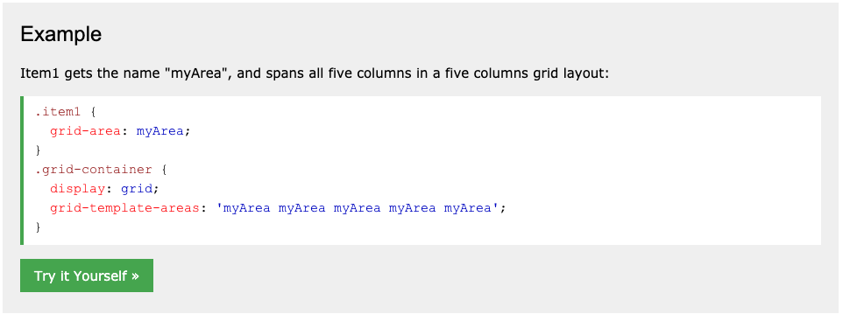

1. On your grid container, create [grid-template-rows](https://www.w3schools.com/cssref/pr_grid-template-rows.asp) and [grid-template-columns](https://www.w3schools.com/cssref/pr_grid-template-columns.asp) to match the visual design of your page. Keep in mind: you can use percentages, pixels, or fraction units to accomplish this.
2. Build out your [grid-template-areas](https://www.w3schools.com/cssref/pr_grid-template-areas.asp) in your grid container to match your design.
3. Apply CSS styles to your CSS Grid to make sure the visual design matches the wireframe that you created during the Unit 16 homework.
4. Create an [HTML comment](https://www.w3schools.com/html/html_comments.asp) above your “My Work” section that reads:   
   <!-- My Work Section Constructed using CSS Grid -->

**Step 6: Code a Mobile Media Query to Make Your Design Responsive for Mobile Devices (1-2 hours)**

1. Write a mobile [media query](https://www.w3schools.com/cssref/css3_pr_mediaquery.asp) at the bottom of your style.css file. Set this mobile media query to take effect at 600 pixels or less using max-width.  
     
   Scroll to the next page.

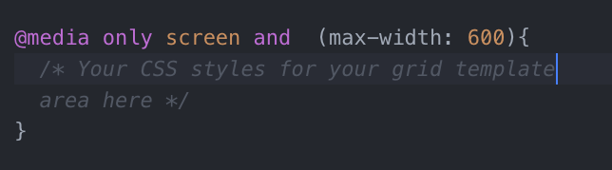

1. Inside your mobile media query’s brackets, rewrite the flex-direction of your [flex container](https://www.w3schools.com/cssref/css3_pr_flex-direction.asp) to display as a column.
2. Rewrite the [width](https://www.w3schools.com/cssref/pr_dim_width.asp) of your flex children to make them take up 100% of the width of their container.
3. Rewrite the [grid-template-areas](https://www.w3schools.com/cssref/pr_grid-template-areas.asp), [grid-template-rows](https://www.w3schools.com/cssref/pr_grid-template-rows.asp), and [grid-template-columns](https://www.w3schools.com/cssref/pr_grid-template-columns.asp) of your grid container to display for mobile views.   
   *Note: See below for an example from Unit 18.2 for an example of how you might accomplish this.*  
     
   Here is a sample grid container set to display on the desktop:  
   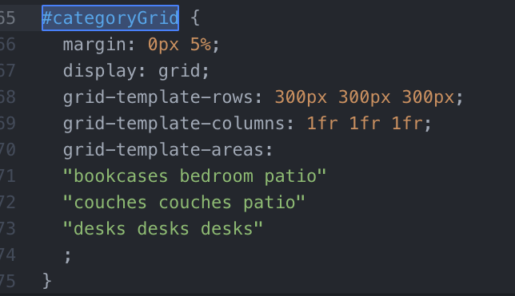  
     
   And here, it is rewritten for mobile browsers. You will have to edit the grid-template-rows and grid-template columns and the grid-template-areas for your grid to display correctly.  
   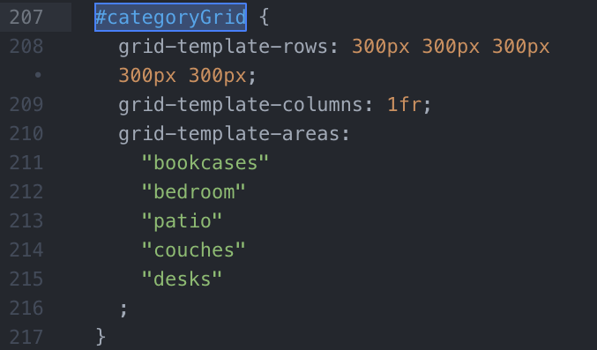

**Step 7: Upload Your Coded Website’s index.html, style.css, and Images Folder to GitHub to Update GitHub Pages (1-2 hour)**

1. Upload your modified webpage to GitHub using GitHub Desktop.
2. Publish your site using GitHub Pages.
3. Open your published GitHub Pages URL to see your changes applied.
4. Make sure you copy the URL. You will need it to submit your homework via Bootcamp Spot.

## **Required Deliverables**

Google doc with the following sections:

1. A link to a G-drive folder containing images of your portfolio wireframe and the redline wireframe mapping out the HTML elements.
   1. The original design of your portfolio website
   2. The redlined “My Ux Skills” and “My Work” sections
2. A link GitHub repository
3. A link to your Github pages website URL.

## **Submission**

Use Google Drive (G-drive) and GitHub to turn in your homework assignment (make sure to double-check that your sharing permissions are set to “Anyone with the link can view”).

Submit the following links to <https://www.bootcampspot.com>:

Here’s what to submit to Bootcamp Spot:

1. **A link to your Google Doc with required deliverable links**