Do Not Cross the Line

NetLogo: AI with A start algorithm.

This game used A\* algorithm to implement the game.

It has starting-level from 1 to 20. Level 1 have 5 points, and level 2 have 6 points etc. There are lines cross each other. This game used A star algorithm to move the points to avoid crossing lines. At the end of game, there will be no lines cross each other.

Start the game:

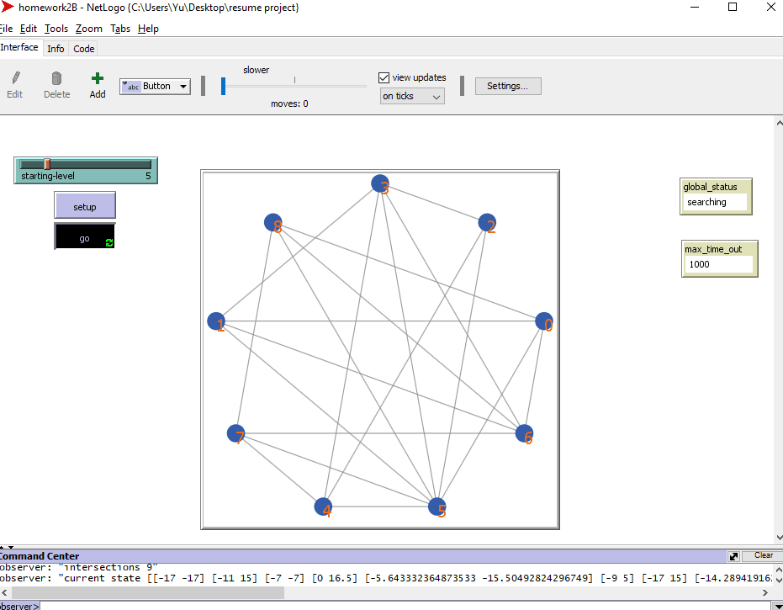

End of the game:

