Create web application with Google Books APIs(https://developers.google.com/books/docs/v1/getting_started).
Example below (This is example, you can provide you own design, use ready-made designs is forbidden):
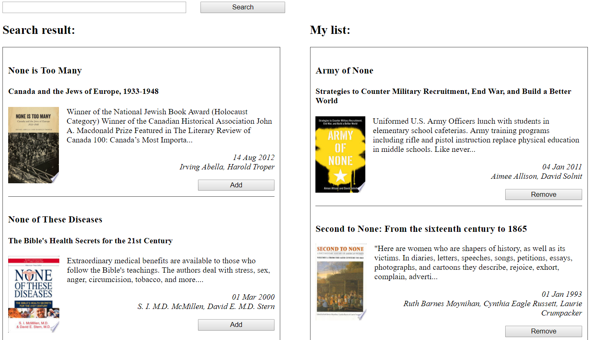
1. Search field (for input search terms).
2. Search button (for send request with search terms).
3. Search result (Title and list with data). Each element contain:
- title (book title);
- subtitle (book subtitle, optional field);
- smallThumbnail (image);
- description (only first 200 symbols, after them “…”);
- publishedDate (date format “DD MM YYYY”);
- authors (list of all authors, separated by “,”);
- button “Add” (For add book to “My list”).
4. My list (Title and list with data). (Title and list with data). Each element contain:
- title (book title);
- subtitle (book subtitle, optional field);
- smallThumbnail (image);
- description (only first 200 symbols, after them “…”);
- publishedDate (date format “DD MM YYYY”);
- authors (list of all authors, separated by “,”);
- button “Remove” (For remove book from “My list”).

