Alyza Wiener

Excel Homework

**Conclusions:**

Use Kickstarter for to raise money for your next play! Theater has a super high rate of getting funded. This is also good place to raise money for hardware, documentaries, and rock music.

People support rock over all other music genres.

Kickstarter is the wrong place to look for funding for your restaurants or food trucks.

**Limitations:**

We don’t know anything about the marketing associated with each campaign.

We don’t have a breakdown showing which campaigns had a single or a few large investments vs campaigns funded solely by small contributions.

We don’t know how Kickstarter compares to other crowdfunding sites.

We don’t know when the time distribution of contributions within the time the campaign was running.

**Possible graphs:**

What is the average amount pledged to successful campaigns by category? What was the average pledged, even if campaigns didn’t hit their goal?

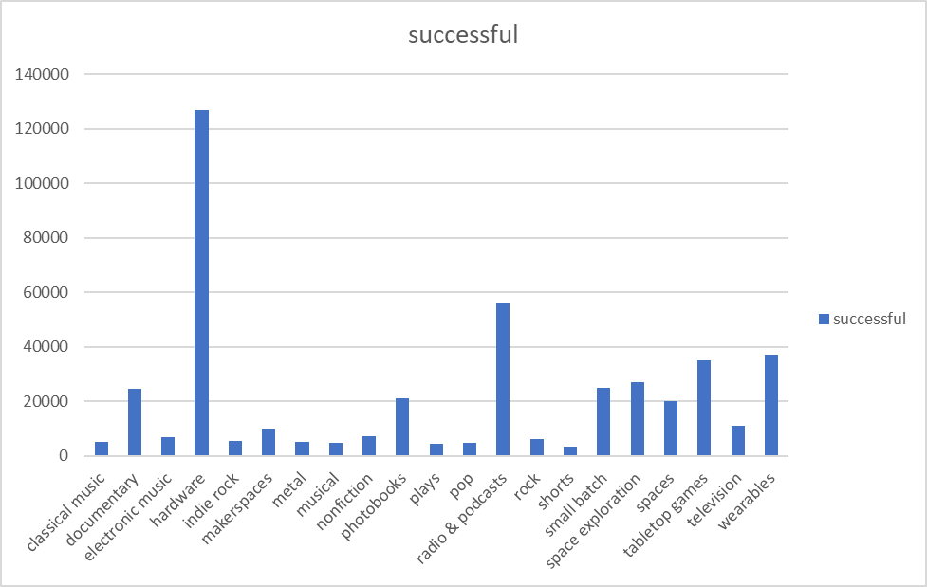

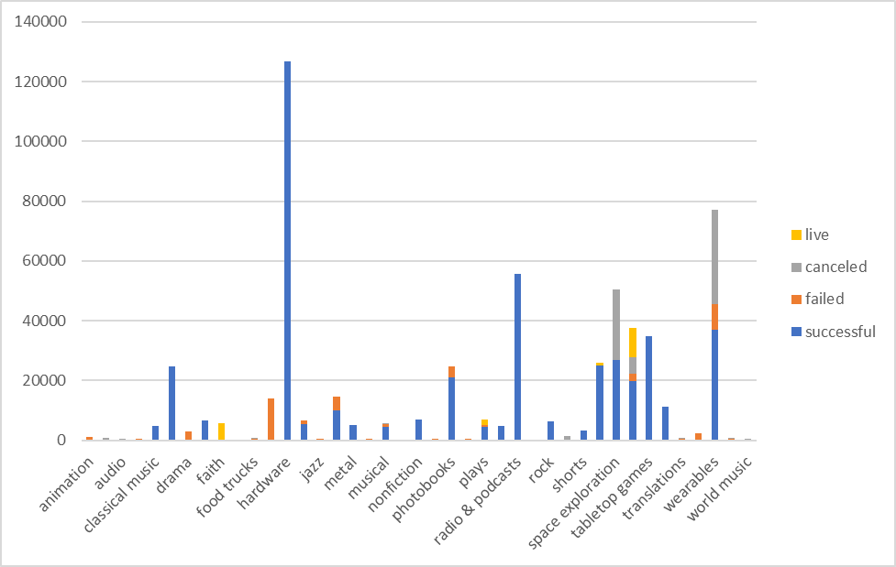

How did the average donation amount received by successful campaigns compare to unsuccessful campaigns? How about the average number of backers? Did successful campaigns receive bigger donations or just more of them?

How much does it help to be selected as a staff pick? Success rate by staff pick:

