Title

Forecasting Hourly Bike Rental Demand with Time-Aware Machine Learning: AR-Style vs VAR-Style Lag Features

Author: Yuan Zhang
Course / Instructor: [Course Info]
Date: [Date]

- Introduction
Urban bike-sharing systems need accurate short-term demand forecasts to keep bikes and docks available where and when riders need them. When demand is underestimated, stations empty out; when it is overestimated, docks fill up and the system becomes inconvenient. It is crucial for people who use it and the bike-sharing company. Because bike usage responds strongly to regular time patterns (rush hours, weekends, seasons) and also to external conditions (temperature, rainfall, solar radiation, etc.), this is a natural machine learning problem: predict the next-hour rented bike count from recent demand history plus weather and calendar information.
In this project, I use the Seoul bike-sharing dataset (SeoulBikeData.csv), which contains hourly observations across roughly one year. The raw data has 8760 rows and 14 columns, with timestamps spanning from 2017-12-01 to 2018-11-30. I do some data cleaning and simple processing. In the dataset, Features include weather measurements (for example, temperature, humidity, wind speed, rainfall, solar radiation) and categorical variables such as Seasons and Holiday. A key modeling choice for demand forecasting is how to represent “memory” of the past. I compare two lag-feature strategies that correspond to two classic time-series ideas:
AR (Autoregressive) features: “predict demand using past demand.” Concretely, I create lagged versions of the target (Rented Bike Count) at 24, 48, 72, and 168 hours (1 day, 2 days, 3 days, and 1 week), so the model can learn daily and weekly repetition patterns. Intuitively, AR is like saying: “What happened yesterday (and last week) at this hour is informative for what will happen now.”
VAR (Vector Autoregressive) features: “predict demand using past values of several variables together.” Here, instead of only lagging the target, I build a multivariate lag set (VAR(1–3)) that includes lags 1–3 not only for demand but also for selected weather variables, producing a wider feature table. Intuitively, VAR-style features let the model learn statements like: “If temperature rose over the last few hours, demand tends to respond in a particular way.”
With these two “memory” designs, the goal of the paper is to (i) compare multiple ML models under a time-aware evaluation protocol, (ii) quantify performance improvements over simple baselines, and (iii) interpret the best-performing model using global and local feature-importance tools (including SHAP) to understand what drives hourly bike demand.
2. Exploratory Data Analysis (EDA)
We visualize demand patterns across categories and time:
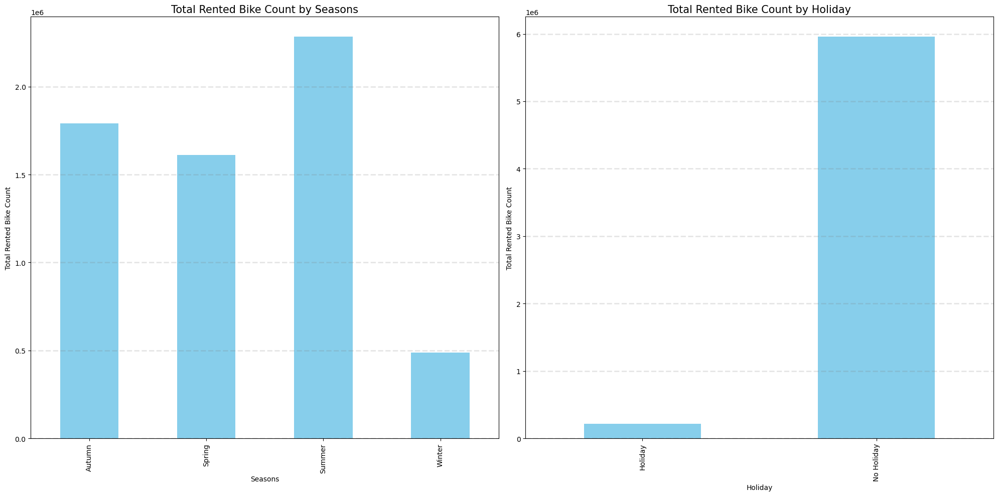
Figure 1: Total rentals by Seasons and Holiday
These figures show the distribution of our target variable in four seasons and holidays. We can seek for more seasonal patterns after looking at these plots.
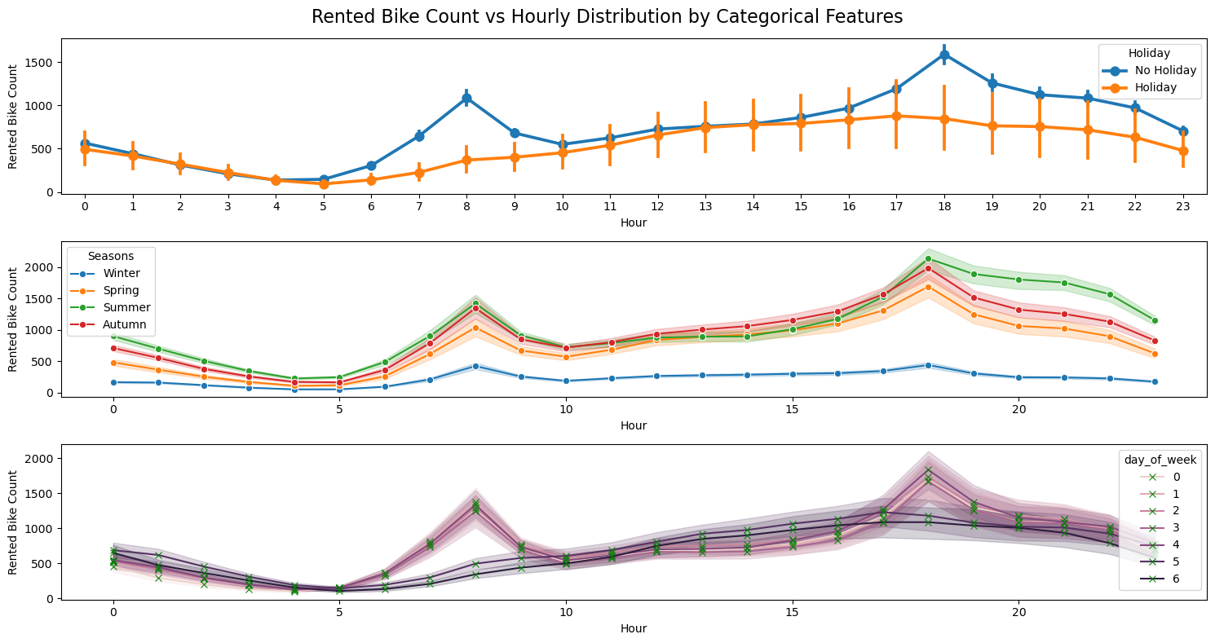
Figure 2: Hourly rental curves conditioned on Holiday, Seasons, and day_of_week.
The plot shows that hour of day is the strongest driver of bike demand, with clear peaks around 8 AM and 6–7 PM, reflecting commuting behavior. On non-holidays, these peaks are much sharper, while holidays show flatter and lower demand, indicating reduced commuting.
Seasonal effects are strong: summer and autumn have the highest demand, spring is moderate, and winter demand is consistently low, though the daily pattern remains similar across seasons. Across days of the week, weekdays exhibit pronounced commute peaks, whereas weekends show smoother, more evenly distributed usage.
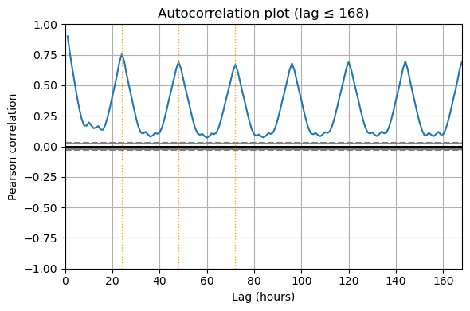
Figure 3: Autocorrelation plot with lag
This autocorrelation plot shows strong temporal dependence, confirming the dataset is not IID. The correlation is very high at small lags (near lag 1), meaning bike rentals are strongly related to recent past values. More importantly, the plot has clear repeating peaks at approximately 24, 48, 72 hours, indicating a pronounced daily seasonality (the same hour on consecutive days behaves similarly). The autocorrelation remains positive and statistically significant for many lags, suggesting that the time series has persistent structure rather than random noise. These patterns directly motivate time-series-aware splitting to avoid leakage, and the creation of lag features such as lag-1 (short-term momentum) and lag-24 / lag-168 (daily/weekly cycles) to capture the dominant periodic behavior in demand.
These plots motivate including both calendar features and lag features to capture repeating patterns.

3. Methods
3.1 Problem setup and feature sets
We predict hourly Rented Bike Count as a regression problem using weather and calendar covariates plus lagged history. The main modeling choice is how to encode temporal “memory,” so I compare two lag-feature designs. The Long AR setting uses seasonal lags of the target at 24, 48, 72, and 168 hours; after constructing these lags and dropping the first 168 rows, the dataset contains 8297 observations. The VAR-style setting adds short lags 1–3 for the target and selected weather variables (temperature, humidity, solar radiation, rainfall, wind speed), producing a dataset of (8462, 35) after dropping the first three rows.
3.2 Time-aware splitting and validation
Because this is a forecasting task, all evaluation is chronological to avoid leakage. The main comparison uses a 60/20/20 TRAIN/VAL/TEST split. Hyperparameters are tuned using GridSearchCV with TimeSeriesSplit (5 folds) on TRAIN only, then the selected pipeline is refit on TRAIN+VAL and evaluated once on TEST.
3.3 Preprocessing and pipelines
All models are implemented as a single scikit-learn Pipeline to keep preprocessing leakage-free. Numeric features are median-imputed and standardized; categorical features are imputed with the most frequent category and one-hot encoded (handle_unknown="ignore").
3.4 Models and hyperparameter tuning
I compare four algorithms: Ridge, Random Forest, Gradient Boosting, and XGBoost (three non-linear). Stochastic models use random_state=42 for reproducibility. Hyperparameters are selected by grid search using negative RMSE scoring. The grids include: Ridge α∈{0.1,1,10,100}; Random Forest n_estimators ∈ {200,400}, max_depth ∈ {None,5,10}, min_samples_leaf ∈ {1,3,5}; Gradient Boosting n_estimators ∈ {200,400}, learning_rate ∈ {0.05,0.1}, max_depth ∈ {2,3}; and XGBoost n_estimators ∈ {300,500}, learning_rate ∈ {0.05,0.1}, max_depth ∈ {3,4}, subsample ∈ {0.8,1.0}, colsample_bytree ∈ {0.8,1.0}.
3.5 Metrics, baselines, and uncertainty
Model selection focuses on RMSE because it keeps errors in the original demand units and penalizes large misses (e.g., rush-hour peaks). Final reporting also includes MAE and R² Baselines include a training-mean predictor and (in the Long AR setting) a naive weekly lag (lag-168) benchmark. Uncertainty is summarized via the standard deviation of RMSE across TimeSeriesSplit folds for the selected model, reflecting sensitivity to temporal splits.

4. Results
4.1 Predictive performance and comparison to baselines

Table 1 summarizes the out-of-sample performance under the chronological 60/20/20 evaluation protocol for both feature settings (Long AR vs VAR-style). Across all models, adding informative lag features dramatically improves over naive baselines. In the Long AR setting, the mean baseline achieves TEST RMSE = 658.04 and R²= −0.226, while a simple weekly seasonal baseline using lag-168 improves to RMSE = 554.19 but still explains little variance (R²= 0.130). In contrast, the best tuned ML model in this setting is XGBoost, which reaches TEST RMSE = 274.07 and TEST R²=0.787. The gains are even larger in the VAR-style setting (lags 1–3 on demand and selected weather variables). The mean baseline remains poor (TEST RMSE = 672.26, R²= −0.258), and the naive lag-1 baseline yields RMSE = 321.57 (R²= 0.712). Among learned models, XGBoost is again the strongest, achieving TEST RMSE = 165.77 and TEST R²= 0.9235, and it is also the overall best model by cross-validated RMSE. This indicates that short-horizon dynamics (last 1–3 hours) contain much more predictive signal than longer seasonal lags alone.
To quantify “how many standard deviations above baseline”, we treat performance improvements in RMSE as z = (RMSE_{base}-RMSE_{model})/ σ_{cv} where σ_{cv} is the TimeSeriesSplit RMSE standard deviation for the tuned model. For VAR-style XGBoost, σ_{cv}=75.16 and the improvement over the mean baseline is (672.26−165.77)/75.16≈6.74 standard deviations. In the Long AR setting, XGBoost improves over the mean baseline by (658.04−274.07) /120.61≈3.18 standard deviations. These comparisons highlight that the best model’s gains are not only large in absolute units, but also robust relative to split-induced variability.
Table 1: Model performance on Test
8. Discussion

Two main lessons emerge:

Lag design matters as much as model choice. The same model class (XGBoost) jumps from ~274 RMSE (Long AR) to ~166 RMSE (VAR-style), indicating that short-lag interactions between demand and weather better capture real-time dynamics.

Demand is strongly autoregressive at short horizons. The dominance of lag-1 demand in permutation/gain/SHAP suggests that the most recent hour carries extremely strong predictive signal, with weather and time-of-day refining the baseline.

Potential limitations include: dependence on one year of data, reliance on engineered lags (may be sensitive to missingness), and a single held-out test segment (could be expanded via rolling-origin evaluation).

9. Conclusion

This project built time-aware pipelines for hourly bike demand forecasting and compared four model families under two lag-feature settings. XGBoost consistently performed best, and the VAR(1–3 on y+weather) feature design achieved the strongest performance (TEST RMSE ≈ 165.77, R² ≈ 0.9235), far outperforming naive and mean baselines. Feature interpretation shows the forecast is driven primarily by recent demand (lag-1), then hour-of-day and solar radiation/temperature.

