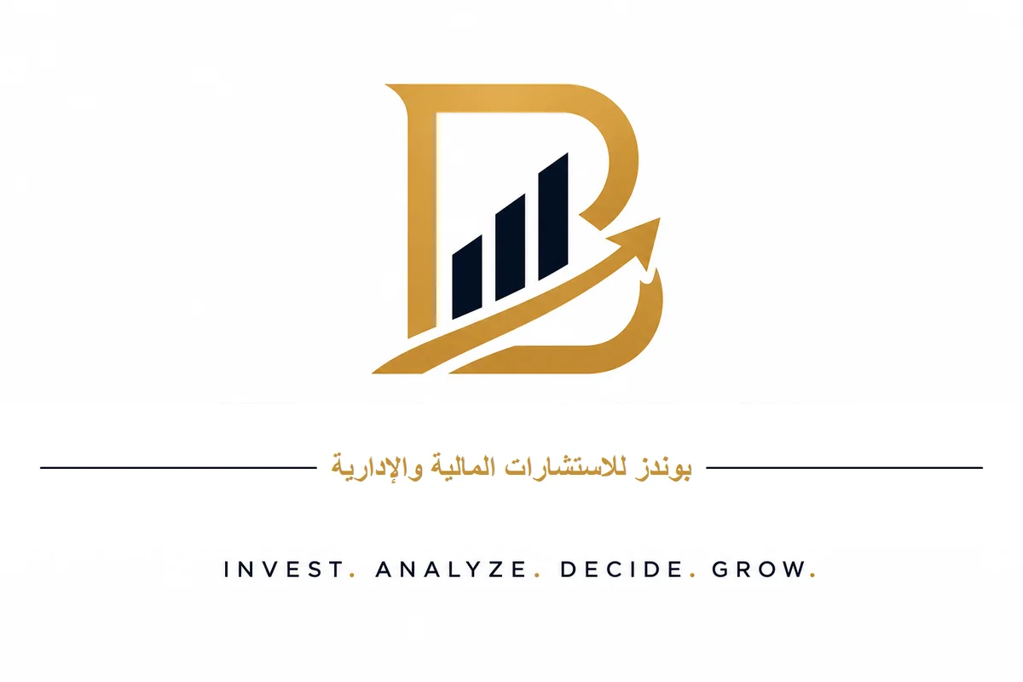

Business Plan
Real Estate Asset Revitalization Company

Closed Joint Stock Company
Kingdom of Saudi Arabia

June 2026
Confidential - For Founding Shareholders Only

Financial Advisor
Dr. Talal bin Hassan Al-Zahrani
+966 56 756 6616

Executive Summary
The Real Estate Asset Revitalization Company is established as a unique investment model aimed at revitalizing incomplete real estate assets in the Kingdom of Saudi Arabia through partnership agreements with property owners, without the need to purchase land or rely on external financing.
The company operates legally as a closed joint stock company, fully funded by its founding shareholders, and adheres to the highest standards of the Saudi Building Code and finishing works, with comprehensive insurance coverage for all projects.

Key Financial Indicators
Indicator | Value
Authorized Capital | SAR 200 million
Total Target Investment | SAR 226 million
Initial Actual Investment | SAR 25 million
Expected IRR over 10 Years | 19% - 20%
Capital Return Multiple at Exit | 2.5x - 4x
Payback Period | 5.5 years

Market Opportunity
- Saudi Arabia is witnessing unprecedented real estate growth driven by Vision 2030 and its massive development projects.
- Thousands of incomplete real estate assets are available due to lack of liquidity or execution expertise.
- Demand for ready-built units exceeds supply in major cities.
- Riyadh and Jeddah record high rental yields reaching 8.89% and 7.89% respectively.

Business Model
- Partnership (Muhassah) with the owner of the incomplete asset.
- The company bears finishing, marketing, and selling costs.
- The owner retains property ownership throughout the project.
- Profits are distributed between the company and the owner according to the signed contract.

1. Company Overview

1.1 Vision
To be the preferred strategic partner for owners of incomplete real estate assets in the Kingdom of Saudi Arabia, by providing professional solutions to revitalize their assets and maximize value for them and the shareholders.

1.2 Mission
Revitalize incomplete real estate assets with high standards of quality and compliance, through a sustainable financial model that generates returns for partners while preserving the rights of asset owners.

1.3 Core Values
- Respect: Respecting the asset owner and his property rights at every stage of the project.
- Quality: Compliance with the Saudi Building Code and highest finishing and safety standards.
- Transparency: Full clarity in contracts, financial reports, and operational reporting.
- Sustainability: Building a long-term economic model that creates value for all parties.
- Innovation: Using technology and smart solutions to improve efficiency and reduce risks.

1.4 Legal Structure
The company is established as a closed joint stock company, licensed by the Ministry of Commerce and the Real Estate General Authority (REGA), in accordance with the Saudi Companies Law. This structure allows raising capital from founding shareholders while maintaining management flexibility and fast decision-making.

1.5 Capital and Ownership Structure
Item | Value
Authorized Capital | SAR 200,000,000
Number of Shares | 40,000 shares
Nominal Value per Share | SAR 5,000
Actual Value per Share | SAR 5,650
Issue Premium and Establishment Costs | SAR 26,000,000
Total Target Investment | SAR 226,000,000

2. Market Analysis

2.1 Overview of the Saudi Real Estate Market
The real estate investment and development sector in the Kingdom of Saudi Arabia is undergoing a radical transformation, driven by Vision 2030 and massive development projects. The sector is maturing, with real demand dynamics becoming tangible in consumer and investor behavior.

2.2 Key Indicators
Indicator | Value
Average Rental Yield in Riyadh | 8.89%
Average Rental Yield in Jeddah | 7.89%
Real Estate Transaction Growth (2025) | +14.2%
Total Real Estate Financing Volume | SAR 730 billion
Average Price-to-Demand Gap | 6%
New Construction Premium | +25%

2.3 Growth Drivers
- Vision 2030 and mega projects such as NEOM, Diriyah, Red Sea Project, and Roshn.
- "Sakani" housing finance programs targeting medium-sized units (70 - 120 m²).
- Salary growth and trend toward smaller, more efficient spaces.
- Internal migration toward major cities and the capital Riyadh.
- Recovery of the rental market and attractive rental yields.

2.4 Target Areas
Riyadh:
- Premium North: Al-Aqeeq, Hittin, Al-Malqa - attracts executives and offers high rental yields.
- Northeast: Al-Munsiyah, Al-Rimal, Al-Yasmin, Al-Narjis - high population density and modern infrastructure.
Jeddah:
- North Coast: Abhur Al-Shamaliyah, Al-Sawari - promising residential and tourism future.
- Vibrant Central: Al-Hamra, Al-Naeem, Al-Zahra, Al-Salama - stable rental yields and continuous commercial activity.

2.5 Competitive Analysis
The main competition is not from large corporations, but from traditional developers whose model requires land purchase and large capital. Our competitive advantage lies in not needing to buy land, and focusing on incomplete assets that do not attract large developers.

3. Services and Solutions

3.1 Core Services
- Comprehensive engineering and legal assessment of incomplete assets.
- Preparation of architectural, structural, and mechanical designs.
- Management of finishing operations and daily supervision.
- Professional marketing and sales of units at market prices.
- Management of delivery, ownership transfer, and profit distribution.

3.2 Partnership Models
Model | Description | Suitable For
Model | Description | Suitable For
Full Muhassah | Company handles finishing and marketing for an agreed profit share | Owner with limited liquidity seeking asset revitalization
Partial Purchase | Company buys part of units after finishing | Owner seeking immediate liquidity
Management Fee | Company charges fixed management fee for finishing and marketing | Owner wishing to retain most profits
Hybrid Model | Balanced mix of Muhassah, purchase, and management fees | Most practical cases

4. Business Model

4.1 How the Company Works
- Identify incomplete real estate assets in target locations.
- Conduct comprehensive engineering, legal, and financial assessment.
- Negotiate with the owner and sign a clear Muhassah or partnership contract.
- Execute finishing works according to highest standards and Saudi Building Code.
- Market and sell units at appropriate market prices.
- Distribute profits between the company and owner per contract terms.

4.2 Revenue Sources
Revenue Source | Expected Share
Revenue Source | Expected Share
Muhassah Revenues (Company Share) | 60%
Resale and Purchase Profits | 25%
Management and Marketing Fees | 10%
Consulting and Administrative Services | 5%

4.3 Cost Structure
Item | Share
Item | Share of Project Cost
Direct Finishing Costs | 55%
Municipal Licenses and Fees | 4%
Engineering Consultation and Supervision | 5%
Marketing and Sales | 7%
Risk Reserve | 10%
Operational Administrative Costs | 6%
Sales and Transfer Fees | 9%
Insurance | 4%

4.4 Competitive Strengths
- No land purchase required, reducing initial capital needs.
- Faster market entry compared to traditional real estate development.
- Extensive network with owners, appraisers, lawyers, and real estate brokers.
- Compliance with Saudi Building Code and insurance, reducing legal and financial risks.
- Flexible financial model self-funded by founding shareholders.

5. Marketing and Sales Strategy

5.1 Digital Marketing Strategy
Channel | Objective | Monthly Budget
Channel | Objective | Monthly Budget
Google Ads | Reach owners of incomplete real estate assets | SAR 10,000
Snapchat Ads | Target age group 25 - 45 | SAR 8,000
Instagram / TikTok | Showcase "before and after" projects | SAR 5,000
SEO | Appear in search results for building revitalization | SAR 3,000
LinkedIn | Reach investors and property owners | SAR 2,000

5.2 Sales Funnel
- Awareness: Reach 100,000 people monthly.
- Interest: Convert 5,000 people into interested prospects.
- Evaluation: Contact 500 potential owners monthly.
- Intent: Hold 50 initial meetings monthly.
- Purchase: Sign 2 - 4 Muhassah contracts monthly.

5.3 Owner Outreach Strategy
- Build a comprehensive database of incomplete real estate assets in target areas.
- Establish strategic partnerships with appraisers and real estate brokers.
- Participate in annual real estate exhibitions within the Kingdom.
- Launch awareness campaigns about the benefits of revitalizing incomplete assets.

6. Operational Plan

6.1 Project Phases
Phase | Duration | Key Activities
Phase | Duration | Key Activities
Assessment | 4 weeks | Structural inspection, legal review, initial cost estimate
Contracting | 2 - 4 weeks | Draft Muhassah contract, obtain necessary approvals
Design | 4 - 8 weeks | Prepare designs and obtain municipal licenses
Finishing | 16 - 24 weeks | Select contractor, daily supervision, periodic inspection
Marketing and Sales | 12 - 24 weeks | Display units, receive clients, sales contracts
Delivery and Settlement | 4 - 8 weeks | Deliver units, transfer ownership, distribute profits

6.2 Key Performance Indicators (KPIs)
Indicator | Target | Warning | Risk
Indicator | Target | Warning | Risk
Finishing Completion Rate | >80% by month 4 | <60% | Contractor delay
Unit Sales Rate | >30% by month 2 | <10% | Weak demand
Finishing Cost vs. Budget | <105% | >115% | Hidden defects
Customer Satisfaction (NPS) | >50 | <30 | Quality issues
Sales Duration | <6 months | >9 months | Market slowdown

6.3 Quality System
- Full compliance with the Saudi Building Code at all execution stages.
- Periodic quality inspections at every phase of finishing.
- Documentation of all materials used and their compliance certificates.
- Project handover with complete technical and legal file for owner and buyer.

7. Management Team and Organizational Structure

7.1 Organizational Structure
The organizational structure is designed to be flexible and efficient, with an initial operational team of 15 employees in the early years, with the ability to expand according to portfolio growth.

7.2 Key Management Roles
Role | Key Responsibilities
Role | Key Responsibilities
Chief Executive Officer | Overall strategy, investor relations, major decision-making
Chief Operating Officer | Project management, contractor coordination, quality assurance
Chief Financial Officer | Cash flow management, financial reporting, financial planning
Commercial Director | Marketing and sales, owner relationships, business development
Legal Director | Contract drafting, compliance, dispute resolution
HR and Administration Manager | Employee management and administrative procedures

7.3 Hiring Plan
Year | Number of Employees | Notes
Year | Number of Employees | Notes
Year 1 | 10 - 15 | Core team for initial phase operation
Year 2 | 15 | Stabilize operational structure
Year 3 | 18 - 20 | Expand number of projects
Year 5 | 25 - 30 | Support portfolio of 10 projects annually

8. Financial Plan

8.1 Financial Model Assumptions
Assumption | Value
Assumption | Value
Average Building Area | 1,500 m²
Number of Units per Building | 6 - 8 units
Finishing Cost | SAR 1,200 - 1,800 per m²
Selling Price | SAR 2,500 - 3,500 per m²
Company Muhassah Share | 50%

8.2 Capital Utilization
Use of Funds | Amount | Share
Use of Funds | Amount | Share
Project Investments (Purchase + Finishing) | SAR 150 million | 66%
Working Capital | SAR 40 million | 18%
Technology and Systems | SAR 10 million | 4%
Establishment, Marketing, and Relations | SAR 15 million | 7%
Emergency Liquidity Reserve | SAR 11 million | 5%

8.3 Summary of Expected Financial Results
Indicator | Value
Indicator | Value
Expected IRR over 10 Years | 19% - 20%
Capital Return Multiple at Exit | 2.5x - 4x
Payback Period | 5.5 years
Expected Net Profit in Year 5 | SAR 9.8 million
Expected Market Value after 5 Years | SAR 120 - 155 million

8.4 Capital Drawdown Mechanism
Capital is not injected in a single payment, but drawn in four phases linked to achieving specific milestones:
- First Tranche (30%): Establishment and purchase of 3 - 5 initial buildings.
- Second Tranche (30%): Completion of first two projects and realization of initial revenues.
- Third Tranche (25%): Reaching 6 active projects and achieving operational break-even.
- Fourth Tranche (15%): Flexible reserve to be released as needed or returned to shareholders.

9. Risk Analysis and Mitigation

9.1 Risks and Mitigation Measures
Risk | Probability | Impact | Mitigation
Risk | Probability | Impact | Mitigation
Difficulty acquiring quality assets | High | Growth stagnation | Build network, database, and partnerships with appraisers
Hidden structural defects | High | Major financial loss | Thorough engineering inspection + insurance + 10% reserve
Delayed unit sales | Medium | Carrying cost burden | Competitive pricing + pre-sale contracts
Contractor delay | Medium | Additional costs | Bank guarantee + contractual delay penalties
Construction material price changes | Medium | Cost increases | Fixed-price contracts with reliable contractors
Legal disputes with owners | Medium | Project stoppage | Clear contracts + binding arbitration clause
Real estate price decline | Low to Medium | Margin compression | Geographic diversification and multiple target segments

9.2 Insurance Policy
- Contractors All Risk (CAR) insurance for each project.
- General public liability insurance for the company.
- Hidden defects insurance for incomplete buildings.
- Professional liability insurance for engineers and consultants.
- Insurance for company headquarters and fixed assets.

9.3 Compliance with Saudi Codes
- Saudi Building Code (SBC) - construction and safety standards.
- Municipal requirements - licensing and periodic inspection.
- Civil Defense requirements - fire safety.
- Real Estate General Authority (REGA) requirements.

10. Implementation Plan and Timeline

10.1 Phase 1: Proof of Concept (Year 1 - 2)
- Complete legal establishment and obtain necessary licenses.
- Inject SAR 25 million as initial investment for the pilot phase.
- Execute 3 - 5 benchmark projects to prove model viability.
- Build a core operational team of 10 - 15 employees.
- Establish a comprehensive database of incomplete assets.

10.2 Phase 2: Growth and Replication (Year 3 - 5)
- Gradually increase called-up capital according to portfolio growth.
- Reach 6 - 10 projects annually.
- Achieve sustainable operational profitability.
- Develop ERP system and automate operational processes.
- Focus on Riyadh and Jeddah as primary markets.

10.3 Phase 3: Strategic Exit (Year 5 - 7)
- Sell controlling stake to a real estate investment fund or major developer.
- Or conduct partial IPO on the Saudi Stock Exchange (Tadawul).
- Or gradually buy back shares from shareholders using profits.

10.4 Main Timeline
Phase | Duration | Key Milestones
Phase | Duration | Key Milestones
Establishment | 0 - 6 months | Obtain licenses, set up office, assemble core team
Launch | 6 - 12 months | Execute first 3 projects, achieve initial revenues
Growth | Year 2 - 3 | 6 projects annually, reach operational break-even
Expansion | Year 4 - 5 | 10 projects annually, sustainable profits
Exit | Year 5 - 7 | Strategic sale or partial IPO

11. Conclusion and Recommendations
The Real Estate Asset Revitalization Company offers a unique investment opportunity in the Saudi real estate market. The business model relies on Muhassah partnerships with owners of incomplete assets, eliminating the need to purchase land and reducing the initial capital required.
Thanks to self-funding by founding shareholders, compliance with the Saudi Building Code, and comprehensive insurance coverage, the company enjoys calculated risks and attractive returns reaching 19 - 20% expected IRR over a 10-year horizon.

Key Recommendations
- Start with a pilot phase of SAR 25 million and execute 3 - 5 benchmark projects.
- Focus on one city (Riyadh or Jeddah) in the early years to avoid spreading efforts.
- Build a database of incomplete assets before official launch.
- Partner with certified contractors who provide bank guarantees for their work.
- Include binding arbitration clauses in all Muhassah contracts.
- Develop an ERP system to manage the portfolio and cash flows.
- Prepare a standardized Muhassah contract that protects both the company and the owner.

