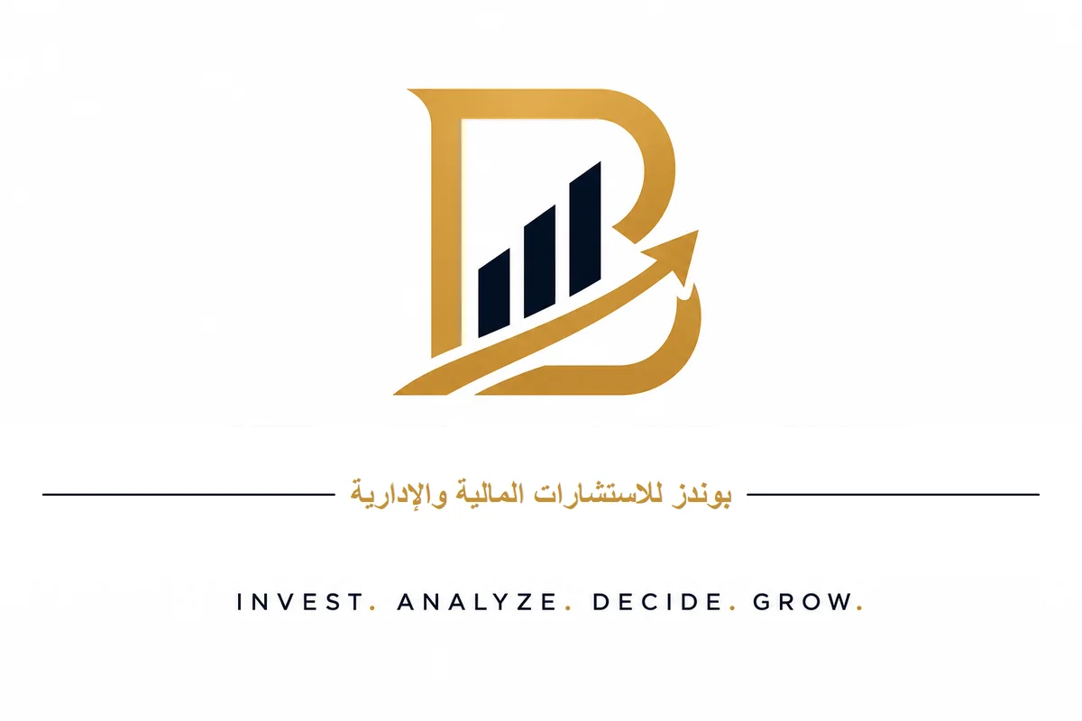

Business Plan
Real Estate Asset Revitalization Company

Closed Joint Stock Company
Kingdom of Saudi Arabia

Financial Advisor
Dr. Talal bin Hassan Al-Zahrani
+966 56 756 6616
info@bonds-global.com

www.bonds-global.com

Executive Summary
The Real Estate Asset Revitalization Company is a unique investment model aimed at revitalizing incomplete real estate assets in Saudi Arabia through partnership agreements with property owners, without purchasing land or relying on external financing.
The company operates as a closed joint stock company, fully funded by founding shareholders, and adheres to the highest standards of the Saudi Building Code and finishing works, with comprehensive insurance coverage.

Key Financial Indicators
Indicator | Value
Authorized Capital | SAR 200 million
Total Target Investment | SAR 226 million
Initial Investment | SAR 25 million
Expected IRR | 19% - 20%
Capital Return at Exit | 2.5x - 4x
Payback Period | 5.5 years

Market Opportunity
- Saudi Arabia is witnessing unprecedented real estate growth driven by Vision 2030.
- Thousands of incomplete assets are available due to lack of liquidity or execution expertise.
- Demand for ready-built units exceeds supply in major cities.
- High rental yields in Riyadh (8.89%) and Jeddah (7.89%).

Business Model
- Partnership (Muhassah) with asset owners.
- Company bears finishing, marketing, and selling costs.
- Owner retains property ownership.
- Profits shared per signed contract.

1. Company Overview

1.1 Vision
To be the preferred strategic partner for owners of incomplete real estate assets in Saudi Arabia.

1.2 Mission
Revitalize incomplete real estate assets with high standards of quality and compliance.

1.3 Core Values
- Respect, Quality, Transparency, Sustainability, Innovation.

1.4 Legal Structure
A closed joint stock company licensed by the Ministry of Commerce and the Real Estate General Authority (REGA).

1.5 Capital Structure
Item | Value
Authorized Capital | SAR 200,000,000
Shares | 40,000
Nominal Value per Share | SAR 5,000
Actual Value per Share | SAR 5,650
Total Target Investment | SAR 226,000,000

2. Market Analysis
The Saudi real estate sector is undergoing radical transformation driven by Vision 2030.

2.1 Key Indicators
Indicator | Value
Rental Yield in Riyadh | 8.89%
Rental Yield in Jeddah | 7.89%
Transaction Growth | +14.2%
Real Estate Financing | SAR 730 billion
Price/Demand Gap | 6%

2.2 Target Areas
Riyadh: Premium North, Northeast.
Jeddah: North Coast, Vibrant Center.

3. Services and Solutions
- Comprehensive engineering and legal assessment.
- Architectural and structural design preparation.
- Finishing management and daily supervision.
- Professional marketing and sales.
- Delivery and ownership transfer.

3.2 Partnership Models
Model | Description
Model | Description
Full Muhassah | Company handles finishing and marketing for profit share
Partial Purchase | Company buys part of units after finishing
Management Fee | Fixed fee for finishing and marketing
Hybrid Model | Mix of Muhassah, purchase, and management fees

4. Business Model
- Identify incomplete real estate assets.
- Conduct engineering, legal, and financial assessment.
- Contract with the owner.
- Finish according to Saudi Building Code.
- Market and sell.
- Distribute profits.

4.2 Revenue Sources
Source | Share
Source | Share
Muhassah | 60%
Resale | 25%
Management Fees | 10%
Consulting | 5%

5. Marketing and Sales Strategy
Channel | Budget
Channel | Monthly Budget
Google Ads | SAR 10,000
Snapchat Ads | SAR 8,000
Instagram / TikTok | SAR 5,000
SEO | SAR 3,000
LinkedIn | SAR 2,000

6. Operational Plan
Phase | Duration
Phase | Duration
Assessment | 4 weeks
Contracting | 2-4 weeks
Design | 4-8 weeks
Finishing | 16-24 weeks
Marketing & Sales | 12-24 weeks
Delivery | 4-8 weeks

7. Financial Plan
Indicator | Value
Indicator | Value
IRR | 19% - 20%
Exit Return | 2.5x - 4x
Payback Period | 5.5 years
Net Profit Year 5 | SAR 9.8 million

8. Risk Analysis and Mitigation
Risk | Mitigation
Risk | Mitigation
Hidden structural defects | Engineering inspection + insurance + 10% reserve
Delayed sales | Competitive pricing + pre-sale contracts
Contractor delay | Bank guarantee + penalties
Legal disputes | Clear contracts + binding arbitration

9. Implementation and Exit
- Years 1-2: Proof of Concept (3-5 projects).
- Years 3-5: Growth and Replication (6-10 projects annually).
- Years 5-7: Strategic Exit.
- Exit options: Sale of controlling stake, partial IPO, buyback.

10. Conclusion and Recommendations
The company presents a unique investment opportunity in the Saudi real estate market. The model relies on Muhassah partnerships with owners of incomplete assets, eliminating the need to purchase land and reducing required capital.
With self-funding, compliance with the Saudi Building Code, and comprehensive insurance coverage, the company enjoys calculated risks and attractive returns.

