**Evaluation Only. Created with Aspose.Words. Copyright 2003-2022 Aspose Pty Ltd.**

Multinomial Naive Bayes classification of Emotion with default hyperparameters: alpha= 1.0, fit_prior= True,class_prior= None

Classification Report:

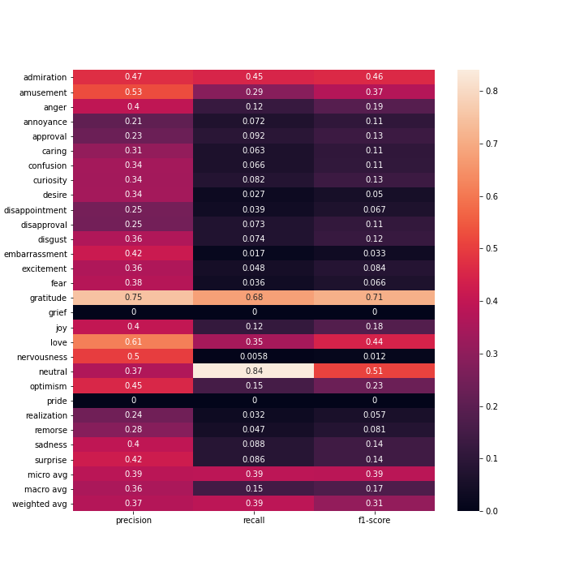

Confusion Matrix

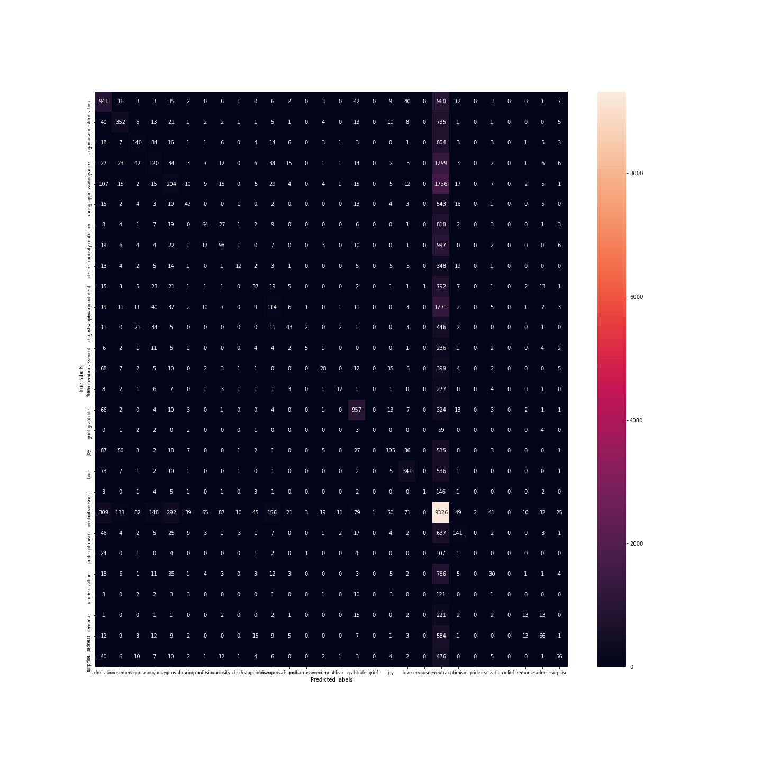Multinomial Naive Bayes classification of Sentiment with default hyperparameters: alpha= 1.0, fit_prior= True,class_prior= None

Classification Report:

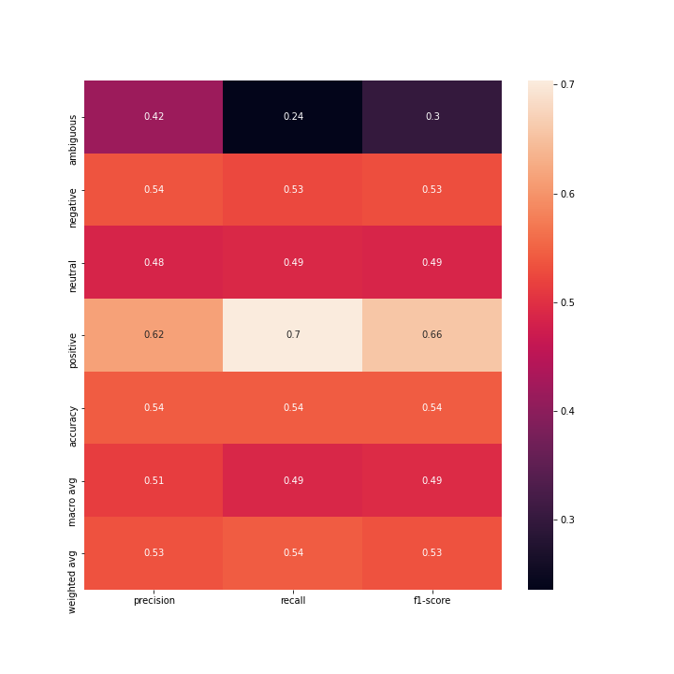

Confusion Matrix

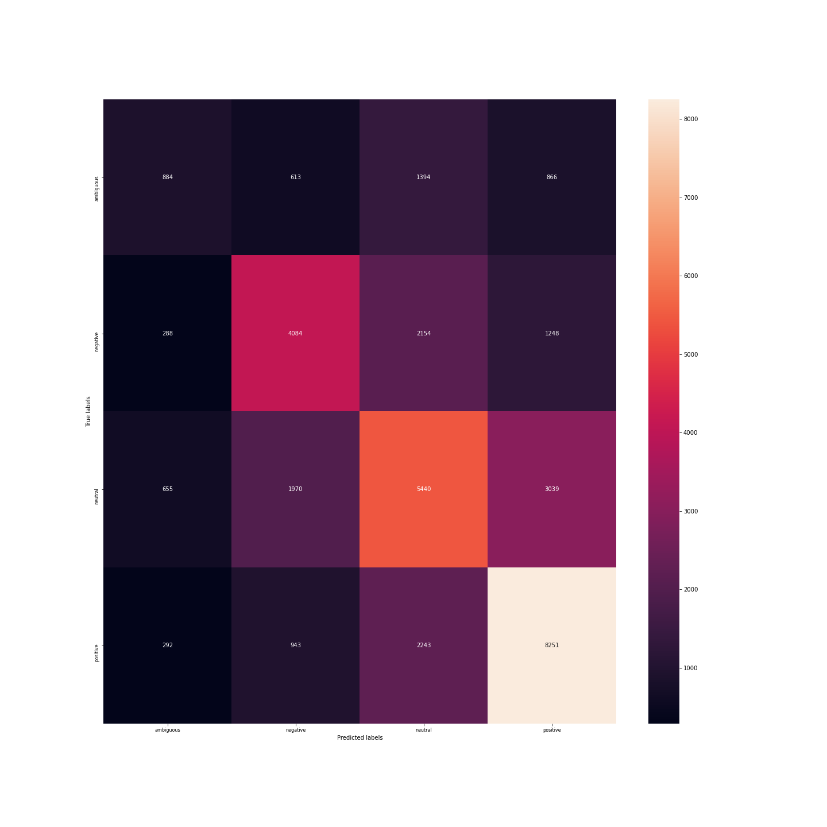Decision Tree classification of Emotion with default hyperparameters: criterion(quality of split)= 'gini'(Gini impurity), splitter= 'best' (choose the best split), max_depth=None, min_sample_leaf=1...

Classification Report:

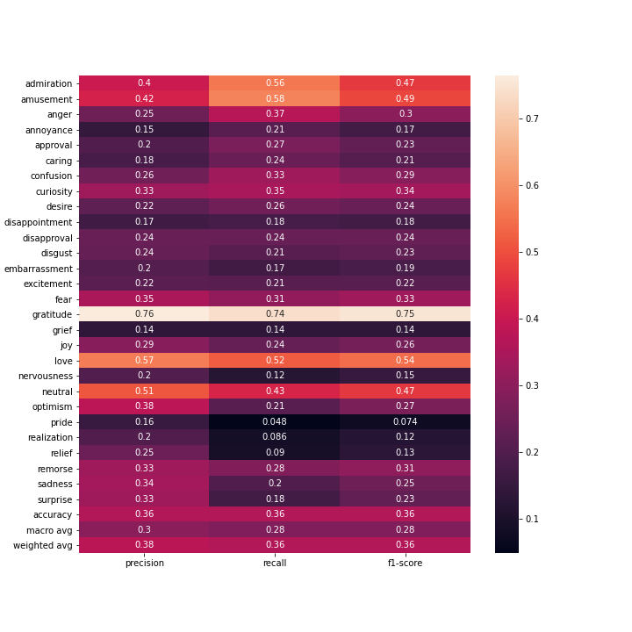

Confusion Matrix

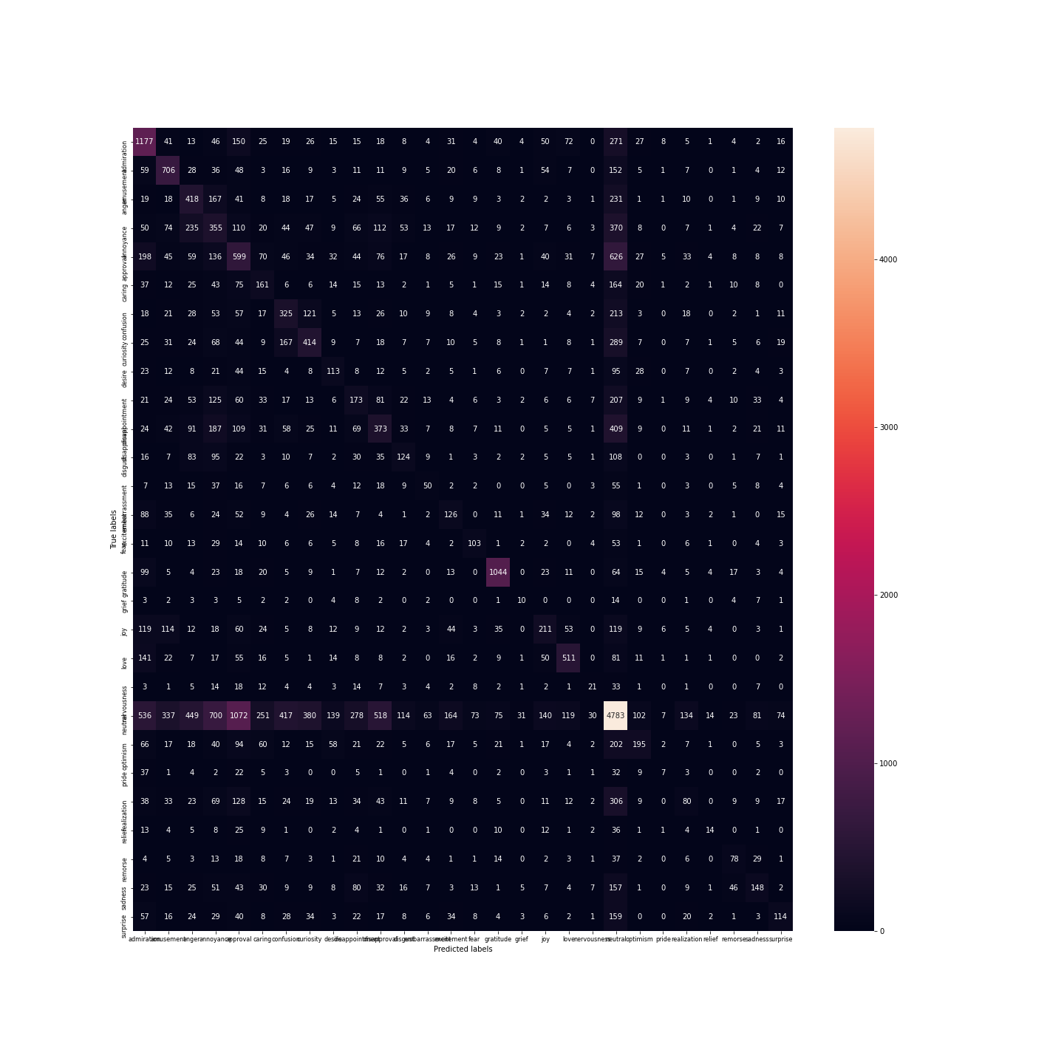Decision Tree classification of Sentiment with default hyperparameters: criterion(quality of split)= 'gini'(Gini impurity), splitter= 'best' (choose the best split), max_depth=None, min_sample_leaf=1...

Classification Report:

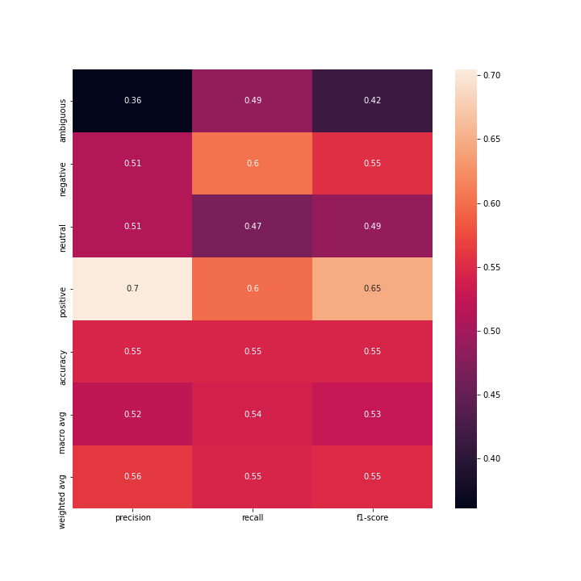

Confusion Matrix

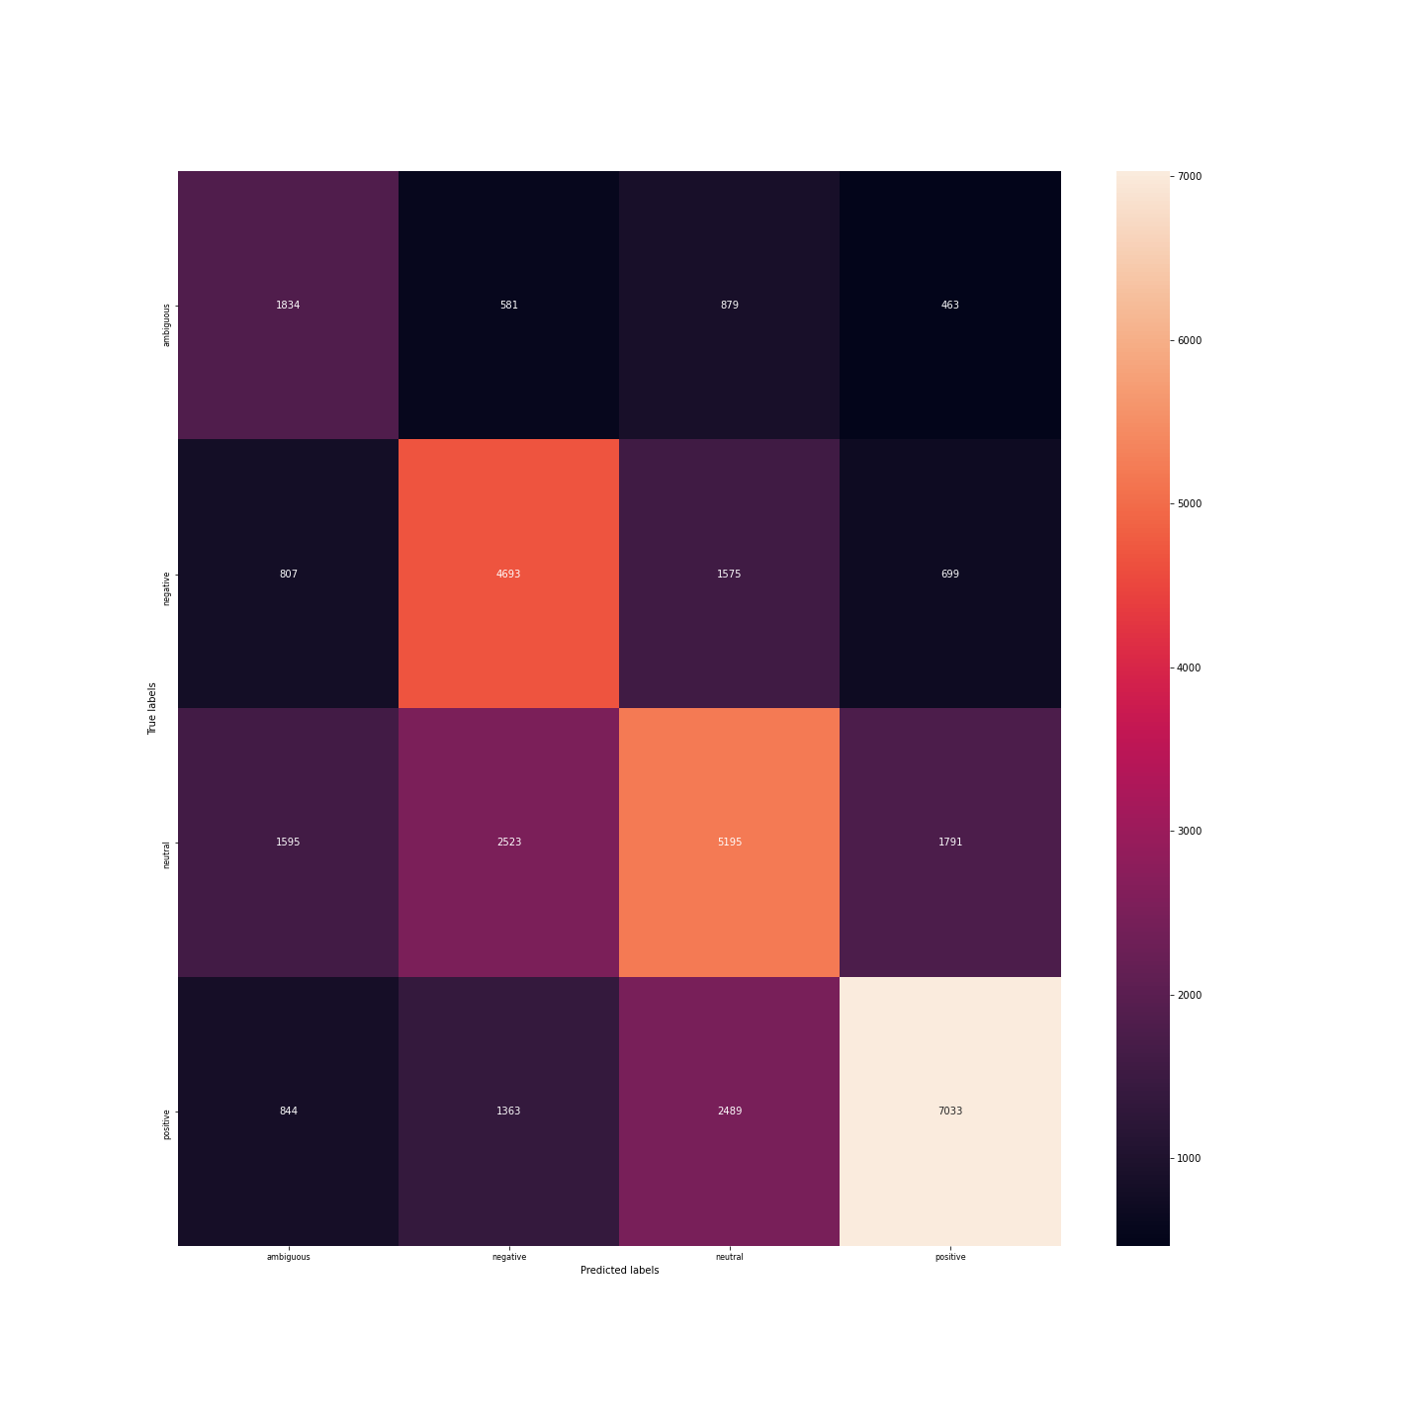Multi-Layered perceptron classificator for Emotion with default hyperparameters: one hidden layer with 100 neurons, activation= 'relu',solver='adam', alpha(regularization)=0.0001...

Classification Report:

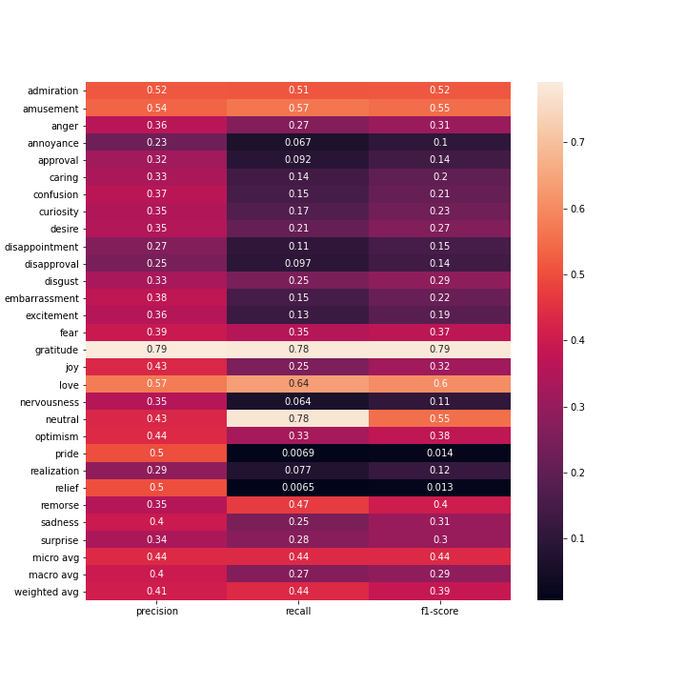

Confusion Matrix

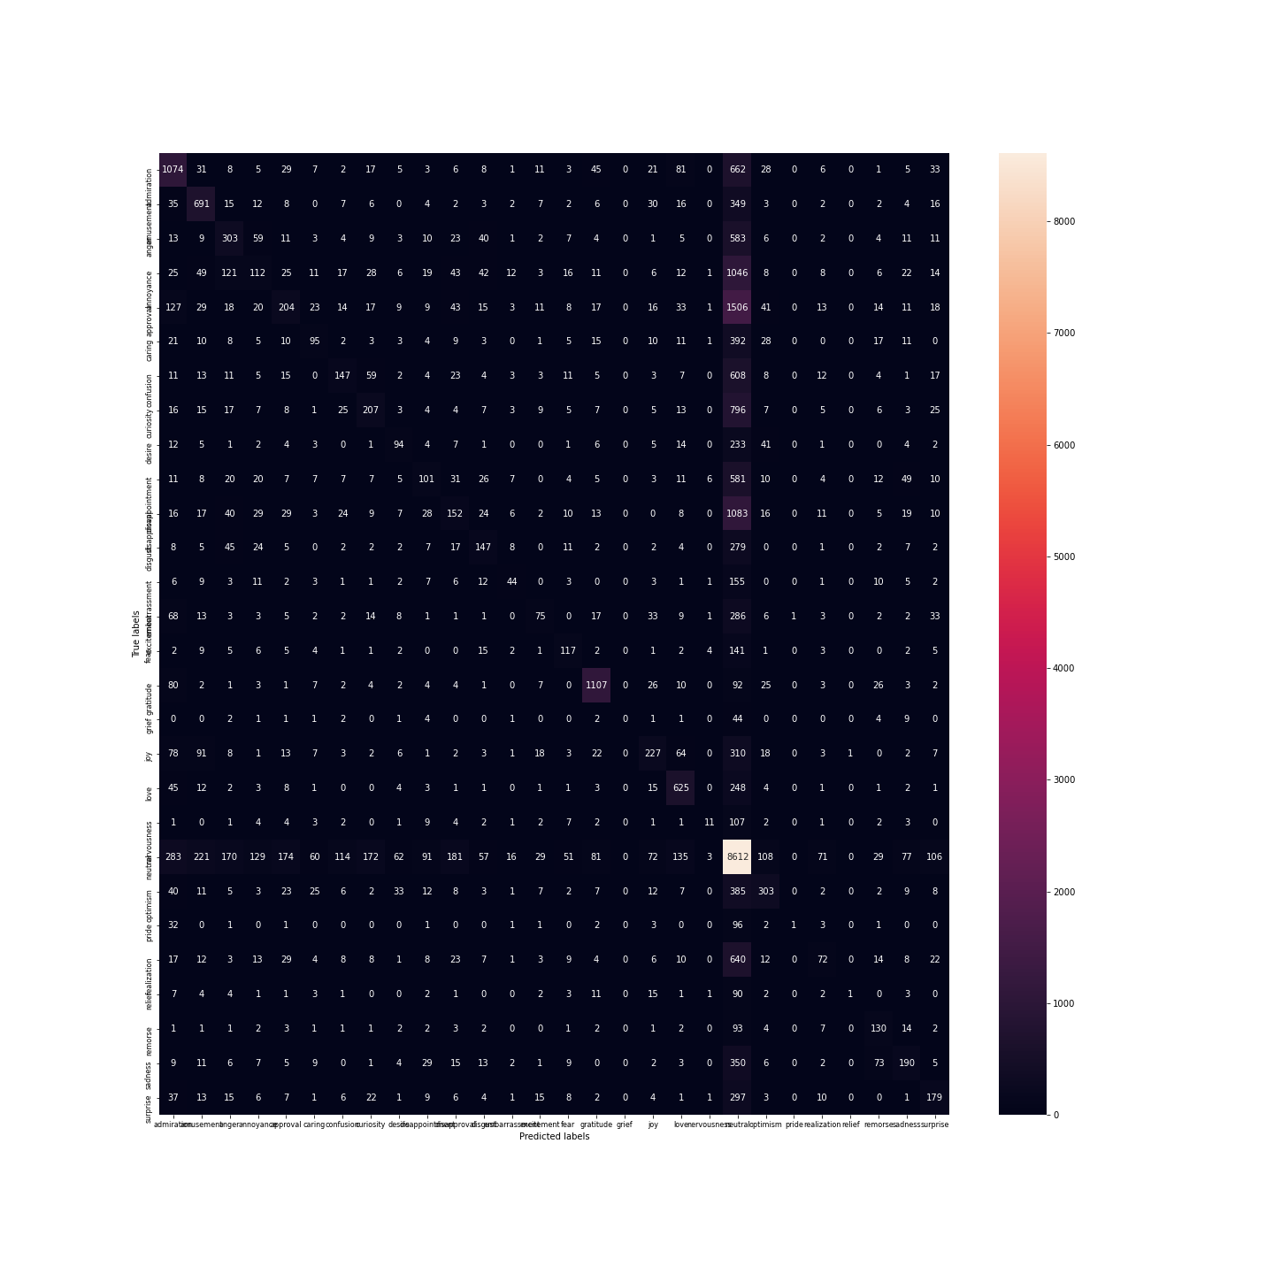Multi-Layered perceptron classificator for Sentiment with default hyperparameters: one hidden layer with 100 neurons, activation= 'relu',solver='adam', alpha(regularization)=0.0001...

Classification Report:

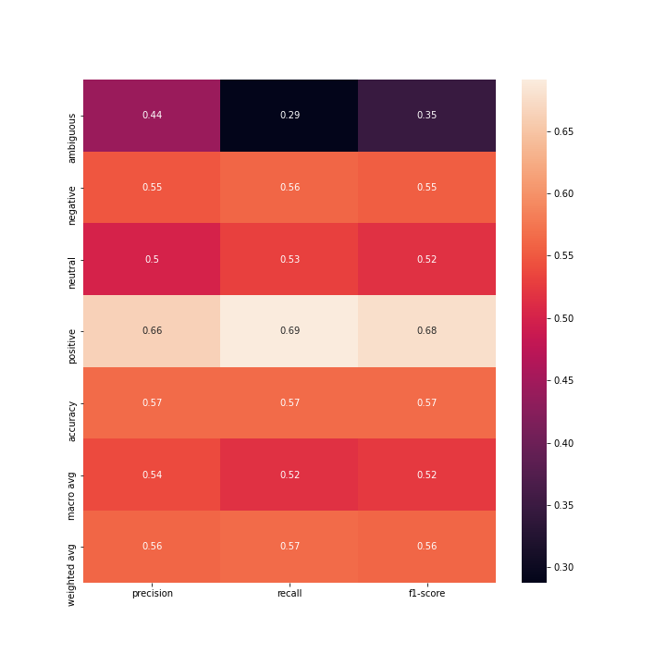

Confusion Matrix

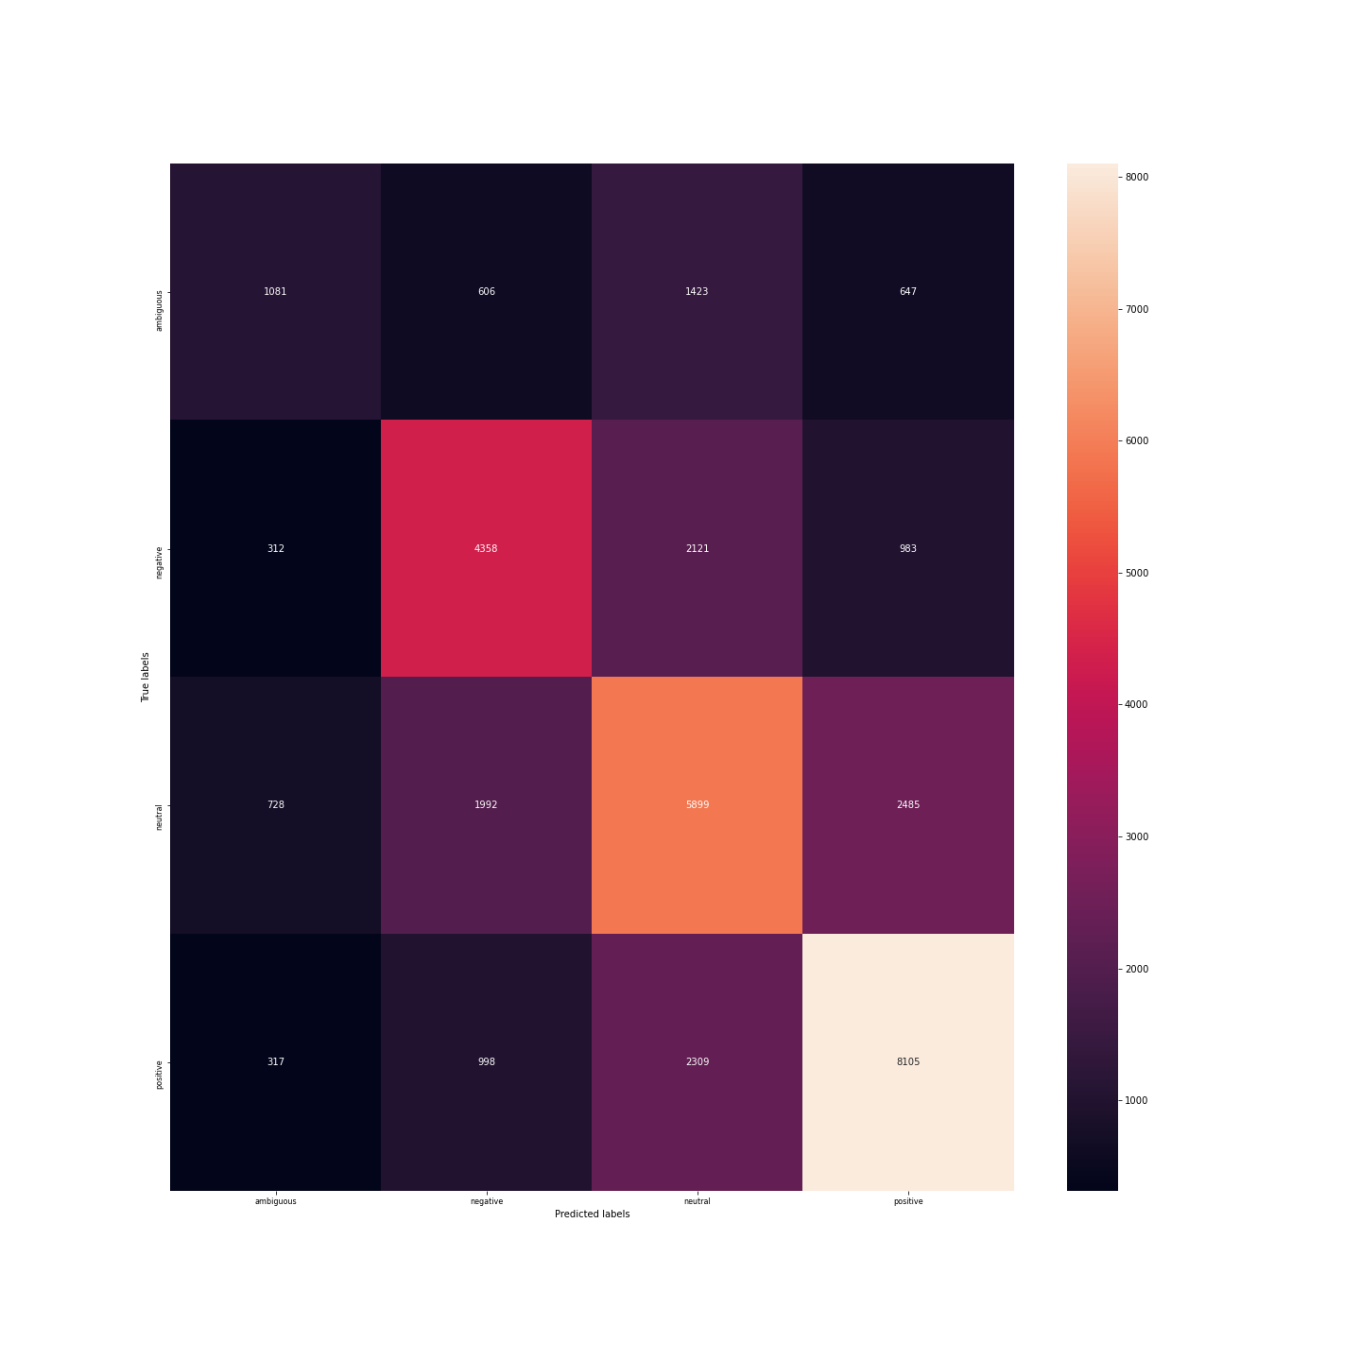Better Multinomial Naive Bayes for emotion classification with hyperparameters tunned by grid search:{"alpha": 0.5}Classification Report:

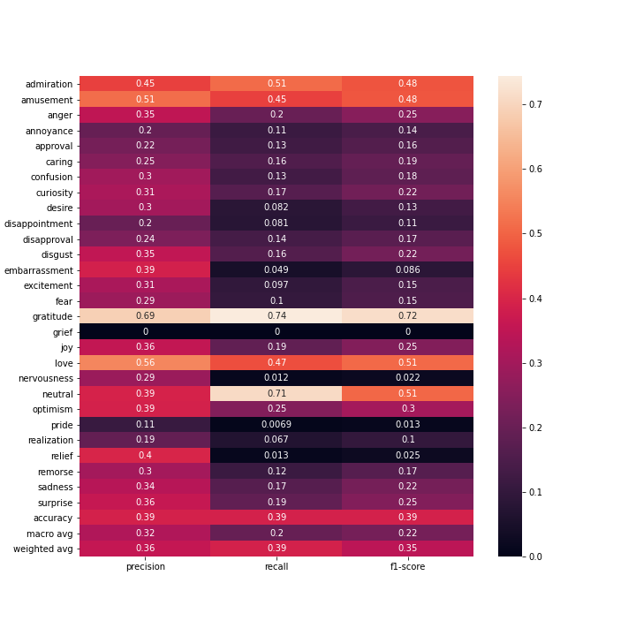

Confusion Matrix

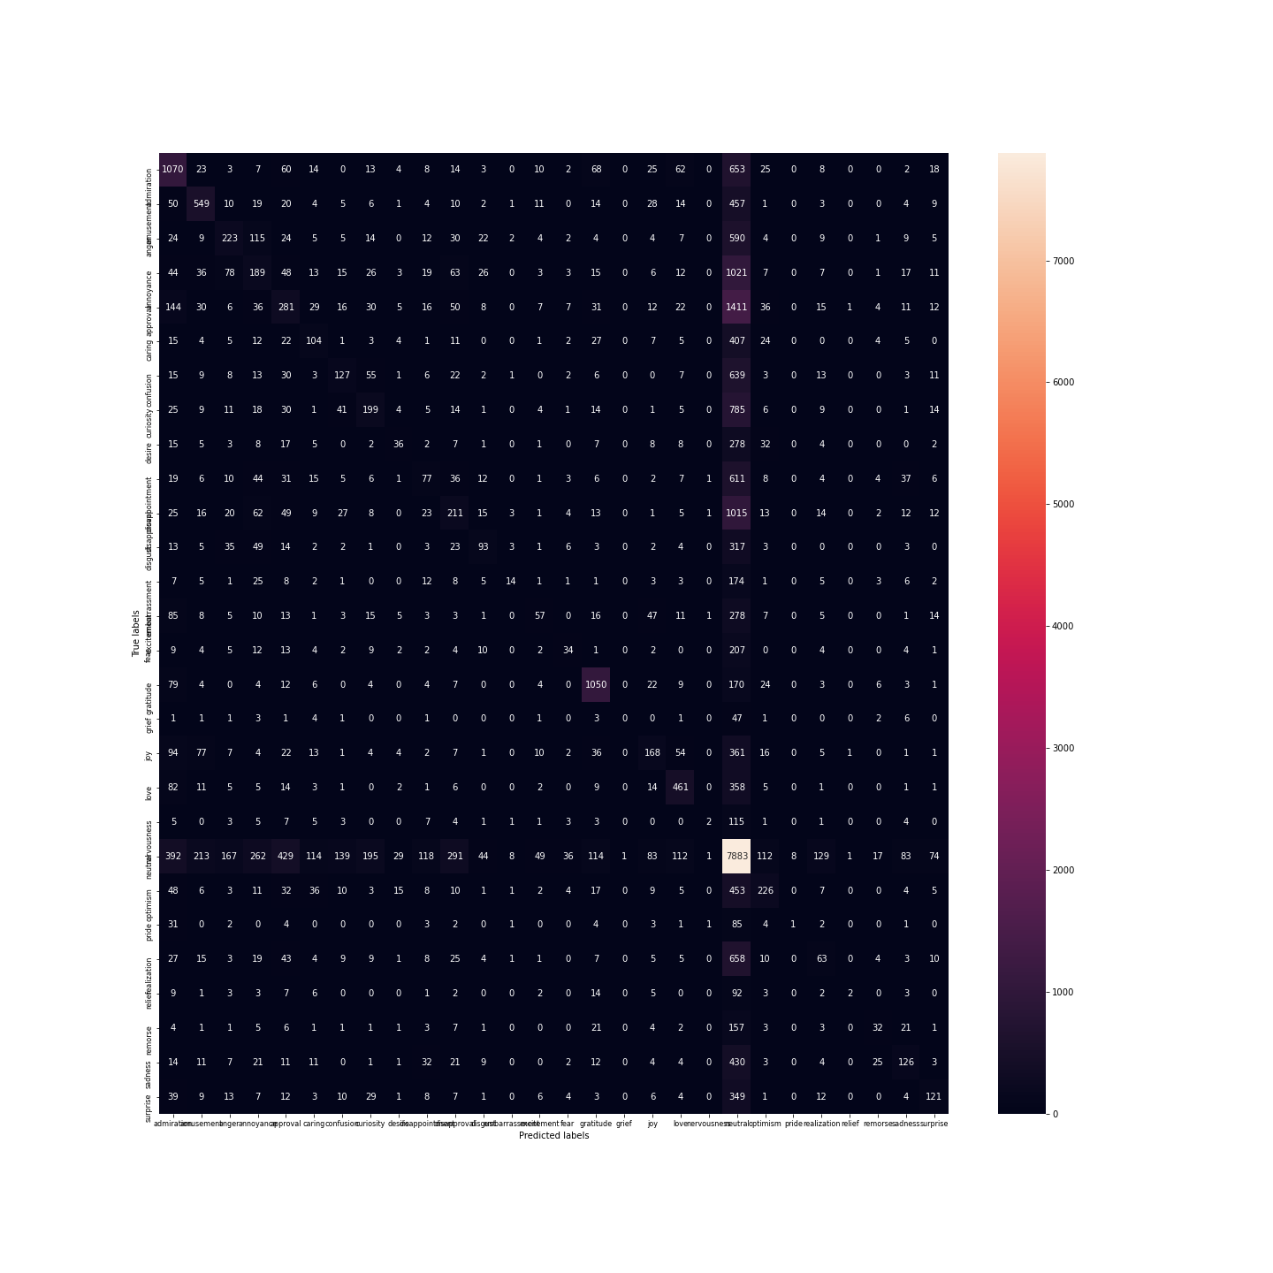Better Multinomial Naive Bayes for sentiment classification with hyperparameters tunned by grid search:{"alpha": 1.2}Classification Report:

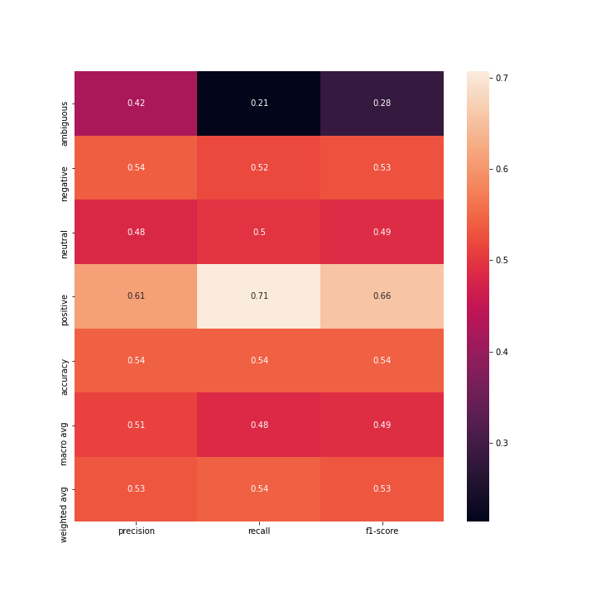

Confusion Matrix

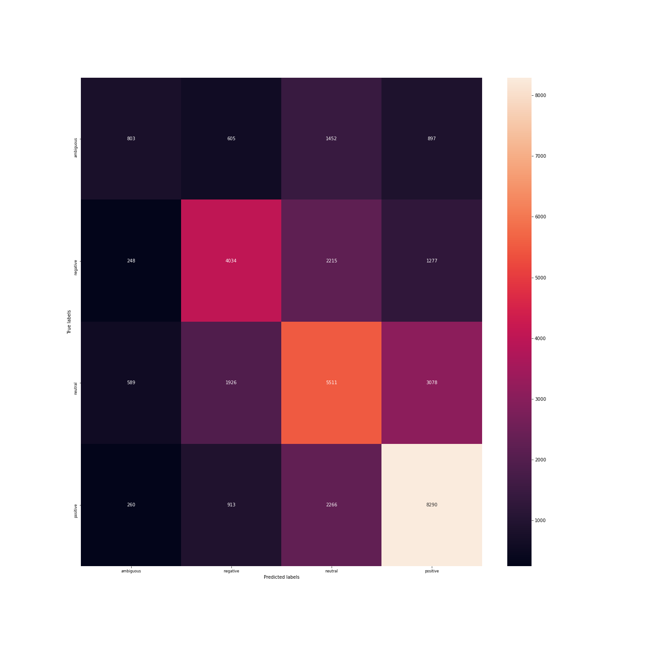Better Desicion Tree for emotion classification with hyperparameters tunned by grid search:{"criterion": "gini", "max_depth": 700, "min_samples_split": 0.1}Classification Report:

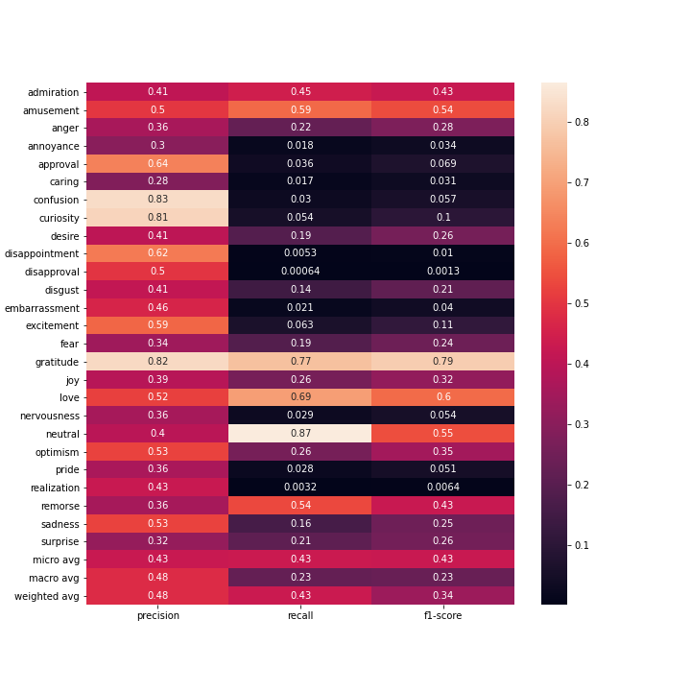

Confusion Matrix

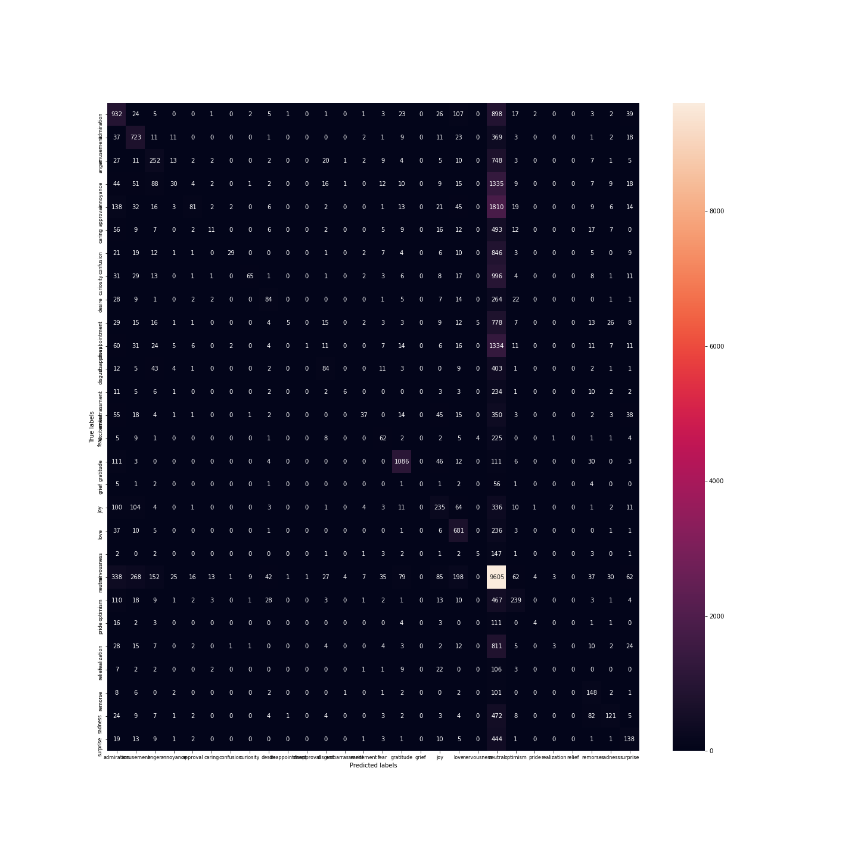Better Desicion Tree Classifier for Sentiment classification with hyperparameters tunned by grid search:{"criterion": "gini", "max_depth": 700, "min_samples_split": 0.1}Classification Report:

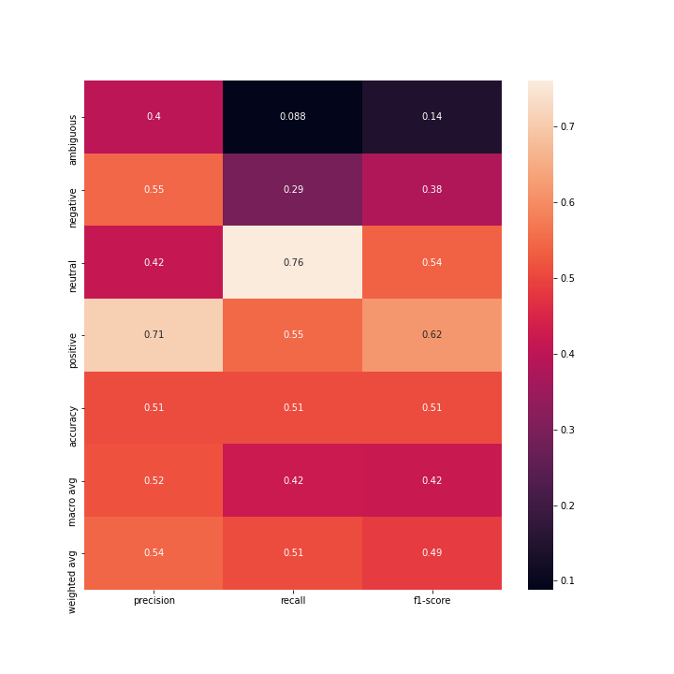

Confusion Matrix

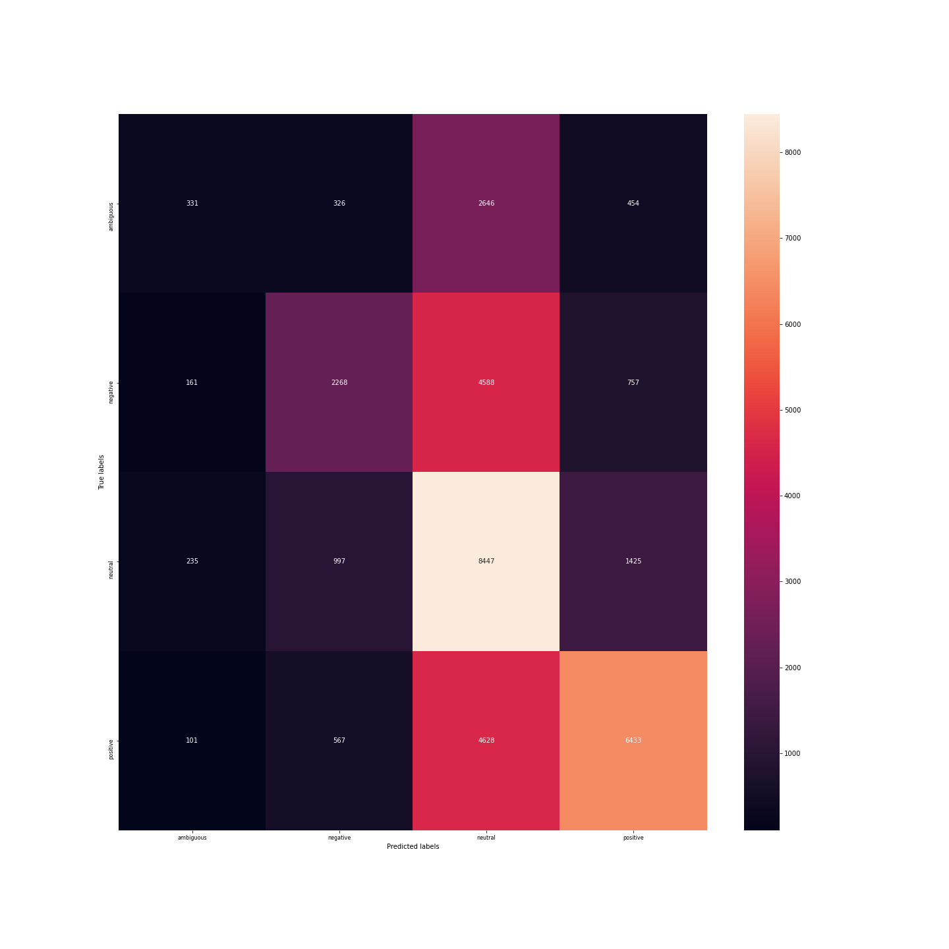Better Multilayered Perceptron for emotion classification with hyperparameters tunned by grid search:{"activation": "tanh", "hidden_layer_sizes": [4, 50], "solver": "sgd"}Classification Report:

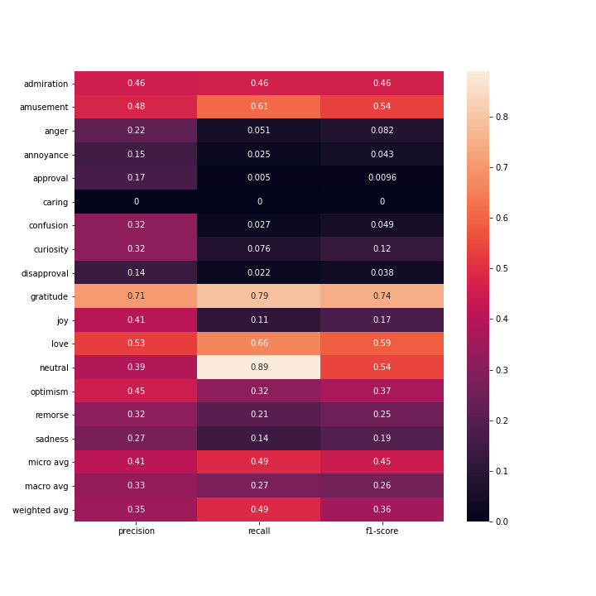

Confusion Matrix

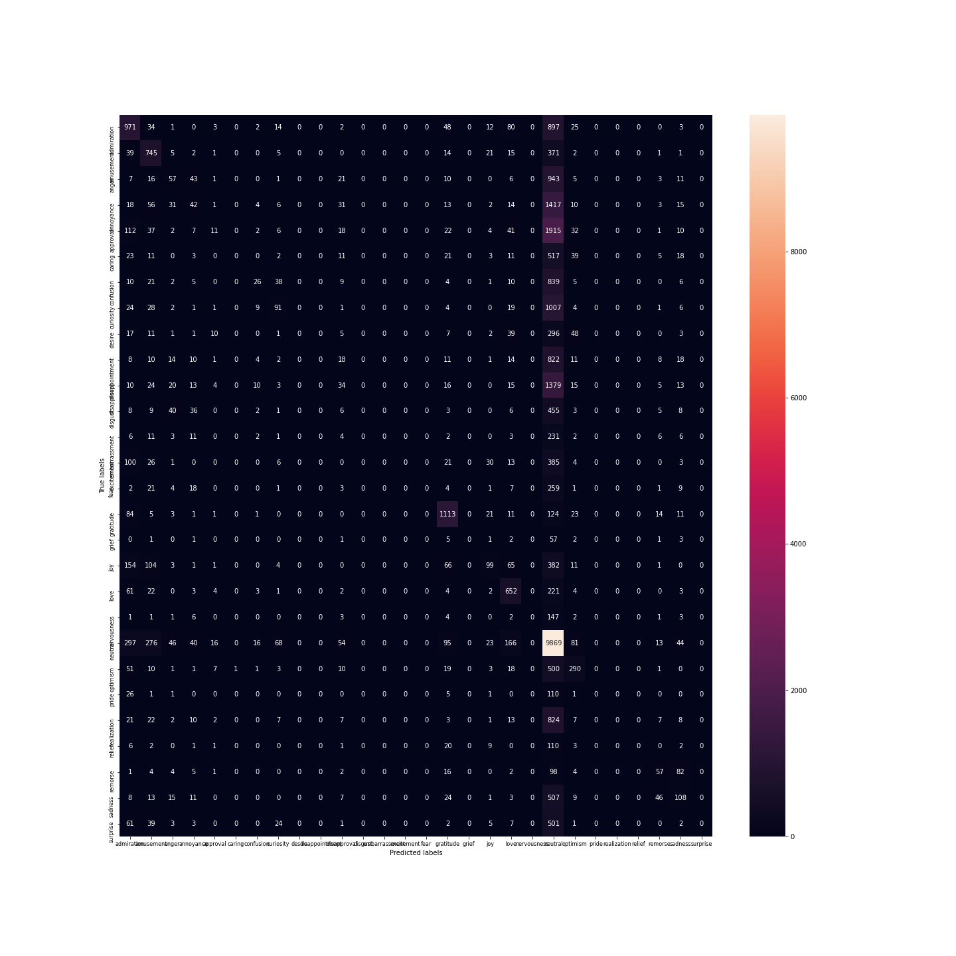Better Multilayered Perceptron for sentiment classification with hyperparameters tunned by grid search:{"activation": "tanh", "hidden_layer_sizes": [4, 50], "solver": "adam"}Classification Report:

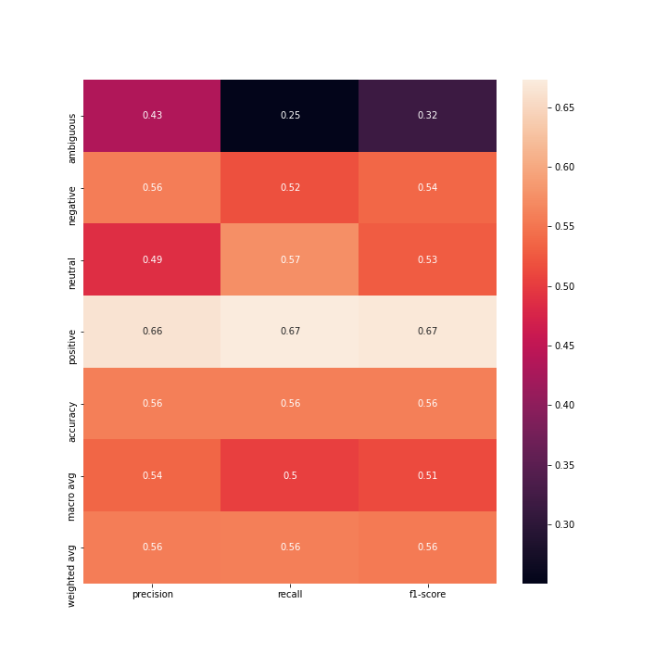

Confusion Matrix

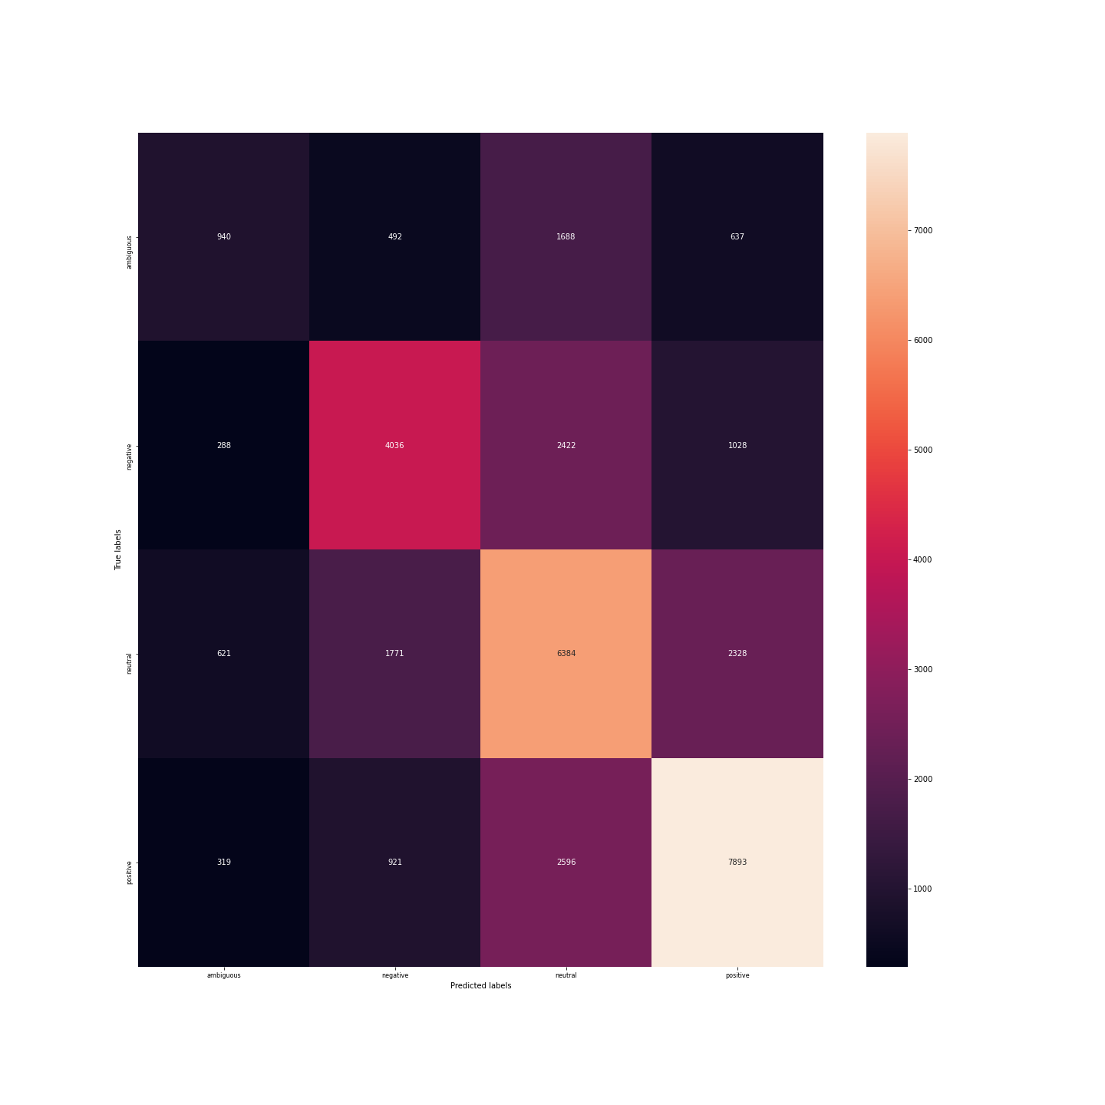2.5 Repetition of steps of 2.3 with tf-idf

Multinomial Naive Bayes classification of Emotion with default hyperparameters: alpha= 1.0, fit_prior= True,class_prior= None

Classification Report:

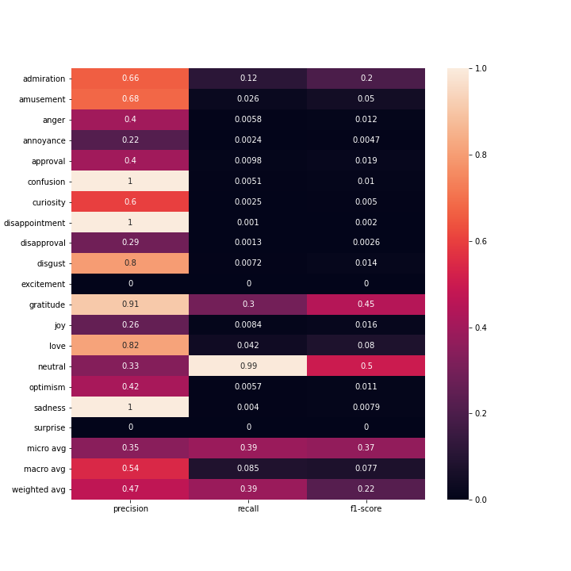

Confusion Matrix

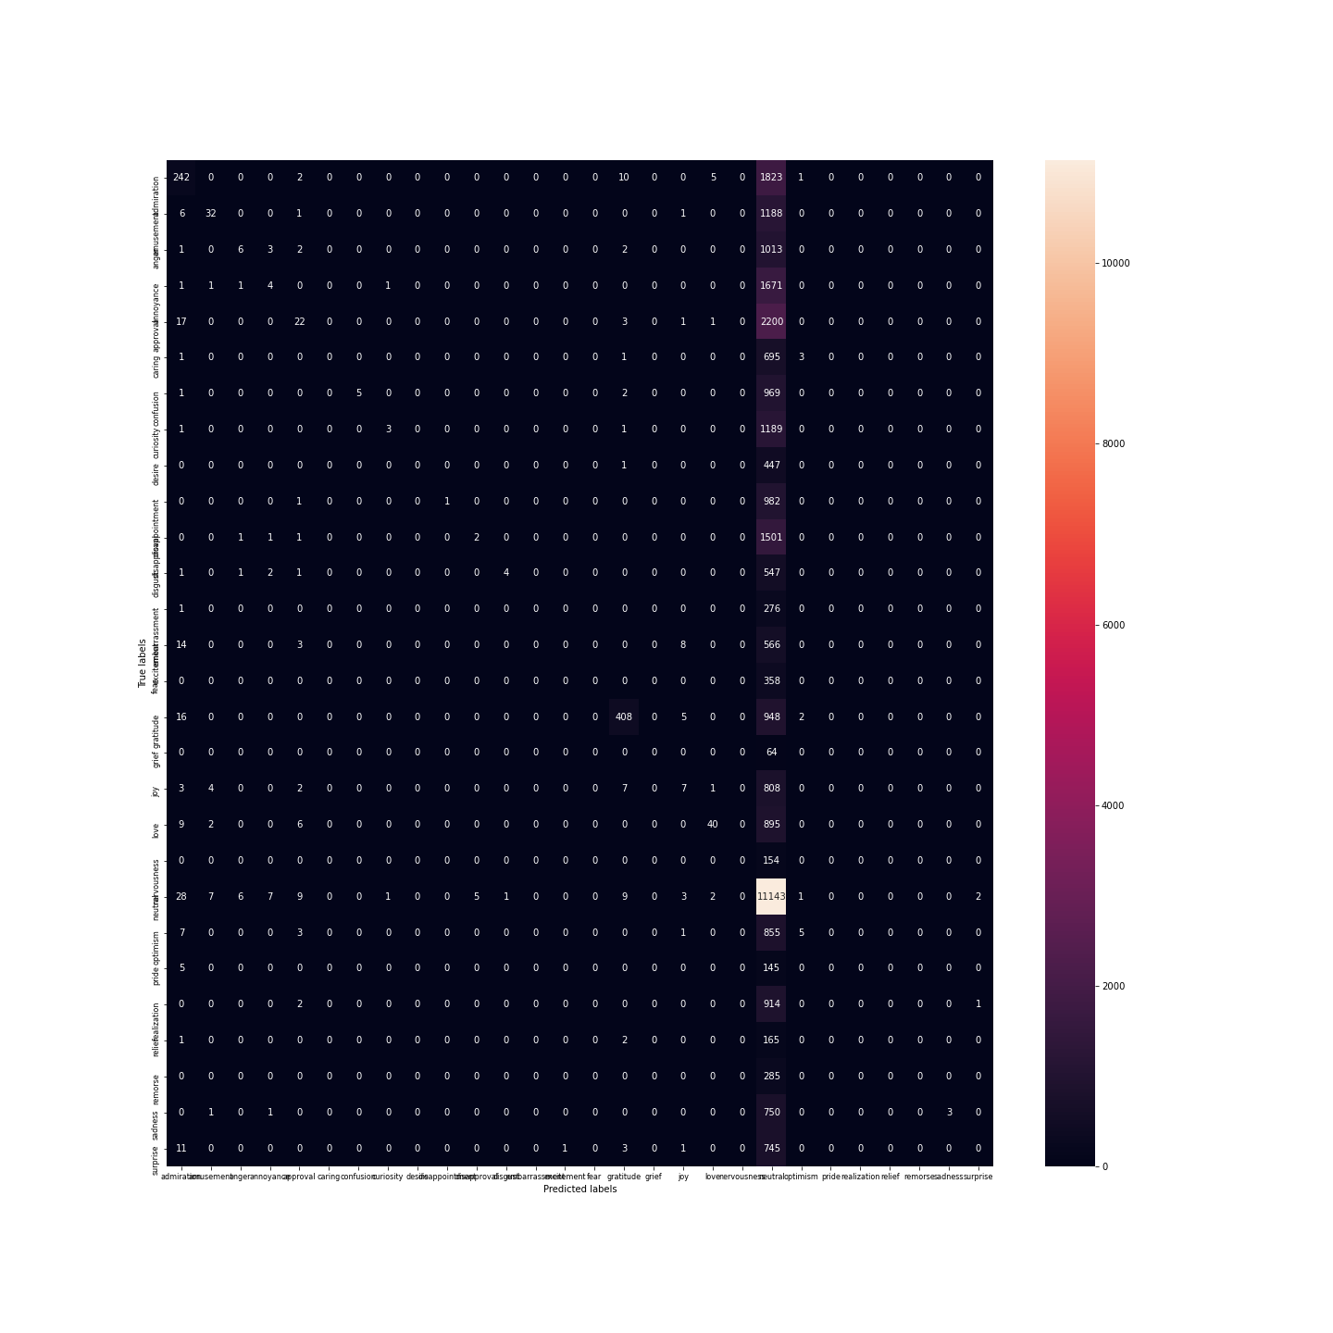Multinomial Naive Bayes classification of Sentiment with default hyperparameters: alpha= 1.0, fit_prior= True,class_prior= None

Classification Report:

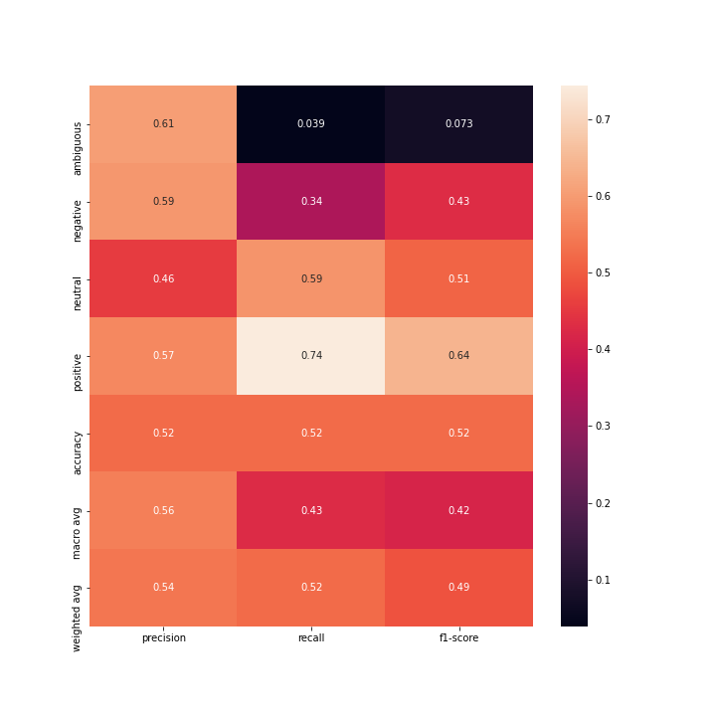

Confusion Matrix

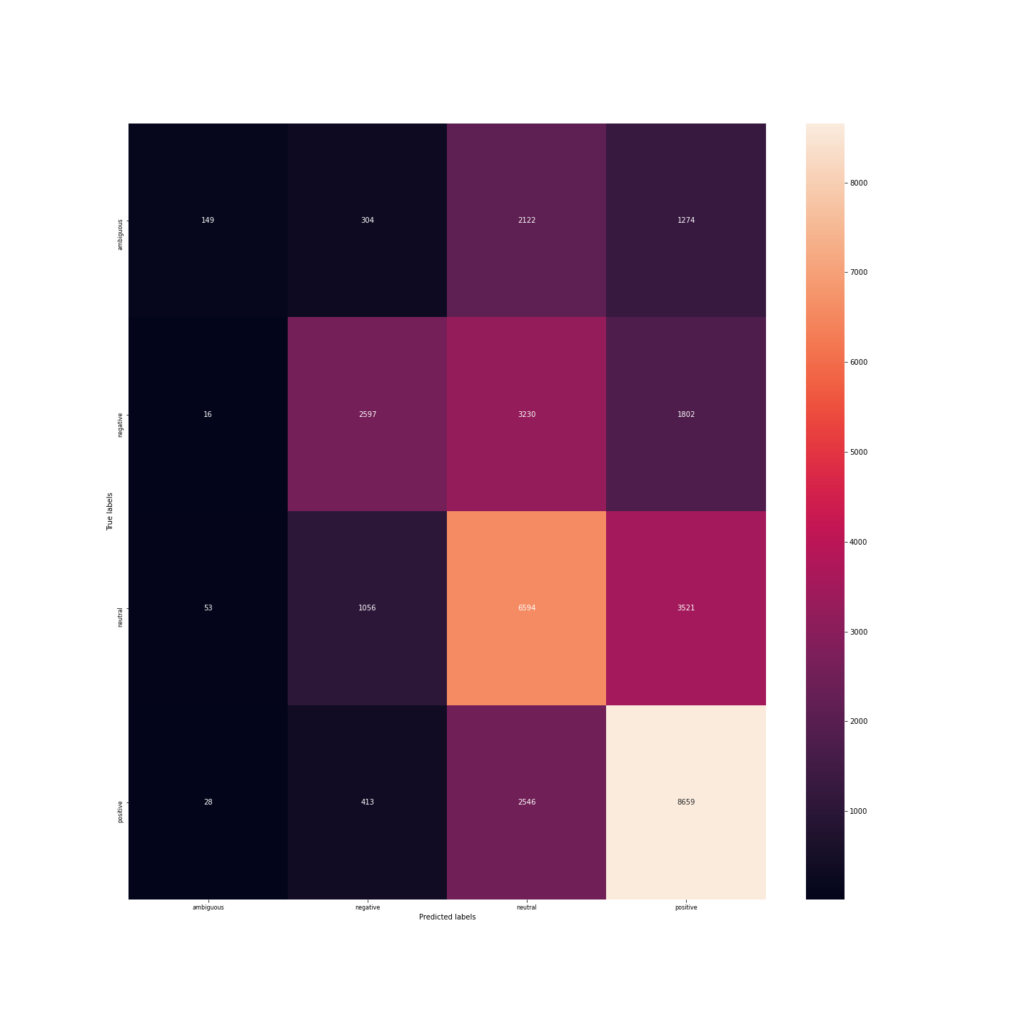Decision Tree classification of Emotion with default hyperparameters: criterion(quality of split)= 'gini'(Gini impurity), splitter= 'best' (choose the best split), max_depth=None, min_sample_leaf=1...

Classification Report:

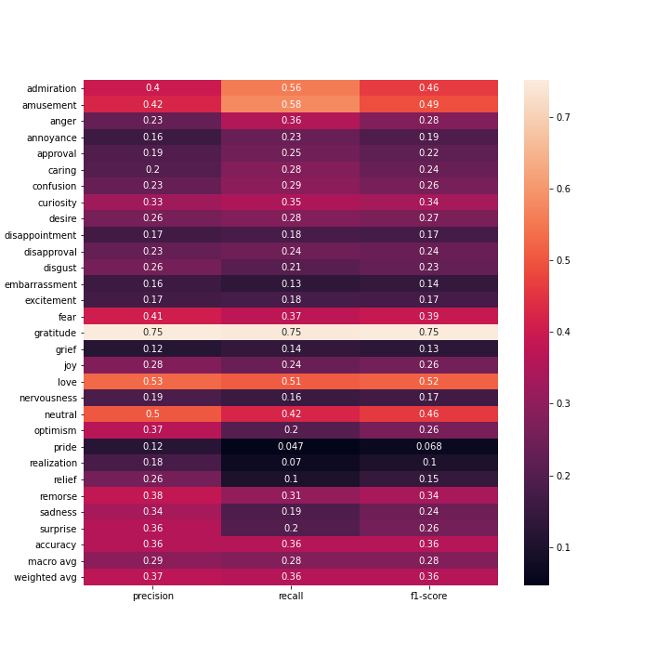

Confusion Matrix

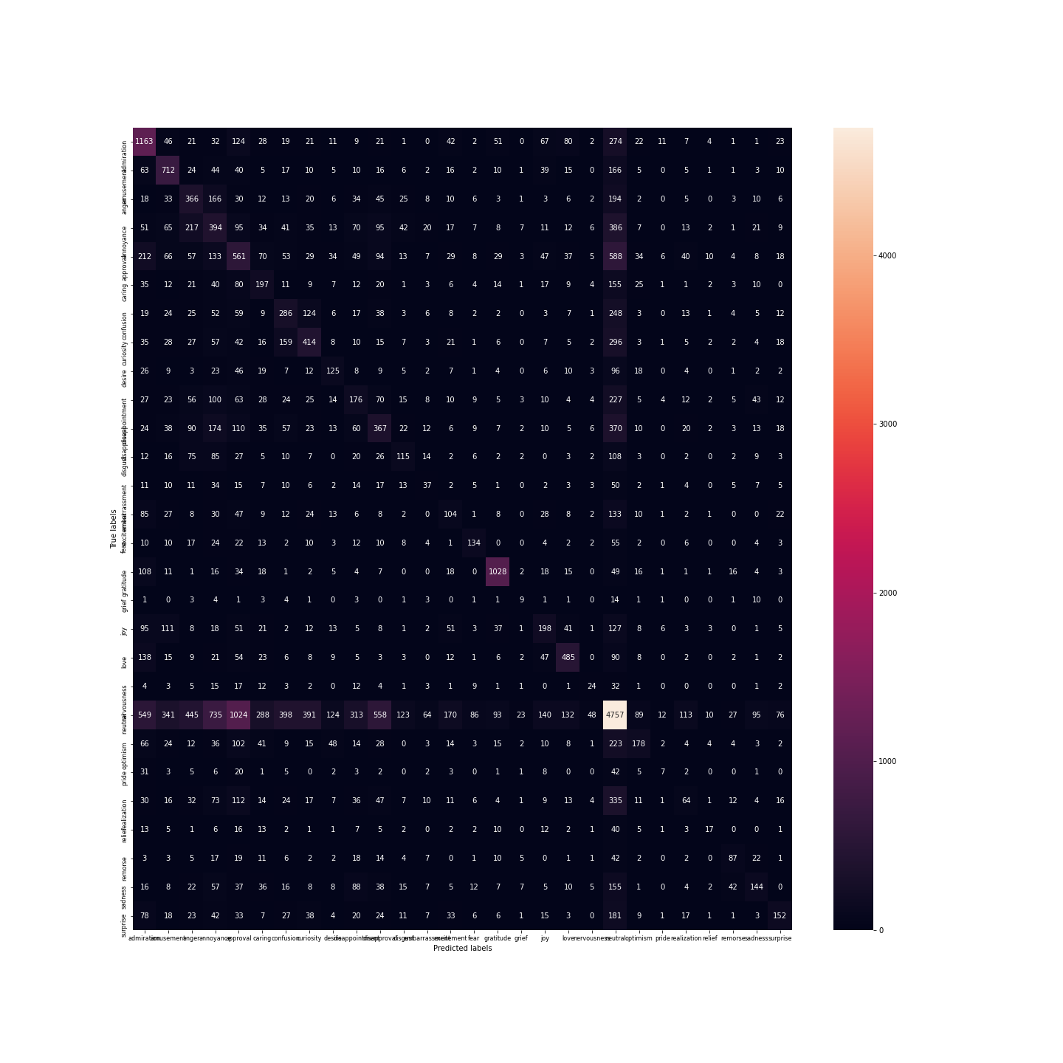Decision Tree classification of Sentiment with default hyperparameters: criterion(quality of split)= 'gini'(Gini impurity), splitter= 'best' (choose the best split), max_depth=None, min_sample_leaf=1...

Classification Report:

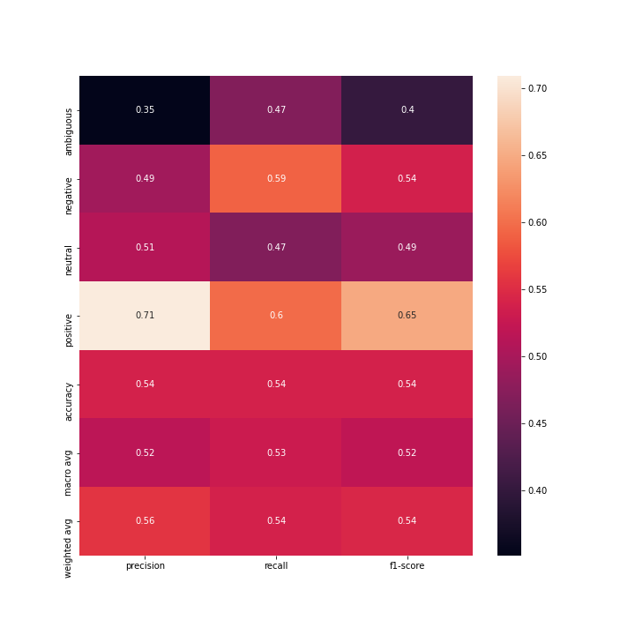

Confusion Matrix

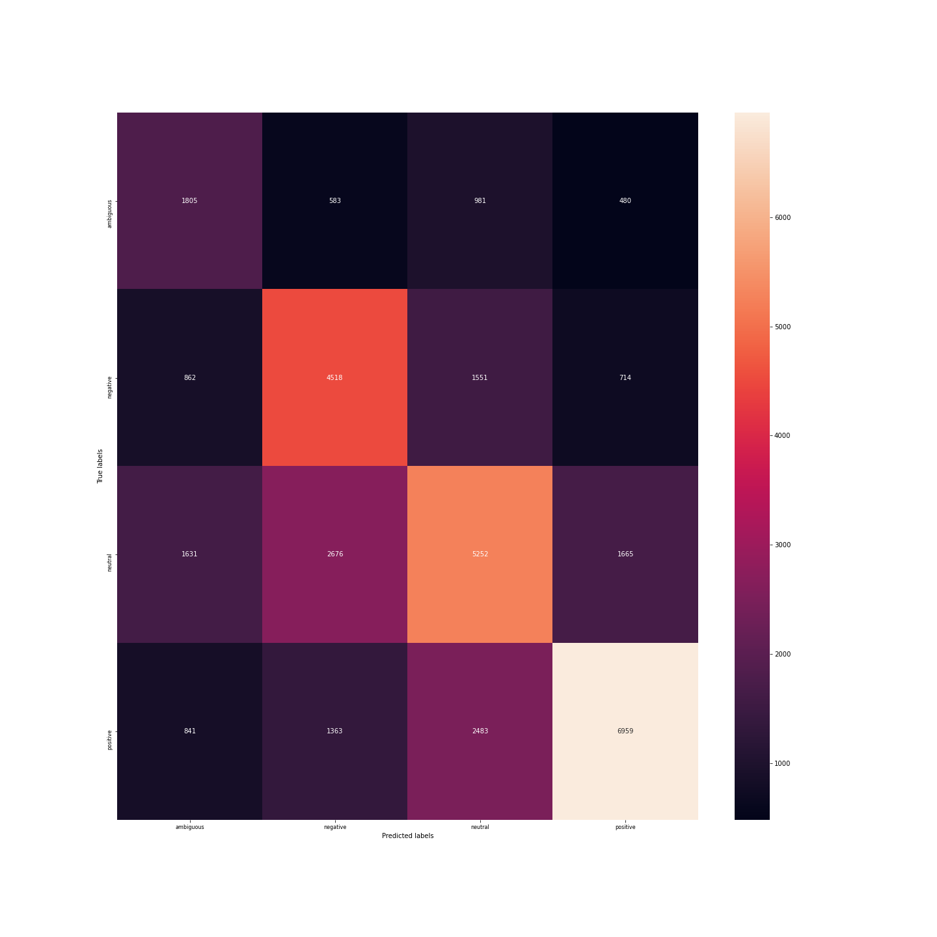Multi-Layered perceptron classificator for Emotion with default hyperparameters: one hidden layer with 100 neurons, activation= 'relu',solver='adam', alpha(regularization)=0.0001...

Classification Report:

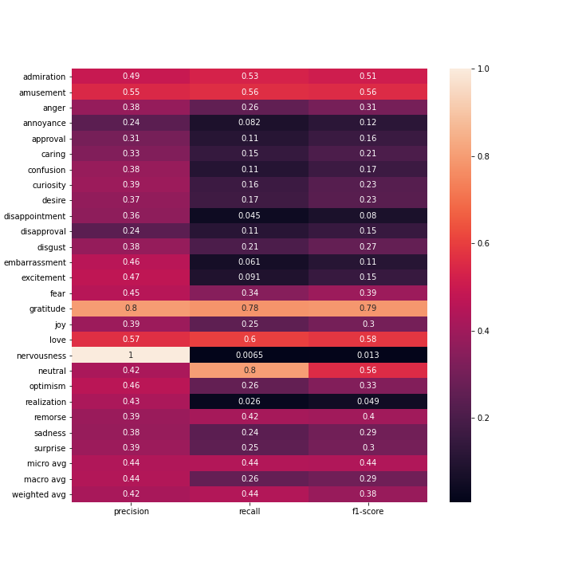

Confusion Matrix

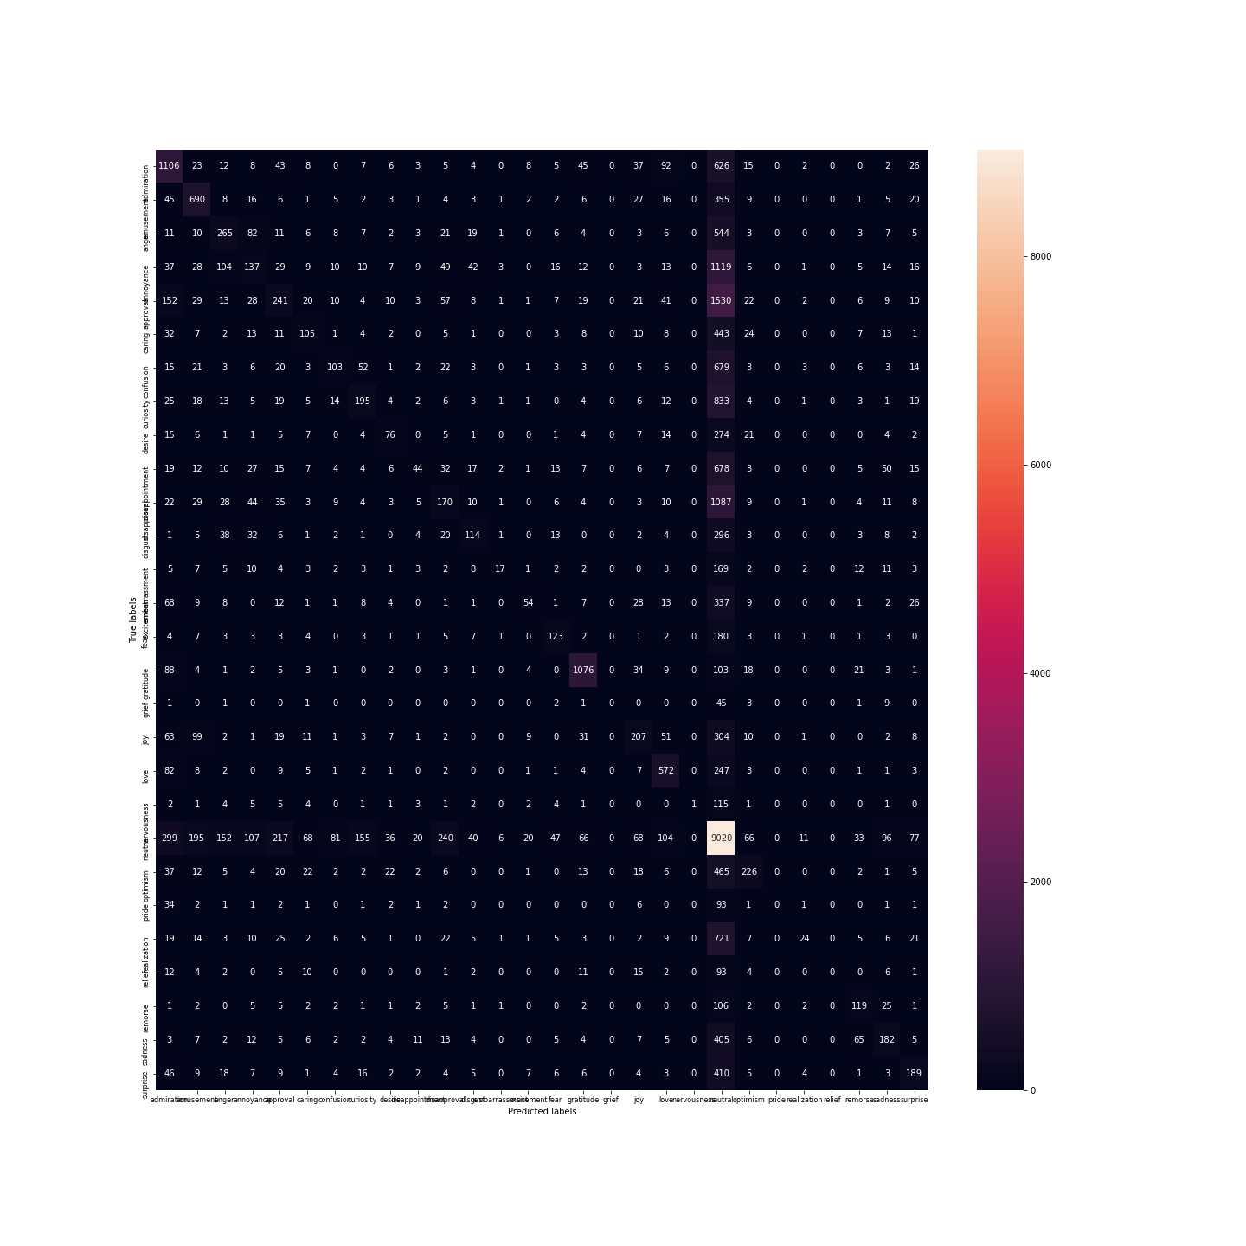Multi-Layered perceptron classificator for Sentiment with default hyperparameters: one hidden layer with 100 neurons, activation= 'relu',solver='adam', alpha(regularization)=0.0001...

Classification Report:

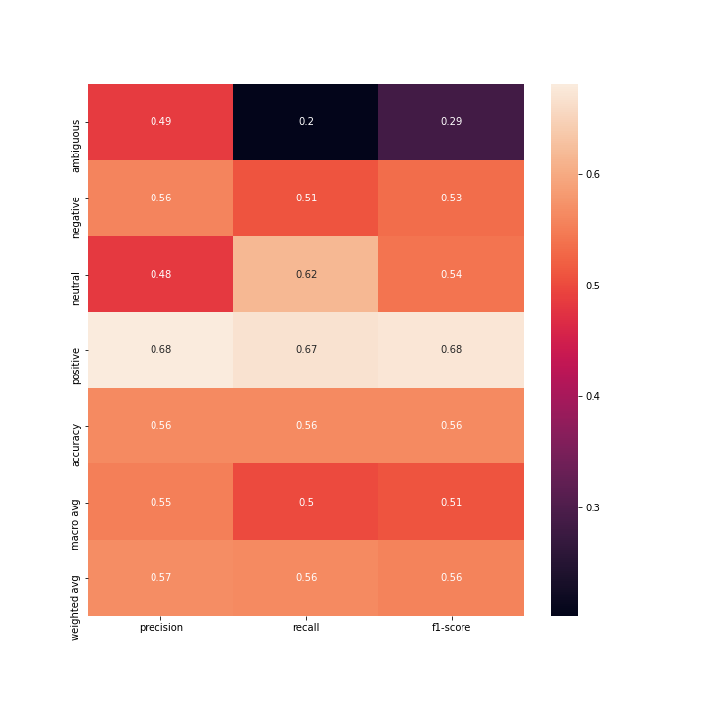

Confusion Matrix

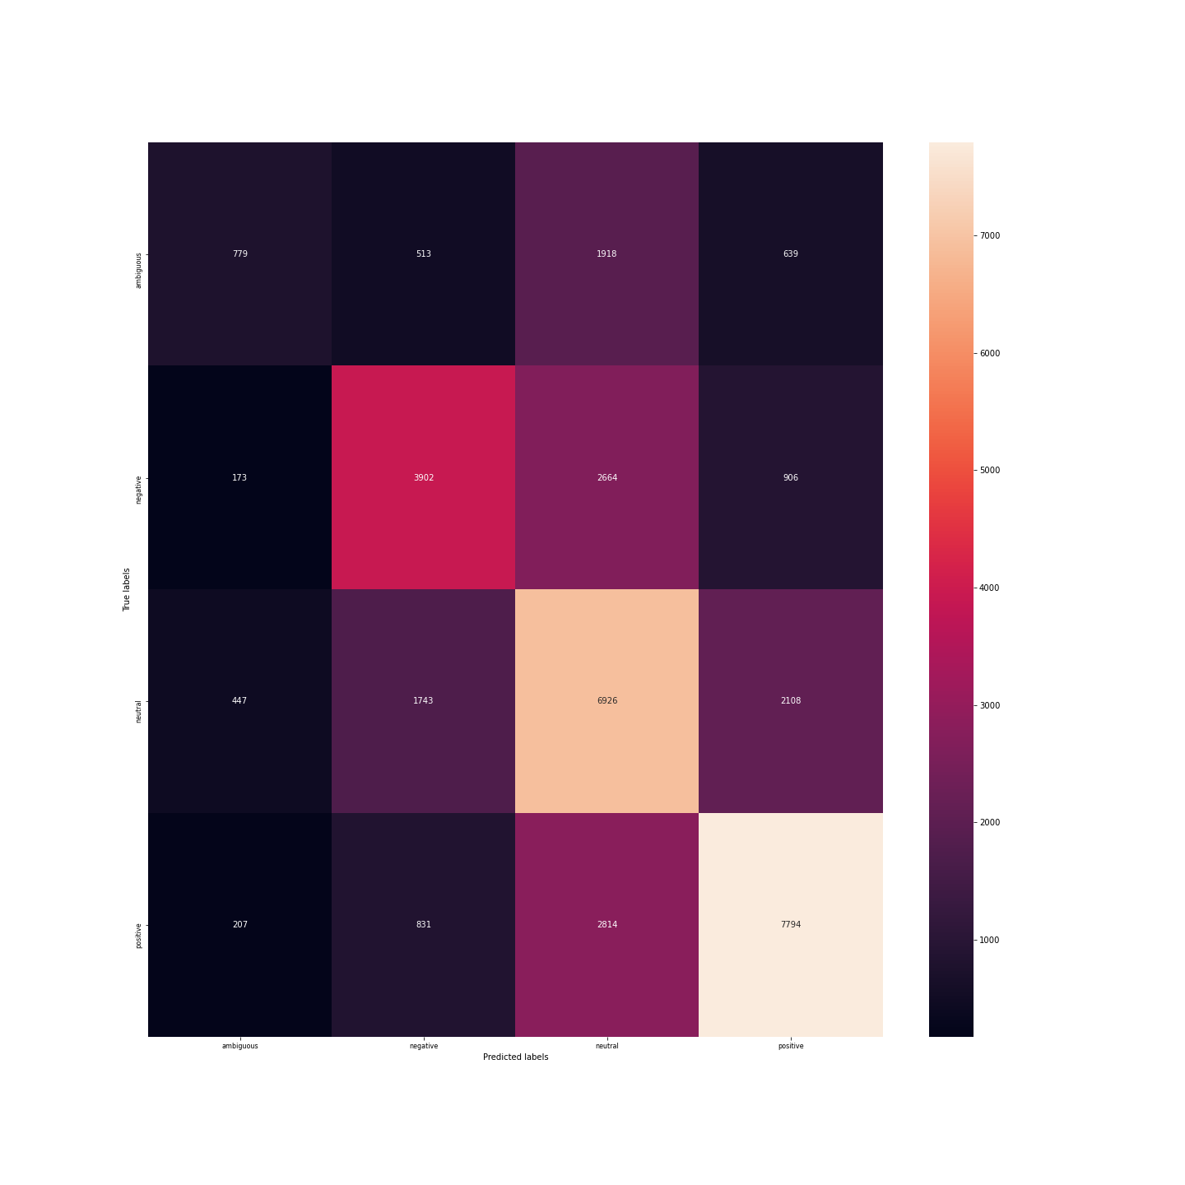Better Multinomial Naive Bayes for emotion classification with hyperparameters tunned by grid search:{"alpha": 0}Classification Report:

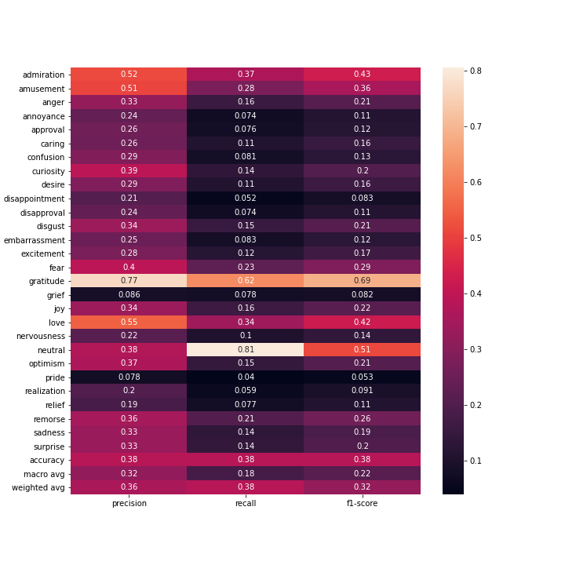

Confusion Matrix

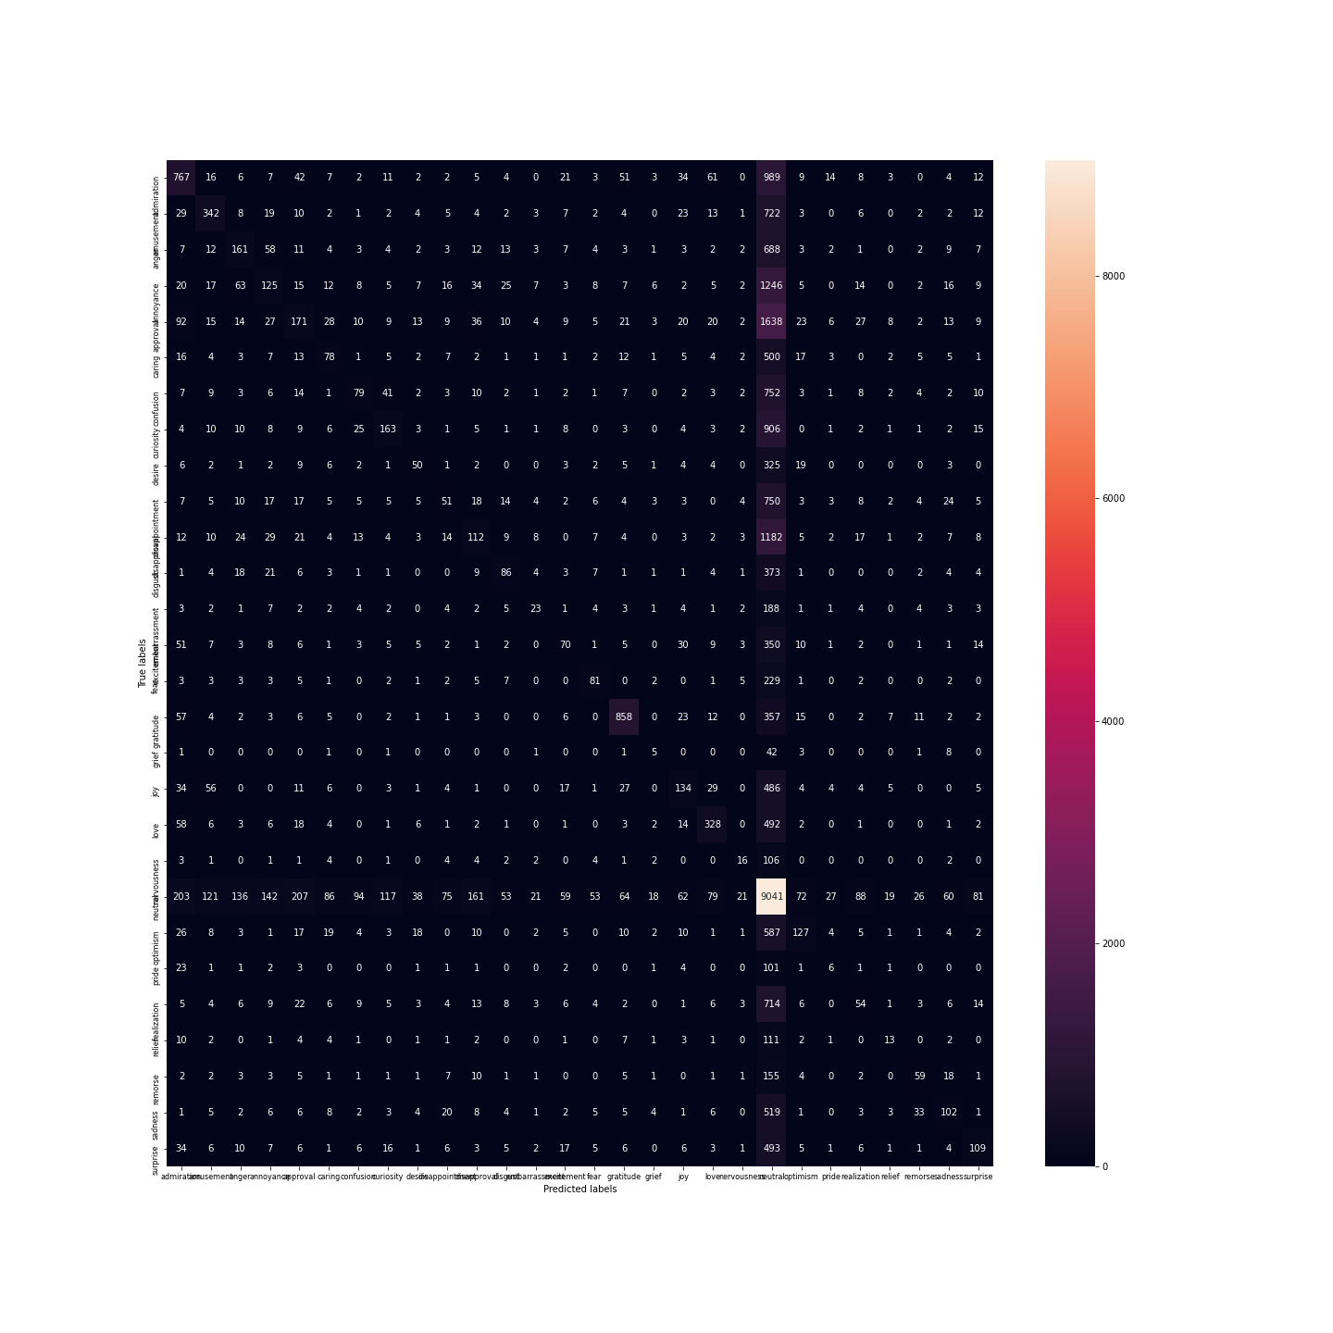Better Multinomial Naive Bayes for sentiment classification with hyperparameters tunned by grid search:{"alpha": 0.25}Classification Report:

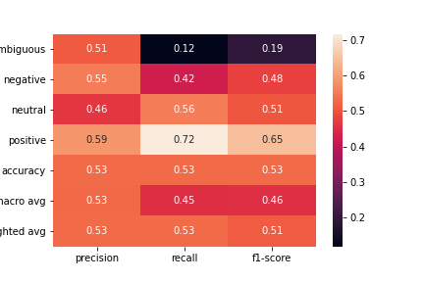

Confusion Matrix

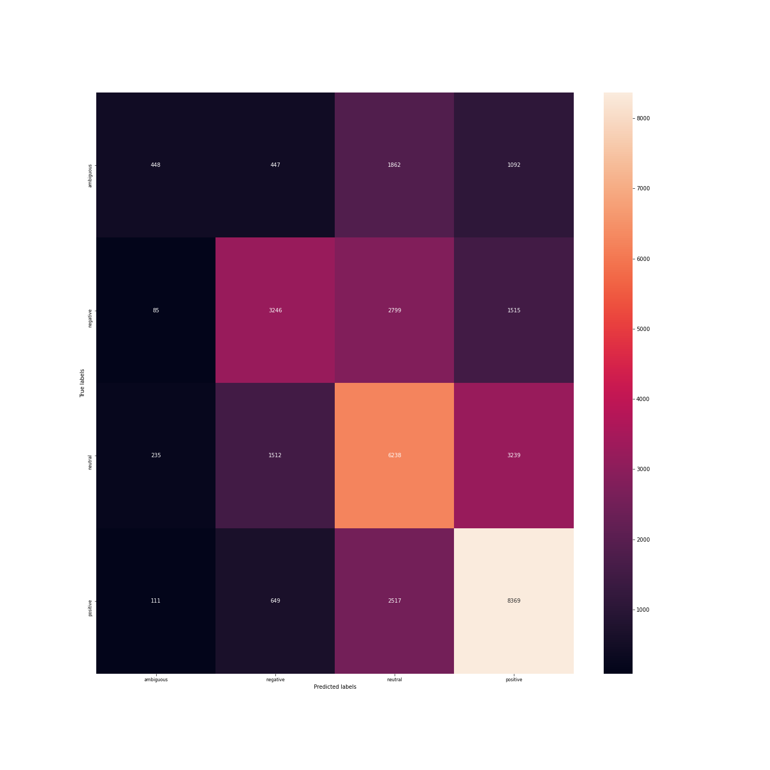Better Desicion Tree for emotion classification with hyperparameters tunned by grid search:{"criterion": "gini", "max_depth": 700, "min_samples_split": 0.1}Classification Report:

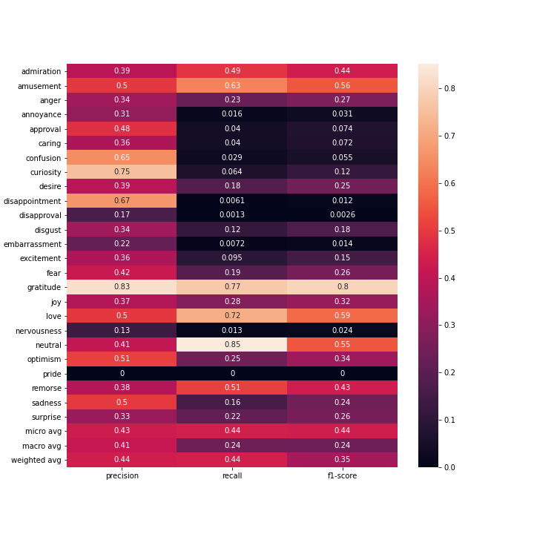

Confusion Matrix

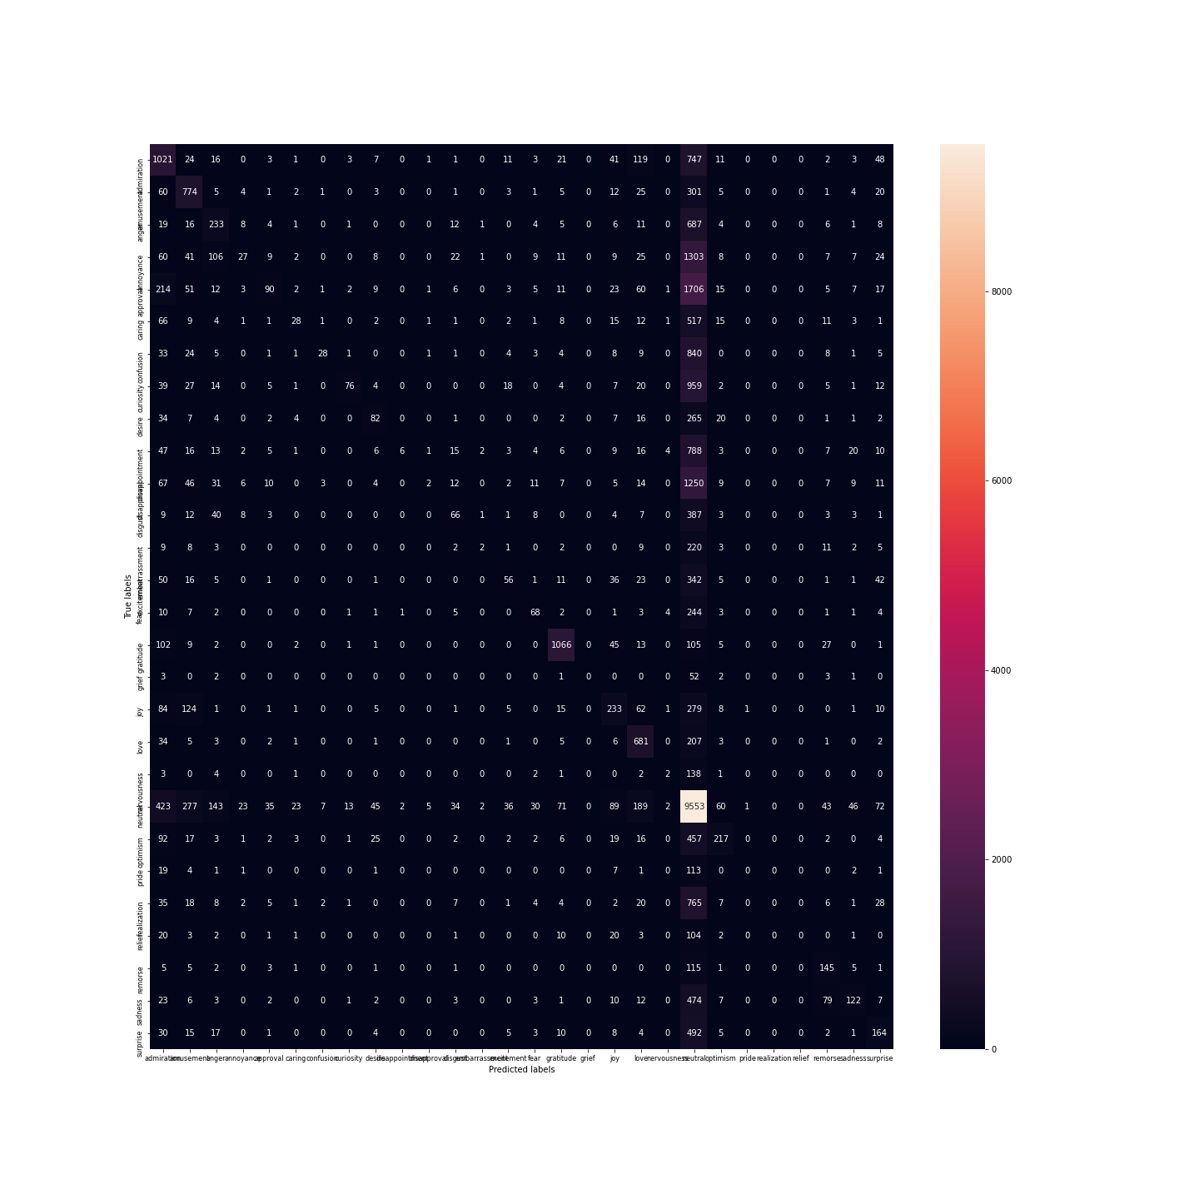Better Multinomial Naive Bayes for emotion classification with hyperparameters tunned by grid search:{"criterion": "gini", "max_depth": 1000, "min_samples_split": 0.1}Classification Report:

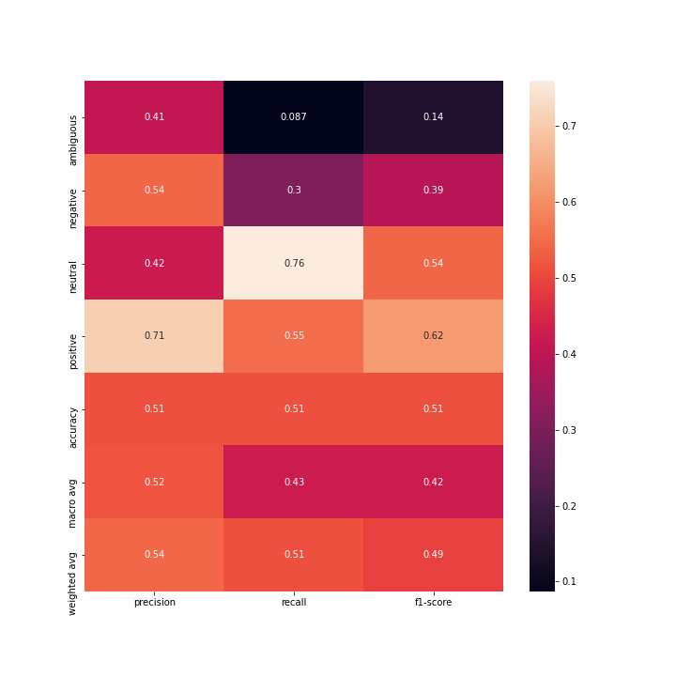

Confusion Matrix

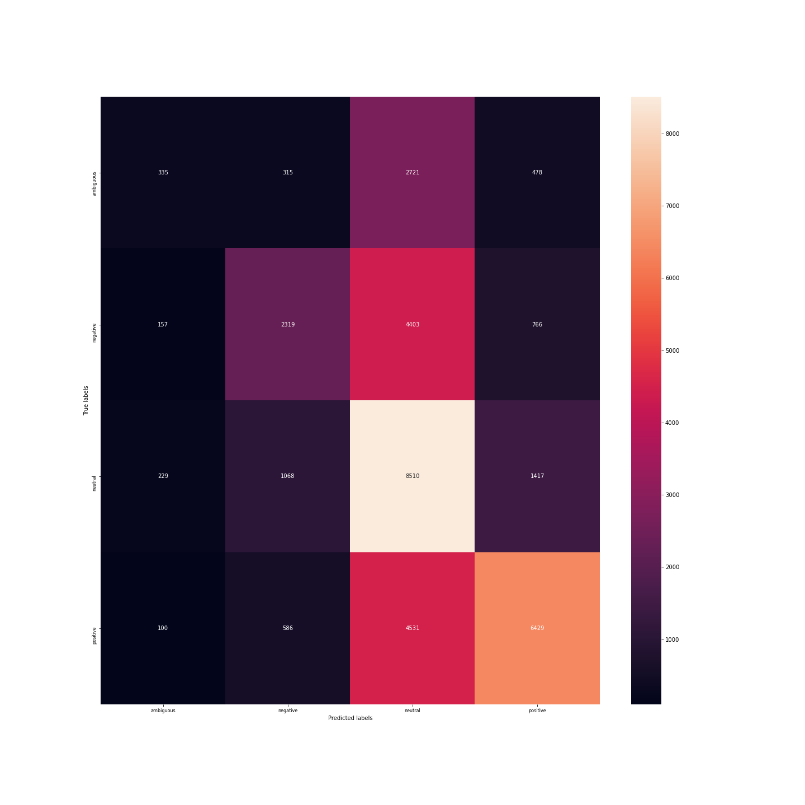Better Multilayered Perceptron for emotion classification with hyperparameters tunned by grid search:{"activation": "identity", "hidden_layer_sizes": [3, 50], "solver": "adam"}Classification Report:

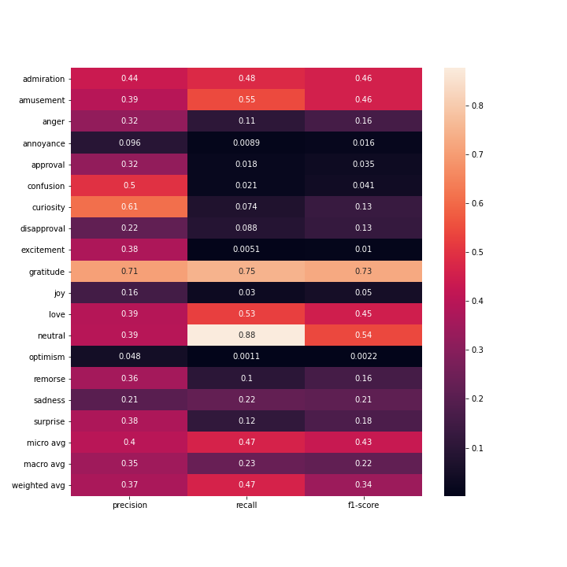

Confusion Matrix

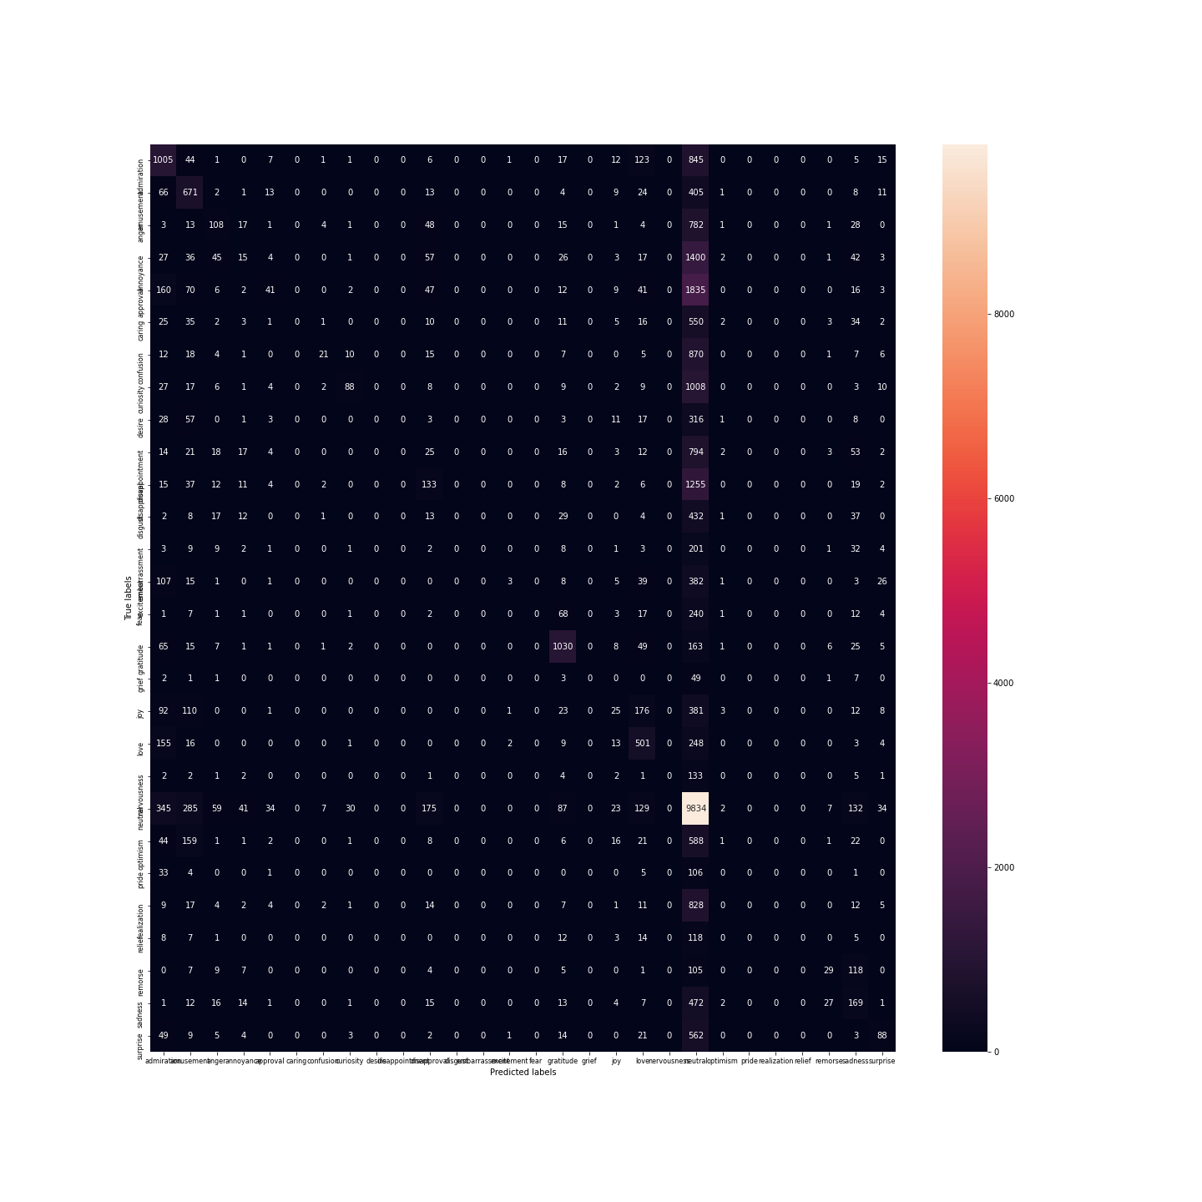Better Multilayered Perceptron for sentiment classification with hyperparameters tunned by grid search:{"activation": "identity", "hidden_layer_sizes": [3, 50], "solver": "adam"}Classification Report:

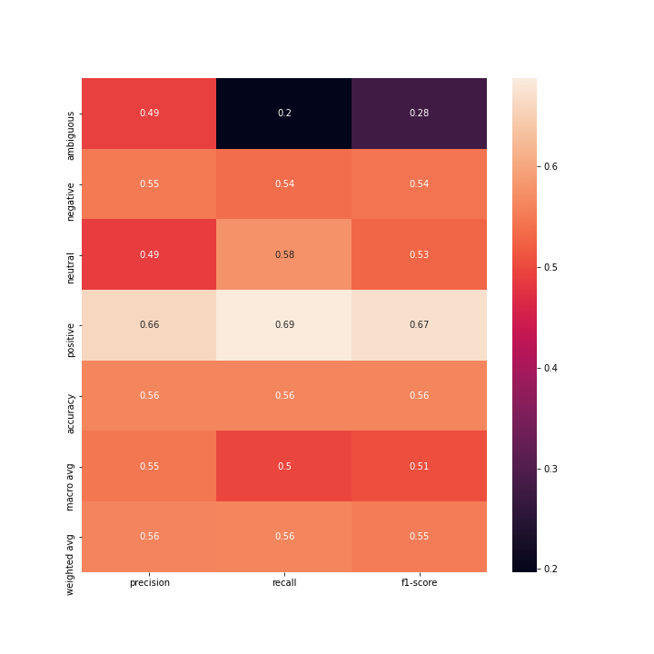

Confusion Matrix

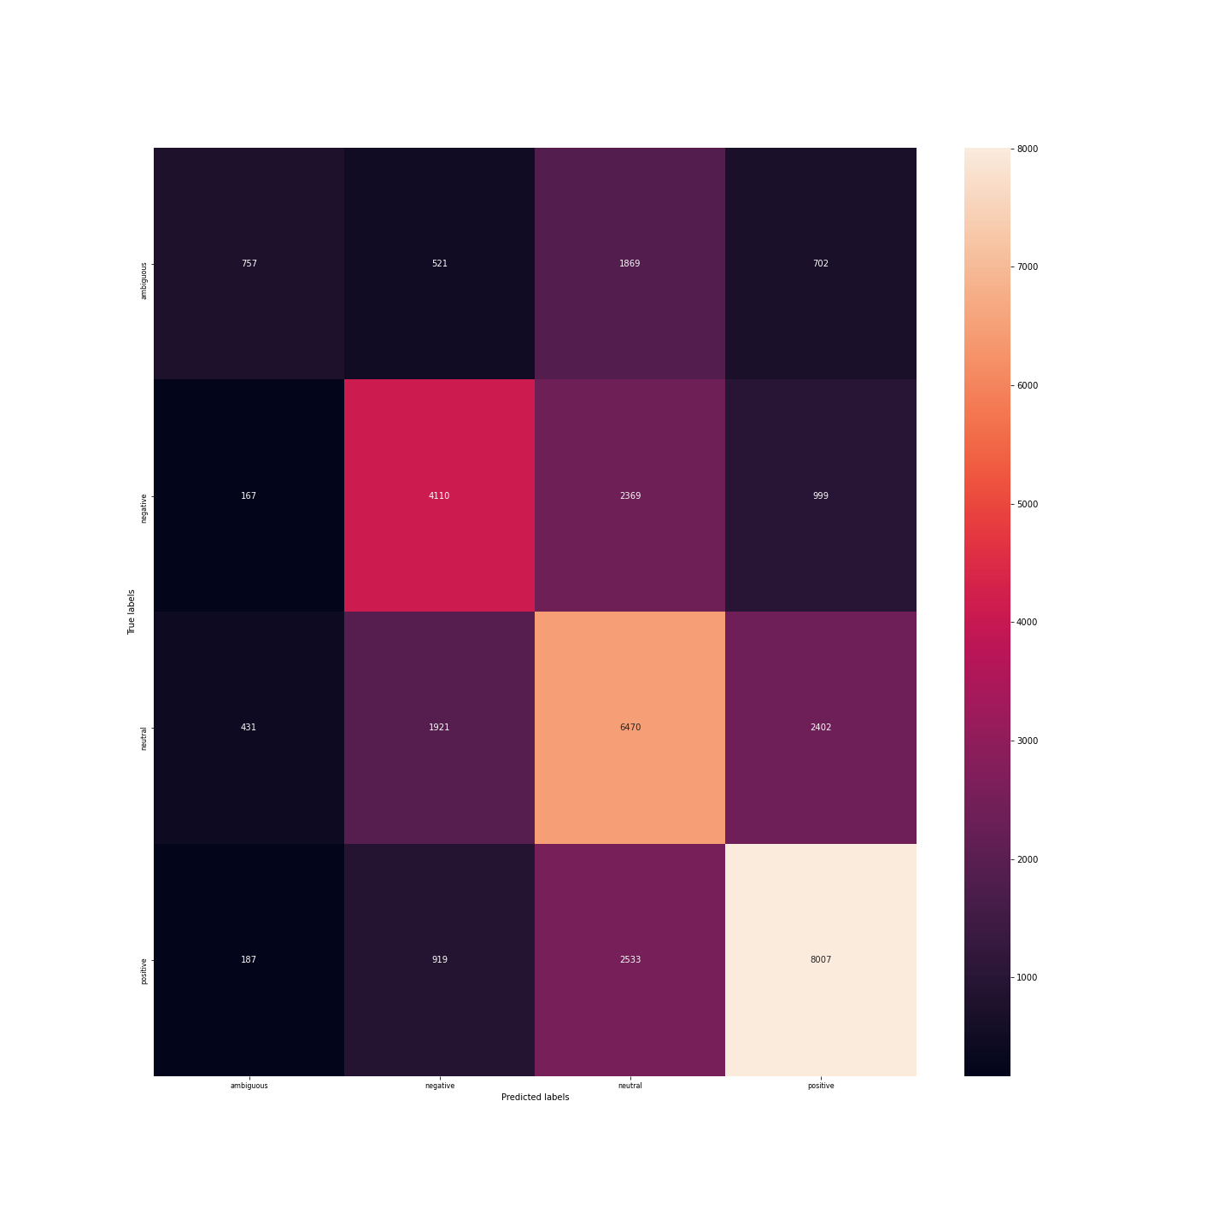**Embedings as features**

Multi-Layered perceptron classificator using the GoogleNews-vectors-negative300 pretrained model for Emotion classification with default hyperparameters: one hidden layer with 100 neurons, activation= 'relu',solver='adam', alpha(regularization)=0.0001...

Classification Report:

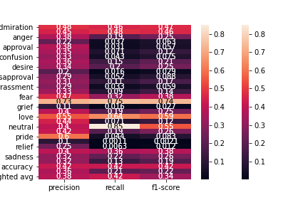

Confusion Matrix

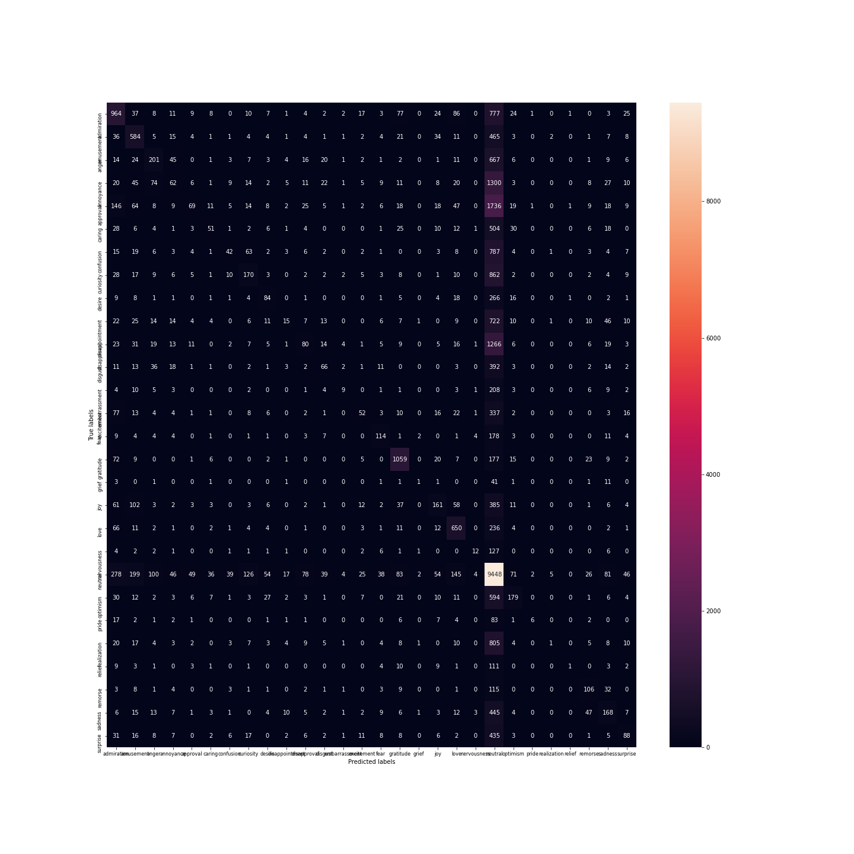Multi-Layered perceptron classificator using the GoogleNews-vectors-negative300 pretrained model for Sentiment classfication with default hyperparameters: one hidden layer with 100 neurons, activation= 'relu',solver='adam', alpha(regularization)=0.0001...

Classification Report:

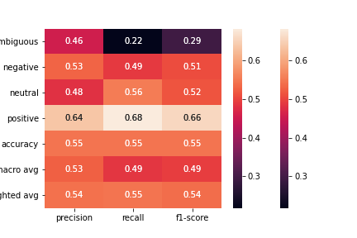

Confusion Matrix

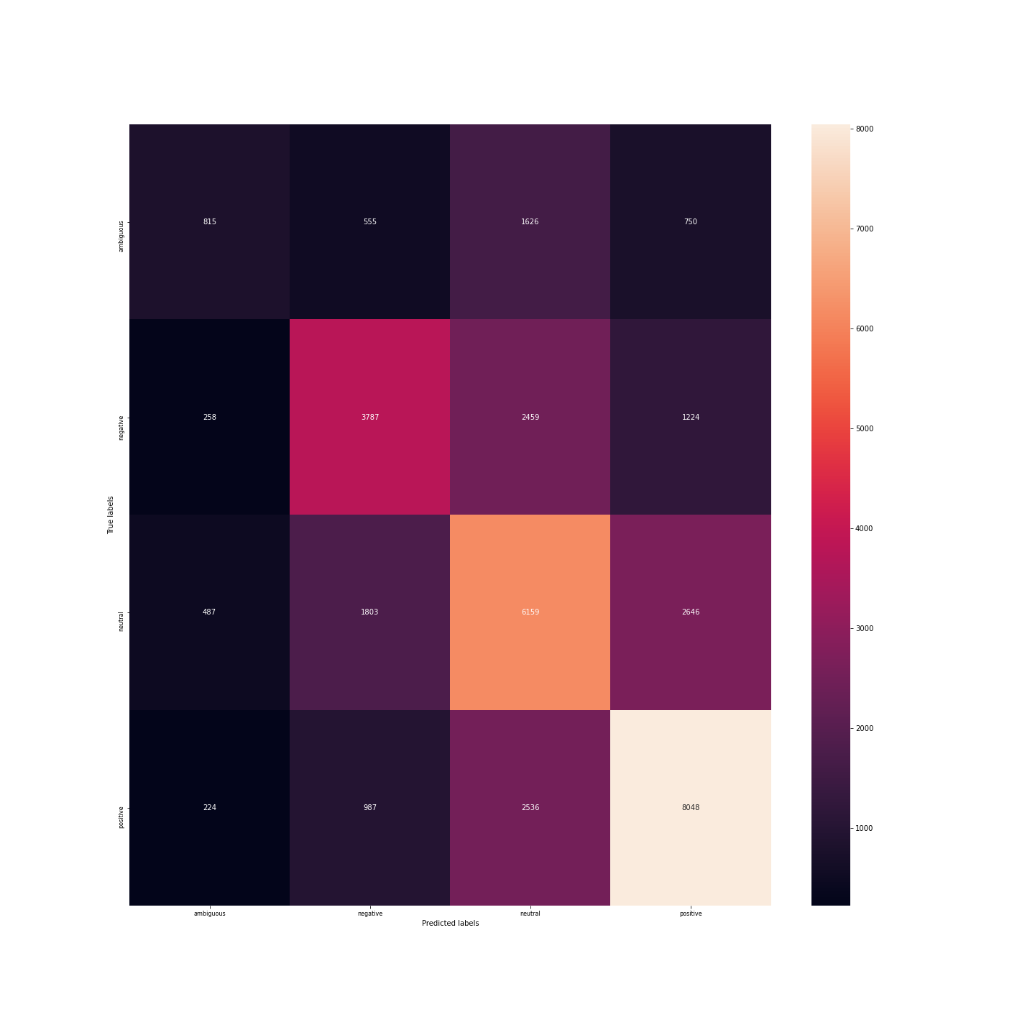Better Multilayered Perceptron using the GoogleNews-vectors-negative300 pretrained model for emotion classification with hyperparameters tunned by grid search:{"activation": "tanh", "hidden_layer_sizes": [2, 30], "solver": "adam"}Classification Report:

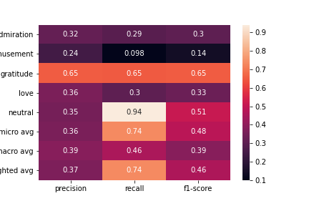

Confusion Matrix

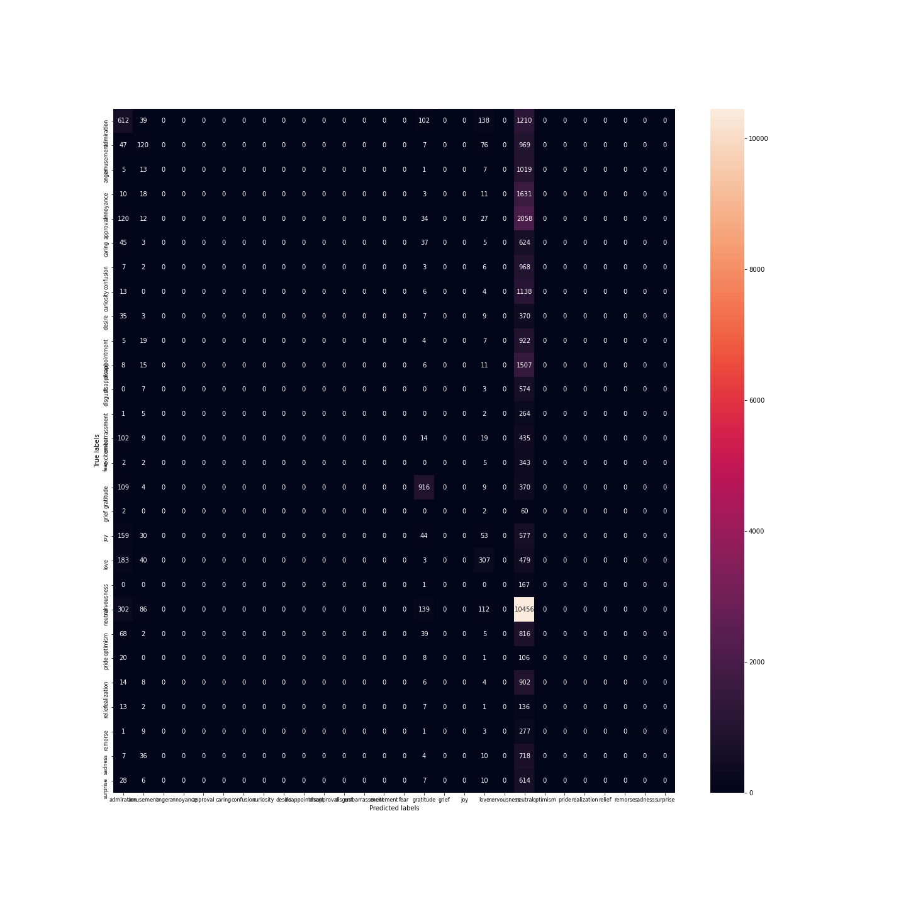Better Multilayered Perceptron using the GoogleNews-vectors-negative300 pretrained model for emotion classification with hyperparameters tunned by grid search:{"activation": "tanh", "hidden_layer_sizes": [2, 30], "solver": "sgd"}Classification Report:

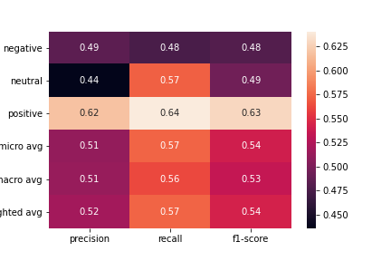

Confusion Matrix

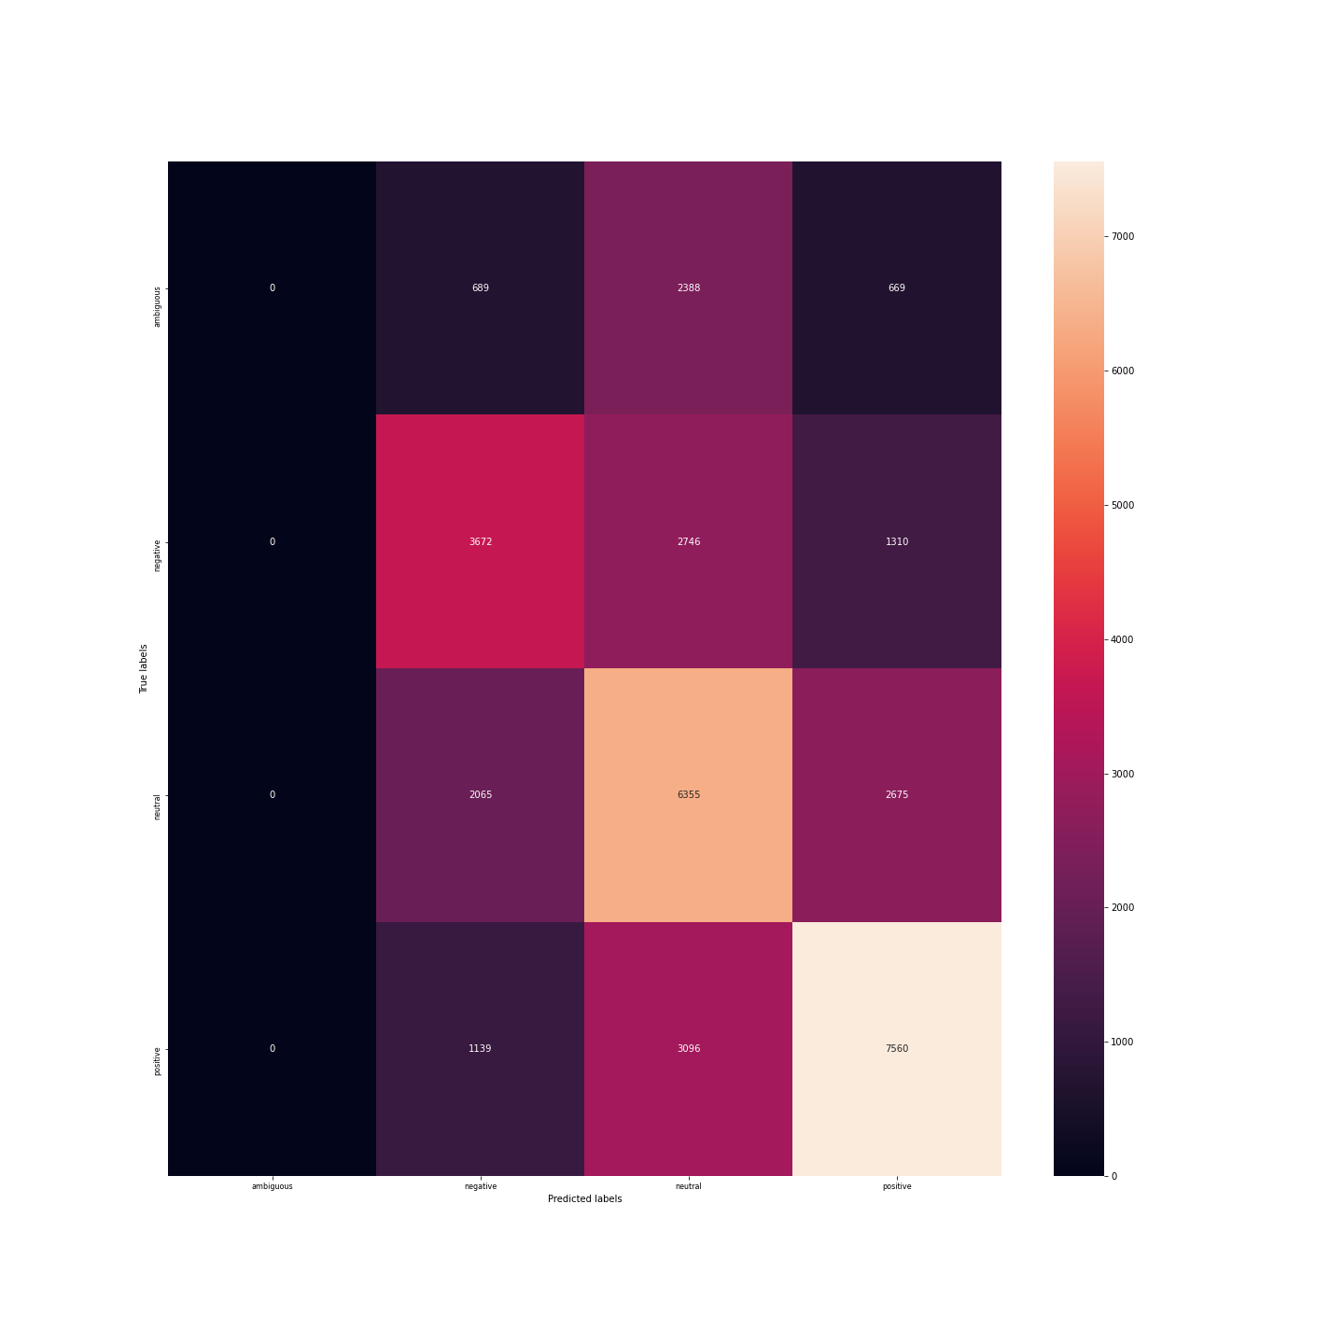Better Multilayered Perceptron using the glove-wiki-gigaword-50 pretrained model for emotion classification with hyperparameters tunned by grid search:{"activation": "identity", "hidden_layer_sizes": [2, 30], "solver": "adam"}Classification Report:

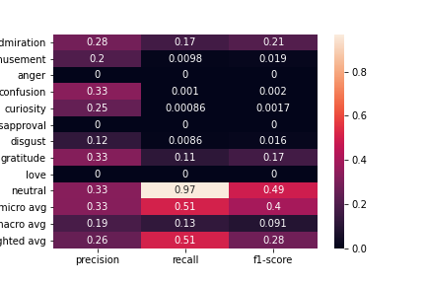

Confusion Matrix

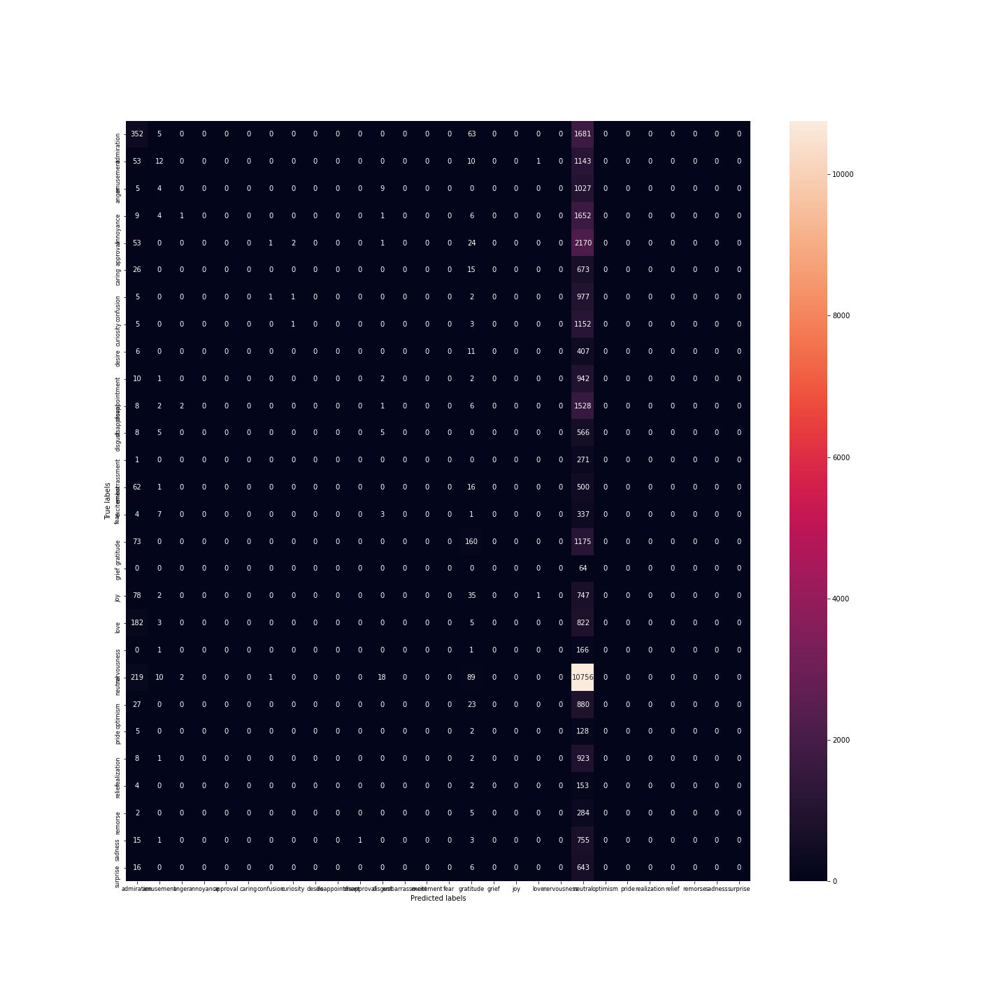Better Multilayered Perceptron using the glove-wiki-gigaword-50 pretrained model for Sentiment classification with hyperparameters tunned by grid search:{"activation": "logistic", "hidden_layer_sizes": [2, 30], "solver": "adam"}Classification Report:

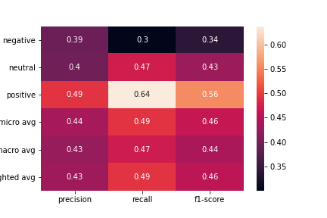

Confusion Matrix

