ChE 397 – Senior Design II – Spring 2022
Rubric for assessment problem on Report 3 (this is a groups submission in a written report format)

Since this course is a senior level course where students work on their design projects, many of the Student Learning Outcomes (SLO) apply. Table 1 Summarizes the Rubric items, mapped SLOs, their averages and Standard Deviations. Scores were calculated on a scale of 3: 3 being satisfactory, 2 for developing and 1 for unsatisfactory.

Table 1. Summary of Rubric items with their mapped SLO, average and standard deviation
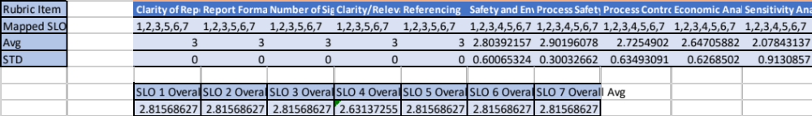

As shown in Table 1, average scores for rubric items except the last item are high. This data suggests that students are strong on process safety and written communication. They are also good at process control. However, the scores for process economics are lower compared to other rubric items; sensitivity analysis being the lowest. Sensitivity analysis is one of the last topics covered in the class. This analysis showed that the course instructor needs to spend more time on process economics and sensitivity analysis and needs to provide more examples on those topics.

