ChE 451 – Renewable Energy Technologies –Fall 2025
Student Learning Outcome 1
Rubric for assessment on Midterm Hone Exam

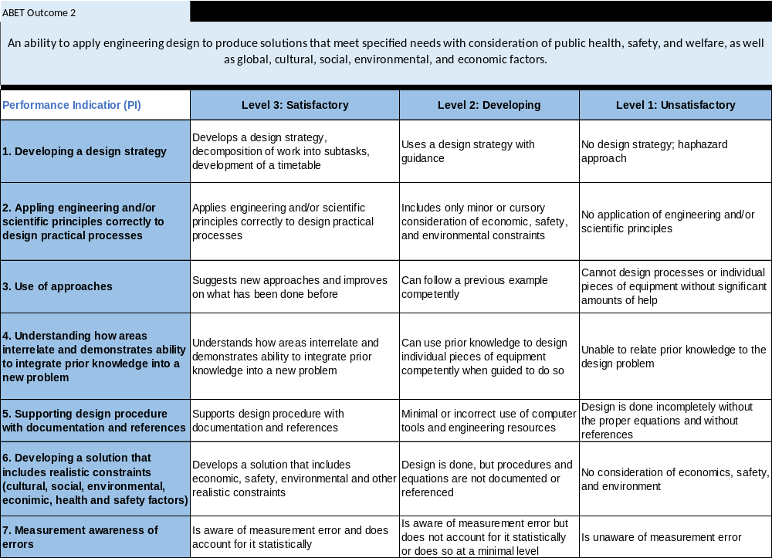

Student Outcome (2) Averages:

Performance Indicators: (1) 2.88 (2) 2.63 (6) 2.38 Overall Average: 2.63

PI (1) is the strongest score. The objective of this indicator is to evaluate the students’ ability to develop a design strategy, and decomposition of work into subtasks for a techno-economic analysis for an off-grid solar+storage system to power a refugee camp. The students demonstrated excellent ability in estimating systems daily load, solar and battery sizing, and evaluating the overall cost of ownership over the lifetime of the project.

The next highest score is for PI (2) which corresponds to being able to apply engineering and/or scientific principles correctly to design practical processes. The students used basic solar energy principles to size the solar array, Li-ion battery capacity and maximum power demand over daily and annual basis. Some students struggled with differentiation between average daily energy need (average daily kWhr) which is covered by the solar and battery sizing versus the maximum power demand (i.e. maximum kW) which requires proper sizing of power electronics (i.e. inverters and converters).

Finally, the PI (6) is the lowest score. It corresponds to developing a solution that includes realistic constraints (cultural, social, environmental, economic, health and safety factors). Most students did not address the financing challenges and cost of capital for executing such humanitarian projects. In addition, the students did not appreciate the impact of cost of electricity for such displaced communities and their inability to afford such cost which may account for a large portion of their income. Finally, the students proposed alternative conventional power options, such as diesel generators, without addressing the environmental and health impacts of such sources and the challenges with accessing fuel supplies for such displaced communities.
Including future course material to discuss socioeconomic challenges of various conventional and alternative energy solution should help improve students’ comprehension of such challenges.

