ChE 453 – Fundamentals of Electrochemistry –Fall 2024
Student Learning Outcome 3: An ability to communicate effectively with a range of audiences (oral communication)
Rubric assessment of individual student presentation on research article

Summary of Results:

Rubric Assessment Table

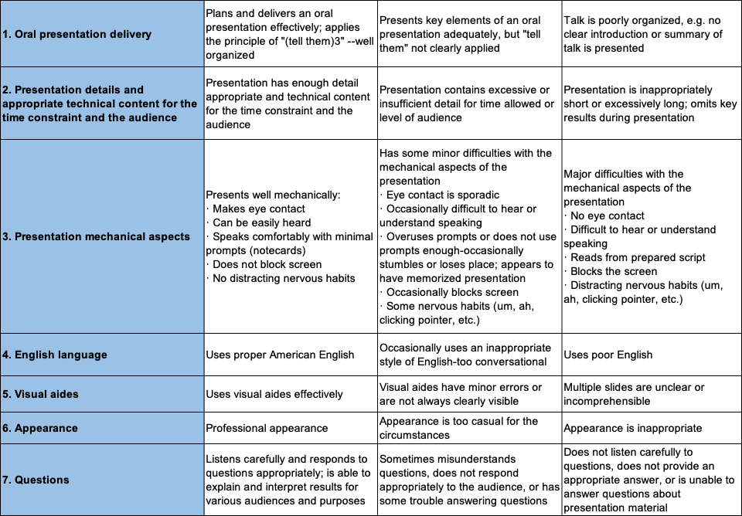

Assignment Description:
Each student is required to give an oral presentation on a peer reviewed journal article assigned by the instructor. The presentation should review current research related to a specific electrochemical technology or a scientific question that advances the fundamental understanding of an electrochemical process. The presentation is in Power Point-type format (15 minutes presentation and 5 minutes Q/A).

