ChE 201 – Introduction to Thermodynamics –Spring 2026
Student Learning Outcome 1
Rubric for assessment problem on Midterm 2 (Problem #2)
Application of energy balance to a piston/cylinder device with air.

SLO 1  Performance Indicator (PI) | (1) Unsatisfactory | (2) Developing | (3) Satisfactory
1. Apply mathematical and scientific principles to formulate models and systems relevant to the subject  Problem 2a, 2b  4 pts | Does not understand the connection between mathematical models and the system or process to be analyzed or designed  (<2 pts) | Chooses a mathematical model or scientific principle that applies to an engineering problem, but has trouble in model development  (2 pts) | Able to successfully combines mathematical and/or scientific principles to formulate models and systems relevant to chemical engineering  (3-4 pts)
2. Solve engineering problems by using the concepts of algebra, calculus, differential equations and/or linear algebra  Problem 2e, 2f, 25pts | Does not understand the application of algebra, calculus, differential equations and/or linear algebra in solving chemical engineering problems  (<10 pts) | Shows nearly complete understanding of applications of calculus and/or linear algebra in problem-solving  (10-14 pts) | Applies concepts of algebra, calculus, differential equations and/or linear algebra to solve chemical engineering problems  (15-25 pts)
4. Translates academic theory into engineering applications  Problem 2c, 2d  6 pts | Does not appear to grasp the connection between theory and the problem  (< 3 pts) | Some gaps in understanding the application of theory to the problem and expects theory to predict reality  (3 pts) | Translates academic theory into engineering applications and accepts limitations of mathematical models of physical reality  (4-6 pts)

Averages:

Performance Indicators: (1) 2 (2) 2.50 (4) 2.42 Overall Average: 2.64

Average scores were fairly uniform although there was wide variation among students. Clearly, most students were strong in formulating the engineering system and model equations, and a majority 10/12 were satisfactory or higher in applying the engineering principles to solve the three problems.

CHE 201 MidTerm Exam 2 March 11th, 2026
QUESTION 2: (35 pts)
A piston cylinder device initially contains 3m³ of air at 500kPa and 150ºC. The air is now expanded to 10m³ , during which the pressure-volume relationship is PV^{1.5} = constant. The air is modeled as an ideal gas and kinetic and potential energy effects are negligible.
- (2 pts) Draw a schematic of the system and label the system boundary.
- (2 pts) State the engineering model
- (2 pts) Write the simplified energy balance and compressibility factor (Z).
- (4pts) Draw P-ν diagram (Pressure-specific volume)
- (10 pts) Determine the work (kJ)
- (15 pts) Determine the heat (kJ) (i) by using Table, (ii) by using constant specific heat values, (iii) by using k= 1.4
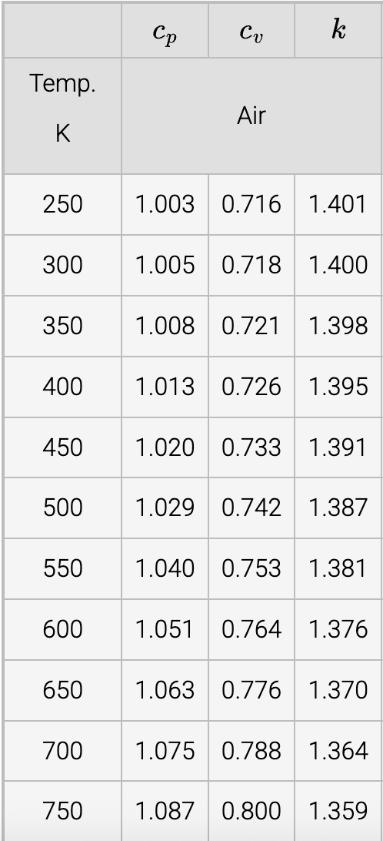

Solution

