ChE 205 – Computational Methods in Chemical Engineering – Fall 2025
Student Learning Outcome 1
Rubric for assessment problem on final exam (Problem # 1, 2, 5, and 3)
Application of computational methods in solving chemical engineering problems.

SLO 1  Performance Indicator (PI) | (1) Unsatisfactory | (2) Developing | (3) Satisfactory
1. Apply mathematical and scientific principles to formulate models and systems relevant to the subject  Problem 1, 10 pts | Able to successfully combines mathematical and/or scientific principles to formulate models and systems relevant to chemical engineering  (<3 pts) | Chooses a mathematical model or scientific principle that applies to an engineering problem, but has trouble in model development  (3-7 pts) | Does not understand the connection between mathematical models and the system or process to be analyzed or designed  (>7 pts)
2. Solve engineering problems by using the concepts of algebra, calculus, differential equations and/or linear algebra  Problem 2, 10 pts | applies concepts of algebra, calculus, differential equations and/or linear algebra to solve chemical engineering problems  (<3 pts) | Shows nearly complete understanding of applications of calculus and/or linear algebra in problem-solving  (3-7 pts) | Does not understand the application of algebra, calculus, differential equations and/or linear algebra in solving chemical engineering problems  (>7 pts)
4. Translates academic theory into engineering applications  Problem 5, 5 pts | Translates academic theory into engineering applications and accepts limitations of mathematical models of physical reality  (< 1.5 pts) | Some gaps in understanding the application of theory to the problem and expects theory to predict reality  (1.5-3.5 pts) | Does not appear to grasp the connection between theory and the problem  (>3.5 pts)
6. The uses of appropriate resources needed to solve problems  Problem 3, 10 pts | Uses no resources to solve problems  (< 3 pts) | Uses limited resources to solve problems  (3-7 pts) | Uses appropriate resources to locate information needed to solve problems  (>7 pts)

Averages:

Performance Indicators: (1) 2.86 (2) 2.93 (4) 1.93 (6) 2.86
Overall Average: 2.64
Standard Deviation: 0.41

Student performance was relatively consistent across Performance Indicators (PI) 1, 2, and 6, though some variance was observed at the individual level. While the data reflects strong proficiency in formulating models, solving engineering problems, and utilizing appropriate resources, a notable weakness emerged in PI 4 (Problem 5). Specifically, 26 out of 28 students were identified as being at the 'developing' stage when tasked with translating academic theory into practical engineering applications.

CHE 205 Final Exam 12/09/2025
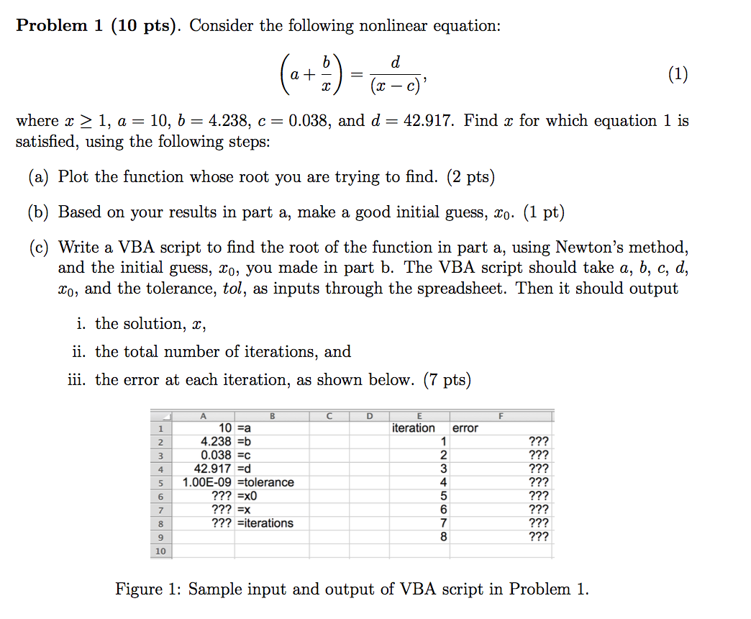

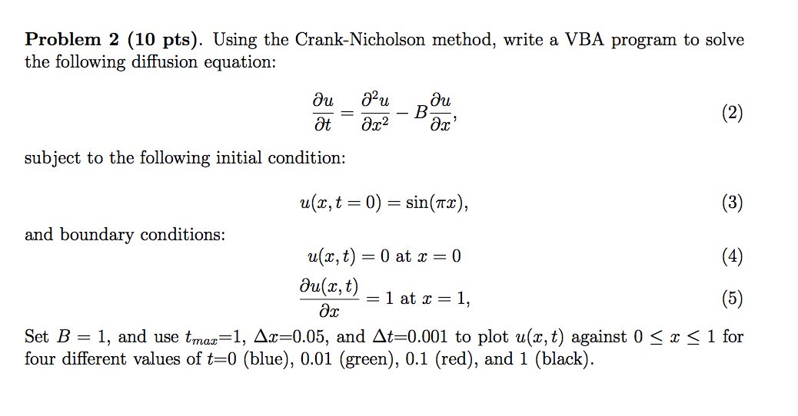

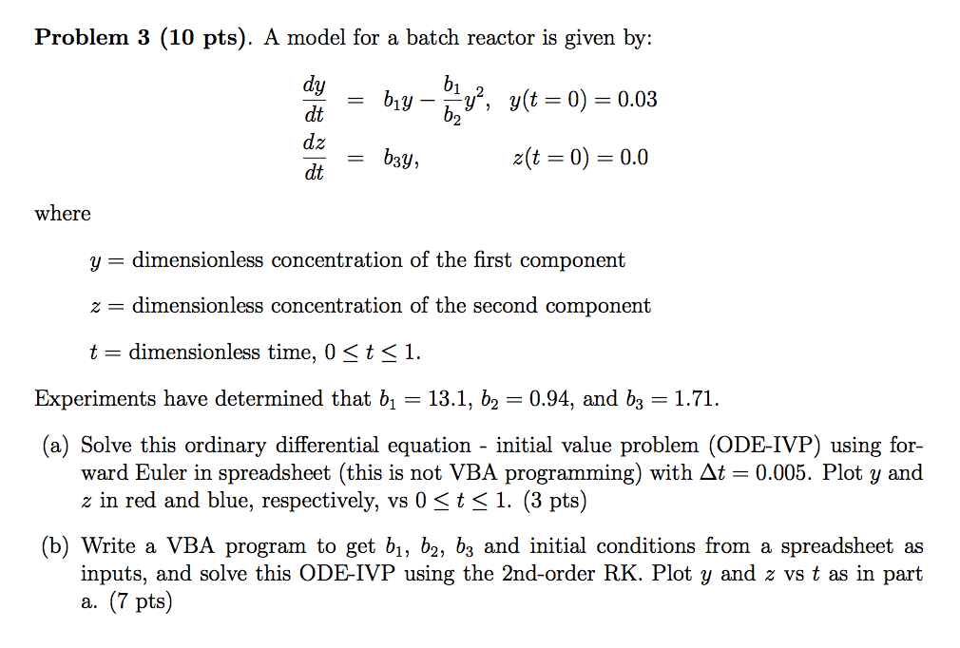

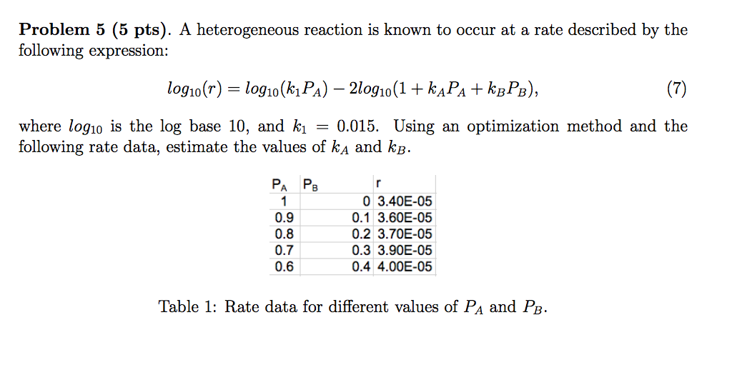

Solutions

Problem 1:
Option Base 1
Option Explicit

Sub Newton()

Dim maxiter, iter, row As Integer
Dim tol, err As Double
Dim a, b, c, d, x0, x, f, fprime As Double

'Make the current Worksheet the selected one:
Worksheets(ActiveSheet.Name).Activate

'Clear up the page
Range("A7:B10").Clear
Range("E2:F20").Clear

maxiter = 100 'Maximum number of iterations

a = Cells(1, 1)
b = Cells(2, 1)
c = Cells(3, 1)
d = Cells(4, 1)
tol = Cells(5, 1)
x0 = Cells(6, 1)

Cells(1, 5) = "'iteration"
Cells(1, 6) = "'error"

err = 1
iter = 0
x = x0
row = 1
While (Abs(err) > tol And iter < maxiter)
iter = iter + 1
Call Fcalc(a, b, c, d, x, f, fprime)
err = f / fprime
x = x - err
row = row + 1
Cells(row, 5) = iter
Cells(row, 6) = err
Wend

If (iter >= maxiter) Then
Cells(6, 1) = "Maximum iteration reached;"
Cells(7, 1) = "Solution might not be valid"
Else
Cells(7, 2) = "'=x"
Cells(7, 1) = x
Cells(8, 2) = "'=iterations"
Cells(8, 1) = iter
End If

Worksheets(ActiveSheet.Name).Cells.Font.Size = 16
Worksheets(ActiveSheet.Name).Cells.Font.Name = "Arial"
Range("F2:F20").NumberFormat = "0.00E+00"

End Sub
Sub Fcalc(a, b, c, d, x, f, fprime)
f = (a + b / x) - d / (x - c)
fprime = -b / x ^ 2 + d / (x - c) ^ 2
End Sub

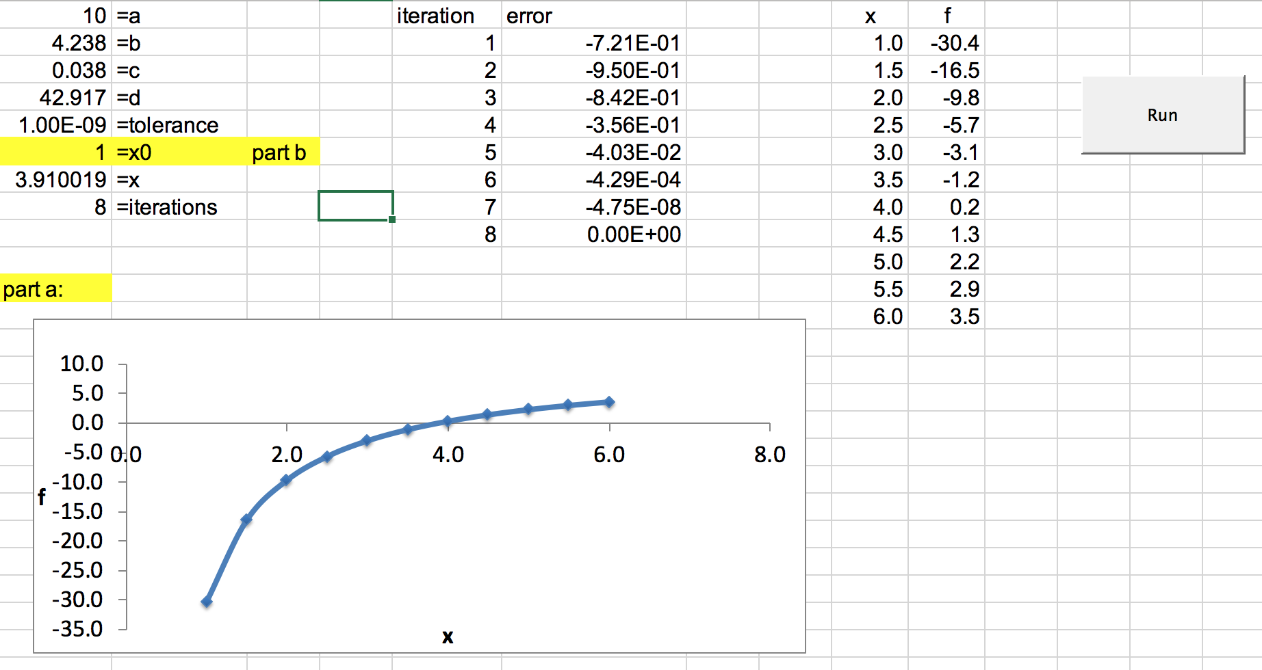

---------------------------------------------------------------------------------------------------------------------------------
Problem 2:

Option Explicit
Option Base 1

Sub CrankNicholsonB()
Dim Bcoeff, Deltax, Deltat, Ratio As Double
Dim Numxsteps As Long
Dim Maxtime As Double
Dim Time As Double
Dim V() As Double
Dim U() As Double

Dim C() As Double
Dim D() As Double
Dim E() As Double
Dim B() As Double
Dim X() As Double
Dim i, j As Long

'clear the active sheet
Dim Lastrow As Long
Lastrow = Range("A" & Rows.Count).End(xlUp).Row
Range("A7:V" & Lastrow).Clear

Bcoeff = ActiveSheet.Cells(1, 3).Value 'get B coefficient
Deltat = ActiveSheet.Cells(2, 3).Value 'get time step
Deltax = ActiveSheet.Cells(3, 3).Value 'get distance step
Ratio = Deltax ^ 2 / Deltat

Maxtime = ActiveSheet.Cells(2, 5).Value 'get maximum time
Numxsteps = Round(1 / Deltax) - 1
Time = 0 'initialize time

ReDim V(1 To Numxsteps + 2) As Double
ReDim U(1 To Numxsteps + 2) As Double

ReDim C(1 To Numxsteps) As Double 'lower diagonal coefficients
ReDim D(1 To Numxsteps) As Double 'diagonal coefficients
ReDim E(1 To Numxsteps) As Double 'upper diagonal coefficients
ReDim B(1 To Numxsteps) As Double 'right hand side vector
ReDim X(1 To Numxsteps) As Double 'unknown temperatures at new time step

'Get the initial temperatures from the spreadsheet

i = 6

For j = 1 To Numxsteps + 2
V(j) = ActiveSheet.Cells(i, j + 1)
Next j

Time = 0
While Time <= Maxtime

'Set up the tridiagonal system coefficients

For j = 2 To Numxsteps + 1
C(j - 1) = -1 - Bcoeff * Deltax / 2
D(j - 1) = 2 * (1 + Ratio)
E(j - 1) = -1 + Bcoeff * Deltax / 2
B(j - 1) = (1 + Bcoeff * Deltax / 2) * V(j - 1) - 2 * (1 - Ratio) * V(j) + (1 - Bcoeff * Deltax / 2) * V(j + 1)
Next j

'right boundary correction
D(Numxsteps) = D(Numxsteps) + 4 / 3 * E(Numxsteps)
C(Numxsteps) = C(Numxsteps) - 1 / 3 * E(Numxsteps)
B(Numxsteps) = B(Numxsteps) - 2 * Deltax / 3 * E(Numxsteps)

Call Thomas(Numxsteps, C, D, E, B, X)

U(1) = 0
For j = 1 To Numxsteps
U(j + 1) = X(j)
Next j
U(Numxsteps + 2) = (4 / 3) * U(Numxsteps + 1) - (1 / 3) * U(Numxsteps) + 2 * Deltax / 3

Time = Time + Deltat 'this is the "new" time

'display the temperatures at the new time
i = i + 1 'move down one row
ActiveSheet.Cells(i, 1) = Time
For j = 1 To Numxsteps + 2
ActiveSheet.Cells(i, j + 1) = U(j)
Next j

For j = 1 To Numxsteps + 2
V(j) = U(j)
Next j
Wend

'change worksheet font size and name
With ActiveSheet
.Cells.Font.Size = "12"
.Cells.Font.Name = "Arial"
End With

'set the number of decimal digits
Columns(1).NumberFormat = "0.000"
Range("B5:V" & Lastrow).NumberFormat = "0.00"

End Sub

Sub Thomas(N, C, D, E, B, X)
Dim Beta() As Double
Dim Gamma() As Double
ReDim Beta(1 To N) As Double
ReDim Gamma(1 To N) As Double
Dim i As Long
Dim j As Long

Beta(1) = D(1)
Gamma(1) = B(1) / Beta(1)
For i = 2 To N
Beta(i) = D(i) - C(i) * E(i - 1) / Beta(i - 1)
Gamma(i) = (B(i) - C(i) * Gamma(i - 1)) / Beta(i)
Next i
X(N) = Gamma(N)
For i = 2 To N
j = N - i + 1
X(j) = Gamma(j) - E(j) * X(j + 1) / Beta(j)
Next i

End Sub

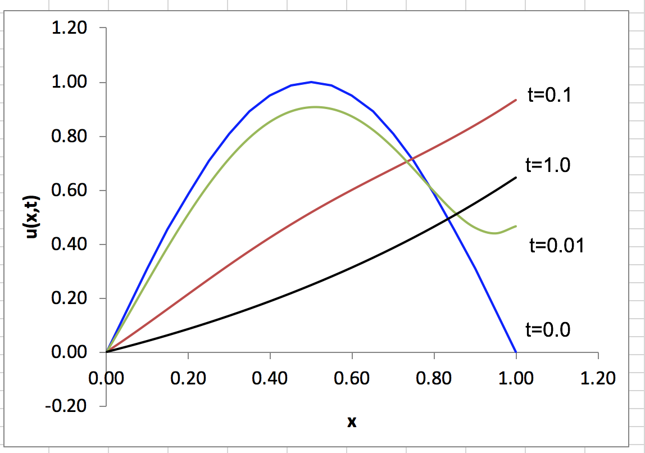

---------------------------------------------------------------------------------------------------------------------------------
Problem 3

Option Base 1
Option Explicit
Sub rk2and4()
'Main routince for solving a set of ODE's using the RK2 Method.
Dim y() As Double 'size N
Dim f() As Double 'size N
Dim h As Double 'fixed time step
Dim b1, b2, b3 As Double 'intermediate time
Dim TimeMax As Double 'maximum integration time
Dim Time As Double 'time counter
Dim ActRow As Integer 'row counter
Dim i As Integer 'a counter
Dim N As Integer ' N = number of state variables and equations

Dim w() As Double 'size N
Dim k1(), k2(), k3(), k4() As Double 'size N

Worksheets(ActiveSheet.Name).Activate

'clear the worksheet
Dim Lastrow As Long
Lastrow = Range("A" & Rows.Count).End(xlUp).Row
If Lastrow > 9 Then
Range("E9:G" & Lastrow).Clear
End If

N = 2 'The number of ODEs
ReDim y(N) As Double 'size N
ReDim f(N) As Double 'size N
ReDim w(N) As Double 'size N
ReDim k1(N), k2(N), k3(N), k4(N) As Double 'size N

TimeMax = ActiveSheet.Cells(1, 2).Value 'get TimMax from spreadsheet
h = ActiveSheet.Cells(2, 2).Value 'get DeltaT from spreadsheet
b1 = ActiveSheet.Cells(3, 2).Value 'get coefficient b1
b2 = ActiveSheet.Cells(4, 2).Value 'get coefficient b2
b3 = ActiveSheet.Cells(5, 2).Value 'get coefficient b3

For i = 1 To N
y(i) = ActiveSheet.Cells(8, i + 5).Value 'get initial y values
Next i

ActRow = 9 'calculated output starts here
Time = 0
Call FCalc(b1, b2, b3, y(), f())
While (Time <= TimeMax)
'###############################
' RK2
For i = 1 To N
k1(i) = h * f(i)
w(i) = y(i) + k1(i)
Next i
Call FCalc(b1, b2, b3, w(), f())
For i = 1 To N
k2(i) = h * f(i)
y(i) = y(i) + 1 / 2 * (k1(i) + k2(i))
Next i
'###############################
' RK4
'For i = 1 To N
' k1(i) = h * f(i)
' w(i) = y(i) + k1(i) / 2
'Next i
'Call FCalc(b1, b2, b3, w(), f())
'For i = 1 To N
' k2(i) = h * f(i)
' w(i) = y(i) + k2(i) / 2
'Next i
'Call FCalc(b1, b2, b3, w(), f())
'For i = 1 To N
' k3(i) = h * f(i)
' w(i) = y(i) + k3(i)
'Next i
'Call FCalc(b1, b2, b3, w(), f())
'For i = 1 To N
' k4(i) = h * f(i)
' y(i) = y(i) + (k1(i) + 2 * k2(i) + 2 * k3(i) + k4(i)) / 6
'Next i
'###############################

Time = Time + h 'Display the results on the spreadsheet
ActiveSheet.Cells(ActRow, 5) = Time 'put time on spreadsheet
For i = 1 To N
ActiveSheet.Cells(ActRow, i + 5).Value = y(i) 'output
Next i
ActRow = ActRow + 1
Wend 'repeat for all times
'change the fontsize
Lastrow = Range("E" & Rows.Count).End(xlUp).Row
Range("E6:G" & Lastrow).Font.Size = 14
Range("E6:G" & Lastrow).Font.Name = "Arial"
Range("E8:E" & Lastrow).NumberFormat = "0.000"
Range("F8:G" & Lastrow).NumberFormat = "0.00"
End Sub
'##################################
Sub FCalc(b1, b2, b3, w, f)

f(1) = b1 * w(1) - b1 / b2 * w(1) * w(1)
f(2) = b3 * w(1)

End Sub
'##################################

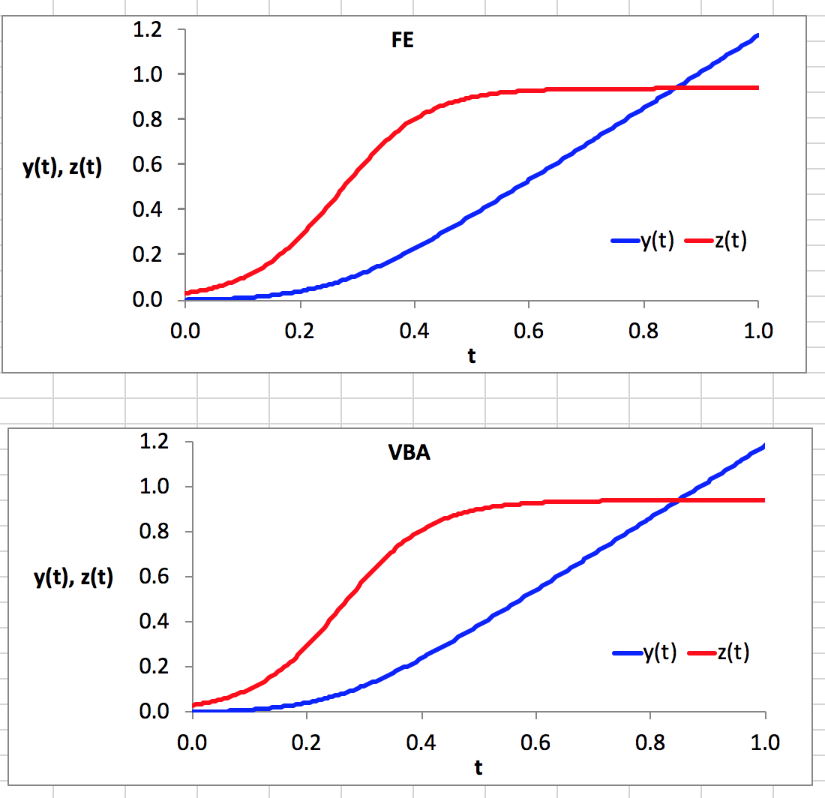
---------------------------------------------------------------------------------------------------------------------------------
Problem 5

