ChE 230 – Molecular Systems in Chemical Engineering – Spring 2026
Student Learning Outcome 1
Rubric for assessment problem on final exam: Part A – Phases
Application of phase diagrams, lever rule, and Gibbs phase rule to binary alloy systems.

SLO 1  Performance Indicator (PI) | (1) Unsatisfactory | (2) Developing | (3) Satisfactory
1. Apply mathematical and scientific principles to formulate models and systems relevant to the subject | Does not correctly identify or apply the governing phase-equilibrium model or Gibbs phase rule. Shows limited understanding of how the mathematical/scientific principle connects to the alloy system. | Identifies the relevant principle, such as Gibbs phase rule or phase equilibrium, but has gaps in applying it correctly to the binary alloy system. | Correctly applies mathematical and scientific principles to formulate the phase-equilibrium model and determine system behavior.
2. Solve engineering problems by using concepts of algebra, calculus, differential equations and/or linear algebra | Does not correctly use algebraic relationships such as the lever rule, or produces incorrect calculations due to major setup errors. | Shows partial understanding of the algebraic method but makes errors in setup, substitution, or final calculation. | Correctly uses algebraic relationships, especially the lever rule, to solve quantitative phase-equilibrium problems.
3. Appropriate engineering interpretation of mathematical and scientific terms | Does not correctly interpret key terms such as phase, microconstituent, eutectic composition, α phase, β phase, or degrees of freedom. | Shows partial understanding of engineering terminology but confuses some related concepts, such as primary α versus total α phase. | Correctly interprets phase-equilibrium terminology and distinguishes between phases, microconstituents, eutectic point, and degrees of freedom.
6. The use of appropriate resources needed to solve problems | Does not effectively use the provided phase diagram, composition values, or phase-rule information to solve the problem. | Uses the provided phase diagram or equations but with some errors in extracting values or applying them to the problem. | Correctly uses the provided Pb-Sn phase diagram, composition data, lever rule, and Gibbs phase rule to support the solution.

Averages:

Performance Indicators: (2) 2.35 Overall Average: 2.35
The strongest performance was observed for PI 2, with an average score of 2.35. This indicator assessed students’ ability to solve engineering problems using algebraic relationships, specifically the derivation of the lever rule. Many students were able to follow the mathematical structure of the derivation and apply algebraic manipulation to relate phase fractions to alloy compositions. This suggests that students are developing reasonable confidence in using mathematical relationships once the variables and governing equations are clearly defined.
To improve student performance, future offerings of the course should include additional in-class examples that explicitly connect phase diagrams, microconstituents, and phase-rule calculations. More emphasis should be placed on helping students distinguish between phases and microconstituents, and on identifying which values from a phase diagram are needed for a specific calculation. In addition, student feedback indicated some perceived overlap between ChE 230 and another course in the curriculum. While some overlap is expected because of foundational topics such as phase behavior, thermodynamics, molecular structure, and material properties naturally support multiple chemical engineering courses, this feedback will be used to refine the course more broadly. Future offerings of ChE 230 will more clearly emphasize its distinct role as a molecular systems course by consistently connecting topics to molecular structure, bonding, microstructure, structure–property relationships, and engineering applications. Course content will also be reviewed to identify areas where coordination with related courses may reduce unnecessary repetition while preserving useful conceptual reinforcement.

Part A: Phases
1. A Lead-Tin (Pb-Sn) alloy with an overall composition of 40 wt% Sn is slowly cooled from the liquid state to just below the eutectic temperature of 183 °C. At this temperature, the maximum solid solubility of Sn in the α phase is 18.3 wt% Sn, the maximum solid solubility of Pb in the β phase is 97.8 wt% Sn, and the eutectic composition is 61.9 wt% Sn.
- Determine the mass fractions of the primary α microconstituent and the eutectic microconstituent.
- Determine the mass fraction of the total α phase in the alloy.

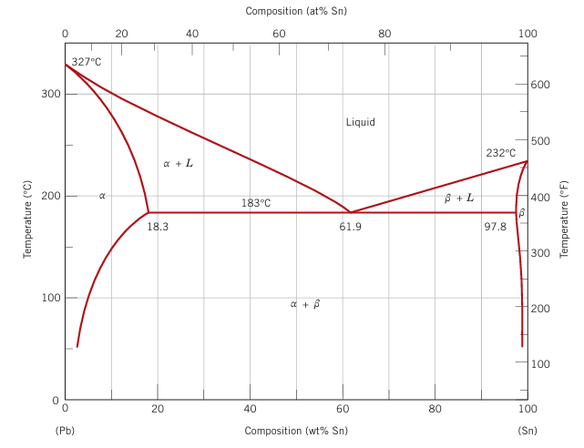

Q1(a). Primary α and eutectic microconstituent (6 pts)
Apply the lever rule across the α + L region just above the eutectic, using Cα = 18.3 wt%, C_eut = 61.9 wt%, C₀ = 40 wt%.
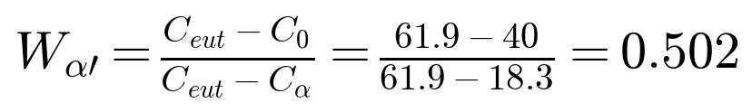
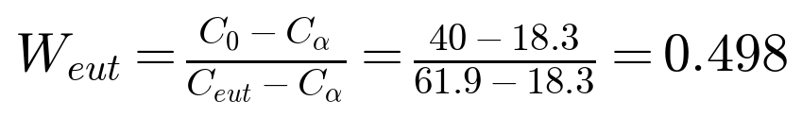
Rubric: 3 pts each — correct formula (1.5) and correct value (1.5). Accept 0.50 / 0.50 with rounding.

Q1(b). Total α phase (4 pts)
Apply the lever rule across the full α + β region just below the eutectic, with Cβ = 97.8 wt%.
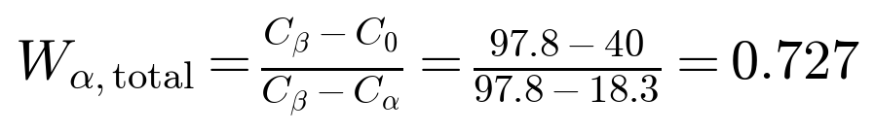
Rubric: correct formula (2 pts), correct substitution (1 pt), correct value (1 pt).

2. Derive the lever rule
Consider a two-phase alloy of overall composition C₀ that separates into phases α (composition Cα) and L (composition C_L). Let Wα and W_L be the mass fractions of each phase.
Step 1 — Total mass balance (1 kg basis):
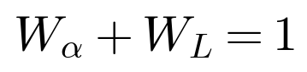
Step 2 — Solute mass balance:
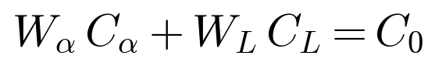
Step 3 — Substitute W_L = 1 − Wα:
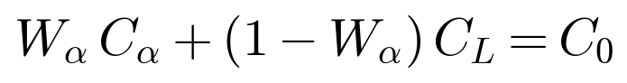
Step 4 — Solve for Wα:
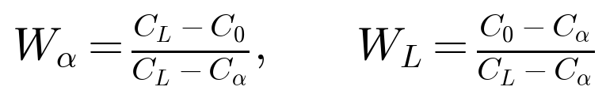
Rubric: mass balance equations 4 pts (2 each), correct substitution 2 pts, final lever rule expressions 2 pts.

3. You are analyzing a binary Copper-Silver (Cu-Ag) alloy system at a constant atmospheric pressure of 1 atm.
a. Write down the condensed Gibbs Phase Rule equation.
b. The alloy is currently exactly at its eutectic temperature and eutectic composition, and it is in the process of solidifying. Calculate the degrees of freedom (F) for the system at this exact moment.

Condensed Gibbs Phase Rule (3 pts)
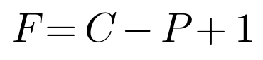
The "+1" replaces the usual "+2" because pressure is fixed at 1 atm, leaving only temperature as an external variable.
Rubric: correct equation (2 pts), correct explanation of "+1" (1 pt).

Degrees of freedom at the eutectic (7 pts)
At the eutectic point during solidification, three phases coexist: liquid, α, and β.
Components: C = 2 (Cu, Ag); Phases: P = 3 (L, α, β).
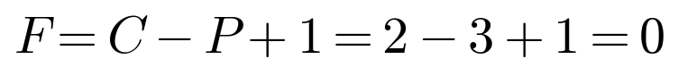
The system is invariant: temperature and the compositions of all three phases are fixed. No variable can change without the system leaving the eutectic point.
Rubric: C = 2 (1 pt), P = 3 (2 pts), compute F = 0 (2 pts), interpret invariance (2 pts).

