La Luce Restaurant Website – Final Report
Students Name:
Joud Mohammed Ahmad , 445003877
Haneen Majed Hassan , 445006683
Hajar Ali , 445035424
Course: Web Technologies
Project: La Luce – Restaurant Website

1. Project Idea
The idea of this project is to create a website for a fictional Italian restaurant named ,'La Luce', which means 'The Light' in Italian. The site allows users to view the restaurant menu, read about the branches, make a reservation, and learn about the restaurant. The goal is to create a modern, elegant website that matches the classy and calm feel of the brand.

2. Interface Design Based on Usage Scenario
The website consists of six main pages: Home, Menu, Selection, Branches, Reservation, and About Us. Each page is designed to be clean and easy to navigate. The design uses a soft color palette (white, beige, olive green, and gold), with clear headings and structured sections. Interfaces were planned using a wireframe-like layout. For example, the homepage contains the restaurant logo, image, navigation bar, and contact info. The reservation page includes a form, and the menu page allows users to view dishes and add them to a cart.
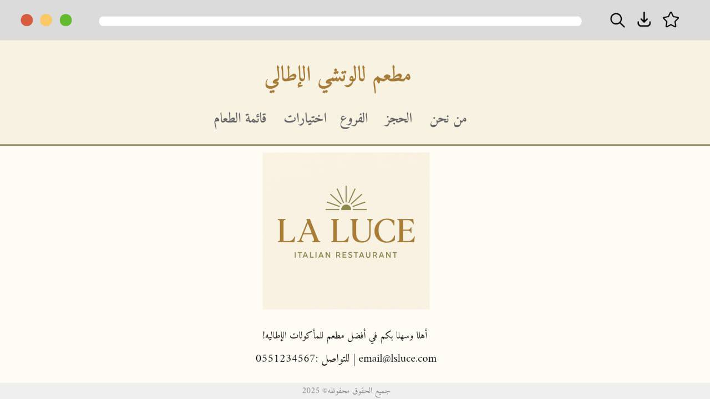

3. HTML Code
The following HTML code shows the structure of the website pages:
In this part, we created all the website pages using only HTML. We made six pages: Home, Menu, Selection, Branches, Reservation, and About. I used basic HTML tags like <header>, <nav>, <section>, <footer>, <img>, <a>, <ul>, <form>, and <input>. Each page is connected with links and uses a simple, clean layout.

4. CSS3 Code
The CSS code below provides the styles for layout, colors, fonts, and responsiveness:
In the CSS part, we designed the website to look nice and modern. We used soft white, beige, olive green, and gold as my main colors. I styled the text, menus, forms, and buttons. We added hover effects, shadows, and rounded corners to make it look better.

5. JavaScript Code
The JavaScript code provides interaction, validation, and shopping cart functionality:
In the JavaScript part, we added simple interaction to the website. we made the reservation form check the fields before submitting. In the menu page, we made a cart that shows the selected items and the total price. we also added a welcome message that greets the user by name.

6. Conclusion
This project demonstrates my ability to combine HTML, CSS, and JavaScript to build a complete and interactive website. The site follows web standards and reflects the project idea through a clean and elegant design. I followed classroom guidelines and applied everything I learned during the course.

