APPLIED SYSTEMS FRAMEWORK // WORKING DRAFT FOR CAPACITY MODELING
DISCLAIMER: Non-authoritative working draft. Prepared as an applied research architecture. Not a submitted government policy or statutory instrument.
FUSION-01: National Climate-Adaptive Social Safety Net & Anticipatory Protection Architecture
Integrated Framework for Pre-Emptive Liquidity, Water Security & SGBV Safeguarding Across Displaced Populations
Target Counterparts: UNICEF / WFP / World Bank Social Protection Global Practice / BISP Liaison • Normative Frameworks: SDG 1 (No Poverty), SDG 5 (Gender Equality), SDG 6 (Clean Water), SDG 13 (Climate Action)
1. EXECUTIVE SUMMARY & POLICY CONTEXT
This master operational framework establishes an automated anticipatory social safety net for climate-vulnerable communities. Rather than relying on traditional ex-post disaster relief—which typically arrives 21 to 45 days after catastrophic flooding—this architecture connects satellite telemetry (Sentinel/MODIS NDVI/NDWI) and PMD rainfall forecasting to the National Socio-Economic Registry (NSER). When flood crests cross the 95th percentile threshold, the system automatically disburses unconditional emergency liquidity grants ($45 per household via branchless banking) and pre-positions water purification supplies and female-safe protection corridors 72 hours prior to inundation.
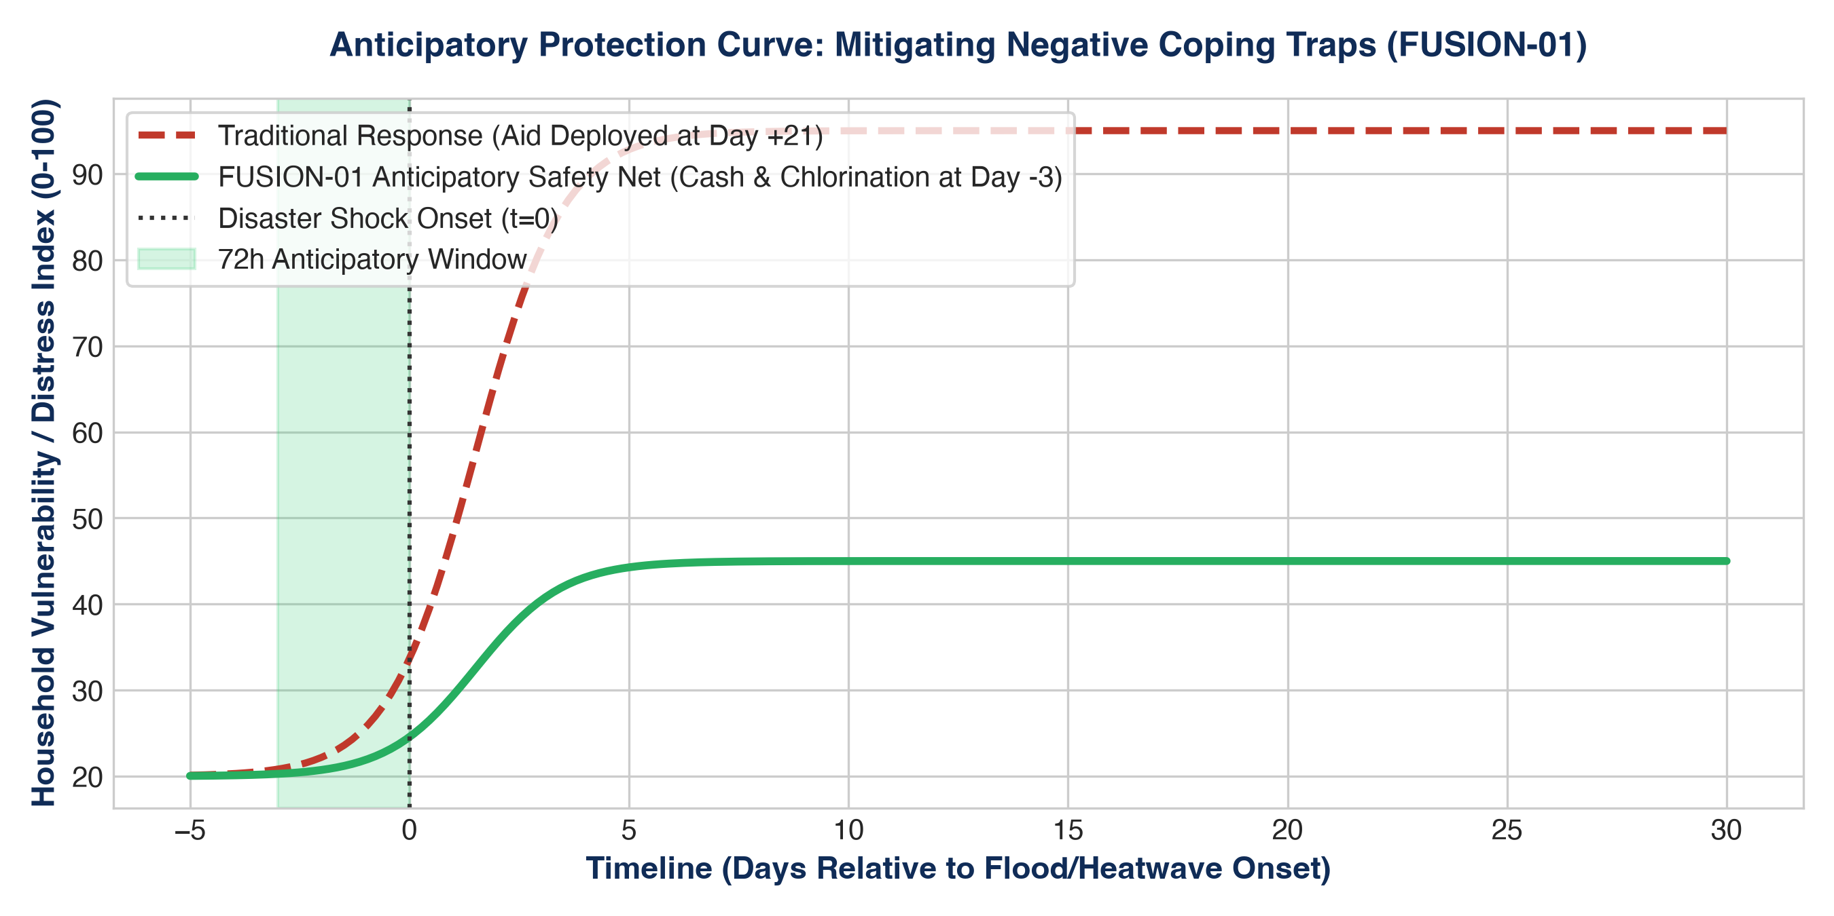
Figure 1: Quantitative Telemetry & Systems Indicator Model (FUSION-01: National Climate-Adaptiv...)
2. OPERATIONAL DIMENSIONS (5W + 1H FRAMEWORK)
Dimension | Operational Specification
WHAT | Automated anticipatory cash transfer and multi-sectoral protection trigger engine.
WHY | Prevents negative coping mechanisms (distress livestock sales, child labor, and transactional survival sex) before displacement occurs.
WHO | Ultra-poor households, female-headed families, and pregnant/lactating women in high-risk flood polygons.
WHERE | Southern Punjab, Lower Sindh (Thatta/Badin/Dadu), and Eastern Balochistan (Jafarabad/Nasirabad).
WHEN | Immediate multi-year rollout (2026–2030), aligned with pre-monsoon and monsoon climatic cycles.
HOW | Satellite remote sensing combined with branchless RAAST/BISP biometric payout rails and dual-signoff financial controls.

3. QUANTITATIVE RISK & MULTI-YEAR KPI MATRIX
Indicator / KPI | Baseline | Mid-Term (Yr 2) | Final Goal (Yr 5) | Verification Source
Direct Households Reached | 0 | 120,000 | 500,000 | Biometrically verified branchless transaction logs
Emergency Response Latency | 21-35 Days | 72 Hours | 24 Hours | Automated system telemetry & SMS dispatch logs
Female Economic Autonomy Ratio | <15% | >60% | >75% | BISP digital wallet ownership verification
Waterborne Morbidity Reduction | Baseline | -35% | -60% | District Health Information System (DHIS) reports
Audit Cleanliness & Transparency | Unverified | 100% Unqualified | Zero Paras | Auditor General of Pakistan external review
4. MULTI-SECTORAL STANDARD OPERATING PROCEDURES (SOPS)
- SOP-01: Free, Prior & Informed Community Consent (FPIC): Mandatory structured rural appraisals conducted in local vernaculars, engaging village elders and women's committees to guarantee community ownership.
- SOP-02: Zero-Tolerance Safeguarding & PSEA Enforcement: Immediate escalation protocols for Protection from Sexual Exploitation and Abuse (PSEA) adhering to Inter-Agency Standing Committee (IASC) global standards.
- SOP-03: Transparent Financial & Public Procurement Integrity: Dual-signoff disbursement protocols, competitive tendering conforming to Public Procurement Regulatory Authority (PPRA) rules, and on-site public financial notice boards.

