APPLIED SYSTEMS FRAMEWORK // WORKING DRAFT FOR CAPACITY MODELING
DISCLAIMER: Non-authoritative working draft. Prepared as an applied research architecture. Not a submitted government policy or statutory instrument.
FUSION-02: Developing-Area Women’s Integrated Legal, Financial & Reproductive Autonomy Nexus
Holistic Grassroots Delivery Architecture: Mobile Civil Identity, Producer Cooperatives & Obstetric Tele-Triage
Target Counterparts: UN Women / UNFPA / National Commission on the Status of Women (NCSW) • Normative Frameworks: SDG 3 (Good Health), SDG 5 (Gender Equality), SDG 8 (Decent Work), SDG 16 (Peace & Justice)
1. EXECUTIVE SUMMARY & POLICY CONTEXT
Rural women in underdeveloped districts face compounding structural exclusion: lack of a CNIC prevents bank account ownership; lack of independent income leaves them unable to escape domestic violence; and isolated healthcare access drives preventable maternal deaths. FUSION-02 deploys Union Council Women Empowerment Centers (WECs) delivering a unified package: mobile NADRA registration vans, formal home-based worker cooperatives with transparent piece-rate pricing, community midwife obstetric tele-triage, and paralegal defense against unlawful inheritance disinheritance.
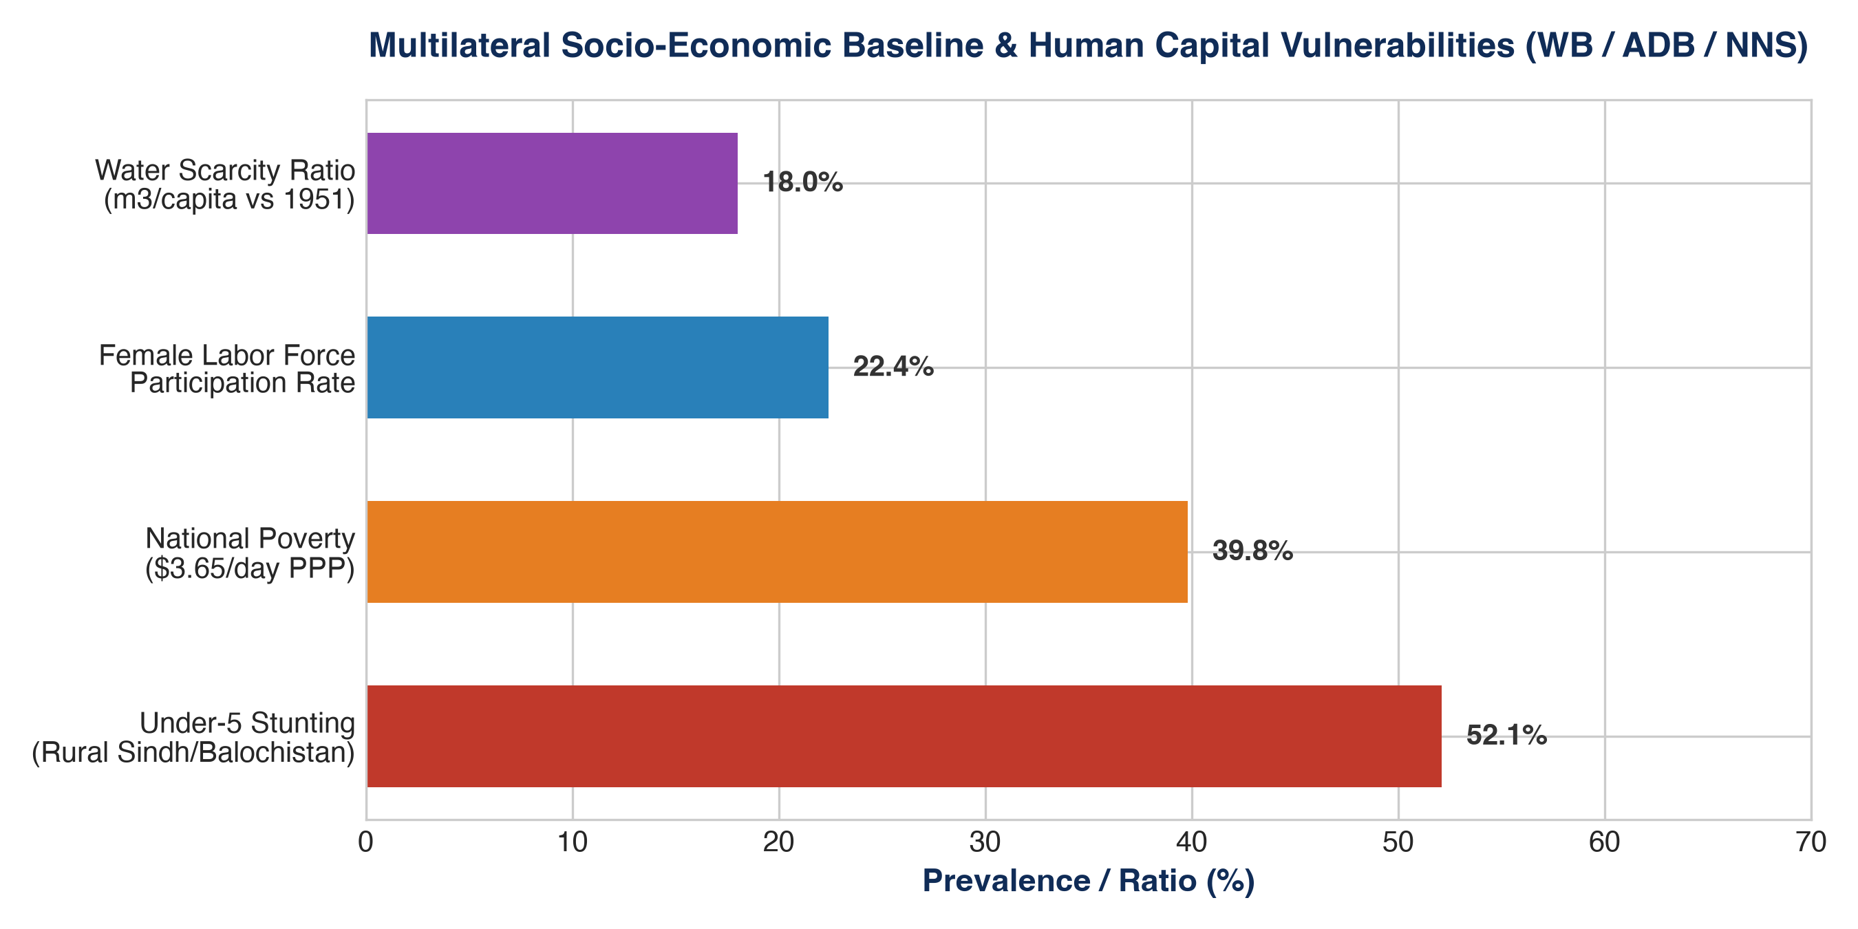
Figure 1: Quantitative Telemetry & Systems Indicator Model (FUSION-02: Developing-Area Women’s ...)
2. OPERATIONAL DIMENSIONS (5W + 1H FRAMEWORK)
Dimension | Operational Specification
WHAT | One-stop decentralized socio-legal, reproductive health, and cooperative economic enablement hub.
WHY | Resolves interlocking gender disadvantages by delivering civil identity, economic power, and healthcare simultaneously.
WHO | Rural home-based female artisans, agricultural tenant workers, and young mothers in underdeveloped union councils.
WHERE | Rural union councils across Khyber Pakhtunkhwa, South Punjab, and rural Sindh.
WHEN | Continuous 3-year phased implementation with quarterly judicial and maternal health milestones.
HOW | Community mobilization via Lady Health Workers, mobile government desks, and fair-trade market linkages.

3. QUANTITATIVE RISK & MULTI-YEAR KPI MATRIX
Indicator / KPI | Baseline | Mid-Term (Yr 2) | Final Goal (Yr 5) | Verification Source
Rural Women CNIC Registration | 38% Local Baseline | >75% | >90% | NADRA verification registers
Cooperative Net Monthly Earnings | <$20 / Month | >$65 / Month | >$110 / Month | Cooperative audited double-entry passbooks
Maternal Mortality Ratio (MMR) | 186 / 100k | 130 / 100k | <85 / 100k | District health vital statistics records
Inheritance Title Mutations Secured | <5% | >45% | >70% | Provincial Revenue Board land records (Fard)
Formal Legal Aid Redress Rate | <10% | >55% | >80% | District Bar Association legal aid rosters
4. MULTI-SECTORAL STANDARD OPERATING PROCEDURES (SOPS)
- SOP-01: Free, Prior & Informed Community Consent (FPIC): Mandatory structured rural appraisals conducted in local vernaculars, engaging village elders and women's committees to guarantee community ownership.
- SOP-02: Zero-Tolerance Safeguarding & PSEA Enforcement: Immediate escalation protocols for Protection from Sexual Exploitation and Abuse (PSEA) adhering to Inter-Agency Standing Committee (IASC) global standards.
- SOP-03: Transparent Financial & Public Procurement Integrity: Dual-signoff disbursement protocols, competitive tendering conforming to Public Procurement Regulatory Authority (PPRA) rules, and on-site public financial notice boards.

