APPLIED SYSTEMS FRAMEWORK // WORKING DRAFT FOR CAPACITY MODELING
DISCLAIMER: Non-authoritative working draft. Prepared as an applied research architecture. Not a submitted government policy or statutory instrument.
FUSION-03: Holistic Child Safeguarding, Psychosocial Rehabilitation & Offline Digital Literacy System
Institutional Architecture for Child Welfare Centers, Unaccompanied Displaced Minors & Safe Learning Pavilions
Target Counterparts: UNICEF Child Protection & Education / National Commission on the Rights of Child (NCRC) • Normative Frameworks: SDG 4 (Quality Education), SDG 10 (Reduced Inequalities), SDG 16 (Peace, Justice & Child Protection)
1. EXECUTIVE SUMMARY & POLICY CONTEXT
This framework reconciles humanitarian child protection in disaster shelters with modern digital education. It establishes air-gapped local education servers and offline LLM learning pods running on donated computers inside welfare homes and transit camps. It pairs cutting-edge, zero-risk digital literacy with rigorous trauma-informed play therapies, Best Interests Determination (BID) case tracking for unaccompanied minors, and strict diversion mechanisms to protect first-time juvenile offenders from adult prison remand under the Juvenile Justice System Act.
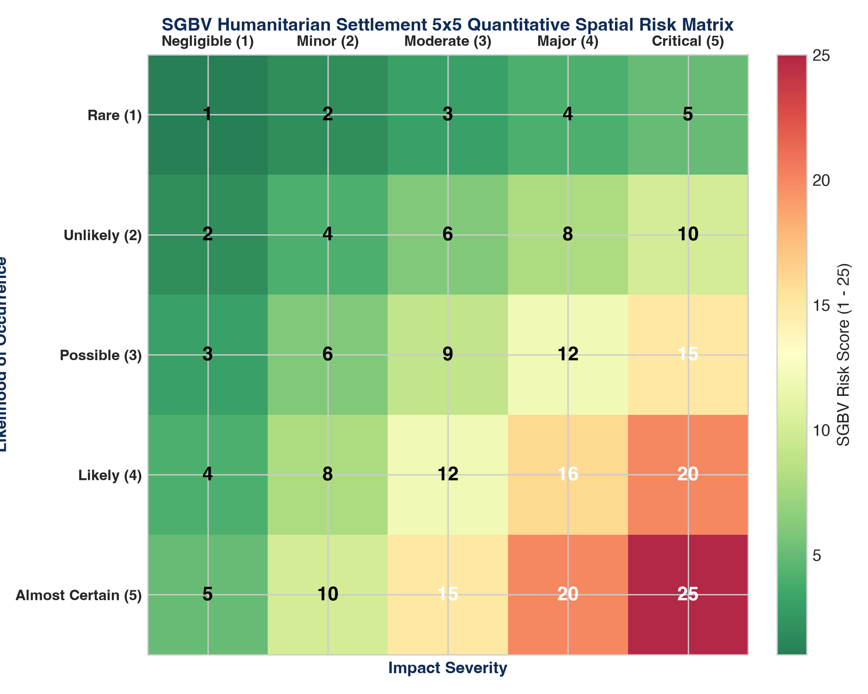
Figure 1: Quantitative Telemetry & Systems Indicator Model (FUSION-03: Holistic Child Safeguard...)
2. OPERATIONAL DIMENSIONS (5W + 1H FRAMEWORK)
Dimension | Operational Specification
WHAT | Multi-tier child protection, psychosocial rehabilitation, and offline digital education system.
WHY | Protects sheltered and displaced children from exploitation while bridging the acute digital knowledge divide.
WHO | Orphaned children, unaccompanied displaced minors, street-connected youth, and juvenile remand candidates.
WHERE | Public orphanages (Dar-ul-Aman), crisis relief camps, and juvenile justice observation centers nationwide.
WHEN | Continuous academic and psychosocial calendar with bi-monthly case management audits.
HOW | Air-gapped local computing hardware, non-biometric privacy schemas, and trauma-informed social caseworkers.

3. QUANTITATIVE RISK & MULTI-YEAR KPI MATRIX
Indicator / KPI | Baseline | Mid-Term (Yr 2) | Final Goal (Yr 5) | Verification Source
Unaccompanied Minors Traced / Safe Foster | <20% | >70% | >90% | UNICEF standardized child protection registers
Offline Digital Literacy Attainment | 0% | >65% Passing | >85% Certified | Practical offline lab challenge scorecards
Juvenile Adult Remand Diversion Rate | <15% | >60% | >85% | Juvenile Justice Committee (JJC) court orders
Psychosocial Trauma Recovery Index | Severe Baseline | Moderate-Mild | Resilient Adaptation | Validated pediatric clinical stress scoring
Zero Safeguarding / PSEA Violations | Unmonitored | 100% Zero-Tolerance | 100% Certified | Independent annual safeguarding audit
4. MULTI-SECTORAL STANDARD OPERATING PROCEDURES (SOPS)
- SOP-01: Free, Prior & Informed Community Consent (FPIC): Mandatory structured rural appraisals conducted in local vernaculars, engaging village elders and women's committees to guarantee community ownership.
- SOP-02: Zero-Tolerance Safeguarding & PSEA Enforcement: Immediate escalation protocols for Protection from Sexual Exploitation and Abuse (PSEA) adhering to Inter-Agency Standing Committee (IASC) global standards.
- SOP-03: Transparent Financial & Public Procurement Integrity: Dual-signoff disbursement protocols, competitive tendering conforming to Public Procurement Regulatory Authority (PPRA) rules, and on-site public financial notice boards.

