APPLIED SYSTEMS FRAMEWORK // WORKING DRAFT FOR CAPACITY MODELING
DISCLAIMER: Non-authoritative working draft. Prepared as an applied research architecture. Not a submitted government policy or statutory instrument.
FUSION-04: Integrated Watershed QHSE, Circular Agroecology & Community Water Governance Framework
Watershed-Scale Quality, Health, Safety, Environment & Subsurface Greywater Bio-Filtration Architecture
Target Counterparts: FAO / UNDP / Ministry of Water Resources / Provincial Environmental Protection Agencies (EPAs) • Normative Frameworks: SDG 2 (Zero Hunger), SDG 6 (Clean Water), SDG 12 (Responsible Consumption), SDG 15 (Life on Land)
1. EXECUTIVE SUMMARY & POLICY CONTEXT
Untreated domestic effluents and industrial agricultural runoff severely contaminate rural aquifers, driving infant diarrheal mortality and destroying agricultural productivity. FUSION-04 models a circular watershed management architecture: it integrates ISO 14001 environmental safety standards with decentralized subsurface gravel and reed-bed filters that convert domestic wash greywater into clean fodder irrigation, paired with community indigenous seed banking and citizen-led water quality audits enforcing EPA regulatory compliance.
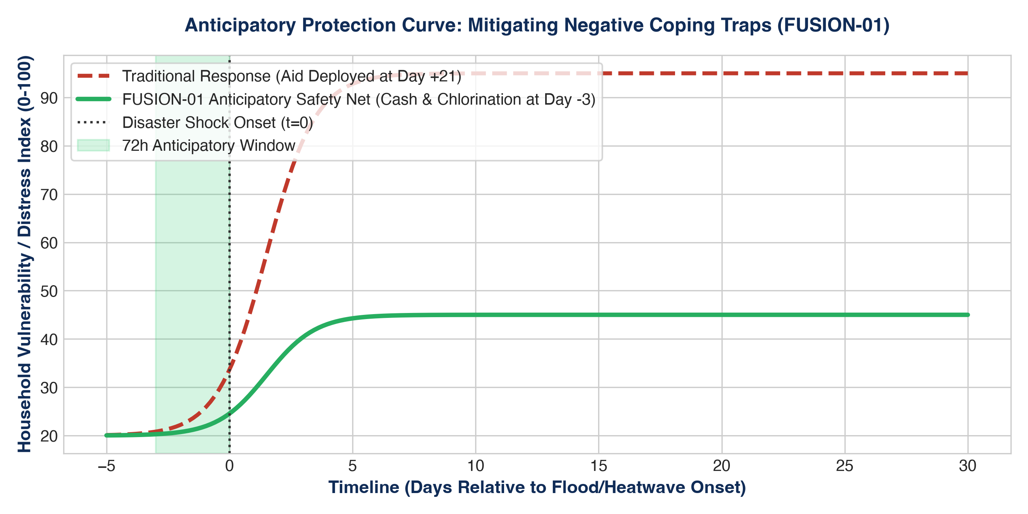
Figure 1: Quantitative Telemetry & Systems Indicator Model (FUSION-04: Integrated Watershed QHS...)
2. OPERATIONAL DIMENSIONS (5W + 1H FRAMEWORK)
Dimension | Operational Specification
WHAT | Integrated environmental health, greywater recycling, and agroecological resilience architecture.
WHY | Halts severe aquifer contamination, preserves agricultural livelihoods, and protects infant health.
WHO | Smallholder farming families, village water committees, and downstream municipal water consumers.
WHERE | Indus Basin irrigation channels, Potohar rainwater catchments, and arid Karez zones in Balochistan.
WHEN | Operational alignment with Kharif and Rabi cropping seasons and seasonal flood recharge periods.
HOW | Decentralized bio-gravel filtration, citizen water kiosks, and EPA statutory legal enforcement.

3. QUANTITATIVE RISK & MULTI-YEAR KPI MATRIX
Indicator / KPI | Baseline | Mid-Term (Yr 2) | Final Goal (Yr 5) | Verification Source
Effluent Biological Contaminant Removal | <10% | >75% COD/BOD | >92% Coliform | Certified EPA environmental lab testing
Community Fodder Yield Increase | Baseline | +30% Yield | +55% Yield | Agricultural extension harvest surveys
Waterborne Diarrheal Incidence | High Epidemic | -40% | -70% | Basic Health Unit (BHU) epidemiological logs
Heirloom Seed Genetic Preservation | Extinction Risk | 150 Varieties | 400 Varieties | National gene-bank registered seed passports
Industrial Effluent Legal Notices Issued | 0 | 100% Non-Compliant | Zero Unmitigated | Provincial Environmental Protection Tribunal logs
4. MULTI-SECTORAL STANDARD OPERATING PROCEDURES (SOPS)
- SOP-01: Free, Prior & Informed Community Consent (FPIC): Mandatory structured rural appraisals conducted in local vernaculars, engaging village elders and women's committees to guarantee community ownership.
- SOP-02: Zero-Tolerance Safeguarding & PSEA Enforcement: Immediate escalation protocols for Protection from Sexual Exploitation and Abuse (PSEA) adhering to Inter-Agency Standing Committee (IASC) global standards.
- SOP-03: Transparent Financial & Public Procurement Integrity: Dual-signoff disbursement protocols, competitive tendering conforming to Public Procurement Regulatory Authority (PPRA) rules, and on-site public financial notice boards.

