APPLIED SYSTEMS FRAMEWORK // WORKING DRAFT FOR CAPACITY MODELING
DISCLAIMER: Non-authoritative working draft. Prepared as an applied research architecture. Not a submitted government policy or statutory instrument.
FUSION-05: Master Civic Accountability, Public Expenditure Tracking & Pro-Poor Governance Architecture
Citizen-Led Public Procurement Audits, RTI Digital Toolkits & Under-Trial Prisoner Statutory Bail Monitoring
Target Counterparts: UNDP Democratic Governance / Transparency International Liaison / Federal & Provincial Ombudsmen • Normative Frameworks: SDG 16 (Peace, Justice & Strong Institutions), SDG 17 (Partnerships for the Goals)
1. EXECUTIVE SUMMARY & POLICY CONTEXT
This framework empowers citizens and civil society oversight coalitions to hold public institutions accountable through transparent data pipelines. It translates complex government budget 'Pink Books' into plain-language civic briefs, equips community paralegals with Right to Information (RTI) procurement audit kits to expose ghost projects, aggregates municipal service failures onto open-source accountability heatmaps, and tracks indigent under-trial prisoners eligible for statutory bail under criminal procedure rules.
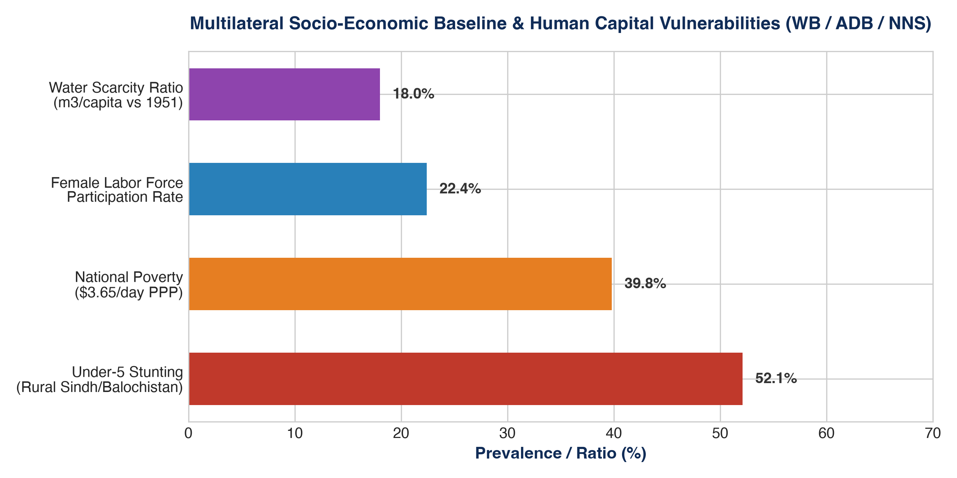
Figure 1: Quantitative Telemetry & Systems Indicator Model (FUSION-05: Master Civic Accountabil...)
2. OPERATIONAL DIMENSIONS (5W + 1H FRAMEWORK)
Dimension | Operational Specification
WHAT | Open-governance ecosystem combining budget transparency, citizen procurement audits, and judicial monitoring.
WHY | Eliminates development budget leakage and structural judicial delays that disproportionately harm indigent citizens.
WHO | Citizen watchdogs, community investigative researchers, marginalized litigants, and civil society coalitions.
WHERE | Municipal corporations, district courts, central prisons, and provincial government line departments.
WHEN | Annual budget review cycles and continuous monthly judicial oversight hearings.
HOW | Open-data budget parsers, statutory RTI filings, community social audits, and pro-bono bail defense.

3. QUANTITATIVE RISK & MULTI-YEAR KPI MATRIX
Indicator / KPI | Baseline | Mid-Term (Yr 2) | Final Goal (Yr 5) | Verification Source
RTI Procurement Petitions Resolved | <10% | >65% | >85% | Provincial Information Commission orders
Public Expenditure Leakage Intercepted | $0 Identified | >$4.5M Audited | >$18M Protected | Public Accounts Committee (PAC) evidence briefs
Indigent Under-Trial Prisoners Released | <5% | >45% Eligible | >80% Eligible | District & Sessions Court statutory bail dockets
Municipal Grievance Repair Compliance | <20% | >65% SLA Met | >85% SLA Met | Municipal line department digital work orders
Citizen Budget Literacy Engagement | <1,000 People | >50,000 Citizens | >250,000 Citizens | Civic portal downloads and radio reach logs
4. MULTI-SECTORAL STANDARD OPERATING PROCEDURES (SOPS)
- SOP-01: Free, Prior & Informed Community Consent (FPIC): Mandatory structured rural appraisals conducted in local vernaculars, engaging village elders and women's committees to guarantee community ownership.
- SOP-02: Zero-Tolerance Safeguarding & PSEA Enforcement: Immediate escalation protocols for Protection from Sexual Exploitation and Abuse (PSEA) adhering to Inter-Agency Standing Committee (IASC) global standards.
- SOP-03: Transparent Financial & Public Procurement Integrity: Dual-signoff disbursement protocols, competitive tendering conforming to Public Procurement Regulatory Authority (PPRA) rules, and on-site public financial notice boards.

