## General Ethos

The website will be simplistic, with the goal of communicating the information on it in a clear, attractive way, without too much visual clutter. Colours used will be attractive, and I am considering a dark red-blue theme. I will likely use my name as a sort of ‘logo’, with a picture of myself and a short paragraph about me in the home page.

## Site Map

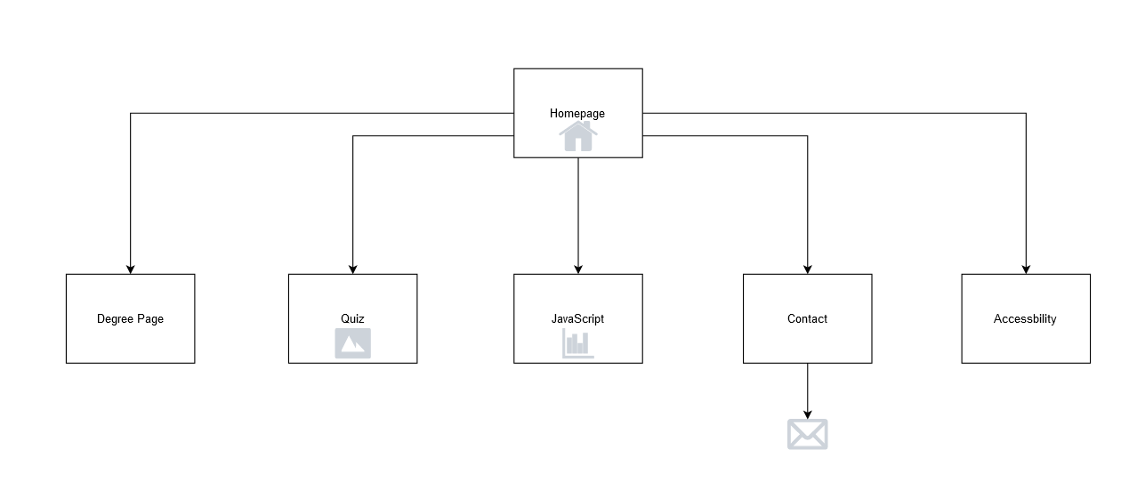

The website will begin on a Homepage, which contains a navigation bar to all the secondary pages, as well as a link to return to the homepage in the same navigation bar. Since the website consists of few webpages which are relatively simple, these pages can be interconnected via one navigation bar without cluttering the site. The contact page also contains a form to send an e-mail directed to my university e-mail. The Quiz page will contain an interactive quiz using images, and the JavaScript page will contain some charts to display data.

## Accessibility

Accessibility will be addressed through a few different methods. Firstly, it will be possible to navigate for people with disabilities who may not be able to use a mouse. This means that the keyboard, and specifically the tab key, will be sufficient to navigate through all the navigation links and the interactable content within the site. Since screen readers are sometimes used, the site will be able to be interpreted with a screen reader. This means that there will be properly labeled semantic elements and alternative text for when an image either cannot be loaded or must be read with a screen reader, and all these will be located next to each other when relevant (for example, captions next to their related images, and buttons close to their related action.) All text on the site will be logically formatted so that it is large enough to read for people with vision impairments, as well as having enough contrast with the background to make sure it is as clear as possible, using the proper contrast ratios of 4:5:1 for text and 3:1 for large text (Web Content Accessibility Guidelines 2.1, 2018).

## Legal issues

All content on the website, such as illustrations, graphs and other images will either be my own, or from online libraries where they are licensed as creative commons. Where some personal data, such as e-mail, will be required in order to contact me, it will be made clear what this data will be used for, and that it is not stored or used for any purposes other than to contact me via my e-mail if they so wish, as privacy laws would require one to do (Epsilis Web Design).

## Design Mock-ups

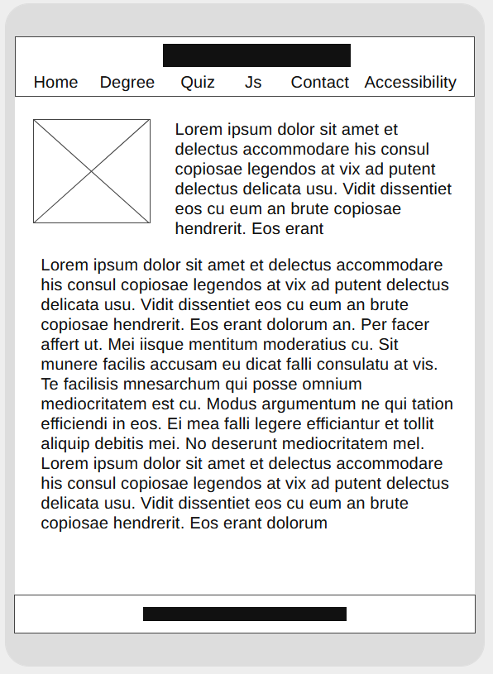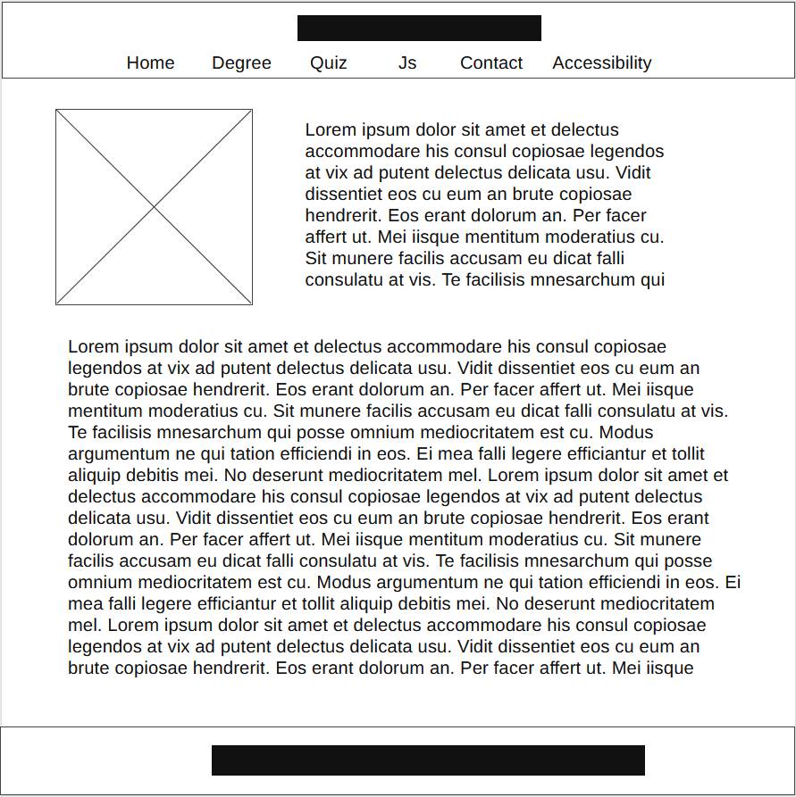

Mobile (home page)

Desktop (home page)

As the mock-up illustrates, content will scale appropriately to the user’s device size. I would be looking to use a mobile-first approach, as 94% of smartphone users use their phone to search for information, most of which still occur even when a desktop is available ( Google Developers, 2020). It is hard to prematurely gauge how many breakpoints and if any tweakpoints would be necessary, but one to to scale up to desktops be the minimum. One more may be required to accommodate for exceptionally small/thin screens or tablets.

## Menu System

The menu system I am planning on using is a simple navigation bar, located at the top of the site, with each link appropriately spaced so as to accommodate for touch screens. As Brad Frost and Erick Arbe explain, this method is called the ‘do-nothing’ approach, as very little is required to be changed other than sufficiently padding the links. This is the easiest and most time-efficient method to implement. Some issues, Brad Frost explains, are that this may end up with the links becoming misaligned on some screens, taking too much vertical height and distracting from the main content page. Since there are relatively few pages on the website, and no more will need to be added at a later date, I expect that there will be no such issue on most, if not all devices.

## Canvas and Javascript demo

The Canvas and Javascript pages will have to be accessible on mobile phones. Buttons will be laid out with proper padding, so they can be pressed on phones, and content will be suitably scaled to the screen size. There would have to be some text describing each picture and graph, either in-page or as an alt attribute, as is in accordance with the Web Content Accessibility Guidelines. I will be looking to visualize my time spent in 3 modules, using 3 types of charts. As the charts are conveying the same information, one description text will suffice in explaining their contents.

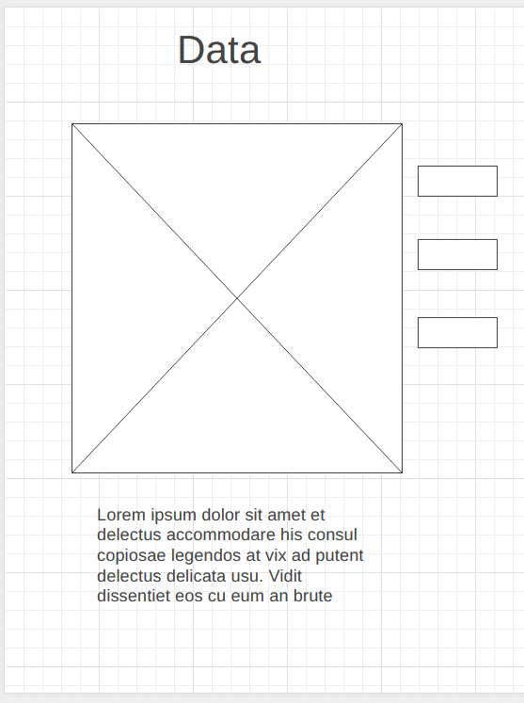

Example of a graph with text explaining the contents, and buttons for switching between.

## References

World Wide Web Consortium (2018), Web Content Accessibility Guidelines 2.1 [online]. W3C. [Viewed 13 November 2020]. Available from: <https://www.w3.org/TR/WCAG21/>

Epsilis Web Design (2020), Legal Issues for Websites [online]. Epsilis. [Viewed 13 November 2020]. Available from: <https://www.epsilis.co.uk/legal-issues-for-websites/>

Google Developers (2020), Mobile-friendliness: Overview [online]. [Viewed 16 November 2020] Available from: <https://developers.google.com/search/mobile-sites>