## Changes

Some parts of the design have changed. I have moved the navigation links for the ‘contact’ and ‘accessibility’ to the bottom of the page, as illustrated below. I found that this cleared up the top navigation bar from clutter, as these pages are not the centre point of the website and would keep it from looking too ‘squished’ on devices with small screen widths. While I had planned for the ‘logo’ of my name to be centralized, I went for a left-aligned approach, to not be too distracting. In addition, while I had originally planned to use darker colours, I lightened them up to the current ones so they are easier on the eye.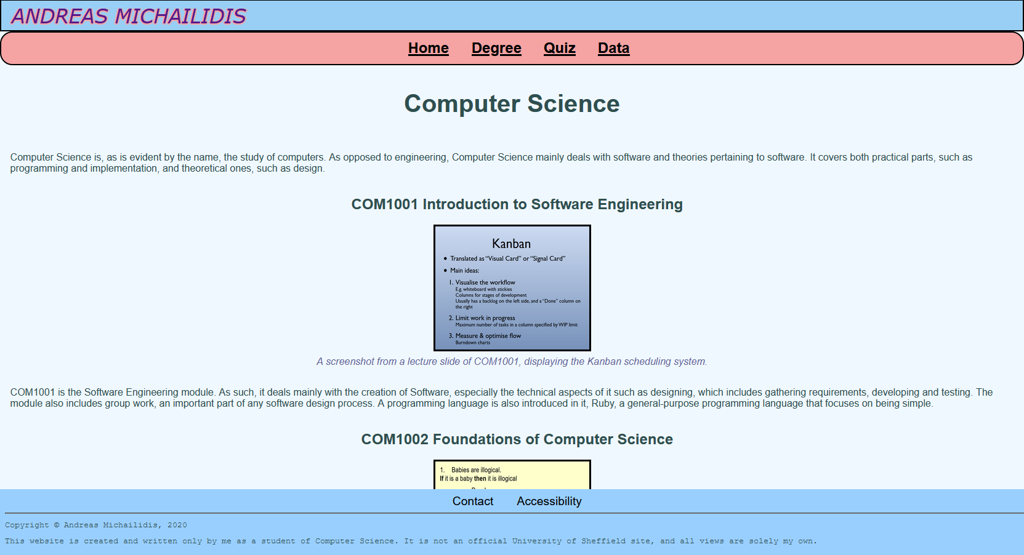

## Organisation

I organised the file structure by creating separate folders for the CSS, JavaScript and images that are used on the site, with all HTML in the main folder. This makes it easy to navigate each HTML file from within the folder itself. I used the Firefox developer tools for debugging. The menu has been organized with the four most important elements in a navigation bar at the top, with the two less important ones appearing in the footer at the bottom. I used JavaScript only for the Data Visualization page, where I used one function for each graph, all organised in one file.

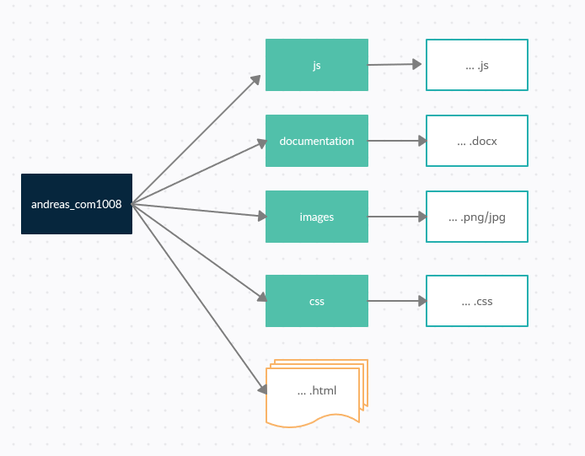

File organisation

## Optimisation

All images have a file size of under 100KB, ensuring they load in a timely manner. CSS and JS have been optimized so as to be small, so they do not lengthen the loading process. I have checked most screen sizes that are commonly used, and optimized images so they are as legible as possible on each size.

## Security

One security concern is the e-mail submission form in order to contact me. In this, it is stated how the data will only be used for purposes of contacting me and will not be stored. Since POST is being used to send this data, there is some protection from the e-mail address of the user being cached. (Twilio, 2017). The JavaScript on the site does not take any user input, so there is no risk of innerHTML being used for cross-site scripting. If this site were to be hosted, it would be advantageous to use HTTPS and SSL as to significantly increase the site’s security, since at the moment it is local, however, there is no need.

## Debugging

I used the HTML and CSS validators available at <https://validator.w3.org/> and <https://jigsaw.w3.org/css-validator/>, respectively. This was mostly used to catch mistakes such as HTML tags that were not closed, and missing closing brackets in CSS due to oversights during implementation. The Firefox developer tools assisted in debugging, for example, when CSS was mistyped, or conflicting with another CSS rule. A problem with the <div> and <span> tags was also caught in the quiz section, where the block element <div> was placed under an inline element <span>. This was fixed in the final version.

## Testing

I tested my website on three common browsers, Mozilla Firefox, Google Chrome and Microsoft Edge. Internet Explorer, while popular, is a discontinued product and is no longer supported. Using the Firefox developer tools, I was able to preview the website on different device resolutions, using its responsive design mode. This allowed me to view my website using several commonly used screen resolutions. I have checked that there are alternative texts for images, and followed several accessibility tests, such as high contrast mode and navigating without the mouse (Karl Groves, 2013). The website seemed to be fully navigable using only the keyboard, and while high contrast mode did result in some borders and one colour scale for the graph to be unviewable, no essential information was lost. Due to the nature of the pictorial quiz, it is difficult to not lose some information if the images are not available.

## References

Twilio (2017), Everything You Ever Wanted to Know About Secure HTML Forms [online]. [Viewed 14 December 2020] Available from: <https://www.twilio.com/blog/2017/09/everything-you-ever-wanted-to-know-about-secure.html-forms.html>

Karl Groves (2013), The 6 Simplest Web Accessibility Tests Anyone Can Do [online]. [Viewed 15 December 2020] Available from: <https://karlgroves.com/2013/09/05/the-6-simplest-web-accessibility-tests-anyone-can-do>