

**(Established under the Presidency University Act, 2013 of the Karnataka Act 41 of 2013)**

**DEPARTMENT OF COMPUTER SCIENCE AND ENGINEERING**

**LAB MANUAL**

**COURSE TITLE & CODE:** Programming in Python & CSE 317

**SEMESTER/YEAR**: VI/III

**COURSE CREDIT STRUCTURE:** 1- 0- 4-3

TABLE OF CONTENT

|  |  |
| --- | --- |
| **Sl. No.** | **Experiment Name** |
| 1 | OPERATORS AND EXPRESSIONS |
| 2 | CONTROL STRUCTURES |
| 3 | SELECTIVE AND REPETITIVE STRUCTURES |
| 4 | STRING |
| 5 | LIST PROCESSING |
| 6 | DICTIONARIES |
| 7 | FUNCTION |
| 8 | FILE AND EXCEPTION HANDLING |
| 9 | DATA VISUALIZATION |
| 10 | CLASSIFICATION AND CLUSTERING ALGORITHM |

**Ex: No. 1 OPERATORS AND EXPRESSIONS**

**Objective**

To create python application which solve the following basic problem using operator and expression.

**QUESTIONS**

1. Write a python program to swap two variables.
2. Write a program to input temperature in Centigrade and convert to Fahrenheit.

Temperature conversion formula from degree Celsius to Fahrenheit is given by.

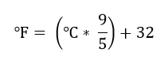

1. Write a program to input base and height of a triangle and find area of the given triangle.

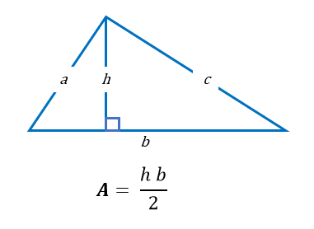

1. Write a Python Program to Convert Kilometers to Miles.
2. Write a program to input marks of five subjects of a student and calculate total and average of all subjects.
3. Write a program to generate a random number between 0 and 9.
4. Write a program read two integer numbers and performs arithmetic operations like addition, subtraction, multiplication, division, floor division, modulus and exponential(power) on them.
5. Write a python program to read characters from the keyboard and print the next characters on the screen.
6. Write a program to find the maximum of two numbers without using if-else and max predefined functions.
7. Write a program to find the minimum of two numbers without using if else and min predefined functions.
8. Write a python program to read number and find the absolute value without using abs () functions and if-else statement.
9. Write a python program to read two complex numbers from the users and perform the arithmetic operations.

**Ex: No. 2 CONTROL STRUCTURES**

**Objective**

To create python application which solve the real time problem using control structures.

**QUESTIONS**

1. VIT university follow the absolute grading system for the CSE program, to assign grades to students at the end of course. The program must do the following:

1. Ask for a student number.
2. Ask for the student’s tutorial mark.
3. Ask for the student’s test mark.
4. Calculate whether the student’s average so far is high enough for the student to be permitted to write the examination. If the average (mean) of the tutorial and test marks is lower than 40%, the student should automatically get an F grade, and the program should print the grade and exit without performing the following steps.
5. Ask for the student’s end term examination mark.
6. Calculate the student’s final mark. The tutorial and test marks should count for 25% of the final mark each, and the final examination should count for the remaining 50%.
7. Calculate and print the student’s grade, according to the following table:

| **Weighted final score** | **Final grade** |
| --- | --- |
| 80 <= mark <= 100 | A |
| 70 <= mark < 80 | B |
| 60 <= mark < 70 | C |
| 50 <= mark < 60 | D |
| mark < 50 | E |

2. An electricity board charges the following rates to domestic users to discourage consumption of energy. For the first 100 units – 60 Paisa per unit. For next 200 units - 80 paisa per unit. Beyond 300 units - 90 Paisa per unit. All users are charged a minimum of Rs. 50.00. If the total amount is more than Rs. 300 then an additional surcharge of 15% is added. Write a program to get the names of the users and the number of units consumed by the user and display the electricity bill for the users.

**3.** Library charges a fine for every book returned late. For first 5 days the fine is 50 paisa, for 6-10 days fine is one rupee and above 10 days fine is 5 rupees. If you return the book after 30 days your membership will be cancelled. Write a program to accept the number of days the member is late to return the book and display the fine or the appropriate message.

4. Consider the following assessment method and Course Completion Criteria used by programming in python lab based theory course conducted in Presidency University.

|  |  |  |  |
| --- | --- | --- | --- |
| **Sl.no** | **Assessment type** | **Marks** | **weightage** |
| **1** | Daily Experiment evaluations | 20 | 10% |
| **2.** | Continuous assessment-1 | 20 | 10% |
| **3** | Continuous assessment-2 | 20 | 10% |
| **4** | Mid term | 40 | 20% |
| **5** | Continuous assessment-3 | 10 | 5% |
| **6** | Continuous assessment-4 | 30 | 15% |
| **7** | End term Lab and Theory examination | 60 | 30% |

**Course Completion Criteria**

1. Minimum attendance is 75%. Otherwise “NP”. (not permitted to appear end term exam)
2. Minimum marks in continuous assessment: 40%. Otherwise “NE” (not eligible)
3. Minimum marks in end term practical and theory: 30%. Otherwise “F” grade.

The program must do the following:

Read student roll number, student’s attendance percentage, student’s assessment marks and check the student’s attendance percentage is less than 75%, print NP grade terminate program, otherwise calculate whether the student’s average so far is high enough for the student to be permitted to write the examination. If the average (mean) of all pre end term continuous assessment is lower than 40%, the student should automatically get an NE grade, and the program should print the grade and exit without performing the following steps. Ask for the student’s end term examination mark. Calculate the percentage and check if it is less than 30% percentage print F grade otherwise print Student is Pass.

**5.** Indian government tax the salaried citizen based on the following table.

Income tax slabs for resident Individual below 60 years of age

|  |  |
| --- | --- |
| Taxable income slabs | Income tax rates and cess |
| Up to Rs 2.5 lakh | Nil |
| Rs 2,50,001 to Rs 5,00,000 | 5% of (Total income minus Rs 2,50,000) |
| Rs 5,00,001 to Rs 10,00,000 | Rs 12,500 + 20% of (Total income minus Rs 5,00,000) |
| Rs 10,00,001 and above | Rs 1,12,500 + 30% of (Total income minus Rs 10,00,000) |

Income tax slabs for resident individual between 60 and 80 years of age (Senior Citizen)

|  |  |
| --- | --- |
| Taxable income slabs | Income tax rates and cess |
| Up to Rs 3 lakh | Nil |
| Rs 3,00,001 to Rs 5,00,000 | 5% of (Total income minus Rs 3,00,000) |
| Rs 5,00,001 to Rs 10,00,000 | Rs 10,000 + 20% of (Total income minus Rs 5,00,000) |
| Rs 10,00,001 and above | Rs 1,10,000 + 30% of (Total income minus Rs 10,00,000) |

Income tax slabs for resident individual above 80 years of age (Super Senior Citizen)

|  |  |
| --- | --- |
| Taxable income slabs | Income tax rates and cess |
| Up to Rs 5 lakh | Nil |
| Rs 5,00,001 to Rs 10,00,000 | 20% of (Total income minus Rs 5,00,000) |
| Rs 10,00,001 and above | Rs 1,00,000 + 30% of (Total income minus Rs 10,00,000) |

Write a program to read the name of citizen, age, salary and compute the income tax of citizen.

**Ex: No. 3 SELECTIVE AND REPETITIVE STRUCTURES**

**Objective**

To create python application which solve the following problem using selective and repetitive structures.

**QUESTIONS**

1. Develop Guess number that prompt user to enter a number. If the number is equal 99 print “congratulations”. If the number is less than 99 print enter again and aim higher else print enter again lower number. The program should print enter again a lower number. The program should run until the user guesses the correct the number that is 99.

2. Implement a simple calculator with a menu. Display the following options to the user, prompt for a selection, and carry out the requested action (e.g. prompt for two numbers and add them). After each operation, return the user to the menu. Exit the program when the user selects 0. If the user enters a number which is not in the menu, ignore the input and redisplay the menu. You can assume that the user will enter a valid integer:

-- Calculator Menu --

0. Quit

1. Add two numbers

2. Subtract two numbers

3. Multiply two numbers

4. Divide two numbers

3. Write a program to read number of row from the users and print following pattern as follows.

1. Square Star Pattern

*****

*****

*****

*****

*****

1. Right Triangle star pattern

*

**

***

****

*****

1. Mirrored Right Triangle Star Pattern

*

**

***

****

*****

1. Pyramid star pattern

*

***

*****

*******

*********

1. Half Diamond star pattern

*

**

***

****

*****

****

***

**

*

1. X Star Pattern

* *

* *

* *

* *

*

* *

* *

* *

* *

1. Diamond Star Pattern

*

***

*****

*******

*********

*******

*****

***

*

4. Write a program that reads an unspecified number of integers, determines how many positive and negative values have been read, and computes the total and average of the input values (not counting zeros). Your program ends with the input 0. Display the average as a floating-point number.

**Ex: No. 4 String**

**Objective**

To create python application which solve the problem using String.

1. Write a program that accepts a sentence and calculate the number of upper case letters and lower case letters. Suppose the following input is supplied to the program:

Hello world!

Then, the output should be:

UPPER CASE 1

LOWER CASE 9

2. Write a program that accepts a sentence and calculate the number of letters and digits. Suppose the following input is supplied to the program:

Hello world! 123

Then, the output should be:

LETTERS 10

DIGITS 3

3. Arrange String characters such that lowercase letters should come first. Given input String of combination of the lower and upper case arrange characters in such a way that all lowercase letters should come first.

Expected Output:

Input String: PyNaTive

Output_String: yaivePNT

4. Write a Python program to count repeated characters in a string.

Sample string: 'thequickbrownfoxjumpsoverthelazydog'

Expected output:

o 4

e 3

u 2

h 2

r 2

t 2

**5.** Write a program to find the first occurrence of word in a string.

Input

Input string: I love programming!

Input word to search: love

Output

'love' is found at index 2.

6. Write a C program to count frequency of each character in a string using loop. How to find frequency of each characters in a string in C programming. Logic to count frequency of each character in a given string in C program.

Input string: Codeforwin

Output

Frequency of all characters in the given string:

'c' = 1

'd' = 1

'e' = 1

'f' = 1

'i' = 1

'n' = 1

'o' = 2

'r' = 1

'w' = 1

7. Write a program to read any string from user and remove last occurrence of a given character from the string.

Input string: I love programming. I love Codeforwin.

Input character to remove: I

Output

String after removing last ‘I’: I love programming. love Codeforwin.

**Ex: No. 5 List Processing**

**Objective**

To create python application which solve the problem using list.

**QUESTIONS**

1.Create an empty list and read the BMI of ‘n’ people. Check each value and display the category as shown.

|  |  |
| --- | --- |
| **BMI** | **Category** |
| 0-18.5 | Underweight |
| 18.5 to 23 | Normal Range |
| 23-25 | Overweight |

1. Read the list of BMI

2. Compare each BMI, as per the BMI and category, display the list of BMI in each category

**INPUT and OUTPUT**

[16.5, 17, 20, 21, 25]

Underweight [16.5, 17]

Normal Range [20, 21]

Overweight [25]

2. Given a list of numbers, write a Python program to count Even and Odd numbers in a List.

Input: list1 = [2, 7, 5, 64, 14]

Output: Even = 3, odd = 2

Input: list2 = [12, 14, 95, 3]

Output: Even = 2, odd = 2

3. Write a program to print index at which particular value exists. If the value exists at multiple location in the list, then print all the indices. Also count the number of times that value is repeated in the list.

INPUT:

L1 0, 1,2,4,5,5,6,4

Enter the value to be searched: 4

OUTPUT:

4 found at location 3

4 found at location 7

4 appears 2 times in the list

4. Create an empty list to insert ‘n’ string values given by the user. Later, print all the elements of the list starting from some specific item from the list mentioned by the user. If the specified item is not found in the list, then print all the elements of the list.

OUTPUT:

Test Case 1:

L= ['bus', 'car', 'train', 'flight', 'boat']

Enter the list item to print from: car

['car', 'train', 'flight', 'boat']

Test Case 2:

Enter the list item to print from: bike

bike Not Found

['bus',”car”, 'train', 'flight', 'boat']

5. Write a program that computes the net amount of a bank account based a transaction log from console input (read the list of transaction from the users and compute the net amount). The transaction log format is shown as following:

D 100

W 200

D means deposit while W means withdrawal.

Suppose the following input is supplied to the program:

D 300

D 300

W 200

D 100

Then, the output should be:

500

6. Generates 100 lowercase letters randomly and assigns them to a list of characters, Named chars, as shown figure (a).



The chars list stores 100 characters, and the counts list stores 26 counts shown in the figure (b), each of which counts the occurrences of a letter. Write a python program to achieve the above operation.

Sample Input and Output:

The lowercase letters are:

e y l s r i b k j v j h a b z n w b t v

s c c k r d w a m p w v u n q a m p l o

a z g d e g f i n d x m z o u l o z j v

h w i w n t g x w c d o t x h y v z y z

q e a m f w p g u q t r e n n w f c r f

The occurrences of each letter are:

5 a 3 b 4 c 4 d 4 e 4 f 4 g 3 h 3 i 3 j

2 k 3 l 4 m 6 n 4 o 3 p 3 q 4 r 2 s 4 t

3 u 5 v 8 w 3 x 3 y 6 z

7. CIT College need the library automation application which should perform the following functionalities.

1. The following details must be there for each Book
   * 1. bookTitle
     2. bookAuthor
     3. bookNoOfCopies
     4. bookAvailability
     5. bookEdition
     6. bookPublisher
2. Add the Book details into library automation application
3. Update the Book details in library automation application
4. Display the Book list with all details in a proper and neat format.
5. Display the list of books of Ashok Nandev author

8. Given a list of integers with duplicate elements in it. The task to generate another list, which contains only the duplicate elements. In simple words, the new list should contain the elements which appear more than one.

Input: list = [10, 20, 30, 20, 20, 30, 40, 50, -20, 60, 60, -20, -20]

Output: output_list = [20, 30, -20, 60]

Input: list = [-1, 1, -1, 8]

Output: output_list = [-1]

**Ex: No. 6 Dictionary**

**Objective**

To create python application which solve the problem using dictionary.

**QUESTIONS**

1. Write python program to read name of the day and the corresponding temperature of days in a week and store it in dictionary. Find the temperature for any day of the week using a dictionary

**Input and Output:**

Enter the day: SUN

Enter the temperature: 31

Enter the day: MON

Enter the temperature: 27

Enter the day: TUE

Enter the temperature: 26

Enter the day: WED

Enter the temperature: 31

Enter the day: THUR

Enter the temperature: 25

Enter the day: FRI

Enter the temperature: 27

Enter the day: SAT

Enter the temperature: 31

Enter a day - SUN, MON, TUE, WED, THUR, FRI or SAT:

SUN

The temperature 31.0

2. Given an array of names of candidates in an election. A candidate name in array represents a vote casted to the candidate. Print the name of candidates received Max vote. If there is tie, print lexicographically smaller name.

**Examples:**

Input: votes = ["Raja", "Raja", "Elango",

"Elango", "Elango", "Elango",

"Elango", "john", "john",

"Alfred", "Raja", "Raja",

"Raja"];

Output: Elango

We have four Candidates with name as 'Raja',

'Elango', 'john', 'Alfred'. The candidates

Raja and Elango get maximum votes. Since Elango is alphabetically smaller, we print it.

3. Write a program performing the following tasks over the dictionary: phonebook= {’John’: "00903234561",’Mary’: "02359332865",’Bill’: "004934784530"}

1. return all names of the phonebook (use function keys(), i.e. tel.keys())
2. return all phone numbers of the phonebook (use function values())
3. return all names and phone numbers in tuples of type (name,tel) (use function items())
4. ask for an alphabetically sorted telephone book
5. ask for the phone number for Mary (you can access values by using dict[key])
6. add new entries in the phonebook (use the function update(key=value) and tel[key] = value)
7. delete an entry (you can use: del dict[key]))
8. check whether there is "John" on the phonebook (use: key in dict)

4. Given a sentence containing n words/strings. Remove all duplicates words/strings which are similar

to each other’s.

Input: Python is great and Java is also great

Output: Python is great and Java also

**5.** Write a function called wordcount () that accepts a list of strings returns a dictionary where the keys are the words and the values are the number of times that word appears.

**Input and Output:**

Enter the String Python is great and Java is also great

{'Python': 1, 'is': 2, 'great': 2, 'and': 1, 'Java': 1, 'also': 1}

6. Kannan stationery store saves the price details in the price dictionary details are as follwows.

PEN 10

NOTEBOOK 20

PENCIL 5

SCALE 10

STAPLER 40

ERASER 2

HIGHLIGHTER 15

Write a python program to solve the following task.

1. Read the list of items and the number of the item bought by the customer.

2. Compute the bill for the customer.

SAMPLE INPUT:

Enter the customer name:

Elango

Enter the list of item and number item bought by customers:

PEN 2, NOTEBOOK 4, STAPLER 2, HIGHLIGHTER 4

SAMPLE OUTPUT:

Name: Elango

Item Number of item Price

PEN 2 20

NOTEBOOK 4 80

STAPLER 2 80

HIGHLIGHTER 4 60

Total amount to be paid: 240

**Ex: No. 7 FUNCTIONS**

**Objective**

To create python application which solve the problem using function.

**QUESTIONS**

1. Suppose the Ganga retail store management wants to provide discount for all bill amounts as mentioned below. Assume bill amount will be always greater than 0.

**Regular Customer**

|  |  |
| --- | --- |
| **Bill Amount** | **Discount %** |
| >=1000 | 5 |
| >=500 and <1000 | 2 |
| >0 and <500 | 1 |

**New Customer**

|  |  |
| --- | --- |
| **Bill Amount** | **Discount %** |
| >=1000 | 3 |
| >=500 and <1000 | 1 |
| >0 and <500 | .5 |

Write a function which accept Bill amount and Type of customer and generate the Discount for the given customers.

2. Write a function called calculator. It should take the following parameters: two numbers, an arithmetic operation (which can be addition, subtraction, multiplication or division and is addition by default), and an output format (which can be integer or floating point, and is floating point by default). Division should be floating-point division.

The function should perform the requested operation on the two input numbers, and return a result.

3. Create dictionary users and store N users’ details such as user name and password. Write a function called acceptlogin (username, password) with two parameters. The function should return true if the user exists and the password is correct and false otherwise.

**Input and output:**

Enter the number of users: 2

Enter user name: raja

Enter user password: 123

Enter user name: Babu

Enter user password: 123

Enter the user name to check raja

Enter the password123

Correct

5. If a five-digit number is input through the keyboard, write a function to print a new number by adding one to each of its digits. For example if the number that is input is 12391 then the output should be displayed as 23402.

**Ex: No. 8 FILE AND EXCEPTION HANDLING**

**Objective**

To create python application which solve the problem using file and exception handling.

**QUESTIONS**

1. Write a python program to read a file of numbers, one in each line and perform the following task.

The count of numbers in the file.

The sum of the number in the file.

The smallest number in the file.

The largest numbers in the file.

2. Consider the inventory management system includes following details stock number, quantity, and price. Store the inventory details into output.txt file and handle appropriate exceptions for the following:

1. An error message, if the stock number is negative or higher than 999
2. The quantity, if it is less than 0
3. The price, if it is over $100.00

3. The Kannan Electronic store maintains the price details in the Price.txt file. Price.txt file contains three filed such as item name and company of item and price of the item.

**Price.txt**

SmartTV Samsung 30000

SmartTV Sony 80000

Mobile Samsung 10000

Mobile Nokia 12000

Laptop HP 50000

Laptop DEL 60000

Write a python program to solve the following task.

1. Read the list of items and company name of the items bought by the customer.

2. Compute the bill for the customer and write the bill detail into the Bill.txt file.

3. Generate the exception when the item is invalid. (Item that is not present in price.txt)

**SAMPLE INPUT:**

Enter the customer name:

Raja

Enter the list of item and type item bought by customers:

SmartTV Samsung, Mobile Nokia, Laptop HP

**SAMPLE OUTPUT:**

Bil.txt

Name: Raja

SmartTV Samsung: 30000

Mobile Nokia: 12000

Laptop HP: 50000

Total amount to be paid: 92000

4. HDFC bank keeps the transaction details in the Transcation.txt file. Transcation.txt file contains transaction details of the HDFC bank customers of the month. Transactions.txt file contains four filed such as customer id, customer name, transaction type (D means deposit while W means withdrawal), and transaction amount. Assume the balance amount of all accounts initially is zero.

**Transcation.txt**

101 Raja D 10000

102 Elango D 20000

107 John D 30000

109 Murugan D 40000

101 Raja W 2000

107 John D 40000

109 Murugan W 1000

Write a program that computes the balance amount of a bank account based on a transaction log from Transcation.txt and writes the balance amount of each customer into Balance.txt. The output should be written in the following format. Generate an exception when the transaction type is invalid.

**Balance.txt**

Accountno name balance amount

101 raja 8000

102 Elango 20000

107 John 70000

109 Murugan 39000

5. Write a python program to reverse the contents of an input.txt file and write it to the output.txt file and handle appropriate exceptions for the following.

i) Generate the exception if the file is not found (File Not Found Exception)

**Ex: No. 9 DATA VISUALIZATIONS**

**Objective**

To create python application which solve the problem using data visualization concepts.

**QUESTIONS**

1. Consider this given Data-set for which we will be plotting different charts: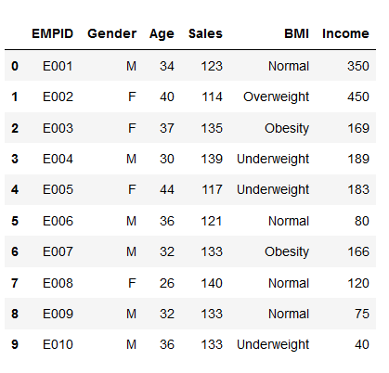

1. Plot the histogram for the income, age and sales.
2. Create the line graph between sales and income.
3. Create the bar graph for the male and female employee average income.

2. Write a Python program to draw line charts of the financial data of Alphabet Inc. between October 3, 2016 to October 7, 2016.    
Date,Open,High,Low,Close  
10-03-16,774.25,776.065002,769.5,772.559998  
10-04-16,776.030029,778.710022,772.890015,776.429993  
10-05-16,779.309998,782.070007,775.650024,776.469971  
10-06-16,779,780.47998,775.539978,776.859985  
10-07-16,779.659973,779.659973,770.75,775.080017  
The code snippet gives the output shown in the following screenshot:  
  
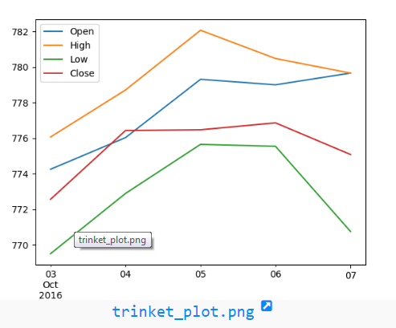

3. Write a Python programming to create a pie chart of the popularity of programming Languages.

Sample data:  
Programming languages: Java, Python, PHP, JavaScript, C#, C++  
Popularity: 22.2, 17.6, 8.8, 8, 7.7, 6.7  
  
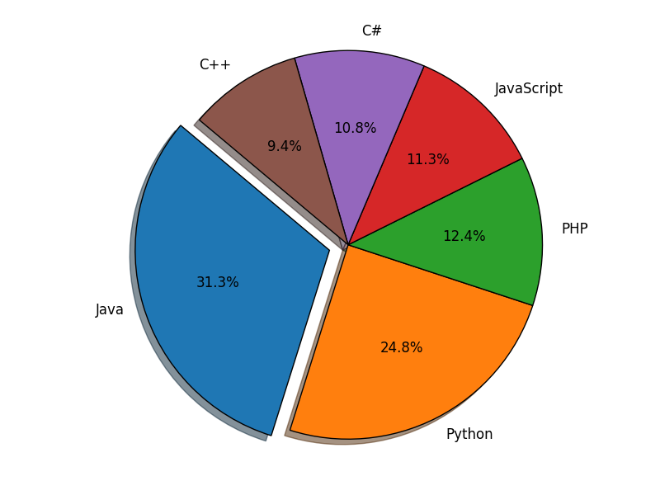

4. Write a Python programming to display a bar chart of the popularity of programming Languages.

Sample data:  
Programming languages: Java, Python, PHP, JavaScript, C#, C++  
Popularity: 22.2, 17.6, 8.8, 8, 7.7, 6.7  
The code snippet gives the output shown in the following screenshot:  
  
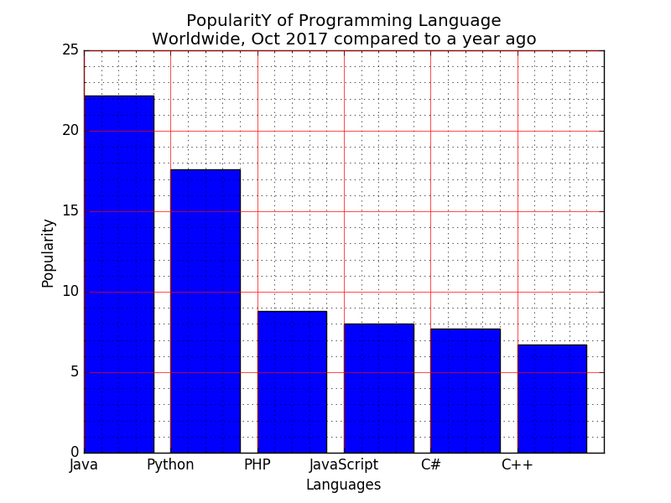

5. Write a Python program to create bar plot of scores by group and gender. Use multiple X values on the same chart for men and women.  
  
Sample Data:  
Means (men) = (22, 30, 35, 35, 26)  
Means (women) = (25, 32, 30, 35, 29)  
The code snippet gives the output shown in the following screenshot:  
  
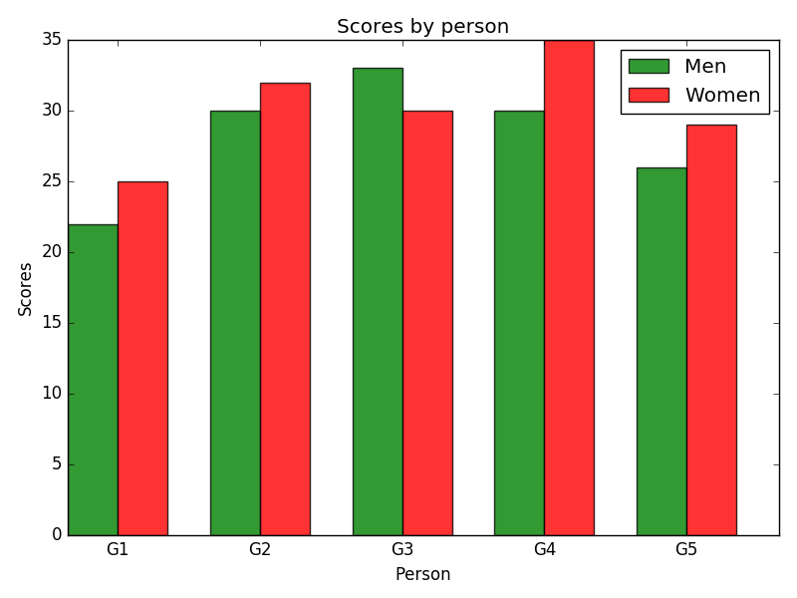

**Ex: No. 10 CLUSTERING AND CLASSIFICATION**

**Objective**

To create python application which solve the problem using data clustering and classification concepts.

**QUESTIONS**

1. Write a Python program using Scikit-learn to print the keys, number of rows-columns, feature names and the description of the Iris data.
2. Write a Python program using Scikit-learn to convert Species columns in a numerical column of the iris dataframe. To encode this data map convert each value to a number. e.g. Iris-setosa:0, Iris-versicolor:1, and Iris-virginica:2. Now print the iris dataset into 80% train data and 20% test data. Out of total 150 records, the training set will contain 120 records and the test set contains 30 of those records. Print both datasets.
3. Write a Python program using Scikit-learn to split the iris dataset into 70% train data and 30% test data. Out of total 150 records, the training set will contain 105 records and the test set contains 45 of those records. Predict the response for test dataset (SepalLengthCm, SepalWidthCm, PetalLengthCm, PetalWidthCm) using the Decision tree classification algorithm and print the accuracy of the model.
4. Write a Python program using Scikit-learn to split the iris dataset into 70% train data and 30% test data. Out of total 150 records, the training set will contain 105 records and the test set contains 45 of those records. Predict the response for test dataset (SepalLengthCm, SepalWidthCm, PetalLengthCm, PetalWidthCm) using the K Nearest Neighbor Algorithm and print the accuracy of the model. Use 5 as number of neighbors.
5. Write a Python program using Scikit-learn to train iris dataset using K-means algorithm and predict the performances of the model for the different k value.