End-Term Lab Examination

Sai Ram. K

20181CSE0621

25-05-2021

Allotted Questions - 20181CSE0621 Q.17&33

**Question No-17:** Write and execute a program to Blink 5 LEDs alternatively or Displaying 6 LEDs ODD and EVEN fashion.

**Question No-33:** Raspberry pi program to implement blinking LED.

**Q.17]**

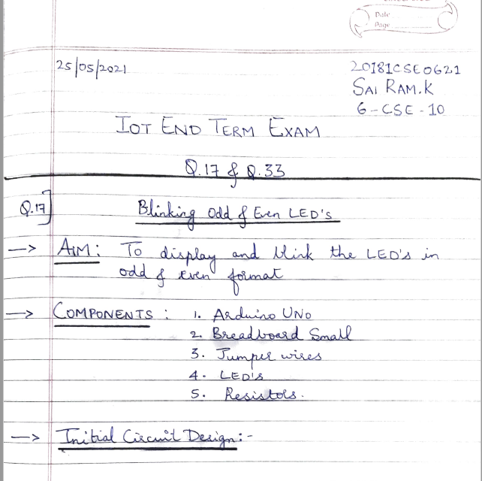

Initial Circuit Design: -

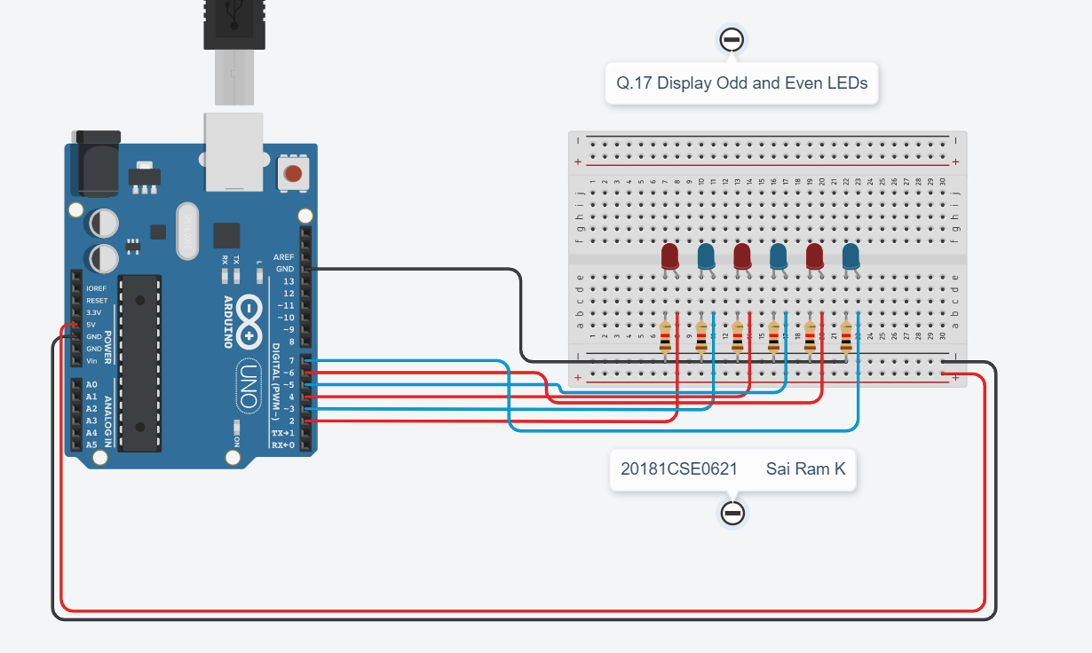

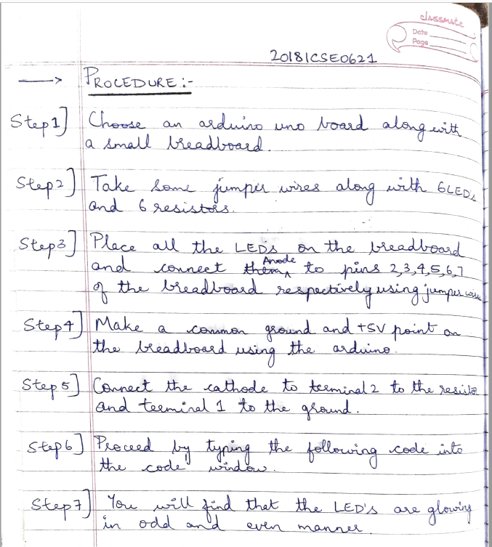

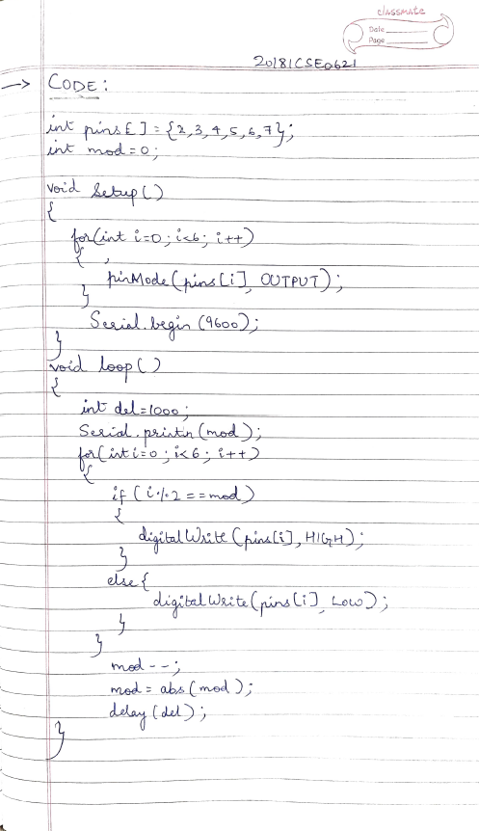

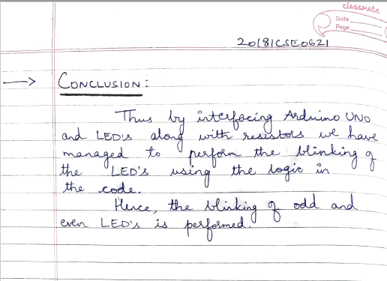

Output: -

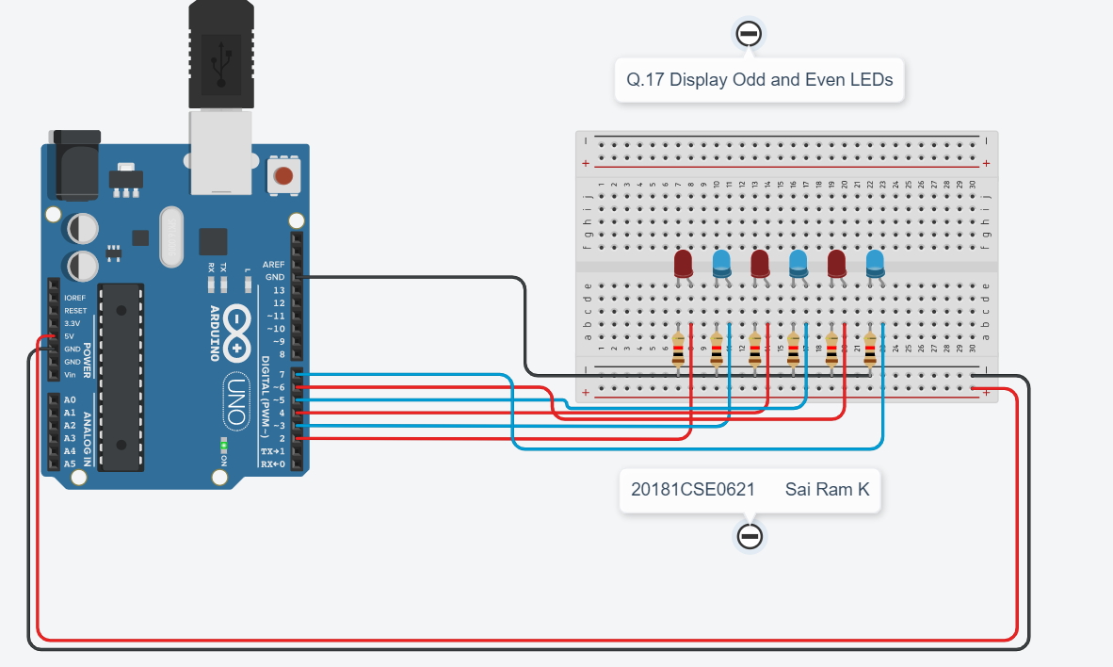

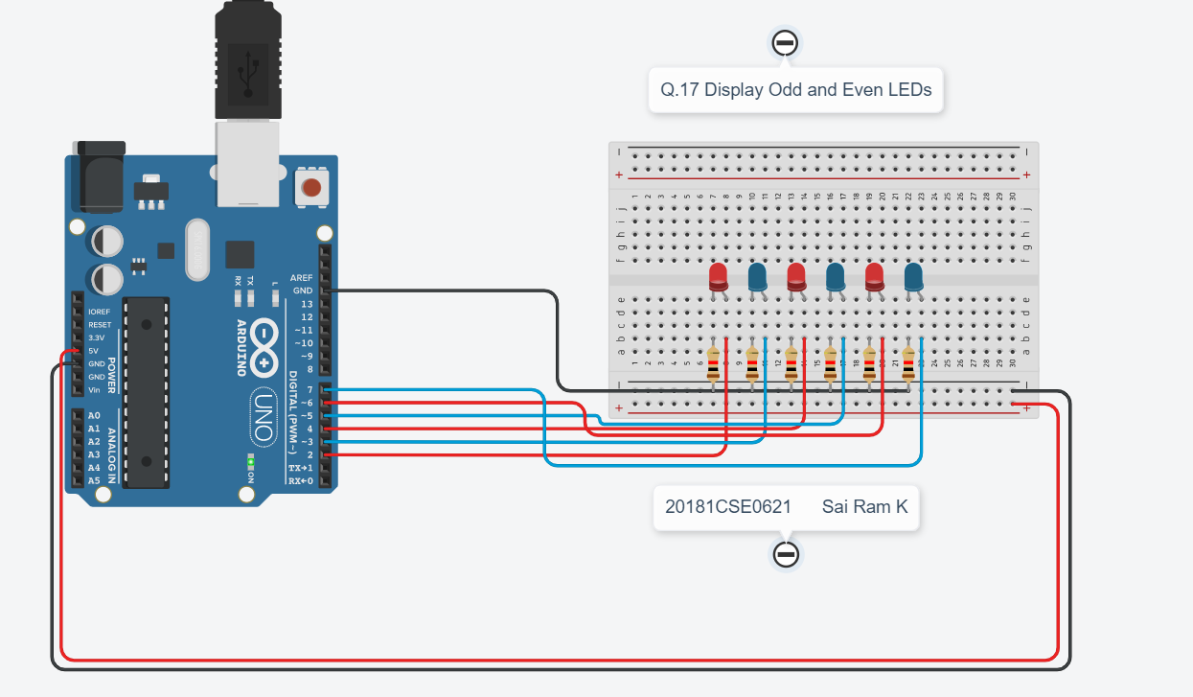

Serial Monitor: -

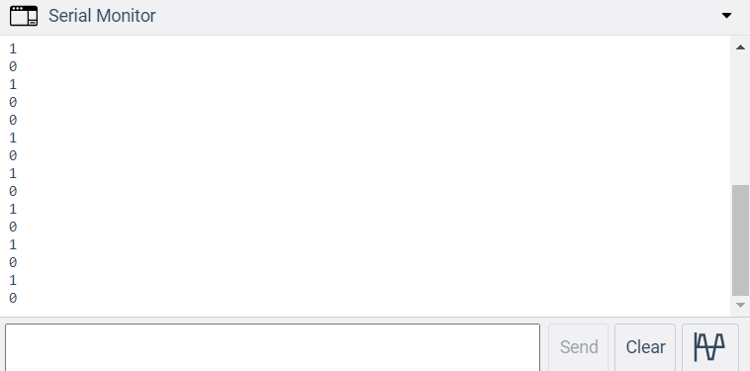

Q. 33] **Raspberry Pi Blinking Led**

