**Continuous Assessment – 1**

**20181CSE0621**

**Sai Ram. K**

**6 – CSE – 10 Set - C**

**Question :** Write a sketch to blink an 10 leds front to back and back to front and simulate using tinker cadd tool.

**Aim :** To blink 10 LEDs forward and backward and simulate using TinkerCad.

**Components Required :** Arduino, Bread board, 10 resistors, 10 LEDs and sufficient jumper wires.

**Initial Circuit Design :**

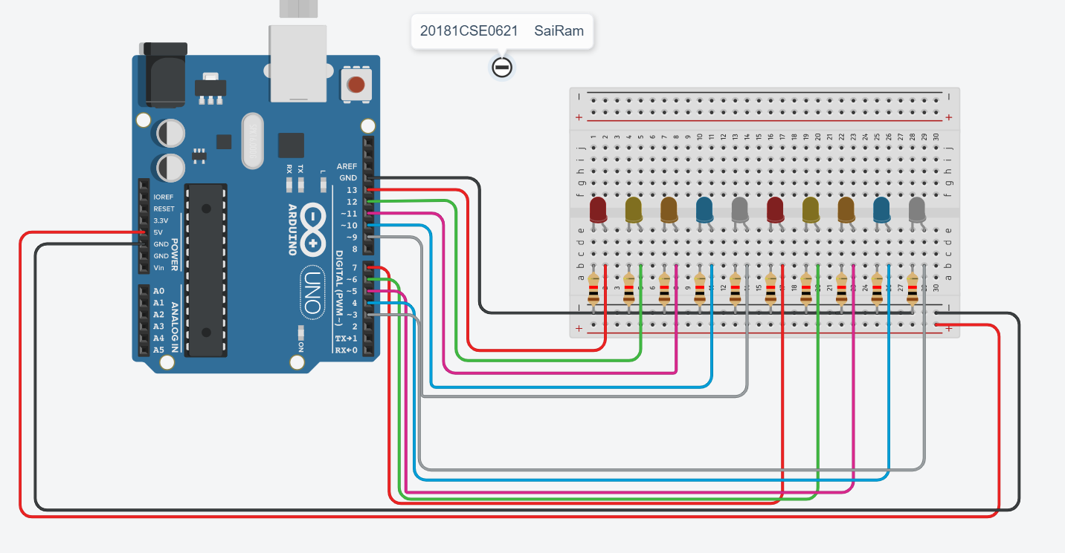

**Sketch :**

int pins[] = {13,12,11,10,9,7,6,5,4,3};

void setup()

{

for(int i=0;i<10;i++){

pinMode(pins[i], OUTPUT);

}

Serial.begin(9600);

}

void loop()

{

for(int i=0;i<10;i++)

{

digitalWrite(pins[i],HIGH);

delay(500);

digitalWrite(pins[i],LOW);

delay(1000);

}

Serial.println("Forward Blinking Completed....");

for(int i=10;i!=-1;i--)

{

digitalWrite(pins[i],HIGH);

delay(500);

digitalWrite(pins[i],LOW);

delay(1000);

}

Serial.println("Backward Blinking Completed....");

}

**Output Screenshots :**

**GIF :**



Forward Blinking :

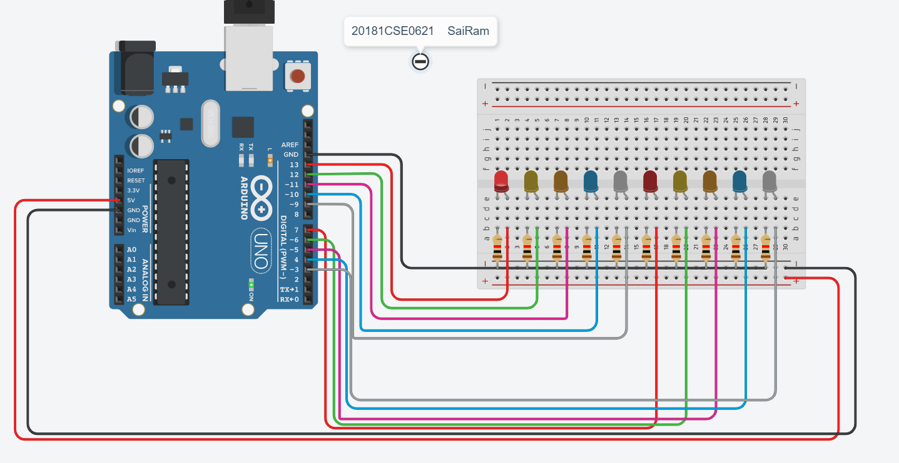

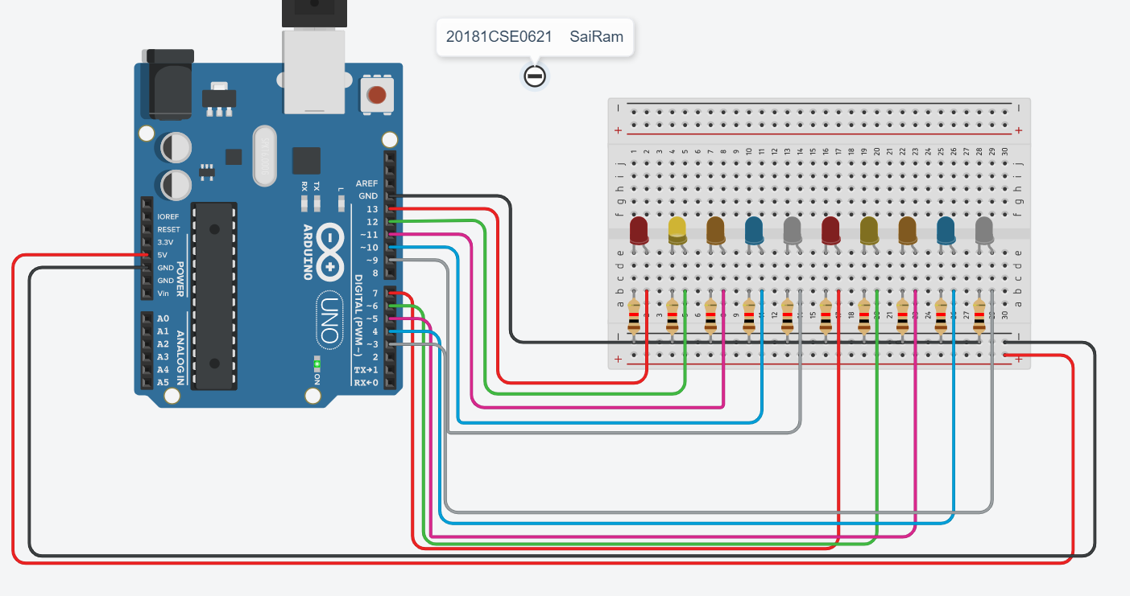

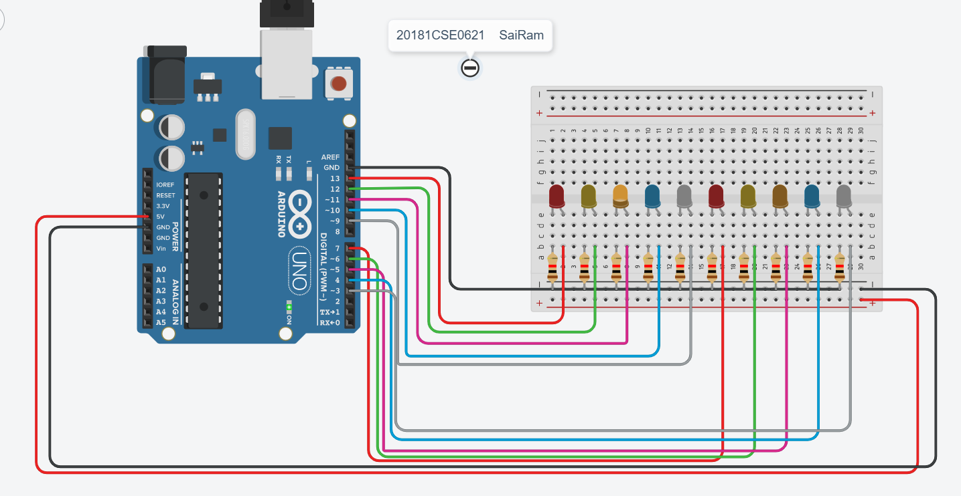

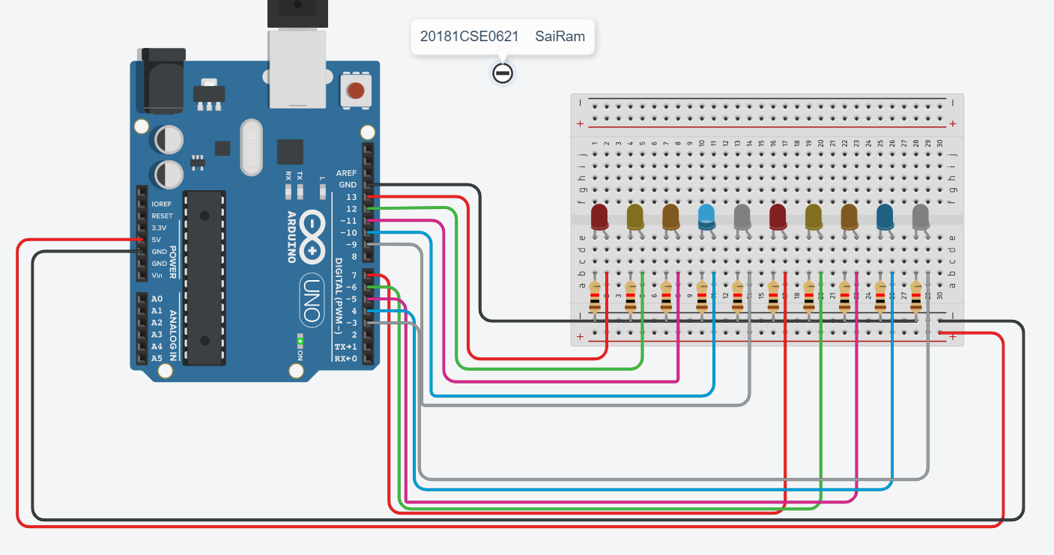

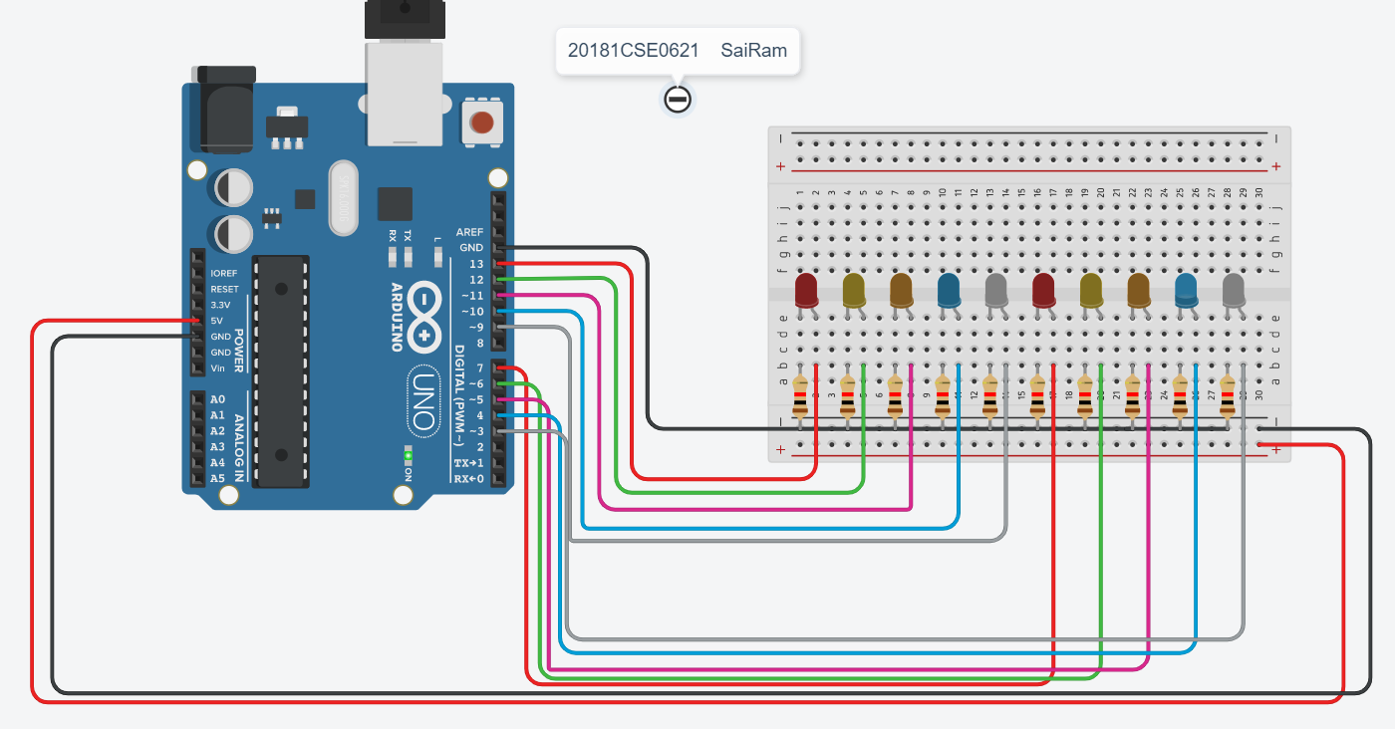

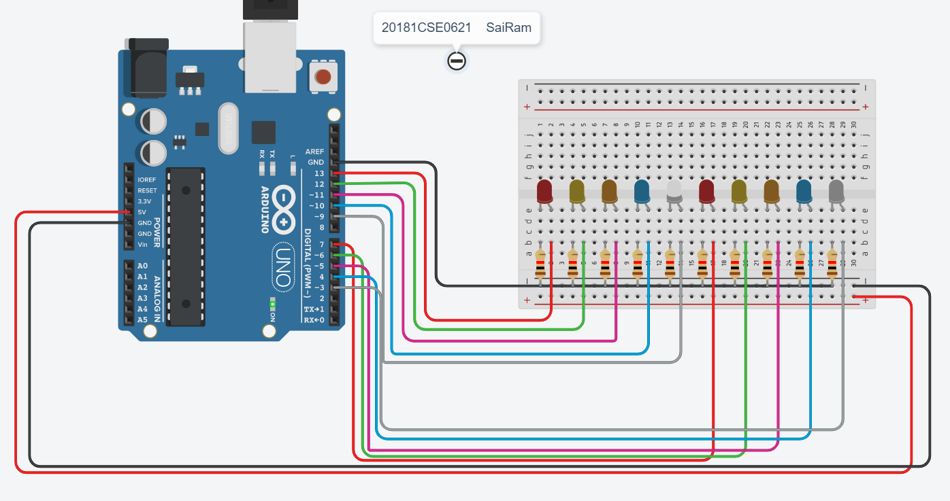

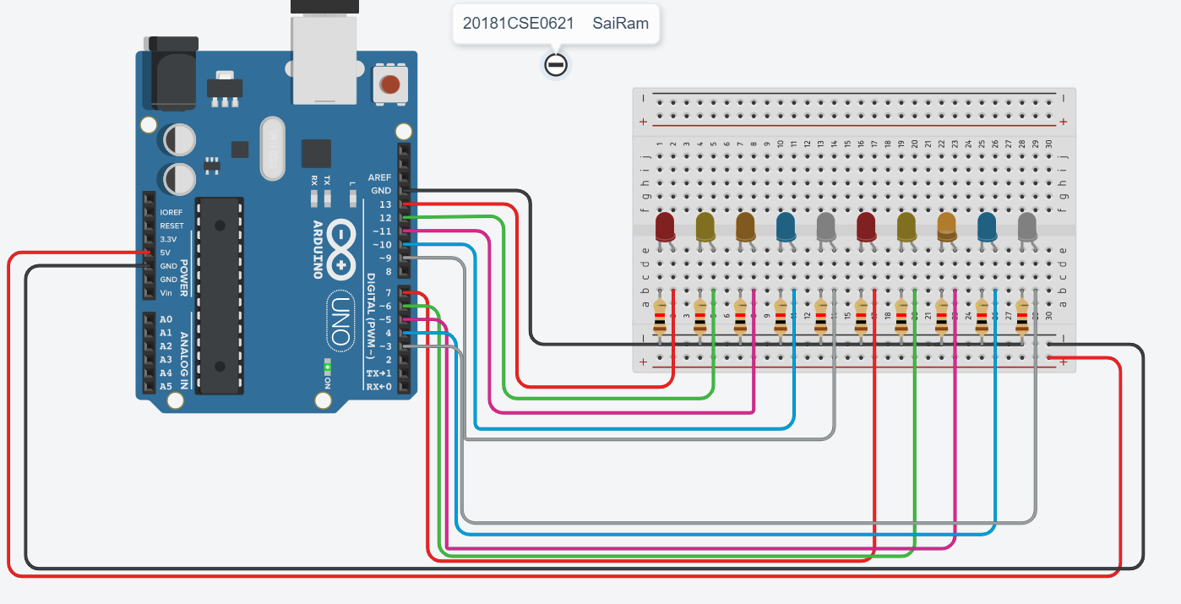

Backward Blinking :

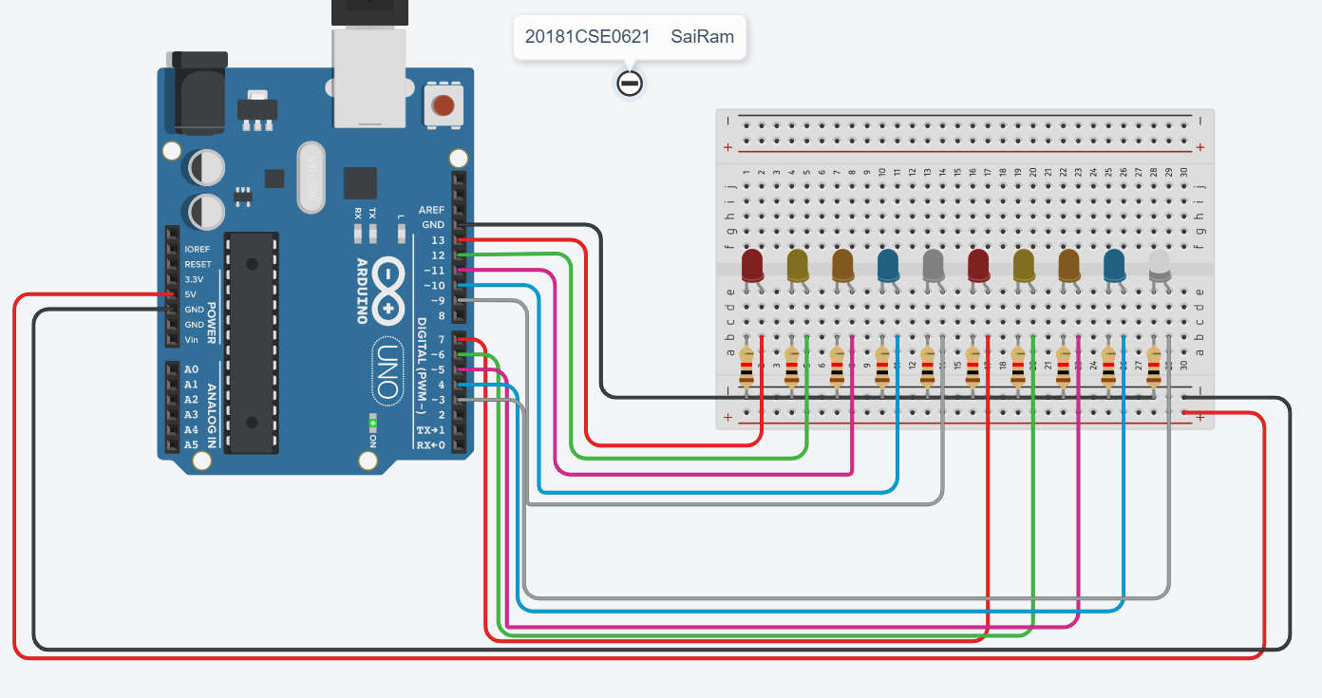

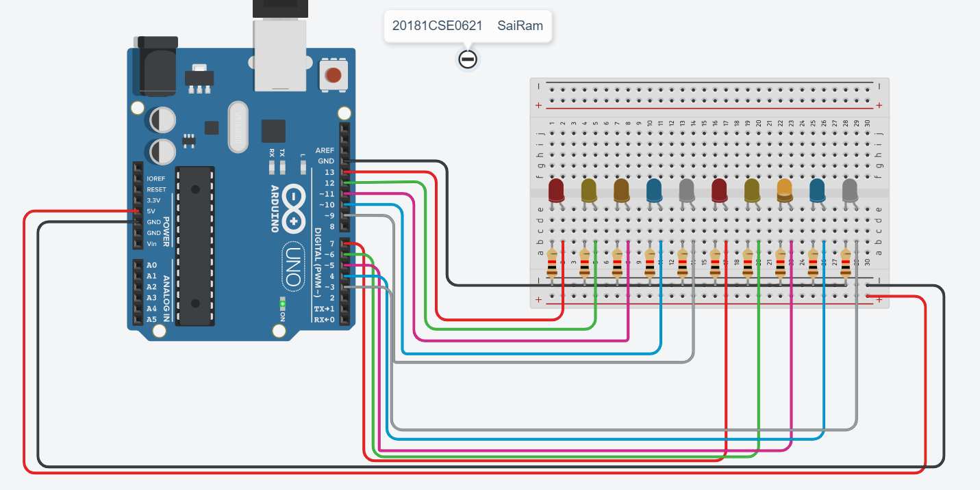



Serial Monitor Output :

