Continuous Assessment – 2

Set – C

Question : Interfacing of Arduino Uno with Ultrasonic Sensor. Write a program to measure the distance in inches and display it on the serial monitor.

**Aim :** To measure the distance of an object using Ultrasonic Sensor.

**Components Required:** Arduino uno, jumper wires, ultrasonic sensor, breadboard.

**Initial Circuit Design :**

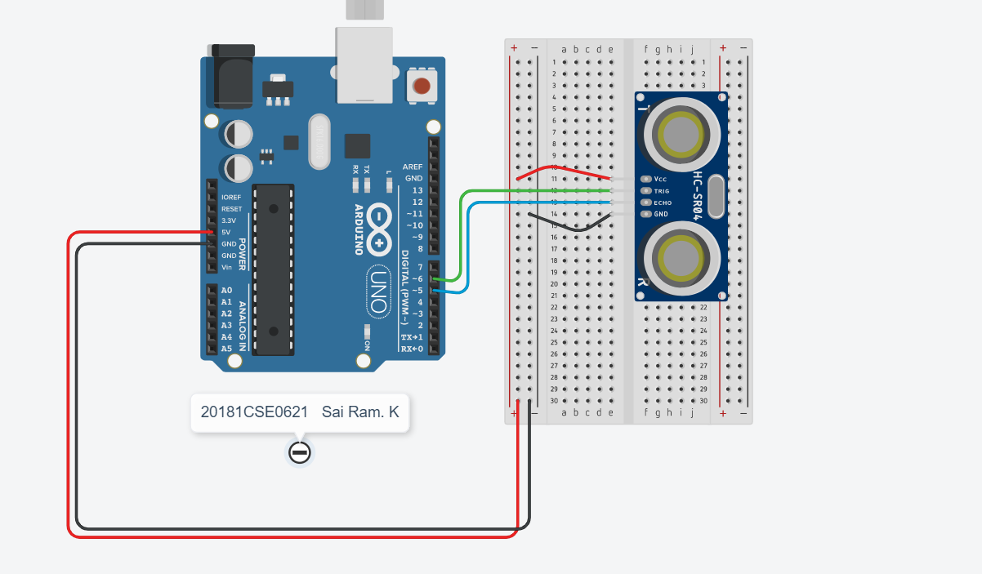

**Sketch [ Code ] :**

const int trig = 6; //trig pin connecttion

const int echo = 5; // echo pin connection

long duration;

int distance;

void setup()

{

pinMode(trig, OUTPUT);

pinMode(echo, INPUT);

Serial.begin(9600);

}

void loop()

{

digitalWrite(trig,LOW);

delayMicroseconds(2);

digitalWrite(trig, HIGH);

delayMicroseconds(10);

digitalWrite(trig,LOW);

duration = pulseIn(echo,HIGH);

distance = (duration/2)/29.41; // for distance in cm

distance*=0.393701; // converting cm to inches as 1cm = 0.33701 inches

Serial.print("Distance = ");

Serial.print(distance);

Serial.print(" inches");

Serial.println("");

}

**Output :**

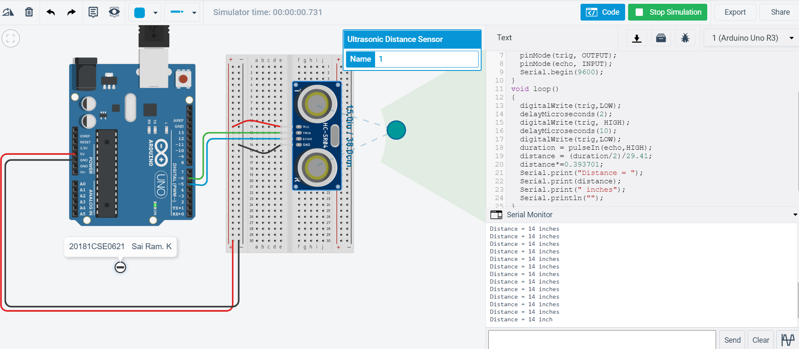

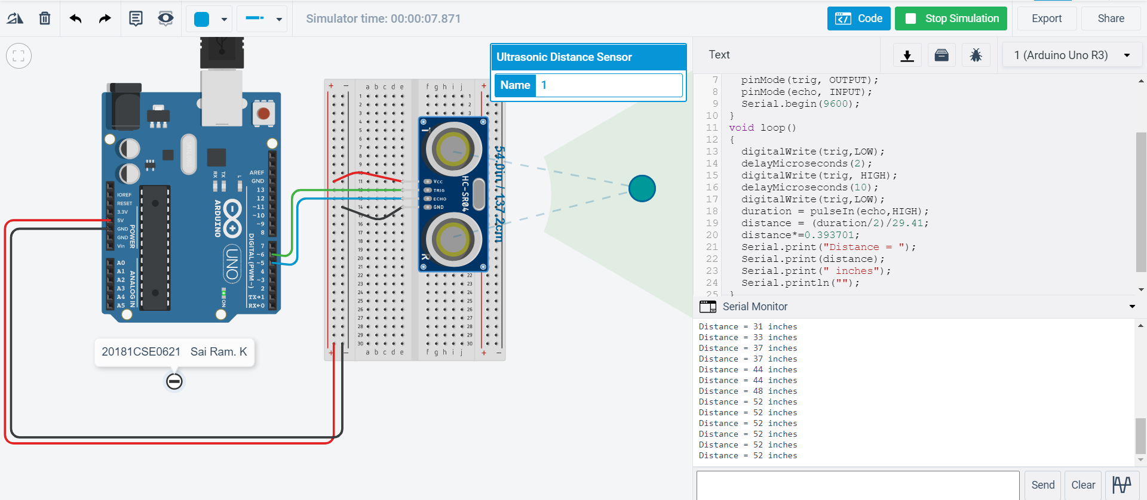

**Serial Monitor :**

