Set – C

Question 1 : Rotating a DC Motor using a push button to control the direction.

**Aim : To rotate a DC motor using a push button to control the direction.**

**Components Required :** Arduino, bread board, jumper wires, IC L293D.

**Initial Circuit Design :**

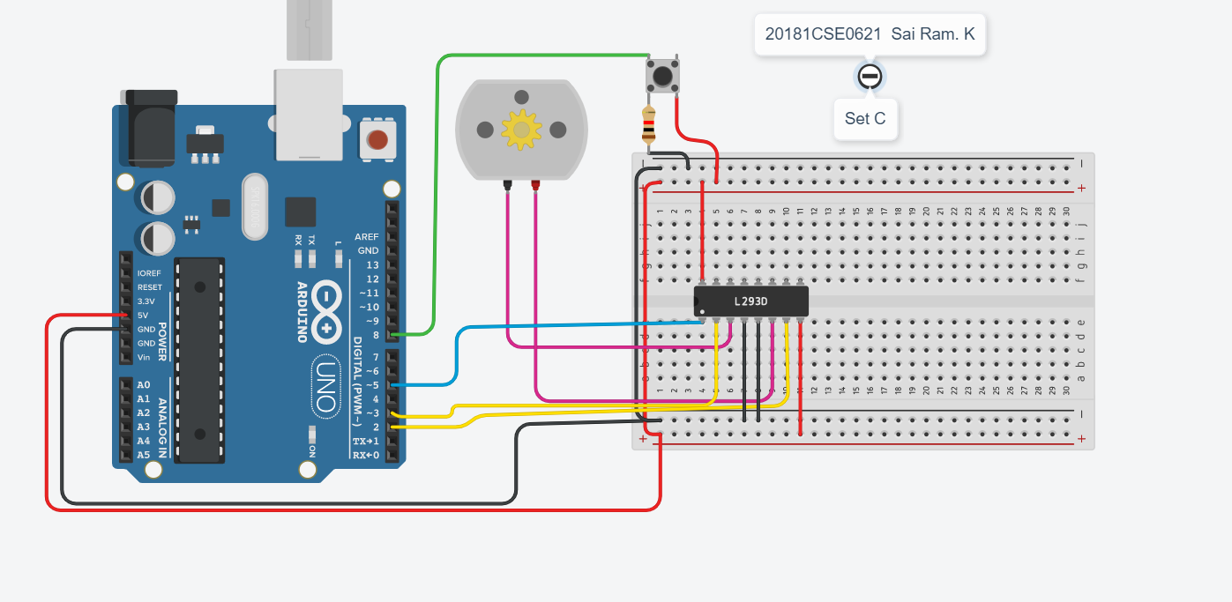

**Sketch :**

int enable=5;

int inp2=3;

int inp3=2;

void setup()

{

pinMode(5,OUTPUT);

pinMode(3,OUTPUT);

pinMode(2,OUTPUT);

Serial.begin(9600);

digitalWrite(enable,HIGH);

}

void loop()

{

if(digitalRead(8)==LOW)

{

digitalWrite(inp2,HIGH);

digitalWrite(inp3,LOW);

Serial.println("Clockwise");

delay(2000);

}

else if(digitalRead(8)==HIGH)

{

digitalWrite(inp2,LOW);

digitalWrite(inp3,HIGH);

Serial.println("Anti-Clockwise");

delay(2000);

}

**Output Screenshots :**

**Clockwise**

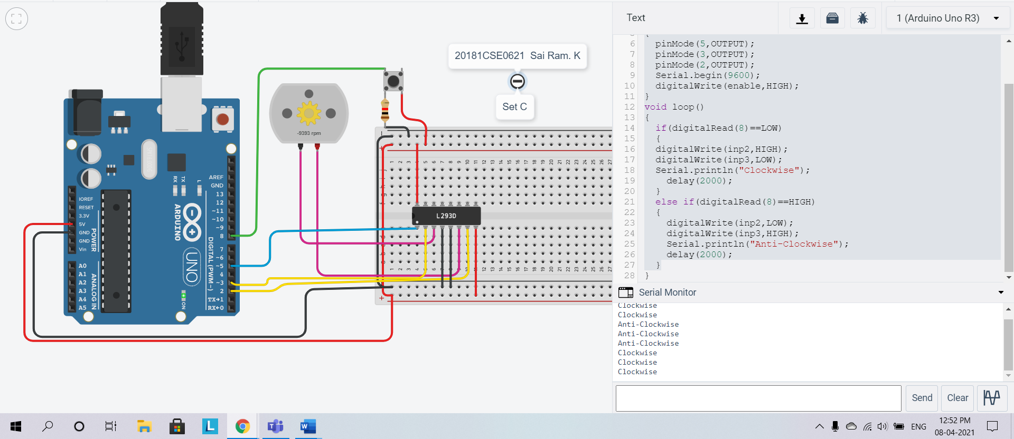

**Anti Clockwise :**

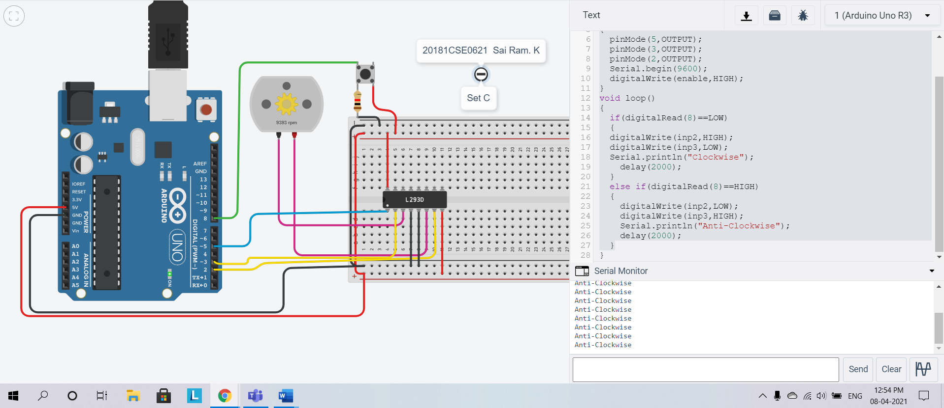

**Serial Monitor :**

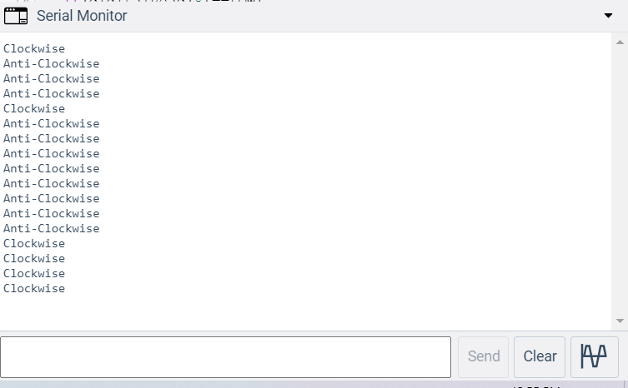

**Question 2 :** Write and execute a program to Scroll 5 LEDs.

Aim : To scroll 5 LED’s.

Components Required : Arduino uno, Breadboard, jumper wires, LEDs, resistors.

Initial Circuit Design :

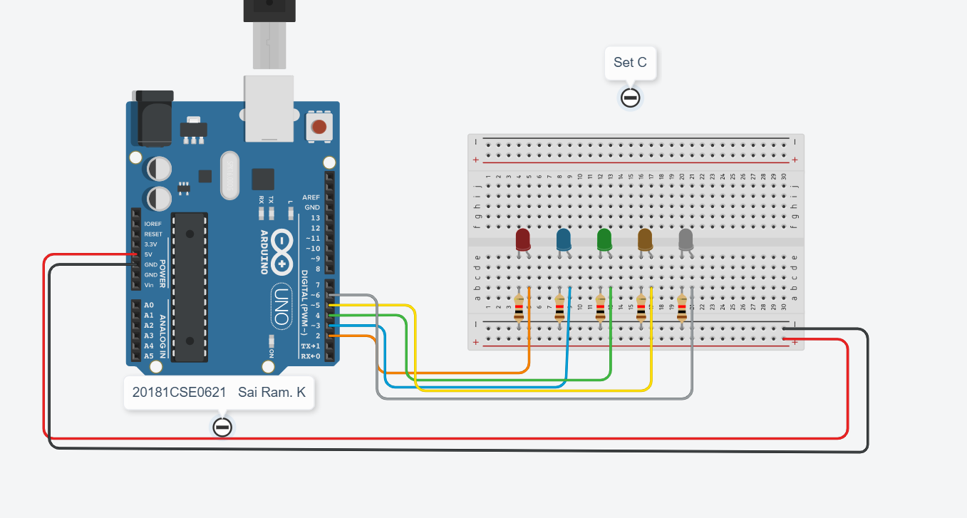

Sketch:

int Pins[]={2,3,4,5,6};

int timer=1000;

void setup()

{

for(int i=0;i<5;i++)

{

pinMode(Pins[i], OUTPUT);

}

Serial.begin(9600);

}

void loop()

{

for(int i=0;i<5;i++)

{

digitalWrite(Pins[i],HIGH);

delay(timer);

digitalWrite(Pins[i],LOW);

}

for(int i=4;i>=0;i--)

{

digitalWrite(Pins[i],HIGH);

delay(timer);

digitalWrite(Pins[i],LOW);

}

}

Output Screenshots :

