20181CSE0621

Sai Ram. K

**Set C**

**Question:**

Write a sketch to display a message “iot is future “ in lcd starting from the position 3rd column 1st row and simulate the same using tinker cad.

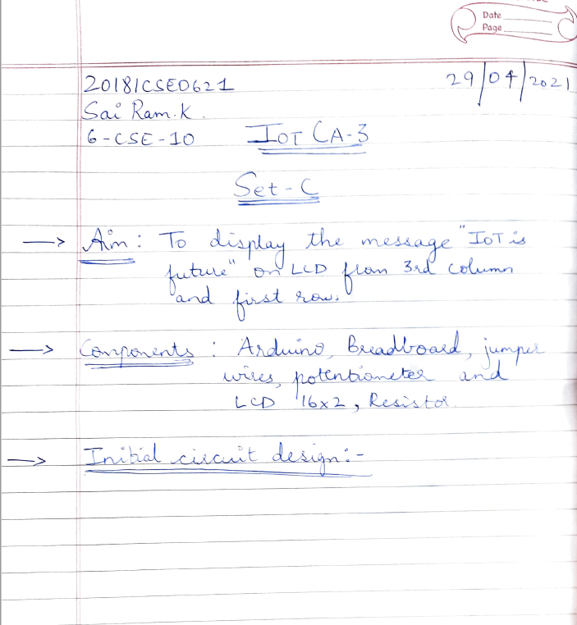

**Initial Circuit Design:**

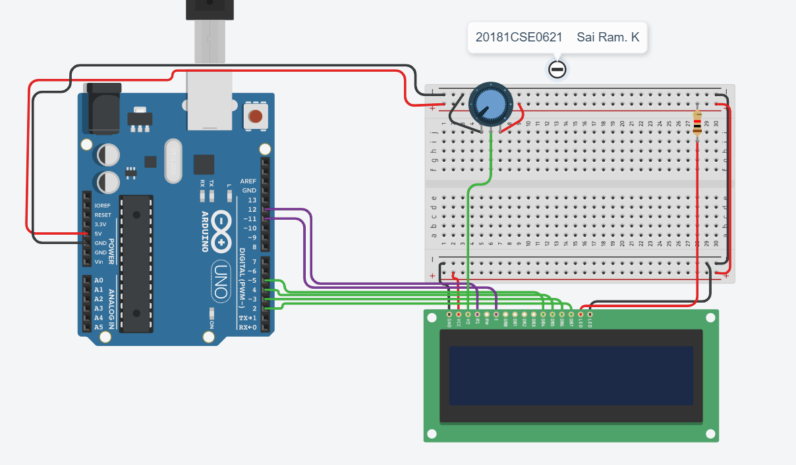

**Procedure:**

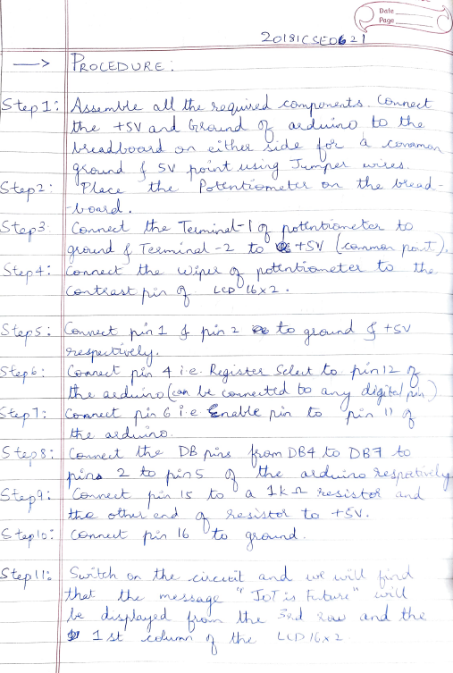

**Sketch:**

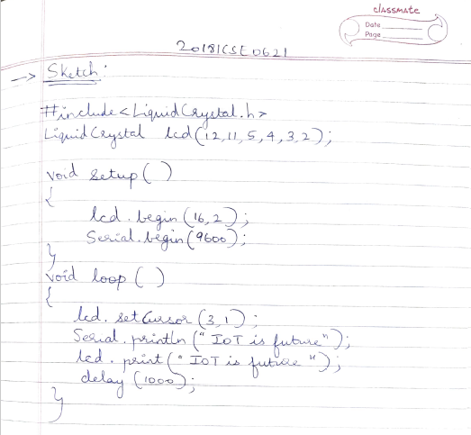

**Output:**

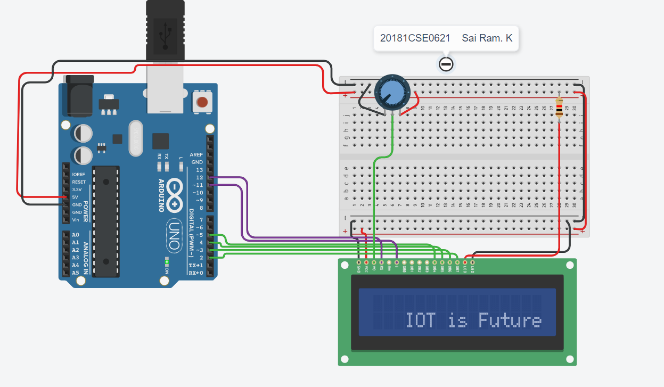

Serial monitor

