Lab – 1

Connecting LED & Glowing LED

**Question :** Write the code to blink an LED on Arduino Uno. Compile and verify the result on the serial monitor of Arduino IDE.

   Additional Programs:

1. To blink two LED’s alternatively
2. To blink odd and even leds
3. To scroll an LED’s

**Aim :** To Glow the LED post connecting the resistors and jumper wires.

**Components :** Arduino UNO, LED, Resistor**,**Tinkercad Simulator.

**Output Screenshots :**

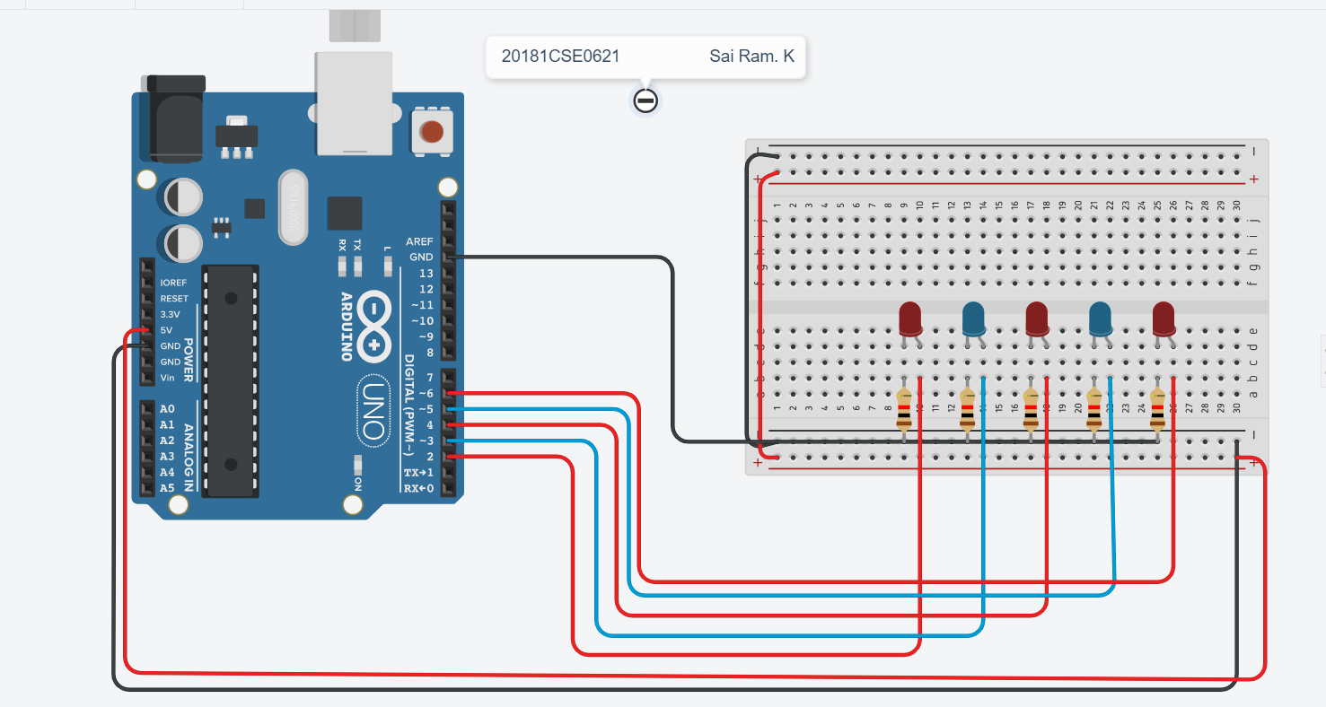

Code :-

void setup()

{

pinMode(13, OUTPUT);

Serial.begin(9600);

}

void loop()

{

digitalWrite(2, HIGH);

delay(500); // Wait for 1000 millisecond(s)

digitalWrite(2, LOW);

delay(500); // Wait for 1000 millisecond(s)

Serial.println("Red");

digitalWrite(3, HIGH);

delay(500); // Wait for 1000 millisecond(s)

digitalWrite(3, LOW);

delay(500); // Wait for 1000 millisecond(s)

Serial.println("Blue");

digitalWrite(4, HIGH);

delay(500); // Wait for 1000 millisecond(s)

digitalWrite(4, LOW);

delay(500); // Wait for 1000 millisecond(s)

Serial.println("Red");

digitalWrite(5, HIGH);

delay(500); // Wait for 1000 millisecond(s)

digitalWrite(5, LOW);

delay(500); // Wait for 1000 millisecond(s)

Serial.println("Blue");

digitalWrite(6, HIGH);

delay(500); // Wait for 1000 millisecond(s)

digitalWrite(6, LOW);

delay(500); // Wait for 1000 millisecond(s)

Serial.println("Red");

Serial.println("Printing In Reverse :- ");

//Reverse

digitalWrite(6, HIGH);

delay(500); // Wait for 1000 millisecond(s)

digitalWrite(6, LOW);

delay(500); // Wait for 1000 millisecond(s)

Serial.println("Rev Red");

digitalWrite(5, HIGH);

delay(500); // Wait for 1000 millisecond(s)

digitalWrite(5, LOW);

delay(500); // Wait for 1000 millisecond(s)

Serial.println("Rev Blue");

digitalWrite(4, HIGH);

delay(500); // Wait for 1000 millisecond(s)

digitalWrite(4, LOW);

delay(500); // Wait for 1000 millisecond(s)

Serial.println("Rev Red");

digitalWrite(3, HIGH);

delay(500); // Wait for 1000 millisecond(s)

digitalWrite(3, LOW);

delay(500); // Wait for 1000 millisecond(s)

Serial.println("Rev Blue");

digitalWrite(2, HIGH);

delay(500); // Wait for 1000 millisecond(s)

digitalWrite(2, LOW);

delay(500); // Wait for 1000 millisecond(s)

Serial.println("Rev Red");

Serial.println("Finished....");

}

B ] Scrolling an led

Output :

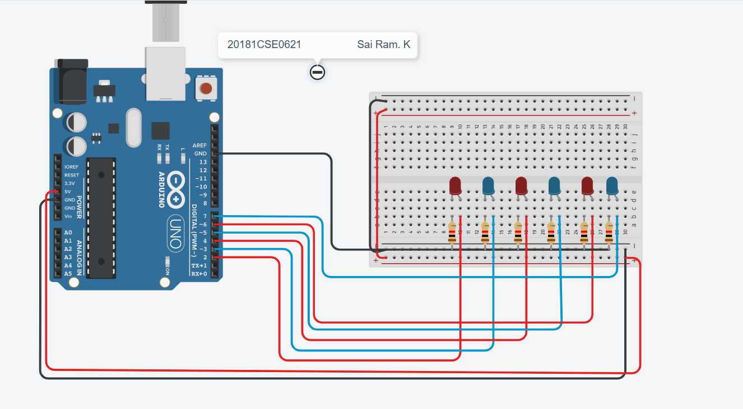

Code :

void setup()

{

pinMode(13, OUTPUT);

Serial.begin(9600);

}

void loop()

{

digitalWrite(2, HIGH);

delay(200); // Wait for 1000 millisecond(s)

digitalWrite(2, LOW);

delay(200); // Wait for 1000 millisecond(s)

Serial.println("Red");

digitalWrite(3, HIGH);

delay(200); // Wait for 1000 millisecond(s)

digitalWrite(3, LOW);

delay(200); // Wait for 1000 millisecond(s)

Serial.println("Blue");

digitalWrite(4, HIGH);

delay(200); // Wait for 1000 millisecond(s)

digitalWrite(4, LOW);

delay(200); // Wait for 1000 millisecond(s)

Serial.println("Red");

digitalWrite(5, HIGH);

delay(200); // Wait for 1000 millisecond(s)

digitalWrite(5, LOW);

delay(200); // Wait for 1000 millisecond(s)

Serial.println("Blue");

digitalWrite(6, HIGH);

delay(200); // Wait for 1000 millisecond(s)

digitalWrite(6, LOW);

delay(200); // Wait for 1000 millisecond(s)

Serial.println("Red");

Serial.println("Printing In Reverse :- ");

digitalWrite(7, HIGH);

delay(200); // Wait for 1000 millisecond(s)

digitalWrite(7, LOW);

delay(200); // Wait for 1000 millisecond(s)

Serial.println("Blue");

Serial.println("Printing In Reverse :- ");

//Reverse

Serial.println("Printing In Reverse :- ");

digitalWrite(7, HIGH);

delay(200); // Wait for 1000 millisecond(s)

digitalWrite(7, LOW);

delay(200); // Wait for 1000 millisecond(s)

Serial.println("Rev Blue");

digitalWrite(6, HIGH);

delay(200); // Wait for 1000 millisecond(s)

digitalWrite(6, LOW);

delay(200); // Wait for 1000 millisecond(s)

Serial.println("Rev Red");

digitalWrite(5, HIGH);

delay(200); // Wait for 1000 millisecond(s)

digitalWrite(5, LOW);

delay(200); // Wait for 1000 millisecond(s)

Serial.println("Rev Blue");

digitalWrite(4, HIGH);

delay(200); // Wait for 1000 millisecond(s)

digitalWrite(4, LOW);

delay(200); // Wait for 1000 millisecond(s)

Serial.println("Rev Red");

digitalWrite(3, HIGH);

delay(200); // Wait for 1000 millisecond(s)

digitalWrite(3, LOW);

delay(200); // Wait for 1000 millisecond(s)

Serial.println("Rev Blue");

digitalWrite(2, HIGH);

delay(200); // Wait for 1000 millisecond(s)

digitalWrite(2, LOW);

delay(200); // Wait for 1000 millisecond(s)

Serial.println("Rev Red");

Serial.println("Finished....");

}

C ] Even and Odd

Output :

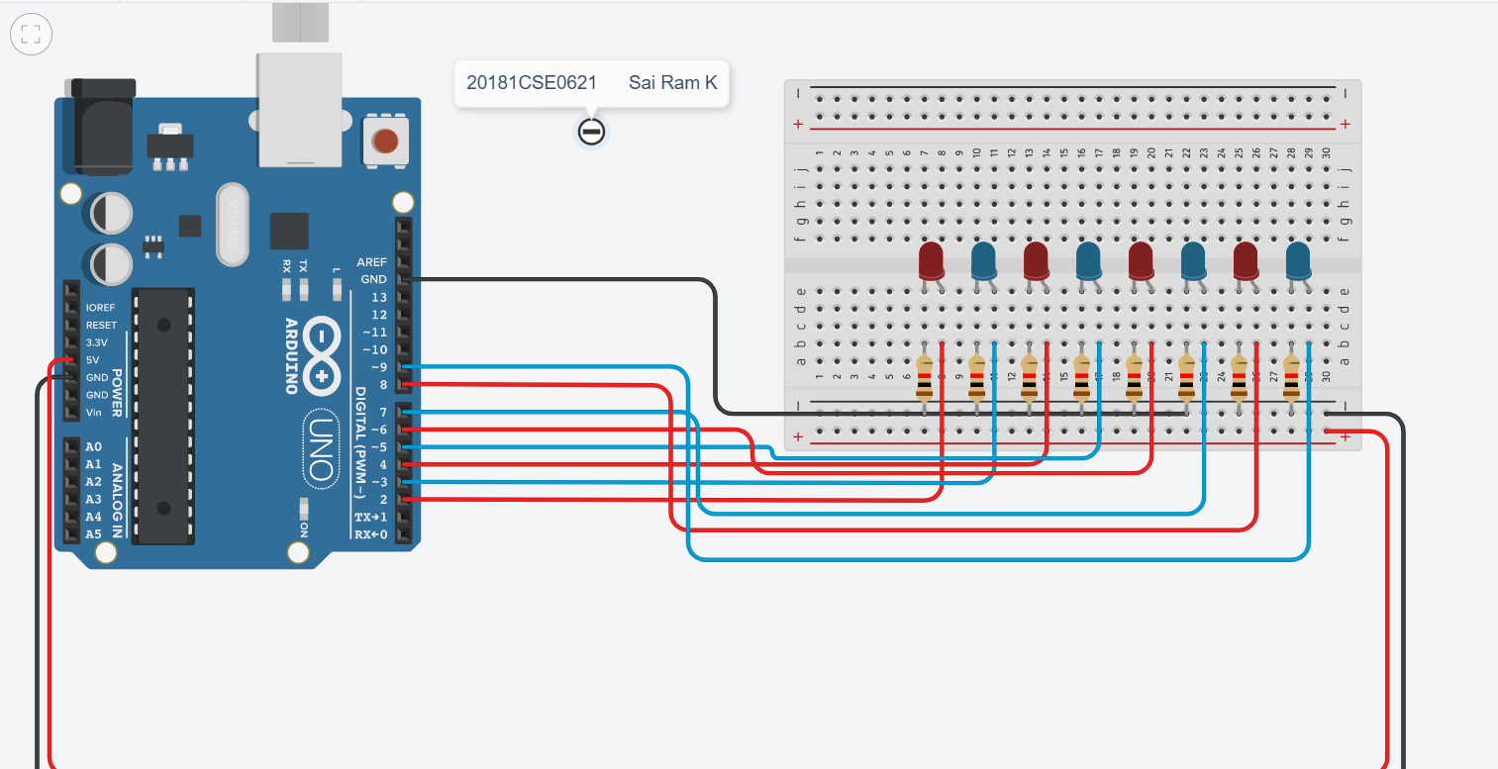

Code :

int del=500;

void setup()

{

for(int i=2; i<=10; i++)

{

pinMode(i,OUTPUT);

}

}

void loop()

{

//Even high

for(int i=2; i<=10; i++)

{

if(i%2==0)

{

digitalWrite(i,HIGH);

delay(del);

}

}

// Even low

for(int i=2; i<=10; i++)

{

digitalWrite(i,LOW);

delay(del);

}

//Odd High

for(int i=2; i<=10; i++)

{

if(i%2!=0)

{digitalWrite(i,HIGH);

delay(del);

}

}

// Odd high

for(int i=2; i<=10; i++)

{

digitalWrite(i,LOW);

delay(del);

}

}