**Internet Technologies – CSE 256**

**End Term Lab Assessment**

**SET - 3**

Sai Ram. K

20181CSE0621 | 7 – CSE – 10

Question 1.

**HTML CODE**

<!DOCTYPE html>

<html lang="en">

<head>

    <meta charset="UTF-8">

    <meta http-equiv="X-UA-Compatible" content="IE=edge">

    <meta name="viewport" content="width=device-width, initial-scale=1.0">

    <title>My Form</title>

    <link rel="stylesheet" href="rough.css">

</head>

<script src="rough.js"></script>

<body>

    <h1>Welcome To Placement Registration!! <br>Enter your details below</h1>

    <div style='float:right; width: 180px; '>

        <div style='position: fixed;background-color: cornflowerblue;padding: 10;border: 2px solid black ; border-radius: 25px;padding: 15px;'>

          Sai Ram. K 20181CSE0621 <br> 7 -CSE- 10 | EndTerm

        </div></div>

    <div class="details">

        <form name="form" action="" method="post " id="form" onsubmit="return validate()">

            <div class="name">

                <label for="name">Name:</label>

                <input id="name" placeholder="Enter your name."><span id="alertname"><strong></strong></span>

            </div>

            <div class="id">

                <label for="id">ID No. : </label>

                <input id="id" placeholder="20181XYZ0000"><span id="alertid"><strong></strong></span>

            </div>

            <div class="mob">

                <label for="mob">Mobile : </label>

                <input id="mob" placeholder="9876543210"><span id="alertmob"><strong></strong></span>

            </div><br>

            <div class="address">

                <label for="address">Address : </label>

                <input id="address" placeholder="#42, Cross, City, State"><span id="alertaddr"><strong></strong></span>

            </div><br>

            <div class="branch">

                <label for="branch">Branch : </label>

                <select name="branch" id="branch">

                    <option value="" disabled selected>Select your branch</option>

                    <option value="CSE">CSE</option>

                    <option value="ISE">ISE</option>

                    <option value="ECE">ECE</option>

                    <option value="EEE">EEE</option>

                    <option value="MEC">MEC</option>

                    <option value="CIV">CIV</option>

                  </select>

                <span id="alertbranch"><strong></strong></span>

            </div><br>

            <div class="sem">

                <label for="sem">Semester : </label>

                <input type="number" min="0" max="8" id="sem" placeholder="1"><span id="alertsem"><strong></strong></span>

            </div><br>

            <div class="cgpa">

                <label for="cgpa">CGPA : </label>

                <input type="number" min="0" max="10" step="0.10"id="cgpa" placeholder="8.50 "><span id="alertcgpa"><strong></strong></span>

            </div><br>

            <div class="btn" style="padding-left: 5rem;">

                <button type="submit" id="submit">Submit</button>

            </div>

        </form>

    </div>

</body>

</html>

**CSS CODE**

*{

    font-family: -apple-system, BlinkMacSystemFont, 'Segoe UI', Roboto, Oxygen, Ubuntu, Cantarell, 'Open Sans', 'Helvetica Neue', sans-serif;

}

body{

    text-align: center;

    background:aquamarine;

}

.details{

    padding: 20px;

    font-family: inherit;

    font-weight: bolder;

    display: inline-block;

}

.name, .id, .sec, .sub{

    padding: 5px;

    margin: 5px;

}

#form input{

    border-radius: 15px;

    outline: none;

    width: 500px;

    height: 35px;

    border: 3px solid black;

}

#form label{

    font-size: 20px;

    padding-right: 10px;

}

::placeholder{

    text-align: center;

    font-size: 20px;

}

#submit{

    border: 3px solid black;

    border-radius: 15px;

    width: 150px;

    height: 75px;

    cursor: pointer;

    text-align: center;

    outline: none;

    background-color: cornflowerblue;

    color: azure;

    font-size: large;

    font-weight: bold;

}

#alertname,#alertmob,#alertaddr,#alertsem,#alertcgpa,#alertbranch,#alertid{

    font-size: 15px;

    text-align: center;

    color: red;

}

#branch{

    border-radius: 10px;

    outline: none;

    width: 500px;

    height: 35px;

    border: 3px solid black;

    text-align: center;

    font-size: 15px;

    font-weight: 500;

}

**JS CODE**

function validate()

{

    var name = document.getElementById("name").value;

    var id = document.getElementById("id").value;

    var mob = document.getElementById("mob").value;

    var address = document.getElementById("address").value;

    var branch = document.getElementById("branch").value;

    var sem = document.getElementById("sem").value;

    var cgpa = document.getElementById("cgpa").value;

    var phoneno = /^\d{10}$/;

   if(name.trim()==""){

        document.getElementById("alertname").innerHTML = "<p>Name Cannot be Blank</p>";

        return false;

    }

    if(id.trim()==""){

        document.getElementById("alertid").innerHTML = "<strong><br>Student ID needs to be provided. Eg:20181XYZ0000</strong>";

         return false;

    }

   if(id.length>12){

    document.getElementById("alertid").innerHTML = "<strong><br>ID cannot be more than 12 characters. Eg:20181XYZ0000</strong>";

    return false;

   }

   if (id!= "20181CSE0621"){

    document.getElementById("alertid").innerHTML = "<strong><br>Enter Valid ID format. Eg:20181XYZ0000</strong>";

    return false;

   }

   if(mob.match(phoneno))

    {

        console.log("Phone no. valid");

    }else{

        document.getElementById("alertmob").innerHTML = "<strong><br>Enter Valid mobile number. Eg:9876543210 </strong>";

        return false;

    }

    if(address.trim()==""){

        document.getElementById("alertaddr").innerHTML = "<strong><br>Enter Valid address.</strong>";

        return false;

    }

    if(branch.trim()==""){

        document.getElementById("alertbranch").innerHTML = "<strong><br>Choose from the menu.</strong>";

    }

    if(sem.trim()==""){

        document.getElementById("alertsem").innerHTML = "<strong><br>Enter Your Semester.</strong>";

    }

    if(cgpa.trim()==""){

        document.getElementById("alertcgpa").innerHTML = "<strong><br>Enter Your CGPA.</strong>";

    }

}

**OUTPUT SCREENSHOTS**

**UI OUTPUT:**

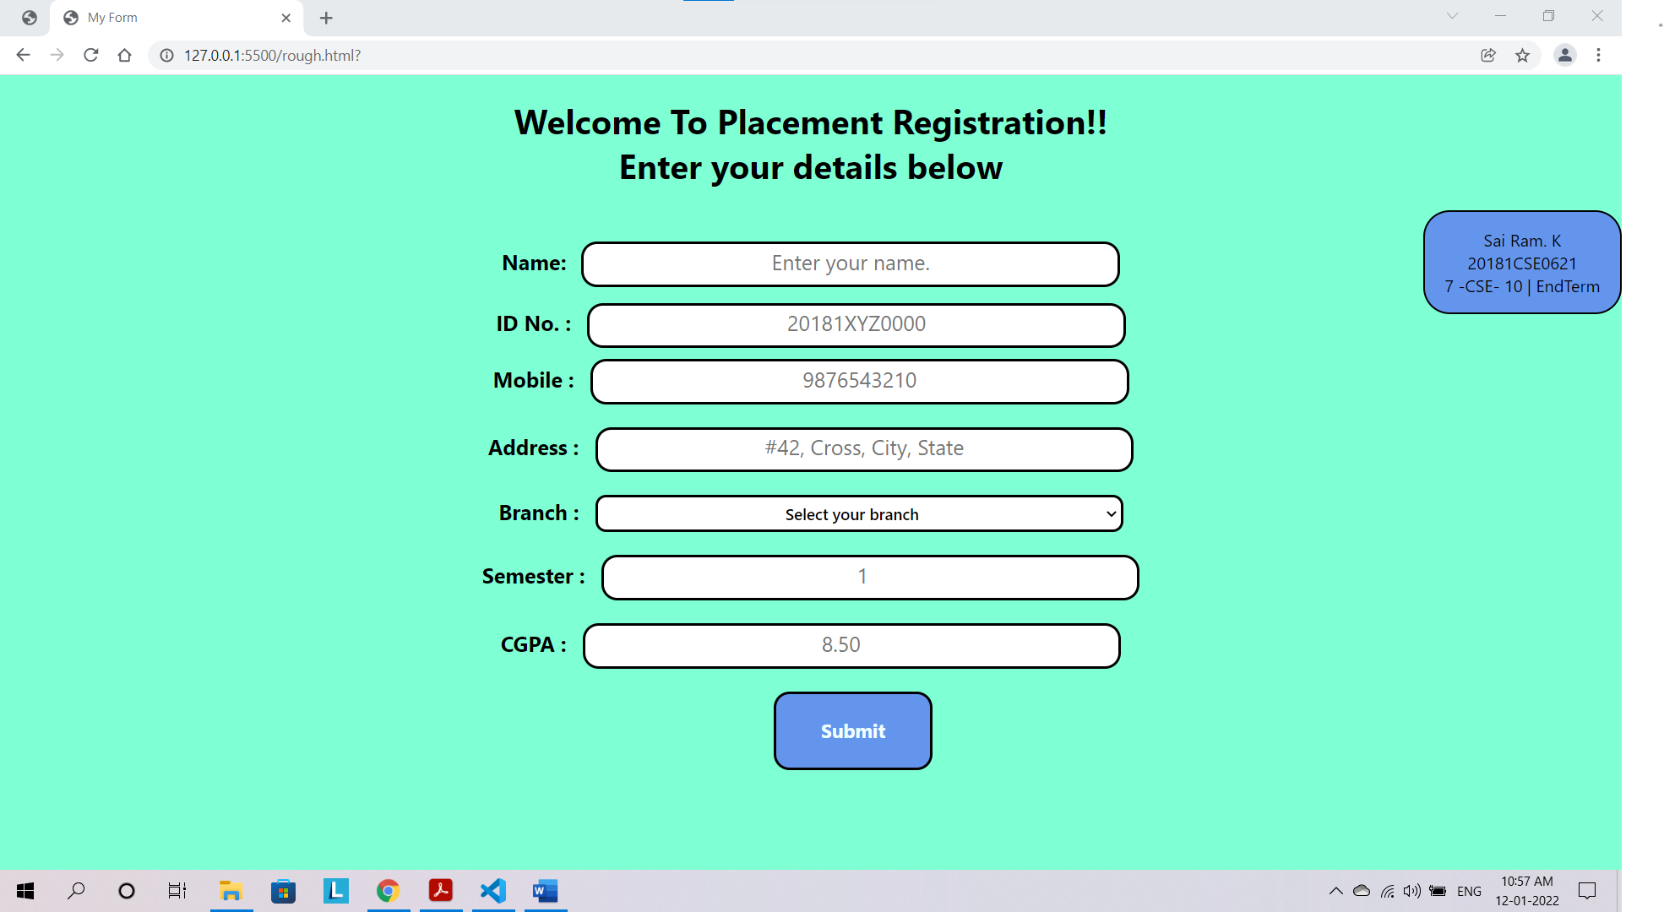

**NAME VALIDATION:**

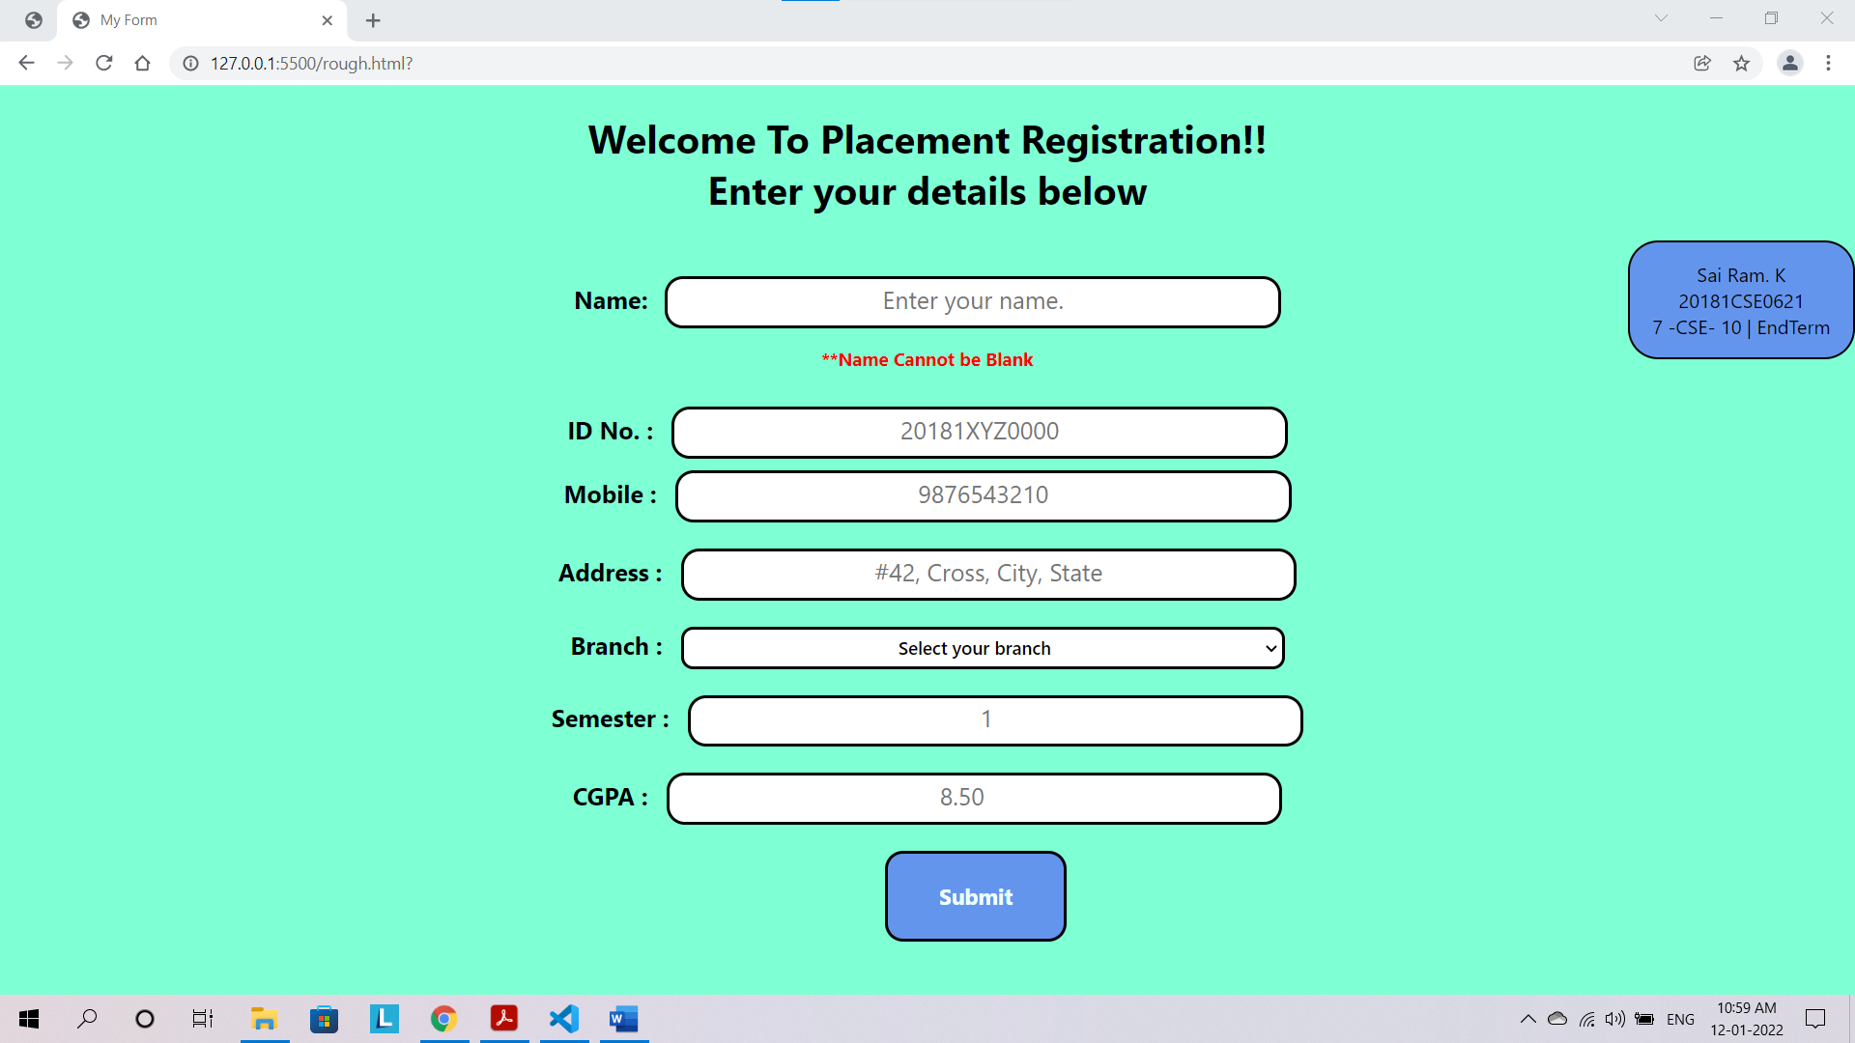

**ID VALIDATION:**

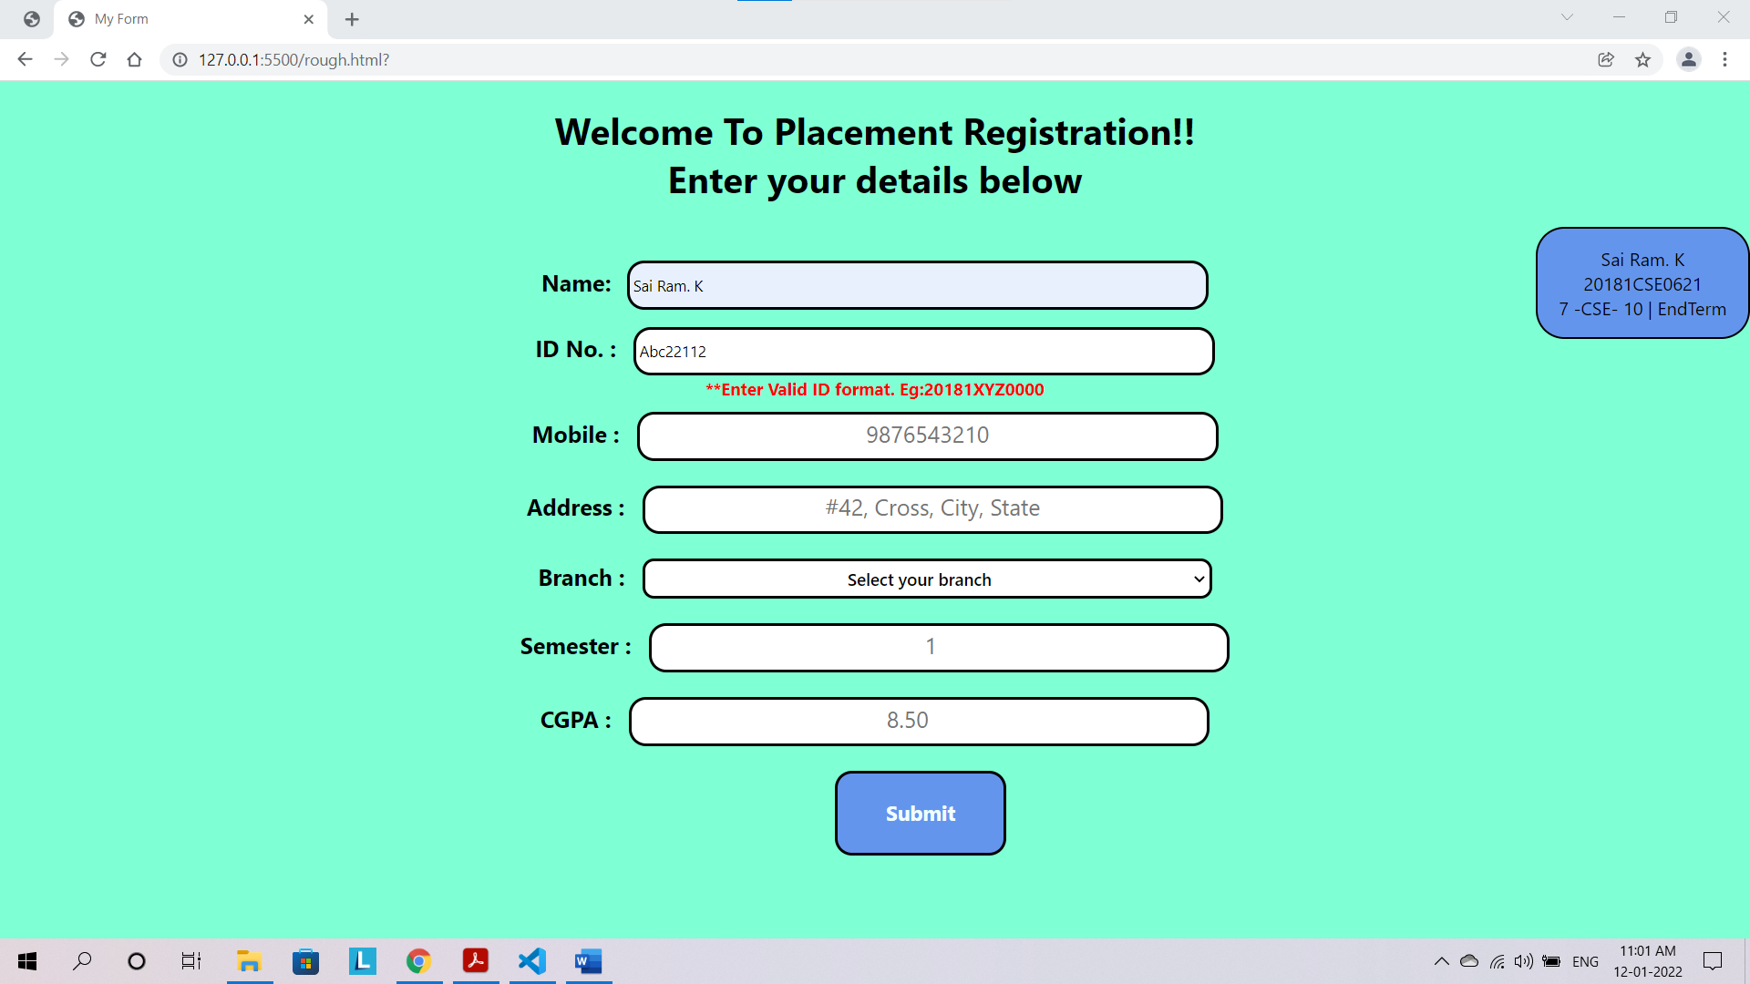

**MOBILE VALIDATION:**

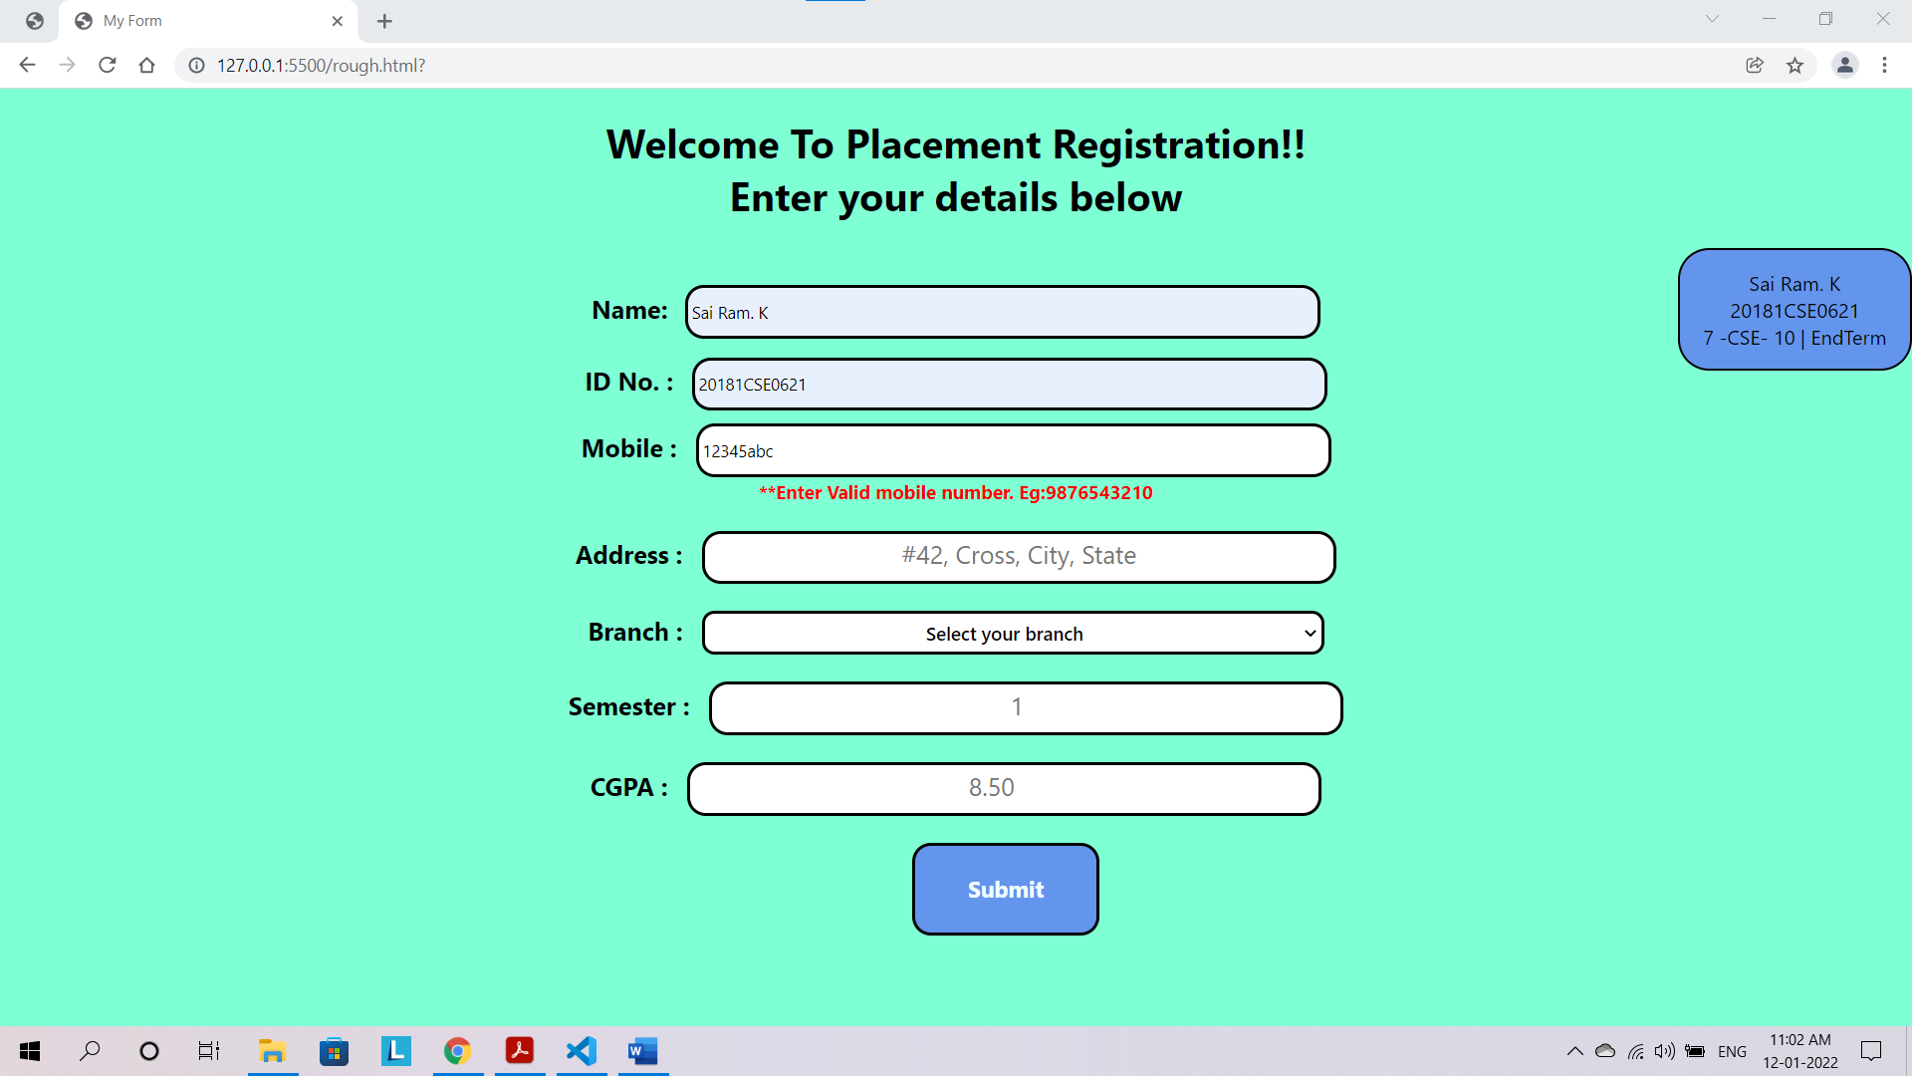

**ADDRESS VALIDATION:**

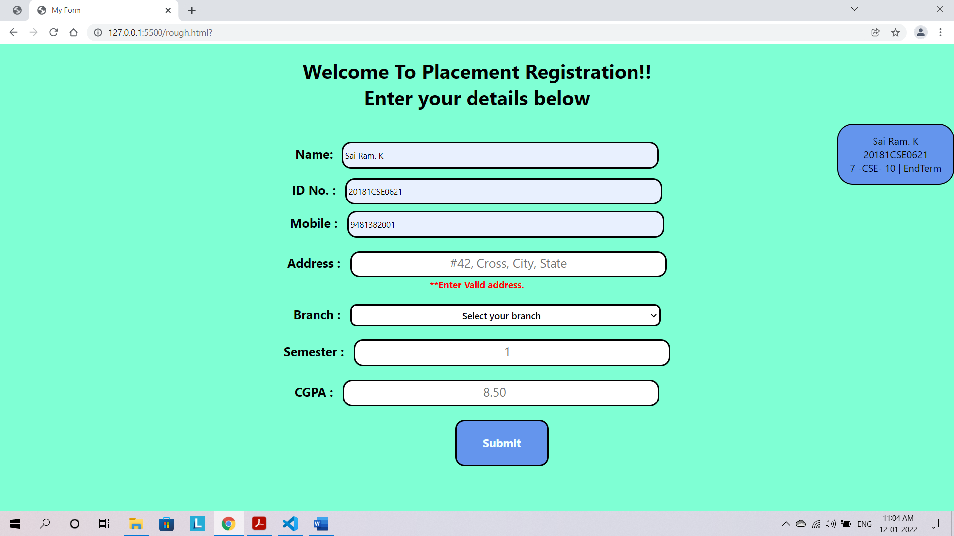

**SEMESTER VALIDATION:**

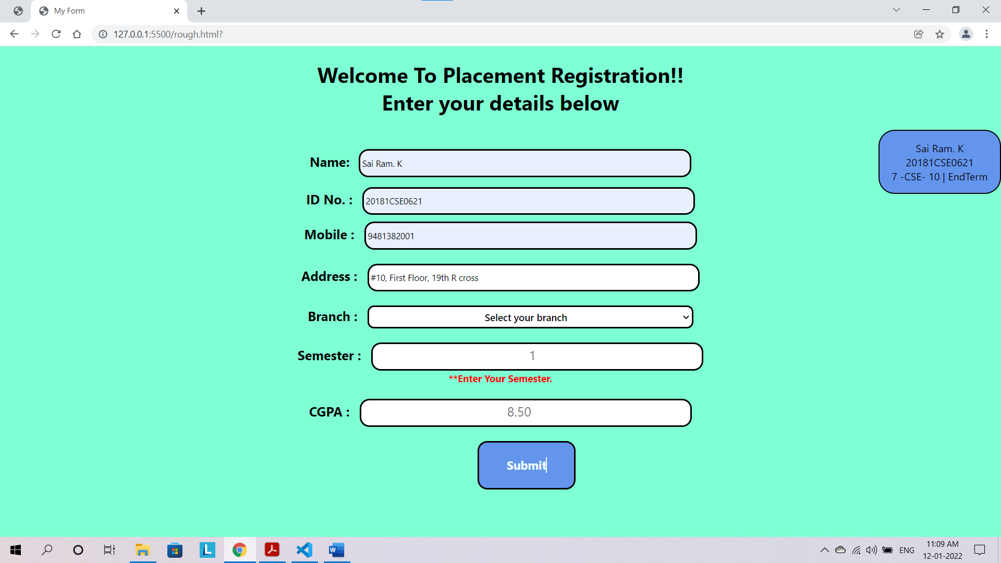

**CGPA VALIDATION:  
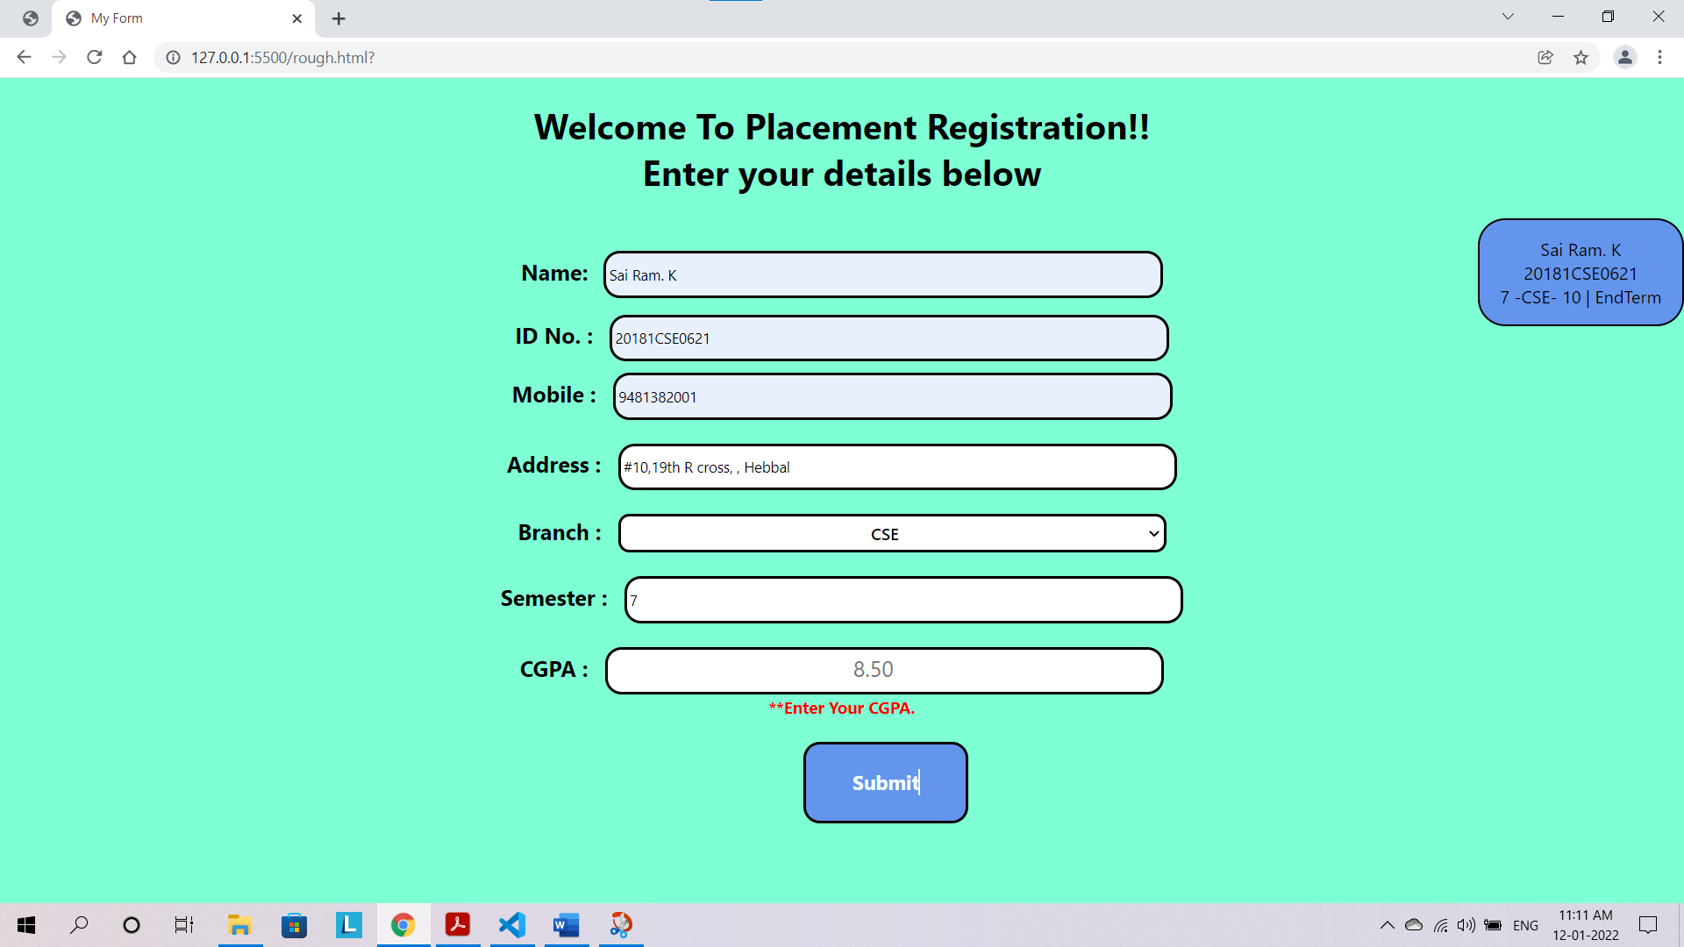**

**OVERALL OUTPUT :**

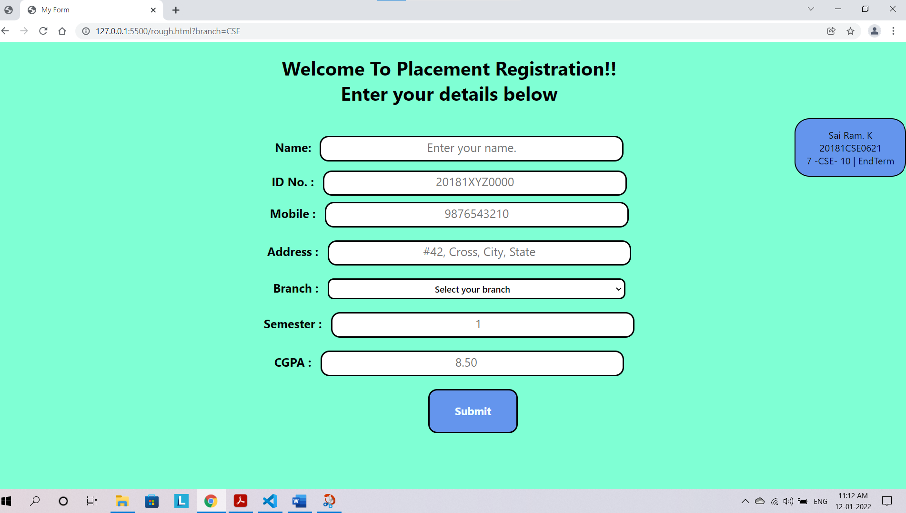

**Question 2.**

**Creation of DB and Tables**

**DATABASE**

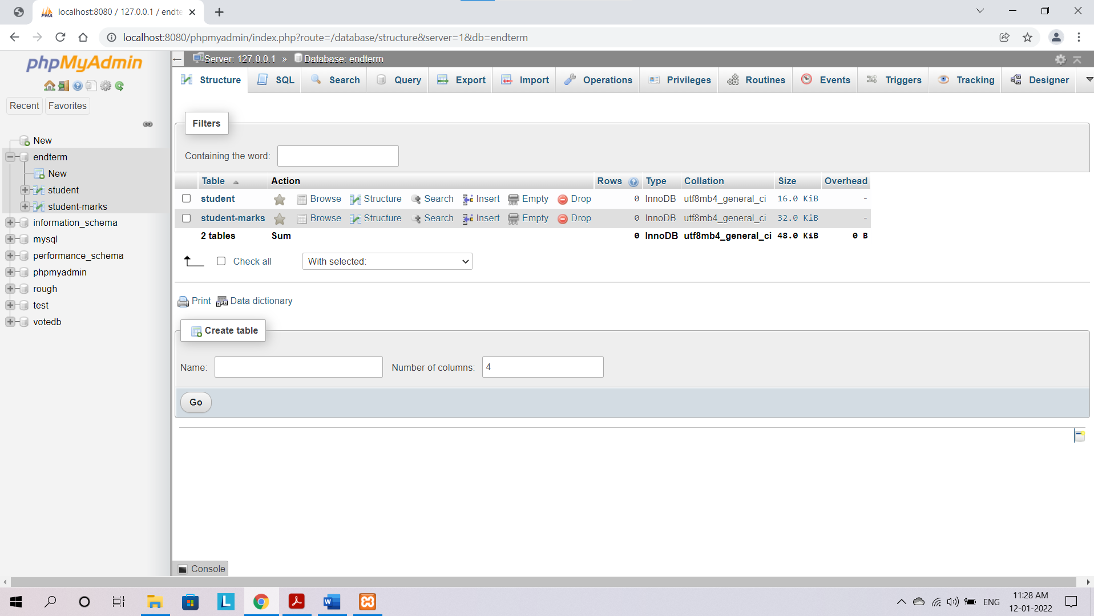

**Student Table**

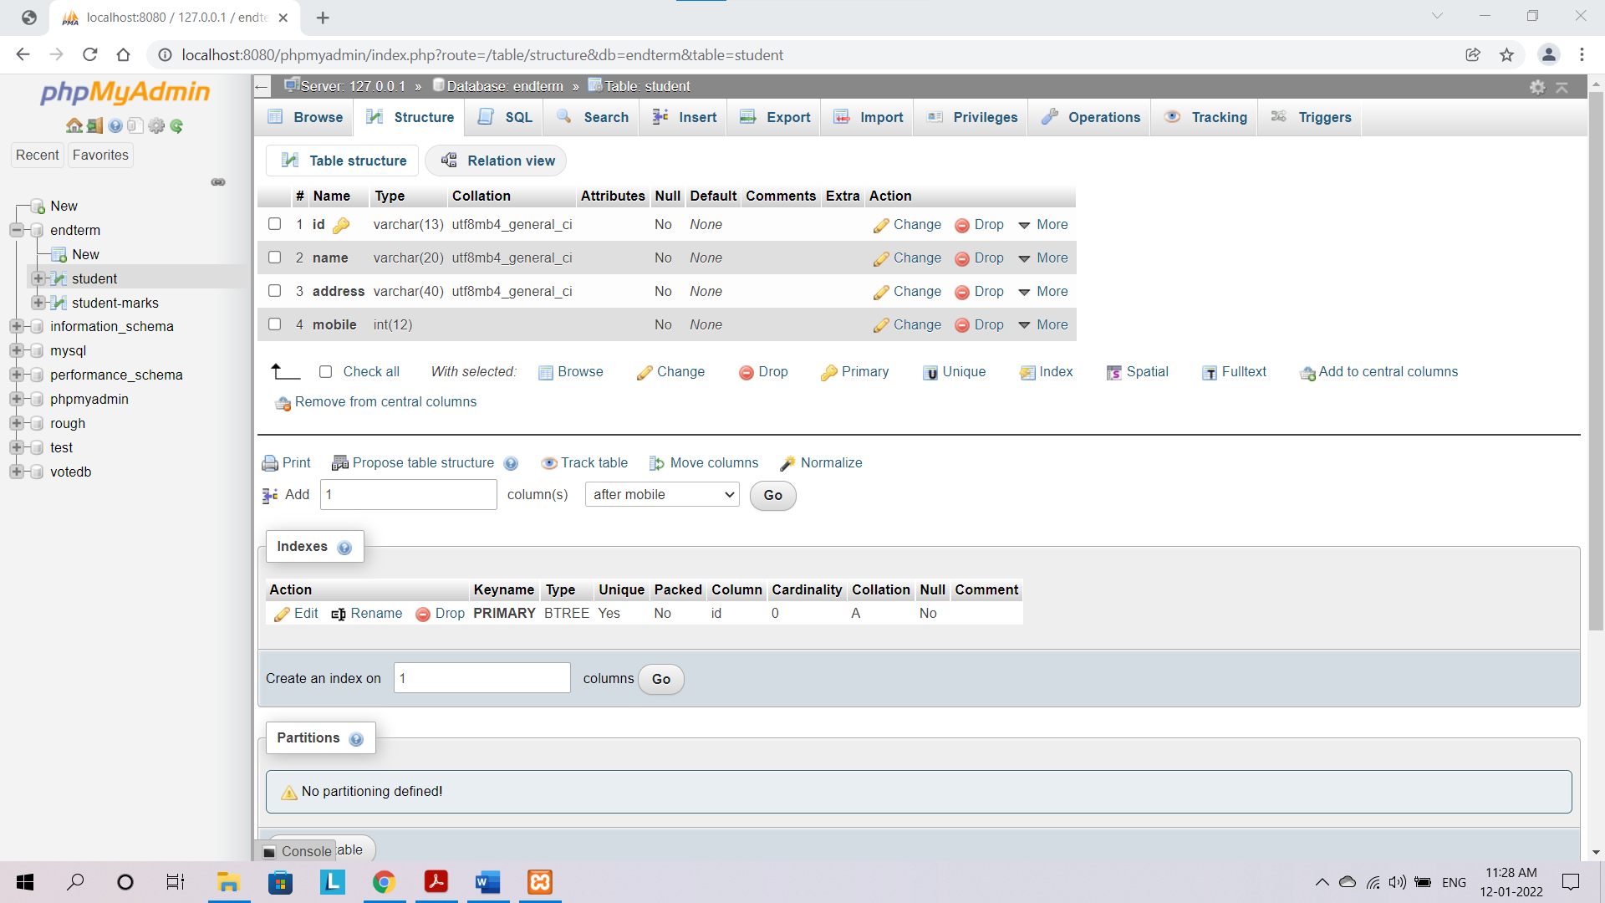

**Student Marks Table**

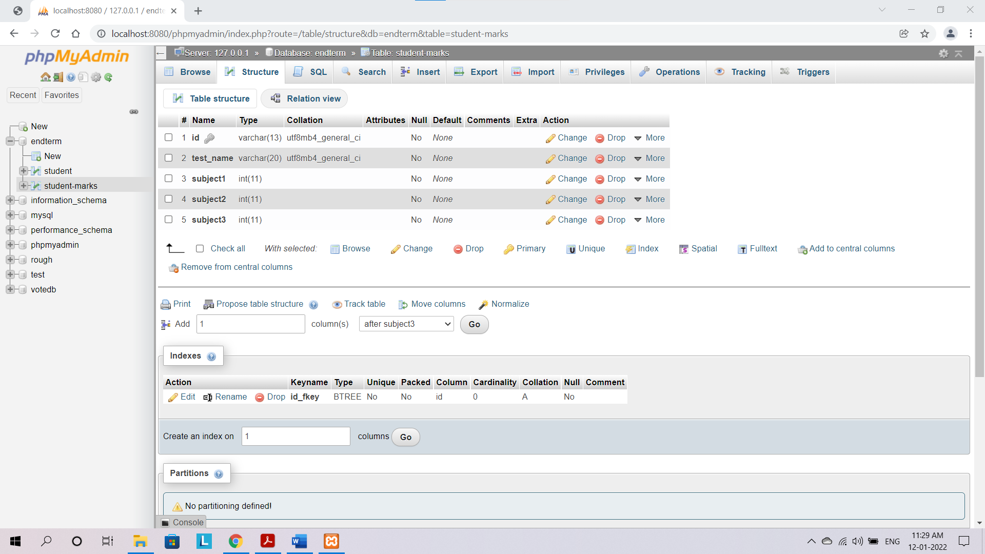

**Structure of Table**

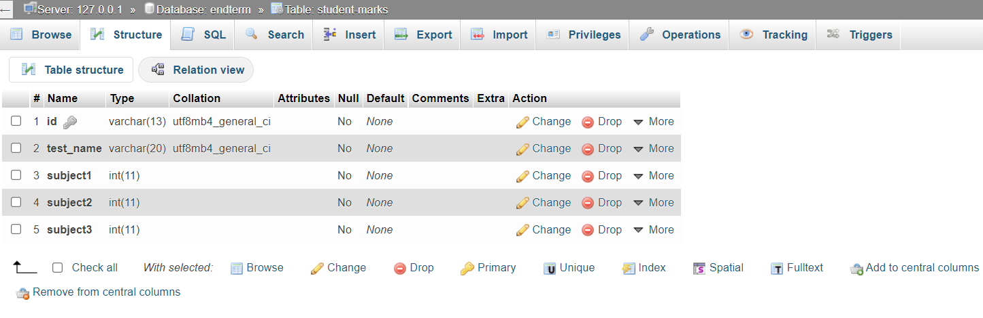

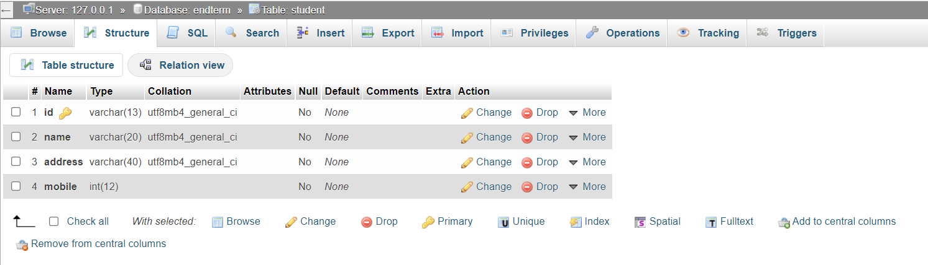

**Insertion of Data into Tables**

**Inserting records in Student table**

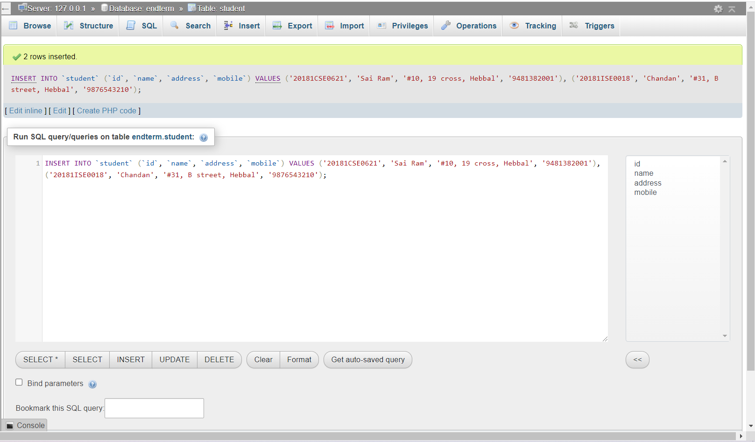

**Inserting records in Marks table**

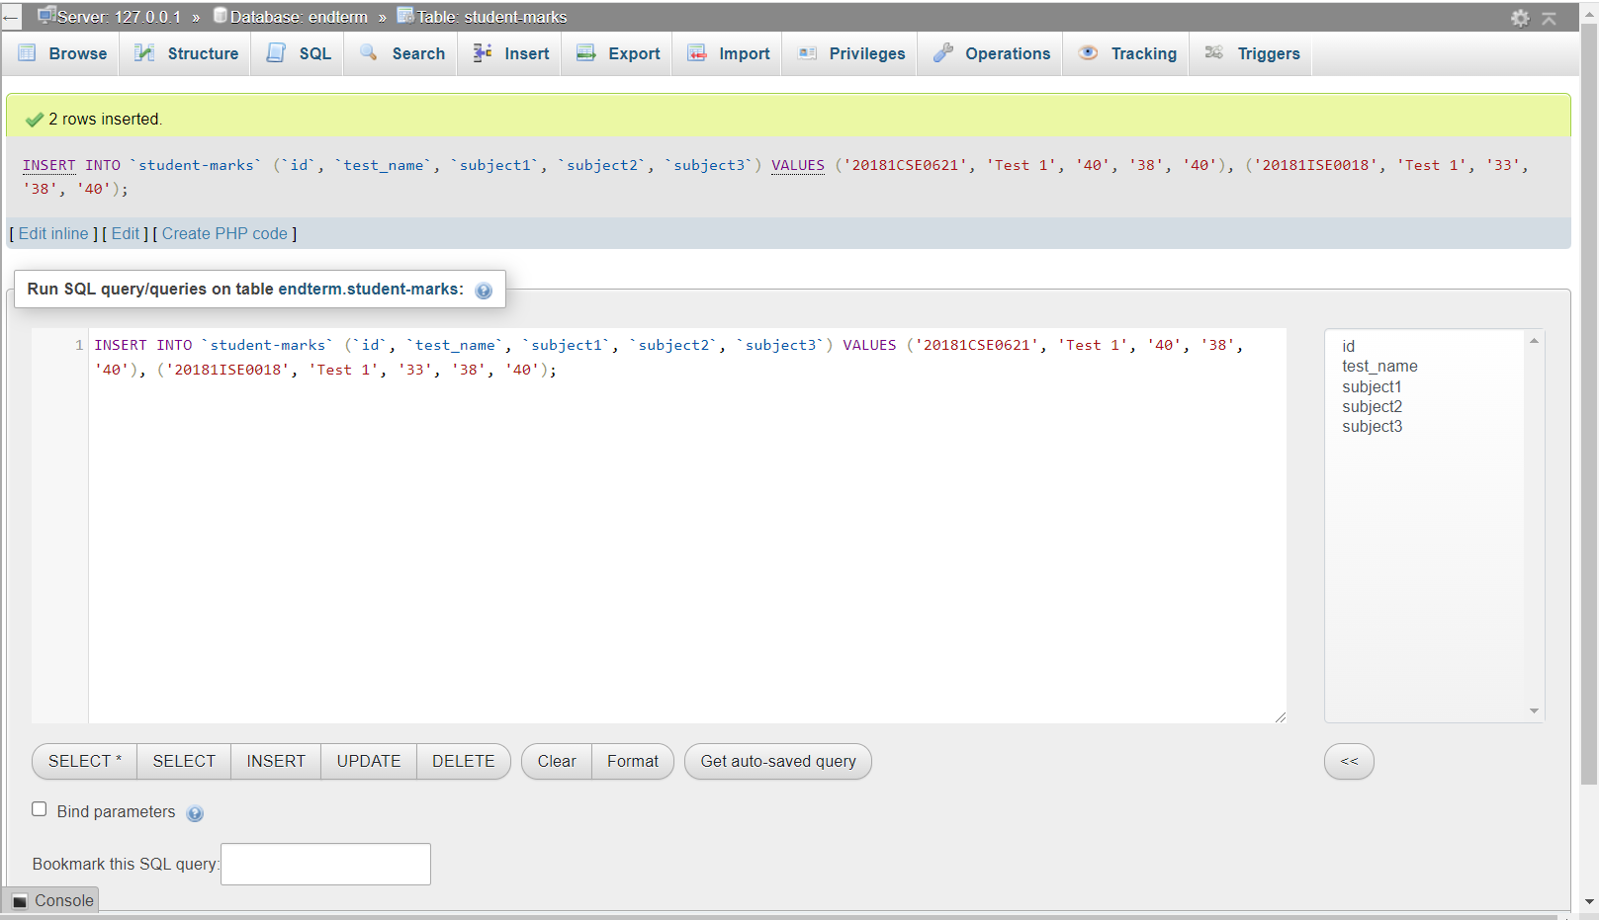

**Creation of HTML PAGE**

**HTML CODE:**

<!DOCTYPE html>

<html lang="en">

<head>

    <meta charset="UTF-8">

    <meta http-equiv="X-UA-Compatible" content="IE=edge">

    <meta name="viewport" content="width=device-width, initial-scale=1.0">

    <title>Progress Report </title>

</head>

<style>

    body{

        background-color: rgb(127, 208, 255);

        text-align: center;

        font-size: 25px;

    }

    #form input{

        text-align: center;

        border: 2px solid black;

        width: 450px;

        height: 35px;

        border-radius: 10px;

        outline: none;

    }

    #submit{

        width: 200px;

        height: 35px;

        text-align: center;

        background-color: rgb(80, 219, 150);

        border-radius: 10px;

        border: 2px solid black;

        cursor: pointer;

        outline: none;

        padding-left: 10px;

    }

</style>

<body>

    <h1>Welcome to our online marks Portal!</h1>

    <h3>Enter your UID to display your marks</h3>

    <form method="post" action="display.php" id="form">

        <div class="id">

            <label for="uid">Enter your uid :</label>

            <input type="text" id="uid" name="uid" placeholder="Eg: 201810XYZ0000">

        </div><br>

        <button type="submit" id="submit">Submit</button>

    </form>

</body>

</html>

<?php

**PHP CODE**

if ($_SERVER['REQUEST_METHOD']=='POST'){

    $uid = $_POST['uid'];

    //echo "$uid";

    $con = mysqli_connect("localhost","root","","endterm");

    if($con){

        //$sql = "INSERT INTO `student` (`email`, `password`) VALUES ('$email', '$pwd')";

        $sql = "SELECT * from `student_marks` where id='$uid' ";

        $result = mysqli_query($con, $sql);

        if ($result = $con -> query($sql)) {

            while ($row = $result -> fetch_row()) {

                $total = $row[2]+$row[3]+$row[4];

                echo "<h1>Hello $uid </h1><br>";

                echo "Your results are<br>";

              printf ("Subject 1: %s\nSubject 2:%s\n Subject 3:%s\n\n ", $row[2],$row[3],$row[4],$row[4]);

              echo "<br><br><strong>Total Marks = $total /120 </strong>";

            }

            $result -> free_result();

          }

        else{

            echo "The marks were not obtained successfully because of this error ---> ". mysqli_error($con);

        }

    }

else{

        echo 'Not Connected';

    }

}

?>

**OUTPUT SCREENSHOT**

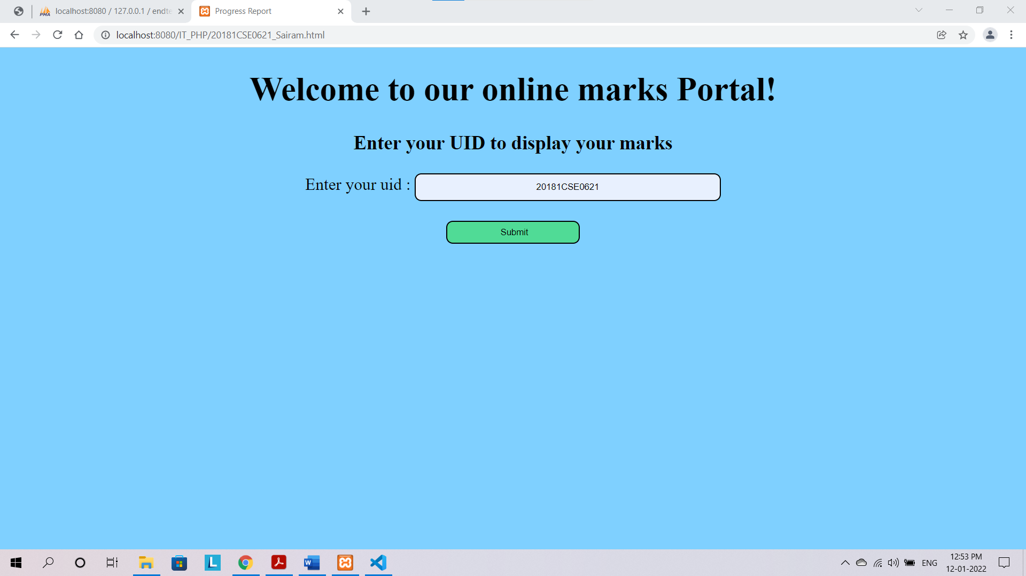

**TOTAL MARKS OUTPUT**

