SOFTWARE ENGINEERING
MINI-PROJECT
DELIVERABLES – PART 1
INTELLIGENT FINANCIAL ANALYTICS
PLATFORM
A microservice-based platform that compares classical machine learning, deep learning and quantum machine learning for financial volatility and derivatives prediction, and automatically selects the best-performing model
Software Requirements Specification • Architecture & Design • Test Plan & Test Cases

Project detail | Value
Course | Software Engineering Mini-Project
University | PES University
Team name | Team Financial Analytics
Document version | 2.0 (revised scope: multi-paradigm model comparison with automatic selection)
Submission date | 12 October 2026
Reference format | Adapted from the CodeCraft Part 1 reference document and the supplied deliverables brief

Team Members
# | Name | SRN
1 | Aryan Arora | PES1UG24AM055
2 | Akarsh Kumar Gupta | PES1UG24AM021
3 | Ahan Mysore | PES1UG24AM019

Document note: This is a proposed academic system specification. Predictions are analytical estimates, not guarantees or personalized investment advice. Quantum models run on classical simulators and no claim of quantum advantage is made. Numerical performance targets below are acceptance criteria to be verified during implementation; they are not claims of achieved results.

Contents
- Part A – Software Requirements Specification (SRS)
- Part B – Software Architecture and Design Specification
- Part C – Software Test Plan and Test Cases
- Appendix A – Experiment Record Template
The document is organized to match the three deliverable groups in the supplied Part 1 brief (SRS, Architecture & Design, Test Plan with test cases). The CodeCraft document is used as the structural and level-of-detail reference; requirements are specific to the IFAP idea: a microservice platform that compares classical, deep-learning and quantum models on volatility and derivatives prediction and selects the best one automatically.

PART A – SOFTWARE REQUIREMENTS SPECIFICATION (SRS)
Prepared in the style of IEEE 830-1998 / ISO/IEC/IEEE 29148:2018. Product: Intelligent Financial Analytics Platform (IFAP).

1. Introduction

1.1 Purpose
This SRS defines the functional, non-functional, interface, data, security and operational requirements for the Intelligent Financial Analytics Platform (IFAP). It is intended for the student development team, instructor, testers and reviewers. The test plan in Part C maps test cases back to the requirements in this section.

1.2 Scope
IFAP is a microservice-based analytics platform that compares three families of predictive models - classical machine learning, deep learning and quantum machine learning - on financial volatility and derivatives prediction, and automatically selects the best-performing model. An authorized analyst uploads historical market data; the platform builds features, runs every selected model in its own service under one identical chronological evaluation protocol, ranks the models on a leaderboard, selects a champion by a pre-declared policy, and serves predictions from that champion.
Two prediction tasks are supported: T1 - volatility forecasting (next-horizon realized volatility of an index or equity) and T2 - derivative pricing (option price or implied volatility for European options). The platform is intended for educational and decision-support demonstrations. It does not execute trades, connect to brokerage or banking systems, run on real quantum hardware by default, guarantee outcomes or provide regulated financial advice.

1.3 Definitions, acronyms and abbreviations
Term | Meaning
IFAP | Intelligent Financial Analytics Platform - the system specified in this document.
Microservice | A small, independently deployable service with its own responsibility, exposing a network API and communicating with other services only through that API or a message queue.
API Gateway | The single public entry point of IFAP; authenticates requests, applies rate limits and routes them to internal services.
Volatility (realized) | Standard deviation of log returns of an asset over a stated window, annualized or per-period as configured; the main prediction target of task T1.
Implied volatility (IV) | The volatility value that makes an option pricing model match the observed option market price; a possible target of task T2.
Derivative / option | A contract whose value depends on an underlying asset. In IFAP, European call and put options on an index or stock.
Classical ML | Non-neural statistical and machine-learning models, e.g. GARCH(1,1), Random Forest, gradient boosting.
Deep learning (DL) | Neural-network models for sequences, e.g. LSTM or GRU.
QML / VQR | Quantum machine learning; here a variational quantum regressor (parameterized circuit trained by a classical optimizer) executed on a quantum simulator.
Baseline model | A simple reference model (GARCH(1,1) for volatility; Black-Scholes with trailing volatility for option price) that every other model must beat to be eligible for selection.
Champion model | The model chosen by the automatic selection policy for a task and dataset; used to serve predictions.
Walk-forward validation | Chronological evaluation in which models are trained on earlier data and tested on later data, repeatedly moving the cut-off forward.
RMSE / MAE / MAPE | Root Mean Squared Error / Mean Absolute Error / Mean Absolute Percentage Error.
QLIKE | Quasi-likelihood loss commonly used to compare volatility forecasts; robust to noise in the volatility proxy.
Data leakage | Use of information in training, tuning or selection that would not have been available at prediction time.
FR / NFR / SR / UC / TC | Functional Requirement / Non-Functional Requirement / Security Requirement / Use Case / Test Case.

1.4 Overview
Section 2 describes the system context, users, assumptions and constraints. Section 3 defines interfaces, use cases, functional requirements, measurable non-functional requirements, the model evaluation and selection policy, and security objectives and requirements. Section 4 documents the proposed datasets, model portfolio and user flow. Part B specifies the architecture and interfaces. Part C defines the test strategy, security validation, test cases and traceability.

2. Overall Description

2.1 Product perspective
IFAP is a set of cooperating microservices behind a single API Gateway, deployed locally with Docker Compose. The browser dashboard talks only to the gateway. The gateway authenticates the user and forwards requests to the Experiment Orchestrator and other services. Each model family runs in its own service behind a common contract, so models can be developed, scaled, replaced or fail independently. Direct banking, brokerage and live market-data integrations are out of scope for Part 1.
Interface | Description
User interface | Web dashboard: dataset upload and validation, experiment configuration, run status, leaderboard, champion and prediction view, run details, report export, service-health page (Admin).
Software interfaces | REST/JSON over HTTP between gateway and services; message queue for long-running training jobs. Proposed stack: Python 3.11, FastAPI, pandas/NumPy, scikit-learn, statsmodels or arch (GARCH), PyTorch (LSTM/GRU), PennyLane or Qiskit simulator (QML), Docker Compose.
Hardware | General-purpose laptop/desktop; no GPU required. Quantum circuits run on a CPU-based simulator limited to a configurable maximum of 8 qubits. Runtime and peak memory are recorded for every model run.
Communications | Only the API Gateway port is published. Internal services communicate on a private container network using service tokens. No uploaded financial data is sent to third-party services; any approved remote endpoint (e.g. a cloud quantum backend) requires explicit approval and authenticated HTTPS.
Storage | Dataset Store (validated data with SHA-256), Model Registry & Run Store (metadata, metrics, champion pointer), Model Artifact Store (trained weights with SHA-256). Raw data and artifacts are never committed to public repositories.
Operations | The analyst uploads data, configures an experiment, starts a comparison, reviews the leaderboard and automatic selection, requests predictions from the champion and exports a report. The administrator monitors service health.

2.2 Product functions
- Import a CSV of daily market data (and optionally an option chain), validate it and report record count, date coverage and detected dataset type.
- Build features centrally in a Feature Engineering service: log returns, rolling realized volatility, and for derivatives moneyness, time to maturity and implied volatility.
- Run the same prediction task through three independent model families - classical ML, deep learning and quantum ML - each in its own microservice behind one common REST contract.
- Evaluate every model under an identical chronological protocol (same features, same walk-forward split, same test timestamps).
- Compare models on RMSE, MAE, QLIKE, directional accuracy (and MAPE where defined), plus training and inference time.
- Automatically select the best-performing eligible model using a policy declared before evaluation, and record the justification.
- Serve volatility forecasts or option-price predictions from the champion model.
- Isolate failures: a failed or timed-out model service is reported and excluded without stopping the comparison or corrupting earlier results.
- Version models and runs in a registry, allow retraining and roll-back of the champion.
- Export an aggregate report with provenance (dataset hash, model configuration, versions, metrics, selection justification).

2.3 User characteristics
Financial Analyst: students, instructors or small-business/finance analysts with basic spreadsheet familiarity who run experiments, review results and request predictions. The UI explains technical metrics in plain language and does not assume machine-learning expertise. Administrator: a team member who monitors service health and manages configuration and models.

2.4 Constraints
- Prediction quality depends on data volume, market regime, time coverage and the chosen target; results are estimates, not guarantees.
- Quantum models run on a classical simulator by default and are limited by qubit count (maximum 8 by default) and circuit depth; they are expected to be slower and are not assumed to be more accurate than classical or deep-learning models.
- Evaluation must respect chronology; random shuffling of time-series records is not permitted in the main evaluation.
- All models in one comparison must share the same target, feature set, split and test timestamps.
- Only approved public, synthetic or de-identified datasets may be used; the platform does not execute trades or connect to brokerage or banking systems.
- The platform is an educational decision-support demonstration and does not provide regulated financial advice.
- Cloud deployment, real quantum hardware and live market-data feeds are out of scope for Part 1.

2.5 Assumptions and dependencies
- The team can access a permitted historical dataset (for example public index or equity daily prices; an option-chain sample or synthetic option data generated from a documented pricing model).
- Price data contains a date column and a closing price; option data contains strike, expiry, option type, underlying price and option market price.
- Docker and the selected Python libraries are available on the development machines.
- The primary metric and selection policy parameters are fixed before final test evaluation.
- A quantum simulator library (PennyLane or Qiskit) can be installed and executed on CPU.

2.6 Apportioning of requirements
The initial academic release focuses on CSV ingestion, central feature engineering, three model families (classical, deep learning, quantum on a simulator), comparison, automatic selection, prediction serving and aggregate reporting. Deferred: real quantum hardware, live data feeds, multi-tenant deployment, automated trading, additional derivative types (exotics, American options), Kubernetes orchestration and production regulatory compliance.

3. Specific Requirements

3.1 External interface requirements
ID | Requirement | Priority | Verified by
UI-01 | Every prediction and result view shall show the dataset version, task, model name, model family, model version and forecast horizon. | Must | TC-15
UI-02 | Every leaderboard shall identify the chronological test period, define each metric, and display the primary metric and selection policy used. | Must | TC-11
UI-03 | Prediction views shall display a notice that outputs are uncertain estimates and not financial advice. | Must | TC-15
UI-04 | An undefined metric (for example MAPE with zero actual values) shall display "n/a", not a fabricated zero. | Must | TC-10
SW-01 | Every model service shall expose the same REST/JSON contract (train, predict, describe, health) so a new model service can be added without changing other services. | Must | TC-06, TC-07, TC-08
HW-01 | Each model run shall display its status and measured runtime; QML runs shall also display the simulator name and qubit count. | Should | TC-08
COM-01 | Internal service traffic shall stay on the private network; uploaded financial records shall not be sent to third-party services by default. | Must | TC-27

3.2 Use case diagram
Primary actors: Financial Analyst and Administrator. External parties: market data supplied as CSV and the quantum simulator backend. The diagram shows the principal interactions within the system boundary.
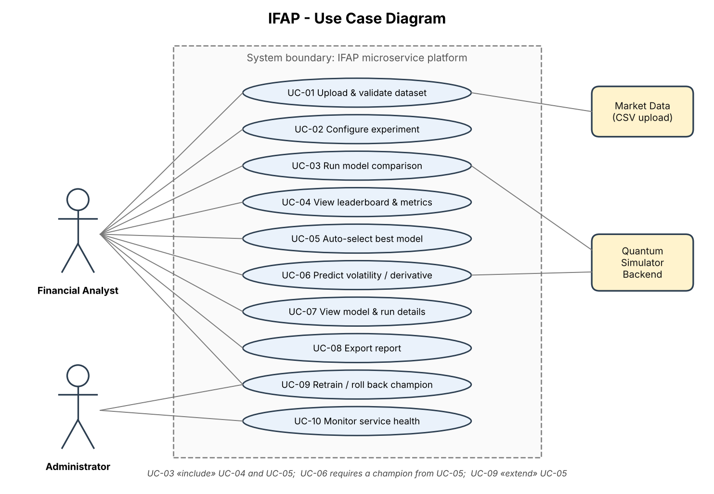
Figure 1. UML use-case diagram – IFAP
ID | Use case | Brief description | Linked requirements
UC-01 | Upload and validate dataset | Upload a CSV, inspect schema and data-quality summary; invalid data is blocked. | FR-01, FR-02, FR-03
UC-02 | Configure experiment | Select dataset, task (volatility or option price), horizon, models and primary metric. | FR-10
UC-03 | Run model comparison | Train and evaluate classical, DL and QML models on identical features and test period. | FR-04, FR-05, FR-06, FR-07, FR-08, FR-09, FR-15
UC-04 | View leaderboard and metrics | Compare models on error metrics, runtime and status. | FR-11, FR-12
UC-05 | Auto-select best model | System applies the selection policy and records the champion and justification. | FR-13
UC-06 | Predict volatility / derivative | Request forecast or option-price prediction from the champion model. | FR-14
UC-07 | View model and run details | Inspect configuration, seed, versions, runtime and hashes. | FR-16
UC-08 | Export report | Download aggregate results with provenance as PDF, CSV or JSON. | FR-17
UC-09 | Retrain / roll back champion | Re-run selection on new data; promote or roll back a previous champion. | FR-19
UC-10 | Monitor service health | Administrator views health and status of every microservice. | FR-18, FR-20

3.3 Functional requirements
Priority: Must = required for acceptance; Should = expected unless time constraints require deferral. Requirements are stated so that they can be tested.
ID | Requirement | Priority | Verification
FR-01 | The system shall accept a UTF-8 CSV file up to 25 MB and, after import, display the row count, column count, date range and detected dataset type (price series or option chain). | Must | TC-01
FR-02 | The system shall validate required columns (price series: date, close; option chain: date, strike, expiry, option type, underlying price, option price), date parseability, numeric validity, non-positive prices, missing values and duplicate dates, and list every issue found. | Must | TC-02, TC-03
FR-03 | If a required field is missing or a blocking validation rule fails, the system shall block feature building and model execution and display the affected field and reason. | Must | TC-02, TC-03
FR-04 | The Feature Engineering service shall compute log returns and rolling realized volatility over configurable windows (default 5, 10 and 22 trading days) and, for option data, moneyness, time to maturity and implied volatility, and shall record the feature-set version. | Must | TC-04, TC-14
FR-05 | The system shall create a chronological train/validation/test split using walk-forward validation with a documented cut-off or ratio; every test timestamp shall be later than every training timestamp, and scalers shall be fitted on training data only. | Must | TC-05
FR-06 | The Classical ML service shall provide at least a GARCH(1,1) baseline and one machine-learning model (Random Forest or gradient boosting), each returning predictions and recording configuration, seed and runtime. | Must | TC-06
FR-07 | The Deep Learning service shall provide at least one sequence model (LSTM or GRU) trained with a documented seed, epochs and early-stopping rule. | Must | TC-07
FR-08 | The Quantum ML service shall provide at least one variational quantum regressor executed on a simulator, with the qubit count configurable up to a maximum of 8; requests above the limit shall be rejected with a clear error. | Must | TC-08
FR-09 | Each model service shall implement the common contract (train, predict, describe, health) and shall be deployable, started and stopped independently of the other services. | Must | TC-06, TC-07, TC-08
FR-10 | The system shall allow the user to select the dataset, task (volatility or option price), target, forecast horizon, date range, models and primary metric before starting an experiment. | Must | TC-09, TC-14
FR-11 | The Evaluation service shall compute RMSE, MAE, QLIKE (volatility task), directional accuracy, training time and inference time for every completed model on identical test timestamps, and MAPE only when meaningful (otherwise n/a). | Must | TC-10, TC-14
FR-12 | The system shall present a leaderboard ranking all models for the experiment, showing family, metrics, runtime and status (completed, failed or timed out). | Must | TC-11
FR-13 | The system shall automatically select a champion using the selection policy in Section 3.5: only completed models that beat the baseline on validation data are eligible; the lowest validation value of the pre-declared primary metric wins; near-ties fall back to lower inference time; if no model beats the baseline, the baseline is selected and flagged. The justification shall be recorded. | Must | TC-12, TC-13
FR-14 | The system shall generate a prediction (volatility forecast for the chosen horizon or option price) using the current champion, and shall show the model, version, validation metric and the disclaimer. | Must | TC-15
FR-15 | If a model service fails, times out or is unavailable, the system shall mark that model as failed with a reason, continue with the remaining models and exclude the failed model from selection. | Must | TC-13, TC-16
FR-16 | The Model Registry shall store, for every run, the dataset hash, feature-set version, model configuration, seed, library versions, metrics, runtime, status, timestamp and champion flag. | Must | TC-17
FR-17 | The system shall export a report (PDF, CSV or JSON) containing aggregate results, leaderboard, selection justification, configuration, provenance hashes and limitations. | Should | TC-18
FR-18 | The dashboard shall explain the platform purpose, the three model families, supported tasks and the limitations of financial predictions. | Must | TC-19
FR-19 | The system shall allow re-running selection on a new dataset or configuration; a new champion shall be promoted only after its run completes, and the previous champion shall be retained and restorable. | Must | TC-17
FR-20 | The system shall provide an Administrator health view listing each microservice with its status and last health-check time. | Should | TC-19

3.4 Non-functional requirements
ID | Category | Measurable requirement | Verified by
NFR-01 | Performance | For a CSV of up to 50,000 rows and 20 columns, validation feedback shall appear within 10 seconds on the documented reference laptop. | TC-20
NFR-02 | Performance | A prediction request to the champion for a horizon of up to 30 days shall return within 2 seconds, excluding queue time. | TC-15
NFR-03 | Time bounds | On a reference dataset of up to 5,000 daily rows, classical models shall train within 5 minutes and DL models within 15 minutes; every model job shall have a configurable timeout (default 20 minutes) after which it is stopped and marked timed out. | TC-21
NFR-04 | Reliability / fault isolation | With any one of the three model services stopped, 3 of 3 experiment runs shall complete with the remaining models and report the stopped service as failed. | TC-16
NFR-05 | Reproducibility | With identical data, configuration, seed and library versions, split timestamps shall match exactly in 5 of 5 repeats and classical-model metrics shall be identical; run-to-run variation of DL and QML models shall be measured and documented. | TC-22
NFR-06 | Extensibility | A new model service that implements the common contract shall be added by registering it in configuration only, with zero code changes to the gateway, orchestrator, evaluator or dashboard. | TC-23
NFR-07 | Portability / deployment | A clean supported machine shall start the whole platform with one command (docker compose up) within 30 minutes using the README; versions shall be pinned and recorded. | TC-24
NFR-08 | Observability | Every request shall carry a correlation ID present in the logs of every service it touches; each service shall answer its health endpoint within 1 second. | TC-19
NFR-09 | Usability | At least 3 of 3 first-time users shall complete upload, experiment run, leaderboard review, prediction and export within 15 minutes using the README only. | TC-25
NFR-10 | Compatibility / readability | The web UI shall work in current Chrome and Firefox at 1366x768 or higher without horizontal scrolling in primary workflows; charts shall have titles, axis labels, units and legends; colour shall not be the only cue; text contrast shall be at least 4.5:1. | TC-25
NFR-11 | Comparison integrity | For every leaderboard, 100% of listed models shall report the same hash of test timestamps and the same feature-set version. | TC-10

3.5 Model evaluation and selection requirements
Model quality is an experimental outcome, not a guaranteed capability, and no model family is presumed to win. The Evaluation & Model Selection service shall apply the following policy, which is fixed and recorded before any test data is examined:
- Candidates are the models that finished with status COMPLETED; failed and timed-out models are listed but excluded.
- The primary metric (default RMSE for volatility, MAE for option price) is declared in the experiment configuration before the run starts.
- Selection uses walk-forward validation data only. Test-period metrics are reported but never used to choose the champion.
- A candidate is eligible only if its validation primary metric is lower than the baseline's by at least the configured margin (default 0%).
- The eligible model with the lowest validation primary metric becomes champion. If two models differ by less than 1%, the one with the lower inference time wins.
- If no candidate is eligible, the baseline is selected and the experiment is flagged "no model beat the baseline".
- The ranked leaderboard, policy parameters, selected model and a plain-language justification are stored in the Model Registry.
RMSE, MAE and QLIKE shall be reported for the volatility task; RMSE and MAE for the option-price task. MAPE shall be reported as n/a when actual values are zero or near zero. Directional accuracy is the share of test points where the predicted change in volatility or price has the same sign as the actual change. Forecast intervals are displayed only if the model supports them.

3.6 Design constraints
- All models in a comparison shall use the same target, feature set, time cut-offs and test timestamps.
- Imputation, scaling, feature selection and hyperparameter tuning shall use training data only; validation data may support tuning and selection; test data stays untouched until final reporting.
- Random splitting is prohibited for the main time-series evaluation.
- The champion shall be chosen on validation metrics; test metrics shall not influence selection.
- Quantum results shall be labelled as simulator results; no claim of quantum advantage shall be made unless supported by recorded experiment evidence.
- Any sample or synthetic dataset shall be labelled as such; no sample metrics shall be presented as real market results.

3.7 Software system attributes
Reliability: failures are isolated per service and never overwrite prior results. Maintainability and extensibility: services are loosely coupled through a common contract. Availability: continuous uptime is not required for the local demonstration, but each service restarts independently. Interpretability: outputs include units, date ranges, model family and limitations. Scalability: compute-heavy services (DL, QML) can be scaled or replaced independently of the rest.

3.8 Security requirements

3.8.1 Security objectives
ID | Objective | Meaning
SO-1 | Confidentiality | Prevent unauthorized access to uploaded financial data, results and internal services.
SO-2 | Integrity and provenance | Ensure datasets, trained models, selections and reports are traceable and cannot be silently altered.
SO-3 | Safe input handling | Prevent malformed or hostile uploads and inputs from executing code or compromising a service.
SO-4 | Availability / resource protection | Prevent heavy or abusive requests (long training jobs, request floods) from exhausting resources or taking services down.

3.8.2 Security requirements
ID | Requirement | Objective | Verified by
SR-01 | All API endpoints except login and the public health probe shall require a valid JWT checked at the gateway; requests without or with an expired token shall receive 401. | SO-1 | TC-26
SR-02 | Only the API Gateway port shall be published; internal services shall be reachable only on the private network and shall require a service token on every call. | SO-1 | TC-27
SR-03 | Upload shall accept only .csv files up to 25 MB; files shall be parsed as data, never executed, and unsupported files shall be rejected before parsing. | SO-3 | TC-28
SR-04 | Secrets, tokens and keys shall be supplied through environment variables, never hard-coded; raw datasets, model artifacts and .env files shall be excluded from repositories via .gitignore. | SO-1 | TC-29
SR-05 | The registry shall store a SHA-256 hash of every dataset and model artifact; a model artifact shall be loaded only if its hash matches, and reports shall include the hashes. | SO-2 | TC-18, TC-30
SR-06 | Errors shall not reveal stack traces, secrets, filesystem paths or raw financial rows; they shall return a safe code, message and request ID. | SO-1, SO-3 | TC-31
SR-07 | Each model job shall run with configured CPU, memory and time limits, and the gateway shall rate-limit each user (default 60 requests per minute), returning 429 when exceeded. | SO-4 | TC-21, TC-32
SR-08 | Role-based access shall distinguish Analyst and Administrator; only Administrators may view service health, change configuration or delete models, and others shall receive 403. | SO-1 | TC-26

4. Supporting Information

4.1 Dataset specification
Data element | Proposed use / rule
Source | Approved public daily price history (e.g. an index or equity) and an option-chain sample, or synthetic option data generated from a documented pricing model; exact source and licence documented before implementation.
Date/time | Required field; parsed to one consistent date granularity and sorted chronologically.
Price series fields | date, open, high, low, close, volume (close and date required).
Option-chain fields | date, underlying price, strike, expiry, option type (call/put), option market price; optional bid/ask and interest rate.
Targets | T1: next-h-day realized volatility. T2: option price (or implied volatility) for a contract on a future date.
Features | Log returns, rolling realized volatility (5/10/22 days), lagged values, moneyness, time to maturity, implied volatility; for QML a reduced set (maximum 8 inputs) chosen on training data only.
Missing values / duplicates | Report and apply a documented policy fitted on training data only; duplicate dates are reported, not silently dropped.
Evaluation | Chronological walk-forward split; identical test timestamps for every model; date coverage and sample counts recorded.

4.2 Model portfolio
Family | Candidate models | Service | Notes
Classical ML | GARCH(1,1) (baseline); Random Forest or gradient boosting | Classical ML Service | Fast, interpretable; strong reference for volatility.
Deep learning | LSTM or GRU on windowed return/volatility sequences | Deep Learning Service | Captures non-linear temporal patterns; needs more data and tuning.
Quantum ML | Variational quantum regressor (parameterized circuit, <= 8 qubits) on a simulator | Quantum ML Service | Experimental; slow on simulators; reduced feature set; no advantage assumed.

4.3 Website pages and user flow
Page / area | What the user can do
Home / overview | Read platform purpose, the three model families, supported tasks and the decision-support disclaimer.
Dataset import | Upload CSV, inspect schema, date coverage, rows and validation issues.
Experiment setup | Choose task, target, horizon, models, primary metric and seed; start the comparison.
Run status | See per-model status (queued, running, completed, failed, timed out) and runtime.
Leaderboard | Compare metrics on identical test timestamps; see the automatically selected champion and justification.
Predict | Request a forecast or option-price prediction from the champion; view chart and disclaimer.
Model & run details | Inspect configuration, seed, versions, hashes and limitations; retrain or roll back the champion.
Export | Download aggregate report with provenance.
Service health (Admin) | View status of every microservice.

PART B – SOFTWARE ARCHITECTURE AND DESIGN SPECIFICATION
Prepared in the style of IEEE Std 1016. Technology selections below are proposed implementation choices and may be changed without altering the requirements.

1. Introduction

1.1 Purpose and scope
This part describes the proposed architecture, components, interfaces, processing flow, data design, security controls and error handling for IFAP. Each design element maps to requirements in Part A and test cases in Part C.

1.2 Design goals
- Independent services so that model families can be added, scaled, replaced or fail without affecting the rest.
- Fair comparison: one shared feature set, split and set of test timestamps for every model.
- Automatic, auditable model selection that cannot be influenced by test data.
- Security at a single enforcement point (gateway) plus private internal network.
- Local deployment with one command on a student laptop.

2. Architectural Design

2.1 Architecture pattern
IFAP uses a microservice architecture with an API Gateway, an Experiment Orchestrator and an asynchronous message queue. Model services follow a Strategy-style common contract, and stores are accessed through repository services. The layers are: presentation (dashboard), edge (gateway), orchestration, domain services (ingestion, features, models, evaluation/selection, reporting) and data stores.
Pattern | Use | Rationale
Microservices | Independent services for ingestion, features, each model family, evaluation/selection and reporting. | Independent deployment, failure isolation and replacement; heavy QML/DL work does not block other services.
API Gateway | Single public entry point: JWT authentication, RBAC, rate limiting, routing, request IDs. | Central security enforcement; internal services stay private.
Strategy (common model contract) | Every model service implements train / predict / describe / health. | New model families plug in without changing the orchestrator or evaluator.
Orchestrator + message queue | Experiment Orchestrator dispatches model jobs asynchronously and collects results. | Parallel model runs, timeouts and per-model failure handling.
Pipeline | Validate -> features -> chronological split -> train -> evaluate -> select -> report. | Explicit data flow reduces leakage risk.
Repository / registry | Dataset Store, Model Registry & Run Store, Artifact Store. | Atomic writes and champion pointer with history for roll-back.

2.2 Component diagram
Figure 2 shows the logical components and their dependencies.
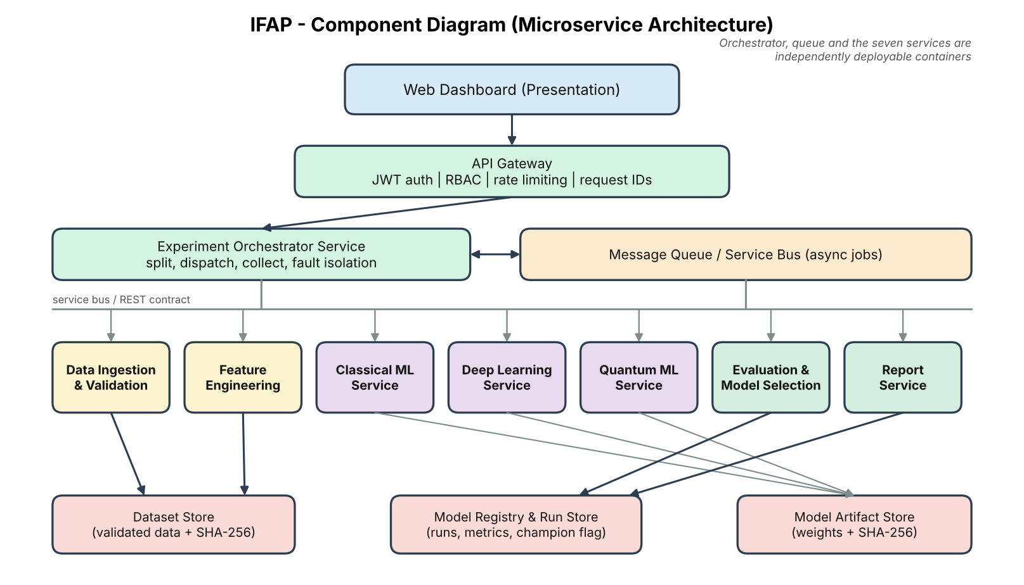
Figure 2. Component diagram – microservice architecture

2.3 Component descriptions
Component | Responsibility | Interface / output
Web Dashboard | Upload, experiment setup, status, leaderboard, prediction, details, export, health. | HTTPS/JSON calls to the gateway.
API Gateway | JWT verification, role checks, rate limiting, request IDs, routing, safe error mapping. | Public REST endpoints (Section 3.4).
Experiment Orchestrator | Creates runs, requests features, dispatches model jobs, enforces timeouts, collects results, isolates failures. | start_experiment(config), get_status(id).
Data Ingestion & Validation | Checks extension, size, schema, dates, numeric values; stores validated data with hash. | ValidationReport(valid, rows, columns, issues, datasetId).
Feature Engineering | Builds returns, realized volatility, option features; creates chronological split; fits scalers on training data. | build_features(datasetId, config) -> featureSetId, splitHash.
Classical ML Service | GARCH(1,1) baseline; Random Forest / gradient boosting. | train(), predict(), describe(), health().
Deep Learning Service | LSTM / GRU forecasting model. | train(), predict(), describe(), health().
Quantum ML Service | Variational quantum regressor on a simulator; qubit limit enforcement. | train(), predict(), describe(), health().
Evaluation & Model Selection | Computes metrics on shared test timestamps; applies the selection policy; writes the champion. | evaluate(runId), select(runId) -> leaderboard, champion, justification.
Report Service | Builds PDF/CSV/JSON aggregate reports with provenance. | build_report(experimentId, format).
Stores | Dataset Store, Model Registry & Run Store, Model Artifact Store. | Read/write via owning service only.

2.4 Proposed technology
- Backend services: Python 3.11 with FastAPI; one container per service; Docker Compose for local orchestration.
- Messaging: Redis or RabbitMQ queue for model jobs.
- Data and classical ML: pandas, NumPy, scikit-learn, statsmodels/arch for GARCH.
- Deep learning: PyTorch (LSTM/GRU) on CPU for the demonstration datasets.
- Quantum ML: PennyLane or Qiskit with a CPU simulator (default.qubit / Aer), at most 8 qubits.
- Storage: PostgreSQL or SQLite for registry and run metadata; file volume for datasets and model artifacts.
- Frontend: HTML/JavaScript or React with an accessible charting library.
- Packaging: pinned requirements per service and a single README; exact versions recorded.

2.5 Deployment view
All services run as containers on one machine under Docker Compose, on a private network. Only the gateway publishes a port, bound to 127.0.0.1 by default. The queue, stores and model services have no published ports. Resource limits (CPU, memory) are set per container, with tighter timeouts on the DL and QML containers. Remote or cloud deployment is outside the initial scope.

2.6 Traceability of requirements to design
Requirements | Components | Design element
FR-01 to FR-03; SR-03 | Dashboard, Gateway, Ingestion & Validation | CSV upload, extension/size/schema checks, ValidationReport.
FR-04, FR-05, NFR-05 | Feature Engineering, Orchestrator | Shared feature set, chronological split, seeds and split hash.
FR-06, FR-07, FR-08, FR-09, SW-01, NFR-06 | Classical, DL and QML services | Common model contract; independent containers; registry-based service discovery.
FR-10, FR-15, NFR-03, NFR-04 | Orchestrator, Message Queue | Async dispatch, per-model timeout, failure isolation.
FR-11, FR-12, FR-13, NFR-11, UI-02, UI-04 | Evaluation & Model Selection | Metrics on shared test timestamps, leaderboard, selection policy.
FR-14, NFR-02, UI-01, UI-03 | Gateway, Registry, champion model service | Champion pointer lookup and prediction call.
FR-16, FR-19, SR-05 | Model Registry, Artifact Store | Versioned runs, hashes, champion history and roll-back.
FR-17 | Report Service | Aggregate report generation with provenance.
FR-18, FR-20, NFR-08, HW-01 | Dashboard, all services (health endpoints) | Overview page, health aggregation, correlation IDs.
SR-01, SR-02, SR-08, COM-01 | Gateway, private network | JWT, service tokens, RBAC, only gateway published.
SR-04, SR-06, SR-07 | Deployment config, Gateway, container limits | Env-var secrets, safe errors, rate limits and job limits.
NFR-01, NFR-07, NFR-09, NFR-10 | Ingestion service, deployment, Dashboard | Vectorized validation, one-command deploy, accessible UI.

2.7 Security architecture
Trust boundaries: (1) browser-to-gateway input is untrusted; (2) uploaded files are untrusted until validated; (3) the private service network is trusted only for authenticated service-token calls; (4) model artifacts are trusted only if their hash matches the registry; (5) outbound network traffic is disabled by default.
Threat | Control | Requirement / test
Unauthorized access to data or APIs | JWT at gateway, RBAC, rate limiting. | SR-01, SR-08 / TC-26
Direct access to internal services | Only gateway published; private network; service tokens. | SR-02 / TC-27
Malicious or malformed upload | Extension and size checks, data-only parsing, escaped display. | SR-03 / TC-28
Secrets or raw data committed to repository | Environment variables; .gitignore for data, models and .env. | SR-04 / TC-29
Tampered model artifact or dataset | SHA-256 stored in registry; verify before load; hashes in report. | SR-05 / TC-30
Information leakage through errors | Safe error code/message and request ID; diagnostics only in restricted logs. | SR-06 / TC-31
Resource exhaustion by heavy jobs or floods | Per-job CPU/memory/time limits; per-user rate limit. | SR-07 / TC-21, TC-32
Misleading selection (leakage) | Selection on validation only; fixed policy recorded before run. | FR-13 / TC-12

3. Detailed Design

3.1 Sequence diagram: run model comparison and auto-select champion
The sequence shows an accepted experiment, shared feature building, parallel model runs with failure isolation, evaluation, automatic selection and result retrieval.
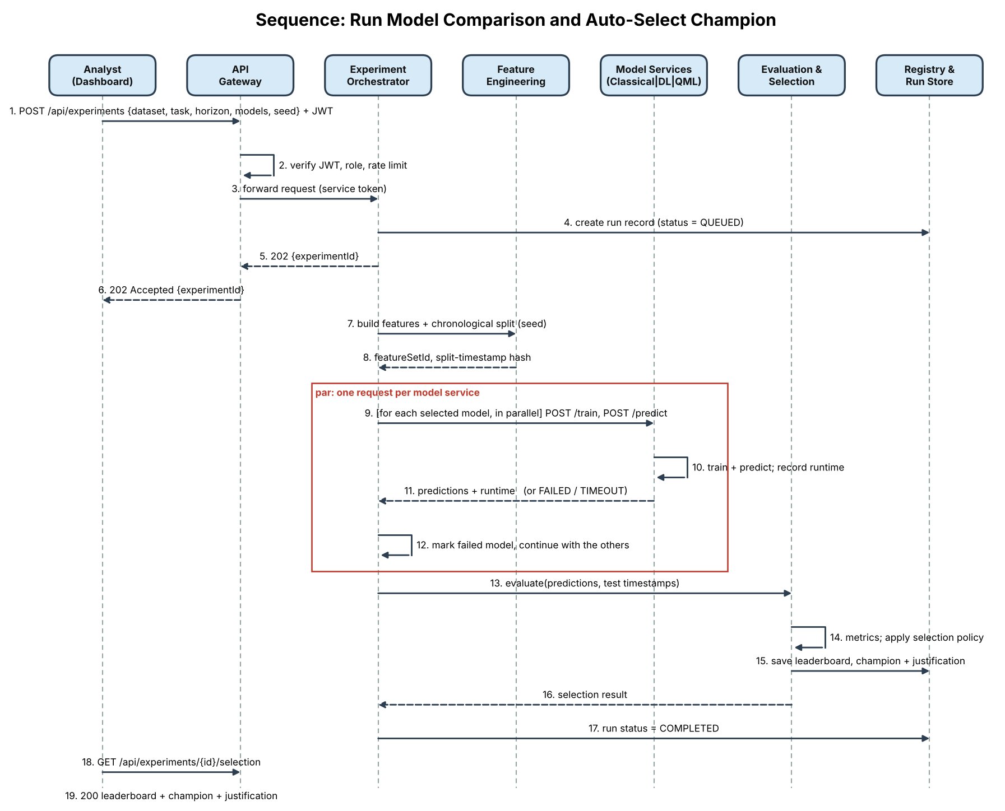
Figure 3. Sequence diagram – run model comparison and auto-select

3.2 Sequence diagram: upload and validate dataset
The sequence shows how unsupported or invalid input is stopped before any data is accepted.
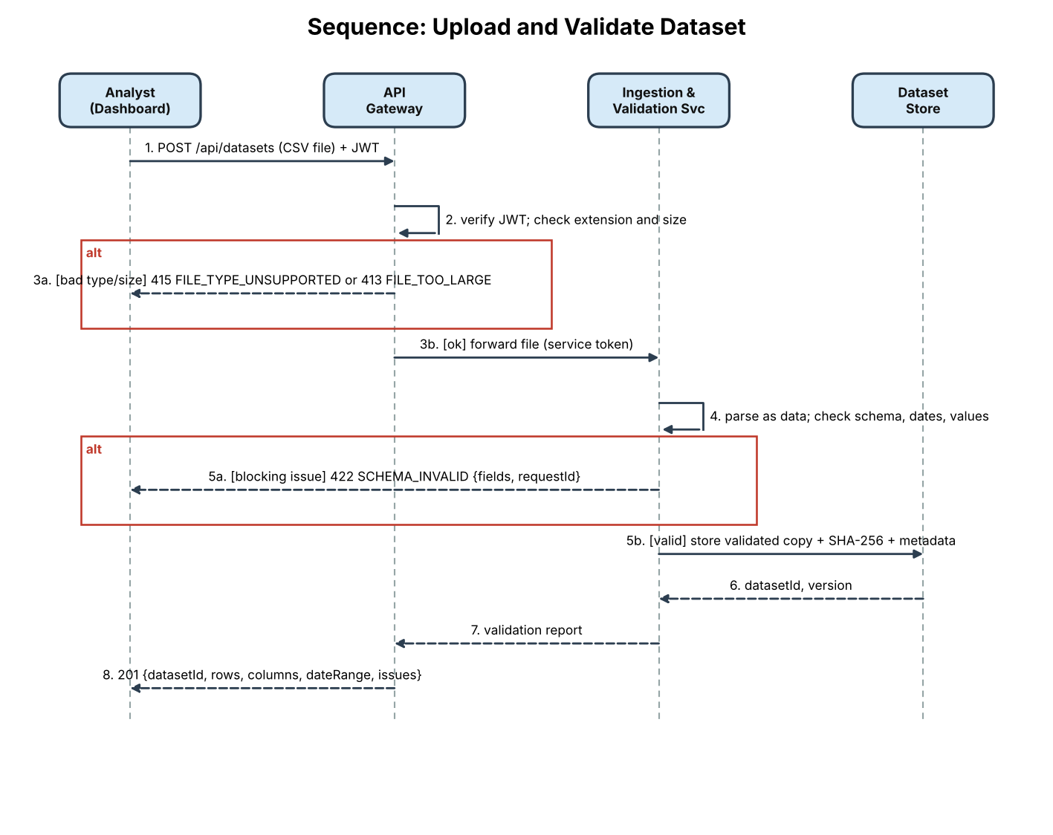
Figure 4. Sequence diagram – upload and validate dataset

3.3 Selection algorithm
The Evaluation & Model Selection service executes the policy in Section 3.5 of Part A:
1. Collect results for all models; drop models with status FAILED or TIMEOUT (kept in the leaderboard with their reason).
2. Compute validation and test metrics on the shared timestamps; verify all models report the same test-timestamp hash.
3. Keep models whose validation primary metric beats the baseline by at least the margin.
4. Sort eligible models by validation primary metric; if the top two differ by less than the tie tolerance (1%), prefer the lower inference time.
5. If no model is eligible, choose the baseline and set flag NO_MODEL_BEAT_BASELINE.
6. Write leaderboard, champion, policy parameters and justification to the registry; update the champion pointer only when the run is COMPLETED.

3.4 Class and contract design
Class / interface | Key attributes / methods | Purpose
ModelService (contract) | name; family; train(featureSetId, config, seed); predict(modelId, featureSetId, horizon); describe(); health() | Common interface implemented by every model service.
ClassicalService | GARCH baseline; RandomForest/GradientBoosting | Implements ModelService for classical ML.
DeepLearningService | LSTM/GRU; epochs; early stopping | Implements ModelService for DL.
QuantumService | circuit ansatz; n_qubits (<= 8); optimizer; simulator | Implements ModelService for QML; enforces qubit limit.
FeatureBuilder | build_features(datasetId, config); split(); fit_scalers(train) | Creates feature sets and chronological split.
ExperimentOrchestrator | experimentId; status; config; start(); collect(); timeout | Coordinates model jobs and failures.
Evaluator | rmse(); mae(); qlike(); directional_accuracy(); mape_if_defined() | Scores models on shared test timestamps.
SelectionPolicy | primaryMetric; margin; tieTolerance; select(results) | Applies the automatic selection rules.
ModelRecord | modelId; family; version; config; seed; metrics; runtime; status; hash; isChampion | Registry entry for each trained model.
ReportBuilder | build(experimentId, format) | Creates aggregate report with provenance.

3.5 API design
Public REST API exposed by the gateway: HTTPS/JSON, all endpoints prefixed with /api, JWT required except login and the public health probe. Upload endpoints enforce the CSV and size restrictions in Part A.
Method | Endpoint | Purpose | Expected response / errors
POST | /auth/login | Obtain a JWT. | 200 token; 401 UNAUTHENTICATED.
POST | /datasets | Upload and validate a CSV. | 201 validation report; 413 FILE_TOO_LARGE; 415 FILE_TYPE_UNSUPPORTED; 422 SCHEMA_INVALID.
GET | /datasets/{id}/summary | Date coverage, counts and summaries. | 200; 404 DATASET_NOT_FOUND.
POST | /experiments | Start a model comparison. | 202 {experimentId, status}; 422 VALIDATION_FAILED; 409 EXPERIMENT_IN_PROGRESS; 429 RATE_LIMITED.
GET | /experiments/{id} | Per-model progress and status. | 200; 404 EXPERIMENT_NOT_FOUND.
GET | /experiments/{id}/leaderboard | Metrics, runtime and status per model. | 200; 409 EXPERIMENT_NOT_COMPLETE.
GET | /experiments/{id}/selection | Champion and justification. | 200; 409 EXPERIMENT_NOT_COMPLETE.
POST | /predictions | Predict with the champion. | 200 prediction; 404 NO_CHAMPION; 422 VALIDATION_FAILED.
POST | /models/champion/rollback | Restore the previous champion for a task. | 200; 404 NO_PREVIOUS_CHAMPION; 403 FORBIDDEN.
GET | /reports/{experimentId}?format=pdf|csv|json | Download aggregate report. | 200 file; 404; 409 EXPERIMENT_NOT_COMPLETE.
GET | /admin/health | Status of every microservice (Admin only). | 200; 403 FORBIDDEN.

Internal model-service contract (identical for the Classical, Deep Learning and Quantum ML services; reachable only on the private network with a service token):
Method | Endpoint | Purpose | Expected response / errors
POST | /train | Train with featureSetId, config, seed, timeoutSec. | 200 {modelId, status, trainTimeSec}; 422 CONFIG_INVALID; 504 MODEL_TIMEOUT.
POST | /predict | Predict for modelId, featureSetId, horizon. | 200 {timestamps, values, inferenceTimeMs}; 404 MODEL_NOT_FOUND.
GET | /describe | Model family, parameters, limits (e.g. maxQubits). | 200 description.
GET | /health | Liveness and readiness. | 200 {status}; answers within 1 second.

3.6 Example request and response
POST /api/experiments
Authorization: Bearer <jwt>
{
"datasetId": "index-daily-v1",
"task": "VOLATILITY",
"target": "realized_vol_5d",
"horizon": 5,
"models": ["garch", "random_forest", "lstm", "qml_vqr"],
"primaryMetric": "RMSE",
"seed": 42
}
202 Accepted
{
"experimentId": "exp-0001",
"status": "QUEUED"
}
GET /api/experiments/exp-0001/selection (shape only; values filled at run time)
{
"champion": { "model": "<model>", "family": "<classical|dl|qml>", "version": "<n>" },
"primaryMetric": "RMSE",
"validationValue": "<value>",
"baseline": "garch",
"excluded": [ { "model": "<model>", "reason": "TIMEOUT" } ],
"justification": "<generated text>"
}
Illustrative payloads only. Dataset IDs, model names and values are examples; no experiment results are claimed.

3.7 Error handling
All API errors use a consistent shape, include an actionable message and avoid stack traces or sensitive values. One model failure never prevents results from other completed models, and a failed run never overwrites the current champion.
{
"error": {
"code": "SCHEMA_INVALID",
"message": "Required column 'close' is missing.",
"fields": ["close"],
"requestId": "req-1042"
}
}
Error code | HTTP status | Situation | System behaviour
UNAUTHENTICATED | 401 | Missing or invalid JWT. | Reject; no data returned.
FORBIDDEN | 403 | Role not allowed. | Reject; log event.
FILE_TYPE_UNSUPPORTED | 415 | Non-CSV upload. | Reject; do not parse or store.
FILE_TOO_LARGE | 413 | File exceeds 25 MB. | Reject and show allowed limit.
SCHEMA_INVALID | 422 | Required field missing or invalid. | List fields; block analysis.
VALIDATION_FAILED | 422 | Invalid experiment configuration or blocking data rule. | No model starts.
EXPERIMENT_IN_PROGRESS | 409 | Conflicting run already active. | Explain active run status.
EXPERIMENT_NOT_COMPLETE | 409 | Result requested before completion. | Ask user to wait or retry.
NO_CHAMPION | 404 | No champion exists for the task. | Ask user to run an experiment.
RATE_LIMITED | 429 | Per-user request limit exceeded. | Reject; Retry-After header.
MODEL_FAILED / MODEL_TIMEOUT | per model | Model service error or time limit. | Mark model failed, record safe reason, continue others; experiment still completes.
ARTIFACT_INTEGRITY_FAILED | 500 | Artifact hash does not match registry. | Refuse to load; keep champion unchanged; alert admin.
SERVICE_UNAVAILABLE | 503 | Required internal service down. | Safe message; other services continue.

3.8 Data design and retention
- Dataset record: datasetId/version, source/licence, row and column counts, date coverage, schema, validation summary, SHA-256.
- Feature set: featureSetId, dataset version, windows, feature list, split cut-offs, split-timestamp hash, scaler parameters (training data only).
- Experiment/run: experimentId, task, target, horizon, models requested, primary metric, seed, software versions, timestamps, status.
- Model record: modelId, family, version, configuration, seed, artifact hash, training time, inference time, status, failure reason.
- Evaluation result: model, metrics on validation and test, test-timestamp hash, notes (e.g. MAPE n/a).
- Selection record: policy parameters, eligible/excluded models, champion, justification; champion pointer per task with history.
- Prediction record: timestamp, champion model version, horizon, values, request ID.
- Raw data is retained only as needed for the academic demonstration in the restricted workspace; reports exclude row-level data by default.

PART C – SOFTWARE TEST PLAN AND TEST CASES

1. Introduction

1.1 Purpose
This test plan defines verification of the IFAP requirements, architecture and security controls. It includes functional, non-functional and security test cases, with traceability back to Part A.

1.2 Scope
Testing covers CSV import and validation, feature engineering, the three model services and their common contract, chronological evaluation, metrics, automatic selection, prediction serving, fault isolation, registry and roll-back, report export, security controls, performance, reproducibility, extensibility, deployment, usability and compatibility. Model accuracy is evaluated against held-out data; no test can guarantee future market outcomes or that one model family is superior.

1.3 Test objectives
- Verify that every requirement has at least one test (checked in the traceability matrix).
- Verify invalid input is rejected before any model execution.
- Verify chronological evaluation prevents future-to-past leakage and that selection never uses test data.
- Verify all models are scored on identical test timestamps and that the selection policy picks the expected champion.
- Verify that a failed, stopped or timed-out model service does not stop the comparison or corrupt earlier results.
- Verify security controls: authentication, RBAC, isolation, upload safety, secret hygiene, artifact integrity, safe errors and resource limits.

2. Test Items
Test item | Description
Web Dashboard / API Gateway | Upload, experiment setup, status, leaderboard, prediction, export, health pages; JWT, RBAC, rate limiting.
Ingestion & Validation service | Extension/size checks, schema, dates, numeric values, missingness, duplicates.
Feature Engineering service | Returns, realized volatility, option features, chronological split, training-only scaling.
Classical, Deep Learning and Quantum ML services | Common contract, training, prediction, qubit limit, runtime recording.
Evaluation & Model Selection service | Metrics, identical test timestamps, leaderboard, selection policy, baseline fallback.
Orchestrator, Registry and Report Service | Failure isolation, timeouts, versioning, champion history/roll-back, artifact hashes, report provenance.

3. Features to be Tested
- Valid import with correct record, column and date-coverage counts; invalid schema, malformed dates, non-positive prices, oversized and unsupported uploads.
- Feature engineering correctness against a hand-computed fixture, for both volatility and option features.
- Chronological split and training-only preprocessing (no leakage).
- Execution of classical, DL and QML models through the common contract, including the QML qubit limit.
- Metric correctness (RMSE, MAE, QLIKE, directional accuracy, MAPE n/a handling) and identical test timestamps across models.
- Automatic selection policy, including baseline fallback and exclusion of failed models.
- Fault isolation when a model service is stopped or times out; champion preservation and roll-back.
- Prediction with the champion, report provenance and disclaimer visibility.
- Security controls: authentication, RBAC, network isolation, upload safety, secret hygiene, artifact integrity, safe errors, rate limiting and job limits.
- Performance, reproducibility, extensibility, deployment, observability, usability and browser compatibility.

4. Features Not to be Tested
- Live market-data feeds, brokerage or banking integrations, and execution of trades or payments.
- Real quantum hardware or cloud quantum backends (simulator only).
- Proving that any model family, including quantum, outperforms another in general; tests verify the platform's comparison and selection behaviour, not market outcomes.
- Guaranteeing future volatility or option prices or trading profitability.
- Production-scale multi-tenant security certification, regulatory compliance and Kubernetes scaling.
- Pricing models beyond European options.

5. Test Approach

5.1 Test levels and methods
Level / method | Approach
Unit testing | Test validator, feature functions, metric functions, selection-policy logic, qubit-limit check and report filters in isolation, using stubbed model outputs.
Contract testing | Run the same contract test suite (train/predict/describe/health, schema and error shapes) against every model service.
Integration testing | Gateway to services, orchestrator to model services and queue, evaluator to registry, report generation.
System / end-to-end | Run upload -> validate -> experiment -> leaderboard -> champion -> prediction -> export on documented fixtures (one volatility, one option-price).
Negative / fault testing | Unsupported files, missing columns, malformed dates, invalid horizons, stopped services, injected timeouts, tampered artifacts.
Performance testing | Time validation for 50,000 rows; record training time, inference time and memory per model; prediction latency of champion.
Reproducibility testing | Repeat runs with same data, configuration and seed; compare split hashes and metrics; document DL/QML variation.
Usability / compatibility | Three first-time users complete the workflow; test current Chrome and Firefox at 1366x768 or higher.

5.2 Security validation
Security validation follows the reference document's emphasis on confidentiality, integrity/provenance and safe input handling, extended with availability/resource protection. Testing is limited to the local academic application and approved fixtures.
Security check | Procedure | Expected result | Trace
Authentication / RBAC | Call endpoints without a token, with an expired token, and as Analyst on Admin endpoints. | 401 for missing/expired token; 403 for Analyst on Admin endpoints. | SR-01, SR-08 / TC-26
Network isolation | Scan published ports; call internal services directly and without a service token. | Only the gateway port is reachable; internal calls without token are rejected. | SR-02 / TC-27
Upload safety | Upload .exe/.xlsx, a CSV over 25 MB, and CSV cells with formula-like or HTML-like strings. | Unsupported/oversized files rejected; cells treated as data and rendered safely. | SR-03 / TC-28
Secret hygiene | Inspect repository, source and configuration for keys, tokens, datasets and model files. | No secrets or raw data committed; secrets come from environment variables. | SR-04 / TC-29
Artifact integrity | Modify a stored model artifact and request a prediction; compare hashes in report and registry. | Load refused with ARTIFACT_INTEGRITY_FAILED; champion unchanged; hashes match for untouched files. | SR-05 / TC-30
Error disclosure | Trigger malformed input and a model exception; inspect UI and restricted logs. | Safe code, message and request ID only; no stack trace, path, secret or raw row. | SR-06 / TC-31
Resource limits | Flood the gateway; submit an oversized or endless training job. | 429 after the limit; job stopped at its time/memory limit and marked timed out. | SR-07 / TC-21, TC-32

6. Item Pass/Fail Criteria
- A test passes only when the actual result matches the expected result and the relevant requirement is satisfied.
- All Must requirements must pass before the final demonstration; unresolved critical security or data-leakage defects block release.
- Performance and time-bound targets are evaluated on the documented reference machine and dataset fixture.
- Undefined metrics must be reported as n/a; fabricated values count as a failure.
- Any mismatch in test timestamps or feature-set version between models in a leaderboard is a failure.
- A champion chosen using test-period metrics is a critical failure.

7. Entry, Exit, Suspension and Resumption Criteria
Criteria | Definition
Entry | Requirements reviewed; all services build and start; dependencies installed; approved fixtures (price, option chain) prepared; test environment documented.
Exit | All Must tests pass or have instructor-approved disposition; no open critical/high security defects; traceability matrix reviewed; results recorded.
Suspension | Stop affected tests on data corruption, unexpected outbound transfer, repeated service crashes, suspected leakage of test data into selection, or sensitive-data exposure.
Resumption | Fix and review the issue, reset fixtures and containers if necessary, rerun failed tests and regression tests for impacted requirements.

8. Test Deliverables
- This test plan and traceability matrix.
- Completed test execution record with actual results and pass/fail status.
- Defect log and retest evidence.
- Fixture descriptions (price series, option chain), versions and validation reports.
- Per-model configurations, split hashes, metrics, runtime/memory observations and the generated leaderboard and selection justification.
- Security validation evidence: authentication, isolation, upload safety, secret hygiene, artifact integrity, safe errors and limits.

9. Responsibilities and Schedule
Role | Responsibility
Aryan Arora (PES1UG24AM055) | Coordinate requirements review, API Gateway/Orchestrator and dashboard acceptance checks.
Akarsh Kumar Gupta (PES1UG24AM021) | Coordinate model services (classical, DL, QML), model comparison, selection and reproducibility checks.
Ahan Mysore (PES1UG24AM019) | Coordinate data validation, security tests, report export and test records.
All members | Peer-review each other's modules, execute end-to-end tests together, log defects and review final deliverables.
Instructor | Review requirements, design and test evidence.

Phase | Timing / dependency
Requirements and design | Part 1 submission: 12 October 2026.
Unit and contract tests | Alongside implementation of each service.
Integration tests | After gateway, orchestrator, queue and at least two model services are connected.
System/security tests | After the end-to-end workflow is stable and before final demonstration.

10. Risks and Contingencies
Risk | Contingency
Insufficient or poor-quality history | Use a labelled synthetic/public fixture; disclose limited history; avoid unsupported conclusions.
Time-series or selection leakage | Chronological split, explicit cut-off tests and validation-only selection; treat leakage as a critical defect.
QML too slow or unstable on simulator | Cap qubits and circuit depth; use reduced features and timeouts; report failure/timeout without blocking others.
DL results vary between runs | Fix seeds; run repeated trials; document variance.
Zero values make MAPE undefined | Return n/a and use RMSE/MAE/QLIKE.
Microservice integration complexity | Contract tests per service; Docker Compose smoke test early; stubs for unfinished services.
Sensitive data accidentally included | Stop testing, remove exposed artifacts, rerun privacy checks with synthetic data.
Deadline pressure | Run all Must tests first; Should tests follow if time permits.

11. Test Cases
The following 32 cases cover functional (F), non-functional (NF) and security (S) requirements. Replace fixture column names and sample values with the approved dataset schema before execution. Test status is intentionally left as Not Run; no execution results are claimed.
ID | Test | Type | Input / action | Expected result | Traces to
TC-01 | Valid CSV import | F | Upload a valid price-series CSV with date and close columns. | Import succeeds; row/column counts, date range and dataset type are shown. | FR-01
TC-02 | Missing required column | F | Upload a CSV without the close column. | Validation blocks analysis, names the missing field; no model starts. | FR-02, FR-03
TC-03 | Invalid values | F | Upload fixture with unparseable dates, non-positive prices, duplicate dates and missing values. | All issues are listed; blocking issues prevent execution without crashing. | FR-02, FR-03
TC-04 | Feature engineering | F | Build features for a small fixture and compare with hand-calculated log returns, 5/10/22-day realized volatility and option moneyness/time to maturity. | Feature values match the fixture within tolerance; feature-set version is recorded. | FR-04
TC-05 | Chronological split / no leakage | F | Build features and inspect train/validation/test timestamps and scaler statistics. | All training timestamps precede validation and test; scalers use training data only. | FR-05
TC-06 | Classical service contract | F | Call train, predict, describe and health on the Classical ML service for GARCH and one ML model. | Contract responses are valid; predictions returned; configuration, seed and runtime recorded. | FR-06, FR-09, SW-01
TC-07 | Deep learning service contract | F | Call train, predict, describe and health on the DL service (LSTM/GRU) with a fixed seed. | Contract responses are valid; epochs, seed and early-stopping recorded; predictions returned. | FR-07, FR-09, SW-01
TC-08 | Quantum service and qubit limit | F | Train the QML service with 4 qubits, then request 9 qubits. | 4-qubit run completes on the simulator and shows simulator name and qubit count; 9-qubit request is rejected with a clear error. | FR-08, FR-09, SW-01, HW-01
TC-09 | Experiment configuration and run | F | Select dataset, task, horizon, models and primary metric; start the experiment. | Run is accepted with an experiment ID; per-model status progresses; configuration is stored. | FR-10
TC-10 | Metrics and identical test timestamps | F | Compare model outputs on a fixture, including a case with zero actual values. | RMSE/MAE/QLIKE/directional accuracy match hand calculation; MAPE shows n/a where undefined; all models share the same test-timestamp hash. | FR-11, NFR-11, UI-04
TC-11 | Leaderboard display | F | Open the leaderboard of a completed experiment. | All models are ranked with family, metrics, runtime and status; test period, metric definitions, primary metric and policy are shown. | FR-12, UI-02
TC-12 | Automatic selection | F | Feed stubbed validation metrics where the QML model is best on test but the DL model is best on validation. | Champion is the validation-best eligible model; test metrics do not change the choice; justification is stored. | FR-13
TC-13 | Baseline fallback | F | Feed stubbed metrics where no model beats the baseline; also include a failed model. | Baseline is selected and flagged; failed model is excluded and listed with its reason. | FR-13, FR-15
TC-14 | Derivatives task end-to-end | F | Upload an option-chain fixture and run the option-price task with at least one model per family. | Option features are built; all models are evaluated on the same test timestamps; a champion is selected. | FR-04, FR-10, FR-11
TC-15 | Prediction with champion | F/NF | Request a 5-day volatility forecast from the champion; measure response time. | Prediction shows model, family, version, dataset version, horizon and disclaimer; response within 2 seconds. | FR-14, NFR-02, UI-01, UI-03
TC-16 | Fault isolation | F/NF | Stop the QML container, then run an experiment; repeat 3 times. | All 3 runs complete; QML is shown as failed with a reason; other models and selection are unaffected. | FR-15, NFR-04
TC-17 | Registry, retrain and roll-back | F | Retrain on new data; force the new run to fail; then promote a good run and roll back. | Failed run does not replace the champion; promotion occurs only after completion; roll-back restores the previous champion; registry history is intact. | FR-16, FR-19
TC-18 | Report export and provenance | F/S | Export a completed experiment as PDF, CSV and JSON; compare with the registry. | Each format downloads; report contains leaderboard, justification, configuration, versions and hashes matching the registry. | FR-17, SR-05
TC-19 | Overview and service health | F | Open the landing page; open the health page as Administrator; check logs for a request. | Purpose, model families and limitations shown; every service status listed; correlation ID appears in all services' logs; health answers within 1 second. | FR-18, FR-20, NFR-08
TC-20 | Validation performance | NF | Validate a 50,000-row, 20-column fixture on the reference laptop. | Feedback appears within 10 seconds; machine specification recorded. | NFR-01
TC-21 | Training time bounds and job limits | NF | Train each family on a 5,000-row dataset; submit a job exceeding the timeout and memory limit. | Classical <= 5 min and DL <= 15 min; the over-limit job is stopped, marked timed out, and other services remain healthy. | NFR-03, SR-07
TC-22 | Reproducibility | NF | Repeat the same experiment 5 times with the same seed and configuration. | Split timestamps identical 5/5; classical metrics identical; DL and QML variation recorded and documented. | NFR-05
TC-23 | Extensibility | NF | Add a stub model service implementing the contract and register it in configuration only. | Stub appears in the experiment setup and leaderboard with no code change in gateway, orchestrator, evaluator or dashboard. | NFR-06
TC-24 | Clean deployment | NF | On a clean supported machine run docker compose up following the README. | All services healthy within 30 minutes; versions recorded. | NFR-07
TC-25 | Usability and browser compatibility | NF | Three first-time users complete the workflow; inspect UI in Chrome and Firefox at 1366x768. | All 3 complete within 15 minutes; no horizontal scrolling; charts have axes, units, legends; contrast >= 4.5:1. | NFR-09, NFR-10
TC-26 | Authentication and RBAC | S | Call endpoints with no token, an expired token and an Analyst token on Admin endpoints. | 401 for missing/expired token; 403 for Analyst on Admin endpoints; Admin succeeds. | SR-01, SR-08
TC-27 | Network isolation and service tokens | S | Scan host ports; call internal services directly and without a service token; inspect outbound traffic. | Only the gateway port is published; internal calls without token are rejected; no outbound transfer of uploaded data. | SR-02, COM-01
TC-28 | Upload safety | S | Upload .exe/.xlsx, an oversized CSV and cells containing HTML/formula-like strings. | Unsupported/oversized files rejected before parsing; cell contents treated as data and rendered safely. | SR-03
TC-29 | Secret hygiene | S | Inspect repository, configuration and source for secrets, datasets and model files. | No secrets or raw data committed; credentials come from environment variables; .gitignore covers data, models and .env. | SR-04
TC-30 | Artifact integrity | S | Modify a stored model artifact byte and request a prediction. | Load refused with ARTIFACT_INTEGRITY_FAILED; champion unchanged; admin alerted. | SR-05
TC-31 | Safe error messages | S/NF | Trigger malformed upload and a model exception; inspect UI and restricted logs. | UI shows only safe code, message and request ID; no stack trace, path, secret or raw row. | SR-06
TC-32 | Rate limiting | S | Send more than 60 requests per minute from one user. | Requests above the limit receive 429 with Retry-After; other users unaffected. | SR-07

11.1 Test execution record template
Test case ID | Date / tester | Actual result / evidence | Status (Pass/Fail/Blocked/Not Run) | Defect ID
 |  |  | Not Run
 |  |  | Not Run
 |  |  | Not Run
 |  |  | Not Run
 |  |  | Not Run

12. Traceability Matrix (SRS to Test Cases)
Every requirement in Part A appears below with the test cases that verify it. The matrix is generated from the test-case table, so the two cannot drift apart.
Requirement | Test case(s) | What is verified
UI-01 | TC-15 | Prediction with champion
UI-02 | TC-11 | Leaderboard display
UI-03 | TC-15 | Prediction with champion
UI-04 | TC-10 | Metrics and identical test timestamps
SW-01 | TC-06, TC-07, TC-08 | Classical service contract; Deep learning service contract; Quantum service and qubit limit
HW-01 | TC-08 | Quantum service and qubit limit
COM-01 | TC-27 | Network isolation and service tokens
FR-01 | TC-01 | Valid CSV import
FR-02 | TC-02, TC-03 | Missing required column; Invalid values
FR-03 | TC-02, TC-03 | Missing required column; Invalid values
FR-04 | TC-04, TC-14 | Feature engineering; Derivatives task end-to-end
FR-05 | TC-05 | Chronological split / no leakage
FR-06 | TC-06 | Classical service contract
FR-07 | TC-07 | Deep learning service contract
FR-08 | TC-08 | Quantum service and qubit limit
FR-09 | TC-06, TC-07, TC-08 | Classical service contract; Deep learning service contract; Quantum service and qubit limit
FR-10 | TC-09, TC-14 | Experiment configuration and run; Derivatives task end-to-end
FR-11 | TC-10, TC-14 | Metrics and identical test timestamps; Derivatives task end-to-end
FR-12 | TC-11 | Leaderboard display
FR-13 | TC-12, TC-13 | Automatic selection; Baseline fallback
FR-14 | TC-15 | Prediction with champion
FR-15 | TC-13, TC-16 | Baseline fallback; Fault isolation
FR-16 | TC-17 | Registry, retrain and roll-back
FR-17 | TC-18 | Report export and provenance
FR-18 | TC-19 | Overview and service health
FR-19 | TC-17 | Registry, retrain and roll-back
FR-20 | TC-19 | Overview and service health
NFR-01 | TC-20 | Validation performance
NFR-02 | TC-15 | Prediction with champion
NFR-03 | TC-21 | Training time bounds and job limits
NFR-04 | TC-16 | Fault isolation
NFR-05 | TC-22 | Reproducibility
NFR-06 | TC-23 | Extensibility
NFR-07 | TC-24 | Clean deployment
NFR-08 | TC-19 | Overview and service health
NFR-09 | TC-25 | Usability and browser compatibility
NFR-10 | TC-25 | Usability and browser compatibility
NFR-11 | TC-10 | Metrics and identical test timestamps
SR-01 | TC-26 | Authentication and RBAC
SR-02 | TC-27 | Network isolation and service tokens
SR-03 | TC-28 | Upload safety
SR-04 | TC-29 | Secret hygiene
SR-05 | TC-18, TC-30 | Report export and provenance; Artifact integrity
SR-06 | TC-31 | Safe error messages
SR-07 | TC-21, TC-32 | Training time bounds and job limits; Rate limiting
SR-08 | TC-26 | Authentication and RBAC

13. Approvals
Role | Name | Signature / date
Team member | Aryan Arora – PES1UG24AM055
Team member | Akarsh Kumar Gupta – PES1UG24AM021
Team member | Ahan Mysore – PES1UG24AM019
Instructor | To be completed by instructor

Appendix A – Experiment Record Template
Field | Value to record
Dataset ID / version and SHA-256
Data source and licence
Date range / granularity
Task and target (volatility / option price)
Feature-set version, train / validation / test cut-offs
Model family, model and configuration
Qubits / simulator (QML) or epochs (DL)
Random seed / software versions
Forecast horizon
Primary metric and selection result
RMSE / MAE / QLIKE / directional accuracy / MAPE (if valid)
Training time, inference time, peak memory
Known limitations / notes

End of Part 1 Deliverables. The document is a proposed specification and test plan; implementation evidence and actual model results must be added after development and test execution.

