MEDICAL SUPPLY CHAIN MANAGEMENT

Paper on Medical Supply Chain Management

*Rishita Ghosh B-Tech Student*

*Department of Data Science and Business Systems SRM Institute of Science & Technology, Kattankulanthur*

*Aman*

*B-Tech Student*

*Department of Data Science and Business Systems SRM Institute of Science & Technology, Kattankulanthur*

*Dr.S.Srividhya Assistant Professor*

*Department of Data Science and Business Systems SRM Institute of Science & Technology, Kattankulanthur*

**ABSTRACT:** Numerous difficulties are brought about by the healthcare supply chain's fragmentation and rising worldwide expenses. The healthcare sector requires effective solutions that can cost-effectively simplify supply chain operations and processes. The biggest names in healthcare are investigating blockchain technology to improve efficiency and take more control over their supply networks.

Health care logistics, also known as supply chain management, is incredibly helpful in the delivery of patient care. Bringing efficiency to the healthcare system is crucial for lowering costs and raising quality while also giving healthcare institutions fantastic prospects thanks to new blockchain technology. The flow of medications from wholesalers to clinics or nursing homes is a component of the supply chain management of healthcare services. The availability and accessibility of these items has an impact on how well medical facilities operate.

Consensus algorithms like Pow, in which miners solve extremely difficult puzzles and are rewarded with a block that can be added to the block as payment. Another is Pos, in which participants who have higher-value crypto currencies stake their money to add a block to the Blockchain network. It is easy to verify , check and authenticate the credentials of suppliers. Like this medical supply chain can play a crucial role in ensuring the availability and accessibility of medical products and equipment needed.

**Keywords**: Supply Chain Management, Healthcare Industry, Healthcare Logistics, Supply Chain Strategies, Cost Management ,Decentralized , Consensus Mechanism, Distributed Ledger Technology.

# INTRODUCTION

The WHO[1] has identified medicine counterfeiting as a global issue in a recent report. According to estimates, every tenth medicine on the market in low- and middle-income nations is either fake or of inferior quality . Utilizing such inferior goods could have detrimental influence on the death rate.

Pharmaceuticals are distributed via a supply chain that involves multiple parties. Typically, these comprise the retailer, wholesaler, and manufacturer. They work in the transportation and production and the retailing of these goods. Another important player in these systems is the governing authority.

Accountable for overseeing every phase of the product batches' journey along the supply chain. More specifically, This participant may be an authorized body at the state level.

Blockchain Technology is already being used by a few pharmaceutical companies to control the drug supply chain.A decentralized network architecture underpins Blockchain, an electronic cryptographic registry where data is dispersed and synchronized between all nodes within the system. A system-deployed consensus[2] algorithm provides this feature via solve the issue of repeated transactions and enable nodes to confirm the accuracy of data prior to it being written straight to the registry. This system also boasts a high fault tolerance.Consequently, the more nodes that are active on the blockchain the lower the likelihood of a full network.A blockchain is an ongoing series of blocks with data constructed in accordance with predetermined guidelines.

Blockchain copies are typically kept separately from one another on numerous machines. The collection of these machines set up as a network using a single protocol for adding . A Blockchain network is created by adding new blocks to the chain, or for carrying out transactions.

As a result, the Blockchain network is a dispersed information system with data regarding all previous transactions completed and working on a predetermined protocol that establishes the transaction processing and validation process[3], as well as the overall network's and its individuals. Furthermore, this network is commonly referred to as a distributed registry since information on each an exchange of that nature.

Every user of the public blockchain may observe and validate any transaction that occurs on the network and can take part in the process of reaching consensus. The public blockchain lacks an administrative node for verifying transactions; instead, authenticity is established by agreement amongst the participants. This kind of network is exemplified by Bitcoin & Ethereum.

An administration node is present in the consortium blockchain[4] and is chosen by the network. participants at first depending on the best means of accomplishing their business objectives, as in the example of a collaboration. These networks allow for the storage of both private and public data, such as confidential information , so it is possible to think of the network as partially decentralized

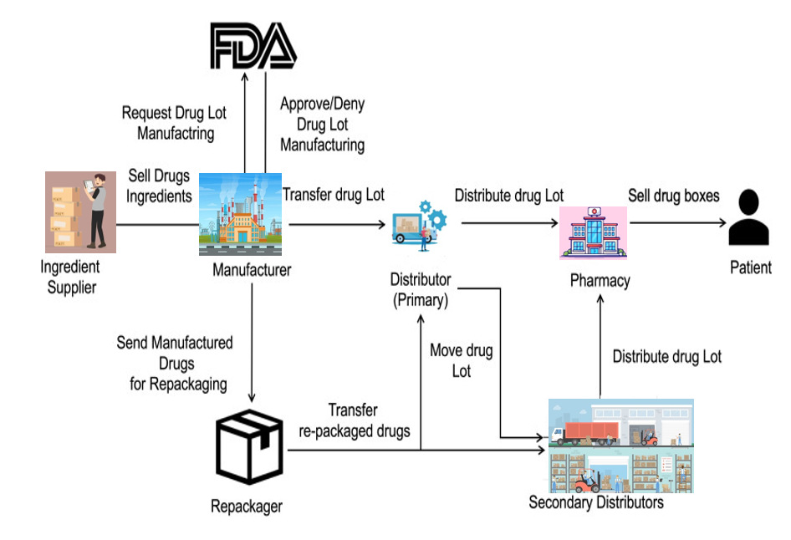

# BENEFITS AND LIMITATIONS

**Benefits:**

1. Logistics and Distribution: - Medical supplies are distributed and transported in an efficient manner. Optimizing routes to ensure deliveries on time.
2. Traceability and Serialization: - Putting in place mechanisms to monitor the flow of goods. Verifying authenticity and avoiding fake goods.
3. Encouraging Sustainability[5] and Ethical Practises: By offering transparency into the production, and distribution processes, blockchain technology may encourage sustainability and ethical

practises throughout the medical supply chain.

1. Compliance with Regulations: - Following the rules and guidelines pertaining to healthcare. Records and filings necessary for conformity.

# Limitations:

* Stakeholder buy-in is necessary for the broad implementation of blockchain-based solutions in the medical supply chain. This includes manufacturers, distributors, healthcare providers, and governmental organizations[6]. Encouraging adoption requires addressing issues with cost, complexity, and regulatory compliance.
* Change management and education: The use of blockchain technology necessitates considerable adjustments to workflows and procedures, which may call for in-depth instruction and training for staff members throughout the supply chain. Adoption[7] success depends on overcoming opposition to change and creating a seamless transition.
* Long-Term Sustainability and Maintenance: It's critical to guarantee the long-term sustainability and upkeep of blockchain-based solutions as these technologies develop. This entails taking care of any obsolescence, preserving compatibility with upcoming technologies, and offering consumers continuous support.

# PROPOSED SYSTEM

Supply chain management is a critical aspect of the pharmaceutical industry[8], as it ensures the timely and efficient delivery of essential drugs to end users. Dual-use drugs are those drugs that have both medical and non-medical applications. However, the management of dual-use drugs presents additional challenges, due to the possibility of misuse, diversion, and tampering[9].TrackX24/7 investigates the use of blockchain technology in the supply chain management of dual-use drugs. The consensus algorithm inherent in blockchain technology makes it an ideal solution for preventing the manipulation and illegal export of dual-use drugs. In order to trace the transit of drugs from one actor role to another, the DApp uses QR codes. End users, manufacturers, distributors, and logistics are all involved in the actor's role. A collaboration is initially formed with the manufacturer after the manufacturer's legitimacy has been confirmed using the firm license and NOC. The Interplanetary File System (IPFS) is used to store these important documents in decentralized storage, and a hash code is generated and kept in the blockchain. Drug information like name, dosage, batch number, contact information, and package inserts (documents providing drug-related information) is recorded on the blockchain. The drug information provided by the manufacturer once a partnership has been established following background checks is maintained on the blockchain. Before dispatching out the drugs, a QR code is created and affixed with the batch number. To authenticate the seamless flow of drugs from one point of contact to another, every actor role must scan the QR code. These logs are stored on a blockchain and can be used in the future to track down medicine counterfeiting. In addition, manufacturers and end users exchange a secret code that is used to halt the supply chain and confirm that the drug has indeed reached the intended end user.

# RESULTS AND DISCUSSION

The transfer of medical products from the producer to the patient may be tracked in a safe, transparent, and unchangeable manner thanks to blockchain technology, which has the potential to completely transform medical supply chain management (MSCM). The following are some possible outcomes of implementing blockchain in MSCM: Better Provenance and Traceability: Blockchain technology can produce an auditable, unchangeable record of each transaction involving medical goods, from patient administration to production. Enhancing resource allocation, preventing diversion and counterfeiting, and ensuring the validity and provenance of items are all made possible by traceability. Here in Streamlined Order Processing and Payments[10] is by automating order processing and payments, smart contracts may minimise mistakes and manual labour. Automation has the potential to increase productivity, decrease administrative burden, and guarantee order and payment fulfilment on time.

Blockchain may also be used to create a safe and verifiable record of compliance with intricate regulatory requirements in the healthcare and pharmaceutical sectors[11] through enhanced regulatory compliance. This can cut compliance costs, encourage adherence to ethical practises, and lessen the likelihood of audits and fines. Blockchain's real-time data insights may be used to forecast supply and demand patterns, averting overstocking and medication shortages. This can save needless inventory expenditures and guarantee that patients have access to important drugs when they need them

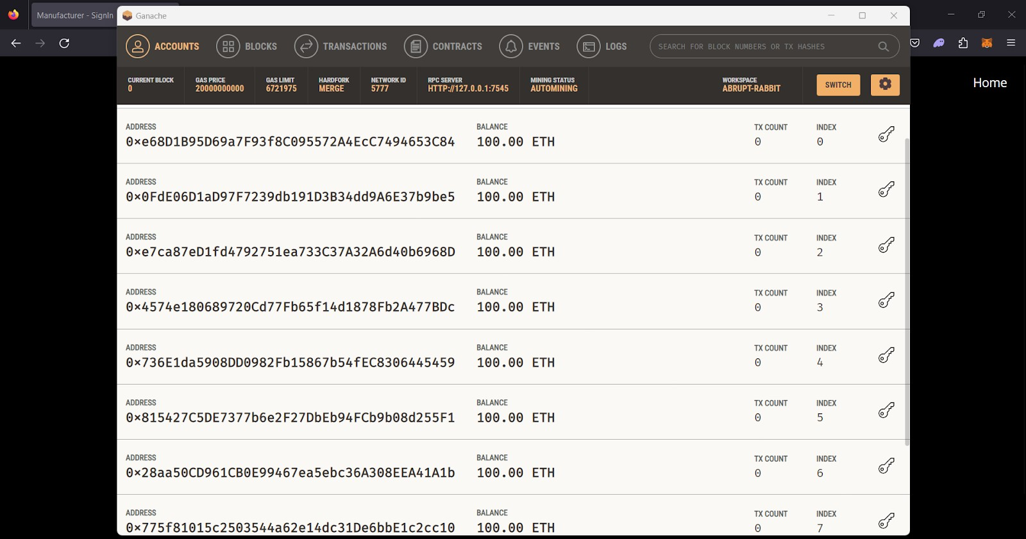

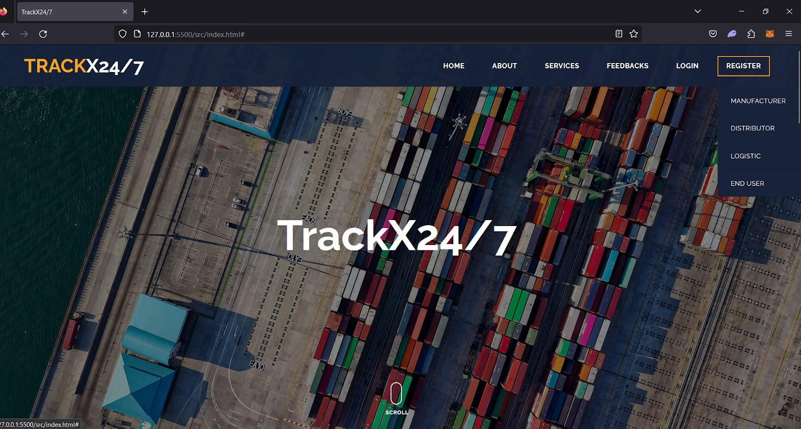

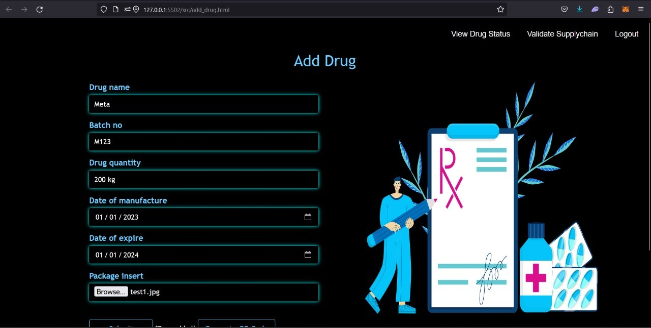

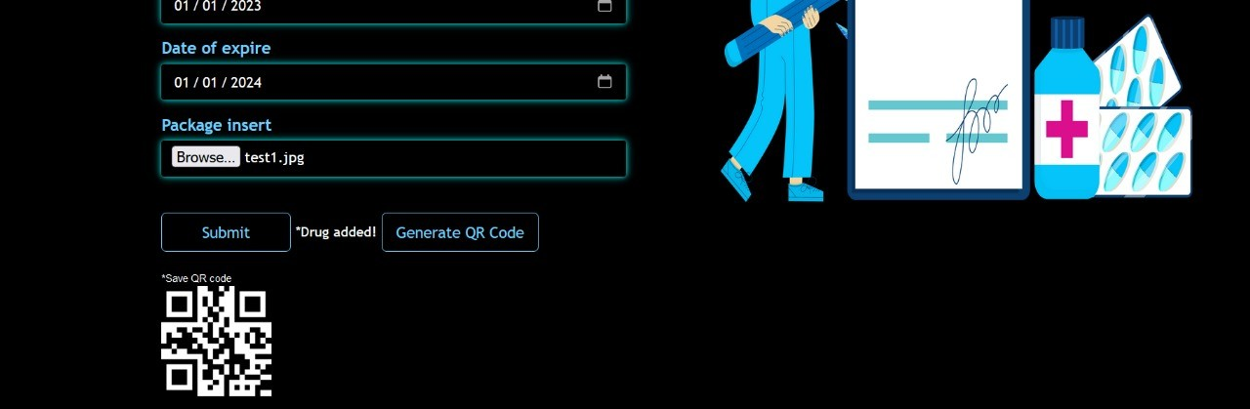

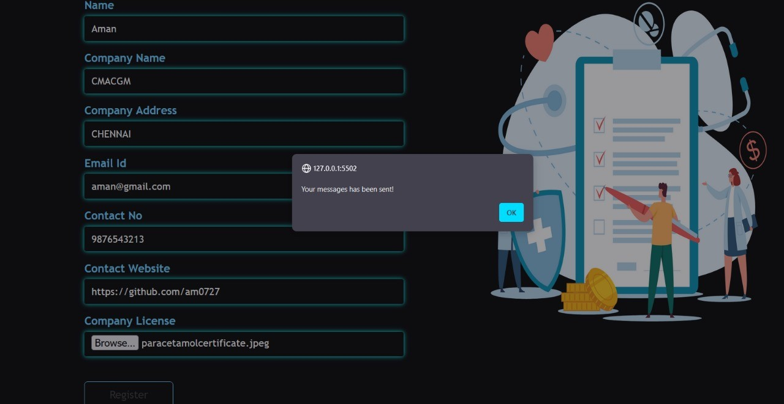

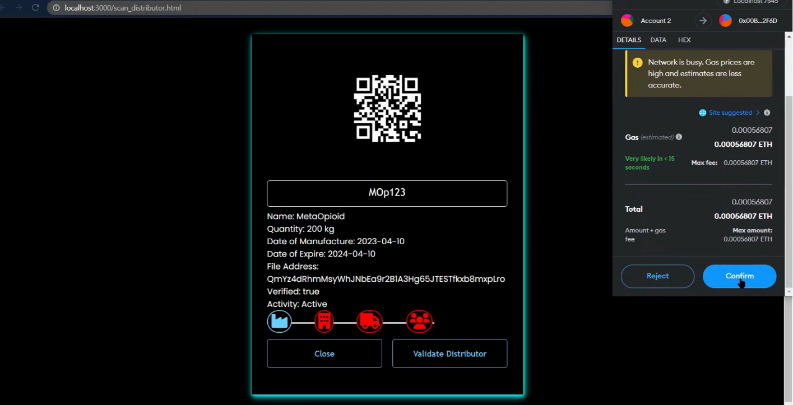

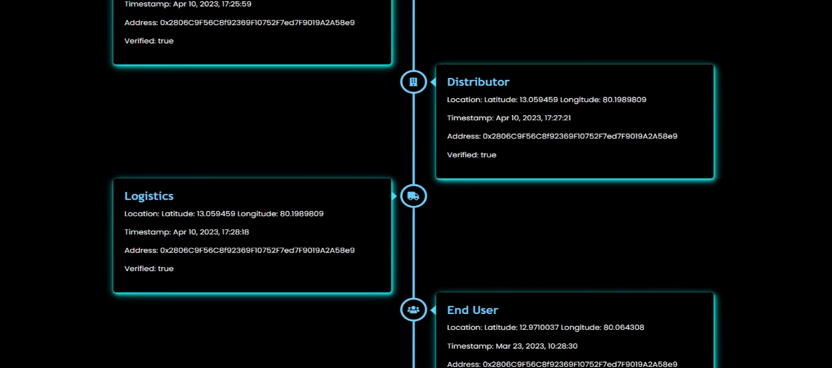

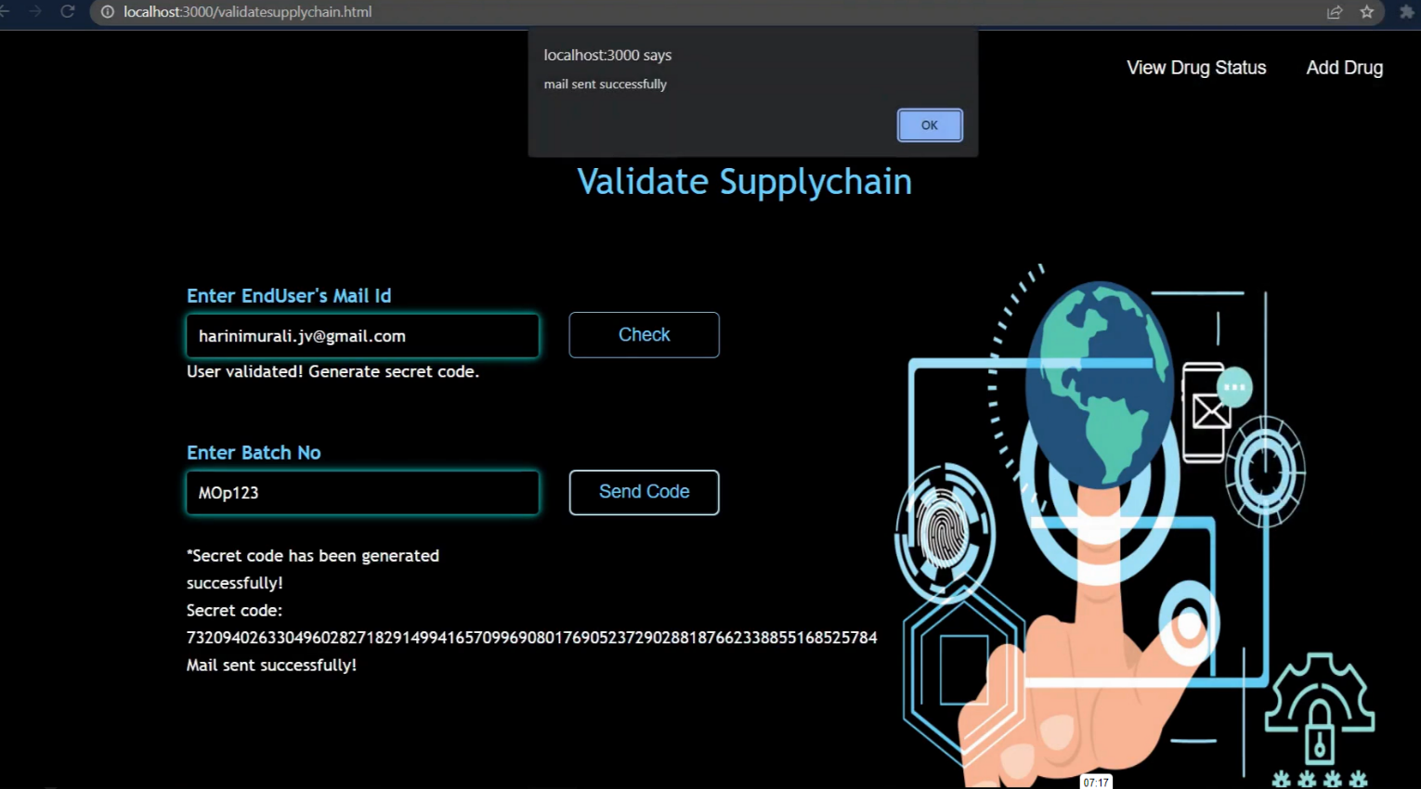

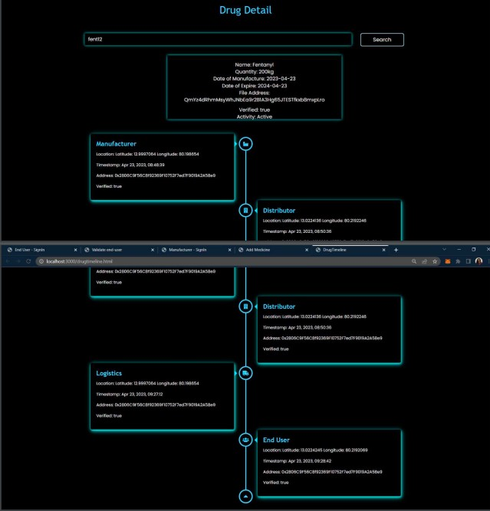

# CONCLUSION AND FUTURE WORKS

**CONCLUSION**

Medical supply chain management, or MSCM, is the intricate and vital process of locating, acquiring, storing, distributing, and monitoring medical goods. It is essential to making sure patients have access to the drugs and supplies they require for high-quality medical care.

Significant technological and innovative developments in recent years have the potential to completely change MSCM. Among these developments are:

With blockchain, the flow of medical goods from the producer to the patient may be tracked securely and openly. This can guarantee that patients are getting the right prescription and help avoid drug diversion and counterfeiting.

Numerous manual MSCM tasks, such tracking and confirming the flow of commodities, may be automated using AI. Costs can be cut and productivity raised by doing this and also Blockchain enhancement.These innovations have the power to completely transform MSCM[12] by enhancing its efficiency, security, and transparency. Nevertheless, in order to properly utilise the promise of these technologies, a number of obstacles must be overcome. These difficulties consist of:

Cost: Putting innovative technology into practise might be costly.

Regulation: The application of new technologies in MSCM is not yet covered by a defined regulatory framework.

Privacy: Care must be taken while implementing new technology to safeguard patient privacy.

The potential advantages of emerging technology for MSCM are substantial, notwithstanding these difficulties. We may anticipate seeing these technologies becoming more and more significant in the healthcare sector as they advance upcoming improvement..Future improvements to MSCM can be made in a number of additional areas as well as the technologies already listed. These consist of:

Increased cooperation[13] between stakeholders: To increase efficiency and transparency, all parties involved in

the medical supply chain—manufacturers, distributors, and hospitals—need to collaborate more closely. Increasing research and development expenditures is necessary to create new technologies and solutions that will enhance MSCM even further.

Creation of precise regulatory rules: To guarantee that new technologies are applied in a responsible and safe way, precise regulatory standards are required. We can continue to enhance MSCM and guarantee that patients have access to the medical supplies they require to obtain high-quality treatment by tackling these issues and seizing the possibilities mentioned above.

# FUTURE SCOPE

The transfer of medical products from the producer to the patient may be tracked in a safe, transparent, and unchangeable manner thanks to blockchain technology[14], which has the potential to completely transform medical supply chain management (MSCM). We should anticipate seeing a broad deployment of blockchain-based solutions throughout the medical supply chain environment as the technology develops and usage increases.

The following are a few fascinating potential uses of blockchain in MSCM:

Enhanced Counterfeit Detection and Prevention: The traceability and immutability of blockchain technology can aid in preventing the supply chain from becoming infiltrated by counterfeit medications. Blockchain technology can provide real-time verification of a drug's origin and production history by establishing a secure record of its authenticity. This can shield people against fake drugs that can be harmful to their health.

Personalised Medication Management: By giving patients safe access to their medical data, which include information on allergies, prescription history, and dose guidelines, blockchain can help with personalised medication management. With the use of this data, doctors may provide patients tailored advice and notifications that will help them take their medications as prescribed and prevent any negative side effects.

Anticipatory Supply Chain Management: Predictive analytics enabled by blockchain technology can assist in anticipating demand and streamlining inventory control, lowering the possibility of stockouts and overstocking. Blockchain algorithms can estimate demand for certain pharmaceuticals and automatically trigger replenishment orders by analysing previous data and current patterns. This ensures that essential supplies are always accessible when needed.

Collaboration in the Cross-Border Supply Chain: Blockchain can promote cross-border cooperation, making it possible to trace medical supplies as they travel across nations and areas with ease. This can expedite import-export procedures, cut down on hold-ups, and raise the general effectiveness of international supply chains.

Transparency in the Patient-Centric Supply Chain: Blockchain technology can provide patients access to information about the pharmaceutical supply chain. Blockchain can contribute to increasing patient trust and confidence in the healthcare system by giving them access to information about the origin, manufacturing process, and distribution routes of their pharmaceuticals[15].

Fighting Illegal Drug Trafficking and Grey Markets: The traceability and transparency of blockchain technology can aid in the fight against illicit drug trafficking and grey markets. Blockchain technology may uncover and disrupt illicit channels by tracing the transfer of drugs from manufacture to distribution, guaranteeing that patients receive authentic prescriptions from approved suppliers.

Enabling medication Development and Clinical studies: Blockchain technology can make it easier to share transparent and safe data for medication development and clinical studies. Blockchain can improve clinical research integrity and speed up the creation of new medications by offering a tamper-proof record of patient data.

Encouraging Ethical and Sustainability Practises: Throughout the medical supply chain, blockchain may encourage ethical and sustainable practises. Blockchain can help stakeholders spot and get rid of unethical practises like child labour and unsustainable resource exploitation by bringing transparency to the sourcing, production, and distribution processes.

# REFERENCES

1. Moulouki Reda, Dominique Bernard Kanga, Taif Fatima, Mohamed Azouazi, Blockchain in health supply chain management: State of art challenges and opportunities,Procedia Computer Science,Volume 175,2020,Pages 706-709,ISSN 1877-0509,
2. Nanda SK, Panda SK, Dash M. Medical supply chain integrated with blockchain and IoT to track the logistics of medical products. Multimed Tools Appl. 2023 Mar 4:1-23. doi: 10.1007/s11042-023-14846-8. Epub ahead of print. PMID: 37362711; PMCID: PMC9985095.
3. Yang, C., Zheng, Z.: Analysis on pharmaceutical supply chain in china and its operational process. Logist. Sci-Tech 34(3), 54–56 (2011)
4. Liang, L.: Analysis of supply chain finance development based on block chain technology: a case study of pharmaceutical industry. Chin. J. Commer. 25, 7–8 (2018)
5. King, B., Zhang, X.: Securing the pharmaceutical supply chain using RFID. In: International Conference on Multimedia and Ubiquitous Engineering. IEEE (2007)
6. Kumar, R., Tripathi, R.: Traceability of counterfeit medicine supply chain through Blockchain. In: 2019 11th International Conference on Communication Systems and Networks (COMSNETS), Bengaluru, India, pp. 568–570 (2019). https://doi.org/10.1109/comsnets.2019.8711418
7. Aich, S., Chakraborty, S., Sain, M., Lee, H., Kim, H.: A review on benefits of IoT integrated Blockchain based supply chain management implementations across different sectors with case study. In: 2019 21st International Conference on Advanced Communication Technology (ICACT), PyeongChang Kwangwoon_Do,

Korea (South), pp. 138–141 (2019). https://doi.org/10.23919/icact.2019.8701910

1. Mo, B., Su, K., Wei, S., Liu C., Guo, J.: A solution for Internet of Things based on Blockchain technology. In: 2018 IEEE International Conference on Service Operations and Logistics, and Informatics (SOLI),

Singapore, pp. 112–117 (2018). https://doi.org/10.1109/soli.2018.847677

1. Yang, Y., Mao, J., Hu, C.: Study on the application of safe RFID and block chain technology in the anti counterfeiting and traceability of bottled wine. Appl. IC 35(3), 66–69 (2018)
2. Chen, S., Shi, R., Ren, Z., Yan, J., Shi Y., Zhang, J.: A Blockchain-based supply chain quality management framework. 2017 IEEE 14th International Conference on e-Business Engineering (ICEBE), Shanghai, pp. 172–176 (2017). https://doi.org/10.1109/icebe.2017.34
3. Zhu, T., Yao, X., Xu, Y., et al: Cross-border remittance tracing platform based on fabric. J. Cyber Secur. 3(3) (2018)
4. W. G. Chambliss, W. A. Carroll, D. Kennedy, D. Levine, M. A. Moné, L. D. Ried, M. Shepherd, and M. Yelvigi, ‘‘Role of the pharmacist in preventing distribution of counterfeit medications,’’ J. Amer. Pharmacists Assoc., vol. 52, no. 2, pp. 195–199, Mar. 2012.
5. T. Guardian. (2017). 10% of Drugs in Poor Countries Are Fake, Says WHO. Accessed: Jun. 3, 2020. [Online]. Available: https://[www.theguardian.com/global-development/2017/nov/28/10-](http://www.theguardian.com/global-development/2017/nov/28/10-) of-drugs-in-poor-countries-are-fake-says-who
6. H. R. Funding. (2017). 20 Shocking Counterfeit Drugs Statistics. Accessed: Jun. 3, 2020. [Online].

Available: https://healthresear. chfunding.org/20-shocking-counterfeit-drugs-statistics

1. A. Seiter, ‘‘Health and economic consequences of counterfeit drugs,’’ Clin. Pharmacol. Therapeutics, vol. 85, no. 6, pp. 576–578, Jun. 2009.