Complete results, explained: what the model finds for osteopenia and osteoporosis
Written 2026-10-25 from the committed pipeline outputs in outputs/ (shipped run of OsteoporosisML.py) plus three exploratory runs done outside the pipeline (Section 12). Every number in Sections 1–11 comes from a file in outputs/; the file name is given each time so it can be checked.

The short version
- What we predict: whether a woman's bone scan (DXA) would show weak bones, using only things she can tell her doctor or that a nurse can measure. No scan and no blood test.
- Two outcomes: osteopenia or worse (T-score ≤ −1.0, 645 of 1,111 women) and osteoporosis (T-score ≤ −2.5, 76 of 1,111 women).
- How well it works: the model ranks women correctly about 3 times in 4 for osteopenia+ (AUC 0.747) and about 4 times in 5 for osteoporosis (AUC 0.786).
- Compared with the free OST formula (0.2 × (weight − age)): a statistical tie on both outcomes. OST scores 0.739 and 0.780.
- Why: body weight carries almost all of the signal, and age adds a little. OST already uses both. The other 14 questions together add about +0.016, which isn't measurably different from zero.
- Nothing else we tried helped: vitamin D, physical activity, sleep, depression score, rheumatoid arthritis, and later medications and weight history.
- The one positive signal is exploratory and not yet in the pipeline. When all races are included (2,820 women), the model beats OST for osteoporosis by +0.021 [+0.008, +0.035].

1. What exactly are we predicting?

The T-score
A DXA scan measures bone mineral density (BMD) at the hip. The T-score compares a woman's BMD with the average of healthy young women:
- T = 0: same as a healthy 30-year-old
- T = −1: one standard deviation below
- T = −2.5: two and a half standard deviations below
This project uses the lower of the femoral-neck and total-hip T-scores (the WHO/ISCD rule). It uses the NHANES III young non-Hispanic White female reference values.

The three bone groups and the two prediction targets
Group | T-score | Women | Share
Normal | above −1.0 | 466 | 42%
Low bone mass (osteopenia) | −2.5 to −1.0 | 569 | 51%
Osteoporosis | −2.5 or lower | 76 | 7%
Total |  | 1,111

The model is trained separately for two yes/no questions:
Target | Who counts as "yes" | Yes | No
Osteopenia+ (at_risk) | Low bone mass or osteoporosis (T ≤ −1.0) | 645 (58%) | 466
Osteoporosis | Osteoporosis only (T ≤ −2.5) | 76 (7%) | 1,035

"Osteopenia+" means osteopenia or worse, so it includes the 76 women with osteoporosis. It's the "early warning" target. Osteoporosis is the "treatment-level" target.

Who is in the study
Women from five NHANES survey cycles (2005–06, 2007–08, 2009–10, 2013–14, 2017–20) who are:
- non-Hispanic White
- aged 50–65
- have a femoral-neck DXA result
- postmenopausal, meaning no period in the last 12 months
That gives 1,111 women. A duplicate-respondent check confirms nobody is counted twice.

2. How the three groups differ
From outputs/table_one.csv. Mean (SD) or %.
Characteristic | Normal (466) | Low bone mass (569) | Osteoporosis (76) | What it shows
Age, years | 57.8 (4.5) | 58.5 (4.4) | 59.5 (3.9) | Small rise with worse bone, under 2 years in total
Weight, kg | 84.6 (17.1) | 71.8 (14.9) | 62.5 (14.4) | The biggest difference: 22 kg between normal and osteoporosis
BMI, kg/m² | 31.5 | 27.3 | 24.4 | Same story as weight
Years since menopause | 11.5 | 12.4 | 15.6 | Longer after menopause means worse bone
Ever used estrogen | 47.7% | 41.9% | 32.9% | Estrogen users have better bone
Ever smoked | 49.8% | 53.1% | 71.1% | Smoking is much more common in osteoporosis
Any prior fracture | 12.7% | 17.0% | 27.6% | Fractures double from normal to osteoporosis
Poverty income ratio | 3.4 | 3.2 | 2.2 | Lower income goes with osteoporosis
Diabetes | 13.1% | 8.1% | 6.6% | Diabetes goes with higher BMD (a known paradox; fracture risk is still higher)
Parental hip fracture | 13.3% | 17.3% | 18.6% | Small rise
Family history of osteoporosis | 26.7% | 31.6% | 36.1% | Small rise
Sleep, hours | 7.2 | 7.1 | 6.8 | Slightly less sleep

BMI groups (from outputs/table_one_categories.csv):
- 58% of the osteoporosis group are at normal weight (BMI 18.5–24.9), against 13% of the normal group.
- Only 14% of the osteoporosis group have BMI 30 or more, against 57% of the normal group.
How to read this: heavier women have stronger bones, because carrying more weight loads the skeleton and fat tissue produces estrogen. That single fact drives most of what follows.

3. How the model was built and tested

Inputs (16 model columns from 15 questions)
Age, weight, BMI, years since menopause, ever used estrogen, diabetes, ever smoked, alcohol (none / under 3 / 3 or more drinks a day), any prior fracture, steroid use, poverty income ratio, parental hip fracture, family history of osteoporosis, PHQ-9 depression score, and sleep hours.
DXA and anything derived from it are blocked from the inputs.

Eight models tried
- Five classifiers trained on the yes/no label: logistic regression, elastic-net logistic regression, random forest, LightGBM and XGBoost.
- Three regressors that predict the T-score number itself: Ridge, random forest and LightGBM.

Testing method
- 5-fold cross-validation. The women are split into 5 groups. The model learns on 4 groups and is tested on the 5th, and this rotates so every woman is tested once by a model that never saw her.
- Nested cross-validation. Picking "the best of 8" on the same data that scores it is optimistic. The nested version picks the model inside each training split, then scores it on untouched women. The nested AUC is the honest number. The leaderboard AUC is an upper bound.
- Comparators: OST (0.2 × (weight − age)) and weight alone.
- The difference is tested with a bootstrap (1,000 resamples), which gives a 95% confidence interval. If that interval includes 0, the model and the comparator are not separable.

What AUC means
Pick one woman with the condition and one without. AUC is how often the model gives the higher risk score to the right one. 0.50 is a coin flip and 1.00 is perfect.

4. Result 1 — Osteopenia+ (T ≤ −1.0, 645 women)

Model leaderboard
From outputs/model_leaderboard_osteopenia.csv. Five-fold test AUC; sensitivity and specificity at the default 0.5 cutoff.
Model | Test AUC | Train AUC | Sensitivity | Specificity
Logistic regression (L2) | 0.752 | 0.767 | 69% | 68%
Elastic-net logistic regression | 0.752 | 0.767 | 69% | 68%
Random forest | 0.748 | 1.000 | 68% | 68%
LightGBM | 0.740 | 0.808 | 61% | 73%
XGBoost | 0.736 | 0.833 | 62% | 69%

- Every model lands between 0.736 and 0.752. Simple logistic regression is at the top. The choice of algorithm makes almost no difference.
- The random forest's train AUC of 1.000 is normal for that method: it memorises its training data. The test AUC is what counts.

The honest result
 | AUC
Leaderboard best (optimistic) | 0.752
Nested CV (honest) | 0.747
OST formula | 0.739
Weight alone | 0.737

Comparison | Difference | 95% CI | Verdict
Model vs OST | +0.008 | [−0.008, +0.025] | Not separable
Model vs weight alone | +0.010 | [−0.007, +0.027] | Not separable

Ridge regression on the T-score was chosen in 3 of the 5 nested splits.
What we're seeing: the model ranks women correctly about 75% of the time. A two-number formula does the same: the gap is less than 1 point out of 100, and the interval runs from −0.8 to +2.5 points, so it could easily be zero. Even weight on its own does about as well.

5. Result 2 — Osteoporosis (T ≤ −2.5, 76 women)

Model leaderboard
From outputs/model_leaderboard_osteoporosis.csv.
Model | Test AUC | Train AUC | Sensitivity | Specificity
Elastic-net logistic regression | 0.793 | 0.834 | 75% | 75%
Logistic regression (L2) | 0.790 | 0.837 | 75% | 76%
Random forest | 0.785 | 1.000 | 24% | 97%
LightGBM | 0.770 | 0.924 | 58% | 83%
XGBoost | 0.733 | 0.978 | 45% | 87%

The honest result
 | AUC
Leaderboard best | 0.793
Nested CV | 0.786
OST formula | 0.780
Weight alone | 0.766

Comparison | Difference | 95% CI | Verdict
Model vs OST | +0.007 | [−0.016, +0.030] | Not separable
Model vs weight alone | +0.021 | [−0.005, +0.048] | Not separable

What we're seeing:
- Osteoporosis is easier to rank than osteopenia (about 79% vs 75%). Women with osteoporosis are more extreme, being lighter, older and more often smokers, so they stand out more.
- It's still a tie with OST.
- This target is underpowered. There are only 76 cases for 16 model columns, which is 4.75 events per predictor. The usual minimum is 10. outputs/power_gate.csv flagged this before the analysis ran. So this result is "can't tell", not "proven equal". The confidence interval is about twice as wide as for osteopenia+.
- The random forest's 24% sensitivity isn't a broken model. Only 7% of women have osteoporosis, so the forest's predicted probabilities rarely cross 0.5. Its AUC (0.785), which doesn't depend on a cutoff, is fine. A screening use would need a lower cutoff (Section 8).

6. What drives the predictions

6.1 Each factor's effect, adjusted for all the others
From outputs/clinical_predictor_table.csv, osteopenia+ target. An odds ratio (OR) below 1 means protective, above 1 means more risk; "ns" means not significant. dAUC is how much AUC is lost when that variable is shuffled inside the model.
Predictor | Unit | OR (95% CI) | Effect | dAUC (logistic)
Weight | per 10 kg | 0.51 (0.39–0.65) | Protective | +0.240
Poverty income ratio | per 1 unit | 0.90 (0.82–0.98) | Protective | +0.005
Age | per 5 years | 1.27 (1.07–1.52) | Risk | +0.010
Any prior fracture | yes vs no | 1.76 (1.20–2.74) | Risk | +0.007
Ever used estrogen | yes vs no | 0.59 (0.43–0.76) | Protective | +0.009
Steroid use | yes vs no | 1.49 (0.98–2.39) | ns | +0.003
BMI | per 5 kg/m² | 1.12 (0.80–1.57) | ns (see note) | +0.000
Years since menopause | per 5 years | 1.07 (0.97–1.17) | ns | +0.002
Alcohol 3+/day | vs under 3 | 0.71 (0.43–1.07) | ns | +0.003
All others (sleep, PHQ-9, smoking, diabetes, family history, parental hip fracture, no alcohol) |  | CIs include 1 | ns | about 0

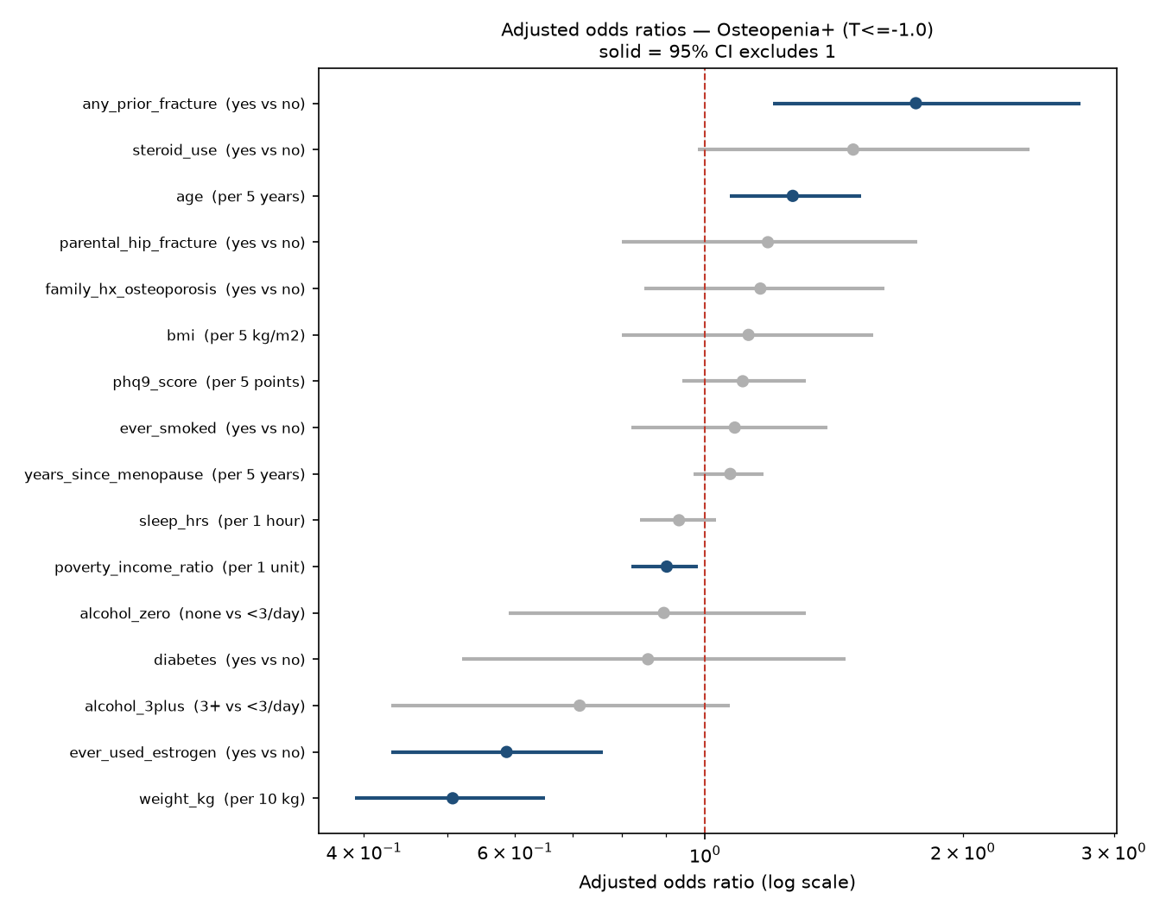
Adjusted odds ratios for osteopenia+. Solid dots: the 95% CI excludes 1.
What we're seeing:
- Each extra 10 kg of body weight halves the odds of osteopenia+.
- Each 5 years of age raises the odds by 27%.
- A past fracture raises the odds by 76%.
- Ever using estrogen lowers the odds by 41%.
- Weight's importance (+0.240) is 24 times that of the next variable (age, +0.010).
- The BMI note: BMI looks unimportant only because weight is already in the model and the two carry the same information. Take them out together and the model collapses (6.2).

6.2 Removing whole groups of variables
From outputs/model_block_ablation_osteopenia.csv. The full model scores 0.755 here.
Test | Variables left | AUC | Loss vs full | 95% CI | Matters?
Drop body size (BMI + weight) | 13 | 0.603 | 0.151 | [+0.115, +0.187] | Yes, hugely
Drop all menopause/hormone variables | 13 | 0.749 | 0.006 | [−0.000, +0.013] | No
Drop all lifestyle variables | 13 | 0.756 | −0.001 | [−0.004, +0.003] | No
Drop all history/family variables | 11 | 0.751 | 0.004 | [−0.003, +0.011] | No
Keep only age + weight (OST's inputs) | 2 | 0.739 | 0.016 | [−0.000, +0.031] | No: 2 variables do nearly the full job
Keep only age + BMI | 2 | 0.718 | 0.037 | [+0.016, +0.057] | Yes (BMI is a worse substitute for weight)

What we're seeing: without body size the model drops to 0.603, close to guessing. Remove any other group entirely and nothing measurable happens. Age and weight alone reproduce OST's 0.739 to three decimals. The other 14 columns add +0.016, and that interval touches zero.

6.3 Removing one variable at a time
From outputs/model_variable_ablation_osteopenia.csv. After correcting for testing 15 variables (Holm correction), only weight is significant on its own (loss +0.018 [+0.007, +0.030]). Estrogen use is next (+0.006, uncorrected p = 0.022, but not significant after correction). Everything else is within noise.

7. Are the predicted risks believable? (Calibration)
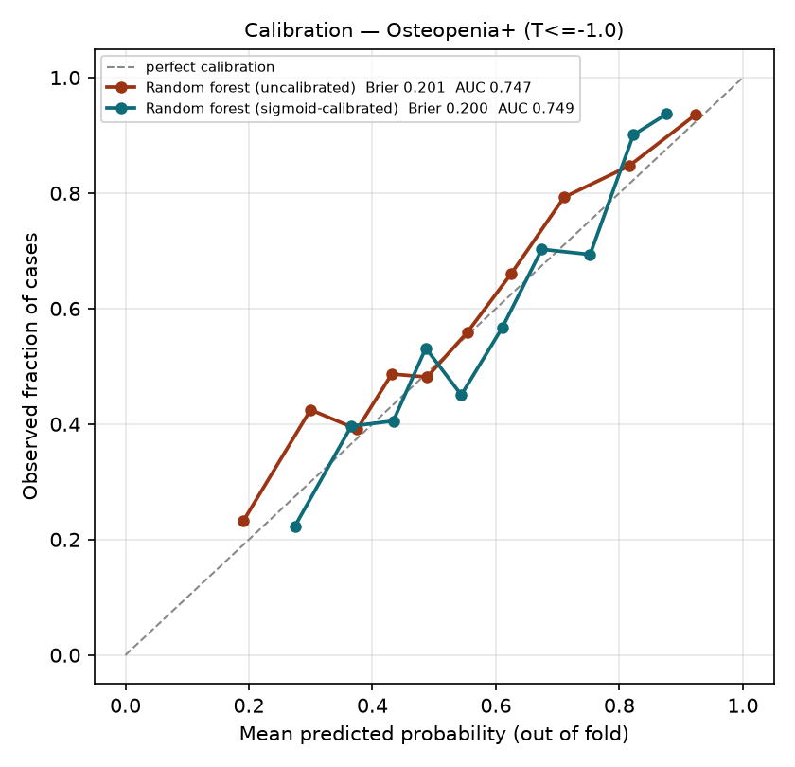
Calibration for osteopenia+: predicted risk against the share who actually had osteopenia+.
- The dashed diagonal is perfect: "predicted 60%" would mean 60% actually have it.
- Both forest curves follow the diagonal fairly closely, with some wobble.
- The Brier score (average squared error of the risk, lower is better) is 0.200 calibrated and 0.201 raw. For comparison, always guessing 58% would score about 0.24.
What we're seeing: when the model says "70% risk", roughly 70% of those women really do have osteopenia+. The probabilities can be used to set a referral cutoff.

8. What it would mean in a clinic

8.1 Scan the top-ranked women
From outputs/referral_table.csv, osteopenia+, using the nested CV ranks.
Rule | Scans ordered | Cases found (of 645) | Missed | Share of scans that find a case
Scan everyone | 1,111 | 645 (100%) | 0 | 58%
Scan top 50% | 556 | 415 (64%) | 230 | 75%
Scan top 40% | 446 | 348 (54%) | 297 | 78%
Scan top 30% | 335 | 281 (44%) | 364 | 84%
Scan top 25% | 280 | 243 (38%) | 402 | 87%

8.2 Scan everyone above a risk cutoff
From outputs/threshold_sweep.csv, using the calibrated forest (AUC 0.749).
Cutoff | Scans ordered | Cases found | Missed | Scans saved vs scanning all
50% | 692 | 482 (75%) | 163 | 419
40% | 895 | 579 (90%) | 66 | 216
35% | 965 | 603 (93%) | 42 | 146
30% | 1,030 | 631 (98%) | 14 | 81
Scan all | 1,111 | 645 (100%) | 0 | 0

What we're seeing:
- Scanning the top half finds 415 cases. A random half would find about 323, so the score finds about 90 more for the same number of scans.
- A 40% cutoff catches 90% of cases while skipping 216 scans (about 19%).
- Because the model ties OST, OST would give very nearly the same savings for free. These tables show what any weight-and-age score can do.

9. Extra variables tested (pre-specified arms)
From outputs/prespecified_arms.csv, osteopenia+. Each arm was refit on the same women with and without the new variable.
Arm | Variable(s) added | Women | Gain in AUC | 95% CI | Verdict
C | Vitamin D + calcium intake | 930 | −0.002 | [−0.006, +0.001] | No gain
D | Blood vitamin D (25(OH)D) | 974 | −0.001 | [−0.008, +0.005] | No gain
E | Rheumatoid arthritis | 988 | 0.000 | [−0.001, +0.001] | No gain
F | Depression (PHQ-9 ≥ 10) | 1,110 | −0.001 | [−0.002, +0.000] | No gain
I | Physical activity (MET-minutes + sitting) | 932 | +0.004 | [−0.002, +0.009] | No gain
I2 | Moderate + vigorous minutes + sitting | 932 | +0.003 | [−0.002, +0.009] | No gain
J | Sleep in five bands | 1,107 | −0.001 | [−0.007, +0.006] | No gain

What we're seeing: every arm lands within ±0.004 of zero. Nutrition, blood vitamin D, activity, sleep, mood and arthritis add nothing once weight and age are known. These tests were written down before running, so the null results count as real findings.

Sensitivity checks (do the choices matter?)
- Diabetes coding (G1: borderline counted as diabetic; G2: diabetes dropped): AUC stays at 0.755.
- Bone site (H1: femoral neck only, 618 cases, AUC 0.747; H2: total hip only, 424 cases, AUC 0.776). Different outcomes, so these aren't subtracted from the headline. The model works at both sites.

10. Robustness checks

3-fold instead of 5-fold cross-validation
Exploratory run, 2026-10-25, with no code changed.
Target | 5-fold nested AUC | 3-fold nested AUC | Δ vs OST, 3-fold | Verdict
Osteopenia+ | 0.747 | 0.752 | +0.014 [−0.003, +0.029] | Not separable (same)
Osteoporosis | 0.786 | 0.790 | +0.011 [−0.013, +0.034] | Not separable (same)

Random forest leaf size
From outputs/rf_leaf_tuning.csv. Test AUC varies only from 0.745 to 0.752 across leaf sizes 1–50, so tuning doesn't change the conclusion.

11. The data leak we found and fixed
From outputs/auc_decomposition.csv. NHANES re-released 2017–2018 inside the 2017–2020 files under new ID numbers, so 176 women were counted twice. Copies of the same woman sat in both the training and test groups, and the model "recognised" them.
Stage | Women | Best AUC | OST | Gain over OST | Beats OST?
A. With duplicates, all DXA women | 1,484 | 0.836 | 0.747 | +0.089 | Yes (false)
B. With duplicates, postmenopausal | 1,272 | 0.831 | 0.733 | +0.098 | Yes (false)
C. Duplicates removed, all DXA women | 1,308 | 0.763 | 0.753 | +0.010 | No
D. Duplicates removed, postmenopausal (final) | 1,111 | 0.755 | 0.739 | +0.016 | No

What we're seeing: removing duplicates alone dropped the AUC by 0.073 (A → C), and the "beats OST" result disappeared. Restricting to postmenopausal women cost almost nothing (−0.005, A → B). All pre-fix AUCs (0.810, 0.806, 0.833) are withdrawn.

12. Exploratory results (outside the pipeline — not yet presentable)
These came from scratch scripts that import the pipeline without changing it. They need to be added to OsteoporosisML.py properly before being presented.

12.1 All races included (2,820 postmenopausal women aged 50–65)
1,453 with osteopenia+ and 156 with osteoporosis.
Target | Model (nested) | OST | Δ vs OST [95% CI] | Verdict
Osteopenia+ | 0.757 | 0.751 | +0.007 [−0.001, +0.014] | Not separable
Osteoporosis | 0.822 | 0.800 | +0.021 [+0.008, +0.035] | Beats OST

The 3-fold version gives the same verdicts: osteoporosis +0.022 [+0.007, +0.038].
OST AUC by race:
Race | Women | OST, osteopenia+ | OST, osteoporosis (cases)
Non-Hispanic White | 1,111 | 0.739 | 0.780 (76)
Non-Hispanic Black | 660 | 0.768 | 0.924 (18)
Mexican American | 441 | 0.692 | 0.797 (16)
Other Hispanic | 315 | 0.744 | 0.746 (17)
Other / multi-racial | 293 | 0.738 | 0.705 (29)

What we're seeing:
- For osteopenia+, more women doesn't help. It's still a tie.
- For osteoporosis, doubling the cases (76 → 156) let the model pull ahead by a small but real 2 points.
- OST works similarly across races for osteopenia+ (0.69–0.77). Each group's osteoporosis numbers rest on too few cases to compare.

12.2 Medications and weight history (24 pre-specified tests)
Medication arm: 8 drug classes (PPIs, antidepressants, thiazides, loop diuretics, thyroid hormone, anticonvulsants, aromatase inhibitors, TZDs). Weight-history arm: weight change since age 25, distance below heaviest weight, change over the past year. Height-loss arm: reported height minus measured height. Each was tested on three cohorts (White, all races, all races excluding women already on osteoporosis drugs).
- Only one test cleared zero: medications, osteoporosis, all races, +0.008 [+0.000, +0.016]. It lost significance after excluding the 119 women already on osteoporosis drugs (+0.006 [−0.002, +0.016]).
- Weight history and height loss added nothing (about ±0.001).
- With 24 tests, about 1 false positive is expected by chance.

13. Bottom line
Question | Answer
Can a questionnaire model spot weak bones? | Yes. It ranks correctly about 75% of the time for osteopenia+ and 79% for osteoporosis
Is it better than the free OST formula? | No, it's a statistical tie for both outcomes in the main cohort
Why? | Body weight carries the signal and age adds a little. OST uses exactly those two
Does the algorithm matter? | No. All 8 score within a few hundredths, and simple regression is at the top
Do extra questions help? | No: 7 pre-specified arms plus 24 medication and weight-history tests show nothing reliable
Any exception? | Osteoporosis in the all-race cohort, a small real gain of +0.021 (exploratory)
Clinical message | For primary care, OST is near the limit of what questionnaire data can do. Use it.

Limitations to state up front
- The osteoporosis target is underpowered: 4.75 events per predictor against a minimum of 10.
- No external validation yet. All results are cross-validated within NHANES.
- NHANES survey weights are not applied, so results describe this sample, not the US population.
- T-scores use a White reference for every woman (the ISCD convention).
- Cross-sectional data. The model detects low BMD today; it doesn't predict future fractures.

Glossary
- AUC: the chance the model ranks a random case above a random non-case. 0.5 is chance, 1.0 is perfect.
- Nested cross-validation: testing that keeps model selection away from the test data. Gives the honest AUC.
- 95% CI: the range the true value plausibly lies in. If a difference's CI includes 0, the two methods are "not separable".
- Odds ratio (OR): above 1 raises risk, below 1 lowers it. 0.51 per 10 kg means the odds halve for every extra 10 kg.
- Sensitivity: the share of real cases the model flags.
- Specificity: the share of non-cases the model correctly clears.
- Calibration / Brier score: whether a predicted "70%" really means 70%. Brier is lower for better probabilities.
- Events per predictor (EPP): cases divided by model inputs. Below 10 means the estimates are unstable.
- OST: Osteoporosis Self-assessment Tool, 0.2 × (weight in kg − age in years). Lower means higher risk.

