Dif.Pojac s BI-polar tranz
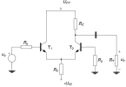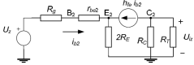
I_{BQ1}=I_{BQ2}=(U_{EE}-U_{BEQ})/R_{g}+2(1+β)R_{E} r_{rb1}=r_{be2}=U_{T}/I_{BQ2} u_{z}=(u_{g1}+u_{g2})/2 u_{d}=u_{g2}-u_{g1}
A_{Vz}=(-h_{fe} R_{C}||R_{T})/R_{g}+r_{be2}+2R_{E}(1+h_{fe}) A_{Vd}=(-h_{fe}R_{C}||R_{T})/2(R_{g}+r_{be2}) fakt potiskivanja ρ=|A_{Vd}/A_{Vz}| U_{iz}=A_{vz}u_{z}+A_{vd}u_{d}
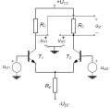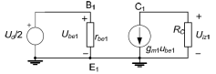
I_{EQ1}=I_{EQ2}=I_{CQ1}=I_{CQ2}=(U_{EE}-U_{BEQ})/2R_{E} U_{CEQ}=U_{CC}+U_{EE}-I_{CQ}(R_{C}+2R_{E})
g_{m1}=g_{m2}=I_{CQ2}/U_{T} u_{iz}=-g_{m}R_{C}u_{d} A_{Vd}=-g_{m}R_{C}
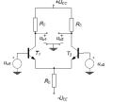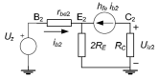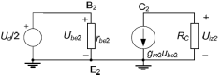
I_{EQ}=(U_{EE}-U_{BEQ})/2R_{E} I_{CQ}=I_{EQ1} β/( β+1) I_{BQ1}=I_{EQ1}/( β +1)
U_{CEQ1}=U_{CC}+U_{EE}-I_{CQ1}R_{C}-2I_{EQ1}R_{E} r_{be}=U_{T}/I_{BQ1} A_{Vz}=(-h_{fe}R_{C})/r_{be2}+2R_{E}(1+h_{fe})
A_{Vd}=(-h_{fe}R_{C})/2r_{be2} U_{ulp-p}=U_{ul1}/2 U_{izl}=|A_{Vz}|U_{zm}+|A_{Vd}|U_{dm} u_{iz2}=-u_{iz1}
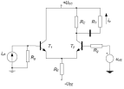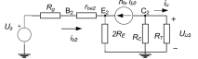
I_{BQ}=(U_{EE}-U_{BEQ})/R_{g}+2(1+ β)R_{E} r_{rb1}=r_{be2}=U_{T}/I_{BQ2} U_{ulzm}=(U_{ul1m}+U_{ul2m})/2
A_{Vz}=(-h_{fe} R_{C}||R_{T})/R_{g}+r_{be2}+2R_{E}(1+h_{fe}) A_{Vd}=0,5(-h_{fe}R_{C}||R_{T})/(R_{g}+r_{be2}) I_{izm}=U_{izm}R_{T}
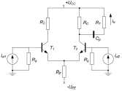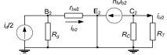
I_{BQ}=(U_{EE}-U_{BEQ})/R_{g}+2(1+ β)R_{E} r_{be2}=U_{T}/I_{BQ2} I_{izm}=A_{iz}I_{zm}+A_{id}I_{dm}
A_{iz}=(-h_{fe}R_{C}R_{g})/(R_{C}+R_{T})(R_{g}+r_{be2}2(1+h_{fe})R_{E}) A_{id}=(-h_{fe}R_{C}R_{g})/2(R_{g}+r_{be2})(R_{C}+R_{T})

Dif.Pojac. sa FET-ovima
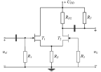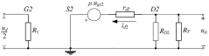
I_{DQ1}=I_{DQ2}=I_{DSS}(1-U_{GSQ}/U_{p})² U_{GSq}=U_{GSQ1}=-2I_{DQ}R_{S} to dvoje nac U_{GSQ}
U_{SQ}=U_{GQ}-U_{GSQ} U_{DQ2}=U_{DQ2}-U_{SQ1}=U_{DD}-I_{DQ}R_{D2}-U_{SQ2} u_{iz}=-A_{Vd}u_{ul}+A_{Vz}u_{ul}/2
g_{m2}=(-2I_{DSS}/U_{p})(1-U_{GSQ}/U_{p})²(1+λU_{DSQ2}) r_{d}=1/ λI_{DQ} μ₂=g_{m2}r_{d}
A_{Vz}=(- μR_{D2}||R_{T})/2R_{S}(1+μ)+r_{d}+R_{D2}||R_{T} A_{Vd}=-0,5(μR_{D2}||R_{T})/r_{d2}+R_{D2}||R_{T}
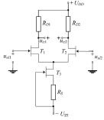 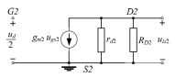U_{GSQ3}=-I_{DQ3}R_{S} I_{DQ}=I_{DSS}(1-U_{GSQ}/U_{p})²
I_{DQ1}=I_{DQ2}=I_{DQ3}0,5 g_{m12}=(-2I_{DSS}/U_{p})(1-U_{GSQ}/U_{p})² A_{Vd}=-0,5g_{m2}R_{D1,2} u_{iz}=2A_{Vd}u_{d}
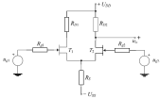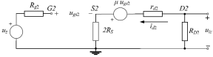
I_{DQ}=I_{DSS}(1-U_{GSQ}/U_{p})² U_{GSQ}=-U_{SS}-2I_{DQ}R_{S} U_{SQ}=U_{GQ}-U_{GSQ} U_{DSQ}=U_{DD}-I_{DQ}R_{D1}-U_{SQ}
i_{d}= I_{DSS}(1-U_{GSQ}/U_{p})²(1+λu_{DS}) g_{m}=(-2I_{DSS}/U_{p})(1-U_{GSQ}/U_{p})²(1+λU_{DSQ}) r_{d}=1/ λI_{DQ}
μ=g_{m}r_{d} A_{Vz}=(-μR_{D2})/2R_{S}(1+μ)+r_{d}+R_{D2} A_{Vd}=-0,5(μR_{D2})/r_{d2}+R_{D2} u_{iz}=A_{vz}u_{z}+A_{vd}u_{d}

Dif.Pojac sa MOS tranz
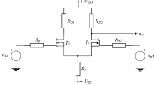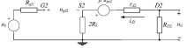
I_{DQ}=I_{DQ1}=I_{DQ2}=0,5K(U_{GSQ}-U_{GS0})² U_{GSQ}=U_{SS}-2I_{DQ}R_{S} U_{SQ}=U_{DD}-I_{DQ}R_{D1}-U_{SQ}
i_{d}=0,5K(u_{GS}-U_{GS0})²(1+λU_{DSQ}) g_{m}=K(u_{GS}-U_{GS0})(1+λU_{DSQ}) r_{d}=1/ λI_{DQ} μ=g_{m}r_{d}
A_{Vz}=(-μR_{D2})/2R_{S}(1+μ)+r_{d}+R_{D2} A_{Vd}=-0,5(μR_{D2})/r_{d2}+R_{D2}
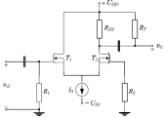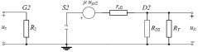
I_{DQ}=I_{o}/2 I_{DQ}=0,5K(U_{GSQ}-U_{GS0})² U_{SQ2}=U_{GQ}-U_{GSQ} U_{DSQ}=U_{DD}-I_{DQ}R_{D2}-U_{SQ2}
i_{d}=0,5K(u_{GS}-U_{GS0})²(1+λU_{DSQ}) g_{m}=K(u_{GS}-U_{GS0})(1+λU_{DSQ}) r_{d}=1/ λI_{DQ} μ=g_{m}r_{d}
A_{Vd}=-0,5(μR_{D2}||R_{T})/r_{d2}+R_{D2}||R_{T} A_{Vz}=besk
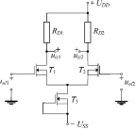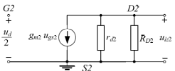
U_{GSQ3}=0 I_{DQ3}=0,5K(U_{GSQ}-U_{GS0})² U_{SQ}=U_{GQ}-U_{GSQ} U_{DSQ}=U_{DD}-I_{DQ}R_{D1}-U_{SQ}
i_{d}=0,5K(u_{GS}-U_{GS0})²(1+λU_{DSQ}) g_{m}=K(u_{GS}-U_{GS0})(1+λU_{DSQ}) r_{d}=1/ λI_{DQ} μ=g_{m}r_{d}
A_{Vd}=-0,5g_{m2}R_{D1,2} A_{Vz}=0 u_{iz1}=A_{Vd}u_{ul1} u_{iz2}=A_{Vd}u_{ul1} u_{iz}=u_{iz2}-u_{iz1}

Kaskadna pojacala
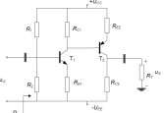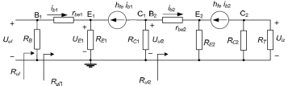
U_{BB}=(U_{CC}+U_{EE})R₂/(R₁+R₂) R_{B}=R₁||R₂ I_{BQ1}=(U_{BB}-U_{BEQ1})/R_{B}+(1+β)R_{E1} I_{BQ2}=(I_{CQ1}R_{C1}+U_{BEQ2})/R_{C1}+(1+β)R_{E2} r_{be1}=U_{T}/I_{BQ1} r_{be2}=U_{T}/-I_{BQ2} R_{ul2}=r_{be2}+(1+h_{fe})R_{E2}
R_{ul1}=r_{be1}+(1+h_{fe})R_{E1} A_{V}=h_{fe}²(R_{C}||R_{T})R_{C1}/(R_{C1}+R_{ul2})R_{ul1} R_{ul}=R_{B}||R_{ul1}

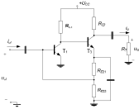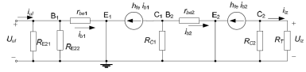
I_{CQ2}=-I_{EQ2}=U_{BEQ1}/R_{E22} U_{CQ1}=U_{BEQ2}+I_{CQ2}(R_{E21}+R_{E22}) I_{CQ1}=(U_{CC}-U_{CQ1})/R_{C1} r_{be1}=U_{T}β/I_{CQ1} r_{be2}=U_{T}β/I_{CQ2} A_{V}=A_{I}R_{p}/R_{ul}
A_{I}=(-h_{fe}²R_{C2}R_{C1}(R_{E21}||R_{E22}))/(R_{C2}+R_{T})(R_{C1}+r_{be2})(R_{E21}||R_{E22}+r_{be1})
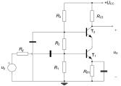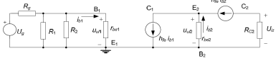
I_{R}=U_{CC}/R₁+R₂+R₃ U_{BQ1}=U_{CC}R₁/R₁+R₂+R₃ -I_{EQ1}=I_{CQ1}=(U_{BQ1}-U_{BEQ1})/R_{E1} r_{be1}=r_{be2}=U_{T}β/I_{CQ2} A_{Vg}=-h_{fe}²R_{C2}(R₁||R₂||r_{be1})/(h_{fe}+1)r_{be1}(R₁||R₂||r_{be1}+R_{g})

Kaskadna pojac sa UNI-polar tranz
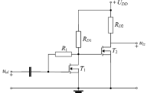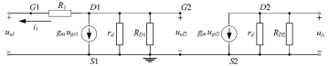
I_{DQ1}=0,5K(U_{GSQ1}-U_{GS0})² U_{GSQ1}=U_{GS0}+-√(2I_{DQ1/K}) U_{DSQ1}=U_{DD}-I_{DQ1}R_{D1} ->R_{D1} U_{DSQ2}=U_{DD}-I_{DQ2}R_{D2} i_{d}=0,5K(u_{GS}-U_{GS0})²(1+λu_{DS}) g_{m}=K(u_{GS}-U_{GS0})(1+λU_{DSQ}) r_{d}=1/λI_{DQ} μ=g_{m}r_{d} A_{V2}=-g_{m}(r_{d}||R_{D2}) i₁=(u_{ul2}-u_{ul})/R₁ u_{ul2}=-(g_{m}u_{ul}+i₁)r_{d}||R_{D1}
A_{V1}=-g_{m}(r_{d}||R_{D1}) A_{V}=g_{m}(r_{d}||R_{D2})g_{m}(r_{d}||R_{D1})
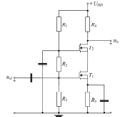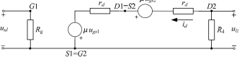
I_{DQ1}=0,5K(U_{GSQ1}-U_{GS0})² U_{GSQ1}=U_{GS0}+-√(2I_{DQ1/K}) R₃=U_{GQ1}(R₁+R₂)/U_{DD}-U_{GQ1} U_{SQ1}=I_{DQ1}R₅ U_{SQ2}=U_{DD}- U_{DD}R₁/(R₁+R₂+R₃)-U_{GSQ2} U_{DSQ2}=U_{DD}-I_{DQ1}R₄-U_{SQ2} U_{DSQ1}=U_{DQ1}-U_{SQ1} i_{d}=0,5K(u_{GS}-U_{GS0})²(1+λu_{DS}) g_{m1}=K(u_{GSQ1}-U_{GS0})(1+λU_{DSQ1})
g_{m2}=K(u_{GSQ2}-U_{GS0})(1+λU_{DSQ2}) r_{d}=1/λI_{DQ} μ=g_{m}r_{d} A_{V}=-R₄μ(1+ μ)/((2+ μ)r_{d}+R₄)
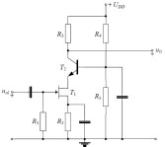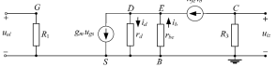
I_{DQ1}=I_{DSS}(1-U_{GS0}/U_{p})² U_{GS0}=U_{p}(1+-√(I_{DQ}/I_{DSS})) R₂=U_{GSQ}/I_{DQ}
U_{DSQ}=R₅U_{DD}/(R₄+R₅)-U_{BEQ}-I_{DQ}R₂ i_{d}=I_{DSS}(1-U_{GS}/U_{p})²(1+λU_{DSQ}) r_{d}=1/λI_{DQ} μ=g_{m}r_{d}
r_{be}=U_{T}/(I_{CQ}/β) u_{iz}=-h_{fe}i_{b}R₃ A_{V}=-g_{m}h_{fe}R₃r_{d}/(r_{d}(h_{fe}+1)+r_{be})
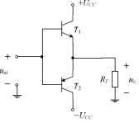P_{CC}=2U_{CC}I_{cm}/π i_{c}=I_{cm}sinωt I_{cm}=U_{CC}/R_{T}
P_{CC}=2U_{CC}²/ πR_{T} P_{RT}=U_{CC}²/2R_{R} p_{Ti,max}=U_{CC}²/4R_{T}
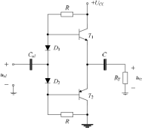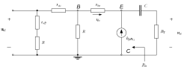
U_{C}=U_{CC}/2 I_{R}=(U_{CC}-U_{C}-U_{BEQ})/R I_{BQ}=(1+β)I_{BQ} r_{d}=U_{T}/I_{DQ}
r_{be}=U_{T}/I_{BQ} τ_{iz}=CR_{T} C=1/(2πR_{T}f_{d})
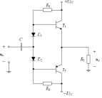P_{R1}=((U_{CC}-U_{BEQ})/R₁)² P_{D}=U_{D}(U_{CC}-U_{BEQ})/R₁) P_{RT,max}=U_{iz,max}²/2R_{T}
P_{Ti}=(U_{CEQ}(U_{CC}-U_{BEQ})/R₁) I_{B,max}=(U_{CC}-U_{BE})/(R₁+(1+β)R_{T}) U_{iz,max}=(1+β)I_{B,max}R_{T}
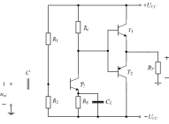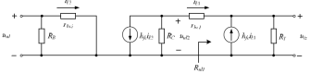

P_{RT,max}=U_{iz,max}²/2R_{T} U_{iz,max}=√(2R_{T}P_{RT,max}) R_{C}= (U_{CC}-U_{BEQ1}-U_{iz,max})/I_{BQ1} I_{BQ1}=U_{iz,max}/(1+β)R_{T} I_{RC}=U_{CC}/R_{C} I_{BQ3}=I_{CQ3}/β I_{RQ}=10I_{BQ3}
U_{BQ3}=-U_{CC}+U_{BEQ3}+R₃(1+β)I_{BQ} R₁=(U_{CC}-U_{BQ3})/I_{BQ} R₂=(U_{CC}+U_{BQ3})/I_{BQ}
A_{Vi}=((1+h_{fe})+R_{T})/(r_{be1}+(1+h_{fe})R_{T}) R_{ul}=(1+h_{fe})R_{T} r_{be3}=U_{T}/I_{BQ3} A_{V3}=-(h_{fe}(R_{c}||R_{ul1})/r_{be3})
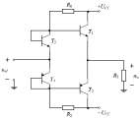P_{T}=U_{CC}I_{cm}/(π)-R_{T}I_{cm}²/(4)+U_{CC}I_{CQ} P_{T,max}=U_{CC}I_{CQ}+U_{CC}²/(R_{T} π²)
I_{CQ}=P_{T,max}/U_{CC} R_{T}=U_{CC}²/( π²(P_{T,max}-U_{CC}I_{CQ})) I_{CQ1}=I_{CQ3}=I_{CQ} R₁=(U_{CC}-U_{BEQ1})/((2+β)I_{CQ})
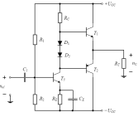 U_{iz,max}=√(2R_{T}P_{RT,max}) I_{B1,max}=U_{izm,max}/(1+β₁)R_{T}
R_{C}= (U_{CC}-U_{BE1}-U_{iz,max})/I_{B1,max} I_{RC}=I_{CQ3} I_{CQ3}=(U_{CC}-U_{BE1})/R_{C} U_{CEQ3}=U_{CC}-U_{D}-I_{CQ3}R_{E} P_{RC}=I_{CQ3}²R_{C} U⁺_{izm,max}=(1+β)R_{T}(U_{CC}-U_{BEQ1})/(R_{C}+(1+β)R_{T})
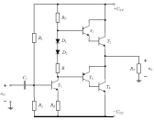I_{R}=(U_{CC}-U_{BEQ1}-U_{BEQ2})/R_{C} I_{R1}=(U_{B5}+U_{CC})/R₂
R=(U_{BEQ2}+U_{BEQ1}-U_{DQ1}-U_{DQ2}-U_{BEQ3})/I_{R} R₁=(U_{CC}-U_{B5})/I_{R1} U_{B5}=-U_{CC}+I_{R}R_{E}+U_{BEQ5}
U⁺_{izm,max}=(U_{CC}-U_{BEQ1}-U_{BEQ2})β₁β₂R_{T}/(R_{C}+β₁β₂R_{T})
I_{R}'=(U_{CC}-2U_{DQ}-U_{CE5,zas}+U_{CC})/(R_{C}+R+R_{E}) U⁻_{idm,max}=-U_{CC}+I_{R}'R_{E}+U_{CE5,zas}-U_{BEQ3}

