**1. CIKLUS (ŽUTA SKRIPTA)**  
  
**Vježba 1.1.**  
**1. Pokus:** Karakteristika laboratorijskog izvora  
**Napon je podešen** na 19.98 V.  
**Izmjerena** je **struja** od 0.187 A.  
**Pokazivanje voltmetra** se smanjuje.  
**Pokazivanje ampermetra** se povećava.  
**Izvor** je isti.  
**Struja** je 0.197 A. **Otpor** je 101.37 Ohma.  
**Pokazivanje voltmetra** se smanjuje.  
**Pokazivanje ampermetra** se povećava.  
**Izvor** je isti.  
**Mjerno područje** 200 Ohma.  
**Izmjereni otpor** je **R** = 4.4. Ohma.  
  
**2.Pokus:** U-I karakteristika nelinearnog elementa

|  |  |  |  |  |  |  |  |  |  |  |
| --- | --- | --- | --- | --- | --- | --- | --- | --- | --- | --- |
| **U, V** | **0** | **1** | **2** | **3** | **4** | **5** | **6** | **8** | **10** | **12** |
| **I, mA** | 0 | 0.130 | 0.172 | 0.201 | 0.215 | 0.235 | 0.259 | 0.300 | 0.317 | 0.330 |

**Vježba 1.2.**  
**1.Pokus:** Elementi, spojevi i zakoni strujnih krugova  
**R(izmjereno)** = 53.7 Ohma  
**Apsolutna pogreška** je 3.7 Ohma.  
**Relativna pogreška** je 0.074%.  
**R(izmjereno)** = 1116 Ohma  
  
**2.Pokus:** Promjenjivi otpor u strujnom krugu

|  |  |  |  |  |  |  |  |
| --- | --- | --- | --- | --- | --- | --- | --- |
| **R3, Ohm** | **0** | **20** | **40** | **60** | **80** | **90** | **beskonačno** |
| **Uv, V** | 0.06 | 1.51 | 2.17 | 2.55 | 2.80 | 2.89 | 3.95 |
| **I1, mA** | 118 | 90 | 77 | 70 | 65 | 62 | 42 |

**3.Pokus:** Potenciometarski spoj

|  |  |  |  |  |  |  |  |  |  |  |  |
| --- | --- | --- | --- | --- | --- | --- | --- | --- | --- | --- | --- |
| **Rx, Ohm** | 0 | 10 | 20 | 30 | 40 | 50 | 60 | 70 | 80 | 90 | 100 |
| **x** | 0L | 0.1L | 0.2L | 0.3L | 0.4L | 0.5L | 0.6L | 0.7L | 0.8L | 0.9L | L |
| **a)U, V** | 0 | 0.51 | 0.90 | 1.23 | 1.55 | 1.91 | 2.32 | 2.81 | 3.42 | 4.23 | 5.71 |
| **b)U, V** | 0 | 0.60 | 1.16 | 1.66 | 2.22 | 2.77 | 3.33 | 3.89 | 4.49 | 5.10 | 5.80 |

**Vježba 1.3.**

|  |  |  |  |  |  |  |
| --- | --- | --- | --- | --- | --- | --- |
| **C4, mikroF** | **10** | **12** | **14** | **16** | **18** | **raste/pada** |
| **Cuk, mikroF** | 6,67 | 6,88 | 7,06 | 7,22 | 7,37 | raste |
| **U1, V** | 4,00 | 4,13 | 4,24 | 4,33 | 4,42 | raste |
| **Upar., V** | 2,00 | 1,88 | 1,76 | 1,67 | 1,58 | pada |

**2.CIKLUS (NARANČASTA SKRIPTA)**  
  
**Vježba 2.1.**  
**1.Pokus:** Vektorski dijagram

|  |  |  |  |  |
| --- | --- | --- | --- | --- |
| **U1, V** | **U2, V** | **U, V** | **I1, mA** | **I2, mA** |
| 6.22 | 7.71 | 12.00 | 10.43 | 7.59 |

**2.Pokus:** Fazorski dijagram

|  |  |  |  |  |  |  |
| --- | --- | --- | --- | --- | --- | --- |
| **I, mA** | **I1, mA** | **I2, mA** | **U(R1), V** | **U(R2), V** | **U(R3), V** | **U(C), V** |
| 18.23 | 6.18 | 12,03 | 6,19 | 6,09 | 7,03 | 4,98 |

|  |  |  |  |  |  |  |
| --- | --- | --- | --- | --- | --- | --- |
| **R3, KOhma** | **0** | **0,5** | **1** | **2** | **3** | **beskonačno** |
| **U(AB), V** | 6,13 | 6,18 | 6,19 | 6,31 | 6,33 | 6,29 |

**Vježba 2.2.**  
a) **f** = 3.014*10^3 Hz  
b) **f** = 3.044*10^3 Hz  
c) -3.012  
d) 56 stup. 26' 8''  
  
a) **f(rez)** = 5.365 * 10^3 Hz **I(rez)** = 5.55*10^(-3)  
b) **Napon** na **zavojnici** je 5V, a na **kondenzatoru** je 0V.

|  |  |  |  |
| --- | --- | --- | --- |
| **frekvencija** | **f < f(rez)** | **f = f(rez)** | **f > f(rez)** |
| **a) serijski** | K - | 0 | I + |
| **b) paralelni** | I + | 0 | K - |

**1.Pokus:** Serijski RC spoj

|  |  |  |  |  |  |  |  |  |  |  |
| --- | --- | --- | --- | --- | --- | --- | --- | --- | --- | --- |
| **f (kHz)** | **1** | **2** | **3** | **4** | **5** | **6** | **7** | **8** | **9** | **10** |
| **U(R), V** | 1.40 | 2,58 | 3,38 | 3,78 | 4,00 | 4,21 | 4,38 | 4,42 | 4,45 | 4,58 |

|  |  |  |  |
| --- | --- | --- | --- |
| **f, kHz** | **2** | **3** | **4** |
| **T(div)** | 10,0 | 6,4 | 5,0 |
| **razlika (div)** | 3 | 2 | 1 |
| **razlika(stupnjeva)** | 108 | 112 st. 30' | 72 |

|  |  |  |  |
| --- | --- | --- | --- |
| **f, kHz** | **2** | **3** | **4** |
| **amplituda (div)** | 2,00 | 2,50 | 2,75 |
| **amplituda (V)** | 4,00 | 5,00 | 5,50 |

|  |  |  |  |  |  |  |  |  |  |  |
| --- | --- | --- | --- | --- | --- | --- | --- | --- | --- | --- |
| **f(kHz)** | **1** | **2** | **3** | **4** | **5** | **6** | **7** | **8** | **9** | **10** |
| **U(R)** | 0,60 | 1,40 | 2,20 | 3,20 | 4,38 | 4,42 | 3,80 | 3,20 | 2,60 | 2,80 |
| **U(C)** | 5,00 | 5,40 | 6,00 | 6,80 | 7,00 | 6,10 | 4,50 | 3,40 | 2,60 | 2,00 |
| **U(L)** | 0,10 | 0,78 | 1,78 | 3,50 | 5,82 | 6,90 | 7,00 | 6,60 | 6,30 | 6,00 |

|  |  |  |
| --- | --- | --- |
|  | **f za Umax, kHz** | **Umax, V** |
| **otpornik** | 6 | 4.42 |
| **zavojnica** | 7 | 7.7 |
| **kondenzator** | 5 | 7 |

*Nedostaje vježba '2.3. Prilagođenje na maksimalnu snagu' (ali nije bitna, ne ulazi u izvješće)  
  
  
  
**3.CIKLUS (ZELENA SKRIPTA)**  
**Vježba 3.1.  
1.Pokus:** Theveninov i Nortonov teorem u istosmjernoj mreži  
**U(T)** = 4.21 V **Viši potencijal** je na točki 1. **U(1,2)** = 2.9V   
**I(N)** = 108 mA **Smjer** od **točke** 1 prema **točki** 2.  
**R(T)** = 39.98 Ohma  
**R(T)** **=** **R(N) =** 39.1 Ohm  
**R(T)** = 39.04 Ohma

|  |  |  |  |  |  |  |
| --- | --- | --- | --- | --- | --- | --- |
| **R2, Ohm** | **10** | **20** | **40** | **60** | **80** | **100** |
| **U, V** | 0,19 | 0,33 | 0,51 | 0,63 | 0,71 | 0,79 |
| **P, mW** | 3,61 | 5,40 | 6,50 | 6,60 | 6,30 | 6,20 |

**U(ž)** = 2.52 V  
  
**2.Pokus:** Theveninov i Nortonov teorem u izmjeničnoj mreži  
**U(Th)** = 12.85 V  
**I(N)** = 220 mA  
**Z(Th)** = **Z(N)** = 5845 Ohm  
**fi** = 31.2 stupnja  
  
  
  
**Vježba 3.2.  
1.Pokus:** Određivanje redoslijeda faza  
**Redoslijed faza** je A🡪B🡪C (postoji više izdanja skripte pa redoslijed može biti drukčiji, u mojoj je   
 ovaj).  
**U(1,0')** = 10.57 V  
**U(2,0')** = 11.46 V  
**U(3,0')** = 2.43 V  
**U(0',0)** = 5.23 V  
  
**2.Pokus:** Simetrično trošilo u zvijezda spoju  
  
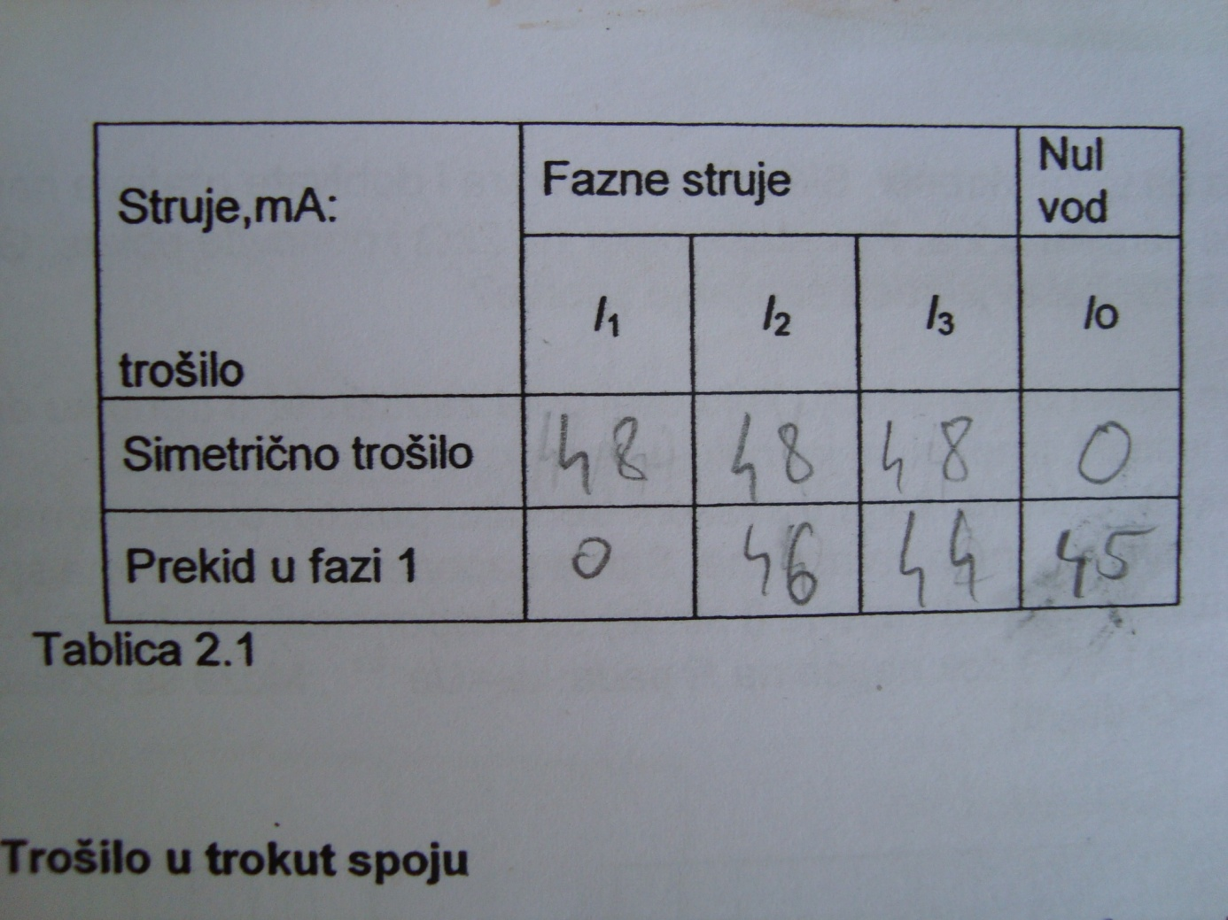

|  |  |  |  |  |  |  |
| --- | --- | --- | --- | --- | --- | --- |
| **Linijske struje** | | | **Fazne struje** | | | |
| **I1, mA** | **I2, mA** | **I3, mA** | | **I(1,2), mA** | **I(2,3), mA** | **I(3,1), mA** |
| 82 | 100 | 120 | | 31 | 70 | 44 |

*Nedostaje vježba '3.3. Prijelazi stanja' (ali nije bitna, ne ulazi u izvješće)

|  |
| --- |
|  |