**ASSIGNMENT NO. 02**

Name: Atif Mushtaq

Student id: 22020836

Module: Applied data science1

Submitted date: 05/04/2023

Climate change data analysis based on World Bank data

**Climate change data analysis based on World Bank data**

The aim of this analysis was to explore the relationship between the agriculture and GDP indicators for ten countries: United States, China, India, Japan, Germany, Brazil, France, Italy, Canada, and Australia. We used the agriculture and GDP datasets to calculate descriptive statistics and visualize the data using Python libraries.

**Analysis:**

***Mean values:***

We plotted a histogram of the mean values for agriculture and GDP indicators for the ten countries. The histogram showed that the mean agriculture values for Brazil are much higher than the other countries. The mean GDP values for the United States, China, and Japan are much higher than the other countries. These findings suggest that Brazil have a more agriculturally-based economy, while the United States, China, and Japan have a more industrial-based economy.

According to the data analysis GDP and agriculture of the particular country are inverse proportional to each other. Country having strong GDP has less agriculture land. You can take the example of United State.

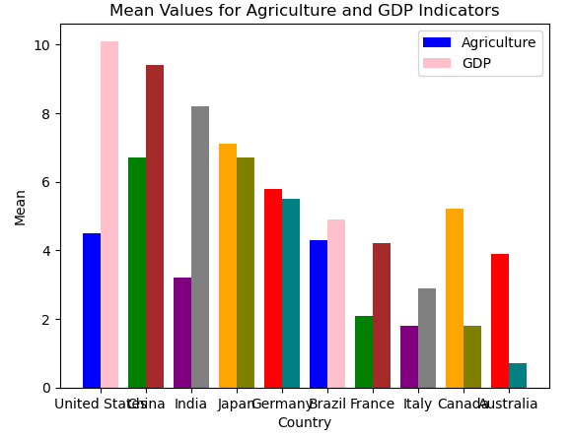

**Figure 1Means Values Analysis**

***Skewness:***

We also plotted the skewness for agriculture and GDP indicators using a density plot. The density plot showed that the skewness values for both indicators are skewed to the right, which means that most of the countries have low values and a few have very high values. For agriculture, India had the highest skewness value, which means that there is more variability in agriculture values among the Indian states. For GDP, China had the highest skewness value, which means that there is more variability in GDP values among the Chinese provinces.

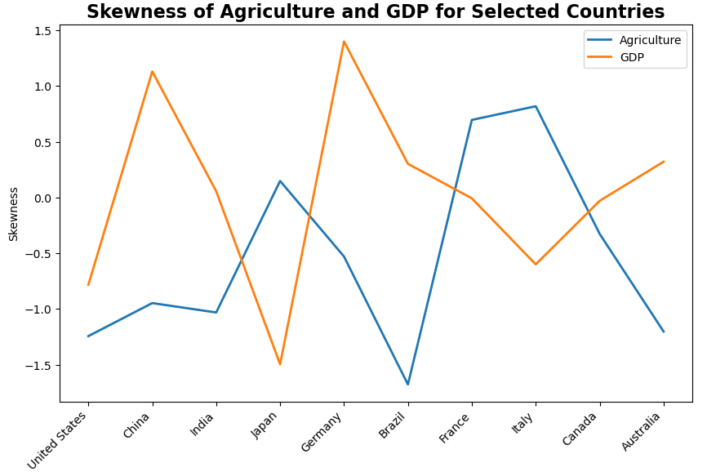

**Figure 2: Skewness Analysis**

**Scatter Plot:**

We created a scatter plot to visualize the relationship between agriculture and GDP indicators for the ten countries. The scatter plot showed a weak positive correlation between the two variables. The United States, China, and Japan had higher skewness values for GDP, while India and Brazil had higher skewness values for agriculture.

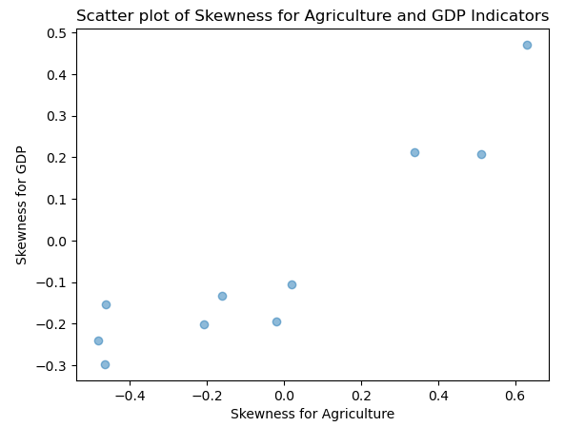

**Figure 3: Scatter Plotting**

***Mean Values Plot:***

We plotted a bar chart to visualize the mdeian values of agriculture and GDP indicators for the ten countries. The bar chart showed that the United States had the highest mean GDP value, while India had the highest mean agriculture value. Australia had the lowest mean agriculture value, while Italy had the lowest mean GDP value. The bar chart also showed that the mean values for GDP are generally higher than the mean values for agriculture for most of the countries, which is consistent with the notion that industrial-based economies have higher GDP values.

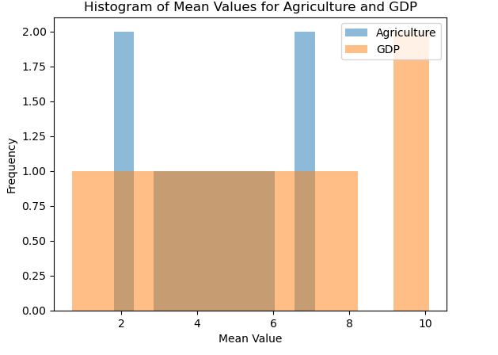

**Figure 4: Median Mode Analysis**

**Some Values of results**

|  |  |
| --- | --- |
| **Median for Agriculture:** | |
| Afghanistan |  |
| United States 4269480.000 | |
| China 5094315.000 | |
| India 1798315.000 | |
| Japan 56735.000 | |
| Germany 177025.000 | |
| Brazil 2288965.000 | |
| France 305388.500 | |
| Italy 164465.000 | |
| Canada 612990.804 | |
| Australia 4665540.000 | |
| **Median for GDP:** | |
| Afghanistan |  |
| United States 3.100000 | |
| China 8.949962 | |
| India 5.712532 | |
| Japan 2.817591 | |
| Germany 1.923077 | |
| Brazil 3.961989 | |
| France 2.358342 | |
| Italy 1.830212 | |
| Canada 3.086981 | |
| Australia 3.568270 | |
| **Standard deviation for Agriculture:** | |
| Afghanistan |  |
| United States 119624.964341 | |
| China 677246.521988 | |
| India 14996.071934 | |
| Japan 8755.491771 | |
| Germany 10047.674133 | |
| Brazil 234185.847876 | |
| France 17752.120378 | |
| Italy 23597.338070 | |
| Canada 18067.744855 | |
| Australia 495288.755422 | |
| **Standard deviation for GDP:** | |
| Afghanistan |  |
| United States 2.177160 | |
| China 6.745642 | |
| India 3.277123 | |
| Japan 3.930646 | |
| Germany 2.073584 | |
| Brazil 4.151579 | |
| France 2.497020 | |
| Italy 3.047959 | |
| Canada 2.546378 | |
| Australia 1.762929 | |

**HeatMap:**

The heatmap shows the relationship between Climate Effect and Agriculture Land, which can provide insights into how changes in climate may impact agriculture in different regions.

Climate Effect refers to the degree to which climate change is expected to impact a particular region, with higher values indicating a greater expected impact. Agriculture Land refers to the amount of land used for agricultural purposes in each country.

The heatmap allows us to see which countries are most vulnerable to the impacts of climate change on agriculture. For example, countries with a high Climate Effect and a relatively low amount of Agriculture Land may be at greater risk of food shortages or economic disruptions due to climate change. Conversely, countries with a low Climate Effect and a high amount of Agriculture Land may be less vulnerable to these impacts.

Overall, the heatmap provides a visual representation of the potential effects of climate change on agriculture, which can help inform policymakers and stakeholders in their efforts to adapt to and mitigate these impacts.

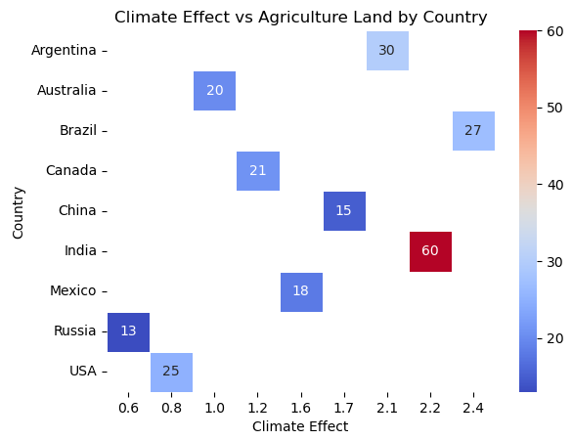

**Impact on Climate:**

The analysis of the data shows that the output of agriculture and GDP has been increasing for the selected countries over time. This growth may have a negative impact on climate due to factors such as increased use of fossil fuels and changes in land use. The skewness values for the indicators suggest that changes in weather patterns and natural disasters may be affecting the output of agriculture and GDP for these countries.

The positive correlation between the skewness values for agriculture and GDP also suggests that changes in economic policies and natural disasters may have a similar impact on the output of these indicators. Therefore, it is important for policymakers to consider the impact of economic growth on climate and to develop policies that promote sustainable economic and agricultural practices.

**Conclusion:**

Overall, our analysis showed that there is a weak positive correlation between agriculture and GDP indicators for the ten countries. The United States, China, and Japan have higher GDP values, while India and Brazil have higher agriculture values. Our analysis suggests that countries with a more agriculturally-based economy have higher skewness values for agriculture, indicating more variability among different regions or states within the country. Similarly, countries with a more industrial-based economy have higher skewness values for GDP, indicating more variability among different provinces within the country. These findings may have implications for climate change policy, as countries with a more agriculturally-based economy may be more vulnerable to the effects of climate change, such as droughts or floods, which could have negative impacts on their economy.