**OOPS EXPERIMENTS**

**1.Write a program to find the greatest number from 3 numbers.**

#include<iostream.h>

#include<conio.h>

void main()

{

clrscr();

int a,b,c;

cout<<"\nEnter first number:";

cin>>a;

cout<<"Enter second number:";

cin>>b;

cout<<"Enter third number:";

cin>>c;

If((a>b)&&(a>c))

cout<<"First number is greatest";

else if((b>a)&&(b>c))

cout<<"Second number is greatest";

else

cout<<"Third number is greatest";

getch();

}

**Output:**

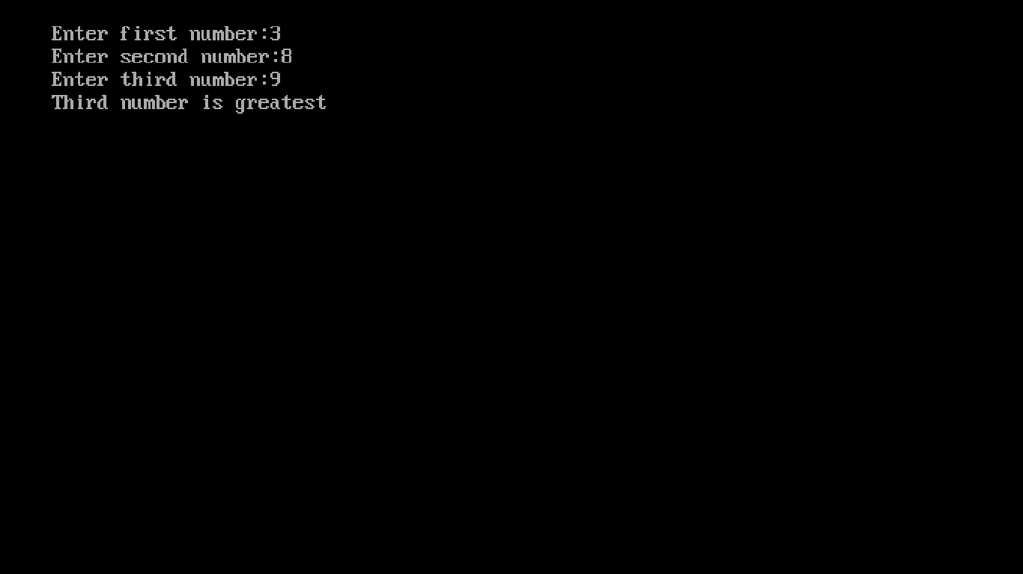

**2.Write a program for different types of patterns.**

#include<iostream.h>

#include<conio.h>

void main()

{

clrscr();

int x=4,y=4;

for(int i=1;i<=5;i++) //Program for 1st pattern

{

cout<<"\n";

for(int j=1;j<=i;j++)

{

cout<<i;

}

}

getch();

cout<<"\n\n";

for(i=1;i<=5;i++) //Program for 2nd pattern

{

cout<<"\n";

for(int j=1;j<=i;j++)

{

cout<<j;

}

}

getch();

cout<<"\n\n";

for(i=1;i<=5;i++) //Program for 3rd pattern

{

cout<<"\n";

for(int j=1;j<=7;j++)

{

if((j<=x)||(j>=y))

cout<<" ";

else

cout<<"*";

}

x--;

y++;

}

getch(); }

**OUTPUT:**

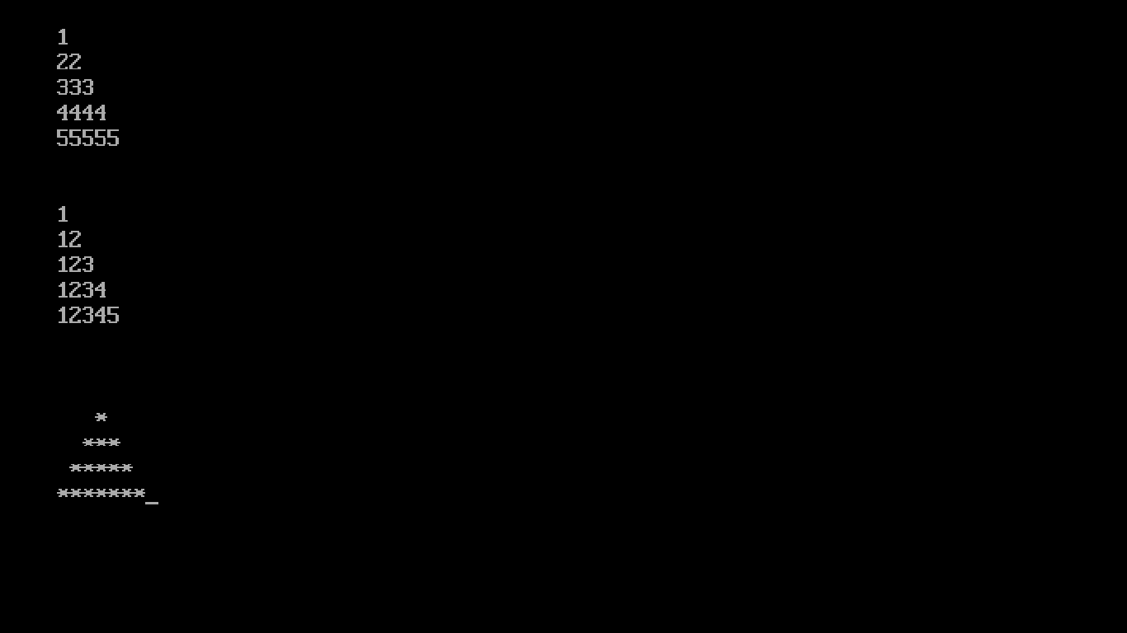

**3.Write a program for finding the % of marks of 5 subjects.**

#include<iostream.h>

#include<conio.h>

void main()

{

clrscr();

float marks[5],avg=0,percent=0;

for(int i=1;i<=5;i++)

{

cout<<"\nEnter Marks Of Subject "<<i<<" ";

cin>>marks[i-1];

avg=avg+marks[i-1];

}

percent=(avg/500)*100;

cout<<"Percentage Of Marks Given Is As "<<percent<<endl;

getch();

if(percent>=75)

cout<<"Passed By First Division";

else if(percent>=60)

cout<<"Passed By Second Division";

else if(percent>=40)

cout<<"Passed By Third Division";

else

cout<<"Failed";

getch();

}

**OUTPUT:**

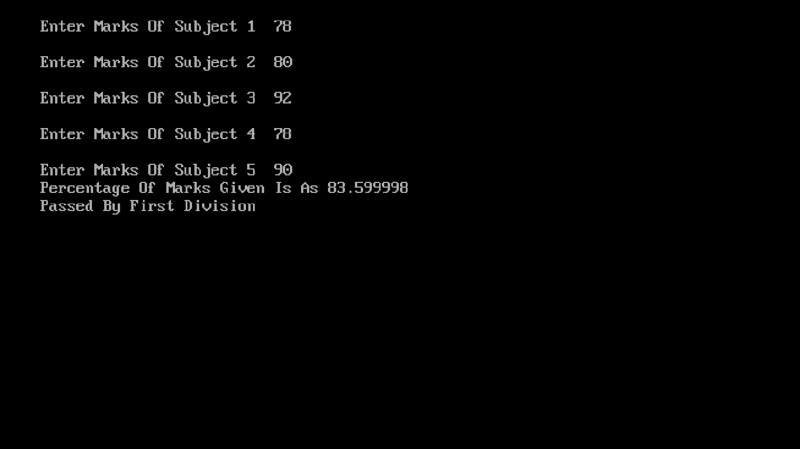

**4.Write a program for Bubble Sort.**

#include<iostream.h>

#include<conio.h>

void main()

{

int a[10],j,n,i,temp;

clrscr();

cout<<"\nEnter Number Of Elements You Want To Insert In Array\t";

cin>>n;

cout<<"Now Enter Elements One By One\n";

for(i=0;i<n;i++)

{

cin>>a[i];

}

for(i=0;i<n;i++)

{

for(j=0;j<n-i;j++)

{

if(a[j]>a[j+1])

{

temp=a[j];

a[j]=a[j+1];

a[j+1]=temp;

}

}

}

cout<<"Sorted array is given below by using insertion sort\n";

for(i=0;i<n;i++)

cout<<a[i]<<" ";

getch();

}

**OUTPUT:**

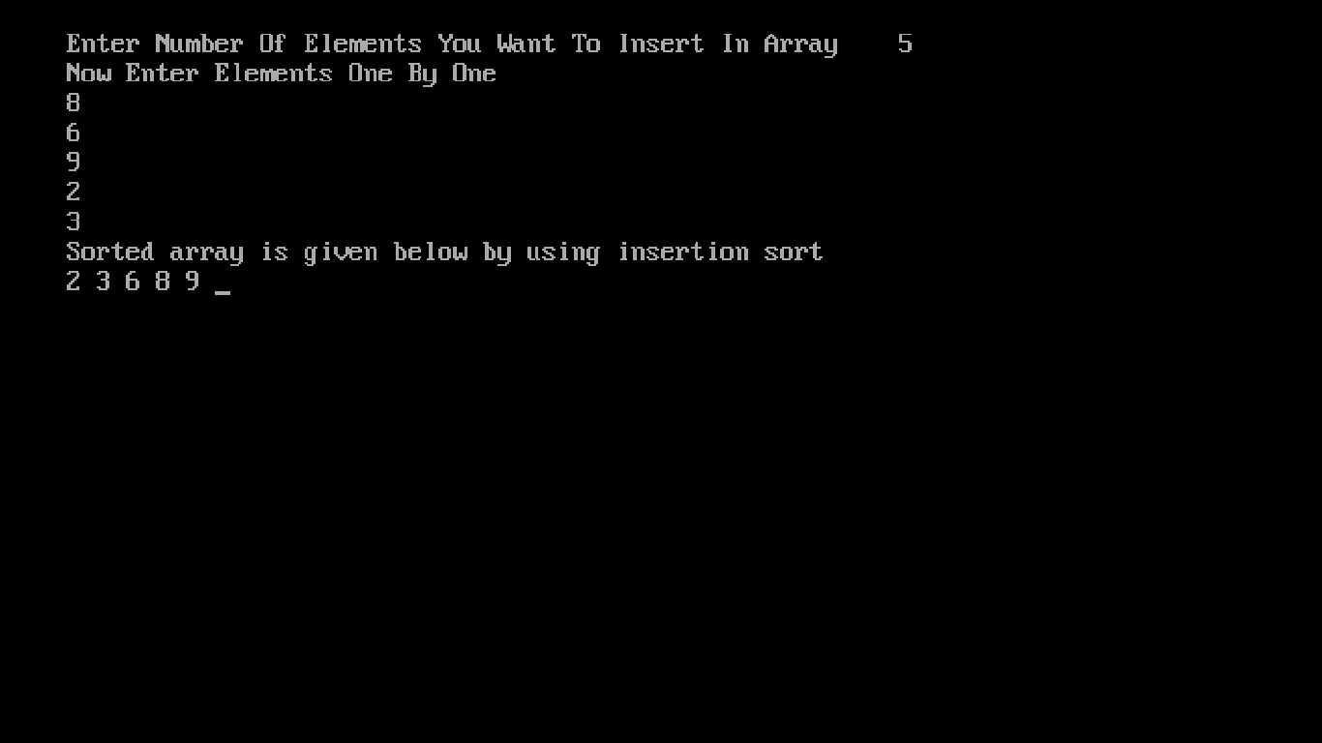

**5.Write a Program for Matrix Calculations(Addition,Subtraction,**

**Multiplication).**

#include<iostream.h>

#include<conio.h>

#include<process.h>

void main()

{

clrscr();

int a[5][5],b[5][5],c[5][5],sum=0,r1,r2,r3,c1,c2,c3,ch;

cout<<"Enter Row Size of First Matrix ";

cin>>r1;

cout<<"Enter Column Size of First Matrix ";

cin>>c1;

cout<<"Now Enter Elements One By One\n";

for(int i=0;i<r1;i++)

{

for(int j=0;j<c1;j++)

{

cin>>a[i][j];

}

}

cout<<"Enter Row Size Of Second Matrix ";

cin>>r2;

cout<<"Enter Column Size Of Second Matrix ";

cin>>c2;

cout<<"Now Enter elements one by one\n";

for(i=0;i<r2;i++)

{

for(int j=0;j<c2;j++)

{

cin>>b[i][j];

}

}

Clrscr();

while(1)

{

cout<<"\nMatrix Operations:";

cout<<"\n1.Addition";

cout<<"\n2.Subtraction";

cout<<"\n3.Multiplication";

cout<<"\n4.Exit";

cout<<"\nChoose any operation you want to perform:";

cin>>ch;

switch(ch)

{ case 1:clrscr();

cout<<"\nAnswer of your Operation\n";

for(int i=0;i<2;i++)

{ cout<<"\n";

for(int j=0;j<2;j++)

{

c[i][j]=a[i][j]+b[i][j];

cout<<c[i][j]<<" ";

}

}

cout<<endl;

break;

case 2:clrscr();

cout<<"\nAnswer of your Operation\n";

for(i=0;i<2;i++)

{ cout<<"\n";

for(int j=0;j<2;j++)

{

c[i][j]=a[i][j]-b[i][j];

cout<<c[i][j]<<" ";

}

}

cout<<endl;

break;

case 3:clrscr();

cout<<"\nAnswer of your Operation\n";

for(i=0;i<r1;i++)

{ cout<<"\n";

for(int j=0;j<c2;j++)

{

for(int k=0;k<c1;k++)

{

sum+=a[i][k]*b[k][j];

}

c[i][j]=sum;

sum=0;

cout<<" "<<c[i][j];

} }

cout<<endl;

break;

case 4:exit(0);

break;

default:clrscr();

cout<<"Please Enter valid option!!";

}}

getch();

}

**OUTPUT:** Entering both Matrices: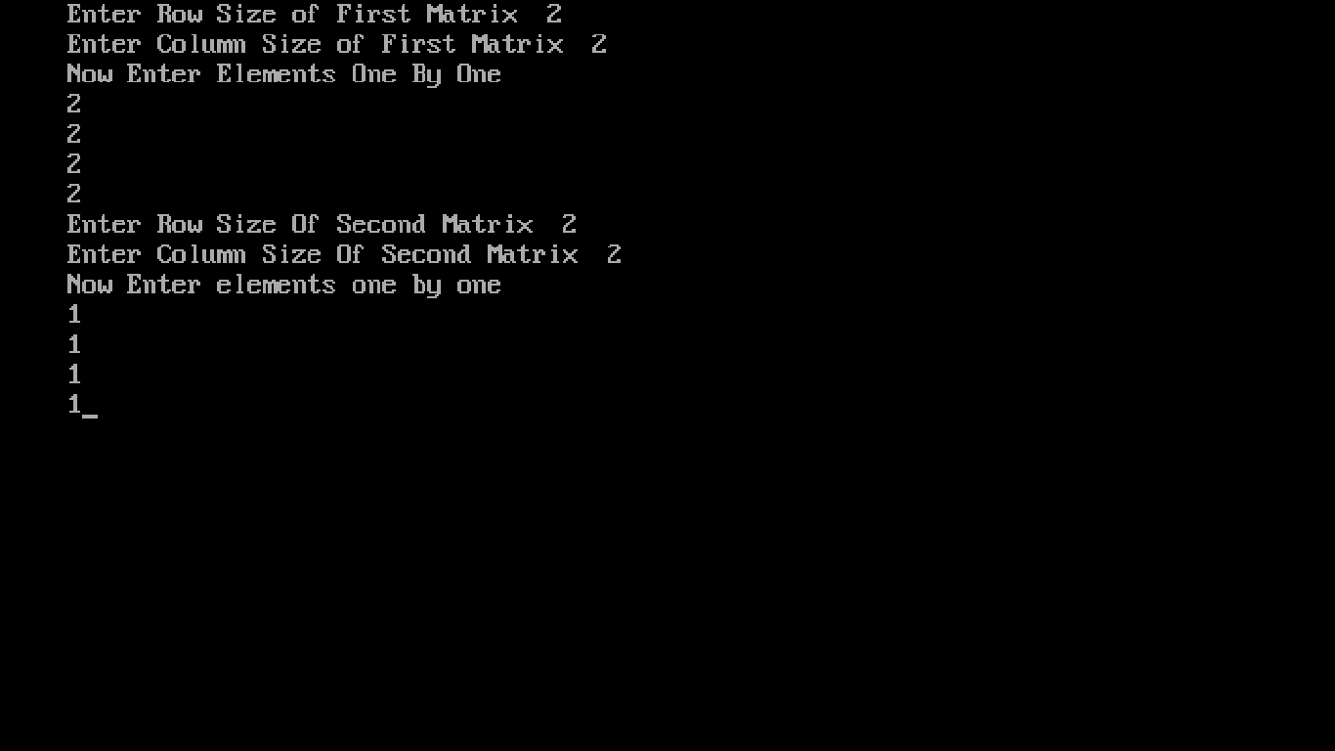

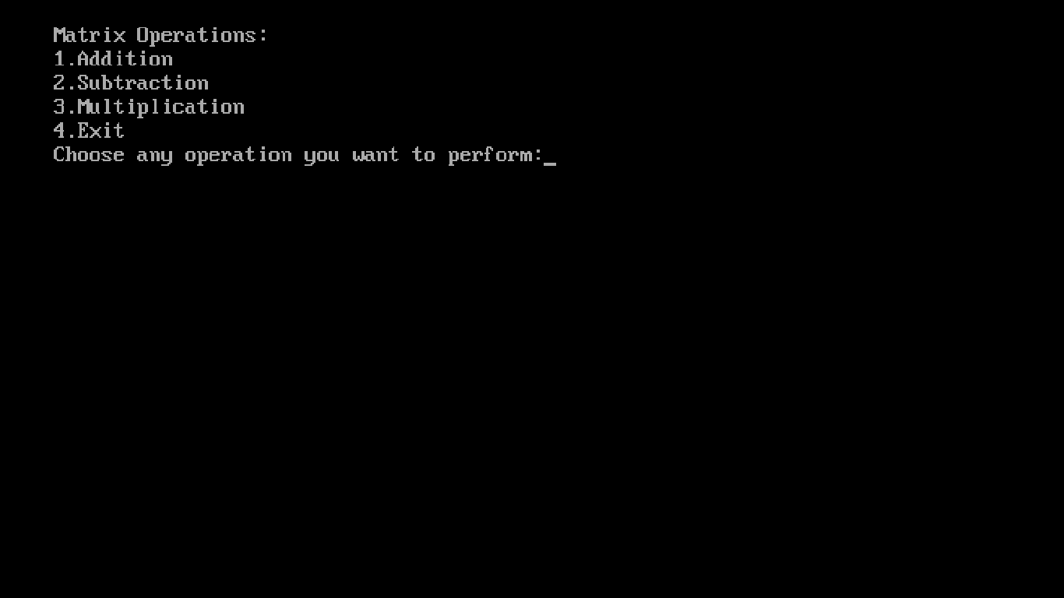

Choosing 1st operation:

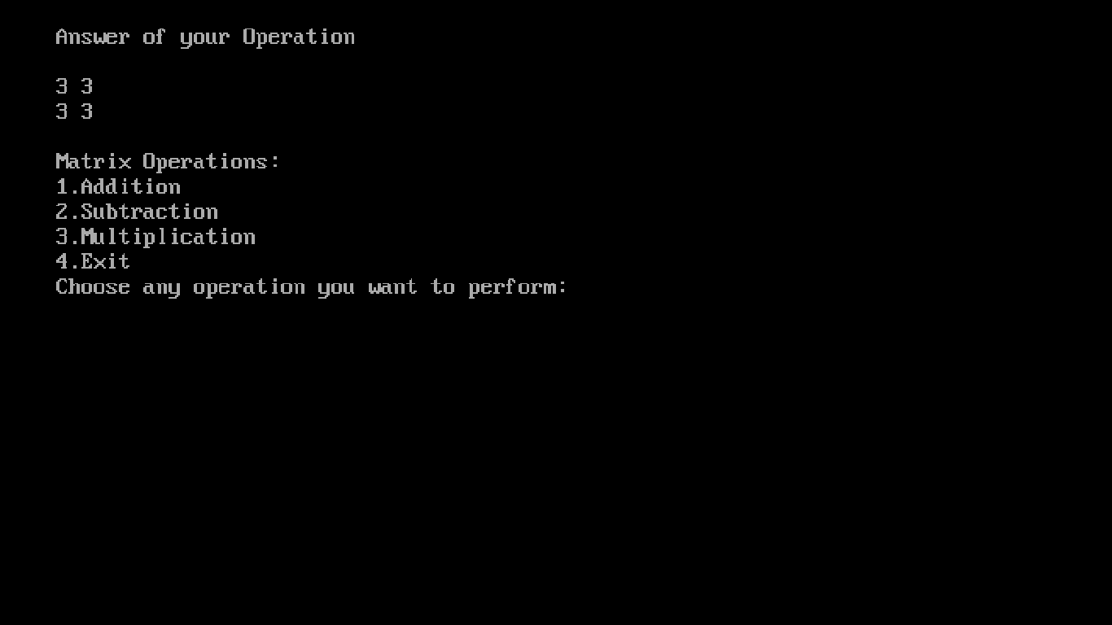

**Choosing 2nd operation:**

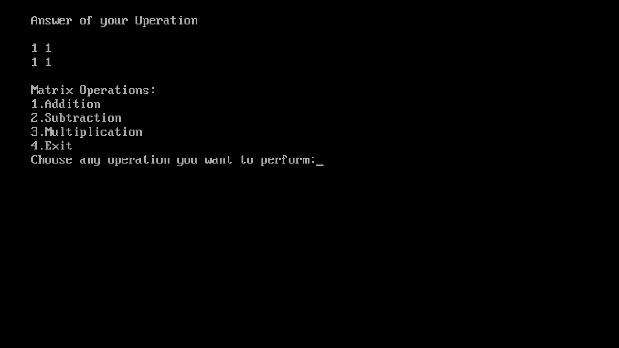

**Choosing 3rd operation:**

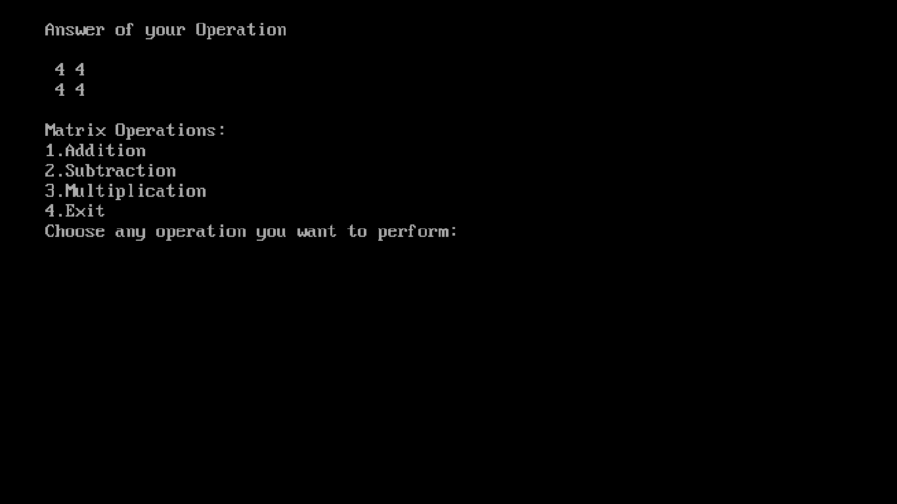

**6.Write a Program for transpose of Matrix.**

#include<iostream.h>

#include<conio.h>

void main()

{

clrscr();

int a[10][10],b[10][10],r1,c1;

cout<<"\nEnter the rows and columns of Matrix:\n";

cin>>r1>>c1;

cout<<"Enter the elements of matrix:";

for(int i=0;i<r1;i++)

{

for(int j=0;j<c1;j++)

cin>>a[i][j];

}

for(i=0;i<r1;i++)

{

for(int j=0;j<c1;j++)

b[j][i]=a[i][j];

}

cout<<"\nYour Matrix";

for(i=0;i<r1;i++)

{ cout<<endl;

for(int j=0;j<c1;j++)

cout<<" "<<a[i][j];

}

cout<<"\nTranspose of Matrix";

for( i=0;i<r1;i++)

{ cout<<endl;

for(int j=0;j<c1;j++)

cout<<" "<<b[i][j];

}

getch();

}

**OUTPUT:**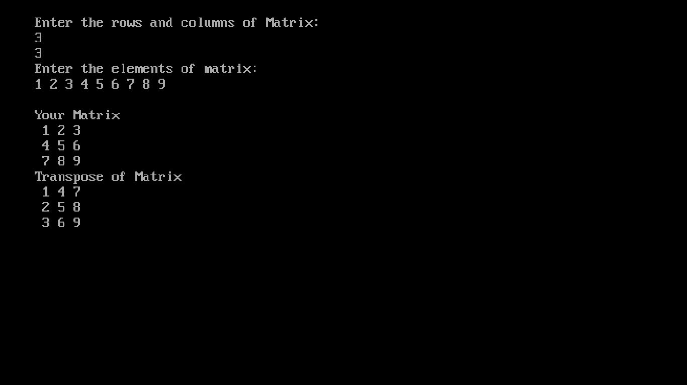

**7. Program to find power by using Default Argument in C++.**

#include<iostream.h>

#include<conio.h>

#include<math.h>

int power(int n,int p=2)

{ int a;

a=pow(n,p);

return a;

}

void main()

{ clrscr();

int n,p;

cout<<"Enter a number:";

cin>>n;

cout<<"Enter power:";

cin>>p;

cout<<"Answer when two values are passed:"<<power(n,p);

cout<<"\nAnswer when one value is passed:"<<power(n);

getch();

}

**OUTPUT:**

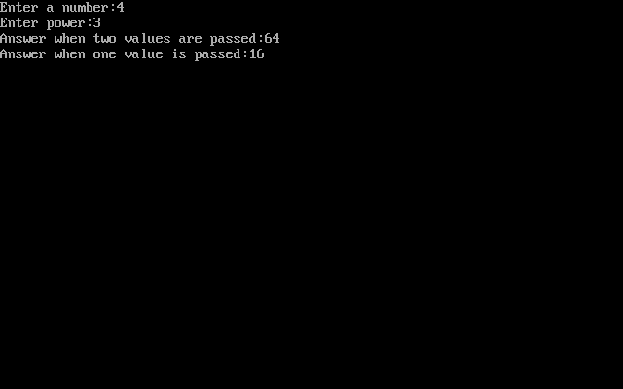

**8. Program to perform Function Overloading in C++.**

#include<iostream.h>

#include<conio.h>

void cal(int a,int b)

{ cout<<"\nArea of square:"<<a*b;

}

void cal(int a,int b,int c)

{ cout<<"\nArea of cube:"<<a*b*c;

}

void cal(int a)

{ cout<<"\nArear of circle:"<<3.14*a*a;

}

void main()

{ clrscr();

int a,b,c;

cout<<"Enter a number:";

cin>>a;

cout<<"Enter a number:";

cin>>b;

cout<<"Enter a number:";

cin>>c;

cal(a,b);

cal(a,b,c);

cal(a);

getch();

}

**OUTPUT:**

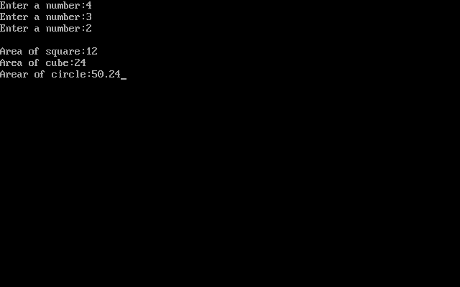

**9. Program to perform Structures in C++**

#include<iostream.h>

#include<conio.h>

Struct student_data

{ char name[10];

introll_no;

};

void main()

{ clrscr();

inti;

student_dataobj[3];

for(i=0;i<3;i++)

{ cout<<"Enter "<<i+1<<" data:\n";

cout<<"Enter name of student:";

cin>>obj[i].name;

cout<<"Enter roll number of student:";

cin>>obj[i].roll_no;

}

for(i=0;i<3;i++)

{ cout<<"\nEntered "<<i+1<<" detail:\n";

cout<<"Entered details are:\nName:"<<obj[i].name<<"\nRoll no:"<<obj[i].roll_no;

}

getch();

}

**OUTPUT:**

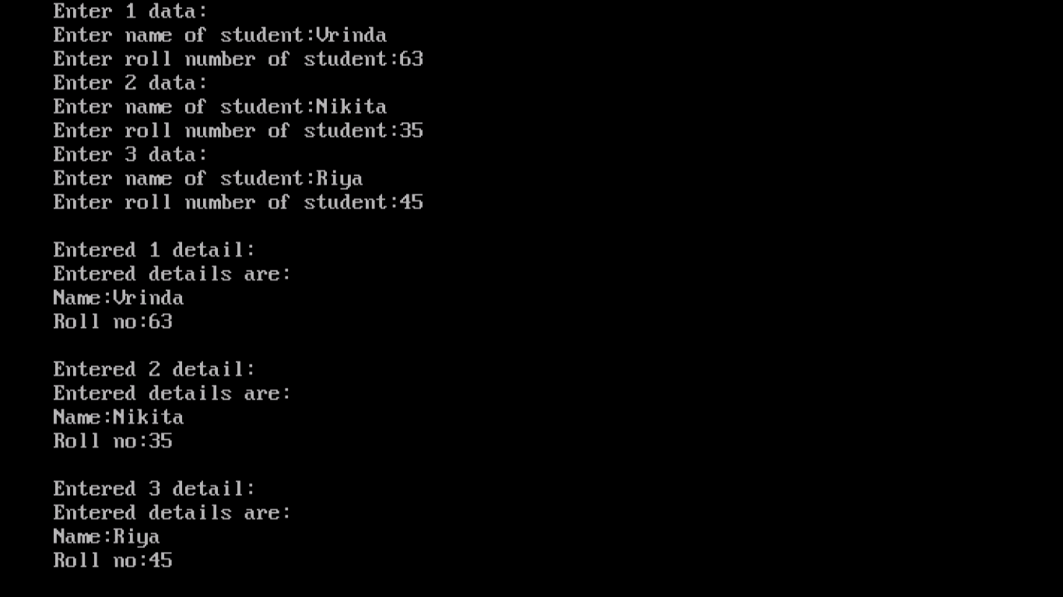

**10. PROGRAM TO PERFORM UNARY OPERATOR OVERLOADING IN C++**

#include<iostream.h>

#include<conio.h>

class abc

{

int a,b;

public:

void input()

{

cout<<"\nenter value of a";

cin>>a;

cout<<"\nenter value of b";

cin>>b;

}

void display()

{

cout<<"\nvalue of a"<<a<<"\nvalue of b"<<b;

}

abc abc::operator -()

{

a=a-1;

b=b-1;

}};

void main()

{

clrscr();

abc obj1;

obj1.input();

-obj1;

cout<<"\nvalues after unary function:";

obj1.display();

getch();

}

**OUTPUT :**

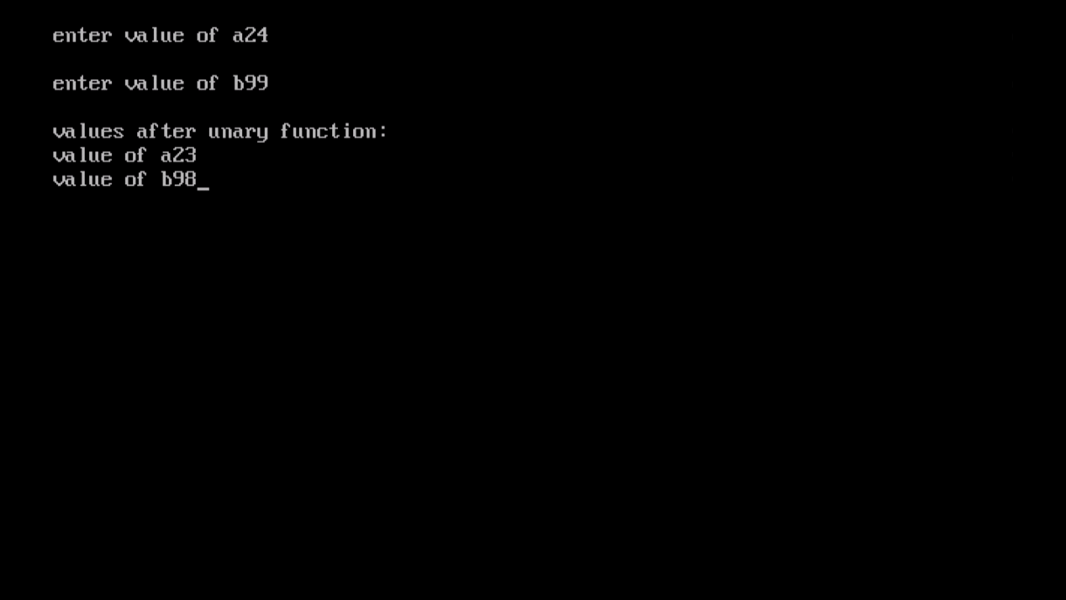

**11. Program to perform Unary Operator Overloading using Friend function in C++**

#include<iostream.h>

#include<conio.h>

class abc

{

int a,b;

public:

void input()

{

cout<<"enter a";

cin>>a;

cout<<"enter b";

cin>>b;

}

void display()

{

cout<<"\nvalue of a"<<a<<"\nvalue of b"<<b;

}

friend abc operator-(abc obj4);

};

abc operator -(abc obj4)

{

abc obj3;

obj4.a=obj4.a-1;

obj4.b=obj4.b-1;

return obj4;

}

void main()

{

clrscr();

abc obj;

obj.input();

abc obj2=-obj;

cout<<"\nvalues after usiing function";

obj2.display();

getch();

}

**OUTPUT:**

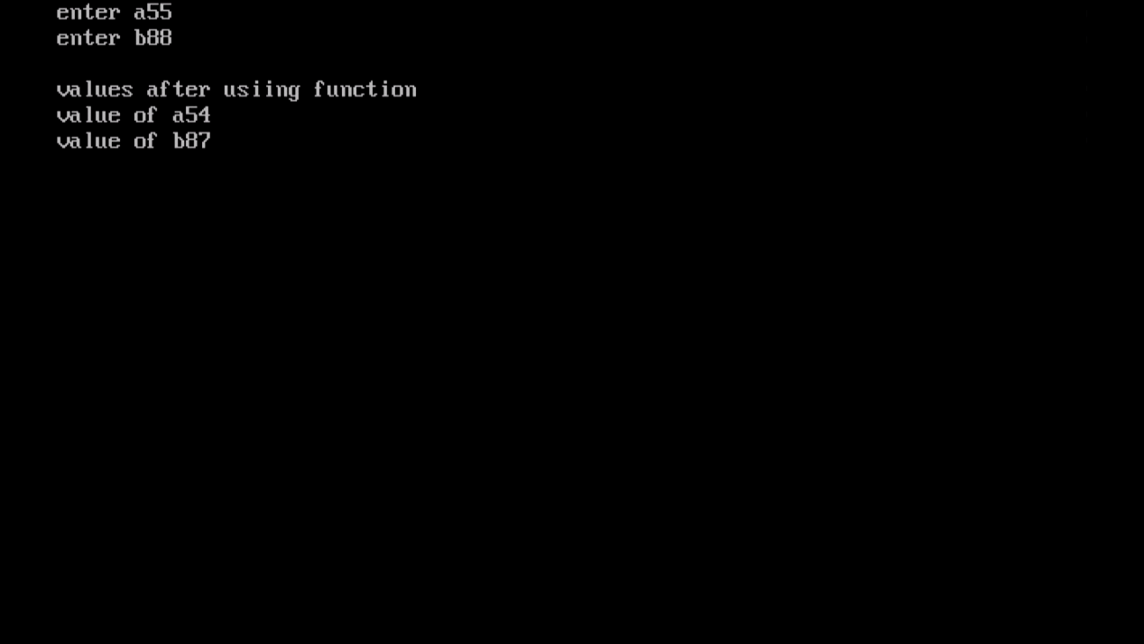

**12. Program to perform Operator Overloading with Friend Function**

#include<iostream.h>

#include<conio.h>

class abc

{

int a,b;

public:

void input()

{

cout<<"enter a";

cin>>a;

cout<<"enter b";

cin>>b;

}

void display()

{

cout<<"\nvalue of a"<<a<<"\nvalue of b"<<b;

}

friend abc operator+(abc obj3,int i);

};

abc operator +(abc obj3,int i)

{

abc obj;

obj.a=obj3.a+i;

obj.b=obj3.b+i;

return obj;

}

void main()

{

clrscr();

abc obj1,obj2;

obj1.input();

obj2=obj1+2;

cout<<"\nvalues after usiing function";

obj2.display();

getch();

}

**OUTPUT:**

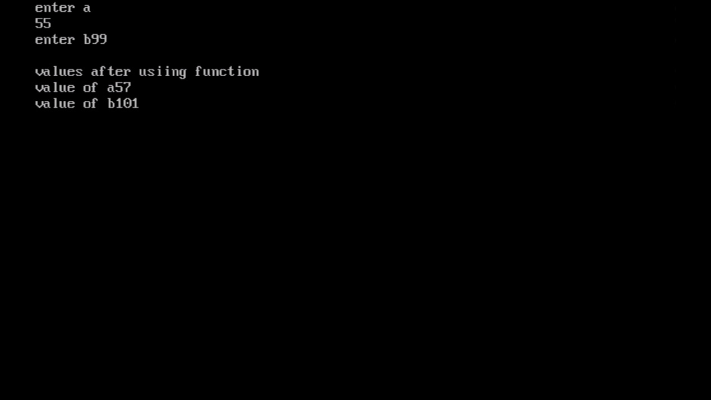

**13.Write a program using Inline Function**

#include<iostream>

using namespace std;

class sample

{

public:

int addition(int a,int b);

};

inline int sample::addition(int a,int b)

{

return a+b;

}

int main()

{

sample s1;

cout<<s1.addition(2,7);

return 0;

}

**OUTPUT:**

