Proportional resasoning across formats

Ayush Munta1

1 Rutgers University

Author note

The authors made the following contributions. Ayush Munta: Conceptualization, Writing - Original Draft Preparation, Writing - Review & Editing.

Correspondence concerning this article should be addressed to Ayush Munta, Postal address. E-mail: [am3008@rutgers.edu](mailto:am3008@rutgers.edu)

Proportional resasoning across formats

# Introduction

Comparing proportions is sometimes very hard! But, even infants seem to be able to do it a little bit. The purpose of this science project was to better understand how well people compare proportions when the proportions are presented in different formats.

The purpose of this class assignment is to take the R-code and plots we’ve been generating over the last several weeks and put it all together into one poster format. Let’s take a look at our research objectives.

## Research Objectives

1. Does average performance vary across format type?
2. Does average performance vary across numerator congruency status?
3. Does numerator congruency vary across format type (i.e., is there an interaction)?

# Methods

A total of 99 adults participated in the study.

First, participants were introduced to a story about a magic ball and that the outcome (i.e., blue or orange) depended on the proportions. They were then asked to compare the proportions of different images.

In other words, participants were shown two images of the same kind at the same time and asked to decide which had a higher proportion of the shape (or dots) colored in blue. You can notice this in Figure 1.

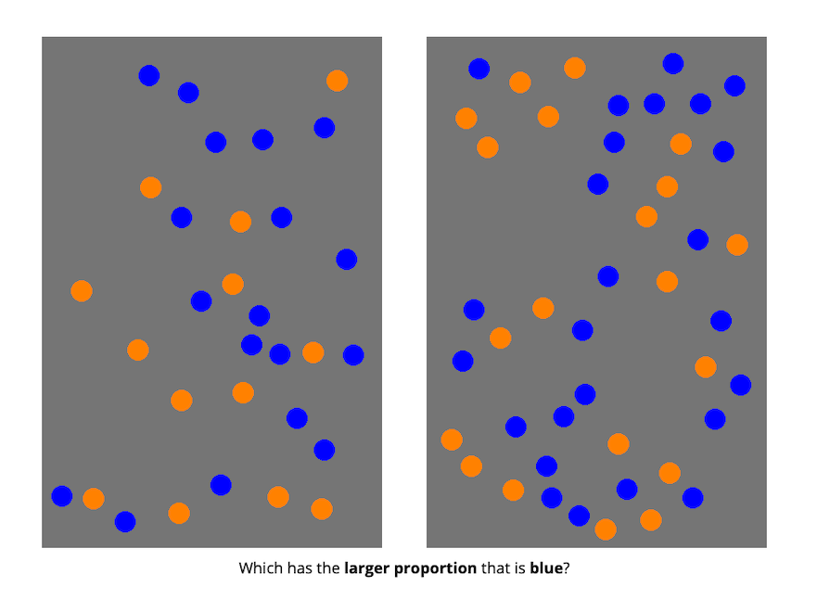

*Figure* 1. Dot Proportion Task

## Data analysis

The data analysis was conducted using the following R packages: dplyr (Wickham, François, Henry, Müller, & Vaughan, 2023) for data wrangling and summarization, and ggplot2 (Wickham, 2016) for data visualization.

# Results

1. Does average performance vary across format type, ignoring all other aspects of the stimuli?

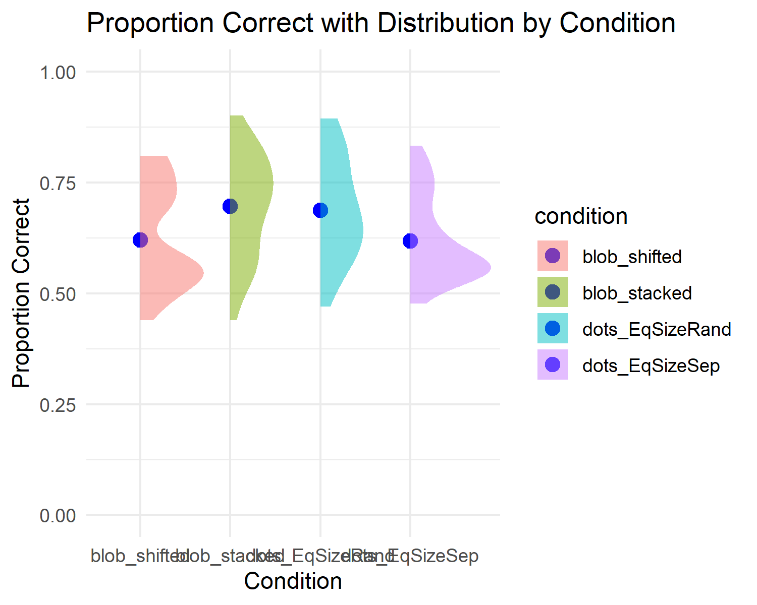

*Figure* 2. Proportion Correct with Distribution by Condition

As seen in Figure 2, it appears accuracy is highest in the blob_shifted condition, but it drops a bit in the block_stacked and dots_EqSizeRand conditions.

1. How are reaction time and accuracy related?

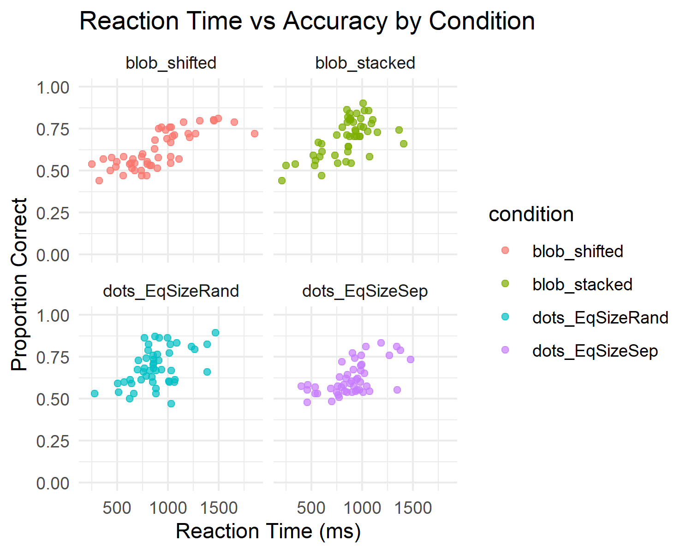

*Figure* 3. Reaction Time vs Accuracy by Condition

As seen in Figure 3, these plots demonstrate a positive correlation between reaction time and proportion correct.

1. How does numerator congruency interact with format type?

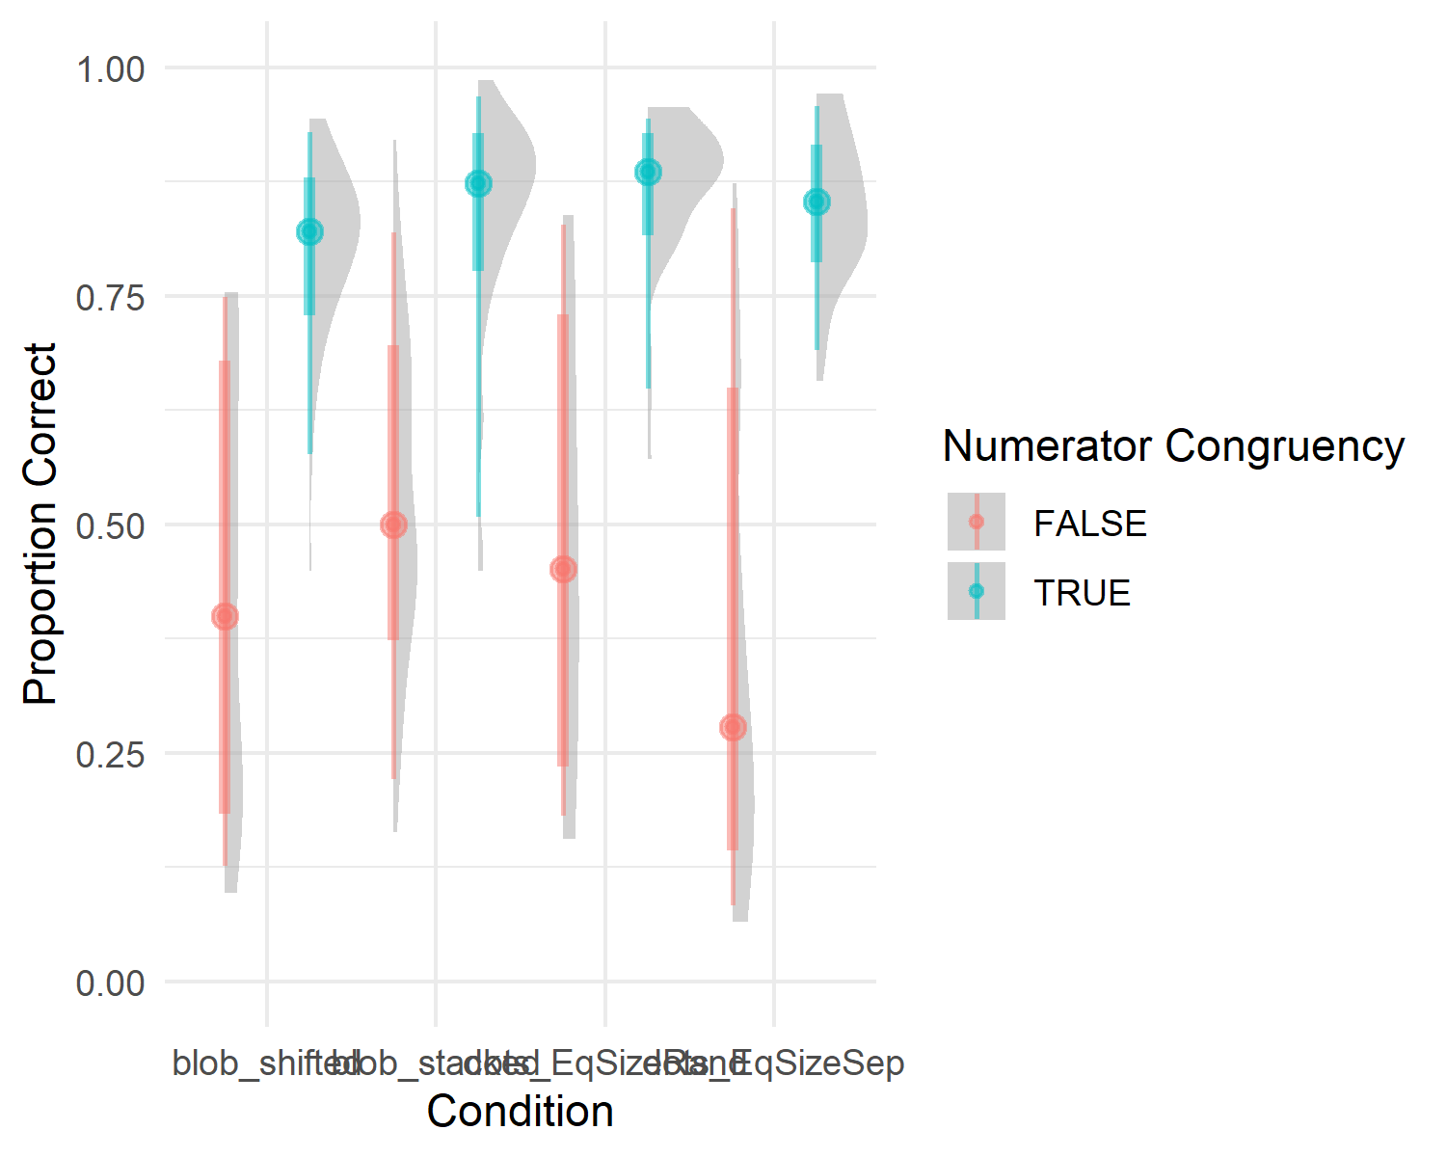

*Figure* 4. Numerator Congruency by Proportion Correct

As seen in Figure 4, numerator congruency seems to cause an increase in proportion correct across format types.

# Discussion

As demonstrated, average performance does vary across format type. Furthermore, average performance also varyies across numerator congruency. On the flipside, there is no variation of numerator congruency across format type.

1. The most annoying thing about this assignment was realizing my captions werent showing because I need extra line spacing after my code chunks.
2. The most satisfying or fun thing about this assignment was changing something in the template and seeing it change easily without much work.

# References

Wickham, H. (2016). *ggplot2: Elegant graphics for data analysis*. Springer-Verlag New York. Retrieved from <https://ggplot2.tidyverse.org>

Wickham, H., François, R., Henry, L., Müller, K., & Vaughan, D. (2023). *Dplyr: A grammar of data manipulation*. Retrieved from <https://CRAN.R-project.org/package=dplyr>