Paul Cabanez

Justin Chau

C8005 – Final Assignment

# PseudoCode

**Client**

Retrieve Input

Spawn number of threaded clients

Start the threaded clients with the method

create socket

connect socket

for each number of messages

send message

wait and receive message

calculate RTT

if the number of message is reached

send last quit message

print out results

**Server**

Retrieve Input

Create Socket

Create epoll object

Connect socket

listen to the socket

Check for epoll events

If there is an event

check the event for server connection

accept the connection

for each connection check for messages

if there is a message

echo back the message to the client

if the message is quit

close the connection of that client

close connections

print out results

**Port Forwarder**

Retrieve IP of host

Read Configuration File

Create a list of connections to configure

Make threads for each connections

Create a socket to listen for connection

Listen to port for incoming messages

If incoming message

Forward message to the configured IP and Port

# State Diagrams

**Client :**

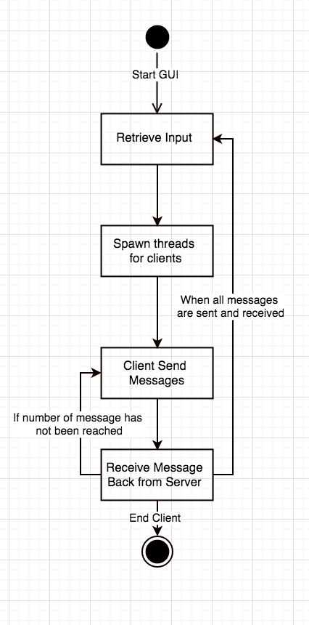

**Server :**

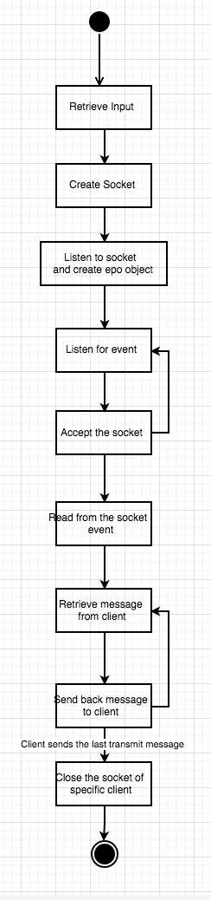

**Port Forwarder:**

