Arman Mottaghi

Pro. David Duvall-Early

Computer Science I

05/09/2014

Minesweeper Project

I implemented the Minesweeper project which is a game that consists of a panel, a 2D array of tiles, bunch of mines and a menu. My program should have the following requirements:

* Present a graphical user interface that is primarily mouse driven for all user actions.
* Allow the user to click on one of the tiles
* Allow the user to question mark the tile.
* After revealing the tile, each tile could have either a mine or a clue for how many mines that are nearby (surrounding the selected tile)
* Once user click on the mine, the game is over!
* User can start a new game by click on the new game which is located in the file menu.

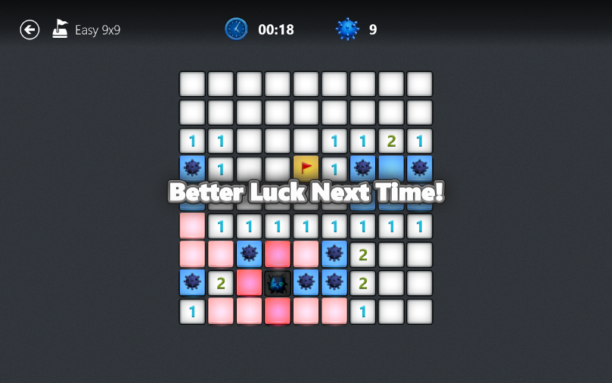

Figure 1 – Minesweeper game for Windows 8

Figure 1 is illustrating an example of a Minesweeper game. In this project, tutors Matthew Krehbiel and Ryan Williams assisted me with figuring out some of the algorithms.