DLP Projector Hack
Complete Project Reference
Direct Laser Imaging for Photolithography — System Analysis, Protocol Decode & Spoofing Strategy

1. Project overview
The objective is to convert a commercial DLP projector into a direct laser imaging system for photolithography. This means replacing the projector’s original light sources (a primary UV/blue source and a red laser) with a TTL-controlled UV laser module (likely 405nm), removing the colour wheel, and retaining only the DMD chip and main board as a programmable spatial light modulator.
The main challenge is that the projector’s main board performs health checks on the light engine via a dedicated light source control PCB and monitors temperatures via an I2C bus. If these checks fail, the system shuts down within seconds. The solution is to build a spoofing microcontroller that emulates the required responses.

2. System architecture
The projector contains five major subsystems connected by seven cables/connectors:
- Power supply (PSU) — 12V AC-to-DC converter, left quarter, full height. Feeds power to main board (6-pin SK04) and to light source control PCB (stacked beneath).
- Light source control PCB — beneath PSU at bottom. Manages both light sources, communicates with main board via 13-pin UART (SK01).
- UV light module — primary blue source, right of PSU in back two-thirds. Powered from PSU.
- Red laser (source 2) — in front of UV module. Driven by control PCB via 8-pin analogue (SK03).
- Colour wheel — below red laser. Driven directly by main board via 7-pin BLDC (SK02).
- Main board — right half. DMD chip (top centre), colour mixing (bottom-left third), lens (below DMD, downward). EEPROM (AT24Cxx) is physically on the main board. 20-pin connector (SK05) routes to thermal management board.
- Thermal management board — external board connected via SK05. Contains the 0x4D temperature sensor, 0x41 fan controller, and autonomous fan speed control.

2.1 Light path
UV module → Red laser → Colour wheel → Colour mixing module → DMD chip → Lens → Output (downward).

2.2 Physical layout diagram
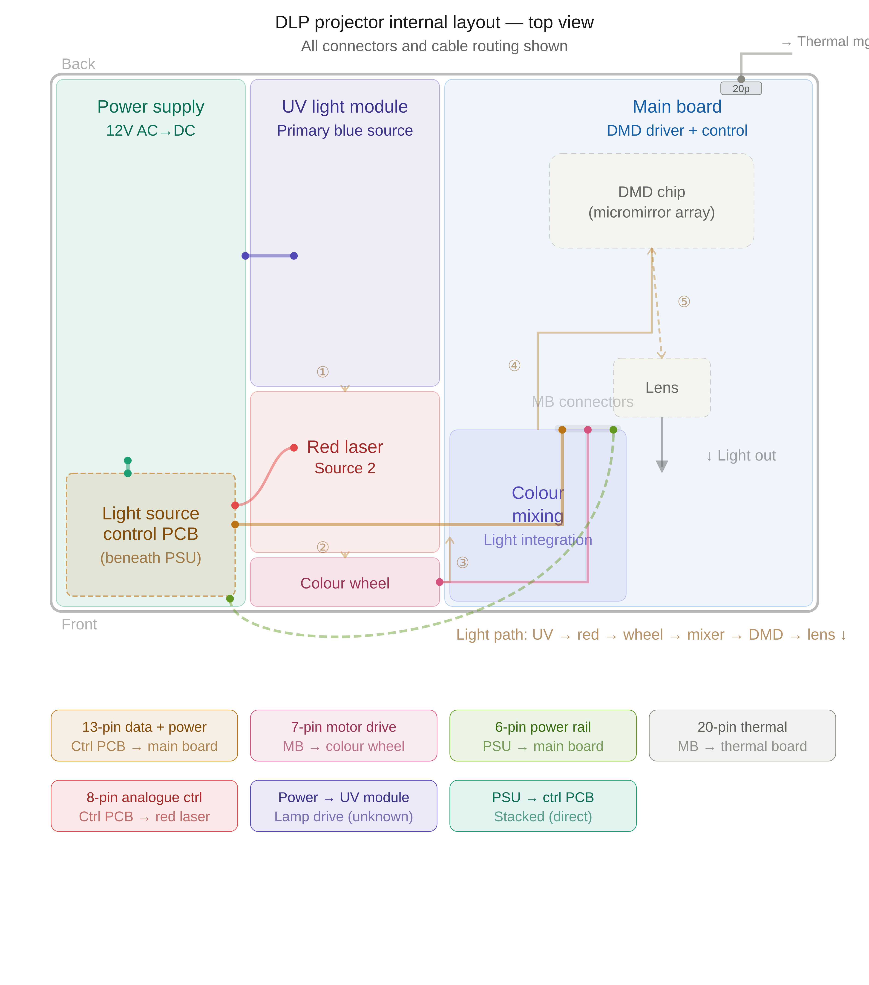
Figure 1: Projector internal layout showing all subsystems, cables, optical path, and the 20-pin thermal connector.

3. Electrical interface control document (EICD)
Each connector is assigned a unique identifier (SKxx). All signal directions are defined from the main board (MB) perspective, as the MB is the central subsystem being retained. OUT = MB drives this signal. IN = MB receives this signal. BIDIR = bidirectional. PWR = power rail. For connectors not directly involving the MB (e.g. SK03: control PCB → red laser), direction is noted from the driving board’s perspective with a clear label.

3.1 SK01 — Light source control PCB ↔ Main board
Type: 13-pin single row | Protocol: UART 19200 baud 8N1 on pins 6/7, PWM on pins 5/8/10
Direction: from main board perspective. Confirmed by disconnection test (SK01 cable removed, MB side probed).

Pin diagram
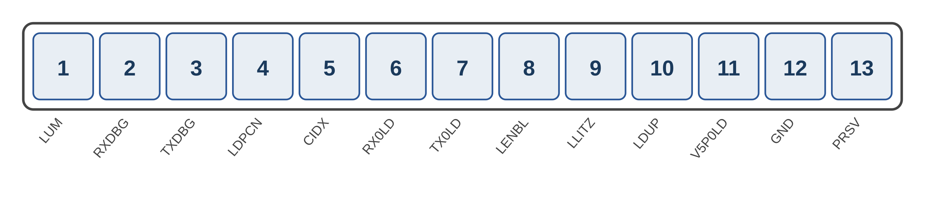

Interface specification
Pin | Signal | Type | Direction | Function
1 | LUM | 0–3V analogue | IN | Analogue brightness reference. Shared circuit — 0V both sides when disconnected. 3V when on. WARNING: logic analyser loading freezes the projector. Scope only with 10x probe.
2 | RXDBG | 5V DC | OUT | Debug UART RX (MB sends debug data)
3 | TXDBG | 3.3V DC | IN | Debug UART TX (MB receives debug data)
4 | LDPCN | 3.3V digital | OUT | Light driver enable. MB asserts HIGH. Retries 2× (4.6s each) if no response.
5 | CIDX | 3.3V PWM | OUT | DMD frame sync. ~120 Hz, 91% duty, period 8.4ms. MB-generated.
6 | RX0LD | 3.3V UART | IN | UART data from control PCB to MB (19200 baud 8N1). Dead without control PCB.
7 | TX0LD | 3.3V UART | OUT | UART commands from MB to control PCB (19200 baud 8N1). Idle HIGH.
8 | LENBL | 3.3V PWM | OUT | Brightness control PWM from MB. 359 Hz, 8.3% duty, HIGH pulse 232µs. NOT a simple enable.
9 | LLITZ | 3.3V DC | IN | Light-is-on feedback. MB reads this. HIGH = light operating. Static LOW without control PCB. 275ms ignition timeout.
10 | LDUP | 3.3V PWM | OUT | High-freq PWM from MB. ~42 kHz, 8.3% duty. CORRECTION: previously listed as input — confirmed as MB output by disconnection test.
11 | V5P0LD | 5V DC | PWR | 5V rail to control PCB
12 | GND | 0V | PWR | Ground
13 | PRSV | 5V DC | IN | Presence detect. MB reads this. Must be held HIGH for system to operate.

Signal electrical characteristics (measured)
Signal | Voltage | Frequency | Duty | Type | Notes
LUM | 0–3V | N/A | N/A | Analogue | MB input. DC reference. 0V off, 3V on. Do NOT probe with logic analyser.
LDPCN | 0/3.3V | N/A | N/A | Enable | MB output. Retries: ON 4.6s, OFF, ON 4.6s, OFF, then gives up.
CIDX | 0–3.3V | ~120 Hz | 91.1% | PWM | MB output. DMD frame sync. Period 8.4ms. HIGH=7.6ms, LOW=0.74ms.
RX0LD | 0–3.3V | ~2.5 kHz | data | UART | MB input. Dead (86 glitches) when control PCB disconnected.
TX0LD | 0–3.3V | ~4.1 kHz | data | UART | MB output. Held idle HIGH. No commands until RX0LD announce received.
LENBL | 0–3.3V | 359 Hz | 8.3% | PWM | MB output. Brightness command. HIGH=232µs, LOW=2552µs.
LLITZ | 0/3.3V | N/A | N/A | Digital | MB input. HIGH=light on. Static LOW without control PCB.
LDUP | 0–3.3V | ~42 kHz | 8.3% | PWM | MB output. HIGH=2µs, LOW=22µs. More active without control PCB.

Disconnection test (SK01 cable removed, MB side probed)
Two captures taken: nominal (30.2s, all signals active) and MB-only with the ribbon cable disconnected (14.5s, probing main board side). Results definitively confirm signal directions:
- LDPCN (MB OUTPUT): MB still drives this with cable disconnected. Retry behaviour: first attempt ON at +1.9s for 4.6s, second attempt ON at +8.8s for 4.6s, then gives up. MB expects the control PCB to respond within ~4.6 seconds.
- CIDX (MB OUTPUT): MB still generates ~137 Hz frame sync with 2688 transitions. The MB produces this regardless of whether the control PCB is present. Slightly faster without feedback (137 Hz vs 120 Hz nominal).
- LENBL (MB OUTPUT): MB still generates exactly 359 Hz, 8.3% duty PWM — identical to nominal. This is a brightness command the MB sends to the control PCB, not a simple digital enable.
- LDUP (MB OUTPUT — CORRECTED): ~42 kHz PWM, 3832 transitions — MORE active than nominal (2007). Previously misidentified as a signal the MB receives. The MB generates this high-frequency signal regardless of the control PCB.
- TX0LD (MB OUTPUT): 10 transitions only. MB holds line HIGH (UART idle) when LDPCN asserts, drops LOW when LDPCN de-asserts. MB waits for RX0LD announce packet before sending commands.
- RX0LD (MB INPUT): 86 transitions — brief glitches only. Without the control PCB, no UART data arrives at the MB. Confirms this is a signal the MB receives.
- LLITZ (MB INPUT — CONFIRMED): Static LOW for entire 14.5s capture. The MB never drives this pin. Without the control PCB, nothing asserts it. The spoofing MCU must drive this HIGH to tell the MB that light is on.
- LUM (MB INPUT — ANALOGUE): Not captured in logic analyser test (freezes the projector). Oscilloscope: 0V both sides when disconnected, 3V when system on. Shared analogue circuit. The spoofing MCU must provide a clean ~3V DC to the MB on this pin.

Spoofing implications (updated from disconnection test)
- MB outputs (no spoofing needed): LDPCN, CIDX, LENBL, LDUP, TX0LD — the MB drives all of these. The spoofing MCU only monitors them.
- LLITZ (MB input — MUST SPOOF): Spoofing MCU must drive this HIGH to tell the MB light is on. Must assert within 275ms ignition timeout.
- RX0LD (MB input — MUST SPOOF): Spoofing MCU UART TX at 19200 baud. Respond to MB commands received on TX0LD.
- LUM (MB input — MUST SPOOF): Provide a clean ~3V DC analogue signal to the MB. Voltage divider from 3.3V or precision reference. Must not be loaded by low-impedance probes.
- PRSV (MB input — MUST SPOOF): Hold at 5V (tie to V5P0LD).
- LENBL (MB output — READ ONLY): Spoofing MCU can optionally read this 359 Hz PWM to know the brightness the MB is requesting, and modulate the TTL laser accordingly.

3.2 SK02 — Main board → Colour wheel
Type: 7-pin single row | Protocol: 3-phase BLDC + tach feedback on pin 5
Direction: from main board perspective.

Pin diagram
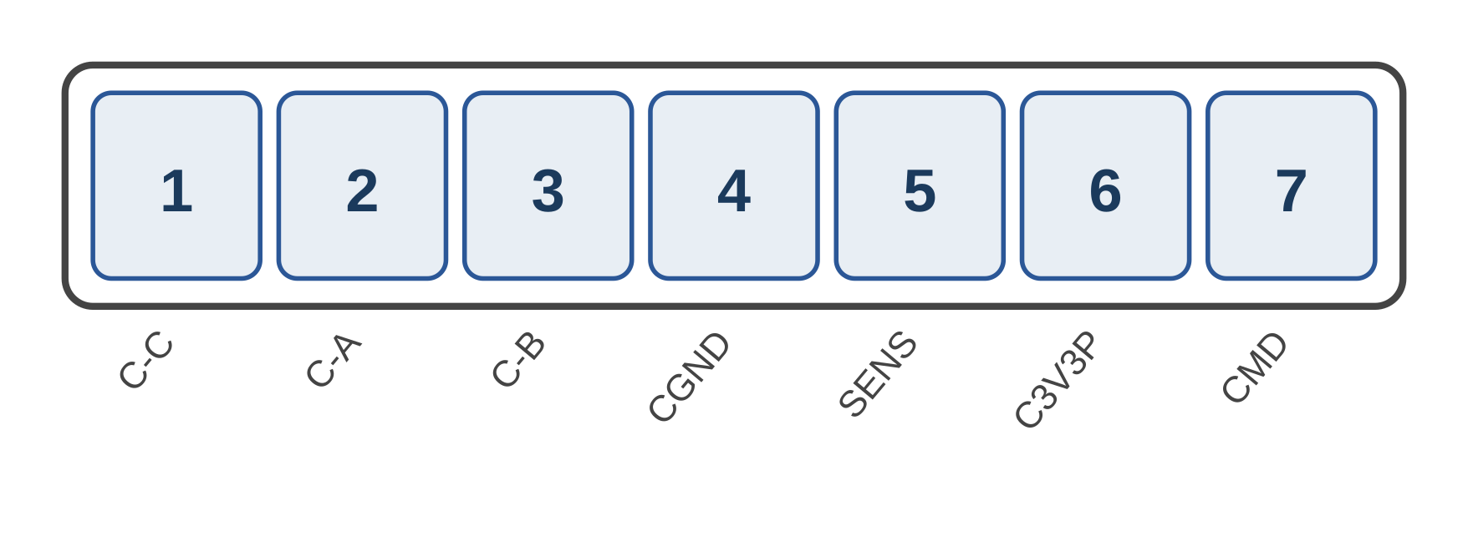

Interface specification
Pin | Signal | Type | Direction | Function
1 | C-C | 12V pulsed | OUT | MB drives BLDC motor phase C
2 | C-A | 12V pulsed | OUT | MB drives BLDC motor phase A
3 | C-B | 12V pulsed | OUT | MB drives BLDC motor phase B
4 | CGND | 0V | PWR | Motor ground
5 | SENS | 3.3V pulsed | IN | MB receives rotation index pulse from hall sensor (~120–170 Hz)
6 | C3V3P | 3.3V | PWR | Logic supply for hall sensors
7 | CMD | ~10V pulsed | OUT | MB drives motor speed control
To remove the wheel, spoof SENS at the measured frequency.

3.3 SK03 — Light source control PCB → Red laser
Type: 8-pin single row | Protocol: DAC-stepped analogue on pins 3–5
Direction: from control PCB perspective. This connector does NOT involve the MB — it runs between the control PCB and the red laser module. Both are removed in the conversion.

Pin diagram
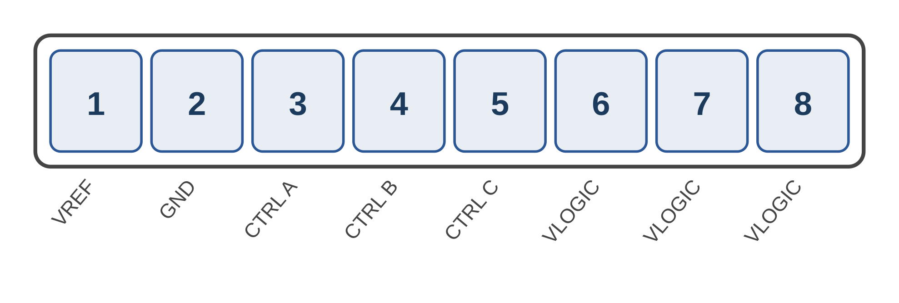

Interface specification
Pin | Signal | Type | Direction | Function
1 | VREF | 2.54V DC | OUT | Control PCB drives reference voltage
2 | GND | 0V | PWR | Ground
3 | CTRL A | 0–3V stepped | OUT | Control PCB drives brightness channel A
4 | CTRL B | 0–3V stepped | OUT | Control PCB drives brightness channel B
5 | CTRL C | 0–3V stepped | OUT | Control PCB drives brightness channel C
6 | VLOGIC | 3.3V DC | PWR | Logic supply (x3)
7 | VLOGIC | 3.3V DC | PWR | Logic supply
8 | VLOGIC | 3.3V DC | PWR | Logic supply
Entirely removed when red laser is eliminated. The MB has no connection to this interface.

3.4 SK04 — PSU → Main board
Type: 6-pin single row | Protocol: DC power + PSU-internal sense
Direction: from main board perspective. Power rails are received by the MB (IN/PWR).

Pin diagram
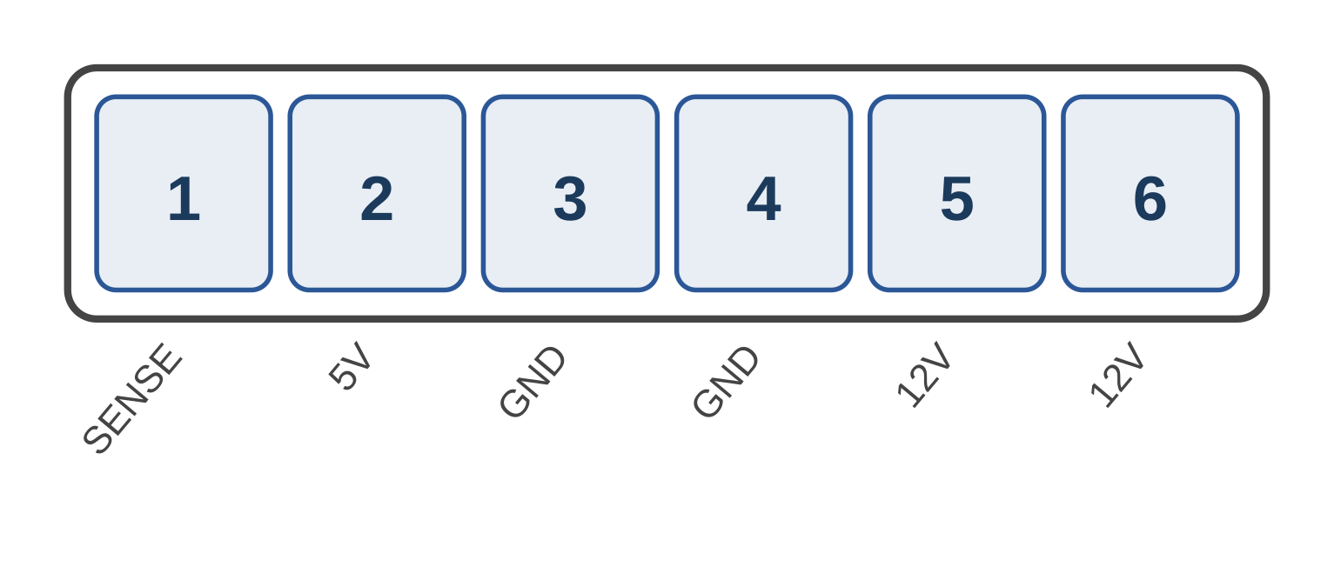

Interface specification
Pin | Signal | Type | Direction | Function
1 | SENSE | 2.7V | N/A | PSU-internal enable. NOT read by MB. Irrelevant when replacing PSU.
2 | 5V | 5V DC | PWR IN | MB receives 5V supply from PSU
3 | GND | 0V | PWR | Ground (pin 1/2)
4 | GND | 0V | PWR | Ground (pin 2/2)
5 | 12V | 12V DC | PWR IN | MB receives 12V from PSU (pin 1/2)
6 | 12V | 12V DC | PWR IN | MB receives 12V from PSU (pin 2/2, doubled for current)

SENSE pin scope capture (bootup)
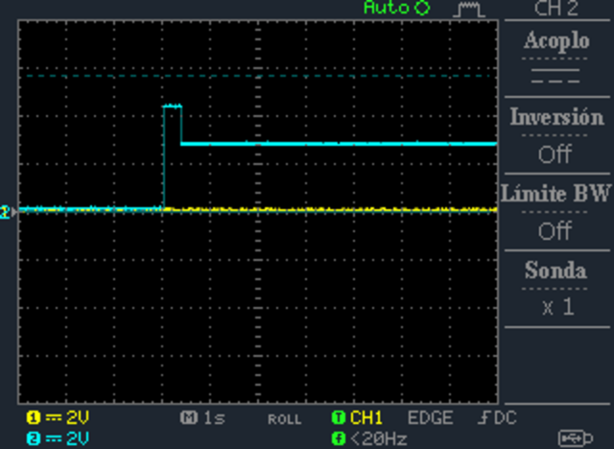
Figure: SENSE pin during bootup (1s/div, 2V/div). Clean step from 4.2V to 2.7V.

SENSE investigation results
- Test 1 — Normal: 4.2V standby, clean step to 2.7V when on, 5mA.
- Test 2 — Disconnected from MB: PSU side stays 4.2V. MB side = 0V (no pull-up). System won’t boot.
- Test 3 — Fed 2.7V/220Ω with MB disconnected: PSU activates normally. System boots. Proves main board does NOT read SENSE.
Conclusion: SENSE is PSU-internal. When replacing PSU, leave it unconnected. To operate original PSU standalone, feed 2.7V through 220Ω.

3.5 SK05 — Main board → Thermal management board
Type: 20-pin dual row (2×10) | Protocol: I2C ~68 kHz on pins 6/7, digital enable on pins 4/5/13/14/15
Direction: from main board perspective. Confirmed by disconnection test (SK05 cable removed, MB side probed).

Pin diagram
Pins 1–10 in column 1 (left), pins 11–20 in column 2 (right):
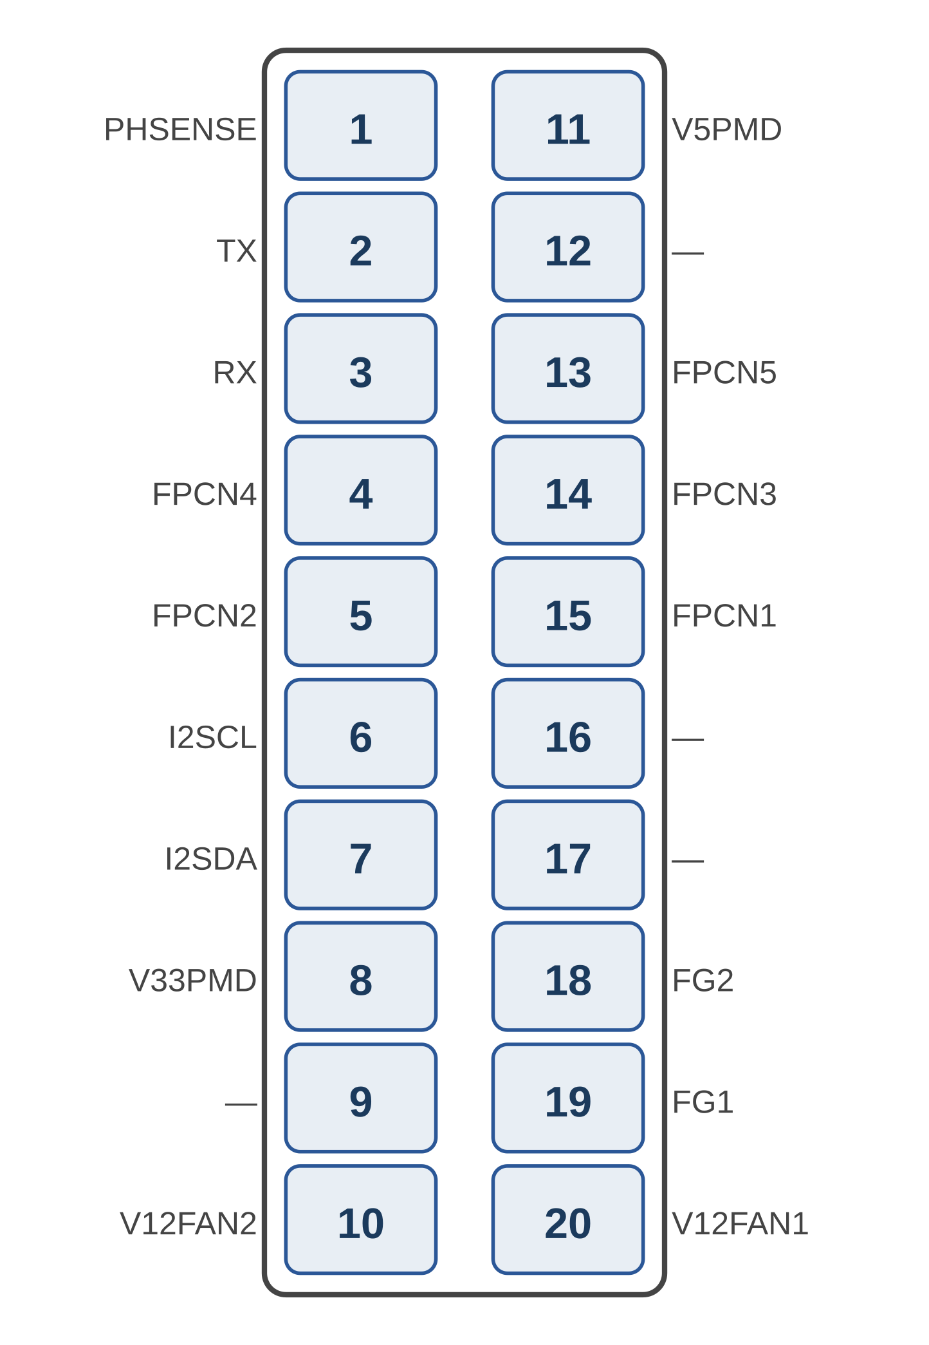

Interface specification — Column 1 (pins 1–10)
Pin | Signal | Type | Direction | Function
1 | PHSENSE | 2.85V analogue | IN | MB receives light feedback from photodiode. 2.85V steady, pulses to 0V at 125 Hz when blocked.
2 | TX | 3.3V UART | OUT | MB sends UART to thermal MCU. Idle HIGH, no activity observed.
3 | RX | 3.3V UART | IN | MB receives UART from thermal MCU. Idle HIGH, no activity observed.
4 | FPCN4 | 3.3V digital | OUT | MB drives fan enable 4. 0V off, 3.3V on. Single pulse, no PWM.
5 | FPCN2 | 3.3V digital | OUT | MB drives fan enable 2. Asserts ~500ms before FPCN4.
6 | I2SCL | 3.3V digital | OUT | MB drives I2C clock (bus master). ~68 kHz.
7 | I2SDA | 3.3V digital | BIDIR | I2C data. MB is master, shared with slave devices.
8 | V33PMD | 3.3V DC | PWR OUT | MB supplies 3.3V to thermal board
9 | — | — | — | Not populated
10 | V12FAN2 | 12V DC | PWR OUT | MB supplies 12V to fan 2

Interface specification — Column 2 (pins 11–20)
Pin | Signal | Type | Direction | Function
11 | V5PMD | 5V DC | PWR OUT | MB supplies 5V to thermal board
12 | — | — | — | Not populated
13 | FPCN5 | 3.3V digital | OUT | MB drives fan enable 5
14 | FPCN3 | 3.3V digital | OUT | MB drives fan enable 3
15 | FPCN1 | 3.3V digital | OUT | MB drives fan enable 1
16 | — | — | — | Not populated
17 | — | — | — | Not populated
18 | FG2 | 3.3V digital | IN | MB input — fan tach 2. Always LOW. Not actively read by MB.
19 | FG1 | 3.3V digital | IN | MB input — fan tach 1. Always LOW. Not actively read by MB.
20 | V12FAN1 | 12V DC | PWR OUT | MB supplies 12V to fan 1

Signal electrical characteristics
Signal | Voltage | Frequency | Duty | Type | Notes
TX | 3.3V idle | 0 Hz | 100% | Static | MB output. UART idle. No activity in any capture.
RX | 3.3V idle | 0 Hz | 100% | Static | MB input. UART idle. No activity in any capture.
FPCN2 | 0–3.3V | N/A | N/A | Enable | MB output. 0V→3.3V at +5.2s boot, 3.3V→0V shutdown.
FPCN4 | 0–3.3V | N/A | N/A | Enable | MB output. 0V→3.3V at +5.7s boot. FPCN2 leads ~500ms.
I2SCL | 0–3.3V | ~68 kHz | 35.1% | I2C clk | MB output. HIGH=5.1µs, LOW=9.5µs. Dominant period=10µs.
I2SDA | 0–3.3V | data | data | I2C data | BIDIR. HIGH avg=42µs, LOW avg=27µs active.
FG1 | 0V | 0 Hz | 0% | Static | MB input. Always LOW. Not actively read by MB.
FG2 | 0V | 0 Hz | 0% | Static | MB input. Always LOW. Not actively read by MB.
PHSENSE | 0–2.85V | 125 Hz* | ~100%* | Analogue | MB input. *Pulses to 0V only when source 2 blocked.

I2C bus analysis
Decoded from three captures: nominal (37.2s, 1258 transactions), fan-failure (82.9s, 2592 transactions), and MB-only with thermal board disconnected (15.0s, 298 transactions). Three I2C devices identified:
0x4D — Multi-channel temperature sensor — ON THE THERMAL BOARD
Four channels polled every ~510ms. Register pairs (MSB = integer °C, LSB = fractional):
Channel | Registers | Nominal | Assignment
Ch1 | 0x3E/0x3F | 46–47°C | Main board / ambient
Ch2 | 0x4E/0x4F | 47–48°C | Secondary board area
Ch3 | 0x5E/0x5F | 74–75°C | Red laser heatsink — SHUTDOWN TRIGGER
Ch4 | 0x6E/0x6F | 41–48°C | UV source area (noisy, affected by fan 3)

Thermal shutdown trigger: When fan 4 was locked, Ch3 jumped from 0x4A (74°C) to 0xFF at t=66.6s. System shut down ~10 seconds later. The 0xFF value is the thermal kill switch. EEPROM fault record written before shutdown.

0x54 — EEPROM (AT24C32/64) — ON THE MAIN BOARD (confirmed by disconnection test)
4KB+ capacity, 16-bit addressing. Reads 2374 bytes at boot (config, calibration, thermal thresholds, session logs). Writes mirrored pairs for data integrity (e.g. 0x01F8/0x06D8, 0x03EA/0x08CA). Shutdown record: 00 00 00 FF 64 40 (identical to SK01 UART shutdown bytes). Must remain connected — main board reads boot config from it.

0x41 — Fan controller or GPIO expander — ON THE THERMAL BOARD
Init: writes reg 00=0x81, 03=0x40, 04=0xC0. Periodic: writes reg 01=0xF8, 02=0xF8 every ~2s. All transactions are writes, never reads. However, if these writes NACK because 0x41 is absent, the main board may detect the failure. This was not testable in the MB-only capture because the system shut down from missing 0x4D before reaching the 0x41 init stage. This is an open risk for longer sessions — even if 0x4D is spoofed, missing 0x41 ACKs could trigger a delayed fault.

Disconnection test (SK05 cable removed, MB side only)
A capture was taken with the SK05 cable completely disconnected, probing the main board side only. This definitively confirmed device locations and signal directions:
- EEPROM (0x54): 291 ACKed transactions. Boot config read completed successfully. EEPROM is physically on the main board.
- Temp sensor (0x4D): 6 NACKs over 3.0 seconds (1 attempt/second), then system gave up. Wrote fault record to EEPROM at t=9.3s. System shut down at t=9.4s. Confirms 0x4D is on the thermal board.
- Fan controller (0x41): Zero attempts. The main board never tried to contact 0x41 because it crashed before reaching that boot stage. Confirms 0x41 is on the thermal board, but leaves open the question of what happens if 0x4D responds and 0x41 doesn’t.
- FPCN2/FPCN4: 0.42µs glitch HIGH then stayed LOW. Main board outputs, but never properly asserted because boot failed.
- FG1/FG2: 0.17µs glitch (capacitive coupling) then stayed LOW. No pull-up on main board. Confirmed as inputs.
- TX/RX: Held idle HIGH throughout. Confirms TX is output (main board holds it), RX is input (pulled up by main board).

Confirmed signal directions (from main board)
Pin | Signal | Direction | Evidence
2 | TX | OUTPUT | Main board holds HIGH (idle UART)
3 | RX | INPUT | Pulled up by main board (idle UART)
4 | FPCN4 | OUTPUT | Main board drives HIGH to enable fans
5 | FPCN2 | OUTPUT | Main board drives HIGH to enable fans
6 | I2SCL | OUTPUT | Main board is I2C bus master
7 | I2SDA | BIDIR | I2C data, master on main board, shared with slaves
18 | FG2 | INPUT | 0.17µs capacitive glitch only, no MB pull-up
19 | FG1 | INPUT | 0.17µs capacitive glitch only, no MB pull-up

Spoofing implications (updated)
- TX/RX: Leave unconnected. UART not active.
- FG1/FG2: Leave LOW. Not monitored.
- FPCN1–5: Assert 3.3V when system on, or keep thermal board connected.
- I2C 0x4D (CRITICAL): Must spoof. I2C slave emulator at address 0x4D. Respond to register reads with safe temps: Ch1=0x2E, Ch2=0x2F, Ch3=0x4A (NEVER 0xFF), Ch4=0x2E. Polled every ~510ms.
- I2C 0x54 (EEPROM): On the main board. Keep connected. No spoofing needed.
- I2C 0x41 (OPEN RISK): On the thermal board. All transactions are writes from the main board. If those writes NACK because 0x41 is absent, it may trigger a delayed fault on longer sessions even with 0x4D spoofed. Safest approach: keep the thermal board connected (or at minimum, keep the 0x41 IC on the bus), and only replace 0x4D with a spoofing MCU.

The simplest and safest approach is to keep the entire thermal management board connected, and intercept only the 0x4D temperature sensor on the I2C bus with a spoofing MCU that returns safe values. This avoids the 0x41 NACK risk entirely while keeping fans operational for DMD cooling.

4. SK01 UART protocol analysis
TX0LD and RX0LD run at 19200 baud 8N1 (confirmed: 52.08 µs/bit). Packets grouped by 2ms inter-byte gap.

4.1 Packet structure
- Byte 0: 0x03 normal, 0x02 graceful shutdown, 0x00 fault shutdown.
- Byte 1: TX0LD: 0x01=read, 0x02=write, 0x03=multi-write, 0x20=heartbeat, 0x40=extended. RX0LD: upper nibble = response type.
- Payload: Telemetry 10–13 bytes, probable IEEE 754 floats (0x43 patterns).
- Last byte: CRC/XOR checksum (algorithm not yet identified). ~490ms polling interval.

5. Nominal boot sequence
LDPCN HIGH at +3.0s → RX0LD announce (03 40 08 F0) at +3.4s → 6 init packets → LLITZ HIGH at +4.8s (light confirmed) → polling at ~490ms → steady-state response 03 48 09 02 00 1F 08 0C 6A BD E8 FF (repeated 6×) → shutdown: TX0LD 02 00, RX0LD 01.

6. No-lamp failure sequence
Boot proceeds normally until LLITZ. LLITZ goes HIGH at +6.4s but drops after only 275ms (vs 14s nominal). All telemetry packets contain 88 0F fault pattern. At +8.4s main board sends unique error query 03 02 D3 95 F0. System shuts down at +10.3s with abnormal termination 00 00 (vs graceful 02 00). The 275ms is the ignition timeout and 88 0F is the fault signature.

7. Complete spoofing strategy

7.1 SK01 — UART + signal emulation
The spoofing MCU replaces the light source control PCB. It reads MB outputs (LDPCN, TX0LD, LENBL) and drives control PCB outputs (RX0LD, LLITZ, LUM, PRSV). Signals CIDX, LDUP, LENBL are MB-generated and require no spoofing.
- Monitor LDPCN (pin 4): MB asserts HIGH to enable. You have a 4.6s window to respond before MB retries.
- Assert PRSV (pin 13): Tie to 5V (V5P0LD) permanently.
- Assert LUM (pin 1): Provide clean ~3V DC when system on. Voltage divider from 3.3V or precision reference. CRITICAL: do not load with low-impedance probes.
- On LDPCN HIGH, send RX0LD announce: 03 40 08 F0
- Replay init ACK sequence on RX0LD: device ID, config ACKs, calibration data (see Appendix).
- Assert LLITZ (pin 9) HIGH: Must go HIGH within 275ms of init completing to signal successful ignition. Failure to assert triggers 88 0F fault pattern.
- For periodic TX0LD polls (~490ms), respond on RX0LD: 03 48 09 02 00 1F 08 0C 6A BD E8 FF
- Echo heartbeat: 03 20 D3 95 F0
- Shutdown ACK: 01
- Optionally read LENBL PWM (pin 8, 359 Hz): duty cycle encodes requested brightness. Use to modulate your TTL laser power.
- LDUP (pin 10) and CIDX (pin 5): MB outputs — ignore. No spoofing needed.

7.2 SK05 — I2C temperature spoofing
I2C slave at address 0x4D responding to register reads with safe temperatures. Keep EEPROM (0x54) and thermal board (0x41) connected.

7.3 SK02 — Colour wheel SENS spoofing
555 timer or MCU generating fake SENS pulse at measured wheel frequency (~120–170 Hz).

7.4 SK04 — PSU replacement
External 12V supply + buck regulator for 5V. SENSE pin is PSU-internal, leave unconnected on MB side.

7.5 Laser integration
405nm TTL laser module (500mW–2W) coupled into colour mixing module input. TTL gated by LDPCN. The MB outputs a 359 Hz PWM brightness command on LENBL (pin 8) that the spoofing MCU can read to modulate laser power proportionally. No colour-segment sync needed with wheel removed.

Appendix A: Raw packet sequences
Copy-paste ready. One packet per line.
=== NOMINAL BOOT: RX0LD (Control PCB -> Main Board) ===
03 40 08 F0
03 42 AB 6F 44 01 01 0D 63 B0
03 40 11 92
03 20 9E EC 02 ED
03 C8 CB C1 00 27 43 A5 88 D6 1A 43 FD
03 A0 C3 24 F8
03 20 6D 2A B2

=== NOMINAL BOOT: TX0LD (Main Board -> Control PCB) ===
03 01 9D 2D E2
03 01 11 92
03 03 E6 8A 27 00 ED
03 01 90 82 FE
03 02 A3 38 24 08
03 02 B5 A7 92 FF

=== NOMINAL STEADY-STATE POLL TX0LD (repeating ~490ms) ===
03 01 04 3E 30
03 01 04 3E FE
03 01 90 82 FE
03 40 90 82 FE
03 01 04 82 FE
03 40 90 82

=== NOMINAL HEARTBEAT (echo back) ===
03 20 D3 95 F0

=== NOMINAL STEADY-STATE RESPONSE RX0LD (healthy telemetry) ===
03 48 09 02 00 1F 08 0C 6A BD E8 FF

=== NOMINAL SHUTDOWN ===
TX0LD: 02 00
RX0LD: 01

=== NO-LAMP: ERROR QUERY (unique to failure) ===
TX0LD: 03 02 D3 95 F0
RX0LD: 03 20 D3 95 F0

=== NO-LAMP: ABNORMAL SHUTDOWN ===
TX0LD: 00 00
RX0LD: 00

=== SK04 SENSE PIN — PSU-INTERNAL (NOT READ BY MAIN BOARD) ===
PSU-internal enable pin. Main board does NOT read this signal.
When replacing PSU: leave SENSE unconnected on main board side.
To operate original PSU standalone: feed 2.7V through 220 ohm into SENSE.

=== SK05 I2C: DEVICE LOCATIONS (confirmed by disconnection test) ===
0x54 EEPROM: ON MAIN BOARD (responded with thermal board disconnected)
0x4D Temp sensor: ON THERMAL BOARD (NACKed, 6 attempts over 3s then shutdown)
0x41 Fan controller: ON THERMAL BOARD (not even attempted without thermal board)
0x7F Bus scan: ON THERMAL BOARD (NACKed)

=== SK05 I2C: TEMPERATURE SENSOR SPOOFING (0x4D) ===
Polling interval: ~510ms, 4 channels per cycle

Register read responses (safe values):
0x3E -> 0x2E (Ch1 MSB: 46 deg C)
0x3F -> 0x80 (Ch1 LSB)
0x4E -> 0x2F (Ch2 MSB: 47 deg C)
0x4F -> 0x80 (Ch2 LSB)
0x5E -> 0x4A (Ch3 MSB: 74 deg C) ** NEVER return 0xFF **
0x5F -> 0x80 (Ch3 LSB)
0x6E -> 0x2E (Ch4 MSB: 46 deg C)
0x6F -> 0x80 (Ch4 LSB)

=== SK05 I2C: DEVICE 0x41 — keep or spoof ===
Init: W 82 00 81 / W 82 01 00 / W 82 02 00 / W 82 03 40 / W 82 04 C0
Periodic (every ~2s): W 82 01 F8 / W 82 02 F8
All transactions are WRITES. Behavior if NACKed is UNKNOWN.
Risk: may trigger fault on longer sessions if main board checks ACK.

End of document

