DLP Projector Hack
Complete Project Reference
Direct Laser Imaging for Photolithography — System Analysis, Protocol Decode & Spoofing Strategy

1. Project overview
The objective is to convert a commercial DLP projector into a direct laser imaging system for photolithography. This means replacing the projector’s original light sources (a primary UV/blue source and a red laser) with a TTL-controlled UV laser module (likely 405nm), removing the colour wheel, and retaining only the DMD chip and main board to act as a programmable spatial light modulator.
The main challenge is that the projector’s main board performs health checks on the light engine via a dedicated light source control PCB. If the control PCB is absent or reports a fault, the system shuts down within seconds. The solution is to build a spoofing microcontroller (ESP32 or STM32) that emulates the control PCB’s UART responses, keeping the main board in a normal operating state while the actual light source is replaced.

2. System architecture
The projector contains five major subsystems connected by six cables/connectors:
- Power supply (PSU) — 12V AC-to-DC converter occupying the left quarter of the projector, full height. Feeds power to the main board (6-pin) and to the light source control PCB (stacked beneath).
- Light source control PCB — sits physically beneath the PSU at the bottom. This is the intelligence layer that manages both light sources and communicates with the main board via 13-pin UART. It receives commands on TX0LD and reports telemetry on RX0LD at 19200 baud.
- UV light module — primary blue source with phosphor wheel, located to the right of the PSU in the back two-thirds. Powered directly from the PSU via a dedicated cable.
- Red laser (source 2) — located in front of the UV module. Driven by the control PCB via 8-pin analogue control (CTRL A/B/C stepped voltages).
- Colour wheel — sits at the bottom, below the red laser. Driven directly by the main board via 7-pin BLDC motor control. The phosphor wheel converts blue to green and passes blue/red through.
- Main board — occupies the entire right half of the projector. Contains the DMD chip (top centre), colour mixing/light integration module (bottom-left third), and the lens assembly (below DMD, projecting downward). A 20-pin connector on the main board routes to an external thermal management board for fan control and temperature monitoring.

2.1 Light path
UV module → Red laser → Colour wheel → Colour mixing module → DMD chip → Lens → Output (downward). Light from both sources is combined through the phosphor wheel, integrated in the mixing module, reflected by the DMD, and projected downward through the lens assembly.

2.2 Connector summary
- 13-pin data + power: Control PCB ↔ Main board — UART, status signals, power rail
- 7-pin motor drive: Main board → Colour wheel — 3-phase BLDC + index sense
- 8-pin analogue control: Control PCB → Red laser — DAC brightness channels
- 6-pin power rail: PSU → Main board — 12V, 5V, GND, sense
- Power cable: PSU → UV module — lamp drive (pins unknown)
- Stacked connection: PSU → Control PCB — direct (pins unknown)
- 20-pin thermal management: Main board → Thermal board — fan PWM, tach feedback, I2C temp sensors, power rails

2.3 Physical layout diagram
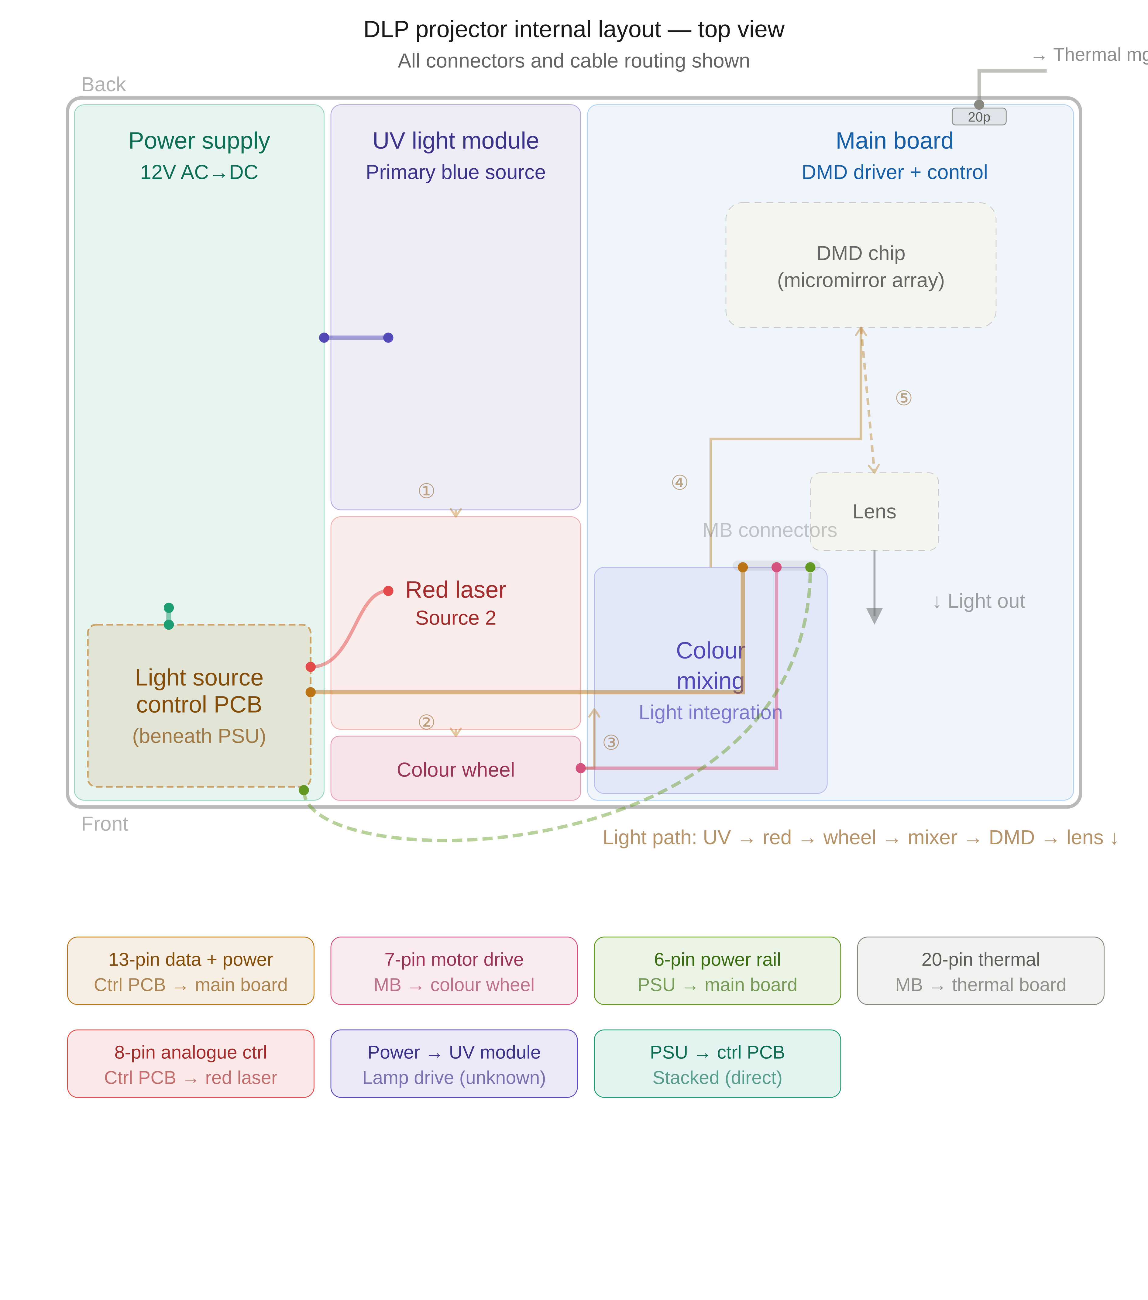
Figure 1: Projector internal layout (top view) showing all subsystems, cable connections, optical path, and the 20-pin thermal management connector on the main board. The light source control PCB (dashed outline) sits physically beneath the PSU.

3. Electrical interface control document (EICD)
This section defines the electrical interface for each connector in the projector system. Each connector is assigned a unique identifier (SKxx) and documented with a pin diagram, pin assignment table, and full interface specification including signal type, direction, and function.
Direction convention: direction is defined from the perspective of the connector’s source board. OUT = signal originates from the source board. IN = signal is received by the source board. BIDIR = bidirectional. PWR = power rail.

3.1 SK01 — Light source control PCB ↔ Main board
Connector ID: SK01
Type: 13-pin single row
Location (source): Light source control PCB (bottom-right edge)
Location (destination): Main board (left edge, above colour mixing module)
Protocol: UART 19200 baud 8N1 on pins 6/7, PWM on pin 10, digital status on pins 4/8/9/13

Pin diagram
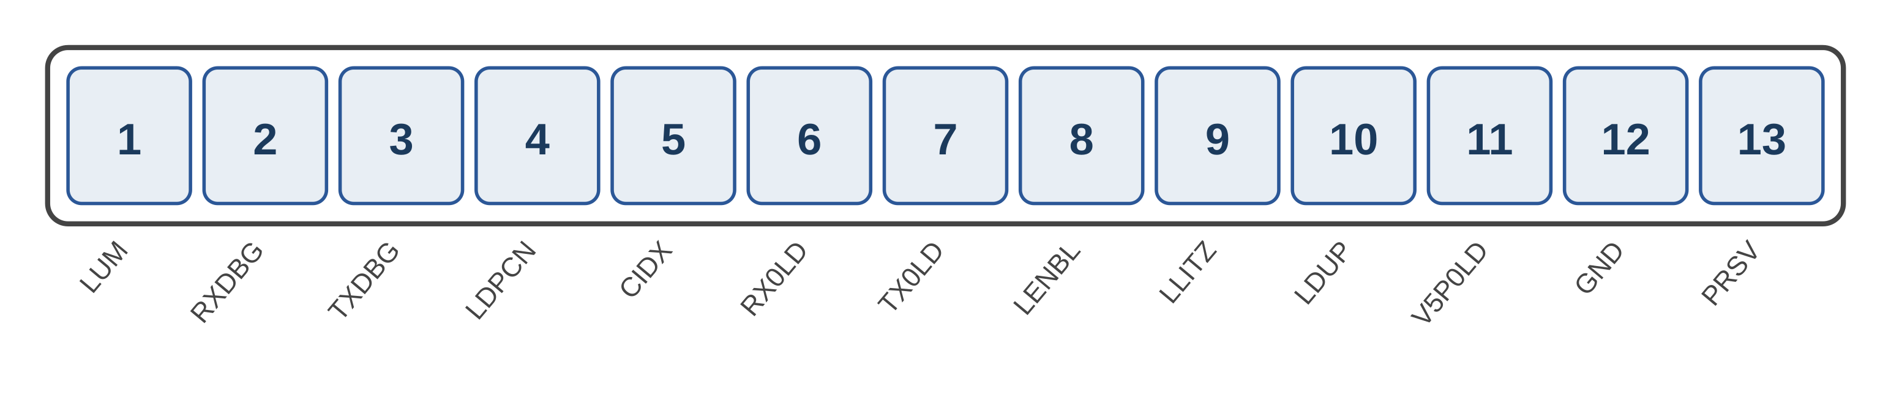

Interface specification
Pin | Signal | Type | Direction | Function
1 | LUM | 3V DC | OUT | Brightness reference from control PCB
2 | RXDBG | 5V DC | IN | Debug UART RX (input to control PCB)
3 | TXDBG | 3.3V DC | OUT | Debug UART TX (mirrors RX0LD first packet)
4 | LDPCN | 3.3V digital | IN | Light driver enable — asserted by main board
5 | CIDX | 3.3V pulsed | IN | Colour/frame sync output from main board to DMD
6 | RX0LD | 3.3V UART | OUT | UART TX from control PCB to main board (19200 baud 8N1)
7 | TX0LD | 3.3V UART | IN | UART TX from main board to control PCB (19200 baud 8N1)
8 | LENBL | 3.3V digital | IN | Light enable signal from main board
9 | LLITZ | 3.3V DC | TBD | Intensity reference — HIGH when lamp on (275ms ignition timeout). Direction not confirmed.
10 | LDUP | 3.3V PWM | OUT | High-frequency PWM proportional to light output power
11 | V5P0LD | 5V DC | PWR | 5V power rail supplied to control PCB
12 | GND | 0V | PWR | Ground
13 | PRSV | 5V DC | OUT | Presence detect — must be HIGH for main board to operate

Notes: This is the critical connector for the spoofing strategy. Pins 6 (RX0LD) and 7 (TX0LD) carry the 0x03-header UART protocol with ~490ms polling. Pin 9 (LLITZ) drops after 275ms if no lamp is detected, triggering the 88 0F fault telemetry pattern. Pin 13 (PRSV) must be held HIGH or the main board will not initialise. Pin 10 (LDUP) must generate PWM at the frequency observed during nominal operation.

3.2 SK02 — Main board → Colour wheel
Connector ID: SK02
Type: 7-pin single row
Location (source): Main board (left edge, below SK01)
Location (destination): Colour wheel motor (below red laser module)
Protocol: 3-phase BLDC commutation on pins 1–3, tachometer feedback on pin 5

Pin diagram
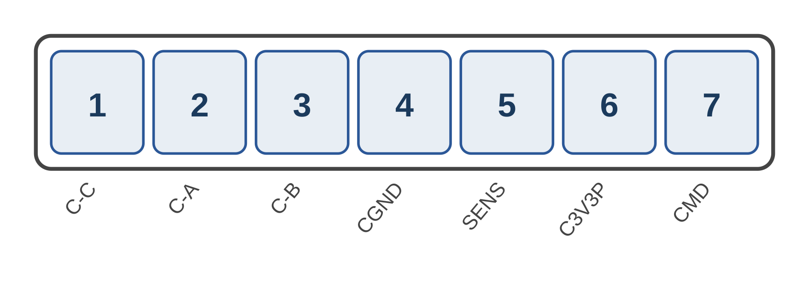

Interface specification
Pin | Signal | Type | Direction | Function
1 | C-C | 12V pulsed | OUT | BLDC motor phase C
2 | C-A | 12V pulsed | OUT | BLDC motor phase A
3 | C-B | 12V pulsed | OUT | BLDC motor phase B
4 | CGND | 0V | PWR | Motor ground
5 | SENS | 3.3V pulsed | IN | Rotation index pulse — 1 pulse/rev (~120–170 Hz)
6 | C3V3P | 3.3V | PWR | Logic supply for hall effect sensors
7 | CMD | ~10V pulsed | OUT | Motor speed control signal

Notes: Main board drives the colour wheel motor directly — this does not route through the control PCB. Pin 5 (SENS) is the rotation index pulse used to synchronise with CIDX on SK01. To remove the wheel, spoof SENS at the measured frequency using a 555 timer or MCU output.

3.3 SK03 — Light source control PCB → Red laser
Connector ID: SK03
Type: 8-pin single row
Location (source): Light source control PCB (bottom-right edge)
Location (destination): Red laser module (source 2)
Protocol: DAC-stepped analogue voltages on pins 3–5 for brightness control

Pin diagram
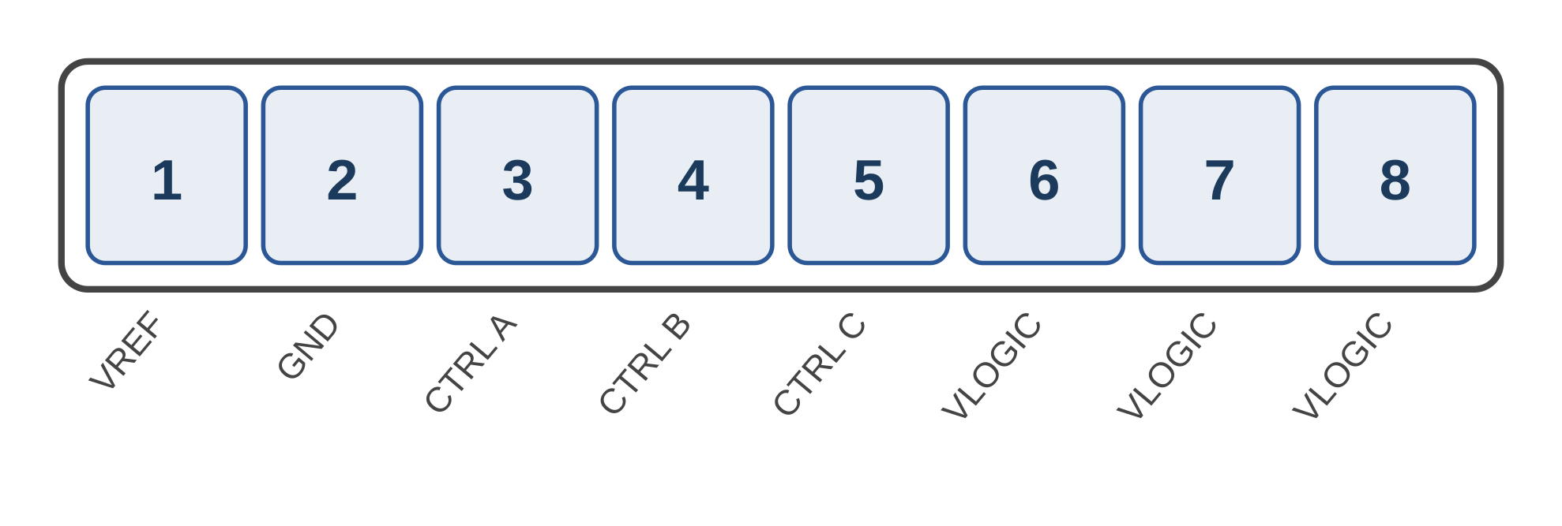

Interface specification
Pin | Signal | Type | Direction | Function
1 | VREF | 2.54V DC | OUT | Reference voltage for DAC circuits
2 | GND | 0V | PWR | Ground
3 | CTRL A | 0–3V stepped | OUT | Red laser brightness/mode control channel A
4 | CTRL B | 0–3V stepped | OUT | Red laser brightness/mode control channel B
5 | CTRL C | 0–3V stepped | OUT | Red laser brightness/mode control channel C
6 | VLOGIC | 3.3V DC | PWR | Logic supply (pin 1 of 3)
7 | VLOGIC | 3.3V DC | PWR | Logic supply (pin 2 of 3)
8 | VLOGIC | 3.3V DC | PWR | Logic supply (pin 3 of 3)

Notes: The control PCB translates UART commands from the main board (received on SK01) into analogue drive signals for the red laser. CTRL A/B/C are DAC outputs providing discrete brightness levels. For the conversion project, this connector is disconnected when the red laser is removed.

3.4 SK04 — PSU → Main board
Connector ID: SK04
Type: 6-pin single row
Location (source): Power supply unit (bottom-right edge)
Location (destination): Main board (left edge, below SK01/SK02)
Protocol: DC power distribution. Pin 1 is a sense/status line.

Pin diagram
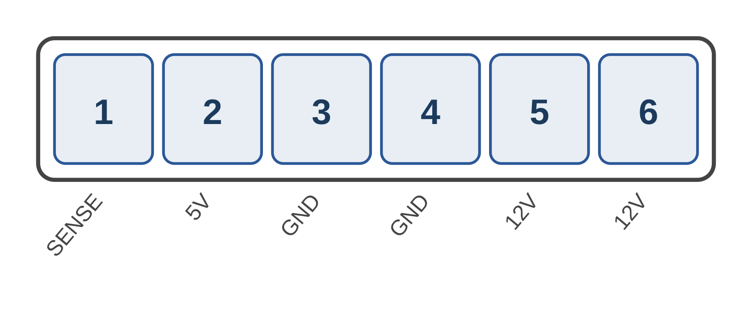

Interface specification
Pin | Signal | Type | Direction | Function
1 | SENSE | 4.2V→2.7V | OUT | PSU status/sense — 4.2V off, drops to 2.7V when on
2 | 5V | 5V DC | PWR | 5V supply rail for main board logic
3 | GND | 0V | PWR | Ground (pin 1 of 2)
4 | GND | 0V | PWR | Ground (pin 2 of 2)
5 | 12V | 12V DC | PWR | Main 12V rail (pin 1 of 2)
6 | 12V | 12V DC | PWR | Main 12V rail (pin 2 of 2, doubled for current capacity)

Notes: The SENSE pin drops from 4.2V to 2.7V when the system is active. This could be a passive resistor divider sagging under load, or an active PSU-good signal. To determine: measure resistance between pin 1 and all other rails with the PSU disconnected. To replace the PSU: provide 12V and 5V from external regulators and replicate the SENSE voltage behaviour.

3.5 SK05 — Main board → Thermal management board
Connector ID: SK05
Type: 20-pin dual row (2×10 matrix)
Location (source): Main board (top-right area)
Location (destination): External thermal management board
Protocol: UART on pins 2/3 to thermal MCU, I2C on pins 6/7 for temperature sensors, digital enable on pins 4/5/13/14/15 for fans

Pin diagram
Pins 1–10 in column 1 (left), pins 11–20 in column 2 (right):
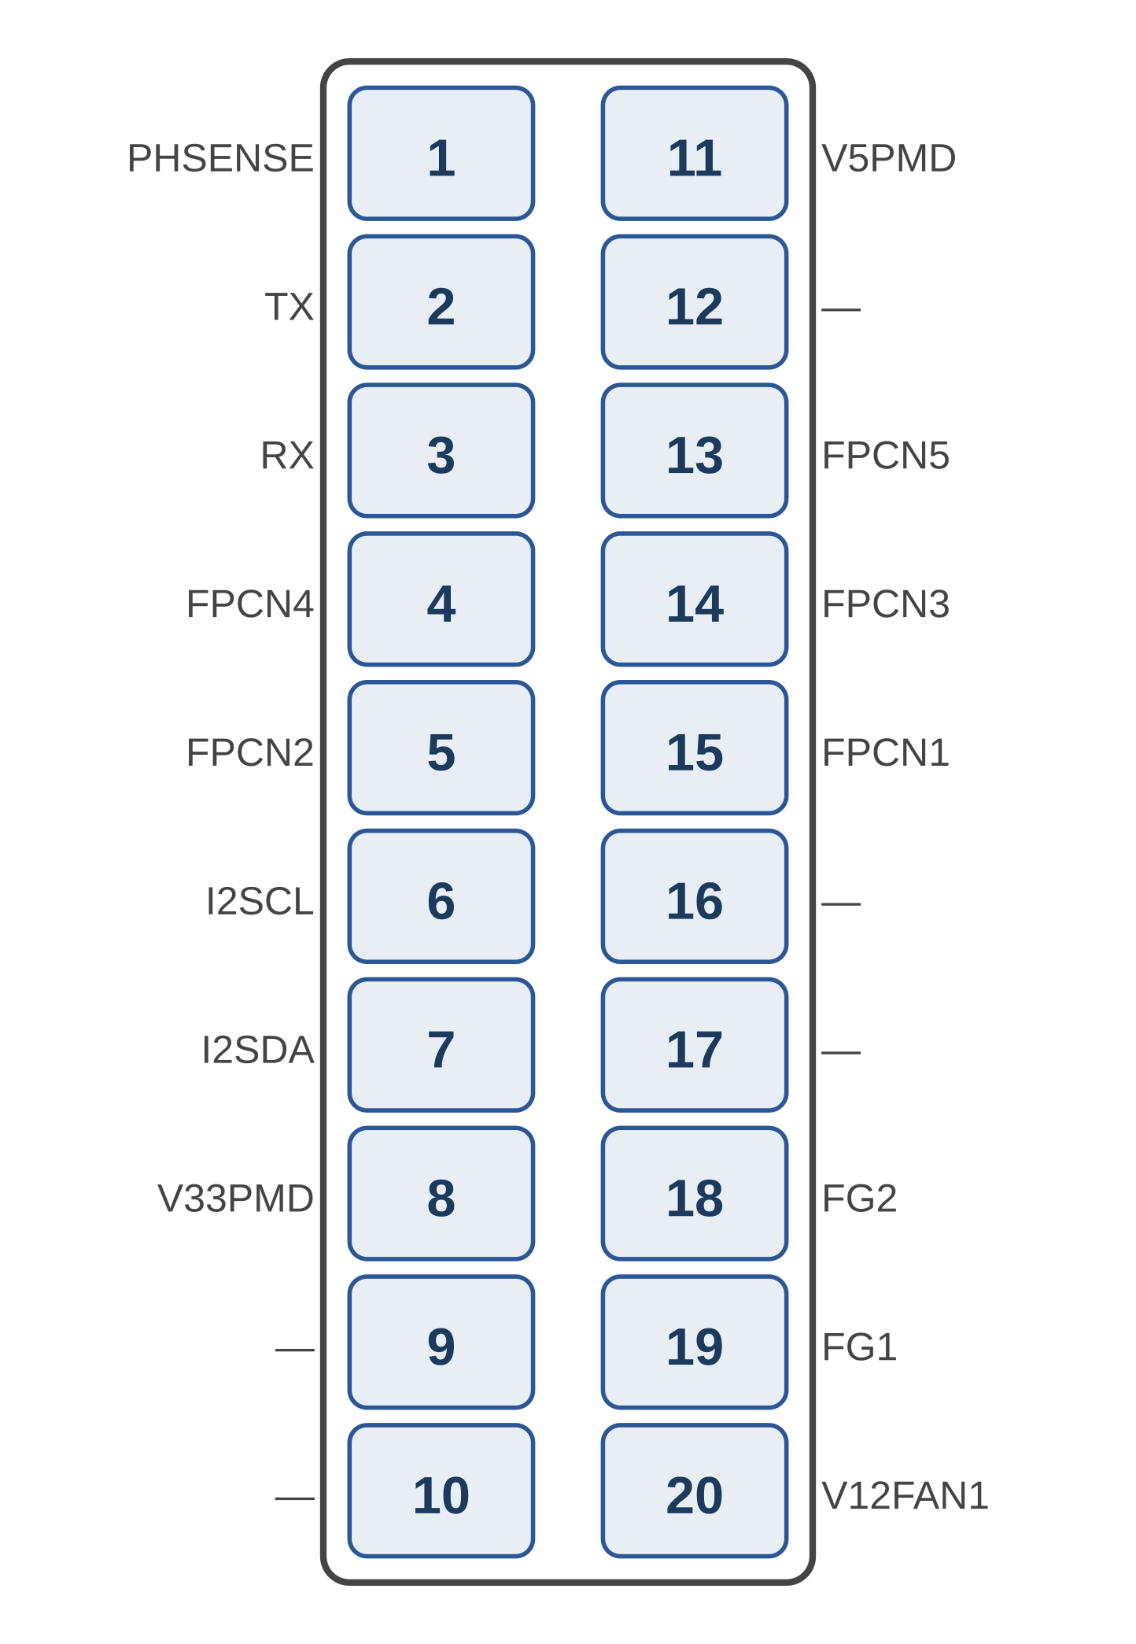

Interface specification — Column 1 (pins 1–10)
Pin | Signal | Type | Direction | Function
1 | PHSENSE | 2.85V analogue | IN | Light feedback sensor — 2.85V steady when source 2 active. Pulses 2.85V→0V at ~125 Hz when red laser output is physically blocked. Likely photodiode monitoring colour wheel light throughput.
2 | TX | 3.3V UART | OUT | UART transmit from main board to thermal management MCU
3 | RX | 3.3V UART | IN | UART receive from thermal management MCU to main board
4 | FPCN4 | 3.3V digital | OUT | Fan enable channel 4 — 0V off, 3.3V on (digital enable, not PWM)
5 | FPCN2 | 3.3V digital | OUT | Fan enable channel 2 — 0V off, 3.3V on
6 | I2SCL | 3.3V digital | OUT | I2C clock line — temperature sensor bus
7 | I2SDA | 3.3V digital | BIDIR | I2C data line — temperature sensor bus
8 | V33PMD | 3.3V DC | PWR | 3.3V power rail to thermal management board
9 | — | — | — | Not populated
10 | V12FAN2 | 12V DC | PWR | 12V fan supply (fan 2)

Interface specification — Column 2 (pins 11–20)
Pin | Signal | Type | Direction | Function
11 | V5PMD | 5V DC | PWR | 5V power rail to thermal management board
12 | — | — | — | Not populated
13 | FPCN5 | 3.3V digital | OUT | Fan enable channel 5 — 0V off, 3.3V on
14 | FPCN3 | 3.3V digital | OUT | Fan enable channel 3 — 0V off, 3.3V on
15 | FPCN1 | 3.3V digital | OUT | Fan enable channel 1 — 0V off, 3.3V on
16 | — | — | — | Not populated
17 | — | — | — | Not populated
18 | FG2 | 3.3V digital | IN | Fan tachometer 2 — measured LOW throughout testing. Not actively read by main board.
19 | FG1 | 3.3V digital | IN | Fan tachometer 1 — measured LOW throughout testing. Not actively read by main board.
20 | V12FAN1 | 12V DC | PWR | 12V fan supply (fan 1)

Measurement notes
- PHSENSE: Steady 2.85V when the red laser is operating normally. When source 2 output is physically blocked, PHSENSE generates pulses from 2.85V down to 0V at approximately 125 Hz. This frequency matches the colour wheel rotation rate, strongly suggesting PHSENSE is a photodiode mounted after the colour wheel that monitors actual light throughput. The “reverse PWM” behaviour (normally HIGH, pulses LOW on obstruction) is characteristic of an active-high photodiode circuit. This signal likely feeds back to the main board to confirm that light is actually reaching the optical path.
- FG1/FG2 (pins 18/19): Remained LOW throughout all testing, including during normal fan operation and when fans were physically stopped. The main board does not appear to read fan tachometer signals through these pins. Fan speed feedback is handled internally by the thermal management board.
- FPCN1–5 (pins 4/5/13/14/15): Behave as simple digital enables, not PWM. All start at 0V, transition to 3.3V when the system turns on, and return to 0V at shutdown. No duty-cycle modulation was observed. When fans were physically stopped, they compensated by running faster — confirming that actual fan speed control is performed by an IC on the thermal management board itself, not by the main board.
- Thermal board intelligence: The thermal management board contains its own controller that receives on/off enable signals from the main board (FPCN1–5), reads its own temperature sensors (via I2C or onboard), and autonomously controls fan speeds using its own PWM drivers.

I2C bus analysis (SK05 pins 5/6)
Decoded I2C traffic from both nominal (37.2s, 1258 transactions) and fan-failure (82.9s, 2592 transactions) captures. TX/RX UART pins stayed at logic HIGH (idle) for the entirety of both captures — the thermal board UART is not active. Three I2C devices were identified:
0x4D — Multi-channel temperature sensor
Four temperature channels polled every ~510ms using register pairs (MSB = integer °C, LSB = fractional). Register addresses and normal operating ranges:
Channel | Registers | Nominal temp | Assignment (inferred)
Ch1 | 0x3E / 0x3F | 46–47°C | Main board / ambient temperature
Ch2 | 0x4E / 0x4F | 47–48°C | Secondary board area
Ch3 | 0x5E / 0x5F | 74–75°C | Red laser (source 2) heatsink — SHUTDOWN TRIGGER
Ch4 | 0x6E / 0x6F | 41–48°C (noisy) | UV source area (affected by fan 3 interference)

Shutdown trigger: When fan 4 (red laser fan) was physically locked, Ch3 jumped from 0x4A (74°C) to 0xFF at t=66.6s. The system continued polling for ~10 seconds before initiating shutdown at t=76.8s (FPCN2/FPCN4 → LOW). During those 10 seconds, the main board wrote fault records to the EEPROM (0x54). After the red laser source was killed, Ch3 briefly recovered to 0x25–0x2B (37–43°C) showing rapid cooling. The final EEPROM write before shutdown contained bytes 00 00 00 FF 64 40 — identical to the shutdown bytes seen in the SK01 UART protocol, confirming the main board writes the same status to both interfaces.

0x54 — EEPROM (AT24C series)
Bulk configuration read at boot (~300 bytes across many register pages). Periodic writes during operation logging operational data. Writes fault records just before shutdown. This EEPROM must be kept connected — it contains boot configuration that the main board reads at startup.

0x41 — I2C peripheral (fan controller or GPIO expander)
Initialised at boot with writes to registers 00–04 (reg 00=0x81, reg 03=0x40, reg 04=0xC0). Then periodically writes reg 01=0xF8 and reg 02=0xF8 every ~2 seconds throughout operation. May need the original IC kept in place, or spoofed.

Spoofing implications
- TX/RX (pins 2/3): Leave unconnected. UART is not active in either capture. No spoofing needed.
- FG1/FG2 (pins 18/19): Leave LOW. Not monitored by the main board. No spoofing needed.
- FPCN1–5 (pins 4/5/13/14/15): Simple digital enables. Assert 3.3V when system is on, or keep the thermal board connected.
- I2C 0x4D (CRITICAL): Must spoof. Respond with safe temperature values: Ch1=0x2E (46°C), Ch2=0x2F (47°C), Ch3=0x4A (74°C), Ch4=0x2E (46°C). The MSB registers (0x3E, 0x4E, 0x5E, 0x6E) must never return 0xFF or the system will initiate thermal shutdown within ~10 seconds. An ESP32 or STM32 I2C slave emulator at address 0x4D responding to register reads is sufficient.
- I2C 0x54 (EEPROM): Keep the original EEPROM connected. It stores boot configuration and operational logs. If the EEPROM is missing, the main board will likely fail to initialise.
- I2C 0x41 (peripheral): Keep original IC or spoof registers 01/02 with value 0xF8 every ~2 seconds. Needs further investigation to determine if the main board reads from this device or only writes.

The simplest approach is to keep the entire thermal management board and EEPROM connected, replace only the 0x4D temperature sensor with a spoofing MCU on the I2C bus. This avoids needing to spoof 0x41 and 0x54 while ensuring the fans continue to run (protecting the DMD and main board). The spoofing MCU only needs to intercept reads to the four temperature register pairs and return safe values.

4. UART protocol analysis
Both TX0LD and RX0LD run at 19200 baud 8N1 (confirmed: TX0LD = 52.08 µs/bit, RX0LD = 51.83 µs/bit). Bytes were grouped into packets using a 2ms inter-byte gap threshold.

4.1 Packet structure
- Byte 0 (Header): 0x03 during normal operation. Shutdown uses 0x02 (graceful) or 0x00 (fault).
- Byte 1 (Command/Status): TX0LD: 0x01=read, 0x02=write, 0x03=multi-write, 0x20=heartbeat, 0x40=extended read. RX0LD: upper nibble encodes response type.
- Bytes 2..N-1 (Payload): Register addresses, data, or telemetry. Telemetry packets are 10–13 bytes containing probable IEEE 754 floats (0x43 patterns suggest 128–255 range), current measurements, and status flags.
- Last byte: Likely CRC or XOR checksum (varies per packet, algorithm not yet identified).
Polling interval: ~490ms. One TX0LD command, one RX0LD response per cycle.

4.2 Status signals (non-UART)
- LDPCN: Digital enable from main board. HIGH = light driver active. Goes HIGH ~3s after power-on.
- LLITZ: Intensity reference. HIGH = light source operating. Nominal: stays HIGH 14.1s. No-lamp: only 275ms (the ignition timeout).
- LDUP: High-frequency PWM (10,269 transitions over 18.9s nominal). Proportional to light output. Not UART.
- LUDUP: High-frequency burst during init (~10ms window). Power status or modulation feedback.

5. Nominal boot sequence (lamp present)

5.1 System-level timeline
Time | Event | Significance
+0.0s | All LOW | Power on, system idle
+2.8s | LUDUP active | Board power stabilised, high-freq PWM on LUDUP
+3.0s | LDPCN → HIGH | Main board enables light driver subsystem
+3.4s | RX0LD first packet | Control PCB announces ready (03 40 08 F0)
+4.3s | UART init burst | 6 init packets exchanged (ID, config, calibration)
+4.8s | LLITZ → HIGH | Intensity ref active — light source confirmed ON
+5.2s | Periodic polling | ~490ms poll cycle begins (TX0LD ↔ RX0LD)
+18.9s | LLITZ → LOW | Intensity ref deactivated (user shutdown initiated)
+22.0s | LDPCN → LOW | Light driver disabled, TX0LD sends 02 00 shutdown

5.2 TX0LD packets (Main board → Control PCB)
Time | Len | Data (hex) | Interpretation
+4.3s | 5 | 03 01 9D 2D E2 | Init: device query
+4.3s | 4 | 03 01 11 92 | Init: config register read
+4.3s | 7 | 03 03 E6 8A 27 00 ED | Init: multi-register config write
+4.3s | 5 | 03 01 90 82 FE | Init: status register read
+4.3s | 6 | 03 02 A3 38 24 08 | Init: calibration parameter write
+4.3s | 6 | 03 02 B5 A7 92 FF | Init: calibration parameter write
+4.7s | 5 | 03 01 90 82 FE | Post-init status check
+5.2s | 5 | 03 01 04 3E 30 | Periodic poll (type A)
+5.7s | 5 | 03 01 04 3E 30 | Periodic poll (type A)
+6.2s | 5 | 03 01 04 3E FE | Periodic poll (variant)
+6.6s | 5 | 03 20 D3 95 F0 | Heartbeat/sync request
+6.7s | 5 | 03 01 90 82 FE | Status register read
... |  | ... | Continues at ~490ms interval
+22.0s | 2 | 02 00 | Graceful shutdown command

5.3 RX0LD packets (Control PCB → Main board)
Time | Len | Data (hex) | Interpretation
+3.4s | 4 | 03 40 08 F0 | Power-on announce (control PCB ready)
+4.3s | 10 | 03 42 AB 6F 44 01 01 0D 63 B0 | Device ID / firmware version
+4.3s | 4 | 03 40 11 92 | Config register ACK
+4.3s | 6 | 03 20 9E EC 02 ED | Multi-register config ACK
+4.3s | 13 | 03 C8 CB C1 00 27 43 A5 88 D6 1A 43 FD | Calibration data response
+4.3s | 5 | 03 A0 C3 24 F8 | Calibration ACK
+4.4s | 5 | 03 20 6D 2A B2 | Init complete ACK
+4.8s | 12 | 03 C8 85 30 00 A5 48 6A 97 43 D4 FF | Telemetry (temp/current/status)
... |  | ... | Telemetry continues at ~490ms
+19.3s | 12 | 03 48 09 02 00 1F 08 0C 6A BD E8 FF | Steady-state (repeated 6×)
+22.0s | 1 | 01 | Shutdown ACK
After reaching steady state (~19s), the RX0LD response locks to a single repeating packet (03 48 09 02 00 1F 08 0C 6A BD E8 FF) for 6 consecutive cycles. This is the “all healthy” telemetry fingerprint.

6. No-lamp boot sequence (failure case)

6.1 System-level timeline
Time | Event | Significance
+0.0s | All LOW | Power on, system idle
+4.4s | LUDUP active | Board power stabilised
+4.7s | LDPCN → HIGH | Main board enables light driver subsystem
+5.1s | RX0LD first packet | Control PCB announces ready (03 40 08 F0)
+5.9s | UART init burst | Init packets exchanged (same device ID)
+6.4s | LLITZ → HIGH | Attempting to light lamp
+6.7s | LLITZ → LOW | LAMP FAILED — LLITZ on for only 275ms (vs 14s nominal)
+6.4–10.3s | Fault telemetry | RX0LD responses all contain 88 0F fault pattern
+8.4s | Error query | TX0LD sends 03 02 D3 95 F0 (unique to failure)
+10.3s | LDPCN → LOW | System shuts down — abnormal 00 00 termination

6.2 TX0LD packets (Main board → Control PCB)
Time | Len | Data (hex) | Interpretation
+5.9s | 5 | 03 01 9D 2D 13 | Init: device query
+5.9s | 5 | 03 01 14 3C E2 | Init: config register read (DIFFERENT)
+5.9s | 6 | 03 03 E6 B1 12 ED | Init: multi-register config
+6.0s | 4 | 03 01 90 82 | Init: status register read (truncated)
+6.0s | 6 | 03 02 A3 38 24 08 | Init: calibration (same as nominal)
+6.0s | 6 | 03 20 6D 2A 92 FF | Init: calibration (DIFFERENT)
+6.4s | 5 | 03 01 04 3E FE | Periodic poll
+6.9s | 5 | 03 01 04 3E 30 | Periodic poll
+7.4s | 5 | 03 01 04 3E FE | Periodic poll
+7.8s | 5 | 03 01 90 82 FE | Status register read
+8.3s | 5 | 03 01 90 82 FE | Status register read
+8.4s | 5 | 03 02 D3 95 F0 | Error query (UNIQUE to no-lamp)
+8.8s | 4 | 03 01 90 82 | Status register read
+9.3s | 4 | 03 40 90 82 | Extended status read
+9.8s | 5 | 03 01 90 82 FE | Status register read
+10.3s | 4 | 03 40 90 82 | Last status check
+10.3s | 2 | 00 00 | Abnormal shutdown (0x00 header, not 0x02)

6.3 RX0LD packets (Control PCB → Main board)
Time | Len | Data (hex) | Interpretation
+5.1s | 4 | 03 40 08 F0 | Power-on announce (same as nominal)
+5.9s | 10 | 03 42 AB 6F 44 01 01 0D 63 B0 | Device ID (identical)
+5.9s | 4 | 03 40 11 92 | Config register ACK
+5.9s | 6 | 03 20 9E EC 02 ED | Multi-register config ACK
+6.0s | 12 | 03 68 35 82 00 FC 88 0F 6B 10 43 FD | Calib data (DIFFERENT — contains 0F fault)
+6.0s | 5 | 03 A0 C3 24 F8 | Calibration ACK (same)
+6.0s | 5 | 03 20 6D 2A B2 | Init complete ACK (same)
+6.4s | 11 | 03 28 F2 30 00 BF 88 0F B6 E8 0D | Telemetry: 88 0F fault pattern
+6.9s | 11 | 03 08 54 C1 20 FC 88 0F 6B 09 43 | Telemetry: 88 0F fault pattern
+7.4s | 11 | 03 A8 94 30 02 FC 88 0F 6B 0E 43 | Telemetry: 88 0F fault pattern
+7.9s | 10 | 03 28 A3 02 00 0F 0F 6B 0F 43 | Telemetry: heavy 0F (all faults)
+8.3s | 11 | 03 68 F6 30 02 FB 88 0F 6B 0D 43 | Telemetry: 88 0F fault pattern
+8.4s | 5 | 03 20 D3 95 F0 | Error ACK / echo
+8.8s | 11 | 03 A8 F6 30 02 FC 88 0F B6 C8 0D | Telemetry: fault continues
+9.3s | 12 | 03 E8 B6 30 02 FC 88 0F 6C 08 D4 F7 | Telemetry: fault continues
+9.8s | 12 | 03 C8 DA 02 00 BF 88 0F 6C C8 0D FF | Telemetry: fault continues
+10.3s | 12 | 03 68 07 30 02 FC 88 0F 6B 10 43 FF | Final telemetry before shutdown
+10.3s | 1 | 00 | Abnormal shutdown ACK

7. How the system detects a missing lamp
The failure is detected through two independent mechanisms:

7.1 LLITZ timeout (275ms)
LLITZ goes HIGH when the system attempts ignition. In the nominal case it stays HIGH for 14.1 seconds. In the no-lamp case it drops LOW after only 275ms. This is likely feedback from a photodiode or current sense circuit confirming actual light output. The 275ms window is the ignition timeout.

7.2 The 88 0F fault pattern in telemetry
From the very first telemetry packet after init, every no-lamp RX0LD response contains the byte sequence 88 0F at recurring positions. In nominal operation, these positions contain varying analogue readings (48 6A, E8 6A, 2C 43, etc.). The locked 88 0F pattern encodes the fault condition. The byte 0F (binary 00001111) may be a 4-bit fault flag field with all faults asserted.

7.3 Error query and shutdown
At +8.4s (~2 seconds after lamp failure), the main board sends 03 02 D3 95 F0 — a packet not seen in the nominal sequence. The control PCB echoes it as 03 20 D3 95 F0. This is an explicit error status query. Approximately 2 seconds later, the system initiates abnormal shutdown (00 00 instead of the graceful 02 00).

8. Spoofing strategy
To replace the light source control PCB with a spoofing microcontroller:

8.1 Static signals
- PRSV: Pull HIGH to 5V (presence detect).
- V5P0LD: Supply 5V from your external regulator.
- GND: Common ground.
- LLITZ: Determine direction first (probe with high-Z during boot). If input to main board, drive HIGH after boot to indicate light operating. If output from main board, just monitor it.
- LDUP: Generate PWM at the frequency and duty cycle observed in nominal capture. Measure with oscilloscope first.
- LDPCN: This is an output from the main board. Monitor it to know when to start responding on UART.

8.2 UART emulation (RX0LD)
Use an ESP32 or STM32 listening on TX0LD (input) and responding on RX0LD (output) at 19200 baud 8N1. The emulator must:
- On LDPCN going HIGH, send announce packet: 03 40 08 F0
- When receiving init packets, replay the nominal ACK sequence in order: device ID (03 42 AB 6F 44 01 01 0D 63 B0), config ACKs, calibration data, and init-complete ACK. See Appendix A for exact bytes.
- For periodic polls (~490ms), respond with the steady-state healthy telemetry: 03 48 09 02 00 1F 08 0C 6A BD E8 FF
- For the heartbeat (03 20 D3 95 F0), echo it back as-is: 03 20 D3 95 F0
- For graceful shutdown (02 00), respond with: 01
- Never send any packet containing the 88 0F fault pattern. This triggers error detection and shutdown.

8.3 Colour wheel spoofing
The main board drives the colour wheel motor and expects a SENS index pulse back. If the wheel is removed, generate a fake SENS signal at the measured frequency (measure during normal operation with a scope — likely ~120–170 Hz). A 555 timer or MCU GPIO output works. The CIDX signal on the 13-pin connector coordinates DMD timing with the wheel, so the fake SENS must be stable.

8.4 Power supply replacement
Replace the original PSU with an external 12V supply feeding: a buck regulator for 5V (to the 6-pin power connector), the 12V rail directly, and the SENSE pin replicated (probe first to determine if passive or active). The control PCB stacked connection is eliminated entirely.

8.5 Laser integration
A 405nm TTL laser module (500mW–2W, marketed for CNC engraving) replaces both original light sources. The laser beam is coupled into the colour mixing module’s input where the original wheel output fed in. TTL enable is gated by LDPCN (system ready) and your own logic. Since the colour wheel is removed, no colour-segment synchronisation is needed — the laser is simply ON when the DMD is active.

9. Recommended next steps
- Determine LLITZ direction: Probe with high-impedance during boot. If main board drives it, it is an output. If the control PCB drives it, your spoofing circuit must assert it HIGH.
- Tap debug UART: Connect USB-to-serial at 19200 baud to TXDBG/RXDBG. May reveal human-readable boot logs and error messages.
- Measure LDUP PWM: Oscilloscope capture of frequency and duty cycle during normal operation and at different brightness settings.
- Measure SENS frequency: Scope the colour wheel index pulse to determine the exact spoofing frequency needed.
- Identify checksum algorithm: Try CRC-8 and XOR-fold variants against captured packets. Essential if you need to construct new packets.
- Build minimal UART replay: ESP32 with hardcoded sequences from Appendix A. Verify main board stays operational without fault shutdown.
- Probe SENSE pin on 6-pin connector: Measure resistance to 12V/5V/GND with PSU disconnected to determine if passive divider or active signal.
- Test laser coupling: Mount 405nm module at the colour mixing input, verify DMD illumination uniformity before building the full system.

Appendix A: Raw packet sequences
All sequences below are hex bytes, one packet per line. Copy-paste ready for firmware development.
=== NOMINAL BOOT: RX0LD (Control PCB -> Main Board) ===
03 40 08 F0
03 42 AB 6F 44 01 01 0D 63 B0
03 40 11 92
03 20 9E EC 02 ED
03 C8 CB C1 00 27 43 A5 88 D6 1A 43 FD
03 A0 C3 24 F8
03 20 6D 2A B2

=== NOMINAL BOOT: TX0LD (Main Board -> Control PCB) ===
03 01 9D 2D E2
03 01 11 92
03 03 E6 8A 27 00 ED
03 01 90 82 FE
03 02 A3 38 24 08
03 02 B5 A7 92 FF

=== NOMINAL STEADY-STATE POLL TX0LD (repeating ~490ms) ===
03 01 04 3E 30
03 01 04 3E FE
03 01 90 82 FE
03 40 90 82 FE
03 01 04 82 FE
03 40 90 82

=== NOMINAL HEARTBEAT (sent periodically, must echo back) ===
03 20 D3 95 F0

=== NOMINAL STEADY-STATE RESPONSE RX0LD (healthy telemetry) ===
03 48 09 02 00 1F 08 0C 6A BD E8 FF

=== NOMINAL SHUTDOWN ===
TX0LD: 02 00
RX0LD: 01

=== NO-LAMP: ERROR QUERY (unique to failure, sent at +8.4s) ===
TX0LD: 03 02 D3 95 F0
RX0LD: 03 20 D3 95 F0

=== NO-LAMP: ABNORMAL SHUTDOWN ===
TX0LD: 00 00
RX0LD: 00

=== NO-LAMP: FAULT TELEMETRY PATTERN (88 0F recurring) ===
03 28 F2 30 00 BF 88 0F B6 E8 0D
03 08 54 C1 20 FC 88 0F 6B 09 43
03 A8 94 30 02 FC 88 0F 6B 0E 43
03 28 A3 02 00 0F 0F 6B 0F 43
03 68 F6 30 02 FB 88 0F 6B 0D 43
03 A8 F6 30 02 FC 88 0F B6 C8 0D
03 E8 B6 30 02 FC 88 0F 6C 08 D4 F7
03 C8 DA 02 00 BF 88 0F 6C C8 0D FF
03 68 07 30 02 FC 88 0F 6B 10 43 FF

=== NOMINAL: FULL TX0LD SEQUENCE (44 packets) ===
03 01 9D 2D E2
03 01 11 92
03 03 E6 8A 27 00 ED
03 01 90 82 FE
03 02 A3 38 24 08
03 02 B5 A7 92 FF
03 01 90 82 FE
03 01 04 3E 30
03 01 04 3E 30
03 01 04 3E FE
03 20 D3 95 F0
03 01 90 82 FE
03 01 04 3E FE
03 01 04 3E 30
03 01 04 3E 30
03 01 04 3E 30
03 40 90 82 FE
03 01 04 3E 30
03 01 90 82 FE
03 01 04 82 FE
03 40 90 82
03 01 90 82 FE
03 40 90 82 FE
03 01 04 3E 30
03 01 90 82 FE
03 01 04 3E 30
03 01 90 82 FE
03 01 04 82
03 01 04 82
03 40 90 82
03 40 90 82 FE
03 01 04 3E FE
03 01 04 3E 30
03 01 90 82 FE
03 01 04 3E 30
03 01 04 3E FE
03 01 90 82 FE
03 01 04 3E 30
03 40 90 82
03 01 90 82
03 40 90 82 FE
03 01 04 3E 30
03 01 04 3E 30
02 00

=== NOMINAL: FULL RX0LD SEQUENCE (45 packets) ===
03 40 08 F0
03 42 AB 6F 44 01 01 0D 63 B0
03 40 11 92
03 20 9E EC 02 ED
03 C8 CB C1 00 27 43 A5 88 D6 1A 43 FD
03 A0 C3 24 F8
03 20 6D 2A B2
03 C8 85 30 00 A5 48 6A 97 43 D4 FF
03 08 A6 30 00 4A E8 6A 94 43 51 E8
03 28 D2 02 00 A9 2C 43 59 28 0D
03 A8 E7 30 00 A9 28 43 D6 02 43
03 20 D3 95 F0
03 A8 69 02 00 A9 27 43 59 28 0D
03 E8 AE 02 00 A4 88 6A 91 43 1F E8
03 C8 7D 30 00 D4 24 43 AC EE E8
03 88 76 30 00 D4 20 43 B1 28 0C
03 28 91 02 00 46 68 D4 85 43 1E E8
03 A8 1A 30 00 45 E8 D4 85 43 0C
03 E8 72 02 00 51 08 D4 81 43 0C
03 08 97 02 00 D4 12 43 35 DB E8
03 28 2B 30 00 A8 0B 43 57 28 C7 FF
03 68 42 C1 00 0F 43 50 48 35 DB E8
03 A8 A9 30 00 A8 02 43 AB D7 E8
03 E8 09 30 00 42 28 0D 56 A8 C7 FF
03 E8 D6 30 00 42 A8 0C AC A8 C7 FF
03 48 75 C1 00 07 43 3F 88 D5 D1 E8
03 88 B1 30 00 A0 48 0C 55 E8 0C
03 48 C9 30 00 40 68 0C AA 88 0C
03 C8 DF 02 00 0D 1F 88 35 C9 E8
03 48 3B 30 00 7F E8 0C AA C7 E8
03 68 49 02 00 7F C8 0C 50 E8 0C
03 68 E5 C1 00 FC 48 0C 6A C6 E8
03 08 54 02 00 0C 8F 3A 43 1C E8
03 E8 25 02 00 3F C8 0C 4D 68 0C
03 48 CD 02 00 0C 3C 48 6A C4 E8
03 48 79 30 00 0C 3C 88 6A C1 E8
03 88 52 30 00 1F E8 C7 28 43 63 FF
03 28 A9 30 00 7D A8 C7 24 43 37 E8
03 48 09 02 00 1F 08 0C 6A BD E8 FF
03 48 09 02 00 1F 08 0C 6A BD E8 FF
03 48 09 02 00 1F 08 0C 6A BD E8 FF
03 48 09 02 00 1F 08 0C 6A BD E8 FF
03 48 09 02 00 1F 08 0C 6A BD E8 FF
03 48 09 02 00 1F 08 0C 6A BD E8 FF
01

=== SK05 I2C: TEMPERATURE SENSOR SPOOFING (0x4D) ===
Polling interval: ~510ms, 4 channels per cycle
Main board writes register address, then reads 1 byte

Register read responses (safe values):
0x3E -> 0x2E (Ch1 MSB: 46 deg C)
0x3F -> 0x80 (Ch1 LSB: .5 deg C fraction)
0x4E -> 0x2F (Ch2 MSB: 47 deg C)
0x4F -> 0x80 (Ch2 LSB: .5 deg C fraction)
0x5E -> 0x4A (Ch3 MSB: 74 deg C) ** NEVER return 0xFF **
0x5F -> 0x80 (Ch3 LSB: .5 deg C fraction)
0x6E -> 0x2E (Ch4 MSB: 46 deg C)
0x6F -> 0x80 (Ch4 LSB: .5 deg C fraction)

Boot init also reads config registers:
0x32 <- write 0x2B (alert threshold config, per channel)
0x42 <- write 0x2B
0x52 <- write 0x2B
0x62 <- write 0x2B

=== SK05 I2C: EEPROM (0x54) — keep original hardware ===
Boot: reads ~300 bytes across register pages 0x00-0x0B
Periodic: writes operational hours/config
Shutdown record: A8 03 EA 00 00 00 FF 64 40

=== SK05 I2C: DEVICE 0x41 — keep or spoof ===
Init sequence:
W: 82 00 81
W: 82 01 00
W: 82 02 00
W: 82 03 40
W: 82 04 C0
Periodic (every ~2s):
W: 82 01 F8
W: 82 02 F8

End of document

