WEB APPLICATION SECURITY


Prepared by:
Ali Alkhatib
Position:
Cyber Security Intern
Date:
20 April 2026
Organization:
Future Interns



CONFIDENTIAL SECURITY ASSESSMENT

Table of Contents
Executive Summary 2
Application Overview 2
Scope 2
Methodology 3
Findings overview 3

Executive Summary
This report presents the results of a vulnerability assessment conducted on the web application: https://demo.testfire.net.
The objective was to identify common security weaknesses using non-intrusive, read-only techniques.
Several issues were identified, including exposed services, technology disclosure, missing security headers, and lack of HTTPS enforcement. These are classified as low to medium risk.
The assessment used Nmap for network analysis and OWASP ZAP for passive vulnerability scanning.
Although no critical vulnerabilities were found, the identified issues highlight the need for improved security configurations. Addressing them will enhance the overall security posture of the application.

Application Overview
The target of this assessment is the web application: http://demo.testfire.net.
It simulates an online banking system with features such as user login, account management, and transactions.
As a publicly accessible application, it provides a realistic environment for identifying common web security issues.
The assessment focused on analysing how the application handles user input, data transmission, and security configurations.

Scope
This assessment was conducted using non-intrusive and read-only techniques.
The scope included:
• Identifying exposed services and open ports
• Inspecting HTTP headers and cookies
• Performing passive vulnerability scanning
The assessment did not include exploitation, denial-of-service attacks, or any harmful activity. All testing followed ethical guidelines and focused on analysis only.

Methodology
The assessment followed a structured approach to identify potential security weaknesses.

The following tools were used:
• Nmap – for network scanning and port analysis
• OWASP ZAP – for passive vulnerability scanning
• Browser Developer Tools – for inspecting headers and cookies

The process included:
1. Information Gathering
2. Network Scanning
3. Vulnerability Analysis
4. Verification and Reporting

All findings were classified based on their risk level with appropriate recommendations.

Detailed Findings
Finding 1: Open Port 8080 |  | Medium
Description: | The network scan revealed that port 8080 is open and accessible on the target system. This indicates that an additional web service or application interface is exposed to external users, which may not be intended for public access.
Impact: | Exposed ports significantly increase the attack surface of the system. Attackers can perform service enumeration, vulnerability scanning, and exploit known weaknesses associated with the service running on this port. If misconfigured or outdated, this service could be used as an entry point to gain unauthorized access, execute malicious code, or move laterally within the system. This may result in service disruption, data exposure, or system compromise.
Recommendation: | Close port 8080 if it is not required for business functionality. If it must remain open, restrict access using firewall rules, allow only trusted IP addresses, and ensure the service is properly configured, updated, and monitored.

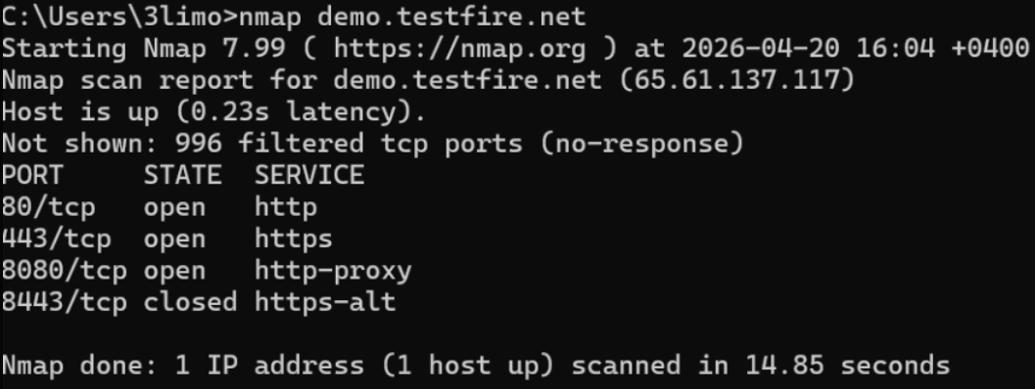
Figure 1: Nmap Scan Showing Open Ports (80, 443, 8080)

Finding 2: Technology Disclosure (Apache Tomcat) |  | Medium
Description: | The server discloses its underlying technology through HTTP response headers, specifically revealing the use of Apache Tomcat and the Coyote JSP engine.
Impact: | Technology disclosure provides attackers with valuable information about the system’s backend infrastructure. This allows them to identify known vulnerabilities, search for publicly available exploits, and perform targeted attacks against the specific software version in use. If the server is outdated or improperly configured, attackers may exploit these weaknesses to gain unauthorized access or disrupt services.
Recommendation: | Disable or modify HTTP response headers to prevent exposure of server details. Remove unnecessary headers such as “Server” or “X-Powered-By,” and ensure the application runs on updated and patched software versions.

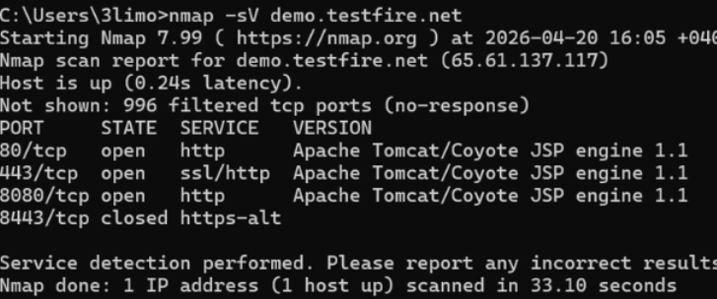
Figure 2: Technology Disclosure
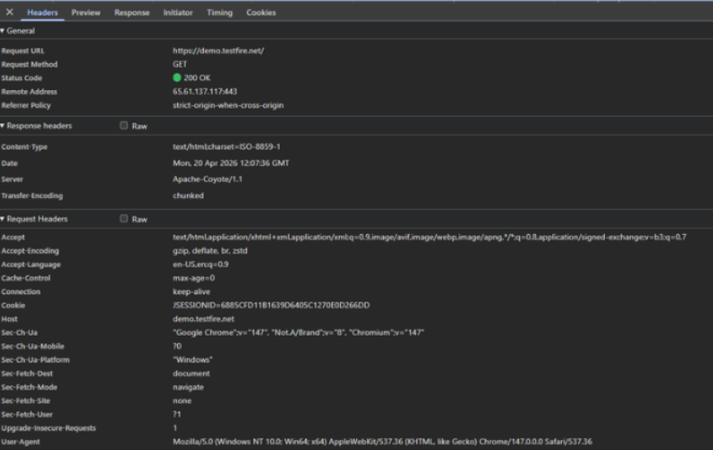
Figure 3: HTTP Response Headers Showing Server Information Disclosure

Finding 3: Missing Security Headers |  | Medium
Description: | The application does not include critical security headers such as Content-Security-Policy (CSP), X-Frame-Options, and Strict-Transport-Security (HSTS), which are essential for protecting modern web applications.
Impact: | The absence of these headers leaves the application vulnerable to multiple client-side attacks. Without CSP, attackers may inject malicious scripts (XSS). Without X-Frame-Options, the application is exposed to clickjacking attacks. Without HSTS, users may unknowingly connect over insecure channels. These vulnerabilities can lead to session hijacking, unauthorized actions, data theft, and compromise of user accounts.
Recommendation: | Implement standard security headers across the application. Configure Content-Security-Policy to control allowed resources, use X-Frame-Options to prevent framing, and enable HSTS to enforce secure communication.

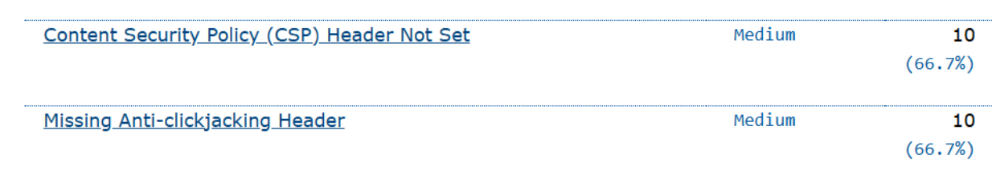
Figure 4: OWASP ZAP Identifying Missing Security Headers (CSP, Clickjacking Protection)

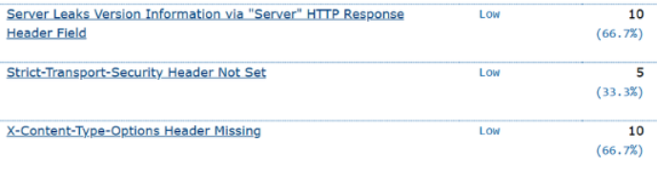
Figure 5: OWASP ZAP Showing Missing HSTS and Server Information Disclosure

Finding 4: No HTTPS Enforcement |  | Medium
Description: | The application allows users to access the website over HTTP without automatically redirecting them to HTTPS, meaning communication may occur over an unencrypted connection.
Impact: | Unencrypted communication exposes sensitive data such as login credentials, session cookies, and personal information to interception. Attackers can exploit this using man-in-the-middle (MITM) attacks to capture or modify data in transit. This can lead to account takeover, data leakage, and loss of user trust, especially in environments where users access the application over insecure networks.
Recommendation: | Configure the server to redirect all HTTP traffic to HTTPS. Implement HSTS to ensure browsers only use secure connections. Additionally, ensure SSL/TLS certificates are properly configured and regularly updated.


Figure 6: Browser Indicating Insecure HTTP Connection

Finding 6: Improper Resource Handling |  | Low
Description: | Some requested resources, such as favicon.ico, return a 404 Not Found response, indicating that certain files are missing or not properly configured.
Impact: | Although low risk, improper handling of resources may reveal information about the application structure and internal paths. It can also indicate weak configuration management and reduce user confidence in the application’s reliability. In some cases, attackers may use such information for reconnaissance and mapping the application.
Recommendation: | Ensure all referenced resources are correctly configured and accessible. Remove unnecessary references and maintain proper file structure to improve both security and user experience.
Figure 7: Missing Resource Returning 404 Not Found (favicon.ico)

Network Exposure Analysis (Nmap Scan)
A network scan was conducted using Nmap to identify publicly exposed services on the target application.
The scan revealed that the application is accessible via:
• Port 80 (HTTP) – Open
• Port 443 (HTTPS) – Open
• Port 8080 (HTTP-Proxy) – Open
The presence of ports 80 and 443 is expected for standard web application functionality. However, the exposure of port 8080 indicates an additional service running on the system, which may increase the overall attack surface if not properly secured. The server responses also revealed the use of Apache Tomcat technology, confirming that the application is hosted on a web server environment.
While no critical vulnerabilities were identified at the network level, exposed services should be regularly monitored and properly secured to reduce potential risks.

OWASP ZAP Validation
A passive vulnerability scan was conducted using OWASP ZAP to validate the findings identified during the assessment. The scan results were consistent with the previously identified issues, including:
• Missing security headers (Content-Security-Policy, X-Frame-Options, and HSTS)
• Technology disclosure through server responses
• Lack of HTTPS enforcement
• Improper resource handling
These findings confirm the presence of common web security misconfigurations and support the accuracy of the assessment.

Conclusion
This vulnerability assessment identified several security weaknesses within the target web application. Although no critical vulnerabilities were found, multiple medium-risk issues were identified, including exposed services, missing security headers, and lack of HTTPS enforcement. If left unresolved, these issues could increase the risk of unauthorized access, data interception, and exploitation of the application.
Implementing the recommended security measures will significantly improve the overall security posture of the system. Regular security testing, continuous monitoring, and adherence to best practices are essential to maintaining a secure and reliable application.

