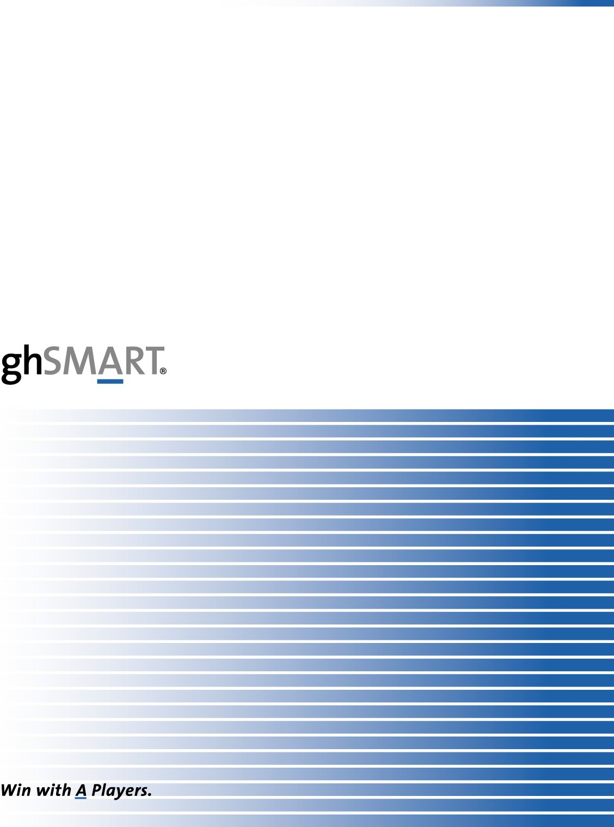

**SmartAssessment® Report**

|  |  |
| --- | --- |
| **Candidate Name** | Mr. Carrot |
| **Title** | COO |
| **Company Name** | Carrots4You |
| **Prepared For** | Bugs Bunny |
| **Prepared By** | Ms. Horse |
| **Purpose of This Assessment** | Development |
| **Date** | July 7th, 2008 |
| **Rating (A,B,C)** | **A- as COO** |
| **Recommendation** | **Retain him as COO and coach him on some specific topics to make him even more effective.** |

**Disclaimer and Confidentiality Policy**

This SmartAssessment document contains professional interpretations of biographical data collected about this individual. All of the data in this report was collected directly from the individual, unless otherwise indicated. Our analysis of the data is based on the specific scorecard that was created at the beginning of this assessment process, and our database of thousands of previous senior management assessments.

This copyrighted document is considered confidential information. It is unlawful to transmit this document to parties who are not named on the cover page without the written authorization of ghSMART and the named client for whom this document was prepared.

**Competency Scorecard**

|  |  |
| --- | --- |
| **COMPETENCIES** | **COMMENTS AND RATING** |
| **Leadership Competencies** |  |
| Hires A players | A- |
| Develops people | B+ |
| Removes underperformers | B |
| Treats people with respect | A |
| Efficiency of execution | A |
| Network of talented people | A- |
| Flexible/adaptable | B+ |
| **Personal Competencies** |  |
| Integrity/honesty | A |
| Organization and planning | B+ |
| Calm under pressure | A |
| Aggressive | C |
| Moves fast | B |
| Follows through on commitments | A |
| **Intellectual Competencies** |  |
| Brainpower/learns quickly | B |
| Analysis skills | B |
| Strategic thinking/visioning | B |
| Creative/innovative | A |
| Attention to detail | B |
| **Motivational Competencies** |  |
| Enthusiasm/ability to motivate others | A- |
| Persistent | B+ |
| Proactivity/takes initiative | B+ |
| Work ethic | A |
| Sets high standards | B |
| **Interpersonal Competencies** |  |
| Listening skills | A- |
| Open to criticism and others’ ideas | A |
| Written communications | n/a |
| Oral communication | B |
| Teamwork | A |
| Persuasion | B+ |
| Holds people accountable | B+ |
| **Technical/Functional Competencies** |  |
| Sales | C |
| Marketing | C |

|  |  |
| --- | --- |
| Information technology | n./a |
| Finance | C |
| Human resources | B |
| Knowledge of the industry | A |