Lab Assignment :3
Name:Amaan Jamadar
Mis:112103008

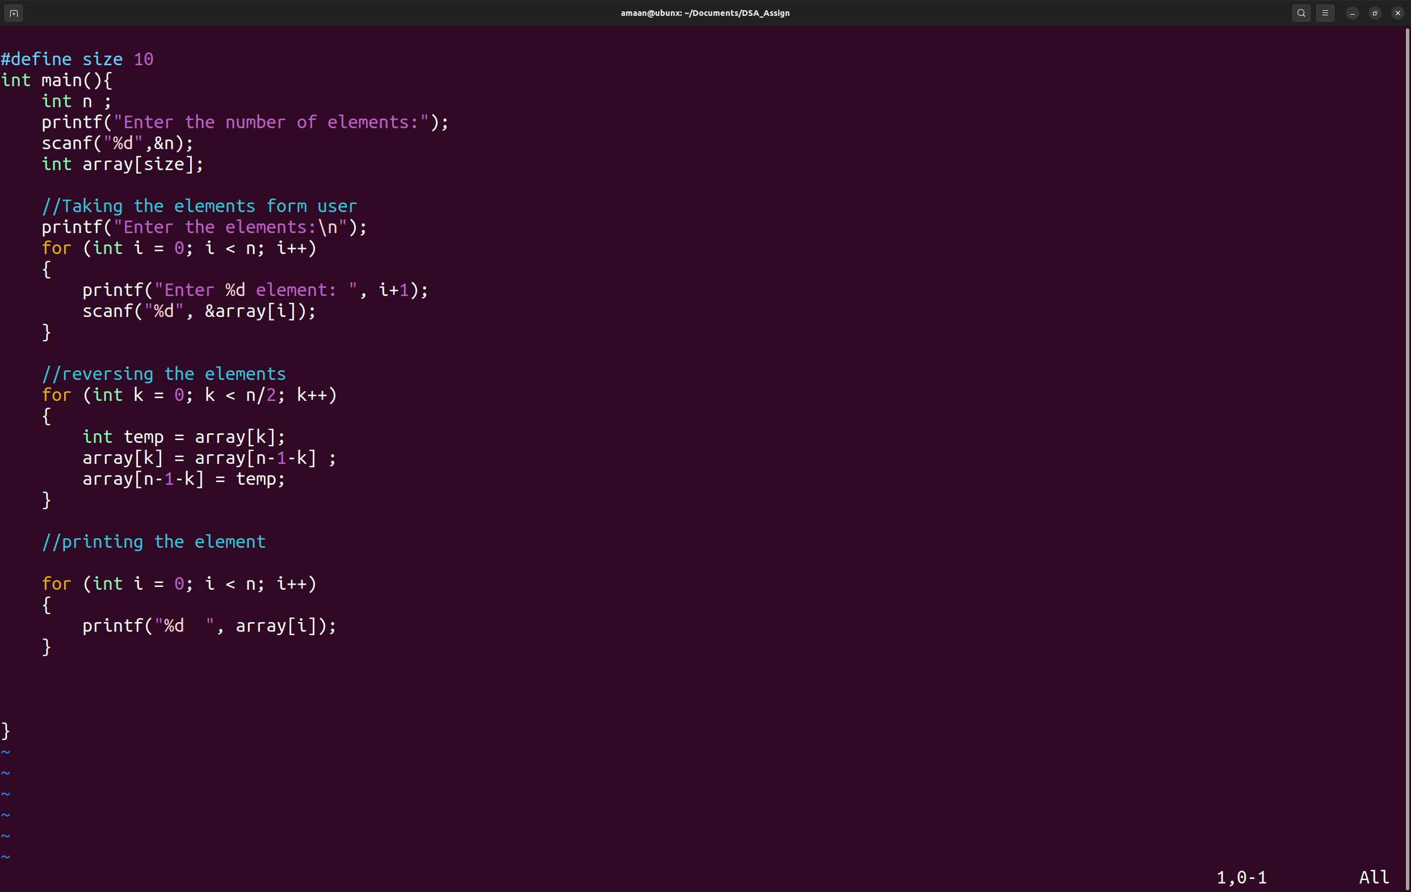
1] Reverse elements of array without using additional array.
Code:
Output:
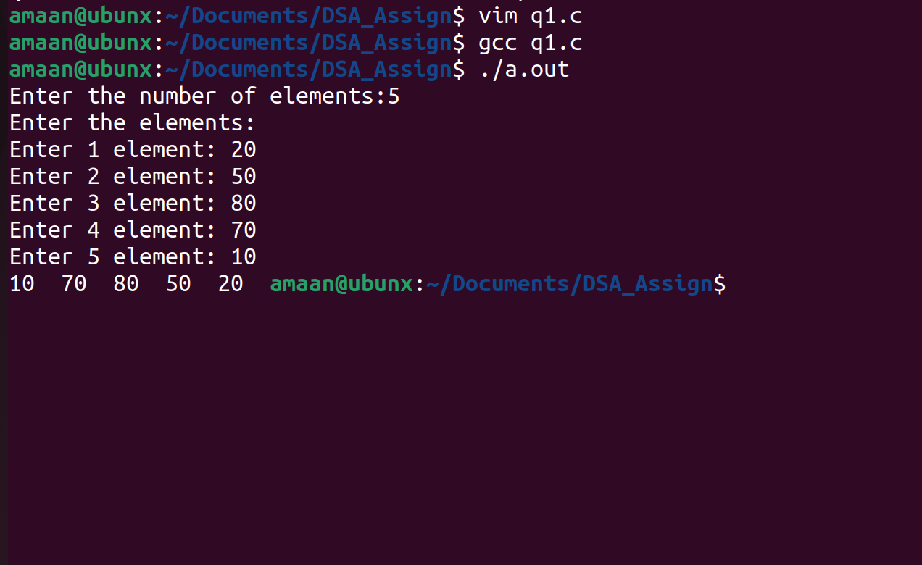

2. C program to find nearest lesser and greater element in an array.

Code:

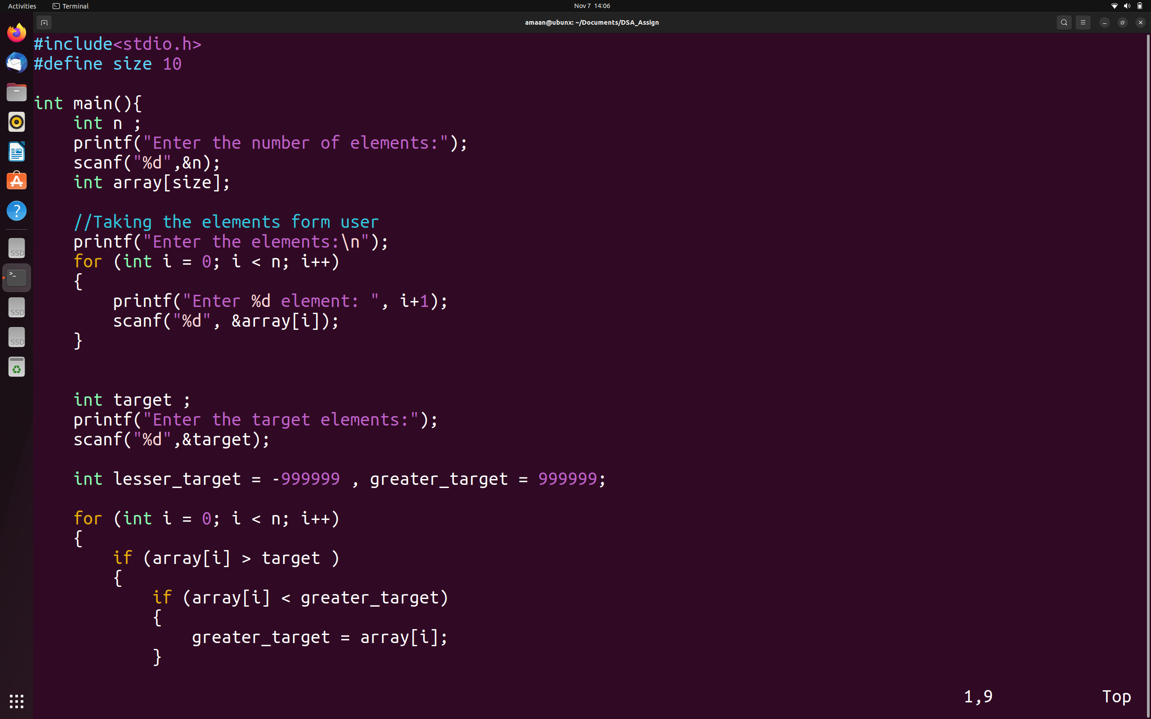
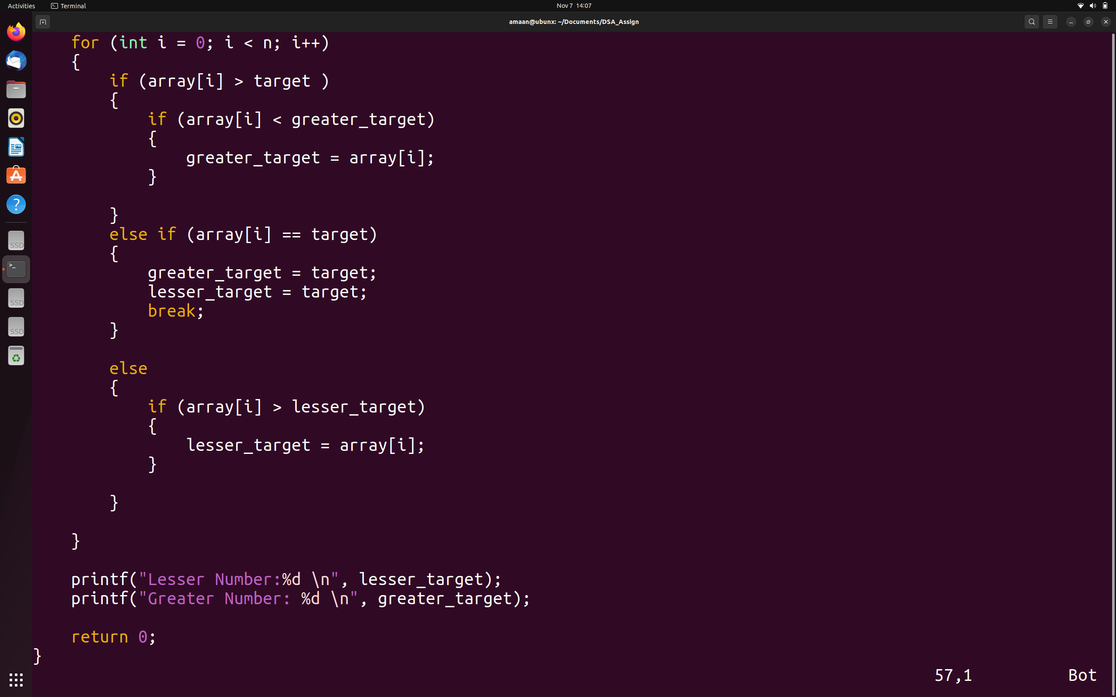

Output:
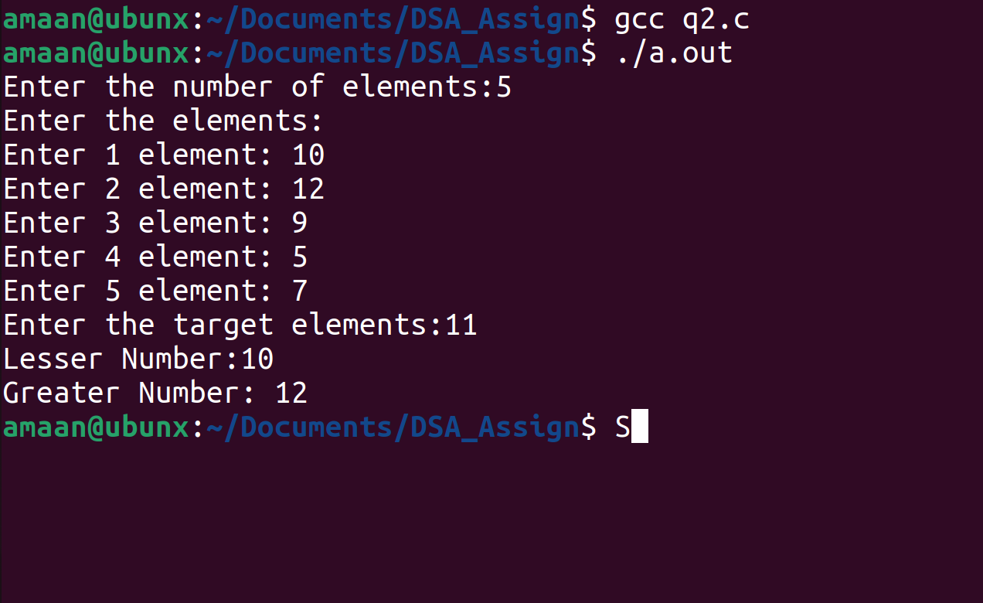

3.Display elements of array in triangle pattern. Use formatting to get a uniform display.

Code:
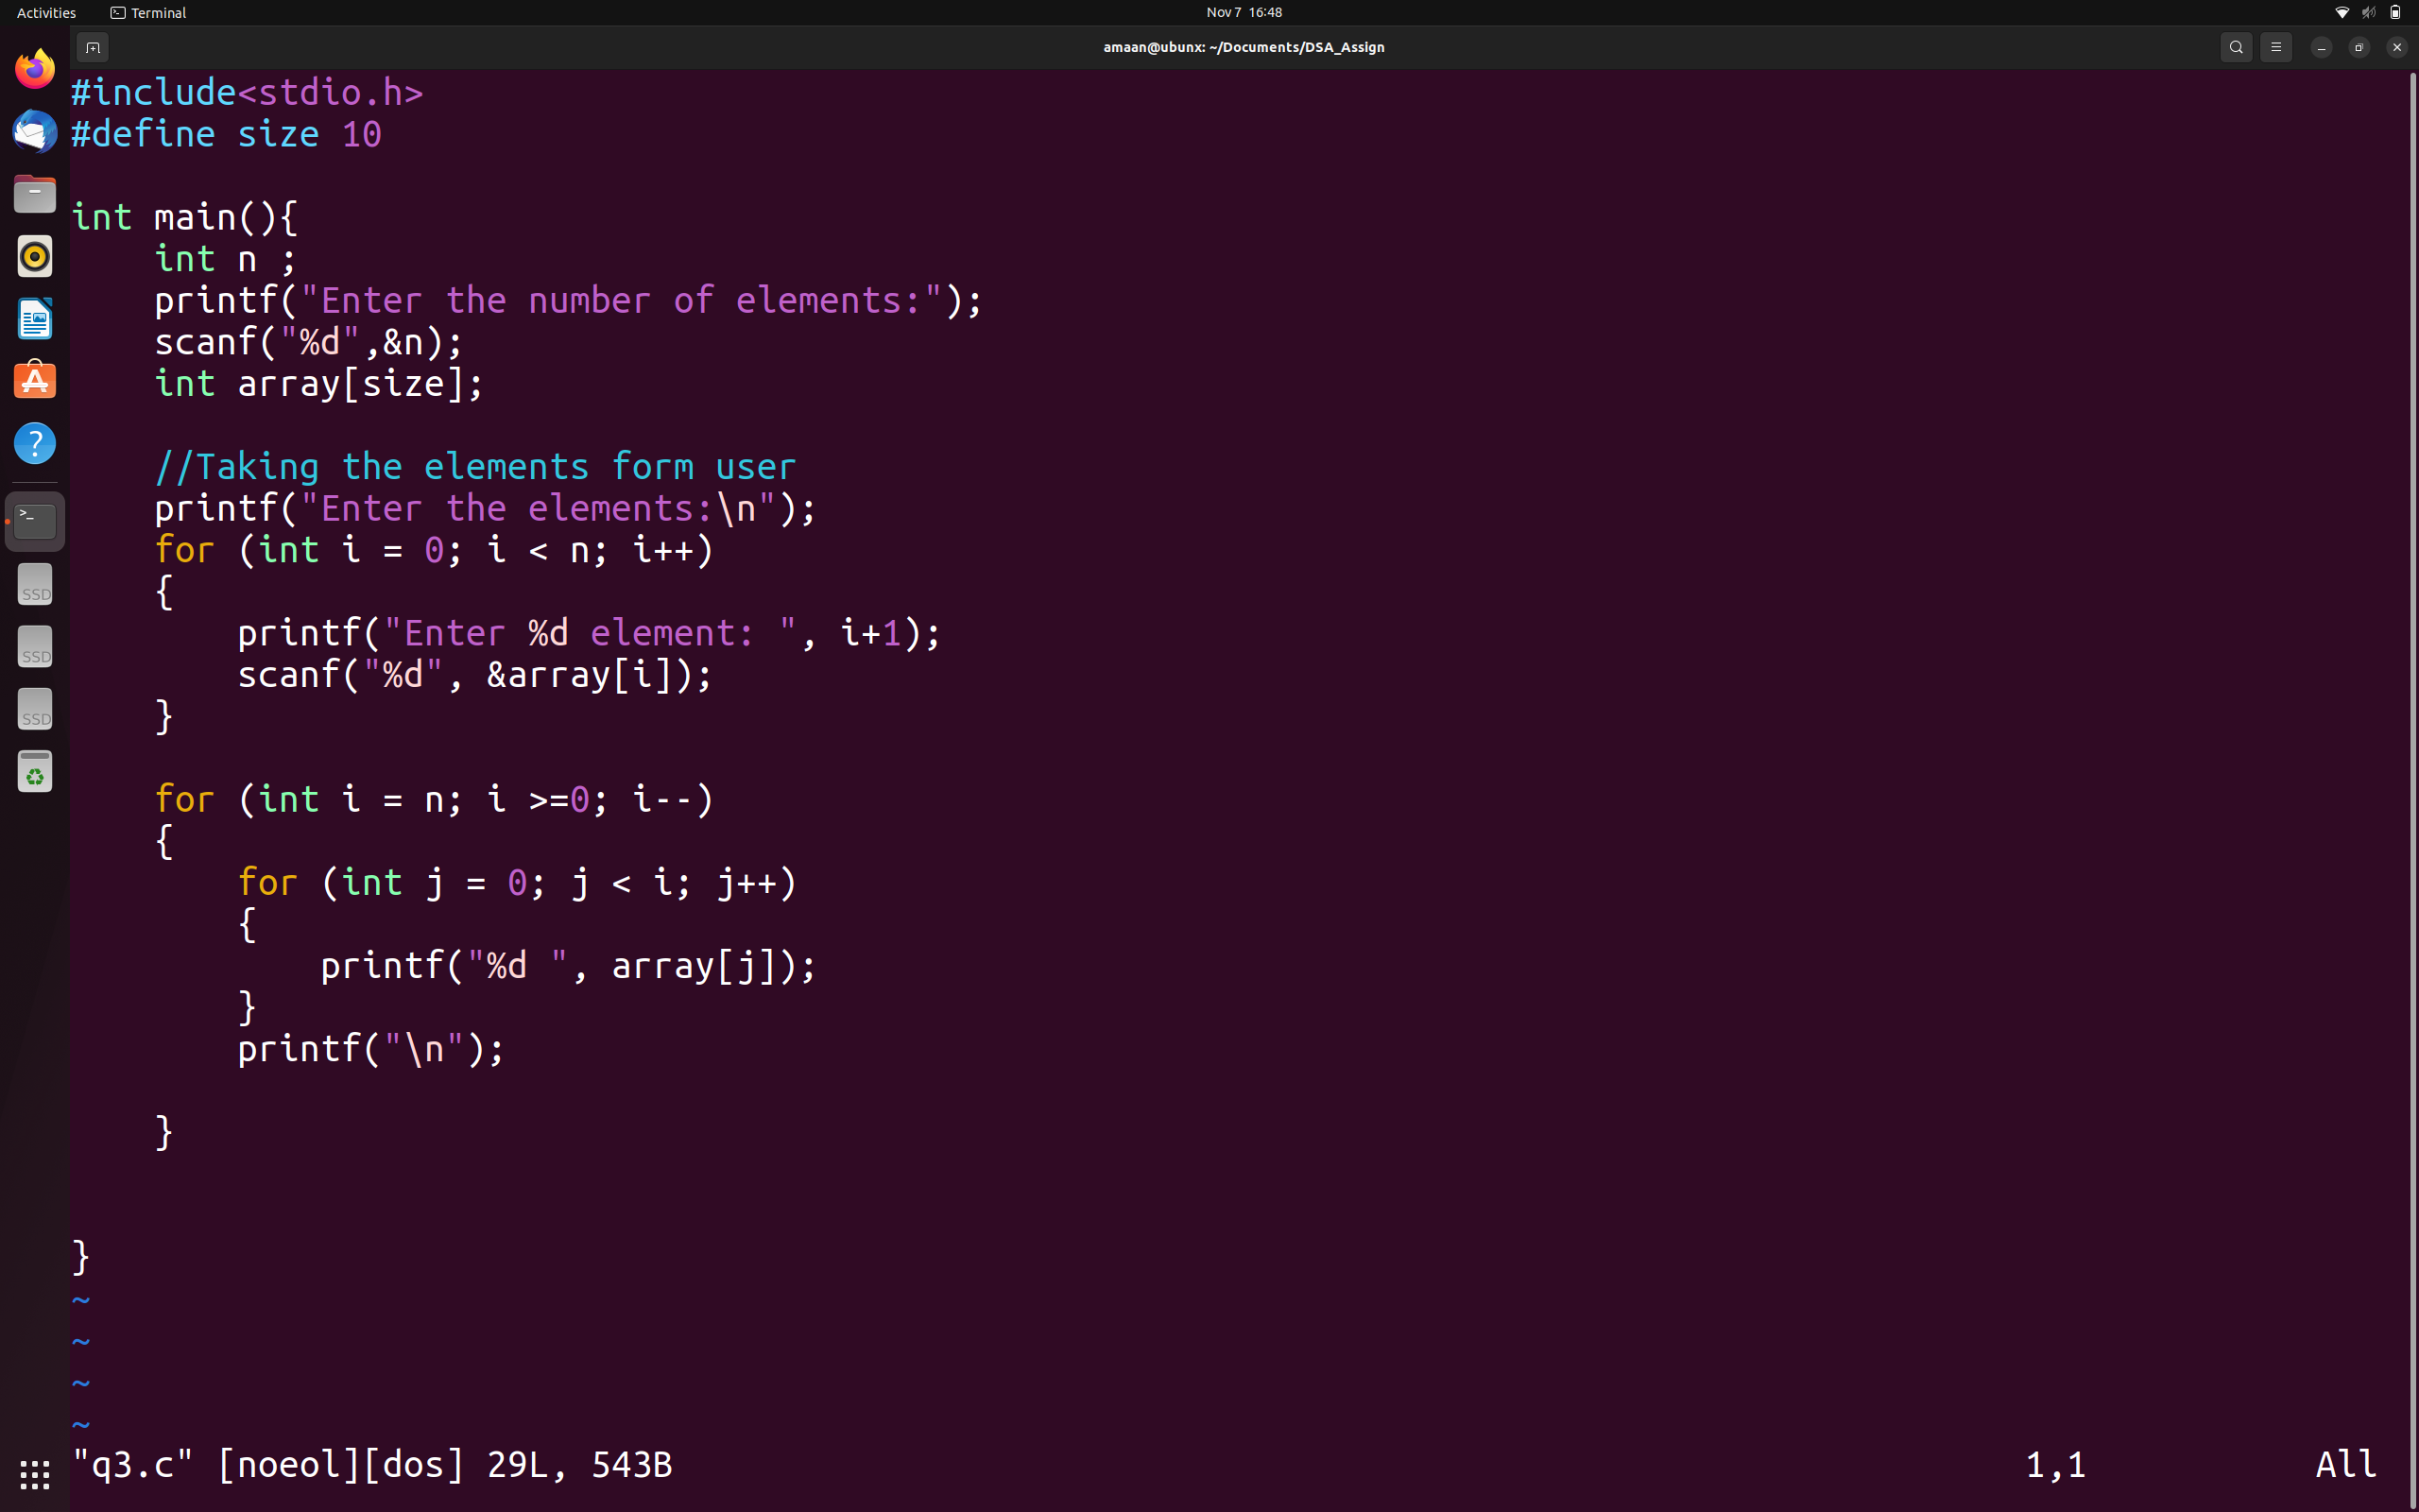

Output:
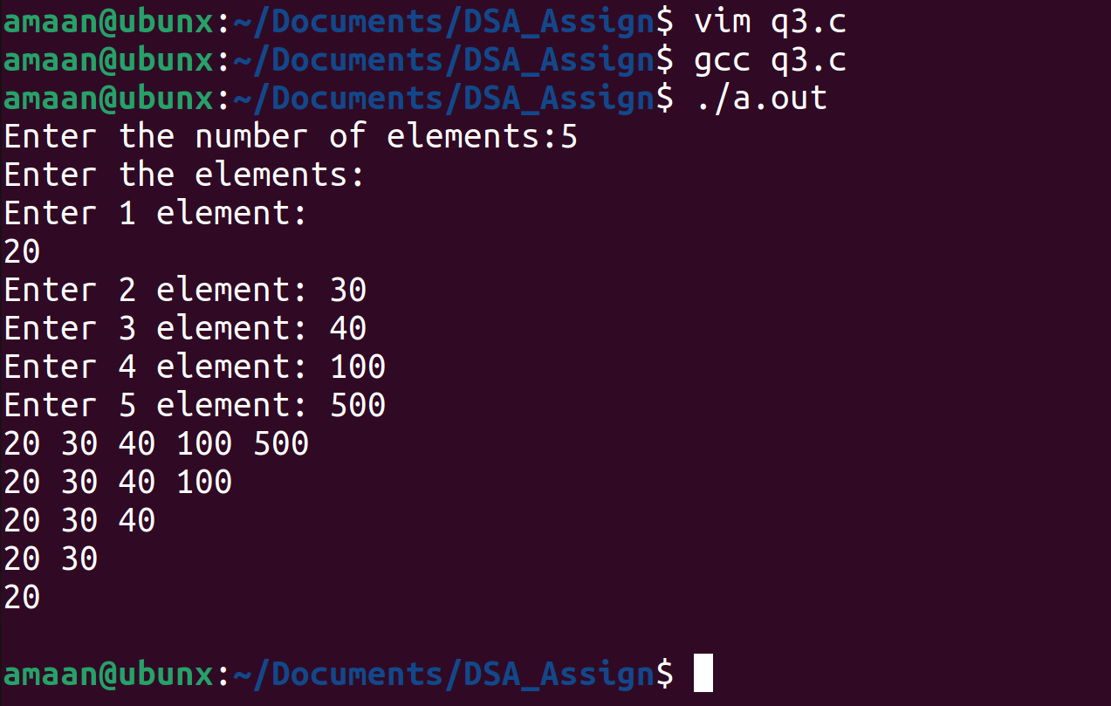

4.Write a program that calculates the sum of even elements of an integer array of size 20

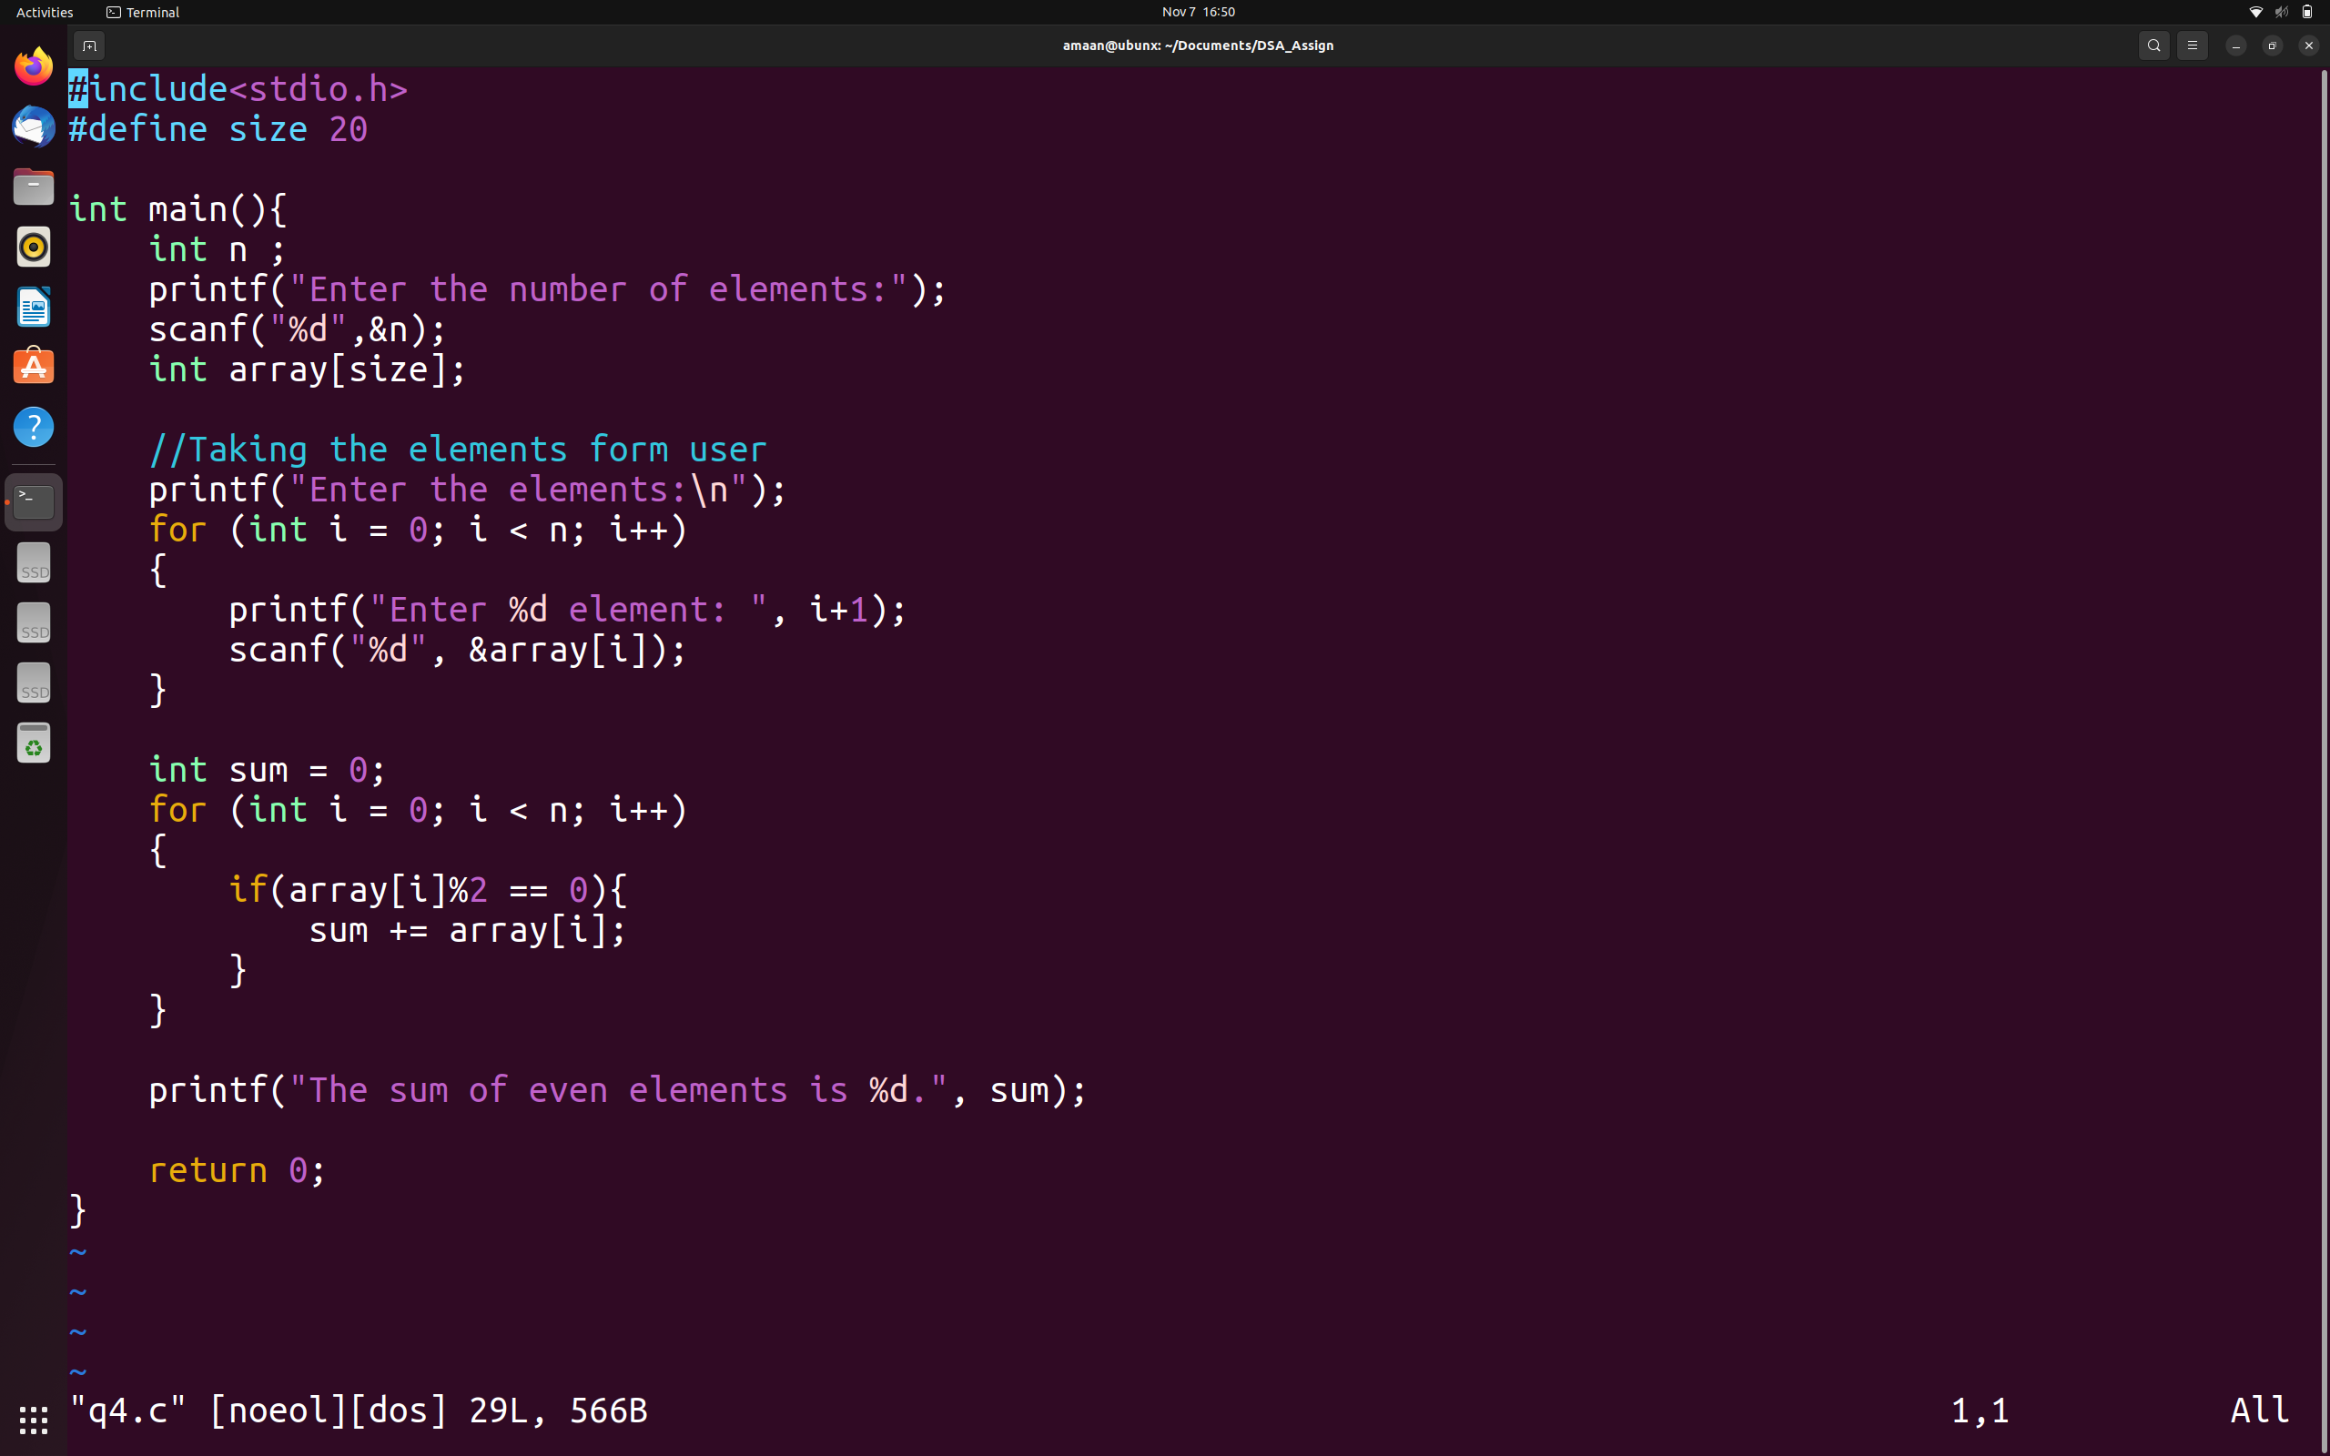
Code:

Output:
