REPORT

ON

**“MUSIC STREAMING WEBSITE” ­**

BACHELOR OF TECHNOLOGY

IN

**COMPUTER SCIENCE AND ENGINEERING**

(Semester Jan-May 2021)



Under the Guidance of – Dr. Bailwinder Kaur Dhaliwal

**School of Computer Science and Engineering**

Lovely Professional University

Phagwara, Punjab (India)

**STUDENT DECLARATION**

This is to declare that this report has been written by us. No part of the report is copied from other sources. All information included from other sources have been duly acknowledged. We aver that if any part of the report is found to be copied, we shall take full responsibility for it.

Mohd Amaan Khan

Date : 13 April 2021

**Name:** Mohd Amaan Khan **Section:** KM036

**Roll No:** B44 **Reg No:** 11805050

**Title of the Project:**

Music Streaming Website (BoomBox)

**Introduction:**

Digital music streaming service that gives you access to songs and other contents.

Basic functions such as playing music are totally free.

Either way, you can:

* Choose what you want to listen to with **Browse** and **Search**.
* View and Listen to collection of artists.

**Objective of the project:**

No need to fill your storage devices with songs now as with **Boombox** (Music Streaming) we present to you a service which streams the high quality songs for you without taking any of your space with requirement of just an internet connection.

**Software Requirements:**

* Microsoft Visual Studio or any PHP editor
* XAMPP Server

**Technology Used:**

* **Front End**: HTML, CSS, Bootstrap, JavaScript.
* **Back End**: PHP, MySQL, Ajax
* **Modules:**

**There are 3 basic Modules**

* **Registration** – This module is for the new users, who are new to the Boombox, this module fetches the details and then creates account validation and verification.
* **Login** – This module is for logging-in the registered **Boombox** users.
* **Streaming** – The purpose of this module is to stream the music.

**Code Snippet**

**Browsing Music (Index Page)**

<?php

include("includes/includedFiles.php");

?>

<h1 class="pageHeadingBig">Music Albums you like!</h1>

<div class="gridViewContainer">

    <?php

        $albumQuery = mysqli_query($con, "SELECT * FROM albums ORDER BY RAND() LIMIT 10");

        while($row = mysqli_fetch_array($albumQuery)) {

            echo "<div class='gridViewItem'>

                    <span role='link' tabindex='0' onclick='openPage(\"album.php?id=" . $row['id'] . "\")''>

                        <img src='" . $row['artworkPath'] . "'>

                        <div class='gridViewInfo'>"

                            . $row['title'] .

                        "</div>

                    </span>

                </div>";  }

    ?>

</div>

**Main Index Page (where above browse file is included)**

<?php

include("includes/includedFiles.php");

?>

<script>openPage("browse.php");</script>

**Searching Scripts**

<div class="searchContainer">

    <h4>Search for an artist, album or song</h4>

    <input type="text" class="searchInput" value="<?php echo $term; ?>" placeholder="Start Boomboxing . ." onfocus="this.value = this.value">

</div>

<script>

$(".searchInput").focus();

$(function() {

    $(".searchInput").keyup(function() {

        clearTimeout(timer);

        timer = setTimeout(function() {

            var val = $(".searchInput").val();

            openPage("search.php?term=" + val);

        }, 2000);

    })

})

</script>

**Updating User Data**

<?php

include("includes/includedFiles.php");

?>

<div class="userDetails">

    <div class="container borderBottom">

        <h2>UPDATE EMAIL</h2>

        <input type="text" class="email" name="email" placeholder="Email address..." value="<?php echo $userLoggedIn->getEmail(); ?>">

        <span class="message"></span>

        <button class="button" onclick="updateEmail('email')">SAVE</button>

    </div>

    <div class="container">

        <h2>UPDATE PASSWORD</h2>

        <input type="password" class="oldPassword" name="oldPassword" placeholder="Current password">

        <input type="password" class="newPassword1" name="newPassword1" placeholder="New password">

        <input type="password" class="newPassword2" name="newPassword2" placeholder="Confirm password">

        <span class="message"></span>

        <button class="button" onclick="updatePassword('oldPassword', 'newPassword1', 'newPassword2')">SAVE</button>

    </div>

</div>

**Artist Gallery**

<div class="row">

  <div class="column">

    <div class="container">

    <img class="image" src="artist image/12.jfif"><div class="overlay">Bae Suzy</div>

</div>

  <div class="container">

    <img src="artist image/2.jpg" style="width:100%">

    <div class="overlay">Billie Eilish</div>

</div>

<div class="container">

    <img src="artist image/3.jpg" style="width:100%">

    <div class="overlay">Billie Eilish</div>

</div>

<div class="container">

    <img src="artist image/16.jfif" style="width:100%">

    <div class="overlay">Iggy Azalea</div>

</div>

<div class="container">

    <img src="artist image/10.jfif" style="width:100%">

    <div class="overlay">Kim Yeri</div>

</div>

<div class="container">

    <img src="artist image/11.jfif" style="width:100%">

    <div class="overlay">Bae Suzy</div>

</div>

<div class="container">

    <img src="artist image/4.jpg" style="width:100%">

    <div class="overlay">Billie Eilish</div>

</div>

  </div>

**Showing User Details in SildeBar**

<?php

include("includes/includedFiles.php");

?>

<div class="entityInfo">

    <div class="centerSection">

        <div class="userInfo">

            <h1><?php echo $userLoggedIn->getFirstAndLastName(); ?></h1>

        </div>

    </div>

    <div class="buttonItems">

        <button class="button" onclick="openPage('updateDetails.php')">USER DETAILS</button>

        <button class="button" onclick="logout()">LOGOUT</button>

    </div>

</div>

**Login Form**

<form id="loginForm" action="register.php" method="POST">

                    <h2>Login to your account</h2>

                    <p>

                        <?php echo $account->getError(Constants::$loginFailed); ?>

                        <label for="loginUsername">Username</label>

                        <input id="loginUsername" name="loginUsername" type="text" placeholder="Eg. Billie Eilish" value="<?php getInputValue('loginUsername') ?>" required>

      </p>

                    <p>

                        <label for="loginPassword">Password</label>

                        <input id="loginPassword" name="loginPassword" type="password" placeholder="Your password" required>

                    </p>

                    <button type="submit" name="loginButton">LOG IN</button>

               <div class="hasAccountText">

                        <span id="hideLogin">Don't have an account yet? Signup here.</span>

                    </div>

                </form>

**Registration Form**

<form id="registerForm" action="register.php" method="POST">

                    <h2>Create your free account</h2>

                    <p>

                        <?php echo $account->getError(Constants::$usernameCharacters); ?>

                        <?php echo $account->getError(Constants::$usernameTaken); ?>

                        <label for="username">Username</label>

                        <input id="username" name="username" type="text" placeholder="Eg. BillieEilish" value="<?php getInputValue('username') ?>" required>

                    </p>

                    <p>

                        <?php echo $account->getError(Constants::$firstNameCharacters); ?>

                        <label for="firstName">First name</label>

                        <input id="firstName" name="firstName" type="text" placeholder="Eg. Billie" value="<?php getInputValue('firstName') ?>" required>

                    </p>

                    <p>

                        <?php echo $account->getError(Constants::$lastNameCharacters); ?>

                        <label for="lastName">Last name</label>

                        <input id="lastName" name="lastName" type="text" placeholder="Eg. Eilish" value="<?php getInputValue('lastName') ?>" required>

                    </p>

                    <p>

                        <?php echo $account->getError(Constants::$emailsDoNotMatch); ?>

                        <?php echo $account->getError(Constants::$emailInvalid); ?>

                        <?php echo $account->getError(Constants::$emailTaken); ?>

                        <label for="email">Email</label>

                        <input id="email" name="email" type="email" placeholder="Eg. BillieEilish@hotmail.com" value="<?php getInputValue('email') ?>" required>

                    </p>

                    <p>

                        <label for="email2">Confirm email</label>

                        <input id="email2" name="email2" type="email" placeholder="Eg. BillieEilish@hotmail.com" value="<?php getInputValue('email2') ?>" required>

                    </p>

                    <p>

                        <?php echo $account->getError(Constants::$passwordsDoNoMatch); ?>

                        <?php echo $account->getError(Constants::$passwordNotAlphanumeric); ?>

                        <?php echo $account->getError(Constants::$passwordCharacters); ?>

                        <label for="password">Password</label>

                        <input id="password" name="password" type="password" placeholder="Your password" required>

                    </p>

                    <p>

                        <label for="password2">Confirm password</label>

                        <input id="password2" name="password2" type="password" placeholder="Your password" required>

                    </p>

                    <button type="submit" name="registerButton">SIGN UP</button>

                    <div class="hasAccountText">

                        <span id="hideRegister">Already have an account? Log in here.</span>

                    </div>

                </form>

**Fetching Album Details from Database**

<?php

    class Album {

        private $con;

        private $id;

        private $title;

        private $artistId;

        private $genre;

        private $artworkPath;

        public function __construct($con, $id) {

            $this->con = $con;

            $this->id = $id;

            $query = mysqli_query($this->con, "SELECT * FROM albums WHERE id='$this->id'");

            $album = mysqli_fetch_array($query);

            $this->title = $album['title'];

            $this->artistId = $album['artist'];

            $this->genre = $album['genre'];

            $this->artworkPath = $album['artworkPath'];

        }

        public function getTitle() {

            return $this->title;

        }

        public function getArtist() {

            return new Artist($this->con, $this->artistId);

        }

        public function getGenre() {

            return $this->genre;

        }

        public function getArtworkPath() {

            return $this->artworkPath;

        }

        public function getNumberOfSongs() {

            $query = mysqli_query($this->con, "SELECT id FROM songs WHERE album='$this->id'");

            return mysqli_num_rows($query);

        }

        public function getSongIds() {

            $query = mysqli_query($this->con, "SELECT id FROM songs WHERE album='$this->id' ORDER BY albumOrder ASC");

            $array = array();

            while($row = mysqli_fetch_array($query)) {

                array_push($array, $row['id']);

            }

            return $array;

        }

    }

?>

**Fetching Songs from Database**

<?php

    class Song {

        private $con;

        private $id;

        private $mysqliData;

        private $title;

        private $artistId;

        private $albumId;

        private $genre;

        private $duration;

        private $path;

        public function __construct($con, $id) {

            $this->con = $con;

            $this->id = $id;

            $query = mysqli_query($this->con, "SELECT * FROM songs WHERE id='$this->id'");

            $this->mysqliData = mysqli_fetch_array($query);

            $this->title = $this->mysqliData['title'];

            $this->artistId = $this->mysqliData['artist'];

            $this->albumId = $this->mysqliData['album'];

            $this->genre = $this->mysqliData['genre'];

            $this->duration = $this->mysqliData['duration'];

            $this->path = $this->mysqliData['path'];

        }

        public function getTitle() {

            return $this->title;

        }

        public function getId() {

            return $this->id;

        }

        public function getArtist() {

            return new Artist($this->con, $this->artistId);

        }

        public function getAlbum() {

            return new Album($this->con, $this->albumId);

        }

        public function getPath() {

            return $this->path;

        }

        public function getDuration() {

            return $this->duration;

        }

        public function getMysqliData() {

            return $this->mysqliData;

        }

        public function getGenre() {

            return $this->genre;

        }

    }

?>

**Fetching User Details from Database**

<?php

    class User {

        private $con;

        private $username;

        public function __construct($con, $username) {

            $this->con = $con;

            $this->username = $username;

        }

        public function getUsername() {

            return $this->username;

        }

        public function getEmail() {

            $query = mysqli_query($this->con, "SELECT email FROM users WHERE username='$this->username'");

            $row = mysqli_fetch_array($query);

            return $row['email'];

        }

        public function getFirstAndLastName() {

            $query = mysqli_query($this->con, "SELECT concat(firstName, ' ', lastName) as 'name' FROM users WHERE username='$this->username'");

            $row = mysqli_fetch_array($query);

            return $row['name'];

        }

    }

?>

**Database Configuration**

<?php

    ob_start();

    session_start();

    $timezone = date_default_timezone_set("India/Kolkata");

    $con = mysqli_connect("localhost", "root", "", "geet");

    if(mysqli_connect_errno()) {

        echo "Failed to connect: " . mysqli_connect_errno();

    }

?>

**Included Files**

<?php

if(isset($_SERVER['HTTP_X_REQUESTED_WITH'])) {

    include("includes/config.php");

    include("includes/classes/User.php");

    include("includes/classes/Artist.php");

    include("includes/classes/Album.php");

    include("includes/classes/Song.php");

    include("includes/classes/Playlist.php");

    if(isset($_GET['userLoggedIn'])) {

        $userLoggedIn = new User($con, $_GET['userLoggedIn']);

    }

    else {

        echo "Username variable was not passed into the page. Check the openPage JS function";

        exit();

    }

}

else {

    include("includes/header.php");

    include("includes/footer.php");

    $url = $_SERVER['REQUEST_URI'];

    echo "<script>openPage('$url')</script>";

    exit();

}

?>

**Navigation Bar or Sidebar**

<div id="navBarContainer">

    <nav class="navBar">

        <span role="link" tabindex="0" onclick="openPage('index.php')" class="logo">

            <img src="assets/images/icons/logo.png">

        </span>

        <div class="group">

            <div class="navItem">

                <span role='link' tabindex='0'

                    onclick="openPage('search.php')" class="navItemLink">

                    Search BoomBox

                    <img src="assets/images/icons/search.png" class="icon" alt="Search">

                </span>

            </div>

        </div>

        <div class="group">

            <div class="navItem">

                <span role="link" tabindex="0" onclick="openPage('browse.php')" class="navItemLink">Browse

                </span>

            </div>

            <div class="navItem">

                <span role="link" tabindex="0" onclick="openPage('yourMusic.php')" class="navItemLink">Artist Gallery

                </span>

            </div>

            <div class="navItem">

                <span role="link" tabindex="0" onclick="openPage('settings.php')" class="navItemLink"><?php echo $userLoggedIn->getFirstAndLastName(); ?>

                </span>

            </div>

        </div>

    </nav>

</div>

**Login Handler using AJAX**

<?php

if(isset($_POST['loginButton'])) {

    //Login button was pressed

    $username = $_POST['loginUsername'];

    $password = $_POST['loginPassword'];

    $result = $account->login($username, $password);

    if($result == true) {

        $_SESSION['userLoggedIn'] = $username;

        header("Location: index.php");

    }

}

?>

**Registration Handler Using AJAX**

<?php

function sanitizeFormPassword($inputText) {

    $inputText = strip_tags($inputText);

    return $inputText;

}

function sanitizeFormUsername($inputText) {

    $inputText = strip_tags($inputText);

    $inputText = str_replace(" ", "", $inputText);

    return $inputText;

}

function sanitizeFormString($inputText) {

    $inputText = strip_tags($inputText);

    $inputText = str_replace(" ", "", $inputText);

    $inputText = ucfirst(strtolower($inputText));

    return $inputText;

}

if(isset($_POST['registerButton'])) {

    //Register button was pressed

    $username = sanitizeFormUsername($_POST['username']);

    $firstName = sanitizeFormString($_POST['firstName']);

    $lastName = sanitizeFormString($_POST['lastName']);

    $email = sanitizeFormString($_POST['email']);

    $email2 = sanitizeFormString($_POST['email2']);

    $password = sanitizeFormPassword($_POST['password']);

    $password2 = sanitizeFormPassword($_POST['password2']);

    $wasSuccessful = $account->register($username, $firstName, $lastName, $email, $email2, $password, $password2);

    if($wasSuccessful == true) {

        $_SESSION['userLoggedIn'] = $username;

        header("Location: index.php");

    }

}

?>

**Screenshots**

**Login**

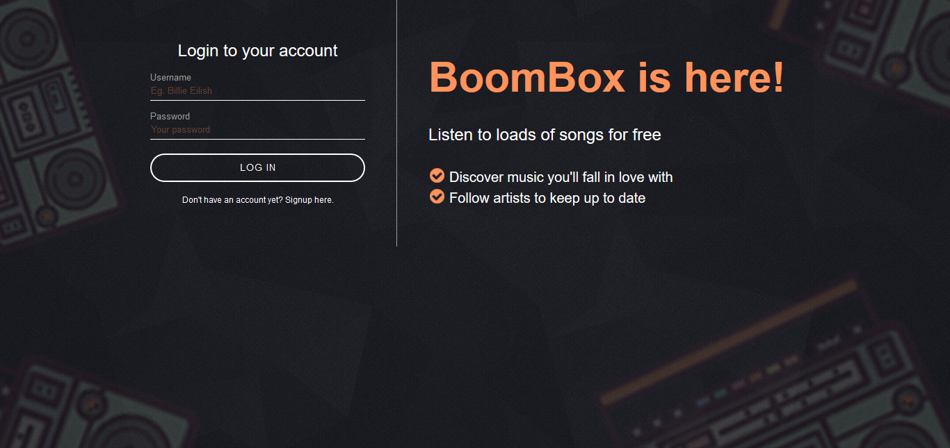

**Registration**

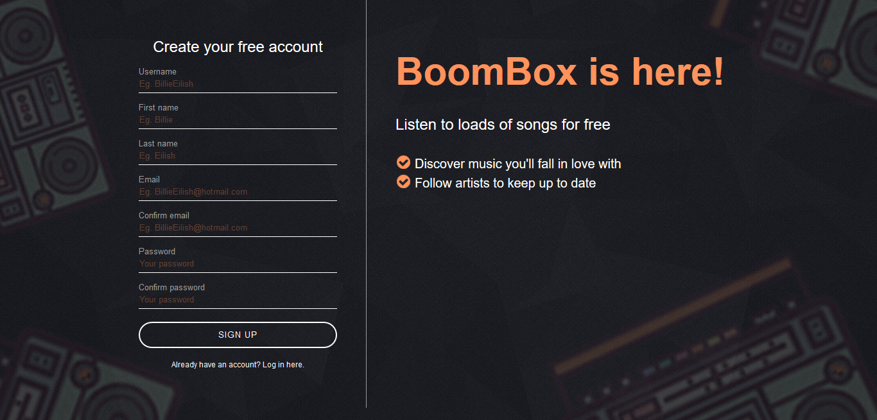

**Main (Index)**

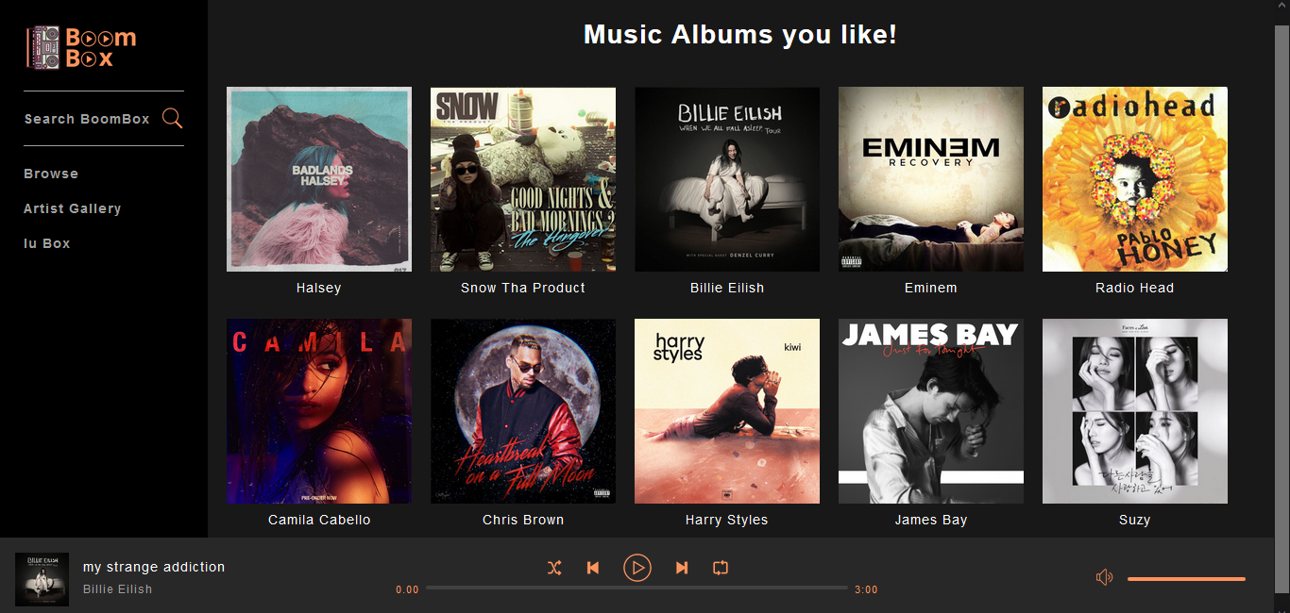

**Artist Gallery**

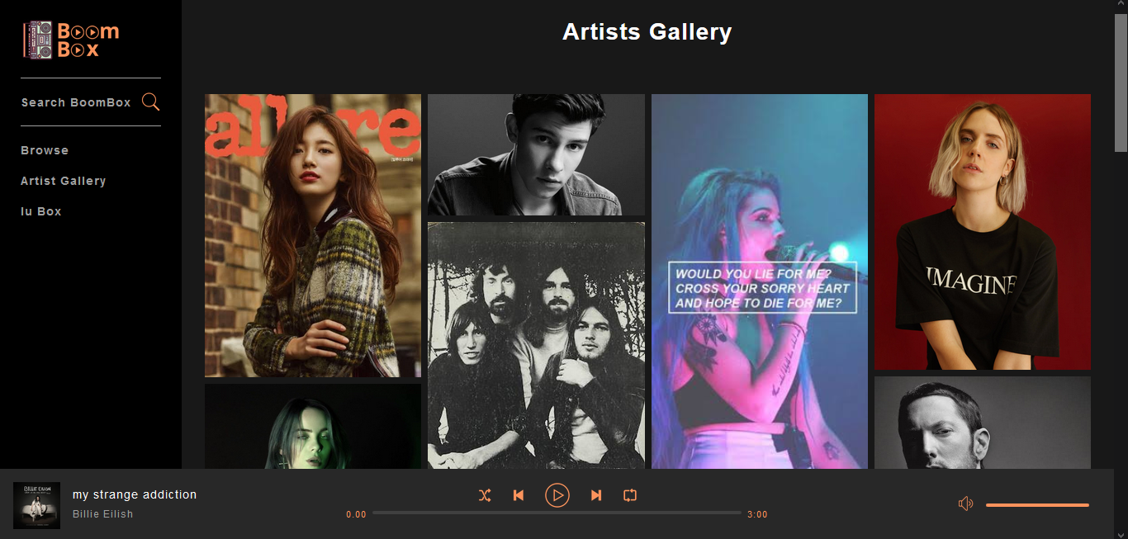

**User Details (also where user can update data)**

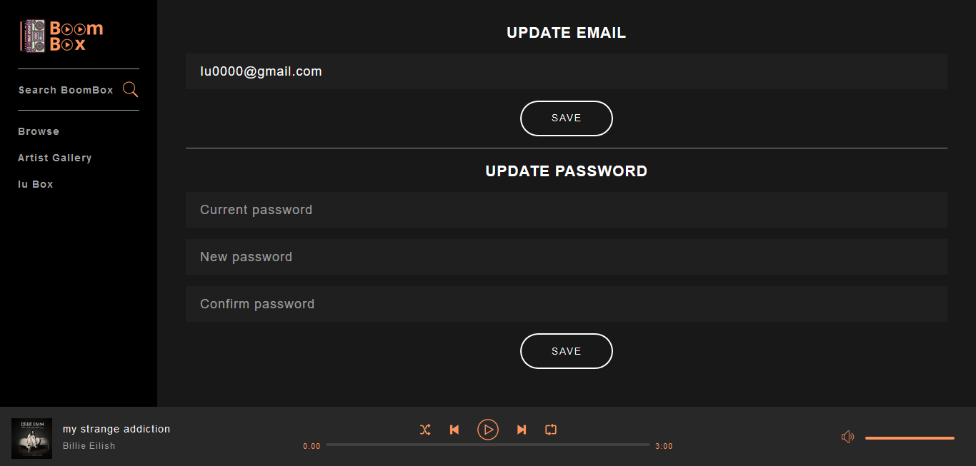

**Search (where user can search by song or artist name)**

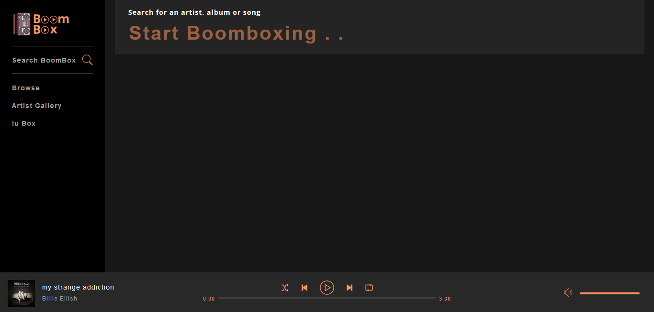

**After Searching (by artist name)**

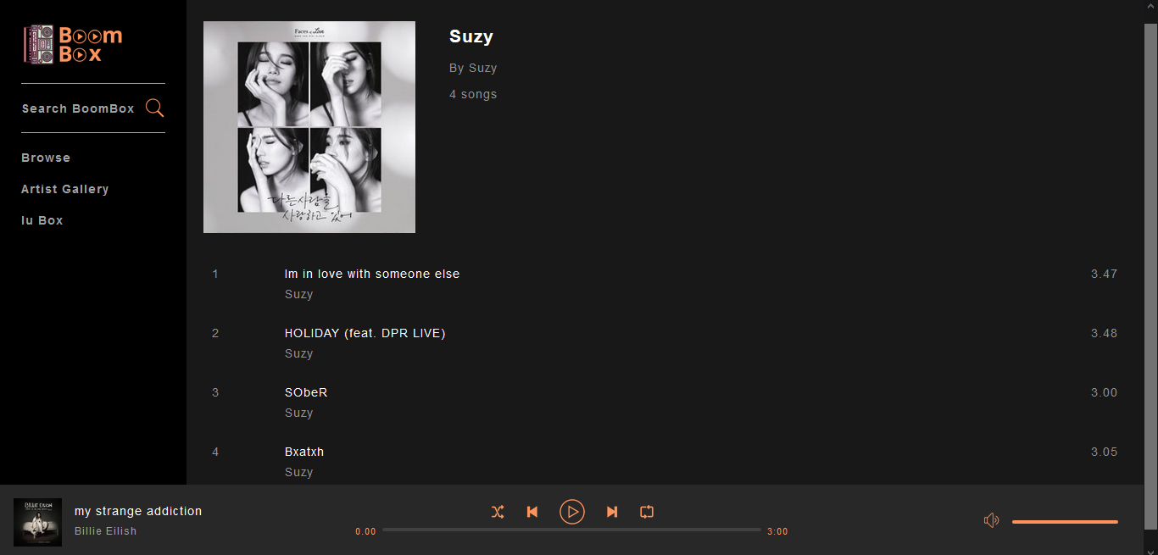

**GitHub Link:** https://github.com/amaan0o7/BoomBox/

**Video Presentation Link:** https://www.youtube.com/watch?v=B20TDpnHrEE&t=70s

**Conclusion:**

Music available anytime, anywhere at your fingertips. A service which streams the high quality songs for you without taking any of your space with requirement of just an internet connection. Say no more to those pesky low space warnings and live everyday by grooving with your favorite tracks on the go!

**References :**

1. [**https://www.javatpoint.com**](https://www.javatpoint.com)
2. [**www.w3schools.com**](http://www.w3schools.com)
3. [**https://www.geeksforgeeks.org**](https://www.geeksforgeeks.org)
4. [**http://www.web-source.net/website-design/**](http://www.web-source.net/website-design/)