
SMART CAMPUS FACILITY RESERVATION SYSTEM WITH AI-ASSISTED RECOMMENDATIONS

AMAAN RASHID
TP073098
APU4F240CE
COMPUTER ENGINEERING

Dr. Mukil Alagirisamy

A project submitted in partial fulfilment of the requirement of
For the degree of
Beng COMPUTER ENGINEERING

ASIA PACIFIC UNIVERSITY OF TECHNOLOGY & INNOVATION
SCHOOL OF ENGINEERING

2026

TABLE OF CONTENTS
TABLE OF CONTENTS i
LIST OF FIGURES i
LIST OF TABLES i
LIST OF SYMBOLS, ABBREVIATIONS AND NOMENCLATURE i
LIST OF APPENDICES i
CHAPTER 1: INTRODUCTION TO STUDY 1
1.1 Introduction 1
1.2 Research problem 1
1.3 Aim and objectives 1
1.4 Justification for this research 1
1.5 Organization of the report 1
1.6 Summary 1
CHAPTER 2: LITERATURE REVIEW 1
2.1 Introduction 1
2.2 Review of selected literature 1
2.3 Critical thinking framework 1
2.4 Summary of literature review 1
2.5 Research gap 1
2.6 Summary 1
CHAPTER 3: CONCEPT DESIGN AND RESEARCH METHODOLOGY 1
3.1 Introduction 1
3.2 Investigation on tools and techniques 1
3.3 Proposed methodology 1
3.4 Concept design based on fundamental engineering principles 1
3.5 Professional engineering practices 1
3.6 Project management, finance and entrepreneurship 1 1
3.7 Summary 1
CHAPTER 4: CONCLUSION 1
REFERENCES 1
APPENDICES 1
Appendix A: Log Sheets 1
Appendix B: FYP Draft Project Proposal / FYP Bank Confirmation 1
Appendix C: Project Specification Form 1
Appendix D: Ethics Form 1
Appendix E: Turnitin Report 1

Note: right-click the table and choose Update Field after opening in Word.

LIST OF FIGURES
Figure 3.1: Proposed system architecture
Figure 3.2: Use case diagram of the proposed system
Figure 3.3: Entity relationship diagram of the proposed database
Figure 3.4: Booking process flow, including conflict handling
Figure 3.5: Administrator facility configuration flow
Figure 3.6: Project Gantt chart for Phase 1 and Phase 2

LIST OF TABLES
Table 2.1: 5W1H synthesis of the reviewed reservation systems
Table 2.2: Summary of literature review
Table 3.1: Comparison of candidate web development frameworks
Table 3.2: Comparison of candidate LLM APIs for the chatbot module
Table 3.3: Mapping of the project to the UN Sustainable Development Goals
Table 3.4: Estimated cost analysis

LIST OF SYMBOLS, ABBREVIATIONS AND NOMENCLATURE
AI - Artificial Intelligence
API - Application Programming Interface
APU - Asia Pacific University of Technology and Innovation
CRUD - Create, Read, Update, Delete
ERD - Entity Relationship Diagram
HEI - Higher Education Institution
LLM - Large Language Model
PDPA - Personal Data Protection Act 2010 (Malaysia)
RAG - Retrieval Augmented Generation
RLS - Row Level Security
SDG - Sustainable Development Goal
SUS - System Usability Scale
UAT - User Acceptance Testing
UI - User Interface

LIST OF APPENDICES
Appendix A: Log Sheets
Appendix B: FYP Draft Project Proposal / FYP Bank confirmation
Appendix C: Project Specification Form
Appendix D: Ethics Form
Appendix E: Turnitin Report

CLO1-PLO2

CHAPTER 1: INTRODUCTION TO STUDY

1.1 Introduction
Universities operate a large stock of shared spaces: library discussion rooms, futsal and basketball courts, badminton halls, meeting rooms, event halls, and laboratories. Demand for these spaces has grown with enrolment, yet at many institutions the booking process still depends on walking to a counter, filling in a paper form, or emailing an administrator who keeps the schedule in a spreadsheet. Asia Pacific University (APU) is typical in this respect: students who want a discussion room or a futsal court queue at service counters, and staff reconcile bookings by hand.
Manual coordination breaks down in predictable ways. Two groups arrive holding approvals for the same court at the same hour. A hall sits empty because the paper schedule showed it occupied. Students give up on booking altogether because the process costs more time than the activity is worth. Prior studies of institutional booking report exactly these failure modes: double bookings, slow approvals, lost records, and no visibility of real-time availability (Venkatesh et al., 2026; Antony et al., 2026).
This project proposes a Smart Campus Facility Reservation System with AI-Assisted Recommendations: a centralized web platform where students reserve facilities online, facility managers process requests through an approval dashboard, and administrators configure booking policy per facility. The system adds two intelligent components on top of the core workflow. A recommendation module scores and suggests time slots using facility availability, group size, and the requester's preferred times, and a chatbot answers routine questions about availability, rules, and operating hours so that front-desk staff do not have to.
Three stakeholder groups define the system's requirements. Students need to find a suitable space quickly, know immediately whether a request will succeed, and understand the rules that apply to it. Facility managers, typically staff attached to the library, sports centre, or administration office, need a single queue of pending requests, a calendar view of their facilities, and the assurance that the system will not let two approved bookings collide. University administrators need control: different facilities operate under different policies, those policies change between semesters, and a system that hard-codes them becomes obsolete at the first policy revision. The design decision that follows from this analysis, treating booking policy as data rather than code, runs through the whole project and is what separates it from the systems reviewed in Chapter 2.

1.2 Research problem
The research problem is that campus facility reservation at APU and comparable institutions remains manual, opaque, and error-prone, and existing digital booking systems described in the literature solve only the record-keeping half of the problem. Reviewed systems digitize the booking form and the approval queue but hard-code a single booking policy for every facility, offer no guidance when a requested slot is taken, and leave policy questions to be answered by staff (Artes et al., 2024; Hwang et al., 2022). A discussion room bookable in 30-minute blocks and an event hall requiring three days of notice cannot be governed by the same fixed rules, and a student refused a slot at 3 p.m. gets no help discovering that the same court is free at 5 p.m.

1.3 Aim and objectives
Aim: to develop a smart campus facility reservation system that centralizes booking of university facilities through per-facility configurable rules, AI-assisted slot recommendations, and a chatbot for reservation queries.
The primary objectives of this project are:
1. To design a centralized web-based reservation platform for campus facilities with role-based access for students, facility managers, and administrators.
2. To develop a configurable rule engine that allows administrators to set per-facility booking policies covering operating hours, duration limits, occupancy restrictions, cancellation rules, and access permissions.
3. To construct an AI-assisted recommendation module that suggests suitable booking slots from facility availability, participant count, and user time preferences, supported by a chatbot that answers common reservation and policy queries.
4. To evaluate the developed system through functional testing and user acceptance evaluation, measuring booking-conflict prevention, recommendation relevance, and usability.
Extension objectives, to be implemented if time allows, include a usage-trend analytics dashboard for administrators, automated notification of booking status changes, and multilingual chatbot support.

1.4 Justification for this research
The project matters on three grounds. Operationally, it removes a recurring source of wasted staff time and student frustration; every reservation processed automatically is a queue interaction that no longer happens. Technically, it addresses a gap the literature confirms: reviewed campus booking systems stop at digitized forms, while recommendation and conversational support have been validated in adjacent domains such as e-commerce and student services but not integrated into facility booking (Valencia-Arias et al., 2024; Dempere et al., 2023). Academically, the project exercises the full engineering design cycle: requirements analysis, architecture and database design, rule-engine construction, applied AI integration, and structured evaluation.
The project supports the United Nations Sustainable Development Goals, principally SDG 9 (Industry, Innovation and Infrastructure), by building digital infrastructure that raises the utilization of existing physical assets rather than requiring new construction, and SDG 4 (Quality Education), by giving all students equal, transparent access to learning and recreational spaces regardless of their familiarity with administrative processes. A fuller SDG mapping is given in Chapter 3.

1.5 Organization of the report
Chapter 2 reviews recent literature on web-based facility reservation systems, recommendation techniques, and chatbots in higher education, using the 5W1H framework, and identifies the research gap. Chapter 3 presents the investigation of candidate tools, the proposed methodology, the concept design including architecture, database design, and the recommendation logic, followed by professional engineering practices and project management, finance, and entrepreneurship considerations. Chapter 4 concludes the investigation and sets out the plan for Phase 2 implementation.

1.6 Summary
This chapter established the context: facility booking at universities is still substantially manual, existing digital systems are rigid and unassisted, and this project answers with a configurable, AI-assisted reservation platform. The aim, four primary objectives, and justification anchored to SDG 4 and SDG 9 were stated. The next chapter examines what has already been built and where it falls short.

CLO2-PLO4

CHAPTER 2: LITERATURE REVIEW

2.1 Introduction
This chapter reviews eleven journal and conference papers published between 2021 and 2026, all within the five-year currency window required for this study. The review is organised using a paper-by-paper approach: each work is examined individually and in the same structure, so that the reader can trace how each contributes to the design of the proposed system. For every paper four elements are reported: the problem the authors intended to solve, the methodology they used, the outcomes they achieved, and the gaps, drawbacks or limitations that remain. These elements are drawn respectively from each paper's introduction, methodology or system-implementation section, results, and its limitations or conclusion.
The papers fall into three groups that together cover the technical foundations of this project. Papers 1 to 5 concern web-based facility reservation systems in educational institutions, which establish the baseline workflow this project must at least match. Papers 6 and 7 concern recommender systems, which inform how booking slots can be suggested intelligently. Papers 8 to 11 concern chatbots and large language models in higher education, which inform the design of the conversational assistant. The purpose of the review is to validate the fundamental knowledge underpinning the project, the techniques available, the outcomes others have achieved, and the gaps that justify the present work.

2.2 Review of selected literature

2.2.1 Paper 1: Venkatesh, Pradeep, Balamurugan, Guhan and Niyasaju (2026)
Design and Implementation of a Web-Based Campus Facility Reservation System, International Journal of Engineering Research and Technology, 15(3). Conducted at the Nehru Institute of Engineering and Technology, India.
Problem intended to be solved: Colleges reserve halls and rooms through paper forms or by speaking directly to office staff. The authors identify that this consumes time, produces double-booked spaces, delays approval, and leaves no reliable record of who used which space, because availability is not visible to anyone outside the office.
Methodology used: A web application was implemented on the MERN stack, comprising MongoDB for storage, Express.js and Node.js on the server, and React.js on the client. The system is divided into modules for user authentication, facility selection, booking request submission, an administrator approval dashboard, and booking status tracking. Duplicate reservations are prevented by validating each request against stored booking records before it is accepted.
Outcomes achieved: The delivered system centralises all bookings in one place, shows real-time facility status, allows users to track the progress of a request without contacting staff, and gives administrators a single dashboard from which to approve or reject requests. The authors report reduced confusion over double bookings and faster approval than the manual process.
Gaps identified: Every facility in the system is governed by identical booking behaviour; there is no mechanism for configuring different rules for different facility types. The system offers no assistance when a requested slot is unavailable, and no conversational interface. The authors themselves list automated email and SMS notification, cloud deployment for larger user numbers, and analytics or reporting on facility usage as work not yet undertaken.

2.2.2 Paper 2: Antony, Maria Thomas, K Suresh, Sony and Saritha (2026)
EDUNEXUS: College Facility Booking Platform, International Journal of Engineering Science Technologies, 10(1), 36-38. Conducted at Saintgits College of Engineering, Kerala, India.
Problem intended to be solved: Scheduling of college facilities is fragmented across departments and handled manually, which the authors argue causes booking conflicts, inefficient use of available spaces, and an absence of oversight for administrators who cannot see how facilities are actually being used.
Methodology used: A web-based platform was built using Node.js and Express.js on the server, MongoDB for persistence, and EJS templating for the interface. The design incorporates role-based access control separating administrator and staff privileges, calendar-based visualisation of bookings to make conflicts apparent before they occur, analytical reporting on facility utilisation, and security measures including input validation, session management, and encrypted authentication.
Outcomes achieved: The platform provides a single centralised point for scheduling and managing campus facilities, reduces scheduling conflicts through calendar visualisation, and supplies administrators with utilisation reports. It is among the more complete systems reviewed, being the only one that combines role separation, visualisation, reporting and explicit security measures.
Gaps identified: The authors explicitly list AI-driven availability prediction as an extension that has not been implemented. This is direct evidence from within the reviewed literature that intelligent assistance is recognised as the logical next step for this class of system but has not yet been delivered. The platform also has no conversational interface, and booking policy remains uniform rather than configurable per facility.

2.2.3 Paper 3: Artes, Lorzano, Tayam and Intal (2024)
Cardinal Reserve: A Proposed Online Room Reservation System for a Higher Educational Institution (HEI), Proceedings of the 2024 6th International Conference on Management Science and Industrial Engineering, ACM, 108-118. Conducted in the Philippines.
Problem intended to be solved: The authors examine a higher education institution in which room reservation is performed manually, and set out to determine where the existing process actually fails from the perspective of the people who use it, rather than assuming the problem is purely technological.
Methodology used: The study follows a service-design methodology. The existing manual reservation process was documented, stakeholders were consulted to identify pain points, and a redesigned reservation workflow was then proposed around those findings. The contribution is therefore a validated process design rather than a novel technical artefact.
Outcomes achieved: A reservation workflow grounded in observed institutional practice and stakeholder requirements, demonstrating that user-centred analysis produces a process that fits the institution rather than one imposed by the technology.
Gaps identified: The proposed system follows the conventional request-approve-record pattern and contains no intelligent features: no recommendation of alternative times, no conversational support, and no configurable policy. The work is also confined to a single institution and a single facility type, so its generalisability is untested.

2.2.4 Paper 4: Hwang, Jung and Lee (2022)
Design and Implementation of Database for Shared Facility Reservation System in School, Journal of Positive School Psychology, 6(8), 7033-7041.
Problem intended to be solved: The authors address the problem of data integrity in shared facility reservation, specifically the risk that two reservations covering the same facility and overlapping time periods can both be accepted, corrupting the booking record.
Methodology used: Rather than building a complete application, the study designs the database layer directly. A relational schema is developed for users, facilities and reservations, and integrity constraints are defined within the database itself so that overlapping reservations cannot be stored, independent of whatever application code sits above it.
Outcomes achieved: A schema in which booking conflicts are structurally impossible rather than merely checked for. The work demonstrates that conflict prevention is fundamentally a data-modelling problem, and that enforcing it at the database layer is more reliable than enforcing it in application logic.
Gaps identified: The contribution stops at the data layer. There is no user interface, no guidance for a user whose requested time is refused, no configurable booking policy, and no evaluation with real users. The paper establishes a necessary foundation but not a usable system.

2.2.5 Paper 5: Lalitha and colleagues (2022)
Online College Event-Hall Booking Reservation System, 2022 International Conference on Computational Science and Technology (ICCST), IEEE.
Problem intended to be solved: The authors target the manual booking of college event halls, where requests are handled informally and the same hall can be promised to two different groups because no shared record of commitments exists.
Methodology used: A web-based booking system was developed that replaces the manual process with digital submission and maintains a comprehensive database of booking records. Incoming requests are compared against stored records so that duplicate reservations for the same hall and period are detected and refused.
Outcomes achieved: Event-hall booking is moved online with a persistent record of every reservation, and duplicate requests are prevented. Administrative effort is reduced because the record is maintained by the system rather than by staff.
Gaps identified: The system covers a single facility type, which allows one fixed set of rules to be applied throughout and therefore avoids the policy-heterogeneity problem that arises as soon as sports courts, discussion rooms and event halls share one platform. There is no recommendation capability, no conversational interface, and no reported user evaluation.

2.2.6 Paper 6: Roy and Dutta (2022)
A Systematic Review and Research Perspective on Recommender Systems, Journal of Big Data, 9, 59.
Problem intended to be solved: The authors set out to organise a fragmented research field, so that designers can determine which recommendation technique suits a given problem instead of selecting one arbitrarily.
Methodology used: A systematic review of recommender system literature, classifying published approaches into collaborative filtering, content-based filtering and hybrid families, and comparing the evaluation metrics and datasets used to assess them.
Outcomes achieved: A structured taxonomy of recommendation approaches together with a clear statement of the conditions under which each performs well, and a catalogue of the persistent weaknesses of the field: cold start when a new user or item has no interaction history, data sparsity when few interactions exist, and scalability as catalogues grow.
Gaps identified: The review is deliberately domain-general and does not address domains where the item catalogue is small, fully known and governed by hard constraints, as is the case for campus facilities. The cold-start and sparsity problems it identifies are precisely what make classical collaborative filtering unsuitable for a system with a handful of facilities and no historical preference data, which motivates the alternative approach adopted in this project.

2.2.7 Paper 7: Valencia-Arias, Uribe-Bedoya, Gonzalez-Ruiz, Sanchez Santos, Chaponan Ramirez and Martinez Rojas (2024)
Artificial Intelligence and Recommender Systems in E-commerce: Trends and Research Agenda, Intelligent Systems with Applications, 24, 200435.
Problem intended to be solved: The authors seek to establish how research on AI-based recommendation has developed and where it is heading, in order to identify which directions are maturing and which remain open.
Methodology used: A bibliometric analysis following the PRISMA protocol, examining publication volume, citation patterns, keyword co-occurrence and research clusters across the recommender-systems literature indexed in major databases.
Outcomes achieved: Evidence of sustained growth in the field and, more importantly for this project, a clear shift in emphasis towards context-aware and explainable recommendation. The authors conclude that users place greater trust in recommendations when the system can articulate why an item was suggested.
Gaps identified: The analysis is confined to e-commerce, where recommendation optimises for taste and commercial outcomes over large catalogues. It does not address resource-constrained booking domains in which recommendations must first satisfy hard feasibility rules. The finding on explainability is nonetheless transferable, and directly motivates the transparent scoring approach used in this project rather than an opaque model.

2.2.8 Paper 8: Okonkwo and Ade-Ibijola (2021)
Chatbots Applications in Education: A Systematic Review, Computers and Education: Artificial Intelligence, 2, 100033.
Problem intended to be solved: The authors address the absence of a consolidated account of how chatbots are actually being used in education, and of what is known about whether they work.
Methodology used: A systematic review of published chatbot applications in educational settings, classifying each by purpose, underlying technique and reported evaluation, and synthesising the benefits and challenges reported across the corpus.
Outcomes achieved: Teaching support and administrative support emerge as the two dominant application areas. The consistently reported benefits are constant availability and consistency of response: a chatbot answers the same routine question identically at any hour, which human service desks cannot.
Gaps identified: The principal challenges identified are maintaining answer accuracy and handling questions that fall outside the system's knowledge. Most reviewed systems were rule-based or intent-based, and the review predates the widespread deployment of large language models, so its conclusions about capability require reassessment in the current context. It also reports few rigorous evaluations of accuracy in administrative settings.

2.2.9 Paper 9: Rahim, Iahad, Yusof and Al-Sharafi (2022)
AI-Chatbots Adoption Model for Higher-Education Institutions: A Hybrid PLS-SEM-Neural Network Modelling Approach, Sustainability, 14(19), 12726.
Problem intended to be solved: Institutions deploy chatbots that students then do not use. The authors investigate which factors actually determine whether students adopt a chatbot in a higher education setting.
Methodology used: Survey data collected from students was analysed using a hybrid approach combining partial least squares structural equation modelling to test hypothesised relationships with an artificial neural network to capture non-linear influence among the significant predictors.
Outcomes achieved: Perceived usefulness and trust were identified as the decisive determinants of adoption. Students continue using a chatbot when it reliably saves them a journey to a service counter, and abandon it once it returns answers they cannot rely on.
Gaps identified: The study measures intention to adopt through self-reported perceptions rather than observed accuracy of a deployed system, so it establishes that accuracy matters without establishing how to achieve it. This places a hard reliability requirement on any chatbot deployed in this context and justifies grounding answers in live institutional data rather than allowing unconstrained generation.

2.2.10 Paper 10: Essel, Vlachopoulos, Tachie-Menson, Johnson and Baah (2022)
The Impact of a Virtual Teaching Assistant (Chatbot) on Students' Learning in Ghanaian Higher Education, International Journal of Educational Technology in Higher Education, 19, 57.
Problem intended to be solved: The authors address the shortage of empirical evidence that chatbots produce measurable benefit, as opposed to being merely well received, in a resource-constrained higher education environment.
Methodology used: A controlled study in which one group of students interacted with a virtual teaching assistant chatbot while a control group did not, with academic performance compared between the two groups.
Outcomes achieved: Students who used the chatbot outperformed the control group, providing empirical evidence that a conversational interface can deliver measurable value in a university context comparable in scale and resourcing to the setting of this project.
Gaps identified: The chatbot supports teaching and learning rather than administrative services such as booking, so the finding transfers by analogy rather than directly. The study is also confined to one institution and one cohort, and does not examine the accuracy of the chatbot's individual responses.

2.2.11 Paper 11: Dempere, Modugu, Hesham and Ramasamy (2023)
The Impact of ChatGPT on Higher Education, Frontiers in Education, 8, 1206936.
Problem intended to be solved: Following the rapid arrival of large language models in higher education, the authors set out to establish systematically what the opportunities and risks are for institutions, rather than leaving the question to anecdote.
Methodology used: A structured literature search across PubMed, IEEE Xplore and Google Scholar prioritising peer-reviewed articles, followed by combined descriptive and thematic analysis of the benefits and risks reported for higher education institutions.
Outcomes achieved: Documented benefits include streamlined enrolment, improved student services, teaching support and research assistance. Documented risks include privacy breaches, misuse, bias, misinformation, reduced human interaction and accessibility issues. The authors conclude that institutions should integrate such technologies deliberately and with controls rather than either banning or adopting them wholesale.
Gaps identified: The study offers no concrete integration guidelines and does not evaluate a specific deployed system. The identified risk of misinformation is the central design constraint it contributes to this project: an assistant that answers confidently but incorrectly about facility rules would actively harm the service it is meant to improve, which is why the assistant designed in Chapter 3 is restricted to answers composed from live institutional data.

2.3 Critical thinking framework
The reviewed literature is further examined through the 5W1H critical thinking framework, which is applied to the five reservation systems that constitute the direct precedent for this project. Table 2.1 presents the synthesis.
Table 2.1: 5W1H synthesis of the reviewed reservation systems
Question | Synthesis across the reviewed reservation systems
Who | Engineering, computing and industrial engineering researchers, in every case reporting on their own institution rather than a multi-institution study
What | Web platforms that digitise facility request, approval and record-keeping; one work addresses the database layer alone
When | 2022 to 2026, so all evidence is current and reflects present-day web technology
Where | India (two studies), the Philippines, South Korea and Kerala, India; all single-institution deployments in the higher education sector
Why | One driver recurs in every case: manual booking produces double bookings, slow approvals and lost records
How | MERN or Node.js stacks with conflict checking performed in application code, with the exception of Hwang et al. (2022), who enforce it in the database schema

The framework exposes a genuine disagreement within the literature rather than mere variation. On the question of where booking conflicts should be prevented, the majority of the reviewed systems validate requests in application code, whereas Hwang et al. (2022) argue for enforcement in the database itself. This project adopts the position of Hwang et al., because application-level validation is vulnerable to race conditions when two requests are processed concurrently, and extends that position from conflict prevention to access control.

2.4 Summary of literature review
Table 2.2 summarises all eleven reviewed works in the format required by the report template.
Table 2.2: Summary of literature review
No. | Year | Authors | Methodology | Outcomes / Advantages | Gaps / Drawbacks
1 | 2026 | Venkatesh et al. | MERN-stack system, modular design | Centralised booking, approval dashboard, status tracking | Uniform policy, no AI, no notifications or analytics
2 | 2026 | Antony et al. | Node.js platform with RBAC and calendar view | Conflict reduction, utilisation reports, security measures | AI prediction explicitly unimplemented, no chatbot
3 | 2024 | Artes et al. | Service design with stakeholder analysis | Workflow validated against institutional practice | No intelligent features, single institution
4 | 2022 | Hwang, Jung & Lee | Database schema design with integrity constraints | Overlapping bookings structurally impossible | Data layer only, no interface or policy flexibility
5 | 2022 | Lalitha et al. | Web system with duplicate detection | Digital event-hall booking with full record | Single facility type, one fixed rule set
6 | 2022 | Roy & Dutta | Systematic review of recommender systems | Taxonomy of approaches and their limitations | Domain-general; cold start and sparsity unsuited to small catalogues
7 | 2024 | Valencia-Arias et al. | PRISMA bibliometric analysis | Trend towards context-aware, explainable recommendation | Confined to e-commerce, not constrained booking domains
8 | 2021 | Okonkwo & Ade-Ibijola | Systematic review of educational chatbots | Availability and consistency as principal benefits | Accuracy and out-of-scope handling; predates LLMs
9 | 2022 | Rahim et al. | PLS-SEM with neural network on survey data | Trust and usefulness determine adoption | Measures intention, not deployed accuracy
10 | 2022 | Essel et al. | Controlled study against a control group | Measurable improvement in student performance | Teaching context, not administrative services
11 | 2023 | Dempere et al. | Structured review with thematic analysis | Benefits and risks of LLMs for institutions catalogued | No integration guidelines; no system evaluated

2.5 Research gap
Reviewing the eleven works together produces three findings that define the gap this project addresses.
First, none of the five reviewed reservation systems supports booking policy that is configurable per facility. Every system applies one set of rules to every space it manages, yet a real campus contains facility types whose requirements are mutually incompatible: a discussion room reasonably permits thirty-minute bookings made the same day, while an event hall requires several days of notice and manager approval. A system that cannot express this difference must either impose the strictest policy on everything or abandon policy enforcement altogether.
Second, none of the reviewed systems assists a user whose request cannot be satisfied. A student refused a slot is told only that it is unavailable. The recommender literature reviewed in papers 6 and 7 shows that suggestion techniques are mature, and that explainable suggestions earn user trust, but no reviewed system applies them to campus slot selection.
Third, none of the reviewed reservation systems provides a conversational interface, despite the evidence in papers 8 to 11 that chatbots deliver measurable benefit in higher education when their answers are accurate, and that trust in those answers is the decisive factor in whether students continue to use them.
This project addresses all three within a single platform. Its contribution relative to the reviewed body of work is therefore the combination of administrator-configurable per-facility policy, explainable slot recommendation applied to a constrained booking domain, and a conversational assistant whose answers are constrained to live institutional data. Chapter 3 sets out how each is designed.

2.6 Summary
Eleven papers published between 2021 and 2026 were reviewed individually, each examined for the problem it addressed, the methodology it employed, the outcomes it achieved and the gaps it left. The reservation systems reviewed establish that digitising the booking workflow reliably reduces conflicts and administrative effort, and that conflict prevention is most robust when enforced in the database. The recommender and chatbot literature establishes that intelligent suggestion and conversational support are mature techniques that measurably benefit users, provided suggestions are explainable and answers are accurate. What no reviewed work provides is a system combining configurable policy, assisted slot selection and grounded conversational support. The next chapter presents the concept design and methodology through which this project delivers that combination.

CLO3-PLO3, CLO4-PLO6, CLO5-PLO10

CHAPTER 3: CONCEPT DESIGN AND RESEARCH METHODOLOGY

3.1 Introduction
This chapter records the investigation of candidate tools and techniques, states the development methodology, and presents the concept design of the proposed system: architecture, database design, the rule engine, the recommendation logic, and the chatbot design. It closes with professional engineering practices and the project management, finance, and entrepreneurship plan required for this phase.

3.2 Investigation on tools and techniques
Three technology decisions shape the system: the web application framework, the backend and database platform, and the AI services. Candidates for each were compared on capability, cost, learning curve, and fit to a single-developer academic project.
Table 3.1: Comparison of candidate web development frameworks
Criterion | Next.js 16 (React 19) | Plain React + Express | Django (Python)
Rendering model | Server + client components, App Router | Client-side, separate API server | Server-rendered templates
Type safety | Full TypeScript support | Full TypeScript support | Python typing (partial)
Ecosystem for dashboards | Strong (shadcn/ui, recharts) | Strong but assembled by hand | Moderate
Deployment | Single deployable app | Two deployables | Single deployable
Fit for this project | Selected | More moving parts | Weaker UI ecosystem

Next.js 16 with React 19 was selected: one codebase serves the three role dashboards and the API layer, the React Compiler removes manual memoization work, and the shadcn/ui component library accelerates dashboard construction. For the backend, Supabase (managed PostgreSQL with built-in authentication and row level security) was selected over Firebase and a self-hosted PostgreSQL/Express stack. PostgreSQL's relational model and exclusion constraints fit the overlapping-interval problem at the heart of conflict prevention, Supabase's row level security enforces role boundaries in the database itself rather than only in application code, and its free tier covers a final year project's load. Firebase's document model makes interval-overlap queries awkward, and self-hosting adds operations work without academic benefit.
For the AI services, two distinct problems were investigated separately. Slot recommendation is a constraint-satisfaction and ranking problem over structured data; a deterministic scoring function is fast, free, testable, and explainable, whereas an LLM-based recommender would be slower, non-deterministic, and difficult to evaluate against objective criteria. The recommendation engine is therefore rule-based (Section 3.4.3). The chatbot, by contrast, is a natural-language problem where an LLM is appropriate. Four API options were compared.
Table 3.2: Comparison of candidate LLM APIs for the chatbot module
Criterion | Gemini Flash | GPT-4o-mini | Claude Haiku 4.5 | Groq (open models)
Free tier | Yes (rate-limited) | No | No | Yes
Paid price (per 1M tokens, in/out) | $0.50 / $3.00 | $0.15 / $0.60 | $0.80 / $4.00 | Free tier suffices
Function calling | Yes, mature | Yes, mature | Yes, mature | Model-dependent
Fit | Selected | Cheap but no free tier | Costliest | Fallback option

Gemini Flash was selected on the strength of its free tier, which fits a zero-budget student project, and its mature function calling, which the chatbot design depends on. The chatbot is wrapped behind a thin internal interface so the provider can be swapped with a one-file change if pricing or availability shifts.

3.3 Proposed methodology
The project follows a prototyping methodology inside an incremental plan. Phase 1 (this report) covers investigation, requirements, and concept design. Phase 2 implements the system in increments ordered by dependency: database schema and authentication first, then the booking workflow with the rule engine, then the recommendation module and chatbot, then the analytics extension, with testing threaded through each increment rather than deferred to the end. Each increment produces a working, demonstrable system slice, which suits the supervisor-review cadence of the FYP and reduces integration risk.
Requirements were gathered through three channels during this phase: review of the booking procedures published by APU's library and sports centre, informal observation of the current counter-based process, and analysis of the requirements reported in the reviewed literature, which converge on the same core workflow across institutions. These sources were distilled into the stakeholder needs stated in Chapter 1 and the functional scope of the objectives. During Phase 2, requirements will be revalidated with the supervisor at each fortnightly meeting, and adjusted where an increment's demonstration exposes a gap, which is the corrective loop that prototyping is chosen for.
The evaluation plan ties directly to objective 4 and uses three levels of testing. Unit and integration testing verify each module against its requirements as it is built: rule validation, slot generation, scoring, and the chatbot's function-call handlers each have testable input-output contracts. System testing exercises the conflict-prevention guarantee directly by issuing concurrent overlapping booking requests and asserting that exactly one succeeds, which tests the database constraint rather than trusting application logic. User acceptance testing with student volunteers evaluates the end-to-end flows: task completion time against the manual process, recommendation relevance measured as the proportion of suggested slots accepted, chatbot answer accuracy against a prepared question set with known correct answers, and usability via the System Usability Scale, for which a score above 68 is conventionally read as above-average usability. Results of all three levels will be reported in the Phase 2 report with discrepancies between expected and observed behaviour analysed.

3.4 Concept design based on fundamental engineering principles
3.4.1 System architecture. Figure 3.1 shows the proposed architecture. Three browser-based role interfaces are served by one Next.js application, which talks to Supabase for data, authentication, and row level security enforcement, to the rule-based recommendation engine for slot scoring, and to the Gemini Flash API for chatbot conversations. The chatbot is grounded through function calling: when a user asks about availability or rules, the model calls server-side functions that query live Supabase data, and answers are composed from the returned facts, which bounds the risk of fabricated answers identified in the chatbot literature.
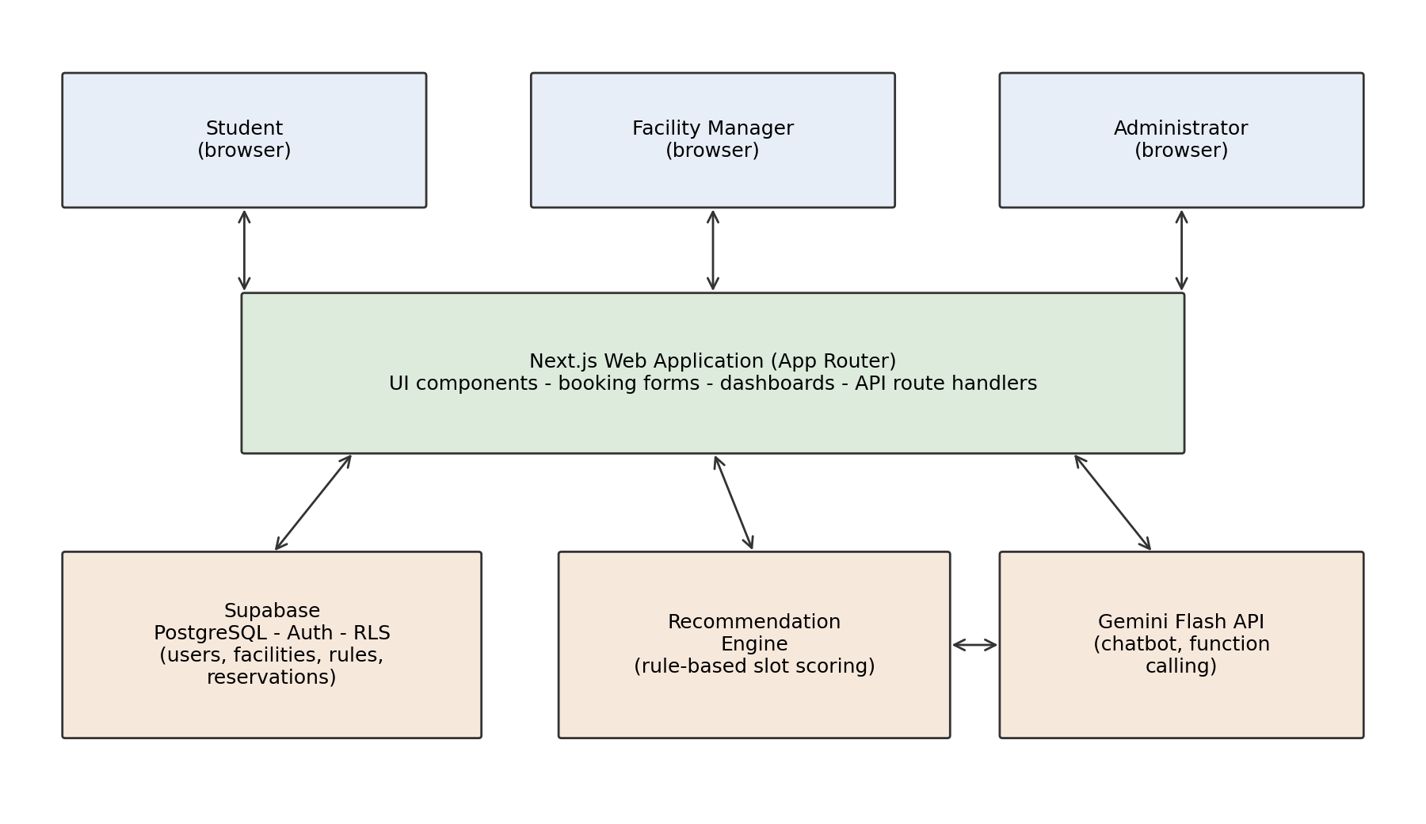
Figure 3.1: Proposed system architecture
3.4.2 Actors and use cases. Figure 3.2 summarises the system's actors and their use cases. Three human actors are supported. Students browse venues and facilities, view live availability and popular times, request and cancel bookings, request equipment, check in, and query the assistant. Facility managers work within a scope: they see only the approval queue, attendance list, equipment inventory, and lost-and-found register of the facilities assigned to them. Administrators define facility types and their rules, add rooms and courts, assign managers, manage user roles, view analytics, and act as the approver for any facility that has no assigned manager. Two non-human actors are shown because they carry behaviour: the AI services (the recommendation engine and the chatbot) and the database, which enforces booking conflicts and generates notifications and audit records through triggers rather than application code.
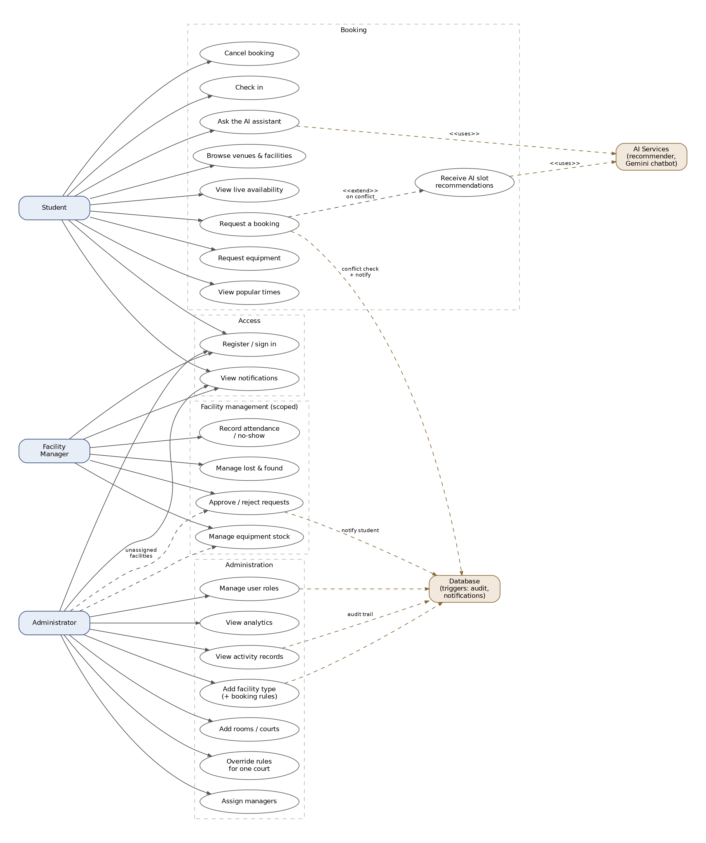
Figure 3.2: Use case diagram of the proposed system
3.4.3 Database design. Figure 3.3 shows the entity relationship diagram of the implemented schema, which comprises twelve tables in four functional groups. The facilities group implements the two-level model that objective 2 requires: facility_categories represents a class of facility such as Badminton or Discussion Room and carries the venue together with the booking rules (operating hours, minimum and maximum duration, advance-booking window, cancellation notice, and an auto-approve flag); facilities represents the individual rooms or courts belonging to a category and stores only what differs between them, namely name, capacity, and status. Because policy lives on the category, changing a rule once updates every room of that type. The facility_rules table is an optional per-room override in which any column left null inherits the category value, and a database view resolves the two into an effective rule set that the application reads. This design means an administrator can create an entirely new facility type without any code change, which is what makes the platform portable between institutions.
The people group contains profiles, which extends Supabase authentication with a role and the per-user recommendation weights described in Section 3.4.4, and facility_managers, a junction table assigning managers to facilities in a many-to-many relationship so that a facility may have several managers and a manager several facilities. The bookings group contains reservations (start and end time, participant count, purpose, status, and the attendance fields checked_in_at and no_show) together with equipment and reservation_equipment, which model bookable resources such as rackets or HDMI cables and the quantities committed to a booking. The operations group contains lost_and_found, notifications, activity_log, and evaluation_events, described in Sections 3.4.7 to 3.4.9.
Two guarantees are enforced at the database layer rather than in application code. Conflict prevention uses a PostgreSQL exclusion constraint over the facility and the booking time range for reservations in pending or approved status, so no sequence of concurrent requests can produce an overlap, consistent with the database-centred position of Hwang et al. (2022). Access control uses row level security policies keyed on role and on the facility_managers table, so a manager can act only on facilities assigned to them, a student can modify only their own bookings, and self-registration can only create a student account; elevation to manager or administrator is possible only through an administrator. Enforcing both at this layer means the guarantees hold regardless of what any client sends.
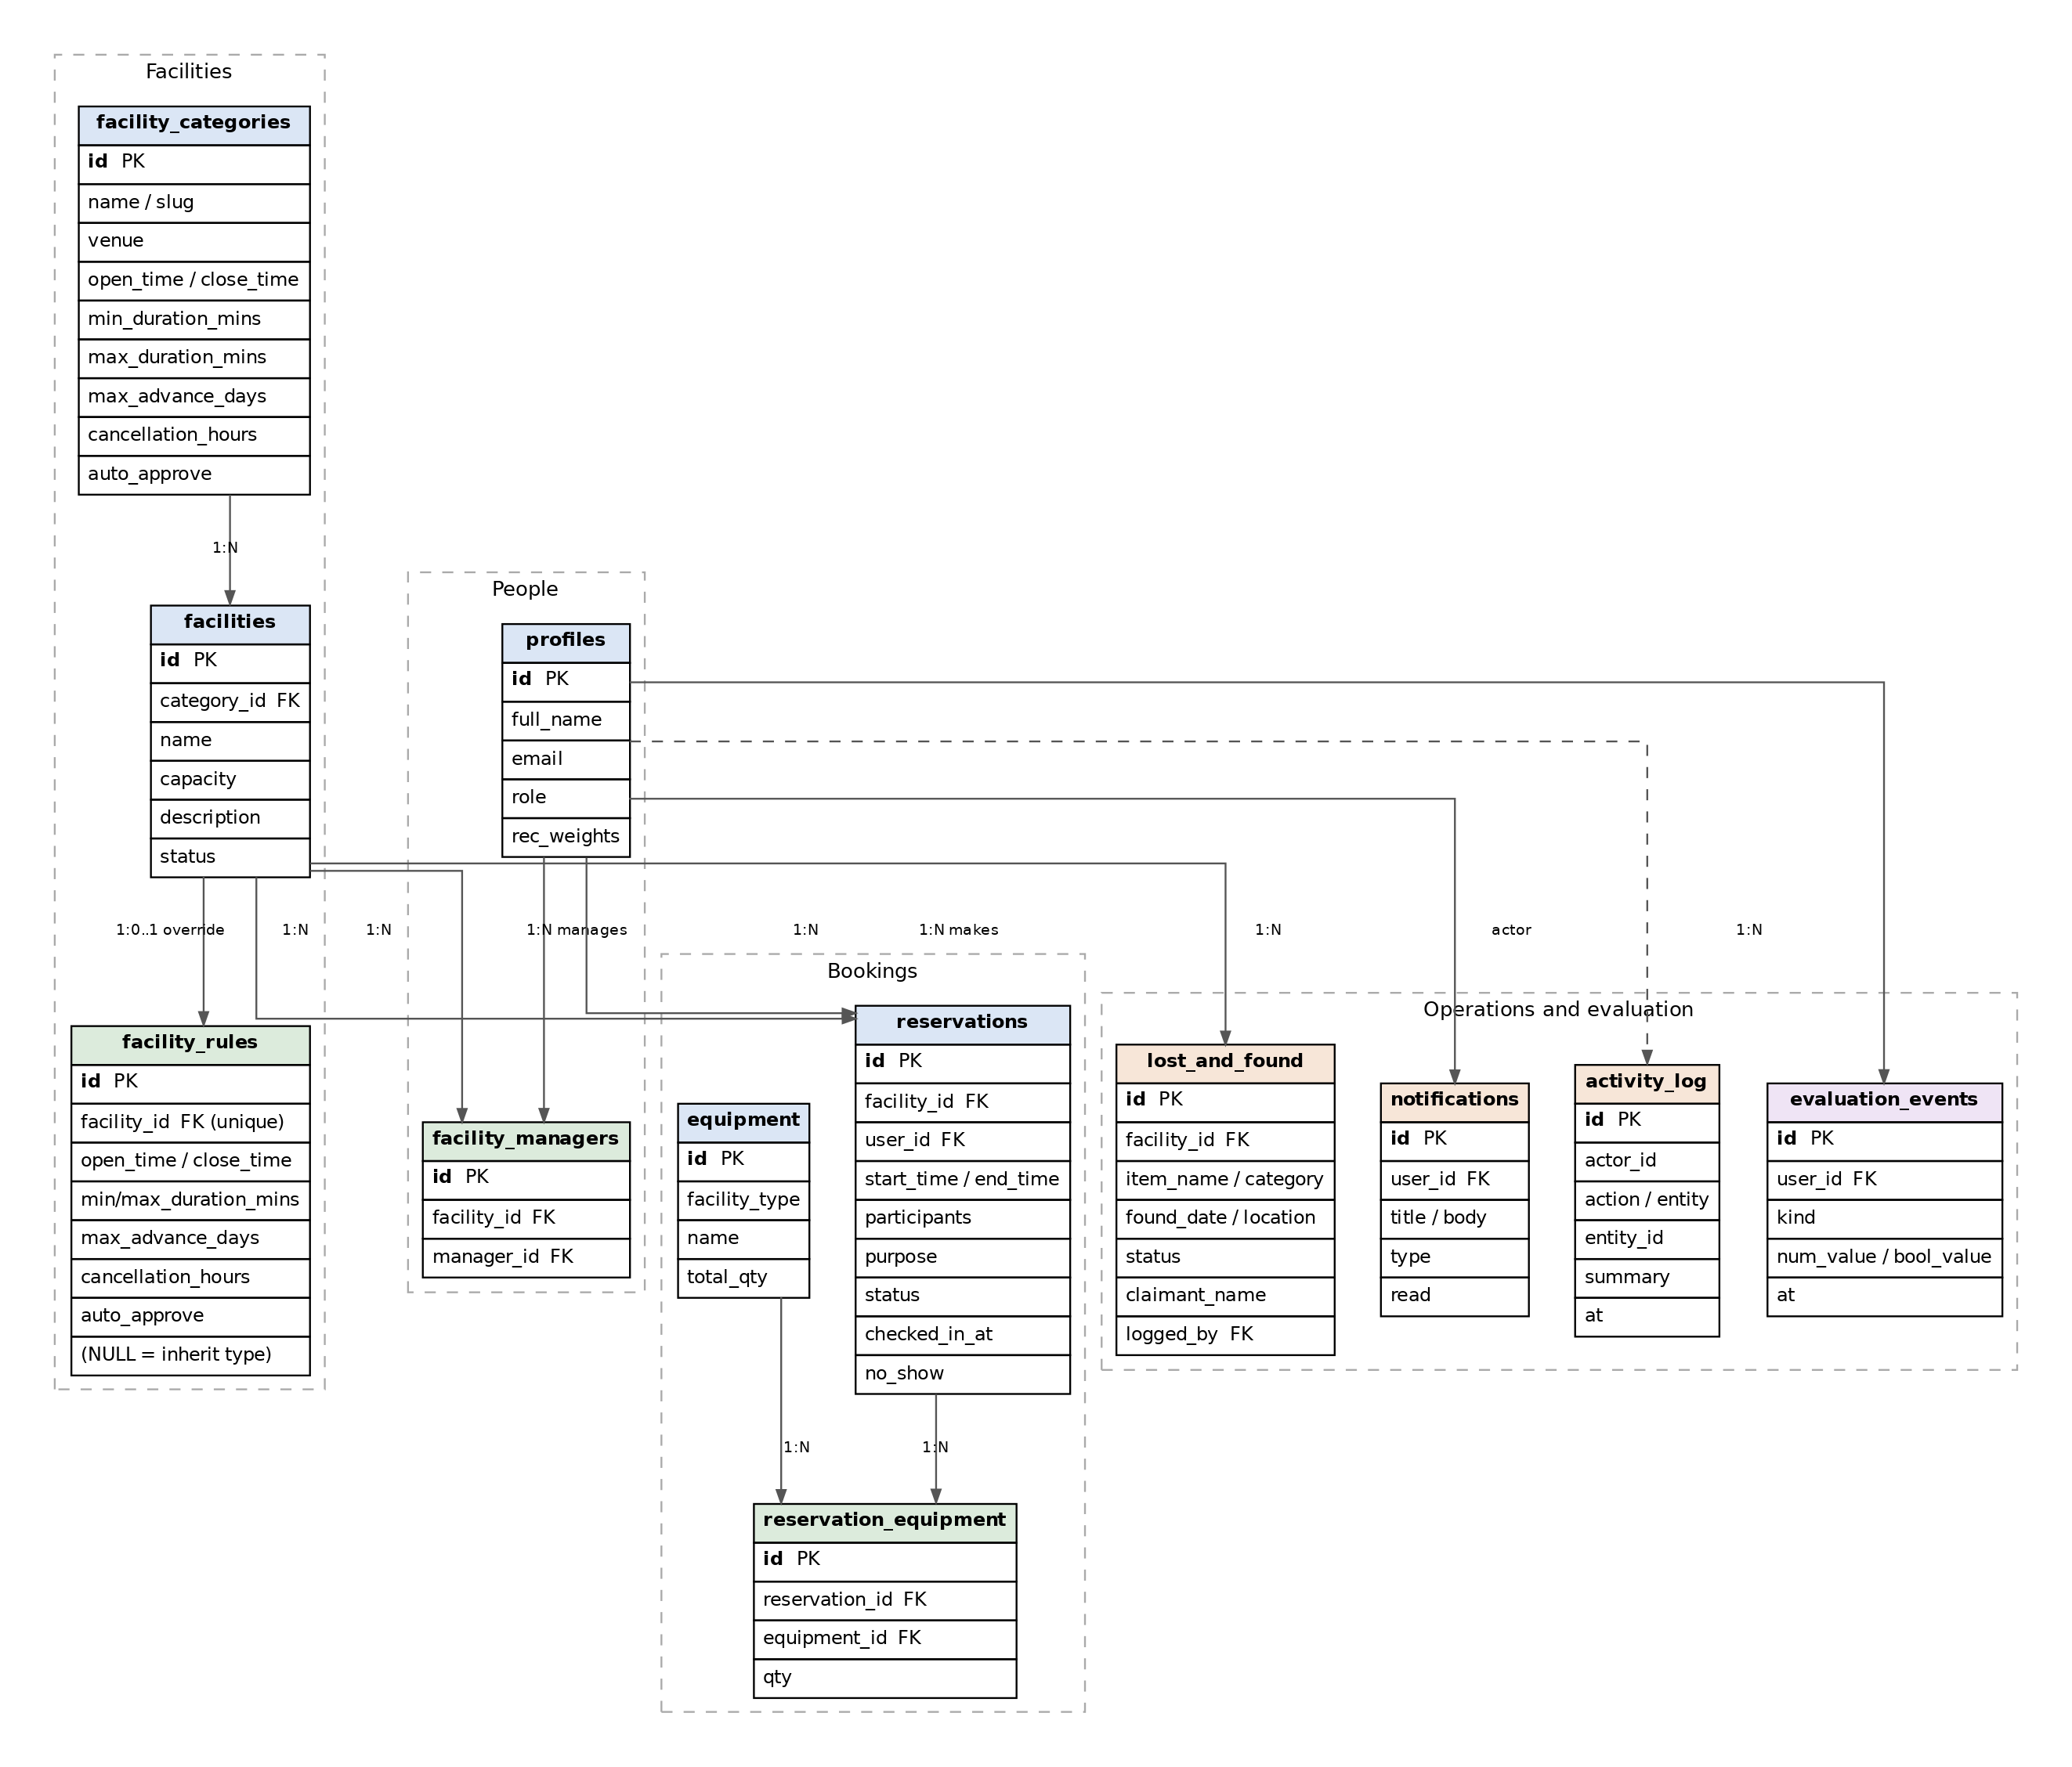
Figure 3.3: Entity relationship diagram of the proposed database
3.4.4 Rule engine and recommendation logic. A booking request is validated against the facility's rule row: inside operating hours, within maximum duration, within the advance window, participant count within capacity, and requester's role permitted. Requests that pass enter the approval workflow (or are auto-approved where the facility's policy allows). The recommendation module activates when a user searches for a slot: candidate slots within the user's date range are generated at the facility's booking granularity, infeasible slots are removed using the same rule checks plus existing reservations, and feasible slots are ranked by a weighted score:
S = w1 * T + w2 * C + w3 * U ...................................................... (3.1)
where T rewards closeness to the user's preferred time, C rewards fit between group size and facility capacity (penalizing a two-person group in an event hall), U rewards off-peak slots to spread utilization, and the weights are initialized from pilot testing and then adjusted adaptively: when users accept or ignore suggested slots, the system nudges the weights in the direction of accepted suggestions, a lightweight online-learning layer that personalizes ranking over time while keeping the scoring model fully inspectable. Because every factor is inspectable, each suggestion can be shown with its reason, which the recommender literature links to user trust (Valencia-Arias et al., 2024). The top-ranked slots may optionally be passed to the LLM to phrase a friendly explanation, keeping the ranking itself deterministic.
3.4.5 Chatbot design. The chatbot is scoped to four question families: availability (is the futsal court free on Friday evening), policy (how long can I book a discussion room, what is the cancellation notice), procedure (how do I cancel, why was my request rejected), and booking status. For each family the server exposes a typed function the model may call: check_availability(facility, date_range), get_facility_rules(facility), get_booking_status(user), and list_facilities(type). When a student asks a question, the model selects and calls the appropriate function, the server executes it against Supabase under the student's own row level security context so the bot can never leak another user's data, and the model composes its answer from the returned rows. Questions outside the four families receive a fixed deflection pointing the student to human staff, a deliberate design choice following the accuracy findings of Rahim et al. (2022): a narrow bot that is right is more useful than a broad one that guesses. Chatbot answer accuracy is one of the UAT metrics defined in Section 3.3.
3.4.6 Booking workflow. Figure 3.4 traces the end-to-end flow that ties the modules together. A student selects a venue, a facility, a date, and a desired time; the system validates the request against the facility's rule row and checks for a clash. If the time is free the booking is written as pending inside a transaction protected by the exclusion constraint, so a simultaneous competing request fails cleanly. If the time is taken, the recommendation engine generates candidate slots, filters them through the same rules and existing reservations, scores the survivors with equation 3.1, and presents the top alternatives with reasons for one-click booking. Any equipment requested is checked against inventory already committed to overlapping bookings before being reserved. The facility manager (or the administrator, for unassigned facilities) sees the request in the approval queue and approves or rejects it, unless the facility's policy allows auto-approval; the student sees the status change on their dashboard. Cancellation follows the facility's cancellation-notice rule automatically.
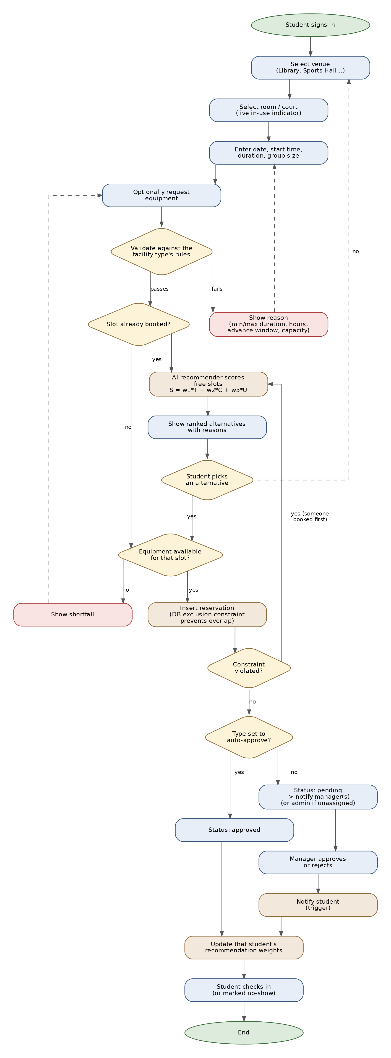
Figure 3.4: Booking process flow, including conflict handling
3.4.7 Attendance and no-show tracking. Approved bookings can be closed out in two ways. A student may check themselves in from fifteen minutes before the start until the end of the session, which records a timestamp; alternatively the facility manager marks the session attended or, where nobody arrived, a no-show. The resulting no-show rate is reported on the administrator's analytics dashboard. This matters because a booked-but-empty room is exactly the waste the project sets out to reduce, and measuring it is the prerequisite for the occupancy-sensor integration proposed as further work in Chapter 4.
3.4.8 Notifications and audit logging. Both are implemented as database triggers rather than application calls, so that no code path can bypass them. When a booking's status changes to approved or rejected, a trigger writes a notification addressed to the student who made it; when a new pending request is inserted, a trigger notifies every manager assigned to that facility, or all administrators if the facility has none. A second family of triggers writes a human-readable record of every booking, approval, facility change, rule change, manager assignment, equipment adjustment, lost-and-found action, and registration into an append-only activity_log that only administrators may read. The audit trail supports accountability, which is a professional-practice obligation as much as an operational convenience.
3.4.9 Lost and found and evaluation instrumentation. Facility managers maintain a lost-and-found register for their own facilities, recording the item, category, where and when it was found, and tracking it through unclaimed, claimed, returned, or disposed states with the claimant's details. Separately, an evaluation_events table captures the measurements that objective 4 requires while the system is used: how many recommendations were shown, whether a suggested slot was accepted and at what rank, and whether the student rated a chatbot answer helpful. These figures surface on the analytics dashboard as a recommendation-acceptance rate and a chatbot-helpfulness rate, so the Phase 2 evaluation can report measured values rather than estimates.
3.4.10 Role interfaces. The student interface is organised as a guided flow: the student first chooses a venue (Library, Sports Complex, and so on), then a specific facility shown with a live in-use indicator, then enters a desired time which is validated against the facility's minimum and maximum duration, operating hours, advance window, and capacity before booking; where the requested time is unavailable, the recommendation engine offers the closest free alternatives. Equipment for the facility's category can be added to the request in the quantities available for that time slot. The facility manager interface is scoped by the facility_managers assignment: a manager sees only the approval queue, upcoming bookings, and equipment inventory for the facilities assigned to them. The administrator interface is organised into tabs. Facility configuration follows the two-step flow shown in Figure 3.5: the administrator first creates a facility type with its venue and booking rules, then adds the individual rooms or courts beneath it, which inherit those rules unless a specific room is given an override. The remaining tabs provide manager assignment, user-role management, an approval queue for facilities that have no assigned manager, an equipment inventory override, a usage-analytics dashboard, and the activity-log record view.
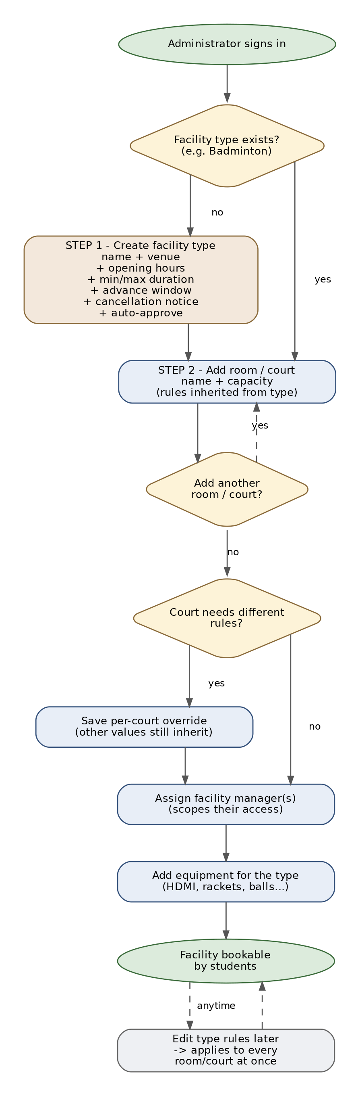
Figure 3.5: Administrator facility configuration flow

3.5 Professional engineering practices
The system handles personal data (names, university emails, booking histories), so the design complies with the Malaysian Personal Data Protection Act 2010: data collected is limited to what the booking function requires, retention is bounded, and access is role-restricted through row level security. Security practice follows OWASP guidance for web applications: parameterized queries throughout, server-side validation of every request, authenticated sessions, and no secrets in client code. Accessibility follows WCAG 2.1 AA so that the platform serves students with disabilities equally, an inclusion obligation as well as a legal-risk consideration. The engineering conduct of the project follows the Board of Engineers Malaysia and IEM codes of professional conduct regarding honesty of reported results and responsibility for public wellbeing, and the chatbot is constrained to grounded answers precisely because releasing a system that confidently misinforms students would breach that responsibility.
Health and safety obligations are indirect but real: occupancy restrictions in the rule engine exist so that the system cannot approve a booking that exceeds a room's safe capacity, which encodes a fire-safety rule that the manual process enforces only by staff vigilance. Legal responsibility also extends to the software supply chain: every library used is open source under permissive licenses (MIT, Apache 2.0), recorded in the project's dependency manifest, so the university can deploy the system without license exposure. Culturally, the platform must serve an international student body, so interface language is kept plain and the extension objective of multilingual chatbot support addresses students more comfortable in Bahasa Malaysia or Mandarin. Socially, moving booking online must not exclude students without reliable devices; the counter process remains available as a fallback, with staff using the same administrator interface, so the system augments rather than replaces human access.
The project's SDG contribution is summarized in Table 3.3.
Table 3.3: Mapping of the project to the UN Sustainable Development Goals
SDG | Contribution
SDG 3: Good health and wellbeing | Lowers the barrier to booking sports facilities, encouraging physical activity
SDG 4: Quality education | Equal, transparent access to study spaces for all students
SDG 7: Affordable and clean energy | Utilization data enables facility scheduling that reduces lighting and air-conditioning of empty rooms
SDG 8: Decent work and economic growth | Frees administrative staff from repetitive queue work toward higher-value tasks
SDG 9: Industry, innovation and infrastructure | Digital infrastructure that raises utilization of existing physical assets
SDG 10: Reduced inequalities | Uniform rules applied by the system remove informal favouritism in allocation
SDG 11: Sustainable cities and communities | Better use of shared community spaces without new construction
SDG 12: Responsible consumption and production | Paperless process; higher yield from resources already built

3.6 Project management, finance and entrepreneurship 1
Figure 3.6 shows the Gantt chart covering both phases. Phase 1 runs from title proposal through report submission and the oral presentation; Phase 2 sequences implementation increments as described in Section 3.3, ending at the viva and hardbound submission. Supervisor meetings are held fortnightly and recorded in log sheets (Appendix A).
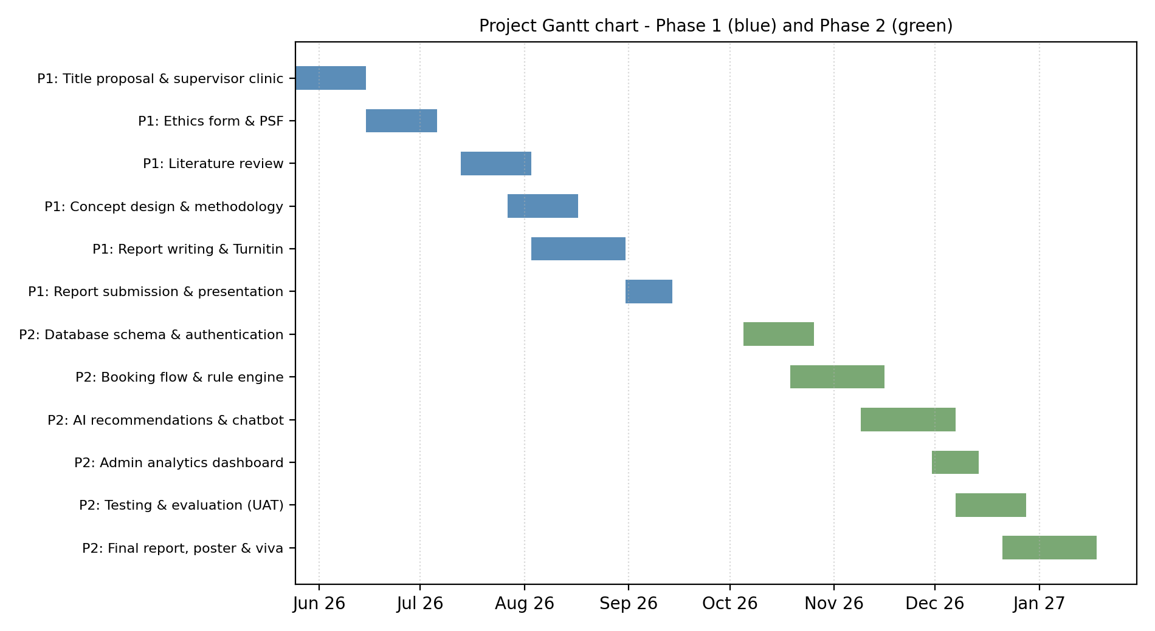
Figure 3.6: Project Gantt chart for Phase 1 and Phase 2
The estimated cost of the project is low by design, which is itself an engineering decision documented in Section 3.2.
Table 3.4: Estimated cost analysis
Item | Provider / plan | Estimated cost (RM)
Database, auth, hosting (backend) | Supabase free tier | 0
Web hosting (frontend) | Vercel free tier | 0
LLM API (chatbot) | Gemini Flash free tier | 0
Contingency: paid LLM usage during testing | Approx. USD 5 | 25
Domain name (optional) | 1 year | 50
Printing and binding (both phases) | Soft + hard bound | 150
Total |  | 225

Risk is managed explicitly given the compressed Phase 1 timeline visible in the Gantt chart. The two highest risks are schedule risk, mitigated by the incremental build order which guarantees a demonstrable core system even if the analytics extension is cut, and dependency risk on the free-tier services, mitigated by the provider-agnostic chatbot wrapper and by Supabase being standard PostgreSQL underneath, so the database is portable. A small contingency budget covers paid LLM usage if free-tier rate limits bind during testing.
On the entrepreneurship side, the per-facility rule engine is the commercially interesting feature: because policy is configuration rather than code, the same platform can be offered to other universities and colleges without modification. A plausible route to market is a software-as-a-service subscription per institution, with the free-tier architecture keeping marginal cost near zero for small deployments. Commercial reservation products exist for corporate meeting rooms, but campus-specific needs (student roles, mixed facility types, approval hierarchies) are underserved, which is the niche this design targets. The marketing strategy for such an offering would lead with the configurability and the near-zero infrastructure cost, targeting private colleges first, where procurement cycles are shorter and existing systems are most often manual.

3.7 Summary
This chapter selected Next.js and Supabase on justified criteria, split the AI design into a deterministic recommendation engine and a grounded LLM chatbot, and presented the architecture, database design with database-level conflict prevention, scoring logic, SDG mapping, Gantt plan, and cost analysis. Together these satisfy the concept-design requirements of Phase 1 and form the blueprint for Phase 2.

CHAPTER 4: CONCLUSION
This investigation set out to determine how campus facility reservation should be modernized and what an AI-assisted version of it requires. The literature review of ten recent works established that digitized booking workflows reliably reduce conflicts and processing time, but that existing campus systems are uniformly rigid: one policy for all facilities, no assistance when a request fails, and no conversational access to information. Recommendation and chatbot techniques are mature in adjacent domains and measurably effective in higher education service contexts, yet unintegrated in this one.
The proposed design answers with three contributions: a per-facility rule engine that turns booking policy into administrator-editable configuration, a deterministic and explainable slot recommendation module, and a function-calling LLM chatbot grounded in live system data. Technology selection was argued from comparison: Next.js 16 with Supabase for the platform, PostgreSQL exclusion constraints for conflict safety, and Gemini Flash for conversational AI at zero cost. The evaluation plan ties directly to the objectives, measuring conflict prevention, recommendation relevance, and usability.
Phase 2 will implement the system in the increments planned in Chapter 3, beginning with the schema and authentication. Further research directions beyond Phase 2 include occupancy-sensor integration for no-show detection, demand forecasting from accumulated booking data, and federated deployment across multiple institutions, each building on the data foundation this design puts in place.

REFERENCES
Antony, A., Maria Thomas, L., K Suresh, M., Sony, M., & Saritha R, R. (2026). EDUNEXUS: College facility booking platform. International Journal of Engineering Science Technologies, 10(1), 36-38. https://doi.org/10.29121/ijoest.v10.i1.2026.737
Artes, A. L., Lorzano, E. R., Tayam, J. R., & Intal, G. L. (2024). Cardinal Reserve: A proposed online room reservation system for a higher educational institution (HEI). Proceedings of the 2024 6th International Conference on Management Science and Industrial Engineering, 108-118. https://doi.org/10.1145/3664968.3664982
Dempere, J., Modugu, K., Hesham, A., & Ramasamy, L. K. (2023). The impact of ChatGPT on higher education. Frontiers in Education, 8, 1206936. https://doi.org/10.3389/feduc.2023.1206936
Essel, H. B., Vlachopoulos, D., Tachie-Menson, A., Johnson, E. E., & Baah, P. K. (2022). The impact of a virtual teaching assistant (chatbot) on students' learning in Ghanaian higher education. International Journal of Educational Technology in Higher Education, 19, 57. https://doi.org/10.1186/s41239-022-00362-6
Hwang, K., Jung, I. H., & Lee, J. M. (2022). Design and implementation of database for shared facility reservation system in school. Journal of Positive School Psychology, 6(8), 7033-7041.
Lalitha, V., et al. (2022). Online college event hall booking reservation system. 2022 1st International Conference on Computational Science and Technology (ICCST), IEEE. https://doi.org/10.1109/ICCST55948.2022.10040388
Okonkwo, C. W., & Ade-Ibijola, A. (2021). Chatbots applications in education: A systematic review. Computers and Education: Artificial Intelligence, 2, 100033. https://doi.org/10.1016/j.caeai.2021.100033
Rahim, N. I. M., Iahad, N. A., Yusof, A. F., & Al-Sharafi, M. A. (2022). AI-chatbots adoption model for higher-education institutions: A hybrid PLS-SEM-neural network modelling approach. Sustainability, 14(19), 12726. https://doi.org/10.3390/su141912726
Roy, D., & Dutta, M. (2022). A systematic review and research perspective on recommender systems. Journal of Big Data, 9, 59. https://doi.org/10.1186/s40537-022-00592-5
Valencia-Arias, A., Uribe-Bedoya, H., Gonzalez-Ruiz, J. D., Sanchez Santos, G., Chaponan Ramirez, E., & Martinez Rojas, E. (2024). Artificial intelligence and recommender systems in e-commerce. Trends and research agenda. Intelligent Systems with Applications, 24, 200435. https://doi.org/10.1016/j.iswa.2024.200435
Venkatesh, S., Pradeep, P., Balamurugan, M., Guhan, S., & Niyasaju. (2026). Design and implementation of a web-based campus facility reservation system. International Journal of Engineering Research & Technology, 15(3). https://doi.org/10.5281/zenodo.19067756

APPENDICES

Appendix A: Log Sheets
[Attach signed fortnightly supervisor log sheets here.]

Appendix B: FYP Draft Project Proposal / FYP Bank Confirmation
[Attach the FYPPGBank title proposal / approval confirmation here.]

Appendix C: Project Specification Form
[Attach the approved PSF here.]

Appendix D: Ethics Form
[Attach the signed ethics form here.]

Appendix E: Turnitin Report
[Attach the Turnitin similarity report here.]

