


VISVESVARAYA TECHNOLOGICAL UNIVERSITY
“Jnana Sangama”, Belagavi-590018

A Project Report (Phase-1)
on
“LLM-Driven Financial Chatbot for Real-Time Stock Market Analysis”
Submitted in partial fulfilment of the requirements for the award of the Degree of
Bachelor of Engineering
in
Computer Science and Engineering
by

Amaan Siddiqui 1DB23CS012
Achuta Rao M 1DB23CS004
Shreejal Dash 1DB23CS201
Kishan Kumar 1DB23CS103

Under the Guidance of
Mrs. Anjali Vyas
(Assistant Professor) Department of CSE

DON BOSCO INSTITUTE OF TECHNOLOGY
DEPARTMENT OF COMPUTER SCIENCE & ENGINEERING
Kumbalagodu, Mysuru Road, Bengaluru-560074 2025-2026



DON BOSCO INSTITUTE OF TECHNOLOGY

Kumbalagodu, Mysore Road, Bangalore-560 074

DEPARTMENT OF COMPUTER SCIENCE & ENGINEERING

CERTIFICATE

This is to certify that the Project Work “LLM-Driven Financial Chatbot for Real-Time Stock Market Analysis” has been carried out by Amaan Siddiqui (1DB22CS012), Achuta Rao M (1DB22CS012), Shreejal Dash (1DB22CS201), Kishan Kumar (1DB23CS103), the bonafide students of Don Bosco Institute of Technology, Bengaluru, in the partial fulfillment for award of Degree of Bachelor of Engineering in Computer Science and Engineering of Visvesvaraya Technological University, Belagavi, during the academic year 2025-2026. The Project Work has been approved as it satisfies the academic requirements in respect of the Project Work prescribed for the Bachelor of Engineering Degree.

Signature of Guide

...................................
Mrs. Anjali Vyas
Assistant Professor Department of CSE

Signature of HOD

..................................
Dr. K B ShivaKumar
B.E, M.E, M.B.A, M.Phil, Ph.D
Professor and Head Department of CSE

Signature of Principal

................................
Dr. Naghabhushana B S
B.E, M.Tech, Ph.D
Principal, DBIT



DON BOSCO INSTITUTE OF TECHNOLOGY
Kumbalagodu, Mysuru Road, Bengaluru-560074

DEPARTMENT OF COMPUTER SCIENCE & ENGINEERING

DECLARATION

We, Amaan Siddiqui (1DB22CS012), Achuta Rao M (1DB22CS012), Shreejal Dash (1DB22CS201), Kishan Kumar (1DB23CS103), students of sixth semester B.E, at the Department of Computer Science and Engineering, Don Bosco Institute of Technology, Bengaluru, declare that the Project Work entitled “LLM-Driven Financial Chatbot for Real-Time Stock Market Analysis” has been carried out by us and submitted in partial fulfillment of the course requirements for the award of degree in Bachelor of Engineering in Computer Science and Engineering of Visvesvaraya Technological University, Belagavi during the academic year 2025-2026. The Project Work has been approved as it satisfies the academic requirements for the award of Bachelor of Engineering Degree.
DECLARATION

Amaan Siddiqui – 1DB22CS012
Achuta Rao M – 1DB22CS004
Shreejal Dash – 1DB22CS201
Kishan Kumar – 1DB23CS103
Place: Bengaluru


ACKNOWLEDGEMENT

The satisfaction and euphoria that accompany the successful completion of any project is incomplete without mention of the people who made it possible and under whose constant guidance and encouragement the task was complete.

We express our sincere gratitude to Dr. B S Nagabhushana, Principal and Management Don Bosco Institute of Technology, Bengaluru for his timely help and inspiration during tenure of the course.

We express our profuse gratitude to Dr. K B ShivaKumar, Professor and Head of the Department of Computer Science & Engineering, for his timely co-operation while carrying the Project Work.

We express our profuse gratitude to Mrs. Anjali Vyas, Assistant Professor, Department of Computer Science & Engineering, Don Bosco Institute of Technology, Bengaluru, for guiding us with numerous helpful discussions. We also thank our guide for valuable guidance, encouragement and inspiration for carrying out the Project Work. We express our acknowledgement to our project coordinator Mrs.Geethanjali S G, Assistant Professor, Dept of CSE for extending their direction and support during the completion of Project.

We would like to express our heartfelt gratitude to Teaching Faculty Members & Non-Teaching staff members, who have directly or indirectly helped us in completion of the Project Work successfully.

ABSTRACT

With over 130 million registered retail investor accounts in India and a growing incidence of uninformed trading losses among first-time market participants, there exists a pressing need for scalable, AI-driven financial guidance. This project introduces FinSight AI, a full-stack conversational investment assistant that integrates real-time market intelligence with large language model reasoning to deliver personalized, actionable financial insights through a natural language interface.
The system architecture comprises a Python FastAPI backend that continuously ingests live equity data from the NSE and BSE, sentiment signals from Reddit communities and financial news aggregators, and IPO data including Grey Market Premium (GMP) indicators. This multi-source data is synthesized into dynamic context and processed by Google Gemini 1.5 Flash to generate highly contextualized stock buy/sell signals, SIP fund recommendations, and comprehensive IPO investment assessments.
To ensure accuracy and combat the common issue of AI hallucinations, a Retrieval-Augmented Generation (RAG) layer built on ChromaDB grounds the model's responses in historical financial documents, regulatory guidelines, and company prospectuses. Furthermore, a dedicated paper trading simulation module enables users to validate recommendations against live market conditions using virtual capital, providing a critical feedback loop for strategy assessment without financial risk. Deployed as a React-based web application with a modular "Bento Grid" UI, FinSight AI targets the underserved segment of retail investors, bridging the gap between complex raw data and professional-grade financial advisory services.

TABLE OF CONTENTS

DECLARATION | I
ACKNOWLEDGEMENT | II
ABSTRACT | III

CHAPTER & TITLE | PAGE NO.
CHAPTER 1: INTRODUCTION  - Problem Statement  - Objectives  - Scope of the Project | 1-2
CHAPTER 2: LITERATURE SURVEY  - Related work  - Comparative Analysis | 3-5
CHAPTER 3: SYSTEM ANALYSIS AND DESIGN  - System Architecture | 6-7
CHAPTER 4: IMPLEMENTATION | 8
CHAPTER – 5: RESULTS (If any)  - Results | 9-11
CHAPTER – 6: CONCLUSION AND FUTURE SCOPE  - Conclusion  - Future Scope | 12
REFERENCES | 13

CHAPTER 1
INTRODUCTION
The Indian stock market has witnessed tremendous growth in retail investor participation over the past decade. The increasing accessibility of mobile trading applications and digital investment platforms has encouraged millions of first-time investors to enter the financial market ecosystem. According to recent reports, India has over 130 million registered retail investor accounts, making the country one of the fastest-growing retail investment markets in the world.
Despite this growth, a large percentage of investors lack sufficient financial literacy and analytical expertise to make informed investment decisions. Most existing trading platforms focus primarily on displaying raw market data such as stock prices, trading volumes, and charts without providing meaningful interpretation of the information. As a result, many retail investors rely on speculation, social influence, or incomplete information while investing, leading to poor financial decisions and increased market risk.

The stock market is highly dynamic and influenced by multiple quantitative and qualitative factors. Quantitative factors include stock prices, market trends, technical indicators, and historical performance, whereas qualitative factors include investor sentiment, financial news, economic policies, and market psychology. Traditional analytical systems often fail to integrate both types of information effectively.
Recent advancements in Artificial Intelligence, Machine Learning, Natural Language Processing, and Large Language Models (LLMs) have opened new possibilities in the domain of financial analysis and intelligent decision support systems. LLMs such as Google Gemini can understand and process unstructured financial text, summarize market trends, and generate contextual recommendations in natural language.
FinSight AI is proposed as a web-based conversational financial assistant that combines real-time market data, sentiment analysis, and AI-powered reasoning to assist retail investors. The system uses live stock market data from NSE/BSE, financial news feeds, and technical indicators to generate stock market insights. In addition, the system integrates a Retrieval-Augmented Generation (RAG) framework using ChromaDB to retrieve relevant financial knowledge and improve the reliability of AI-generated responses.
The project also incorporates a paper trading simulation module where users can practice stock trading using virtual capital. This enables users to evaluate strategies and understand market behavior without financial risk.

By integrating intelligent market analysis with a conversational chatbot interface, FinSight AI aims to democratize financial guidance and provide accessible investment assistance to retail investors.

1.1 Problem Statement
Retail investors in India often incur financial losses due to the absence of intelligent systems capable of interpreting market data and investor sentiment in real time. Most trading platforms provide raw market information but fail to combine technical indicators, financial news, and AI-driven contextual analysis into meaningful investment insights.
Consequently, many investors struggle to understand market trends, evaluate risks, and make informed investment decisions. There is a need for an AI-powered financial assistance system that can analyze multi-source market information and provide understandable recommendations through a conversational interface.

1.2 Objectives
The primary objective of this project is to develop FinSight AI, an intelligent conversational financial assistant capable of providing real-time investment insights and stock market analysis.
The specific objectives are as follows:
- To collect and process live stock market data from NSE and BSE.
- To implement technical analysis indicators such as RSI and Moving Average crossover.
- To analyze financial news sentiment for market mood detection.
- To integrate Google Gemini 1.5 Flash for AI-driven conversational responses.
- To implement a Retrieval-Augmented Generation framework using ChromaDB.
- To provide SIP recommendations and IPO analysis.
- To develop a paper trading simulation module using virtual funds.
- To build a user-friendly web-based conversational interface.

1.3 Scope of the Project
The scope of FinSight AI includes stock market analysis, sentiment-based investment insights, conversational AI interaction, and paper trading simulation for retail investors.
The system is designed primarily for educational and research purposes and aims to assist beginner investors in understanding stock market behavior. The project focuses on Indian stock market data obtained through publicly available APIs and financial news sources.
The platform provides the following functionalities:
- Real-time stock market monitoring
- Buy/Hold/Sell signal generation
- Sentiment analysis of financial news
- SIP recommendation system
- IPO evaluation and analysis
- Conversational AI chatbot support
- Paper trading portfolio management

The system does not perform actual financial transactions and is intended only as a market research and educational assistance platform.

CHAPTER 2
LITERATURE SURVEY
2.1 Related Work

Recent research in stock market prediction and financial advisory systems has focused on integrating Artificial Intelligence, Machine Learning, sentiment analysis, and Large Language Models to improve market forecasting and investment decision-making.

Luckianto and Gunawan proposed MARAG-Fin, a multi-agent Retrieval-Augmented Generation architecture that combines financial news sentiment and time-series data for stock market forecasting. The framework uses NeuralProphet models and multiple AI agents to generate data-driven trading decisions. The study demonstrated that integrating RAG with financial forecasting can improve contextual understanding and predictive accuracy. However, the architecture suffers from high latency during real-time multi-agent coordination.

Das et al. presented an order-aware multimodal fusion framework for financial advisory summarization. Their research focused on combining video and textual financial data using transformer-based fusion techniques to generate financial summaries. Although the framework improves information summarization quality, it primarily focuses on summarization rather than stock market prediction.

Liagkouras and Metaxiotis proposed a hybrid Long Short-Term Memory model integrated with sentiment analysis for stock market forecasting. Their work combines financial news sentiment with LSTM-based prediction models to identify directional stock movements. The study highlights the significance of sentiment-aware forecasting but remains limited to regulatory news sources.
Jadhav and Mirza conducted a comprehensive review of Large Language Models in equity markets. The study explored applications of LLMs in portfolio management, risk assessment, and market research. The authors identified the potential of LLMs in financial systems while also discussing interpretability challenges and the “black box” nature of AI models.
Srivatsan introduced a hybrid model that combines zero-shot sentiment analysis with LSTM and XGBoost for stock price prediction. The study demonstrated improved prediction accuracy when integrating social sentiment with traditional machine learning techniques. However, the effectiveness of the model heavily depends on the availability of large-scale social media discussions.

The literature survey indicates that while several systems focus on prediction accuracy and sentiment analysis, there is still a lack of integrated conversational financial assistance systems capable of combining real-time data, RAG-based contextual retrieval, sentiment analysis, and user-friendly interaction.

Table 2.1 : Comparison of Existing Systems vs. Proposed System

Reference | Focus Area | Key Technology/Approach | Limitation / Gap
Luckianto et al. (2026) – MARAG-Fin [1] | AI-driven Financial Decision Making / Stock Forecasting | Multi-Agent RAG-LLM Architecture with NeuralProphet and Financial Sentiment Integration | High latency in real-time agent coordination and increased computational complexity.
Das et al. (2025) [2] | Financial Advisory Summarization / Multimodal Analysis | Transformer-based multimodal fusion of financial videos and textual data | Focuses mainly on summarization quality rather than stock prediction and investment guidance.
Liagkouras et al. (2025) – Hybrid LSTM System [3] | Stock Market Forecasting / Sentiment-based Prediction | LSTM integrated with financial news sentiment analysis | Limited to regulatory news sources and lacks broader market sentiment integration.
Jadhav et al. (2025) – LLMs in Equity Markets [4] | Applications of LLMs in Financial Markets | Review of LLM techniques for portfolio management and risk analysis | Highlights interpretability and “black-box” issues in LLM-generated financial insights.
Srivatsan N. (2025) – Hybrid LLM Model [5] | Stock Price Prediction using Social Sentiment | Combination of Zero-shot Sentiment Analysis, LSTM, and XGBoost | Prediction accuracy depends heavily on high social media activity and sentiment availability.

6

2.2 Comparative Analysis
Existing systems mainly focus on specific functionalities such as stock prediction, sentiment analysis, or financial summarization. Very few systems integrate all these functionalities into a unified platform.
Traditional stock analysis systems primarily rely on numerical market data and technical indicators without considering qualitative information such as investor sentiment and financial news. Sentiment-based systems improve market understanding but often lack conversational interaction and contextual reasoning.
Recent LLM-based systems demonstrate improved natural language understanding and contextual analysis capabilities. However, most research implementations are experimental and not designed as practical web-based platforms for retail investors.
FinSight AI differs from existing systems by integrating the following features into a single platform:
- Real-time stock market analysis
- Technical indicator-based signal generation
- Financial news sentiment analysis
- Conversational AI interaction using Gemini 1.5 Flash
- Retrieval-Augmented Generation using ChromaDB
- IPO assessment and SIP recommendations
- Paper trading simulation

The proposed system aims to provide an end-to-end AI-powered financial assistance platform for retail investors.

CHAPTER 3
SYSTEM ANALYSIS AND DESIGN

3.1 System Architecture
FinSight AI follows a Decoupled Three-Tier Architecture integrated with a Multi-Agent Retrieval-Augmented Generation framework. The system architecture is designed to ensure scalability, modularity, and efficient real-time data processing.
The frontend layer is implemented using React.js and TailwindCSS. This layer provides the conversational interface, stock dashboard, and paper trading interface. Users interact with the platform through a chatbot-style interface where they can ask queries related to stocks, SIPs, and IPOs.
The backend layer is developed using FastAPI in Python. The backend acts as the central orchestration layer responsible for handling API requests, processing market data, generating technical indicators, and communicating with the Gemini API.
The Orchestrator Module is responsible for identifying user intent and coordinating various services. Depending on the query, the orchestrator fetches live stock prices, retrieves sentiment scores, analyzes technical indicators, or accesses financial documents from the vector database.
The system uses yfinance and NSE-based scraping modules to collect live stock market data. Technical indicators such as Relative Strength Index and Moving Average crossover are calculated using pandas.

For sentiment analysis, the system processes financial news obtained from Economic Times and Moneycontrol RSS feeds. Sentiment scores are generated using weighted scoring mechanisms.
The Intelligence Layer integrates Google Gemini 1.5 Flash, which acts as the primary inference engine for conversational reasoning and financial insight generation.
A Retrieval-Augmented Generation pipeline is implemented using ChromaDB. Financial documents such as DRHP prospectuses, SEBI guidelines, and RBI circulars are embedded and stored in the vector database. During query processing, relevant documents are retrieved and injected into the Gemini prompt to improve contextual grounding.
The system also includes a paper trading simulation engine that enables users to simulate stock purchases and track virtual portfolio performance. The trading engine manages virtual balance calculations, transaction history, and profit/loss analysis.
The architecture ensures asynchronous communication and non-blocking execution to maintain responsive user interaction even during concurrent API calls and real-time market updates.

Data Flow Architecture
The system employs a hybrid data ingestion strategy consisting of quantitative, qualitative, and knowledge streams.
The quantitative stream retrieves live market data such as stock prices, OHLC values, and NIFTY market trends using yfinance and NSE scrapers.
The qualitative stream processes financial news feeds and sentiment-related information from public market sources.
The knowledge stream stores static financial documents inside ChromaDB for semantic retrieval.
During execution, the orchestrator collects data from these streams and combines them into a structured context prompt. This context is passed to Gemini 1.5 Flash, which generates a conversational financial response for the user.

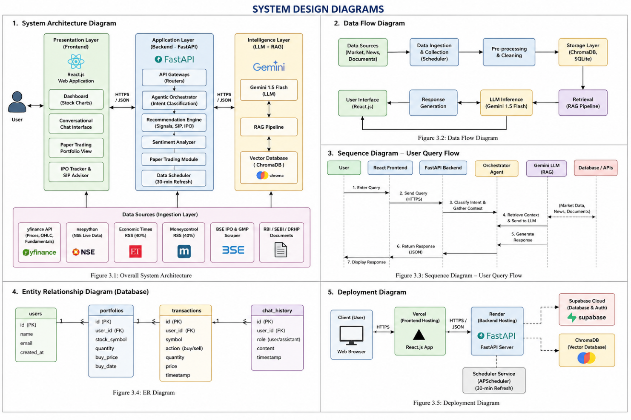
Fig 3.1 : System Design Diagrams

Design Patterns Used

The project uses several software design patterns to improve maintainability and scalability.
- Agentic Tool-Use Pattern: The LLM is allowed to invoke specific tools for data retrieval.
- Asynchronous Programming Pattern: Used to ensure non-blocking API execution.
- Singleton Pattern: Used for database and ChromaDB connection management.
- Modular Service Pattern: Backend functionalities are separated into independent service modules.

CHAPTER 4
IMPLEMENTATION

The implementation of FinSight AI is divided into frontend development, backend services, data ingestion modules, sentiment analysis modules, RAG implementation, and paper trading simulation.

The frontend of the application is developed using React.js and TailwindCSS. React components are used to build reusable UI modules such as the conversational chatbot interface, stock dashboard, IPO tracker, SIP advisor, and portfolio management interface.

The backend is implemented using FastAPI because of its asynchronous capabilities and high performance in handling concurrent API requests. FastAPI routers are created for chat services, market signals, IPO analysis, SIP recommendations, and portfolio management.

The market data module retrieves live stock prices and historical data using the yfinance library. NSE-related information is collected using custom scraping modules.

The sentiment analysis module fetches financial news using RSS feeds from Economic Times and Moneycontrol. Sentiment scoring is performed by analyzing keywords associated with bullish and bearish market trends.

The technical analysis engine calculates indicators such as RSI and Moving Average crossover using the pandas-ta library. These indicators are used to generate stock buy, hold, or sell recommendations.

Google Gemini 1.5 Flash is integrated through API-based communication. User queries are processed along with contextual financial data before being sent to the Gemini model.

The RAG implementation uses ChromaDB as the vector database. Financial documents are chunked, embedded using Gemini embeddings, and stored in ChromaDB collections. During query processing, semantically relevant chunks are retrieved and appended to the prompt.

The paper trading simulation module manages virtual trading transactions. Each user receives a virtual capital amount that can be used to simulate stock investments. The module calculates profit/loss values and maintains transaction history.

Supabase is used for authentication and portfolio data storage. User accounts, portfolios, and transaction records are securely maintained.

The backend services are deployed using Render free-tier deployment, while the frontend is deployed using Vercel.

Error handling and logging mechanisms are implemented across all modules to improve system reliability and debugging.

CHAPTER 5
RESULTS
5.1 Results
The initial implementation of FinSight AI demonstrates the successful integration of multiple AI and financial analysis modules into a unified conversational platform.
The system is capable of retrieving real-time stock market data and generating technical analysis-based recommendations using RSI and Moving Average crossover techniques.
The sentiment analysis module successfully processes financial news feeds and generates market sentiment scores. Positive and negative sentiment trends are reflected in the generated stock recommendations.
The conversational chatbot interface successfully interprets user queries and generates contextual financial responses using Gemini 1.5 Flash.
The RAG pipeline improves response quality by retrieving relevant financial documents from ChromaDB. Responses generated with contextual retrieval are more reliable and informative compared to standalone LLM responses.
The paper trading module successfully tracks virtual stock purchases and maintains portfolio calculations.

Snapshots :

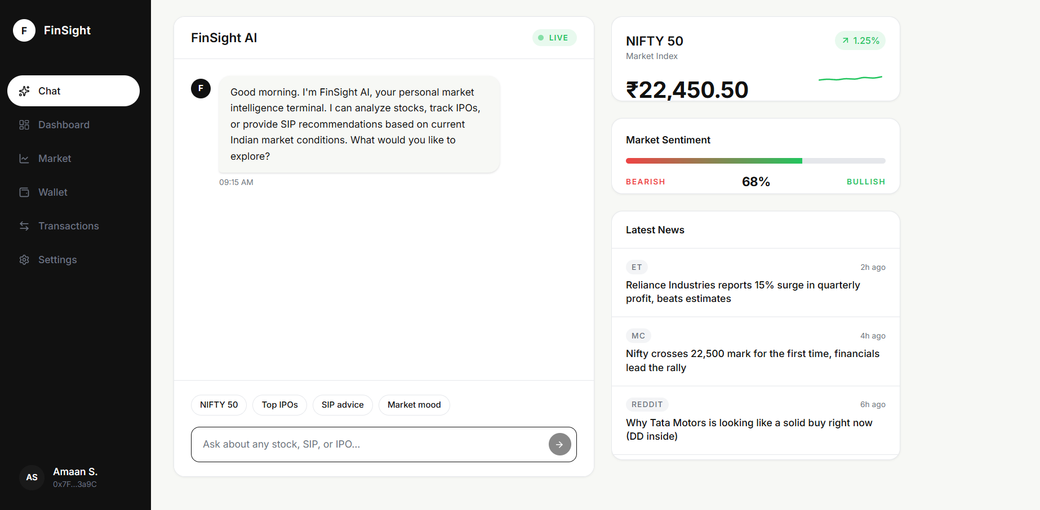
Fig 5.1.1 : Chat Section

The snapshot shows the main dashboard of FinSight AI, a web-based AI-powered financial advisory platform designed for retail investors. The interface includes a conversational chatbot that allows users to interact using natural language queries related to stocks, SIP recommendations, IPO analysis, and market conditions. The dashboard also displays real-time NIFTY 50 market information, including the current index value and trend analysis. A market sentiment indicator is provided to represent the overall bullish or bearish market mood based on financial news and data analysis.

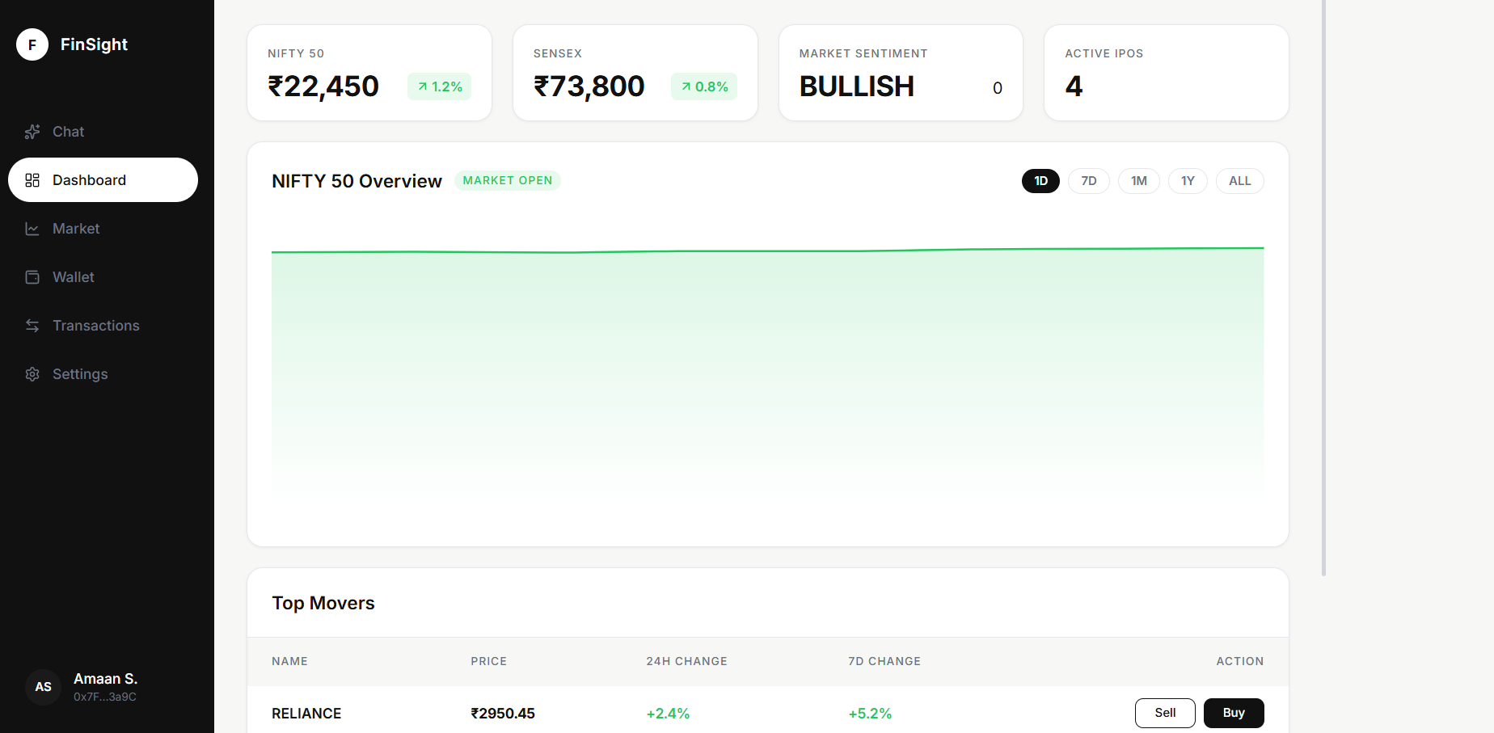

Fig 5.1.2 : Main Dashboard

The snapshot displays the dashboard section of FinSight AI, which provides users with a real-time overview of the Indian stock market. The interface shows key market indicators such as the current NIFTY 50 index value, SENSEX value, overall market sentiment, and the number of active IPOs. A graphical market overview section visualizes the NIFTY 50 market trend and indicates that the market is currently open. The dashboard also includes a “Top Movers” section that highlights stocks with significant price changes, displaying details such as stock price, daily and weekly percentage change, along with buy and sell options. The left-side navigation panel allows users to access modules such as chat, market analysis, wallet, transactions, and settings. Overall, the dashboard provides a clean and interactive interface for monitoring live market conditions and supporting investment-related decision-making.

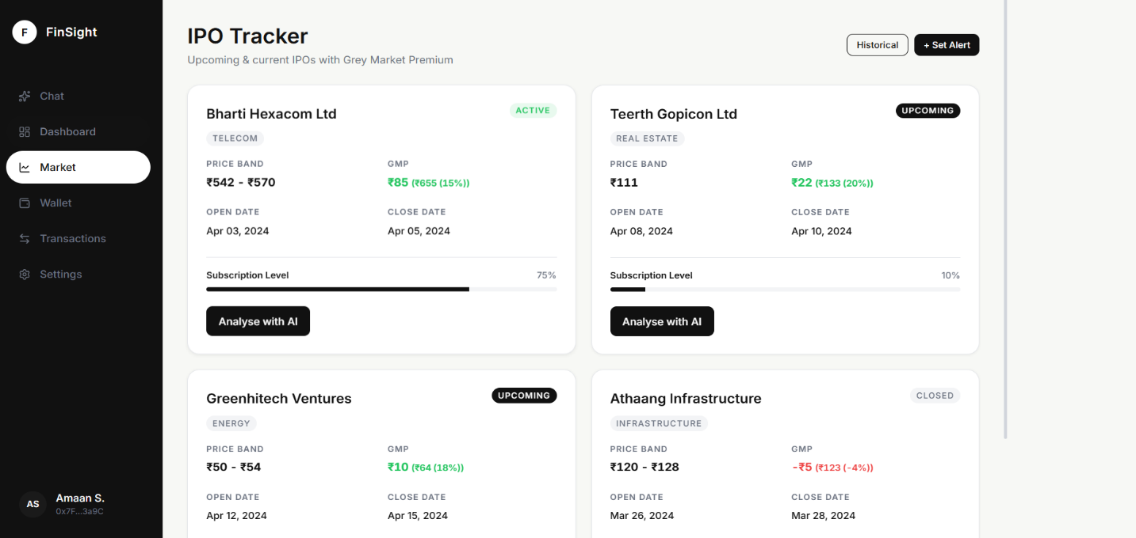

Fig 5.1.3 : IPO Tracker Dashboard

The above snapshot displays the IPO Tracker module of FinSight AI, which provides users with detailed information about current and upcoming Initial Public Offerings (IPOs). The interface presents multiple IPO listings along with important investment details such as company name, sector, price band, Grey Market Premium (GMP), opening and closing dates, and subscription levels. IPOs are categorized as active, upcoming, or closed to help users understand their current status. The module also includes an “Analyse with AI” feature that allows users to receive AI-generated insights and evaluations for each IPO. Additionally, options such as historical IPO analysis and alert notifications are available to enhance user engagement and decision-making. Overall, the IPO Tracker helps investors monitor IPO opportunities and evaluate market demand using real-time financial indicators and AI-driven analysis.

Observed Outputs
- Real-time stock market dashboard visualization
- Buy/Hold/Sell recommendations
- Sentiment-aware market insights
- IPO assessment generation
- SIP recommendation generation
- Portfolio profit/loss tracking
- Context-aware conversational responses

Performance Observations
- Asynchronous FastAPI services improved API responsiveness.
- ChromaDB retrieval reduced hallucination in financial explanations.
- Gemini generated accurate and understandable conversational responses.
- Paper trading simulation provided realistic virtual investment experience.
The implementation validates the feasibility of integrating LLMs, RAG frameworks, technical indicators, and financial sentiment analysis into a single AI-powered investment assistance platform.

CHAPTER 6
CONCLUSION AND FUTURE SCOPE

6.1 Conclusion
FinSight AI presents a web-based AI-powered financial assistant designed to simplify stock market analysis and investment decision-making for retail investors.
The project successfully integrates real-time stock market data, technical analysis indicators, sentiment analysis, Large Language Models, and Retrieval-Augmented Generation into a unified conversational platform.
The use of Gemini 1.5 Flash enables natural language interaction and contextual financial reasoning, while ChromaDB improves the factual reliability of generated responses.
The paper trading simulation module provides users with an opportunity to test investment strategies without financial risk.

Overall, the project demonstrates how AI-powered systems can bridge the gap between complex financial analysis and accessible investment guidance for retail investors.

6.2 Future Scope
Several enhancements can be implemented in future versions of the project.
- Integration with real-time brokerage APIs for live trading support.
- Personalized portfolio optimization using user investment behavior.
- Advanced forecasting using deep reinforcement learning.
- Integration of multilingual chatbot support.
- Mobile application deployment for Android and iOS.
- Improved sentiment analysis using transformer-based financial NLP models.
- Real-time notification system for stock alerts and IPO updates.
- Advanced visualization dashboards with predictive analytics.

The future scope of FinSight AI is extensive and has the potential to evolve into a scalable AI-driven financial advisory platform.

REFERENCES

[1] M. Luckianto and A. A. S. Gunawan, “MARAG-Fin: An Intelligent Multi-agent RAG-LLM Architecture Integrating Financial News Sentiment and Time Series Data for Data-driven Trading Decision-making,” International Journal of Intelligent Engineering Systems, vol. 19, no. 1, pp. 738–748, 2026.

[2] S. Das, S. Ghosh, A. Tiwari, R. E. Z. M. Lynghoi, S. Saha, Z. Murad, and A. Maurya, “Presenting an Order-Aware Multimodal Fusion Framework for Financial Advisory Summarization With an Exclusive Video Dataset,” IEEE Access, vol. 13, pp. 48364–48381, 2025.

[3] K. Liagkouras and K. Metaxiotis, “A Hybrid Long Short-Term Memory with a Sentiment Analysis System for Stock Market Forecasting,” Electronics, vol. 14, no. 2753, pp. 1–18, 2025.

[4] A. Jadhav and V. Mirza, “Large Language Models in Equity Markets: Applications, Techniques, and Insights,” Frontiers in Artificial Intelligence, vol. 8, no. 1608365, pp. 1–15, 2025.

[5] N. Srivatsan, “Using Large Language Models to Predict Stock Price: A Hybrid Model Combining Social Media Sentiment and Market Data,” National High School Journal of Science, pp. 1–12, 2025.

